DOCUMENTATION OF MIFOX TESTING

Initially, I set up accounting books for the savings and loan products to be created. This was done from the chart of accounts section, under Accounting.

After creating the loan product, I set up the accounting books for the GL account, the savings product and loan product with their GL Codes 25000, 25101 and 25100 respectively. It has 3 parts, the accounting book with account usage as a header, while we used detail for savings and loan product.

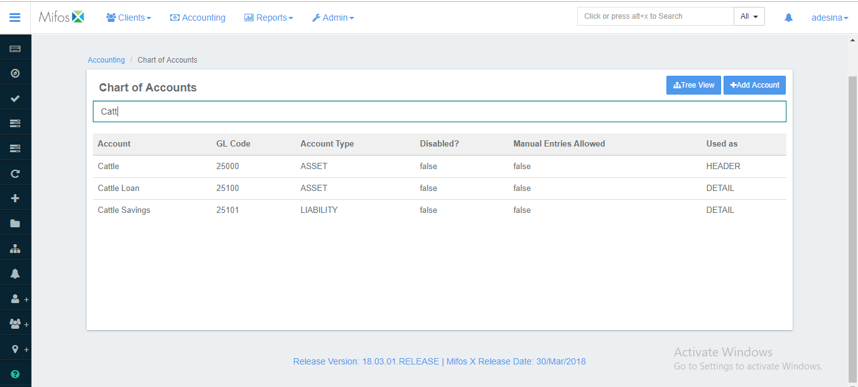

Create GL Account with Cattle

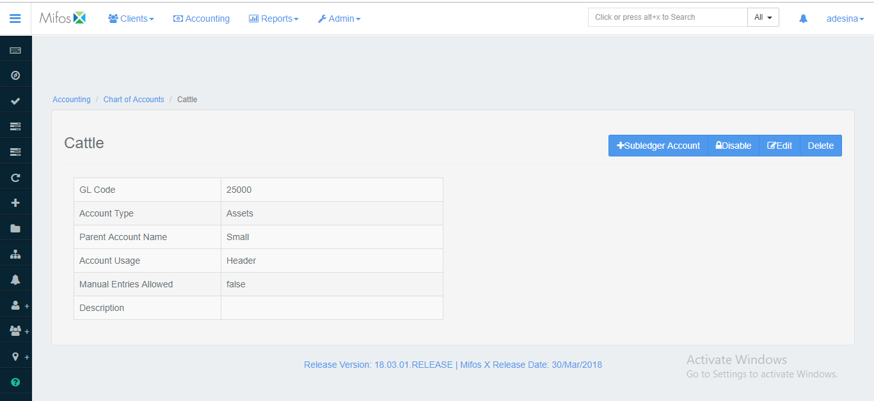

Create Savings Product with Cattle Savings

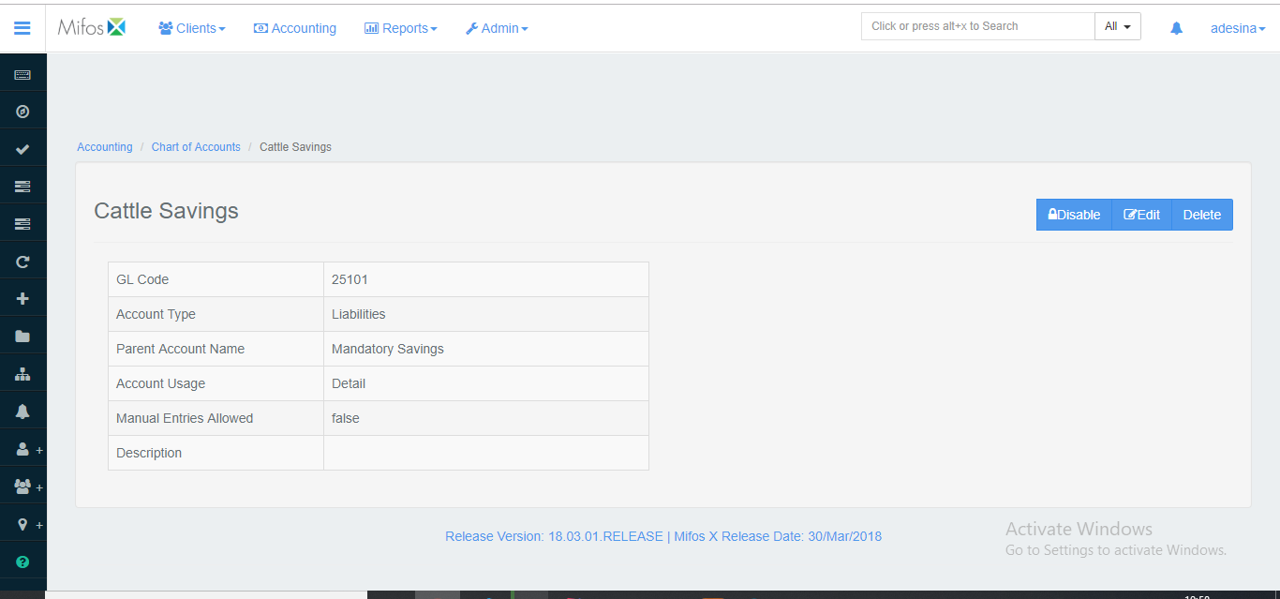

Create Loan Product with Cattle Loan

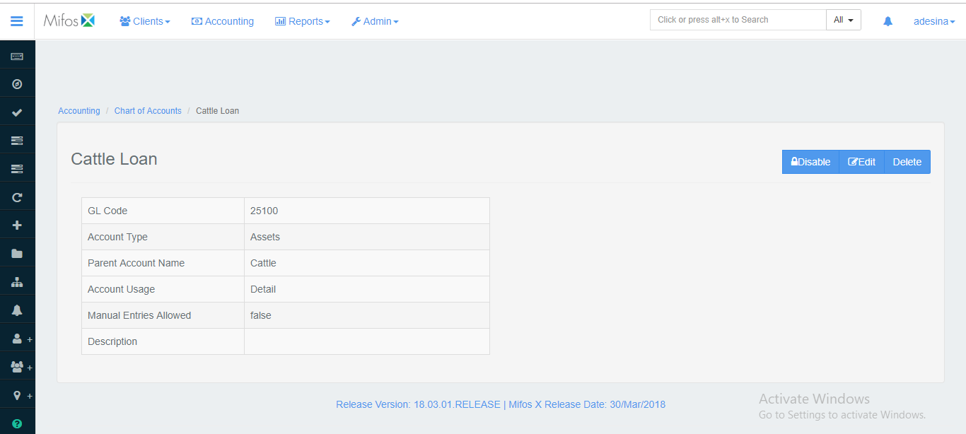

After Loan product is created book loan for a client and link to saving account

Screenshot after disbursement

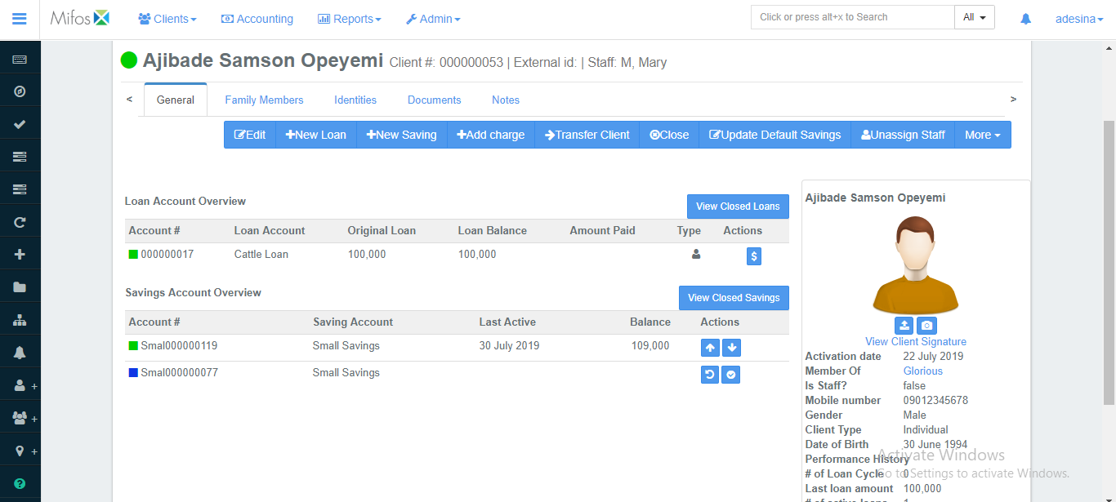

The new client’s balance shows that the (#100,000) loan has been credited to the savings account.