

Module Title: Software Development

Module Code: CST4010 Module Leader: Dr. Carl Evans

Software Guide

Group B

Game Name: Snail Space

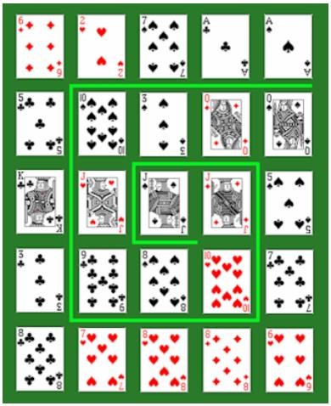

|  |  |
| --- | --- |
| **Team Members’ Name** | **Student ID** |
| Abbas, Adil | M00694171 |
| Ahmaditeshnizi, Elaheh | M00835624 |
| Alinezhadtilaki, Nina | M00961599 |
| Bahmani, Morvarid | M00929274 |

**Software Guide for Snail space**

**Operating System**:

Microsoft Windows 10 or above.

**Web Browsers:**

Latest versions of Google Chrome, Mozilla Firefox, Microsoft Edge, or other modern browsers with JavaScript enabled.

**Prerequisites:**

No additional software or dependencies are required beyond the specified operating system and web browser.

**Unzipping the Application**

* Locate "**snailspace_game.zip**" file in your file explorer.
* Right-click on the file and select "**Extract All**" to unzip the contents.
* Follow the on-screen instructions to complete the extraction process.

**Build Instructions:**

As the application is web-based and written in JavaScript using jQuery and Bootstrap, there's no traditional build step required.

**Runtime Instructions:**

* Open the application by double-clicking the "**index.html**" file or right click to open the file with any browser.
* For the best experience, use the application in **desktop** **view** on your web browser.

**Troubleshooting Tips:**

* If the application fails to launch, ensure that JavaScript is enabled in the web browser settings.
* Check for any browser extensions or plugins that may interfere with the application's functionality and disable them if necessary.