# XYZ Company

EXECUTIVE SUMMARY

# Overview

# Company XYZ owns a supermarket chain across the country. Each major branch located in 3 cities across the country recorded sales information for 3 months, to help the company understand sales trends and determine its growth, as the rise of supermarkets competition is seen to increase. The data folder contains datasets from three different branches; Lagos, Abuja and Port-Harcourt. Each data file from the branches contains the same attribute information and see below the attribute description.

Project Description

**Invoice ID**: Customer Identification number  
  
**Branch**: Supermarket Branch across the country (A, B, C)  
A - Lagos Branch  
B - Abuja Branch  
C - Port Harcourt Branch  
  
**City**: Supermarket Location  
  
**Customer Type**: Type of customers, Members - Returning customer with membership card, Normal - Customer without membership (could be returning, first-time or walk-in customer)  
  
**Gender**: Customer Gender Information  
  
**Product line:** Product categorization groups - Electronic accessories, Fashion accessories, Food and beverages, Health and beauty, Home and lifestyle, Sports and travel  
  
**Unit Price:** Price of each product in Naira  
  
**Quantity**: Number of products purchased by customer  
  
**Tax**: 5% tax fee for customer buying  
  
**Total:** Total price including tax  
  
**Date:** Date of purchase (Supermarket Record available from January 2019 to March 2019)  
  
**Time:** Purchase time (Supermarket Hours - 10am to 9pm)  
  
**Payment**: Payment used by customer for purchase (3 methods are available – Cash, Card and Epay)  
  
**COGS**: Cost of goods sold  
  
**Gross margin percentage:**Gross margin percentage  
  
**Gross income**: Gross income  
  
**Rating:** Customer Satisfaction rating on their overall shopping experience (On a scale of 1 to 10)

**Projects Requirements**

* Loading Datasets
* Data Exploration
* Dealing with DateTime Features
* Unique Values in Columns
* Aggregation with GroupBy
* Data Visualization

The briefed steps used to carry out the analysis are as follows:

* **df= pd.read_csv():** To Import the company’s datasets
* **df.head():** To Retrieved the data from datasets
* **df.isnull():** Checking the null values from the datasets
* **import datetime as dt :** To work with date time on the datasets
* **df.groupby()**: to group columns according to their relevance.
* **sns.countplot().set_title()**: to visualize the analyzed data. With title of the title of visualization.

# Highlights

The chart below show visual analysis of the datasets for the XYZ Company from all the branches. Using seaborn visualization. The first chart shows the payment method used most in all the branches while the second chart shows the product line of the company.

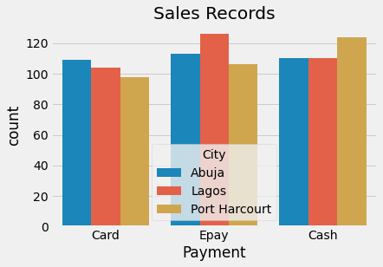

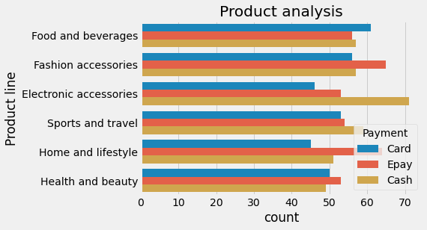

This chart shows the most used payment method for the products. As shown in the chart electronic accessories is the most purchased with cash. Which means the most common payment method is cash followed by Epay.

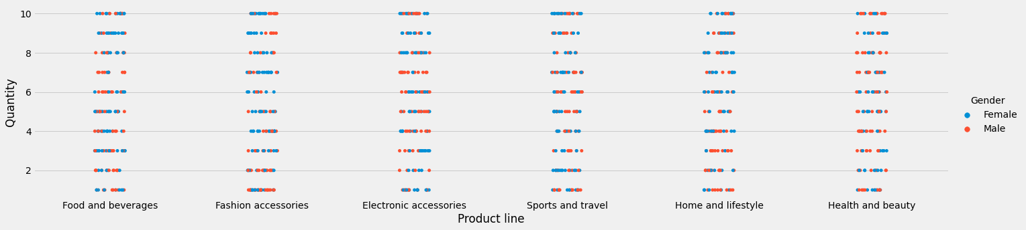

Using catplot() to generate visualization for the "product line" on x-axis, quantity on the y-axis, and hue as gender. To know which gender patronize the products most.

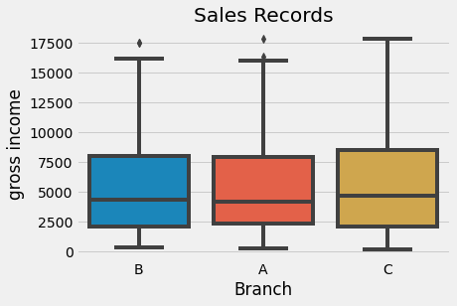

Using boxplot visualization we were able to analyse the the Branch with most gross income.

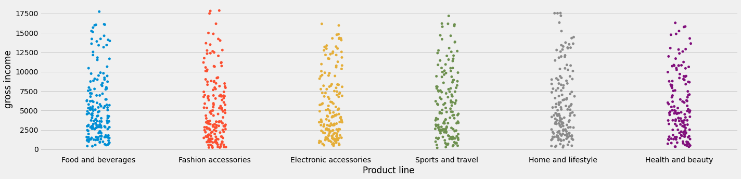

Using.catplot(x="Product line", y="gross income", data=df, aspect=4) visualization to analyse the product line and the gross income.

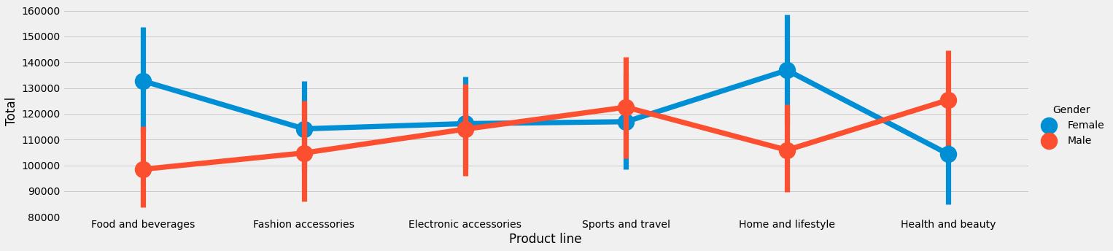

Using catplot visualisation with “kind= ’point’”to analyse total product patronize by m/f gender.

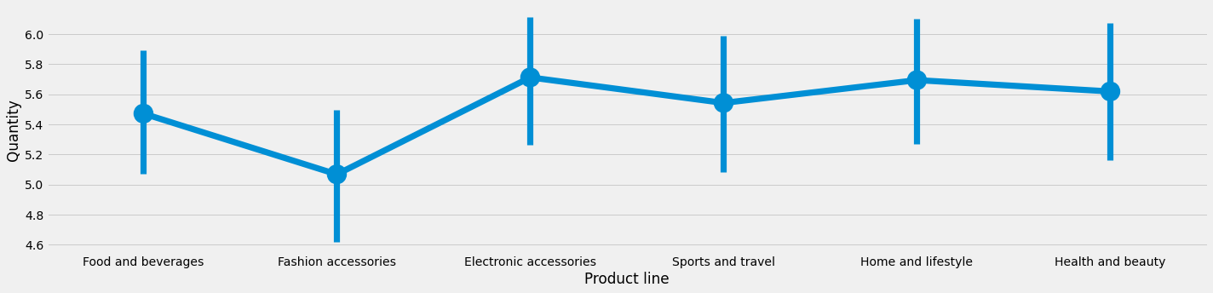

Using catplot visualisation with “kind= ‘point’”to analyse product line, quantity and the unit price per product.

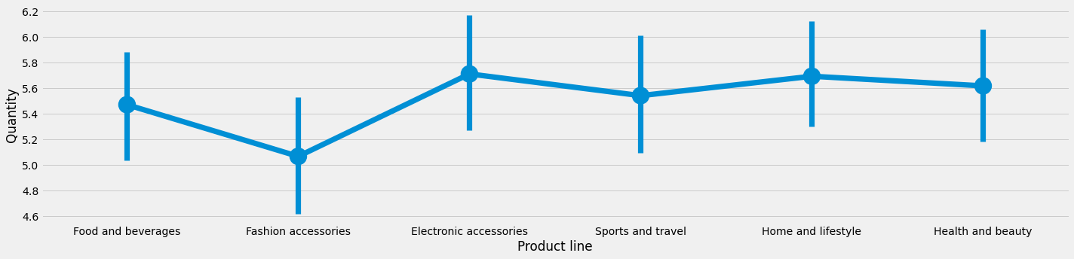

Using catplot visualisation with “kind= ‘point’”to analyse product line, quantity and the quantity per product.