Nom:

Popcorn

Qui:

Bibliothèque de films.

Slogan:

Make it pop!

Logos: ici

https://github.com/adesombergh/Popcorn-Logos

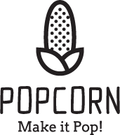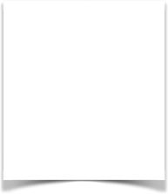

Couleurs:

#FFFFFF

#44AF69

#F8333C

#FCAB10

#2B9EB3

#DBD5B5

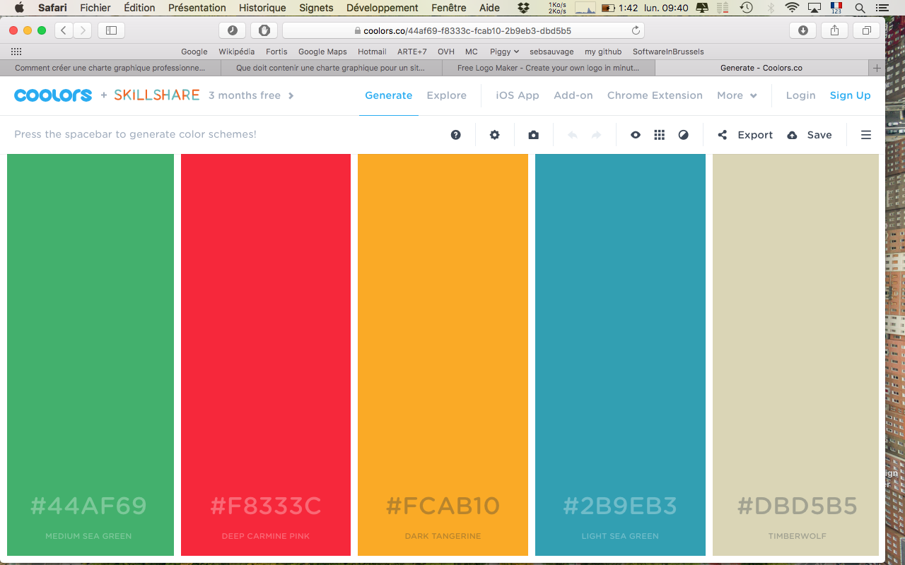

Polices:

Google Fonts:

* BioRhyme Regular
* Open sans

Icones:

Marques : <https://simpleicons.org>

Reste: <http://glyphicons.com>