**Nama: Ade Sugiantoro**

**NIM: 18090064**

**Kelas: 5B**

1. **Source Code**

Latihan1.php > application/controllers

Latihan2.php > application/controllers

Model1.php > application/models

Latihan2(view).php > application/views

1. **URL**

<http://localhost/pustakabooking/index.php/Latihan1>

<http://localhost/pustakabooking/index.php/Latihan1/penjumlahan/7/8>

<http://localhost/pustakabooking/index.php/Latihan2/penjumlahan/7/8>

1. **Hasil Layar**

**Latihan1**

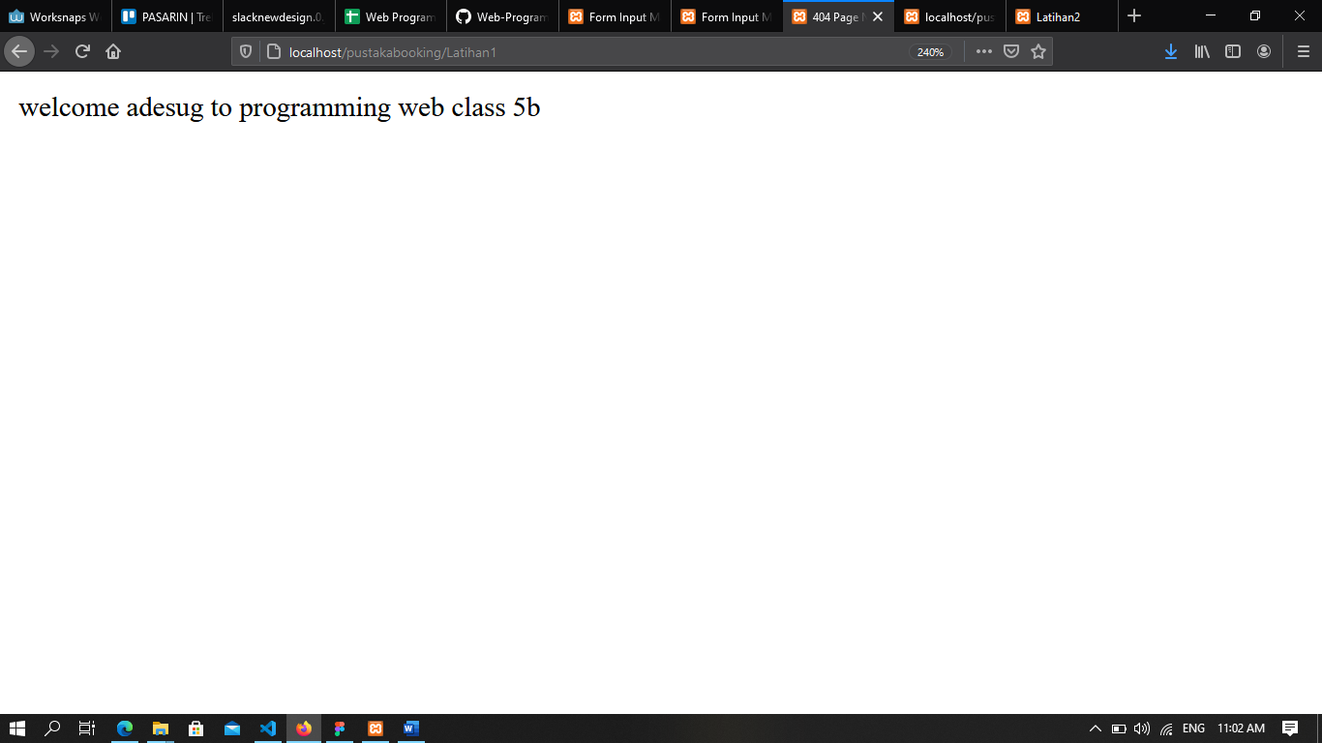

**Latihan1/penjumalahan/7/8**

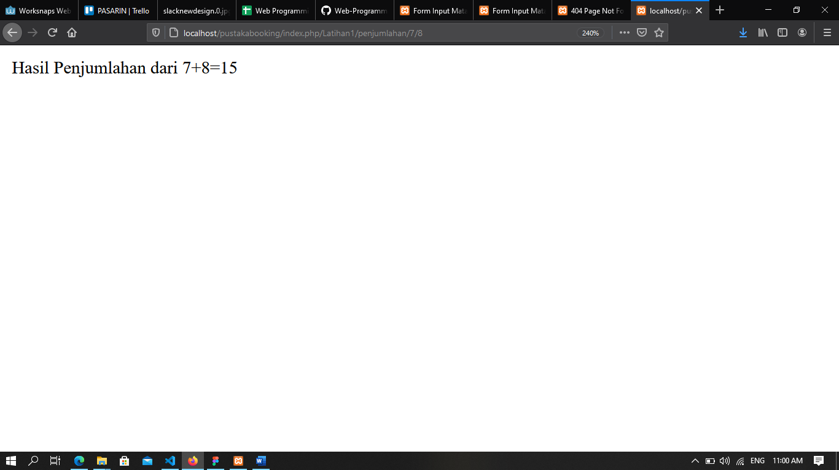

**Latihan2/penjumlahan/7/8**

