CHAPTER ONE

INTRODUCTION

1.1 BACKGROUND TO THE STUDY

The Judiciary is the system of courts of justice in a country, the arm of government charged with the responsibility to administer justice. Nigeria's legal system was built on a foundation of received Anglo-Saxon common law, statutory law, and other documents. (The Judicial Secretary, 2021). It is independent from other government functions and provides a forum for the just   
resolution of disputes in order to preserve the rule of law and to protect the rights and liberties   
guaranteed by the Constitution of Nigeria. The Nigerian Judiciary consists of the Superior Courts

of Judicature, which include the Supreme Court, the Court of Appeal, the High Court and the lower courts currently comprising the Circuit Courts, the District Courts and the Juvenile Courts. The Fast Track, Commercial Courts, Human Rights Court, Financial, Industrial (Labor) and   
Land Courts have recently been established as divisions of the High Court to facilitate the speedy resolution of disputes, particularly those of a specialized nature. (Dickson, 2020)

The advancements of the 21st century have led to an emergence of many disciplines with great   
potential to solve existing problems. One such potential field is Technology, which has over the   
years been increasingly adopted in many processes to avert the problems of ineffective and   
inefficient service delivery. (Chrisphine, 2021). One of the key areas of interest is automation of   
the judicial processes. Many challenges have been faced in the process of attaining justice   
including delays due to misplacement of the case files at the registry when reference is ought to be   
made. As legal practice has become more technologically advanced, pressure mounts on the courts   
is to join the flow of technological progress in other to provide a good service delivery. In addition,   
to emphasis on government transparency, to build public trust and confidence in judicial   
institutions. (Slowes, 2021)

Electronic Case Distribution System (eCDS) was introduced in Judicial Service of Nigeria. Under the Electronic Case Distribution System (eCDS), cases are assigned to the judges by the registrar. The system was to select adjudication cases at the High Court and was automated to eliminate suspicion of case fixing. It was introduced to judicial staffs and other stakeholders in Kumasi by Robert Cudjoe the Director of ICT in Judicial Service. (Joy FM, 2011). The court can now electronically manage a case from the filing state and assigning cases to judges.

1

* Case management

Case management is one of the main management activities in use within courts. The other main   
management effort is court management. While case management is connected to the primary   
processes in courts, which includes court administration and other processes that are directly   
related to case processing, the court management is connected to the secondary processes in courts   
and involves activities like strategy making, human resource management, research and   
development, Technology, finance, and maintenance of the build environment. (Rooze, 2021).

* Component of case management

Electronic case management systems provide support and automation in case management. In   
order to support or automate case management, it is necessary to understand the components of   
case management as a management support. A typical process in court consists: (a) receive   
documents; (b) administrative preparation; (c) content preparation; (d) court decision-making; (e) content elaboration; (f) administrative completion; (g) send and archive. (Rooze, 2021).

1.2 STATEMENT OF THE PROBLEM

Recently, Prosecuting Attorney’s current case management system is a desktop base application where cases that are registered are printed out and pasted on the notice board to enhance public access. The courts print out the cases that will be held in that particular week and keeps the outdated cases that have already been held in excel on the desktop. Due to this clients need to come back to the court to confirm the day its case will be held and sometimes leads to frustrations . (Rooze, 2021).

This project seek is to control and allow complete registration of all cases related to court activities to enhance reduction of time and eliminating manual works. The System delivers core functionality that is to provide meaningful ancillary benefits to the courts, such as more efficient data entry, more effective data retrieval, better tools and enhanced bar and public access, thus the public can have access to it anytime and anywhere.

Well developed and implemented Electronic Court Case Management System (eCCMS) make it possible for a court to stick more closely to a published standard schedule and timetable, which the court can track cases better, and controls the use of resources and notify and inform all on what has been decided and what is to be expected.

2

**1.3 AIMS AND OBJECTIVES**

The aim of this project is to develop and implement an Electronic Court Case Management System   
(eCCMS) to control and allow complete registration of all court case which is related to the court   
by the domain user thus registrar, who can register, update, delete, and search case and create   
report. The flow of information provides communication and notification between the courts and   
public.

THE FOLLOWING ARE THE OBJECTIVES OF THE PROJECT

➢ To implement an Electronic Court Case Management System (eCCMS) for case

registration which are related to courts, and creation, modification and updating through user interface.

➢ The software will allow information to be entered by users,

➢ The system “Event” and “Scheduling” is to determine new case arrivals, session   
 appointments, case deadline, reservation of courtroom and the judge who will head the case.

➢  To develop friendly user interfaces combined with intuitive layouts.   
➢ To create a database to store, manage and backup case records.   
➢  To create an administrator page that will show statistical analysis.

1.4 SIGNIFICANCE OF THE STUDY

When this project is completed, it will benefit the following stakeholders: the industry (Judicial service), the society and the academia.

1.4.1 THE INDUSTRY (JUDICIAL SERVICE)

The system will be used by the registrar for case registration and data processing (data storage and   
data retrieval) which involves creation, modification and updating information through user   
interface. The Chief registrar as well will be able to know the activities that is going on in various courts such as the name of registrars and the judge in each court, the time the registrar spent after login and also show the total number of a case type in each court such as trespassing, defrauding, robbery, data breach etc.

3

1.4.2 THE SOCIETY

The system will enable client or individuals to get access to a case details anywhere and anytime by going online to visit the webpage, which shows the details of a case such as the sitting date, the suit number, the name of the judge who will handle the case, the courtroom which the case will be held, the names of both plaintiff and defendant, etc.

1.4.3 ACADEMIA

This project will illustrate how open source tools can be used for the development of web-based applications thereby making the academia aware of the benefits of using cheaper tools. This project in future will allow other students to review the application and to think of new ways in which some components of the application will be improved or think of ways of adding new components to meet more needs.

1.5 PURPOSE OF THE STUDY

To study the influence of the Electronic Case Management System (eCCMS) on implementation and effectiveness of court service delivery in the Law Court Complex, Judicial Service of Nigeria.

1.6 METHODOLOGY

The nature of the project recommended agile model of System Development Life Cycle   
(SDLC).The agile model process starts with a simple implementation of a subset of the software   
requirements and iteratively enhances the evolving versions until the full system is implemented. The agile methodology gives the need to develop a system based on the requirements of the users,   
and enable to add up various units of the system pertaining the various feedbacks received from   
the users. At each iteration and increment, design modifications are made and new functional   
capabilities are added. And the phases includes Identifying Problems, Opportunities and Objectives, Determine Human Information Requirement, Analyzing System Needs, Designing the Recommended System, Developing and Documenting Software, Testing and Maintenance of the   
system.

Observation at the Supreme Court and The Law Court Complex showed that the Court had   
traditional ways with managing administration tasks, such as case registrations, viewing the case   
list (Cause list) to the public and scheduling of cases. The courts sometimes struggle with tracking   
cases since their system is a desktop based system. This problem presented itself as an opportunity   
that can be built upon. The public sometimes complains they had to come far away from their   
destination to check when a case will be held and the courtroom. People visiting the first time get   
frustrated since he will pass through many processes sometime wait for long to know the time a   
case will be held.

4

Obtaining this information a system will be designed that will meet the requirement of all the users both the Domain users and the public. In the design phase, every user interface will be designed for each section of the web application. Each user interface will be designed based on the principles of the User Experience (UX).

Localhost, MySQL and MariaDB will serve as database source. The familiarity with MySQL offers the chance to work without problems. The development of this web application will require HTML CSS, jQuery. These will help in the development of the user interface and its elements such as web forms, buttons, and modals.

Finally, PHP as server side programming language to interact with MySQL database and MariaDB. The web application will be implemented via a hosting plan. Users will be able to access the web application by going to the specified URL of the application. The design will ensure a smooth transition to the web application for all users of the system.

1.7 **OPERATIONAL DEFINITION OF TERMS**

The project report is divided into five chapters. Chapter one of the study introduces the problem   
statement and describes how the specific problem will be addressed through the aims and   
objectives and it also contains the significance of this study. Chapter two focuses on the review   
of literature and relevant research associated with the problems addressed in the study. Chapter   
three presents the methodology and procedures used for data collection and analysis,   
determining functional and non-functional requirements of such an application. In chapter four,   
covers the areas of implementing and testing of various prototypes at different stages in the   
development and also it also contains the various techniques and languages used in the   
development process. Chapter five offers a summary and discussion of findings, implications   
for practice, present and future and recommendations for future research.

5

CHAPTER TWO

LITERATURE REVIEW

**2.1 THEORETICAL FRAMEWORK**

2.1.1 OVERVIEW

This chapter explains global, African and Nigerian and local perspective in the use of Information Technology (IT) and Electronic Court Case Management System (eCCMS) in the delivery of justice. A reliable and accurate case system is fundamental to the effectiveness of day-to-day court operations and fairness of judicial decisions. The maintenance of case records directly affects the timeliness and integrity of case processing. There is a pressing need for a clear definition of legal framework (Johare 2023).

Apparently the web has been a major driving force in almost every sector relating to business, banking, health, education and many others. However, it emerges as a very effective platform where people communicate, transact business, learn or acquire information all over the world. According to the Internet live statistics, as of August 07, 2021 there was an estimated 3,179,035,200 internet users worldwide. The number of internet users represents nearly 40% of the world’s population.

The internet has been a contributing factor to the growth of Nigeria’s economy due to the fact that most Government agencies, companies, businesses, hospital etc. rely on the internet as a medium for running their day to day activities e.g.: transacting business, collecting data etc.

2.1.2 WEB APPLICATION

The development of web application keeps increasing day in day out due its importance and multifunctional ability in computing, a web application or web app is a client-server software application in which the client (or user interface) runs in a web browser. Web applications are popular due to the ubiquity of web browsers, and the convenience of using a web browser as a client to update and maintain web applications without distributing and installing software on thousands of client computers. Common web applications include webmail, online retail sales, online auctions, wikis, instant messaging services etc.

2.1.3 EFFECTIVENESS OF SERVICE DELIVERY IN THE JUDICIARY

In the last two decades there has been a widespread use of ICT around the world due to the expected benefits that have been achieved by the governments and organizations that have embraced it. ICT is a technology like computers, software, peripherals, and Internet connections infrastructure required to support information processing in order to execute and delivery of services. (Chrisphine, 2021).

6

According to Larsson (2022) at the organizational level, ICT is widely accepted, though not fully appreciated. Its integration in organizational functions is necessary for increased efficiency, costeffectiveness, and competitiveness. Some institutions are increasingly providing information and public services to the public by use of internet and this process motivates the society to use information and telecommunication technologies in order to take advantage of the public platforms both government and individual formations.

Gouanou & Marsh (2024) alleged that in order to minimize the risks and costs of regulatory and legal non-compliance, litigation, discovery, business inefficiency and failure, organizations need to remove the human element by automating records management via technology. This transformation means enforcing electronic record creation, creation and preservation of meta-data, minimizing duplicate records by creating a central information repository which will also facilitate knowledge and content management, systematically archiving and tracking records and amendments. The major issues in implementing electronic records in organizations are regarding access, security and interoperability (Manaf & Ismail 2021; Ojo, Janowski & Estevez 2019). Interoperability refers to the ability of different IT systems and software applications to communicate to exchange data among them accurately, effectively and especially to use the information that has been exchanged (Ataullah 2018).

Finally, the influence of technology changes traditional ways of court case operations such as case filing, case fees, cause list etc. Legal information processed through technology tools becomes more and more important in comparison to traditional source.

2.1.4 USE OF ELECTRONIC COURT CASE MANAGEMENT SYSTEM IN DIFFERENT COUNTRIES:

Many countries have embraced information technology use in their court systems. Transparency and effectiveness are emphasized as two positive consequences of the use of information and communication technologies (ICT) in courts. It has expanded the possibilities of access to information and judicial decisions. (Filho, 2023)

Court automation is not a new phenomenon in many national judiciaries, but the scope and level of development varies tremendously even among more advanced industrialized countries. To date, only a few countries have attempted comprehensive integration and automation of court case records, case management, document management, and electronic transmission and receipt of records. Many courts claims some progress, but few have succeeded. (2021, p. J. Michael Greenwood1 and Gary Bockweg).

7

2.1.5 RUSSIA

When the internet reached Russia in mid-1990s, Russian judicial chiefs actively embraced the idea   
of having a solid presence of national judiciary on the web. The judges in Russia believes that,   
having court web sites would improve public awareness about Russian courts and relieve   
overloaded court clerks from answering mundane questions about the location of courthouses,   
judge who will be taking the case, schedule of hearings, and so on. (Solomon, pp. Solomon   
2003,2004, Trochev, 2006). However, the development of court system in Russia helps individual   
to access case details online on web to avoid client physically go to court and also need to follow   
up daily after case filing.

2.1.6 BRAZIL

Brazilian court system used to be manual in nature; the decisions used to be written as if they ne of a kind even for cases related to mass litigation. For a client to know the contents of the litigation, one had to physically go to court. A daily follow-up of every case was required in order to avoid surprises such as the missing of deadlines. The process used to be time consuming but since they embraced ICT, all the previous challenges have been eliminated.

The Brazilian system has the following features and uses;

* The general public knows what is going on through Technology based web services

Veronese et al 2006 reports that every court has its web page that provides different services to the general public. Moreover, their autonomy allows every web page to have a design of its own. It displays the following information to the general public and users.

* Technology links public bodies and judiciary in public service agreements

A common database linking together different public services has been developed and reduced the time period initially taken for a decision to be made. Transformational Government calls on the public sector to standardize and share commodity services such as human resources, finance and customer service call centers (Barder, 2023).

* Transformation of the profession

Technology is definitely changing the practice of law in Brazil (Filho, 2009). The legal profession   
is changing and is increasingly adopting Technology in its operations. The intermediation provided   
by a judge’s work is thus no longer limited to the building of an accepted decision by the parties,   
but it has become a very complex task where other functions have been integrated. (Filho, 2009).   
Technology provides new input to its actions as well as enhancing its accessibility and   
transparency. But as it also reshapes the role of lawyers (Susskind, 2008), it exposes the existence   
of a professional digital divide between lawyers and among different Brazilian courts and regions.

8

2.1.7 AUSTRALIA

* Innovation in Australia

In Australia there is still work to be done to integrate ICT. Many courts still operate independent   
systems. Currently, Victorian courts and tribunals use 11 different case management systems. Of   
particular concern is the fact all Supreme Court filings are required to be in hard copy. For e-court use, those documents have to be reprocessed manually to be put in electronic format and then   
resubmitted. Partial case management systems have been implemented in some of the other   
Victorian courts and tribunals, all varying use and extent. The integrated Courts Management   
System Project currently being undertaken in Victoria (Integrated Courts, n.d) will integrate all existing case management systems into one standard system, delivering case and financial management, e-filing, scheduling and reporting, and online access to lawyers and the public. (Martínez, 2023).

* Venezuela

The Venezuelan judicial branch is headed by the Supreme Tribunal of Justice and also consists of lower courts, including district courts, municipal courts, and courts of first instance. The State has taken steps towards the modernization of the Justice Administration System in order to improve the quality, efficiency and effectiveness of the management of judicial processes (Fabri et al., 2001). Conventionally, courts operated with little or no technological support but now all is changing fast. According to Fabri and Contini (2001) the focus of the reform effort includes legal changes, transparency enhancement, organizational efficiency and user access which have a seamless integration of ICT applications. The ICT measures are both directed at the Supreme Court and lower court levels in jurisdictional and administrative areas.

In July 1999, the judiciary implemented a new Organizational Model and an integrated ICT   
Management System, Juris 2000 that had a number of specific functions (Fabri et al., 2001). It   
serve as an aid to case processing by facilitating the production of interactive documents, the   
automatic integration of information stored in databases, as well as feedback to the databases of   
new information. It allows for the automatic “capture” of information once it has been entered into   
the System, thus avoiding the need for multiple or repeat data entries. The system also supports   
the judicial decision process as it serves as a warehouse of information on legislation, doctrine and   
jurisprudence, including information produced in other parts of the judiciary (Fabri et al., 2001).

**9**

whereby the system can be used for a single court or a group of courts, and is adjustable to legislative reforms without need for system changes; (iii) visual interface and user friendly screen operation that allows staff with little or no training run the system; (iv) consistency in ensuring homogeneity in judicial procedures, within and across the courts; (v) self-sufficiency as information can be entered directly and immediately into the System, without need for further steps (fabri et al., 2021)

2.1.8 KENYA

Kenyan judiciary has embarked on a modernization program aimed at improving the service   
delivery to the general public. Kenyans are hoping for first-class service and technology will   
accelerate that, as well as improve efficiency in the judiciary, the attorney general's chambers and   
the National Council for Law Reporting (Wanjiku, 2008). ICT is expected to reduce the incidences   
of corruption in the judiciary that had been highly prevalent before the famed judicial purge of   
2003, spearheaded by justice Ringera (Sitienei, 2010). According to Gallup poll, (2021), public   
confidence in the judicial system and in the moral authority and integrity of the judiciary is of the   
utmost importance in a modern democratic society. At present, the Kenyan judicial system faces   
a number of significant challenges that affect the efficiency and effectiveness of the administration   
of justice. These include: large backlog of cases, lack of sufficient and sustainable funding,   
shortage of judges and magistrates and lack of effective case management (International Bar   
Association (IBA, 2021). All these have greatly contributed to the loss of public confidence in   
the judiciary.

The use of Information, Communication and Technology (ICT) is considered as one of the key elements to significantly improve administration of justice. This has been evident in countries like Brazil, Australia, Mexico and Venezuela. The rapid development of technology opens up new opportunities that were unthinkable only a decade ago (Velicogna, 2023). The influence of ICT in any judiciary however, needs to be measured and evaluated accordingly. This is to avoid white elephant projects, as automation is a great consumer of resources. Since it’s commissioning, Eldoret Court station case managements system has never been appraised on the basis of the cost of ICT, employee job satisfaction, court data security and the level of Fraud/corruption. This is a big gap considering the judiciary’s big plans to automate its processes and eventually become paperless in its delivery of justice.

10

2.1.9 NIGERIA

In decades Nigeria was using the traditional way in court case processing, recently an Electronic Case Distribution Management System (ECDMS) was introduced purposely for filing case and assigning case to judges. This was also introduced to eliminate fixing of cases and duplication. (Joy FM, 2011). Now the judicial system of Nigeria faces some challenges that’s affecting the efficiency and effectiveness in the court operations. Where often it overloads court clerks answering of mundane questions about the location of courthouses, judge who will be taking the case, schedule of hearings, and so on. And also insufficient data storage.

Success can be measured in many ways: the degree of adoption by courts, legal community, and the public; the volume and extent of usage both transmitting documents to and from the courts; the reliability, validity and dependability of the service; the efficiency and effectiveness of the service and productivity of staff; and improvements in the overall quality of justice.

2.1.10 FACTORS INFLUENCING EFFECTIVE JUDICIAL SERVICE DELIVERY

Judicial service delivery is viewed from both the eyes of its employees as well as the perception of the public. Efficiency in service delivery in Nigeria is crucial towards the realization of the transformed judiciary. Several factors influence service delivery in the Nigeria judiciary. Among them: cost of ICT, employee job satisfaction, and security of court data.

11

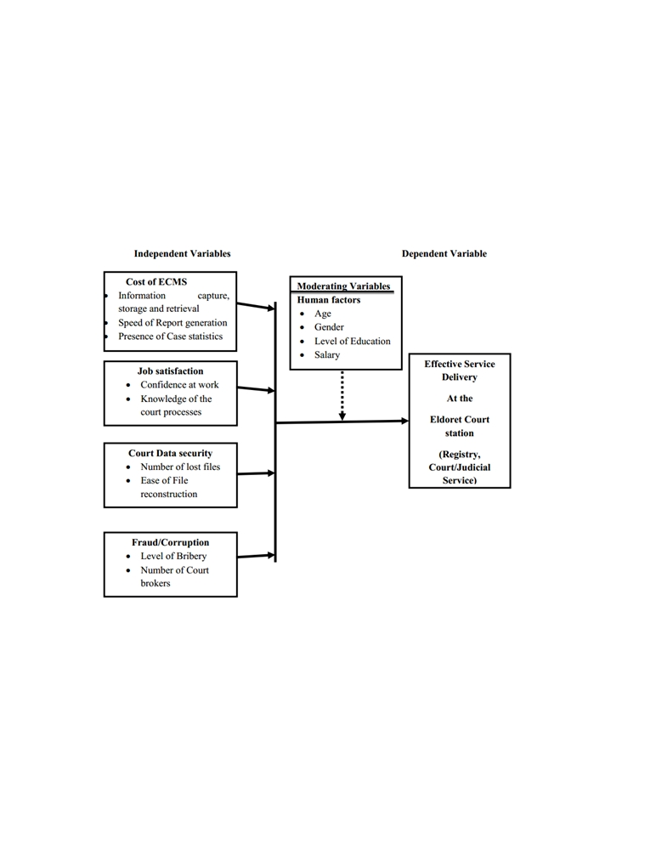

2.2 CONCEPTUAL FRAMEWORK

Figure 1-(Conceptual framework)

12

**2.2.1 TECHNICAL, ECONOMICALLY & OPERATIONAL FEASIBILITY**

1. **Financial feasibility:**

Financial feasibility refers to financial support required. It refers to finance incurred

during the development of the project.

1. **Technical feasibility:**

Technical feasibility refers to technical knowhow and auxiliary devices required.

1. **Behavioral feasibility:**

Refers to reaction of the people towards the project.

1. **Operational feasibility:**

Operational feasibility means is it possible to practically implement the project.

While installing this software, the hardware and software requirements should be specified.

* + 1. **FEASIBILITY GAINEED BY THE SYSTEM**
* **Technical Feasibility**

Since the project will be implemented JavaScript and PHP, so we need to have a

strong base in programming. A computer with necessary installation is required.

* **Economical Feasibility**

To implement the system we require more than one computer. Since the system will be

implemented in existing environment there will be no need to buy the computers. The

system is economically feasible to implement.

* **Operational Feasibility**

The system will be easy to install and use. Hence the system is operationally feasible.

* **Cost-Benefit Analysis**

The cost incurred by the system includes only the software cost and cost of the computer

needed to run the project. The benefits incurred by the system will include.

**2.2.3 CONCEPT OF COMPUTER NETWORKING AND THE INTERNET**

According to Microsoft Encarta premium (2022), computer networking is simply a system used in linking two or more computers. Networking itself is a group of connected computers that allow people share information and equipment. Computer networking uses a communication link or node through which the E-mails, files resources and other applications are sent and received. A computer system and a printer can both serve as communication links in a network. However, there are other devices. It has layers, and criteria, parts and connection types, topology and types of networks, network peripherals and at areas of applications. All these

13

computer networking process must pass through to ensure effective on-line business. Networks are specified through broad and narrow definitions. The broad definition considers an on-line transaction to be the sale or purchase of goods or services either between businesses, households, individuals, government, and other private or public organizations. The role of networking in on-line book shopping is that of conveying, providing computer system and other resources and connecting them for the on-line transactions. The internet on the other hand is a computer based global information system. It is composed of many interconnected computer networks. Each network may link tens, hundreds or even more. The satellite systems are vital tools/equipments in internet computer network. Its role is of paramount importance. It includes advertising the books selling, buying delivery and providing other customer services. Meanwhile, the narrow definitions of Batty J.B and Lee R.M (2022) have it that internet transaction (on-line shopping) to the sale or purchase of goods and services whether between businesses; households’ individual’s governments and other public or private organizations are conducted over the internet. The goods and services are ordered over the internet, but the payment and the ultimate delivery of goods or services may be conducted on or off line.

**2.2.4 INTERNET ACCESS**

According to Microsoft Encarta premium (2021) Internet Access technological refers to the communication between residences or a business and the ISP (internet services provider) that connects them to the internet. They are of three types namely; dedicated, dial up and wireless internet access. It is therefore the communication that is going to exist between the customer, the ISP and the bookshop through the internet. It is all about the easy accessibility the customers will enjoy.

**2.2.5 THE CONCEPT OF INTERNET GATEWAYS**

The computer system hardware contains software that connects networks that use different protocols (the rules the hardware components and the software components use to communicate) or that transfers data between two incompatible applications on a network. It reformats data so that it is acceptable to the receiving network application. The term internet gateway is usually used to describe any computer that transfers data from one computer system to another; Microsoft Encarta premium (2021).

**2.2.6 THE WORLD WIDE WEB AND ITS BENEFITS**

This is the multimedia interface that connects us to resources or the customers to the documents, goods, services, e-mails, chats about the books and other websites available on the internet. The World Wide Web which is abbreviated www is the window from which we

14

see the information in the internet. It all began in 1992, prior to it, the internet was just an ordinary text, documents without pictures, sounds or video, it is through the website that we will carry out the on-line book shopping. The benefits accruing from the use of the World Wide Web are so numerous. To mention but a few, the ease it has given to people to send and receive messages to study and even purchase goods on-line and to know and see things and other people in other parts of the world.

2.2.7 OVERVIEW OF DATABASES

The application that will be developed has aspects of managing and storing data of the cases which are brought to the court, there is a need to deploy a database that will be of immerse benefit, to store their records.

Database technology has a major impact on the growing use of computer. A database is a collection of related data organized in a way that the stored data can be easily accessed, managed and updated. For example, the storage of case records such as date, suit number, plaintiff, defendant, name of court, name of judge who holds case etc. on the application.

A Database Management System (DBMS) is a software that allows creation, definition and manipulation of database. The DBMS has a number of advantages as compared to traditional computer file processing approach. The database administrator must keep in mind the benefits or capabilities of DBMS during designing databases, coordinating and monitoring the DBMS. Some of these benefits are as follows:

1) Controlling Data Redundancy: In the traditional way of managing records, books were used to store record changes and updates of cases. This may cause the duplication of copies of the same data but in the proposed system all the data will be integrated into a single database. The data is recorded at only one place in the database and it is not duplicated.

2) Data Consistency: By controlling the data redundancy, the data consistency is obtained. If a data item appears only once, any update to its value will be done only once and that updated value will be available to authorized users.

3) Data Sharing: In DBMS, data can be shared by authorized users of the clinic. The database administrator manages the data and gives rights to users to access the data. Many users can be authorized to access the same set of information simultaneously. The remote users can also share same data. Similarly, the data of same database can be shared between different application programs.

15

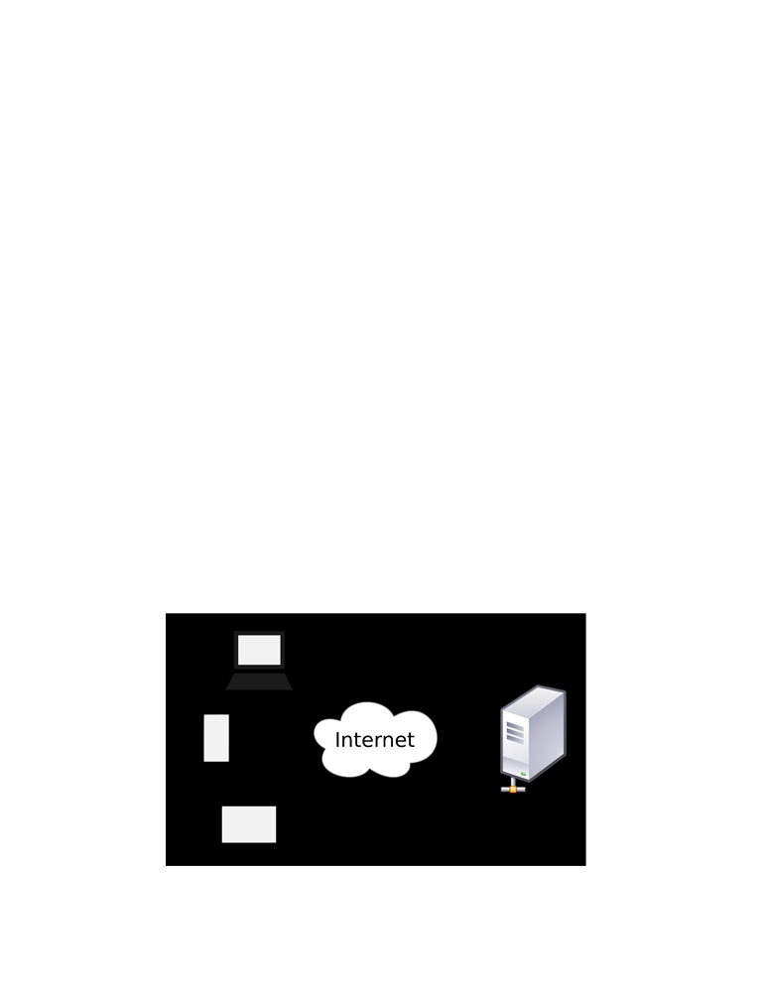

2.2.7.1 THE ROLE OF THE CURRENT ECCMS

The system plays a major role in judiciary system. This is mainly because it takes care of most of the functions in Legal Department. The uniqueness of the eCCMS is that it simplifies most of the communication aspects within the Legal sector to both the court and public.

2.2.7.2 USER

The system will be used for case registration and data processing (data storage and data retrieval)   
it involves creation, modification and updating information through user interface. The user will   
be required credentials that is needed to control the access of the application in terms of security.

2.2.7.3 PUBLIC ACCESS

The eCCMS will show new case arrivals, session appointments, case date of start, Reservation of courtrooms and the judge who will take the case, which the public can view the details on the web and search for a case.

2.2.7.4 HOW WEB APPLICATIONS WORK

Web applications use the client/server architecture. The Web application resides on a server and responds to requests from multiple clients over the Internet.

Figure 2-(how web applications work)

16

**2.2.8 UML (Unified Modeling Language)**

Unified Modeling Language (UML) is a language used for visualizing, specifying, constructing and documenting an artifacts of a software intensive development project. UML is a graphical language where graphical notation is used to express the ideas rather than using in a textual notation for modeling system. There are three types of UML namely Structural Modeling, Behavioral Modeling and Architectural Modeling.

**2.2.8.1 USE CASE DIAGRAM**

The use case diagrams for this application illustrate the interactions that exist between users (actors) and use cases (actions) within the application. There are two actors identified for this application – administrator (admin) and user actors. As a result, there are two use case diagrams for the software application – admin use case diagram and customer use case diagram. The admin who performs various administrative tasks such as add case, view ase, and update case status while the user is any individual who appeal.

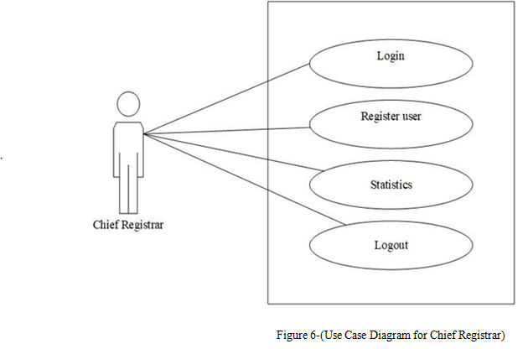

17

**2.2.8.2 SEQUENCE DIAGRAM**

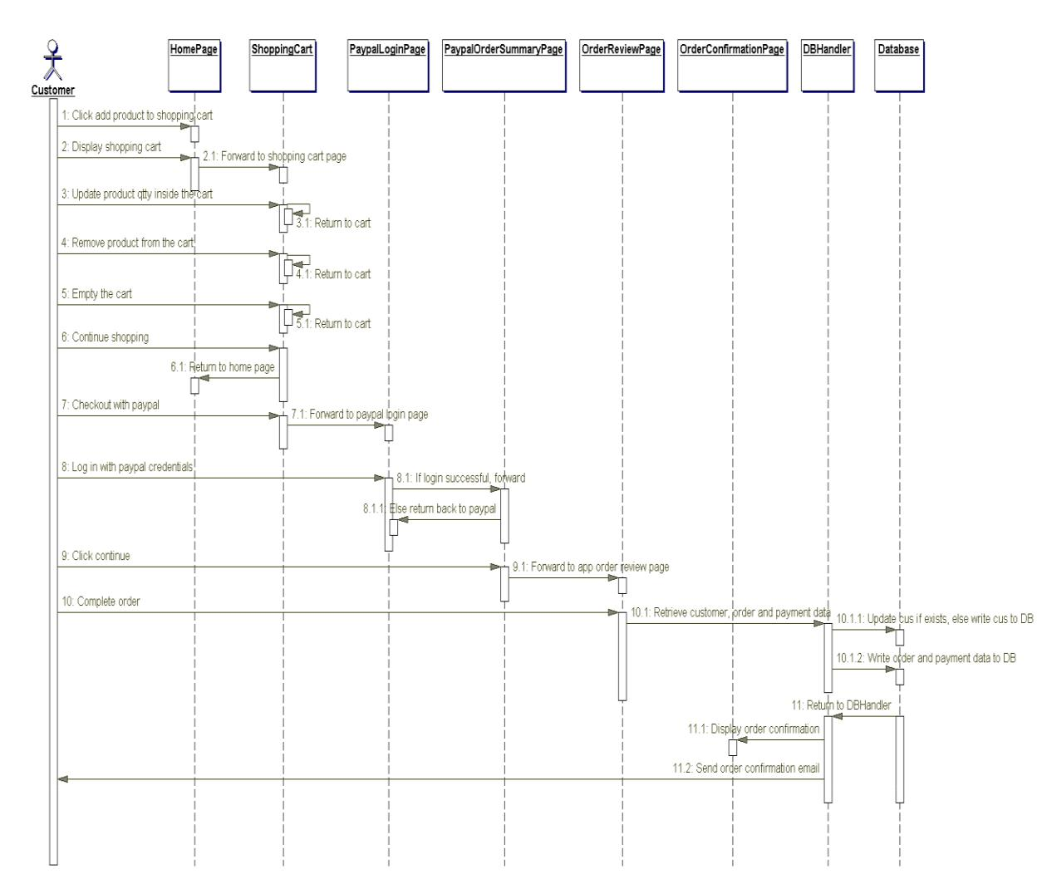 A sequence diagram gives a detailed visual description of how the various classes in a system interact with each other. Also, it depicts the order in which different objects exchange messages with one another in a system. The sequence diagrams for this application are presented in the following sub-sections.

**Figure 4.** Sequence diagram.

**2.2.8.3 COMPONENT DIAGRAM**

A component diagram is used to depict the organizations of software components and the relationships that exist among them. Figure 7 illustrates the component diagram for this web application. It was modeled according to the Model-View-Controller (MVC) pattern used for structuring web applications. The MVC pattern makes coding, testing and maintenance of an application easier and it is usually considered as a best practice.

As can be seen in Figure 5, the MVC pattern divides this application into three distinct layers: the model, the view, and the controller. The model is the business layer of the application, which contains the JavaBeans for the application. A is simply a plain old Java object (POJO) used to encapsulate data. The view represents the presentation layer, which contains JSP files for displaying

18

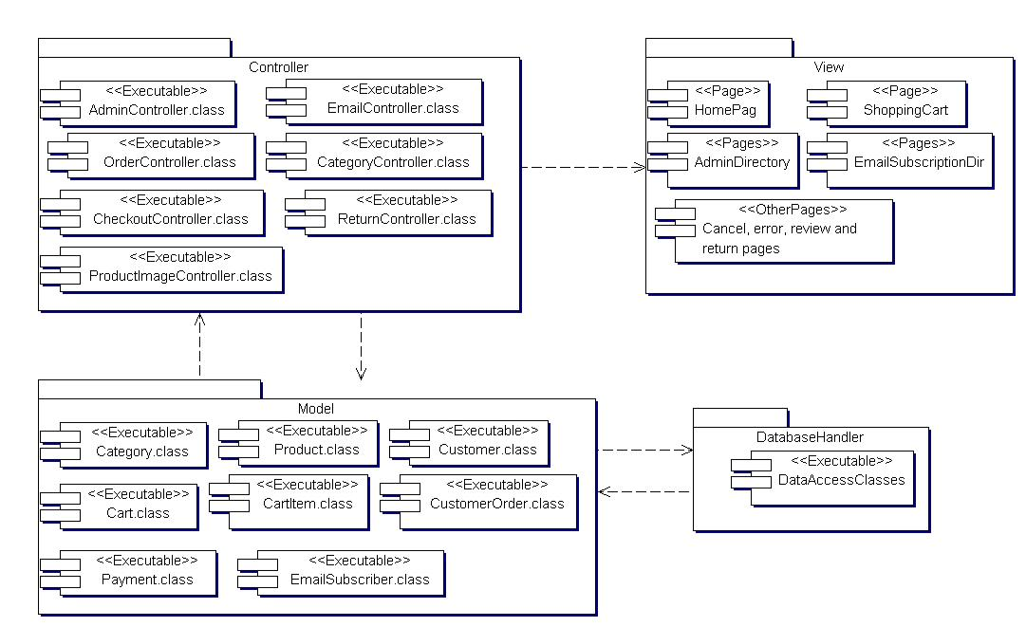the various pages of the application. The controller controls the flow of data between the model and the view. It contains servlets for updating the model object and saving it to the database through the database handler. The servlets also update the view for presentation when necessary. In addition, the database handler consists of data access classes, which provide methods for storing data in the database since the JavaBeans do not provide these methods.

**Figure 5.** Component diagram.

**2.2.8.4**  **DEPLOYMENT DIAGRAM**

The deployment diagram for this application is illustrated in Figure 6. The diagram shows the configuration of the run-time hardware components (nodes) and the software components running on those nodes. As can be seen in Figure 6, to deploy this web application a database server, an application server, and computers with internet access are needed. Also, backup servers are provided for the database and application servers.

19

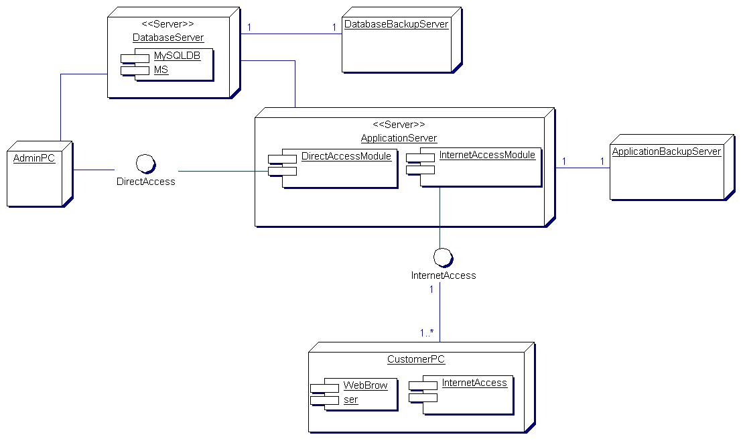

**Figure 6.** Deployment diagram.

**2.3 EMPIRICAL FRAMEWORK**

**2.3.1 HTML, CSS and JAVASCRIPTS**

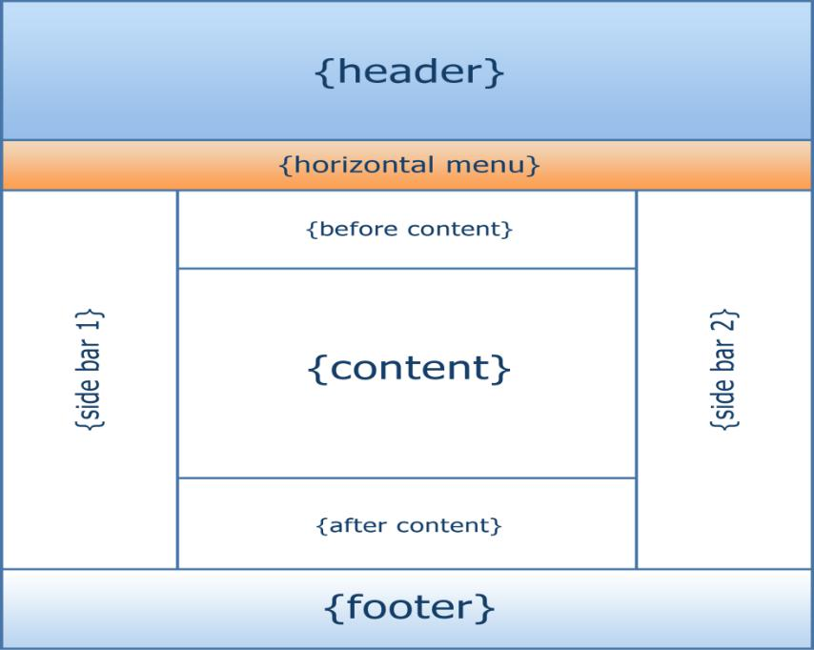**HTML** means Hypertext Markup Language. This language is used in creating web pages. This language also supports other languages such CSS, PHP, JAVASCRIPT, etc. in creating interactive and responsive pages on the pages. HTML5 is just an updated version of the HTML. It supports new features, new attributes, new HTML elements, full CSS3 support, video and audio, 2D/3D graphics that help users and also help web developers to create new features easily on the website. The structure of HTML5 is shown in **figure 7**

**Figure 7**: The structure of the Html/Html

20

* **CSS 3**

CSS is simply referred to as Cascading Style Sheets.CSS is used to define styles for web pages, including the design, layout, and variations in the display for different de-vices and screen sizes.

**The general structure of CSS**

**Basic syntax:**

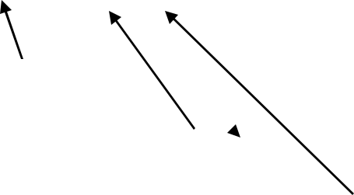selector{property: value}

HTML tag you want to modify

the property you want to change

The value you want the property to take

Example:

*p{text-align: center;*

*color: black;*

*font-family: arial}*

* **JAVASCRIPT**

**JavaScript** is a high-level language which could be used independently or inculcated into the webpage. It can be used to, handle requests and responses and also add dynamic behavior and also store information on a website.

**2.3.2 PHP MYSQL**

**PHP** is a server-side scripting language that is used to develop Static websites or Dynamic websites or Web applications. It is designed for web development to implement dynamic web pages and can be embedded into HTML for it to be displayed. Figure 8 demonstrates how the web server operates.

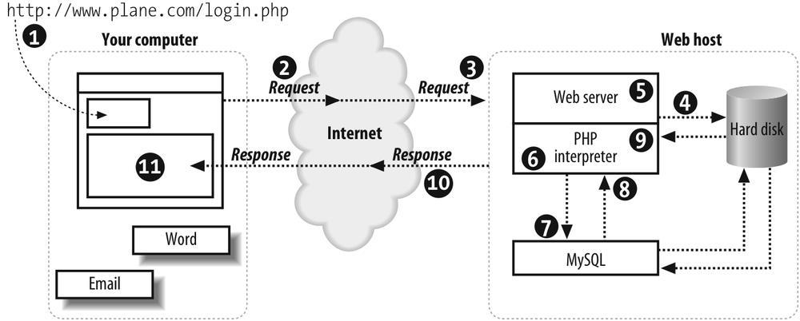

21

* **MySQL**

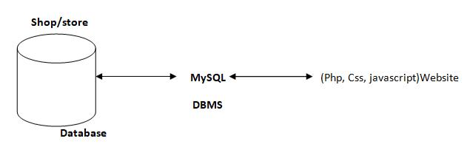 **MySQL** is a free source database system, and it enables the cost-effective delivery of reliable and a high-performance and scalable Web-based and embedded database applications. It is a relational database system (RDBMS). It is a high performing program and scalable to meet the demands of users and data. MySQL is written in C and C++, so it is compatible with most of the operating systems available around the world.

**Figure 9**: A diagram showing the concept of MySQL

* + 1. **XAMPP**

**XAMPP** is an integrated development surrounding, which incorporates Apache HTTP Server, MySQL Database, and PHP, Mercury, PERL or Python on a home Windows-based computer. Apache is a free web server. MySQL is an open source database.

XAMPP is used in collaboration with, PHP, MySQL and, Windows 10 operating system.

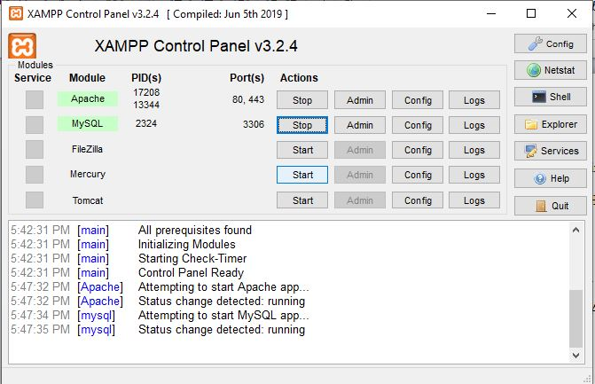

* + 1. **BRACKET (Editor)**

Brackets are a free-source editor written in HTML, CSS, and JavaScript. It is created via Adobe structures, certified underneath the MIT License, and is presently maintained on GitHub. Brackets are compatible with Mac, Windows, and Linux operating system.

22

**2.3.5** **PhpMyAdmin**

PhpMyAdmin is a free and open source MySQL management program application written in PHP and was first launched in 1998 under the GNU preferred Public License. It is cross-platform help for the essential working structures and helps management of more than one servers. It supports most MySQL capabilities and has an intuitive net interface. It additionally has supports developing PDF graphics of data-base layout, importing information from CSV and SQL formats as well as exporting records to various codes such as SQL, XML, PDF and, CSV.

**2.3.6 APPLICATION DESCRIPTION**

This application is divided into two parts – the home page and the admin page. The home page is where student and optionally subscribe to an email list while the admin page is where the admin can carry out administrative tasks. The admin page is restricted and can only be accessed through authentication provided by the Apache Tomcat servlet container. This means that all the web resources in the admin page can only be accessed by an authorized user.

**2.3.7 ANALYSIS MODELS**

Modeling involves the designing of software systems before coding takes place. Modeling plays an important role in any software development project. It guarantees the completeness and correctness of a software system and the fulfillment of end-users’ expectations. In addition, modeling serves as the only reference point to cross-check requirements before coding.

A Unified Modeling Language (UML) based tool was used to model this application. UML diagrams give both static and dynamic views of an application and it is well suited for object-oriented languages like Java and C#. The following sub-sections present the UML diagrams used to model this application.

23

**CHAPTER THREE**

**SYSTEM ANALYSIS DESIGN AND IMPLEMENTATION**

3.1 METHOD

This chapter tackles the approaches that were used to achieve the objective of the project. It also   
demonstrates mainly the techniques to be used to capture user requirements and specification.

3.1.1 RESEARCH DESIGN

Parahoo (1997:142) describes a research design as “a plan that describes how, when and where data are to be collected and analyzed”. This study focuses on the plaintiff and defendant who are involved in the case, the date which the case will be held, the judge who will be taking the case and the court which the case will be held.

3.1.2 DEVELOPMENT METHODOLOGY

Methodologies in System development are principles or rules from which specific methods or   
procedures may be derived to solve different problems within the scope of a particular discipline.   
It can also be said to be a framework, since is used to structure, plan and control the development   
of an information system. Typically, it encompasses concepts such as theoretical model, phases   
and quantitative or qualitative techniques. In system development selecting right methodology   
approach and following through to deliver the intended system can be a bane for system   
developers.

The agile development methodology was deployed in the development of the system. Agile method proposes incremental and iterative approach to software design rather that waterfall model where development of the software flows sequentially from start point to end point. This model enables the customer to have early and frequent opportunities to look at the product and make decision and changes to the project.

24

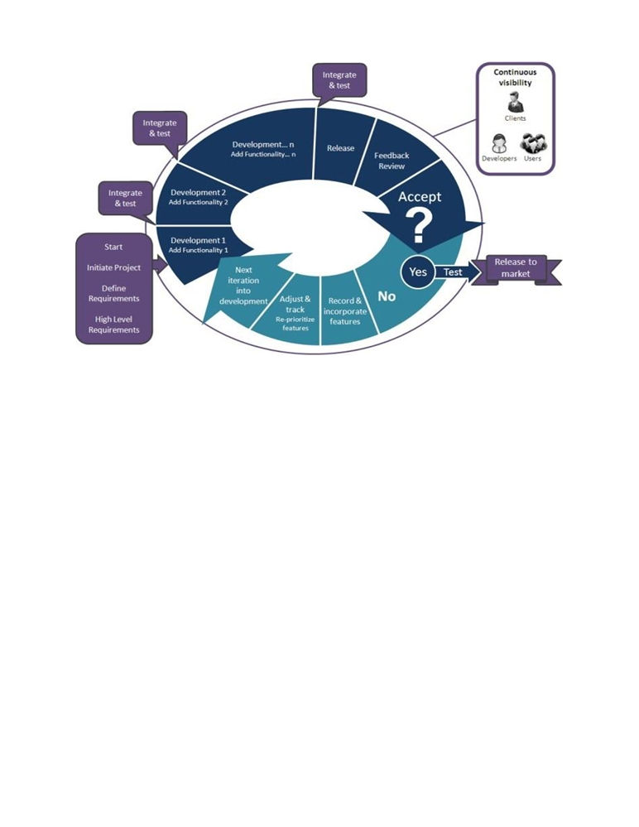

Figure 3-(Agile Model Process)

3.1.3 WHY AGILE DEVELOPMENT METHODOLOGY

The agile methodology gives the need to develop a system based on the requirements of the users,   
and enable to add up various units of the system pertaining the various feedbacks received from   
the users. It provides face-to-face conversation between the developer and the client. Active participation   
with clients improves communication and helps client to be aware of every details and steps of the   
way.

The agile process promotes and requires that functionalities with higher business value which are ought to be done first and to deliver the features that provides the most business value. It provides a breakdown of project into manageable units, where the team can focus on high-quality development, testing, and collaboration. By help of time-boxed, news features are delivered quickly and frequently, with a high level of predictability, which provides the opportunity to release the software earlier then planed if there is sufficient business value.

25

3.1.4 FACT FINDING TECHNIQUES

Fact finding techniques aid in collecting information about system problems requirements and preference. It is the process of collecting data and in formation based on techniques which contains sampling of existing documents, research, observation, questionnaires, interviews, prototyping and joint requirements planning. (Essays, 2021). In this project, research, interview and observation are the fact finding techniques that were deployed.

3.1.5 RESEARCH

Information such as background information, technical materials and news about the Judicial Service trends and development which were gathered to publish this topic were obtained in sources like newspapers, journals and internet.

3.1.6 INTERVIEWS

Interview is the most commonly used techniques to collect information from the face-to-face   
interviews and also one of the key research tools for finding out new accurate data. I had the   
opportunity to move to the Law Courts Complex, Supreme Court and schedule interview sessions   
with both the clients and registrars in some courts in order to gather vital information about their   
daily activities and problems they face. This information will helps me in the development of the   
system to solve problems which are incurred in their daily activities such as follow up cases after   
registration, paper works etc. The system will be solely for the Judicial Service thus The Law Court   
Complex. The information gathered gave me the guidelines as to how to go about the system and   
what to do.

3.1.7 OBSERVATION

The observation is another fact finding techniques that was adopted, which I paid close attention to the day to day activities which provided another perspective and better understanding of procedures.

3.1.8 SYSTEM CATEGORY

The proposed system is categorized as a web based application.

**3.2 MATERIAL**

A requirement is a formal definition for the functionality of a system. It contains conditions about the performance and functionality of the entire system. The functionality can be classified into two main groups;

❖ Functional Requirement

❖ Nonfunctional Requirement

26

3.2.1 FUNCTIONAL REQUIREMENTS

The functional requirement describe how the system will work in terms of its inputs, the behavior, and outputs. The functional requirements of the system for users are:

❖ Login Module: This shall be developed to have a centralized rights and authentication   
 facility to ensure only authorized users have access to the system providing a security   
 standard to protect vital information.

❖ Adding and Removing Cases: This will provide the registrar the authority to add   
 new cases and to terminate cases if they pass away.

❖ A Database Facility: This shall be developed to store, record, information about users,   
 (date, suit number, plaintiff, defendant, judge etc.)

❖ Edit or Update Module: This shall be developed to ensure easy corrections of mistakes.   
 Only registrar can access this feature.

❖ Reporting Facility: At the end of every day’s activities a report will be printed out. So as to keep track of events.

❖ Backup: This shall be developing to backup data periodically.

3.2.2 NON-FUNCTIONAL REQUIREMENTS

Non-functional requirement describe how a system should behave and what limits there are on its functionality.

❖ Performance: The system shall allow several case registrations at the same time without   
 downgrading performance.

❖ Availability: The system shall be available to all court and can be access anywhere.

❖ Usability: The system shall be easy to learn and use by all users including registrar and   
 administrator.

* Reliability: The system has low system failure occurrence and low risk. And will not   
   take much time to resolve it.

❖ Accuracy: The system shall work accurately without high failure or error.

❖ Security: each user is required to login. The system shall allow people with assigned   
 user names and passwords. The system shall be designed to make it impossible for   
 unauthorized people to logon without valid usernames or password.

27

**3.3 ALGORITHM**

**Input:** Case details (case ID, client information, case type, status, evidence, deadlines).

**Output:** Updated case records, case progress, notifications, and reports.

**Process:**

1. **Start:**
   * Initialize the system and connect to the case management database.
2. **Case Registration:**
   * **Input:** Case ID, client details, case type, and initial status.
   * **Process:**
     + Check if the case already exists in the database.
     + If not, create a new case entry and store the details.
     + Generate a unique case ID.
   * **Output:** Case registered with a unique case ID.
3. **Evidence Management:**
   * **Input:** Evidence details (evidence ID, type, description, associated case ID).
   * **Process:**
     + Link the evidence to the corresponding case ID.
     + Store evidence securely with proper indexing.
   * **Output:** Evidence associated with the case and stored securely.
4. **Case Assignment:**
   * **Input:** Case ID, staff ID (lawyer, paralegal), case priority.
   * **Process:**
     + Assign the case to the appropriate staff based on workload and case

priority.

* + - Update the case record with the assigned staff ID.
  + **Output:** Case assigned to staff, and notifications sent.

1. **Case Progress Tracking:**
   * **Input:** Case ID, progress updates, deadlines.
   * **Process:**
     + Update the case status with new progress details.
     + Monitor deadlines and send reminders.
   * **Output:** Updated case status and progress reports.

28

1. **Document Generation:**
   * **Input:** Case ID, template selection, case details.
   * **Process:**
     + Populate the selected template with relevant case details.
     + Generate legal documents, letters, or reports.
   * **Output:** Document generated and stored in the system.
2. **Client Communication:**
   * **Input:** Case ID, communication type (email, SMS), message content.
   * **Process:**
     + Draft and send communication to the client based on case updates or

requests.

* + **Output:** Client receives communication, and record is stored in the system.

1. **Case Closure:**
   * **Input:** Case ID, final status, outcome.
   * **Process:**
     + Verify that all tasks are complete and all evidence is documented.
     + Update the case status to closed and archives the case.
   * **Output:** Case closed and archived, final report generated.
2. **System Maintenance:**
   * **Process:**
     + Regularly backup the database.
     + Perform routine checks for data integrity and system performance.
   * **Output:** Maintained and optimized case management system.
3. **End:**
   * Terminate the session and log out from the system.

29

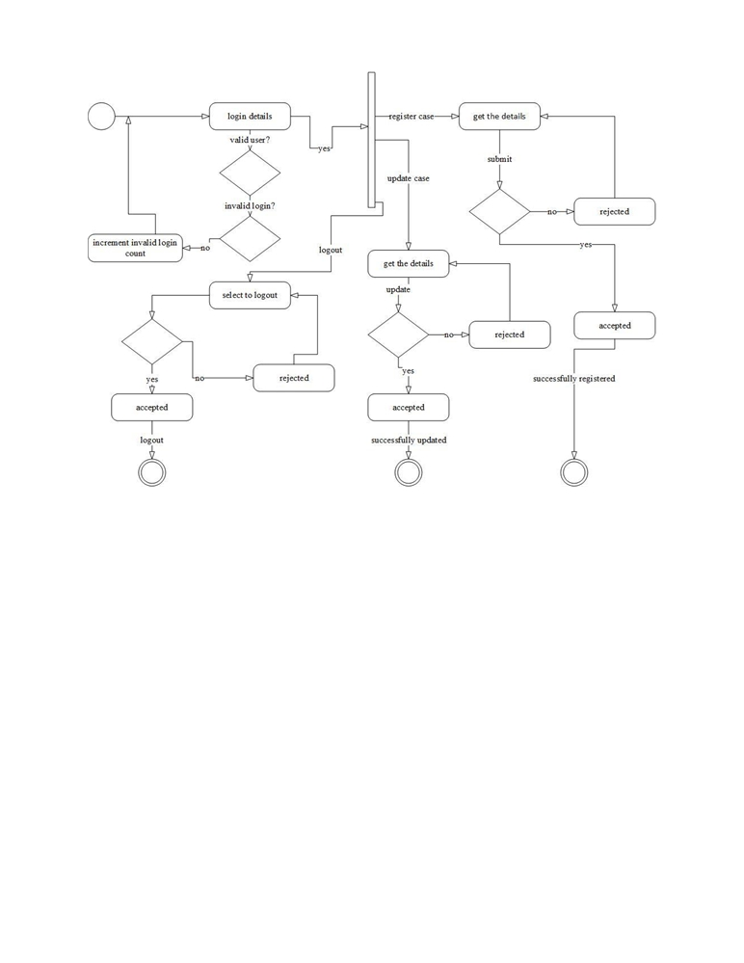

**3.4 FLOWCHART DIAGRAM**

Figure 8-(Flowchart) 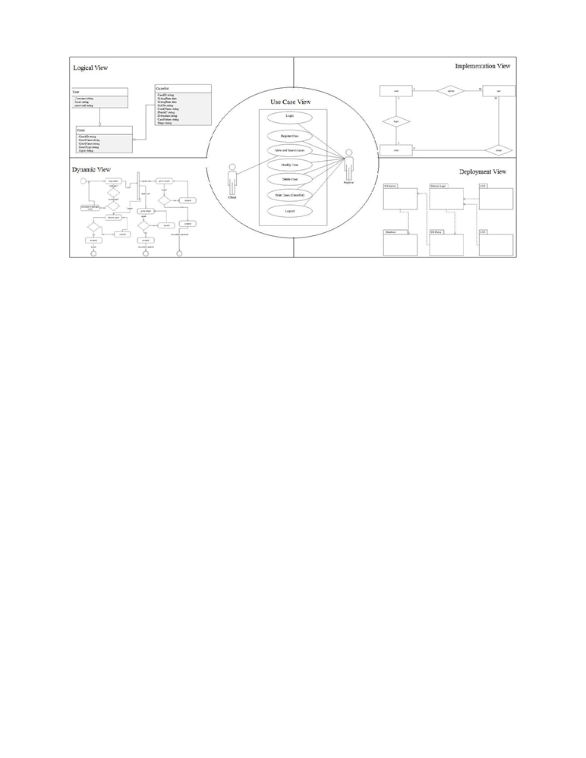

**3.6 SYSTEM ARCHITETURE**

Figure 8-(System architecture)

30

**3.7 DATABASE DESIGN**

The database design for the Case Management System focuses on organizing and managing all case-related data effectively. The schema includes several key components, each representing different entities and their relationships within the system. Below is a detailed description of the database design:

**Key Components of the Database Design:**

1. **Users Table**
   * **UserID (Primary Key):** A unique identifier for each user in the system.
   * **Username:** The user's chosen username for logging into the system.
   * **Password:** Encrypted password for secure authentication.
   * **Email:** User's email address for communication and recovery.
   * **Role:** Defines the role of the user (e.g., lawyer, paralegal, admin).
   * **ContactInfo:** Contact information of the user (phone number, address).
2. **Clients Table**
   * **ClientID (Primary Key):** Unique identifier for each client.
   * **ClientName:** Name of the client.
   * **ContactInfo:** Client’s contact information (phone number, email, address).
   * **ClientType:** Type of client (e.g., individual, corporate).
   * **Notes:** Additional notes or details about the client.
3. **Cases Table**
   * **CaseID (Primary Key):** Unique identifier for each case.
   * **CaseTitle:** Brief title or name of the case.
   * **ClientID (Foreign Key):** Links the case to a specific client.
   * **AssignedStaffID (Foreign Key):** Links the case to the staff responsible for handling it.
   * **CaseType:** Type of case (e.g., civil, criminal, family law).
   * **CaseStatus:** Current status of the case (e.g., open, in progress, closed).
   * **StartDate:** Date when the case was initiated.
   * **EndDate:** Date when the case was closed (if applicable).
   * **Description:** Detailed description of the case.
4. **Evidence Table**
   * **EvidenceID (Primary Key):** Unique identifier for each piece of evidence.
   * **CaseID (Foreign Key):** Links the evidence to the associated case.
   * **EvidenceType:** Type of evidence (e.g., document, video, photograph).

**31**

* + **Description:** Detailed description of the evidence.
  + **StorageLocation:** Location where the evidence is stored (physical or digital).
  + **DateAdded:** Date when the evidence was added to the system.

1. **Tasks Table**
   * **TaskID (Primary Key):** Unique identifier for each task.
   * **CaseID (Foreign Key):** Links the task to the associated case.
   * **AssignedStaffID (Foreign Key):** Links the task to the staff responsible for it.
   * **TaskTitle:** Title or brief description of the task.
   * **TaskDescription:** Detailed description of what needs to be done.
   * **DueDate:** Deadline for the completion of the task.
   * **TaskStatus:** Current status of the task (e.g., pending, in progress, completed).
2. **Documents Table**
   * **DocumentID (Primary Key):** Unique identifier for each document.
   * **CaseID (Foreign Key):** Links the document to the associated case.
   * **DocumentTitle:** Title or name of the document.
   * **DocumentType:** Type of document (e.g., legal brief, contract, report).
   * **FilePath:** Path or location where the document is stored.
   * **DateCreated:** Date when the document was created or added to the system.
3. **Communications Table**
   * **CommunicationID (Primary Key):** Unique identifier for each communication record.
   * **CaseID (Foreign Key):** Links the communication to the associated case.
   * **ClientID (Foreign Key):** Links the communication to the specific client.
   * **CommunicationType:** Type of communication (e.g., email, phone call, meeting).
   * **Content:** Details of the communication.
   * **Date:** Date when the communication took place.
4. **Payments Table**
   * **PaymentID (Primary Key):** Unique identifier for each payment transaction.
   * **CaseID (Foreign Key):** Links the payment to the associated case.
   * **PaymentAmount:** Amount paid by the client.
   * **PaymentDate:** Date when the payment was made.
   * **PaymentMethod:** Method of payment (e.g., credit card, bank transfer).
   * **PaymentStatus:** Status of the payment (e.g., completed, pending).

**32**

1. **Notifications Table**
   * **NotificationID (Primary Key):** Unique identifier for each notification.
   * **UserID (Foreign Key):** Links the notification to the specific user.
   * **NotificationContent:** Content of the notification.
   * **NotificationDate:** Date when the notification was sent.
   * **ReadStatus:** Indicates whether the notification has been read.

**Relationships and Integrity Constraints:**

* **Foreign Key Constraints:** Enforce the relationships between tables (e.g., CaseID in the Evidence Table links to CaseID in the Cases Table).
* **Indexes:** Improve query performance for frequently accessed data.
* **Data Integrity:** Ensure data consistency with constraints like NOT NULL and UNIQUE on critical fields.

**33**

**CHAPTER FOUR**

**RESULTS AND DISCUSSION**

**4.1 SYSTEM IMPLEMENTATION**

**4.1.1 OUTPUT GENERATION**

In a Case Management System, output generation is a critical aspect that ensures all case-related information is accessible and can be presented in a meaningful format. The process of output generation involves retrieving data from the database, processing it according to the user’s requirements, and then presenting it in a structured and user-friendly format. This could include generating reports, case summaries, or any other documents that are essential for case management. Generating reports on sales and inventory,

* **Data Retrieval:** The system queries the database to retrieve relevant data based on the user's request. This may involve complex queries that filter, sort, and aggregate data to ensure that only the necessary information is extracted.
* **Data Processing:** Once the data is retrieved, it undergoes processing to format it correctly. This may involve calculating totals, generating statistics, or compiling various pieces of data into a cohesive report. The system may also apply filters or formatting rules to ensure that the output is clear and concise.
* **Output Delivery:** The generated output is then delivered to the user. This could be done by displaying the information on the screen, sending it via email, or exporting it to a file format such as PDF or Excel for further use. The delivery method depends on the system’s design and the user's needs (Johnson, 2021).

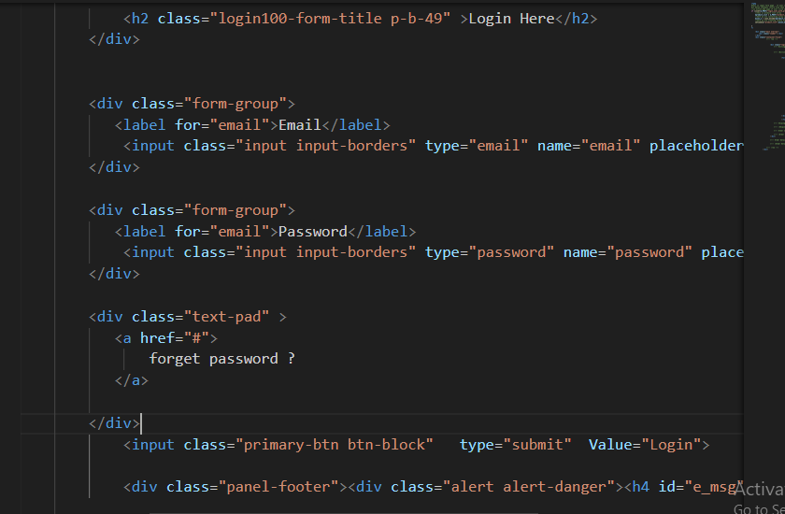

**Figure 14**: Showing the logic

**34**

**4.1.2 ANALYSIS OF RESULTS**

This section provides a concise analysis of the system testing results, focusing on performance, reliability, and usability.

**Performance**

- Response Time: Consistently quick, ensuring a smooth user experience.

- Transaction Speed: Efficient processing, minimizing wait times.

**Reliability**

- Error Rates: Low, indicating high reliability.

- System Uptime: High availability with minimal downtime.

**Usability**

- User Feedback: Positive, with an intuitive and easy-to-use interface.

- Navigation: Easy navigation and accessibility for users.

**Discrepancies**

- Response Time Variability: Some variability under heavy load.

- Minor Bugs: A few minor issues identified for resolution.

**4.2.1 SOFTWARE REQUIREMENTS**

The software requirements for developing and operating an e-commerce website include the necessary tools, frameworks, and platforms to ensure functionality, security, and scalability:

1. **Operating System:**
   * Linux (preferred for server environment)
   * Windows or macOS (for development environment)
2. **Programming Languages:**
   * HTML, CSS, JavaScript (for frontend development)
   * PHP or Python (for backend development)
   * MySQL or PostgreSQL
   * Apache HTTP Server or Nginx
3. **Frameworks and Libraries:**
   * Bootstrap (for responsive design)
   * jQuery (for enhanced JavaScript functionality)
   * Laravel or Django (for backend framework)
4. **Integrated Development Environment (IDE):**
   * Visual Studio Code or PhpStorm
5. **Payment Gateway Integration:**
   * PayPal, Stripe, or other secure payment gateways

**35**

#### 4.2.2 HARDWARE REQUIREMENTS

The hardware requirements for developing and running an e-commerce website

ensure that the system can handle the expected load and perform efficiently:

1. **Development Machine:**
   * Processor: Intel Core i5 or equivalent
   * RAM: 8 GB minimum
   * Storage: 256 GB SSD minimum
   * Display: Full HD (1920x1080) resolution
2. **Server Hardware:**
   * Processor: Intel Xeon or AMD EPYC (multi-core)
   * RAM: 16 GB minimum, scalable based on traffic
   * Storage: 1 TB SSD minimum, with RAID configuration for redundancy
   * Network: Gigabit Ethernet, with a reliable internet connection
3. **Backup and Storage:**
   * External hard drives or cloud storage solutions for regular backups
   * NAS (Network Attached Storage) for additional storage and redundancy
4. **Networking Equipment:**
   * Router with firewall capabilities
   * Switches for network connectivity
   * UPS (Uninterruptible Power Supply) for power backup
5. **Additional Hardware:**
   * Load balancer (for handling high traffic and ensuring availability)
   * CDN (Content Delivery Network) integration for faster content delivery

**4.3.1 PERFORMANCE METRICS**

This subsection delves into the specific performance metrics used to evaluate the system. Metrics such as response time, transaction processing speed, and error rates are analyzed to measure the system's efficiency and effectiveness. The new system's performance metrics are compared against the benchmarks set by the previous system, showcasing the improvements achieved.

**4.3.2 USER SATISFACTION**

User satisfaction is assessed through surveys, feedback forms, and interviews with the system's users. This subsection discusses the level of satisfaction among customers and administrators, and how the system has improved their experience.

**36**

**4.4 TESTING**

Testing the application was expedient as it ensured that the intended system generated the required   
output given the necessary input. Also to determine if the system is able to complete actions in   
relation to its function and non-functional requirement. I actually execute the   
system to verify that it was free of errors and function as required. The thorough testing of the   
system before its release needs to be done via the various test cases and modules so that the   
software becomes devoid of bugs and uses minimum space requirements as well as a minimal   
time to perform, however software testing process begins when the application is developed, the   
documentation and related data structures are designed. During the software test and   
implementation, the software as a whole is tested to ensure that all its components work well   
together otherwise the application or the project cannot be said to be complete. If the test is   
successful, the software is then sent to the user to evaluate the software against their acceptance   
criteria. If the software satisfies these criteria, the application is put to use. Since I developed a   
web application I had to go through various web application testing methods.

**4.4.1 FUNCTIONALITY TESTING**

This involves validating if an application conforms to its specifications and correctly performs all its required functions. This entails a series of tests which perform a feature by feature validation of behavior, using a wide range of normal and erroneous input data. This can involve testing of the product's user interface, database management, security, installation, networking; etc. Testing can be performed on an automated or manual basis using black box or white box methodologies.

Below are some of the checks that are performed:

* To verify there is no dead page or invalid redirects in the system.
* First check all the validations on each field.
* To check for Wrong inputs to perform negative testing.  Verify the workflow of the system.
* Verify the data integrity.

**37**

**4.4.2 USABILITY TESTING**

This involves verifying how the application is easy to use. This is a process by which human   
computer interactions characteristics of a system are measured, and weakness are identified for   
correction. Ease of learning, navigation, subjective user satisfaction and general appearance   
were some of the factors considered when this system was subject to a usability testing.

* Test the navigation and controls.
* Content checking.
* Check for user intuition.

**4.4.3 COMPATIBILITY TESTING**

This testing is done to ensure the compatibility of an application’s operating system, and hardware platforms. Compatibility testing can be performed manually or can be driven by an automated functional or regression test suite. Compatibility testing is performed based on the context of the application.

* Browser compatibility.
* Operating system compatibility.
* Compatible to various devices like notebook, mobile, etc.

**4.4.4 PERFORMANCE TESTING**

This testing involves verifying the server response time and throughput under various load conditions.

* Load testing - is the simplest form of testing conducted to understand the behavior of   
   the system under a specific load. Load testing will result in measuring important   
   business critical transactions and load on the database, application server, etc. are also

**4.4.5 VALIDATION TESTING**

This testing runs the system in a live environment using real data. This will test for system performance (throughput and response time) peak work load performance, methods and procedures, backup and recovery.

**4.4.6 ACCEPTANCE TESTING**

This testing is performed on the final system wherein users conduct verification, validation, and audit test. It uses real data over an extended time period.

**38**

**4.4.7 UNIT TESTING**

The primary goal of unit testing is to take the smallest piece of testable code or software in an   
application/system, isolate it from the remainder of the code and determine if it behaves as it   
should. The main modules of the system are at best complex and for them to work seamlessly,   
each would have to undergo rigorous repetitive logical, as well as semantic tests (data handling).   
This test was done at the development level so as to ensure each piece of the code that was written   
will work. It was most often tested independently of the other modules of the web based   
application.

**4.4.8 INTEGRATING TESTING**

Integration testing is a form of testing in which software components, hardware components or both are combines and tested to evaluate the interaction between them. This testing determines that applications involved are functioning well with each other. Integration testing including user interface testing and usability testing.

**4.5.1 PACKAGING (INTEGRATION)**

Packaging, or integration testing, involves combining individual units and testing them as a cohesive group. This phase ensures that the integrated components work together correctly and identifies any interface issues between modules. Key aspects of integration testing include:

* **Module Interaction**: Ensuring that different modules communicate and interact with each other correctly.
* **Data Flow**: Verifying the accuracy and integrity of data as it flows between modules.
* **Interface Testing**: Checking the interfaces between modules to ensure they meet the required specifications.
* **Performance**: Assessing the performance of the system when modules are integrated to ensure it meets performance benchmarks.
* **Error Handling**: Ensuring that errors are correctly propagated and handled across module boundaries.

**39**

**4.6 SCREENSHOTS**

USER INTERFACES

User interface is a visual platform for users which support them, and also enabling them to interact with the system. The interface is the crucial aspect which needs more attention. Some of the system functionalities of the project are shown below with the user interfaces.

LOGIN PAGES

The login page is the page were users enter their credentials for the system to authenticate and ensure only authorized users to access the system providing a security standard to protect vital information. The system has two login pages one for the Chief Registrar unknown as the administrator and the other for the court Registrar, they are the users.

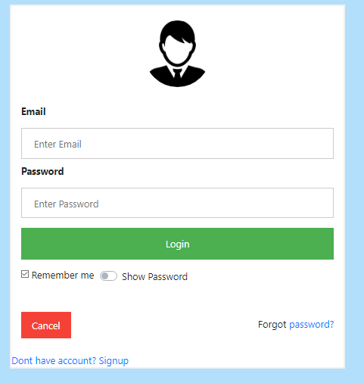

**Figure 12**: Showing login page.

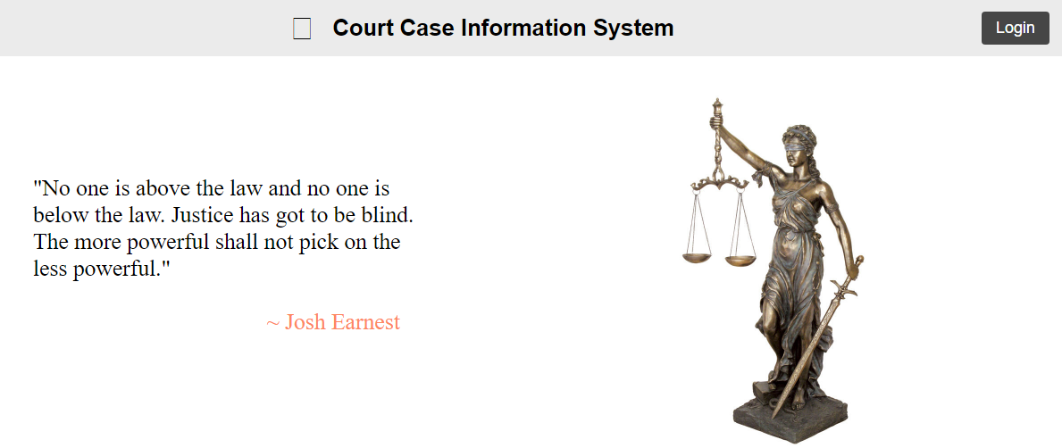

**Figure 12**: Showing index page.

**40**

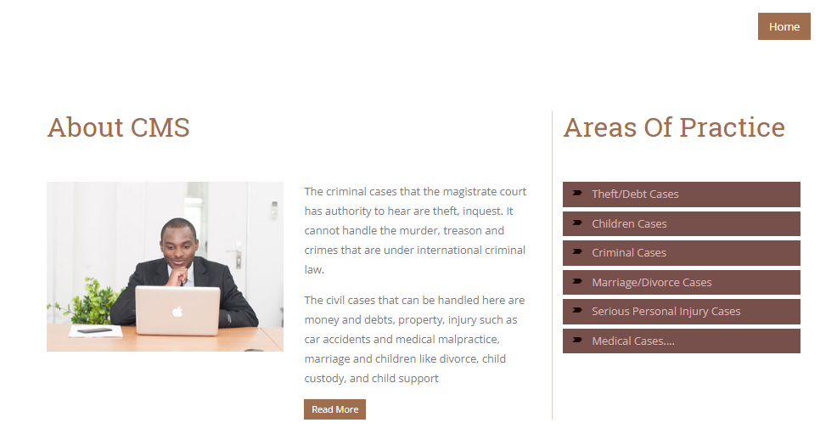

**Figure 12**: Showing Practice page.

**4.7 DISCUSSION ON IMPLEMENTATION CHALLENGES**

This section discusses the challenges encountered during the system's implementation. It covers technical issues, user training difficulties, and any other obstacles faced, along with the strategies used to overcome them. Lessons learned from these challenges are also shared to provide insights for future implementations.

**Technical Issues**

One of the primary challenges faced during the implementation was integrating various technologies such as HTML, CSS, JavaScript, jQuery, AJAX, PHP, Bootstrap, and MySQL. Ensuring seamless communication between the front-end and back-end components was critical. Specific technical issues included:

* **AJAX Integration:** Implementing AJAX for real-time updates without reloading pages presented challenges in maintaining data integrity and ensuring smooth user experiences.
* **Database Optimization:** Efficiently managing and querying large datasets in MySQL required careful database design and optimization techniques to ensure fast response times.
* **Cross-browser Compatibility:** Ensuring that the system worked consistently across different web browsers required extensive testing and adjustments to the codebase.

**4.7.1 SOFTWARE DESIGN DOCUMENTATION (SDD)**

The Software Design Documentation (SDD) for the Case Management System provides a detailed blueprint of the system's architecture and design.

**41**

**Key Components:**

1. **System Overview**
   * **Purpose and Scope:** This section defines the overall functionalities of the Case Management System, including its boundaries and the specific needs it addresses within the legal or organizational context. The purpose is to provide a clear understanding of the system's objectives and the scope of its capabilities.
2. **Architecture Design**
   * **System Architecture:** This includes a high-level view of the system’s structure, detailing how different components interact with one another. The architecture outlines the main modules and their relationships, ensuring that the system's design supports scalability, flexibility, and maintainability.
   * **Data Flow Diagrams (DFD):** These diagrams visually represent how data moves through the Case Management System, from input through processing to output. The DFDs help in understanding the flow of information and identifying potential bottlenecks or inefficiencies in data processing.
3. **Module Descriptions**
   * **User Module:** This module manages user activities such as case entry, modification, and retrieval. It ensures that user roles and permissions are correctly implemented to provide appropriate access to system features.
   * **Case Management Module:** Handles all operations related to managing cases, including case creation, assignment, tracking, and resolution. This module is the core of the system, facilitating the management of case lifecycles.
   * **Document Management Module:** Manages the storage, retrieval, and organization of case-related documents. This module ensures that all necessary legal documents are securely stored and easily accessible.
   * **Reporting Module:** Facilitates the generation of various reports, such as case summaries, status reports, and performance metrics. This module allows users to create and customize reports based on their specific needs.
   * **Notification Module:** Manages system notifications, including reminders, alerts, and updates. This ensures that users are kept informed of important deadlines, case changes, and other relevant information.

**42**

1. **Database Design**
   * **ER Diagrams:** The Entity-Relationship Diagrams (ERDs) represent the database schema, showing how different entities such as users, cases, documents, and reports are related. The ERDs are essential for understanding the structure of the database and how data is stored and retrieved.
   * **Table Descriptions:** This section provides detailed descriptions of each table within the database, including the fields, data types, and relationships between tables. It ensures that the database is designed to efficiently support the system’s operations.
2. **User Interface Design**
   * **Wireframes:** Layouts of the user interfaces are provided, offering a visual guide to how the system will look and function. Wireframes are crucial for aligning the design with user expectations and ensuring a user-friendly experience.
   * **Navigation Flow:** This section outlines the paths users will take to navigate through the system, ensuring that the interface is intuitive and that users can easily access the features they need.
3. **Security Design**
   * **Authentication and Authorization:** Details the security mechanisms in place to ensure that only authorized users can access the system and perform specific actions. This section is vital for protecting sensitive case data from unauthorized access.
   * **Data Encryption:** Explains the encryption methods used to protect data both in transit and at rest. This is critical for maintaining the confidentiality and integrity of case information.
4. **Error Handling and Logging**
   * **Error Strategies:** Describes how the system will handle errors, including user errors, system failures, and unexpected issues. Effective error handling ensures that the system can recover gracefully from problems without compromising data integrity.
   * **Logging:** Details the logging mechanisms that track system events, user actions, and errors. Logging is important for auditing, troubleshooting, and improving system performance.

**43**

**CHAPTER FIVE**

**SUMMARY, CONCLUSION AND FUTURE WORK**

**5.1 SUMMARY ON FINDINGS**

In this project, the development and implementation of the Case Management System have been explored extensively, focusing on creating a solution that effectively addresses the complexities and demands of managing cases within an organization. The system was specifically designed to tackle the inefficiencies and security challenges often associated with traditional case management processes. This summary outlines the key findings and achievements from the project, emphasizing the system's ability to enhance workflow, safeguard sensitive information, and provide a user-friendly experience.

The project began with an in-depth analysis of the requirements necessary for the Case Management System. This analysis identified several critical functionalities, including user management, case tracking, document management, reporting, and notification systems. Each of these features was carefully integrated into the system's architecture to ensure that it met the diverse needs of different organizations. The system was built with scalability in mind, allowing it to grow alongside the organization, accommodating an increasing volume of cases without sacrificing performance or security.

Throughout the development process, particular attention was given to the system's architecture, ensuring it was both robust and flexible. Modern technologies were utilized to build a platform that could support various case management scenarios while maintaining a high level of reliability. The architecture also incorporated strong security measures, such as authentication, authorization, and encryption, to protect the confidentiality and integrity of case data.

During the implementation phase, the focus was on creating a user-friendly interface that would simplify the case management process for users with varying levels of technical expertise. The interface was designed to be intuitive, with clear navigation paths that allowed users to access the system's features quickly and efficiently. The database design was another critical component of the project, optimized to handle large volumes of data, ensuring quick access and retrieval of information, which is crucial for timely decision-making in case management.

Extensive testing and evaluation were conducted to ensure that the Case Management System met all the outlined objectives. The system was tested under various conditions to assess its performance, security, and usability. The results of these tests confirmed that the system significantly improved the efficiency of case management processes, reducing manual errors and providing a secure platform for handling confidential information. The system's performance in these areas was further validated by feedback from potential users, who expressed a high level of satisfaction with its functionality and ease of use.

**44**

5.2 CONCLUSION

The development of the Case Management System marks a significant milestone in enhancing the efficiency, accuracy, and security of case management processes within organizations. By automating and streamlining various tasks traditionally handled manually, this system provides a comprehensive solution that addresses the challenges faced by case managers in today's fast-paced and data-driven environment.

The system's design prioritizes ease of use, making it accessible to users with varying levels of technical expertise. The intuitive user interface allows for seamless navigation, enabling users to manage cases, track progress, and access relevant information with minimal effort. This focus on user experience is critical in ensuring that the system is adopted widely and used effectively across the organization .

From a technical standpoint, the Case Management System is built on a solid architectural foundation, utilizing modern technologies that ensure reliability, scalability, and security. The modular design of the system allows for flexibility and adaptability, making it possible to integrate new features or adjust existing ones as organizational needs evolve. This adaptability is crucial in a constantly changing landscape where new requirements and challenges frequently arise .

Security has been a paramount consideration throughout the development of the Case Management System. The system incorporates robust authentication and authorization mechanisms, ensuring that only authorized personnel can access sensitive case data. Furthermore, data encryption is employed to protect information both at rest and in transit, safeguarding it from potential breaches. The importance of these security features cannot be overstated, given the sensitive nature of the information managed by the system .

The database design of the system has been meticulously planned to ensure efficient data storage, retrieval, and management. By optimizing the database schema, the system can handle large volumes of case data without compromising on performance. This is particularly important as organizations scale and the volume of cases increases. The system's ability to manage data effectively is a key factor in its success, enabling users to access the information they need when they need it, without delay.

In conclusion, the Case Management System is a robust, reliable, and user-friendly solution that significantly enhances the way organizations manage cases. Its combination of a well-designed user interface, strong security measures, and a scalable architecture makes it a valuable tool for any organization looking to improve its case management processes. The system not only meets the current needs of organizations but is also well-positioned to adapt to future challenges and requirements.

45

5.3 RECOMMENDATION

Based on the findings of this project, several recommendations can be made to further enhance the Case Management System:

* **User Training:** While the system is designed to be user-friendly, comprehensive training should be provided to all users to ensure they are fully aware of all the features and functionalities. This will maximize the system's effectiveness and reduce the learning curve for new users.
* **Continuous Monitoring and Updates:** Regular monitoring of the system's performance is recommended to identify any potential issues or areas for improvement. Periodic updates should be scheduled to incorporate new features, improve security, and address any emerging challenges.
* **Integration with Other Systems:** To further enhance the system's capabilities, integration with other existing systems, such as human resource management or financial systems, should be considered. This would create a more holistic approach to managing cases within the broader organizational context.
* **Scalability Planning:** As the organization grows, the system will need to scale accordingly. Planning for scalability from the outset will ensure that the system can handle increased data volumes and user traffic without compromising performance.
* **Enhanced Security Measures:** Although the system includes robust security features, ongoing assessment of potential security threats is recommended. Implementing advanced security measures, such as multi-factor authentication and regular security audits, will help maintain the integrity and confidentiality of case data.

**5.4 FUTURE WORK**

While the Case Management System developed in this project has achieved its primary objectives, there are several areas where future work can enhance its functionality, scalability, and adaptability to changing organizational needs. These areas include further system integration, advanced analytics, mobile accessibility, artificial intelligence (AI) enhancements, and ongoing security improvements.

**46**

**1. Integration with Other Systems:**  
Future work could focus on integrating the Case Management System with other enterprise systems, such as Customer Relationship Management (CRM) software, Human Resources Management Systems (HRMS), and financial systems. This would allow for seamless data sharing across platforms, further improving organizational efficiency and providing a more holistic view of case-related data. For instance, integration with CRM systems could provide a comprehensive view of client interactions, while linking to HRMS could assist in managing employee-related cases.

**2. Advanced Analytics and Reporting:**  
The inclusion of advanced analytics and reporting capabilities would be a valuable enhancement to the system. Future iterations could incorporate data mining and predictive analytics to identify trends and patterns in case management, enabling organizations to make data-driven decisions. Machine learning algorithms could be employed to analyze historical data, predict case outcomes, and recommend actions, thereby improving decision-making and resource allocation.

**3. Mobile Accessibility:**  
In an increasingly mobile world, making the Case Management System accessible via mobile devices is crucial. Future work could involve developing a mobile application or a responsive web interface that allows users to manage cases on the go. This would be particularly beneficial for field workers or professionals who need access to the system outside of traditional office environments. Ensuring that the mobile interface is as user-friendly and secure as the desktop version would be a key focus.

**4. Artificial Intelligence and Automation:**  
The integration of AI-driven features could significantly enhance the system's functionality. For example, AI could be used to automate routine tasks such as case categorization, document sorting, and initial client responses. Additionally, natural language processing (NLP) could be implemented to enable users to interact with the system using voice commands or chatbots, further streamlining case management processes. AI could also assist in identifying high-priority cases that require immediate attention, optimizing workflow management.

**5. Enhanced Security Measures:**  
Given the sensitive nature of case management, continuous improvement of security measures is essential. Future work could focus on implementing advanced encryption techniques, multi-factor authentication, and real-time threat detection systems. Additionally, developing a robust auditing and compliance framework within the system would help organizations meet regulatory requirements and ensure that all activities are traceable and secure.

47

**REFERENCES**

Architects, I., 2023. The Seven Phases of the System-Development Life Cycle. [Online]

Available at: <https://www.innovativearchitects.com/KnowledgeCenter/basic-IT->

systems/system-development-life-cycle.aspx

(Accessed 13 02 2023).

B., L., 2002. Courts of the future’ Law and Information Technology. p. 225-238.

Beal, V., 2022. Entity-Relationship Diagram (model). [Online]

Available at: <http://www.webopedia.com/TERM/E/entity_relationship_diagram.html>

(Accessed 10 May 2017).

Bockweg, J. M. G. a. G., 2012. Insights to Building a Successful E-Filing Case

Management Service: U.S.. International Journal For Court Administration, pp. 1-9.

Chrisphine, M. K., 2012. Mbugua_Electronic case management system.pdf. [Online]

Available at:

http://erepository.uonbi.ac.ke/xmlui/bitstream/handle/11295/10911/Mbugua_Electronic% 20case%20management%20system.pdf?sequence=4&isAllowed=y   
(Accessed 24 October 2016).

Christian, 2009. The seven phases of the systems development life cycle. (Online)

Available at: <http://petersheehan.blogspot.com/2009/01/seven-phases-of-systems->

development_11.html (Accessed 13 02 2017).

Dickson, O. B., 2015. The Structure and Jurisdiction of Court the Courts. [Online) Available at:

<https://www.academia.edu/12694626/THE_STRUCTURE_AND_JURISDICTION_OF_THE_COURTS>

(Accessed 27 October 2016).

Essays, U., 2015. Definition Of Fact Finding Techniques Information Technology Essay.(Online)

Available at: https://www.ukessays.com/essays/information-technology/definition-of-  
fact-finding-techniques-information-technology-essay.php

(Accessed 30 May 2017).

F., F. M. a. C., 2001. Justice and technology in Europe: How ICT is Changing the   
 Judicial Business. Kluwer Law International, Netherlands, pp. 297-315.

48

Giampiero Lupo, J. B., 2014. Designing and Implementing e-Justice Systems: Some   
 Lessons Learned from EU and Canadian Examples. laws, pp. 353-387.

Haider, W. S. a. A., 2011. Electronic court records management in Malaysia: A case   
 study. (Online)

Available at:

https://www.researchgate.net/publication/290042096_Electronic_court_records_manage ment_in_Malaysia_A_case_study (Accessed 27 October 2016).

Joy FM, 2011. High court judges to be selected electronically - Chief Justice, Accra: Fifi   
 Koomson.

Martínez, A. C., 2008. E-Justice: Using Information Communication Technologies in the   
 Court System. (Online) Available at:

https://www.google.com.gh/search?q=In+Australia+there+is+still+work+to+be+done+to +integrate+ICT.+Many+courts+still+operate+independent+systems.+Currently%2C+Vic torian+courts+and+tribunals+use+11+different+case+management+systems.+Of+particu lar+concern+is+ (Accessed 24 October 2016).

Murungi, M., 2011. Judiciary commissions electronic case management system. [Online]   
 Available at: http://michaelmurungi.blogspot.com/2011/02/judiciarycommissions-  
 electronic-case.html (Accessed 20 October 2016).

16. poll, G., 2009. Lacking faith in judiciary: Kenyans lean toward The Hague. [Online]

Available at: www.gallup.com/poll/122051/lacking-faith-judiciarykenyans-leantoward-  
hague.aspx. (Accessed 25 October 2016).

Rooze, E. J., 2010. IJCA - Differentiated Use of Electronic Case ManagementSystems.(Online)

Available at: http://www.iaca.ws/files/ErwinRooze-ElecCaseMgmt.pdf (Accessed 26 October 2016).

Shollei, G., 2012. Transforming the judiciary. [Online]

Available at: http://www.judiciary.go.ke/portal/crjs-speeches.html (Accessed 31 Ocoter 2016).

Slowes, R., 2012. Benefits of a Modern Court Case Management System. Thomson   
Reuters, pp. 1-6.

Solomon, A. T., 2003,2004,2006. Court On The Web in Russia. [Online]   
 Available at:

https://books.google.com.gh/books?id=iDrTMazYhdkC&pg=PA260&lpg=PA260&dq=S olomon,+2003,+2004;+Trochev,+2006&source=bl&ots=D36YvcJMZO&sig=4aVAjylJz d_4rLLNN2hiOeN6n-

49

APPENDIX

Source code for the Registrar page

<?php

include("connection.php");   
session_start();

if(!isset($_SESSION["user"])){   
header("location:admin.php");   
 }

?>

<!DOCTYPE html>   
<html lang="en">   
<head>

<title>causelist</title>

<link rel="stylesheet" type="text/css" href="css/main.css" /> <link rel="stylesheet" type="text/css" href="css/min.css" />   
</head>

<body>

<ul style="text-align:right">

<li><a href="admin.php">Register case</a></li>   
<li><a href="view.php">View cases</a></li>   
<li><a href="logout.php">logout</a></li>   
 </ul>

<div id="pic"><center><img src="image/logo.jpg"></center></div>

<nav id="admin_page">

<p style="float: right">Registrar: <i><strong><?php   
 $user_message=" {$_SESSION['user']}";   
 echo "$user_message";

?></i></strong></p><h6 style="color: white;font-family: verdana;font-size: 13px;margin-left:

20px;margin-top:15px;">

View CauseList</h6>   
 </nav>

<!--Main section of the page -->   
 <div id="view_container">

<center><h2>Causelist</h2></center><hr></hr> <div id="print">

<input name="search" class="printbtn" type="submit" value="Print Causelist" onclick="printContent('div1')">

</div>

50

<!--search-->

<form action="search.php" method="POST"> <div id="search">

<input name="valueToSearch" class="searchtxt" type="text"

placeholder="Search..." required>

<input name="search" class="searchbtn" type="submit" value="Search"> </div></form>

<br>

<!--end search-->   
 <div id="div1">   
<table>

<tr>

<th>SITTING DATE</th>   
<th>SUIT NO</th>

<th>PLAINTIFF</th>   
<th>VS</th>

<th>DEFENDANT</th>

<th>NATURE OF CASE</th>   
<th>STAGE</th>

</div> <th>COURT</th>   
<th>UPDATE</th>   
<th>DELETE</th>

</tr>

<tr>

<?php

include ("connection.php");

if($user=$_SESSION["user"]){

$i = "select c.sdate,c.suitno,c.plaintiff,c.defendant,c.casenature,c.stage,c.cname from causelist   
c,users u WHERE c.cname=u.cname AND username='".$user."' order by c.sdate";   
}

$h = mysqli_query($ecms,$i);

while($tr=mysqli_fetch_array($h))   
{

?>

<tr>

<td><?php echo $tr[0]; ?></td>   
<td><?php echo $tr[1]; ?></td>   
<td><?php echo $tr[2]; ?></td>   
<td><?php echo "VS" ?></td>   
<td><?php echo $tr[3]; ?></td>   
<td><?php echo $tr[4]; ?></td>   
<td><?php echo $tr[5]; ?></td>   
<td><?php echo $tr[6]; ?></td>

<td style="padding-left: 20px"><a href="update.php?suitno=<?php echo $tr["suitno"];

?>"><i class="fa"></i></a></td>

51

<td style="padding-left: 20px"><a href="delete.php?suitno=<?php echo $tr["suitno"];

?>"onclick="return confirm('You are about to DELETE this record, Are you sure?');"><i

class="da"></i></a></td>

</tr>

<?php

}

?>

</table>   
 </div>   
 </body>   
</html>

Source code for the Chief Registrar page

<?php

include("connection.php");   
session_start();

if(!isset($_SESSION["admin"])){   
header("location:login.php");   
 }

if($admin=$_SESSION["admin"]){

$i = "SELECT (SELECT COUNT(*) FROM `causelist` WHERE

`casenature`='TRESPASSING' and cname='".$_GET['cname']."') AS 'num',

(SELECT COUNT(*) FROM `causelist` WHERE `casenature`='ROBBERY' and

cname='".$_GET['cname']."') AS 'numb', (SELECT COUNT(*) FROM `causelist` WHERE

`casenature`='DEFRAUDING' and cname='".$_GET['cname']."') AS 'n',

(SELECT COUNT(*) FROM `causelist` WHERE `casenature`='DATA BREACH' and

cname='".$_GET['cname']."') AS

'nu',c.sdate,c.suitno,c.plaintiff,c.defendant,c.casenature,c.stage,c.cname,u.judge,s.username from   
causelist c,court u,users s WHERE c.cname=u.cname and u.cname=s.cname AND

c.cname='".$_GET['cname']."' group by casenature;";

52

}

$h = mysqli_query($ecms,$i);   
$tr=mysqli_fetch_array($h);

?>

<!DOCTYPE html>

<html lang="en">   
<head>

<title>Dashboard</title>   
<!--css reference links-->

<link rel="stylesheet" type="text/css" href="css/main.css" /> <link rel="stylesheet" type="text/css" href="css/min.css" /> <!--jquery link for datepicker

<script src="https://code.jquery.com/jquery-1.12.4.js"></script>   
<script src="https://code.jquery.com/ui/1.12.1/jquery-ui.js"></script>

<script>

$( function() {

$( "#datepicker" ).datepicker();   
} );

</script>

end of script-->   
</head>

<body>

<!--menu list-->

<ul style="text-align:right">

<li><a href="logout.php">logout</a></li>   
</ul>

<!--page logo-->

<div id="pic"><center><img src="image/logo.jpg"></center></div>

<nav id="admin_page">

<p style="float: right">Registrar: <i><strong><?php   
 $user_message=" {$_SESSION['admin']}";   
 echo "$user_message";

?></i></strong></p><h6 style="color: white;font-family: verdana;font-size: 13px;margin-left:

20px;margin-top:15px;">

Chief Registrar Dashboard</h6>

53

</nav>

<!--Main section of the page -->   
 <div id="dash_container">   
 <div id="dash">

<center><h2>Electronic Court Case Management

System</h2></center><hr></hr>   
 <div id="dashdiv">

<center><h2> COURT: <?php echo $tr['cname']; ?></h2></center>   
<div class="thedetail"><img src="image/1.ico" height="30px">

<h2 style="margin-top: -30px;padding-left: 40px">Registrar: <?php echo

$tr['username']; ?></h2>

</div>

<div class="thedetail"><img src="image/2.png" height="30px">

<h2 style="margin-top:-30px;padding-left: 40px">Judge: <?php echo $tr['judge'];

?></h2>

</div>

<div class="thedash"><img src="image/3.png" height="30px">

<h2 style="margin-top: -25px;text-align: center;padding-right:25px">TRESPASSING <br><br><?php echo $tr['numb']; ?></h2>

</div>

<div class="thedash"><img src="image/4.png" height="30px">

<h2 style="margin-top: -25px;text-align: center;padding-right:55px">ROBBERY

<br><br><?php echo $tr['num']; ?></h2>

</div>

<div class="thedash"><img src="image/5.png" height="30px">

<h2 style="margin-top: -25px;text-align: center;padding-

right:25px">DEFRAUDING<br><br><?php echo $tr['n']; ?></h2>

</div>

<div class="thedash"><img src="image/6.jpg" height="30px">

<h2 style="margin-top: -25px;text-align:

BREACH<br><br><?php echo $tr['nu']; ?></h2>

</div>

</div>

</div>

</div>

</body>

</html>

<?php

mysqli_close($ecms);

?>

54

center;padding-ri