**TABLE OF CONTENTS**

**CONTENT PAGES**

TITLE PAGE... . i

CERTIFICATION... . ..ii

DEDICATION……………………………………………………………………………………... iii

ACKNOWLEDGEMENT ………………………………………………………………………… iv

ABSTRACT ... ... v

TABLE OF CONTENT ... .... vi – vii

LIST OF FIGURES………………………………………………………………………………….viii

CHAPTER ONE: INTRODUCTION ... .. 1

1.1 Background to the study ... .. 1

1.2 Statement of the Problem ... ... 2

1.3 Purpose of the study ... .. 3

1.4 Project Aims and Objectives ... . 3

1.5 Significance of the study ... . 3

1.5.1 The industry (Judicial Service) ... ... 4

1.5.2 The society ... . 4

1.5.3 Academia ... ... 4

1.6 Methodology... . 4

1.7 Organization of the study ... ... 6

CHAPTER TWO: LITERATURE REVIEW... . 7

2.1 Overview ... . 7

2.2 Web Application ... . 7

2.4.1 Russia... ... 9

2.4.2 Brazil ... ... 9

2.4.3 Australia... ... 10

2.4.4 Venezuela ... ... 11

2.4.5 Kenya ... . 12

2.4.6 ]Nigeria] ... . 13

2.5 Factors influencing effective judicial service delivery ... . 13

2.5.1 Cost of eCCMS ... . 13

2.5.2 Employee job satisfaction using eCCMS ... ... 14

2.5.3 Security of court data in eCCMS ... . 15

vi

2.5.4 Fraud/Corruption ... . 15

2.5.5 Conceptual framework ... . 16

2.6 Overview of Databases... .. 17

2.7 The role of the current eCCMS ... . 18

2.7.1 User ...................................................................................................................................... 18

2.7.2 Public access ... 18

2.8 How web applications work ... 18

2.9 Summary of the chapter ... 19

CHAPTER THREE: SYSTEM DESIGN AND SPECIFICATION ... 20

3.1 Introduction ... 20

3.2 Research Design ... 20

3.3 Development Methodology ... 20

3.3.1 Why Agile Development Methodology ... 21

3.4 Fact finding Techniques ... 22

3.4.1 Research... 22

3.4.2 Interviews ... 22

3.4.3 Observation ... 23

3.5 System Category ... 23

3.6 Requirement Specification ... 23

3.6.1 Functional Requirements ... 23

3.6.2 Non Functional Requirements ... 24

3.6.3 Hardware Requirements ... 24

3.7 System Modeling... 25

3.7.1 System Modeling using Unified Modeling Language ... 25

3.8 UML: Structural Modeling... 25

3.8.1 Class Diagram... 25

3.9 UML: Behavioral Modeling ... 27

3.9.1 Use Case Diagram ... 27

3.9.2 Use Case Diagram ... 28

3.9.3 Entity Relationship Diagram ... 29

3.9.4 Activity Diagram ... 30

3.10 UML: Architectural Modeling ... 31

References ... 32

vii

**LIST OF FIGURES**

Figure 1-(Conceptual framework) ... 16

Figure 2-(how web applications work) ... 18

Figure 3-(Agile Model Process) ... 21

Figure 4-(Class Diagram) ... 26

Figure 5-(Use Case Diagram for Client and Registrar) ... 28

Figure 6-(Use Case Diagram for Chief Registrar) ... 29

Figure 7-(Entity Relationship Diagram) ... 30

Figure 8-(Activity Diagram) ... 31

Figure 9-(Architectural Model) ... 32

viii

**CHAPTER ONE: INTRODUCTION**

**1.1 BACKGROUND TO THE STUDY**

The Judiciary is the system of courts of justice in a country, the arm of government charged with the responsibility to administer justice. Nigeria's legal system was built on a foundation of received Anglo-Saxon common law, statutory law, and other documents. (The Judicial Secretary,   
2022). It is independent from other government functions and provides a forum for the just   
resolution of disputes in order to preserve the rule of law and to protect the rights and liberties   
guaranteed by the Constitution of Nigeria. The Nigerian Judiciary consists of the Superior Courts

of Judicature, which include the Supreme Court, the Court of Appeal, the High Court and the

lower courts currently comprising the Circuit Courts, the District Courts and the Juvenile Courts. The Fast Track, Commercial Courts, Human Rights Court, Financial, Industrial (Labor) and   
Land Courts have recently been established as divisions of the High Court to facilitate the speedy resolution of disputes, particularly those of a specialized nature. (Dickson, 2023)

The advancements of the 21st century have led to an emergence of many disciplines with great   
potential to solve existing problems. One such potential field is Technology, which has over the   
years been increasingly adopted in many processes to avert the problems of ineffective and   
inefficient service delivery. (Chrisphine, 2023). One of the key areas of interest is automation of   
the judicial processes. Many challenges have been faced in the process of attaining justice   
including delays due to misplacement of the case files at the registry when reference is ought to be   
made. As legal practice has become more technologically advanced, pressure mounts on the courts   
is to join the flow of technological progress in other to provide a good service delivery. In addition,   
to emphasis on government transparency, to build public trust and confidence in judicial   
institutions. (Slowes, 2022)

Electronic Case Distribution System (eCDS) was introduced in Judicial Service of Nigeria. Under the Electronic Case Distribution System (eCDS), cases are assigned to the judges by the registrar. The system was to select adjudication cases at the High Court and was automated to eliminate suspicion of case fixing. It was introduced to judicial staffs and other stakeholders in Kumasi by Robert Cudjoe the Director of ICT in Judicial Service. (Joy FM, 2022). The court can now electronically manage a case from the filing state and assigning cases to judges.

1

* **Case management**

Case management is one of the main management activities in use within courts. The other main   
management effort is court management. While case management is connected to the primary   
processes in courts, which includes court administration and other processes that are directly   
related to case processing, the court management is connected to the secondary processes in courts   
and involves activities like strategy making, human resource management, research and   
development, Technology, finance, and maintenance of the build environment. (Rooze, 2023).

* **Component of case management**

Electronic case management systems provide support and automation in case management. In   
order to support or automate case management, it is necessary to understand the components of   
case management as a management support. A typical process in court consists: (a) receive   
documents; (b) administrative preparation; (c) content preparation; (d) court decision-making; (e) content elaboration; (f) administrative completion; (g) send and archive. (Rooze, 2022).

**1.2 STATEMENT OF THE PROBLEM**

Recently, Prosecuting Attorney’s current case management system is a desktop base application where cases that are registered are printed out and pasted on the notice board to enhance public access. The courts print out the cases that will be held in that particular week and keeps the outdated cases that have already been held in excel on the desktop. Due to this clients need to come back to the court to confirm the day its case will be held and sometimes leads to frustrations.

This project seek is to control and allow complete registration of all cases related to court activities to enhance reduction of time and eliminating manual works. The System delivers core functionality that is to provide meaningful ancillary benefits to the courts, such as more efficient data entry, more effective data retrieval, better tools and enhanced bar and public access, thus the public can have access to it anytime and anywhere.

Well developed and implemented Electronic Court Case Management System (eCCMS) make it possible for a court to stick more closely to a published standard schedule and timetable, which the court can track cases better, and controls the use of resources and notify and inform all on what has been decided and what is to be expected.

2

**1.3 PURPOSE OF THE STUDY**

To study the influence of the Electronic Case Management System (eCCMS) on implementation and effectiveness of court service delivery in the Law Court Complex, Judicial Service of ]Nigeria].

**1.4 PROJECT AIMS AND OBJECTIVES**

The aim of this project is to develop and implement an Electronic Court Case Management System   
(eCCMS) to control and allow complete registration of all court case which are related to the court   
by the domain user thus registrar, who can register, update, delete, and search case and create   
report. The flow of information provides communication and notification between the courts and   
public.

**1.4.1 THE FOLLOWING ARE THE OBJECTIVES OF THE PROJECT**

➢ To implement an Electronic Court Case Management System (eCCMS) for case

registration which are related to courts, and creation, modification and updating through user interface.

➢ The software will allow information to be entered by users, control information in the   
 system and tracking of current case status to enhance public access.

➢ The system “Event” and “Scheduling” is to determine new case arrivals, session   
 appointments, case deadline, reservation of courtroom and the judge who will head the   
 case.

➢ To develop friendly user interfaces combined with intuitive layouts.   
➢ To create a database to store, manage and backup case records.   
➢ To create an administrator page that will show statistical analysis.

**1.5 SIGNIFICANCE OF THE STUDY**

When this project is completed, it will benefit the following stakeholders: the industry (Judicial service), the society and the academia.

3

**1.5.1 THE INDUSTRY (JUDICIAL SERVICE)**

The system will be used by the registrar for case registration and data processing (data storage and   
data retrieval) which involves creation, modification and updating information through user   
interface.

The Chief registrar as well will be able to know the activities that is going on in various courts such as the name of registrars and the judge in each court, the time the registrar spent after login and also show the total number of a case type in each court such as trespassing, defrauding, robbery, data breach etc.

**1.5.2 THE SOCIETY**

The system will enable client or individuals to get access to a case details anywhere and anytime by going online to visit the webpage, which shows the details of a case such as the sitting date, the suit number, the name of the judge who will handle the case, the courtroom which the case will be held, the names of both plaintiff and defendant, etc.

**1.5.3 ACADEMIA**

This project will illustrate how open source tools can be used for the development of web-based applications thereby making the academia aware of the benefits of using cheaper tools. This project in future will allow other students to review the application and to think of new ways in which some components of the application will be improved or think of ways of adding new components to meet more needs.

**1.6 METHODOLOGY**

The nature of the project recommended agile model of System Development Life Cycle   
(SDLC).The agile model process starts with a simple implementation of a subset of the software   
requirements and iteratively enhances the evolving versions until the full system is implemented.

4

The agile methodology gives the need to develop a system based on the requirements of the users,   
and enable to add up various units of the system pertaining the various feedbacks received from   
the users. At each iteration and increment, design modifications are made and new functional   
capabilities are added. And the phases includes Identifying Problems, Opportunities and

Objectives, Determine Human Information Requirement, Analyzing System Needs, Designing the   
Recommended System, Developing and Documenting Software, Testing and Maintenance of the   
system.

Observation at the Supreme Court and The Law Court Complex showed that the Court had   
traditional ways with managing administration tasks, such as case registrations, viewing the case   
list (Cause list) to the public and scheduling of cases. The courts sometimes struggle with tracking   
cases since their system is a desktop based system. This problem presented itself as an opportunity   
that can be built upon. The public sometimes complains they had to come far away from their   
destination to check when a case will be held and the courtroom. People visiting the first time get   
frustrated since he will pass through many processes sometime wait for long to know the time a   
case will be held.

Obtaining this information a system will be designed that will meet the requirement of all the users both the Domain users and the public. In the design phase, every user interface will be designed for each section of the web application. Each user interface will be designed based on the principles of the User Experience (UX).

Localhost, MySQL and MariaDB will serve as database source. The familiarity with MySQL offers the chance to work without problems. The development of this web application will require HTML CSS, jQuery. These will help in the development of the user interface and its elements such as web forms, buttons, and modals.

Finally, PHP as server side programming language to interact with MySQL database and MariaDB. The web application will be implemented via a hosting plan. Users will be able to access the web application by going to the specified URL of the application. The design will ensure a smooth transition to the web application for all users of the system.

5

**1.7 ORGANIZATION OF THE STUDY**

The project report is divided into five chapters. Chapter one of the study introduces the problem   
statement and describes how the specific problem will be addressed through the aims and   
objectives and it also contains the significance of this study. Chapter two focuses on the review   
of literature and relevant research associated with the problems addressed in the study. Chapter   
three presents the methodology and procedures used for data collection and analysis,   
determining functional and non-functional requirements of such an application. In chapter four,   
covers the areas of implementing and testing of various prototypes at different stages in the   
development and also it also contains the various techniques and languages used in the   
development process. Chapter five offers a summary and discussion of findings, implications   
for practice, present and future and recommendations for future research.

6

**CHAPTER TWO**

**LITERATURE REVIEW**

**2.1 OVERVIEW**

This chapter explains global, African and ]Nigeria]ian and local perspective in the use of Information Technology (IT) and Electronic Court Case Management System (eCCMS) in the delivery of justice. A reliable and accurate case system is fundamental to the effectiveness of day-to-day court operations and fairness of judicial decisions. The maintenance of case records directly affects the timeliness and integrity of case processing. There is a pressing need for a clear definition of legal framework [Johare 2024].

Apparently the web has been a major driving force in almost every sector relating to business, banking, health, education and many others. However, it emerges as a very effective platform where people communicate, transact business, learn or acquire information all over the world. According to the Internet live statistics, as of August 07, 2015 there was an estimated 3,179,035,200 internet users worldwide. The number of internet users represents nearly 40% of the world’s population.

The internet has been a contributing factor to the growth of ]Nigeria]’s economy due to the fact that most Government agencies, companies, businesses, hospital etc. rely on the internet as a medium for running their day to day activities e.g.: transacting business, collecting data etc.

**2.2 WEB APPLICATION**

The development of web application keeps increasing day in day out due its importance and multifunctional ability in computing, a web application or web app is a client-server software application in which the client (or user interface) runs in a web browser. Web applications are popular due to the ubiquity of web browsers, and the convenience of using a web browser as a client to update and maintain web applications without distributing and installing software on thousands of client computers. Common web applications include webmail, online retail sales, online auctions, wikis, instant messaging services etc.

7

**2.3 EFFECTIVENESS OF SERVICE DELIVERY IN THE JUDICIARY**

In the last two decades there has been a widespread use of ICT around the world due to the expected benefits that have been achieved by the governments and organizations that have embraced it. ICT is a technology like computers, software, peripherals, and Internet connections infrastructure required to support information processing in order to execute and delivery of services. (Chrisphine, 2024).

According to Larsson (2024) at the organizational level, ICT is widely accepted, though not fully appreciated. Its integration in organizational functions is necessary for increased efficiency, costeffectiveness, and competitiveness. Some institutions are increasingly providing information and public services to the public by use of internet and this process motivates the society to use information and telecommunication technologies in order to take advantage of the public platforms both government and individual formations.

Gouanou & Marsh (2024) alleged that in order to minimize the risks and costs of regulatory and legal non-compliance, litigation, discovery, business inefficiency and failure, organizations need to remove the human element by automating records management via technology. This transformation means enforcing electronic record creation, creation and preservation of meta-data, minimizing duplicate records by creating a central information repository which will also facilitate knowledge and content management, systematically archiving and tracking records and amendments. The major issues in implementing electronic records in organizations are regarding access, security and interoperability (Manaf & Ismail 2023; Ojo, Janowski & Estevez 2024). Interoperability refers to the ability of different IT systems and software applications to communicate to exchange data among them accurately, effectively and especially to use the information that has been exchanged (Ataullah 2024).

Finally, the influence of technology changes traditional ways of court case operations such as case filing, case fees, cause list etc. Legal information processed through technology tools becomes more and more important in comparison to traditional source.

8

**2.4 Use of Electronic Court Case Management System in different countries:**

Many countries have embraced information technology use in their court systems. Transparency and effectiveness are emphasized as two positive consequences of the use of information and communication technologies (ICT) in courts. It has expanded the possibilities of access to information and judicial decisions. (Filho, 2024)

Court automation is not a new phenomenon in many national judiciaries, but the scope and level of development varies tremendously even among more advanced industrialized countries. To date, only a few countries have attempted comprehensive integration and automation of court case records, case management, document management, and electronic transmission and receipt of records. Many courts claims some progress, but few have succeeded. (2023, p. J. Michael Greenwood1 and Gary Bockweg)

**2.4.1 RUSSIA**

When the internet reached Russia in mid-1990s, Russian judicial chiefs actively embraced the idea   
of having a solid presence of national judiciary on the web. The judges in Russia believes that,   
having court web sites would improve public awareness about Russian courts and relieve   
overloaded court clerks from answering mundane questions about the location of courthouses,   
judge who will be taking the case, schedule of hearings, and so on. (Solomon, pp. Solomon   
2022, 2023, Trochev, 2024). However, the development of court system in Russia helps individual   
to access case details online on web to avoid client physically go to court and also need to follow   
up daily after case filing.

**2.4.2 BRAZIL**

Brazilian court system used to be manual in nature; the decisions used to be written as if they ne of a kind even for cases related to mass litigation. For a client to know the contents of the litigation, one had to physically go to court. A daily follow-up of every case was required in order to avoid surprises such as the missing of deadlines. The process used to be time consuming but since they embraced ICT, all the previous challenges have been eliminated.

9

The Brazilian system has the following features and uses;

**i. The general public knows what is going on through Technology based web services**

Veronese et al 2024 reports that every court has its web page that provides different services to the general public. Moreover, their autonomy allows every web page to have a design of its own. It displays the following information to the general public and users.

**ii. Technology links public bodies and judiciary in public service agreements**

A common database linking together different public services has been developed and reduced the time period initially taken for a decision to be made. Transformational Government calls on the public sector to standardize and share commodity services such as human resources, finance and customer service call centers (Barder, 2024).

**iii. Transformation of the profession**

Technology is definitely changing the practice of law in Brazil (Filho, 2024). The legal profession   
is changing and is increasingly adopting Technology in its operations. The intermediation provided   
by a judge’s work is thus no longer limited to the building of an accepted decision by the parties,   
but it has become a very complex task where other functions have been integrated. (Filho, 2024).   
Technology provides new input to its actions as well as enhancing its accessibility and   
transparency. But as it also reshapes the role of lawyers (Susskind, 2008), it exposes the existence   
of a professional digital divide between lawyers and among different Brazilian courts and regions.

**2.4.3 AUSTRALIA**

**Innovation in Australia**

In Australia there is still work to be done to integrate ICT. Many courts still operate independent   
systems. Currently, Victorian courts and tribunals use 11 different case management systems. Of   
particular concern is the fact all Supreme Court filings are required to be in hard copy. For e-

court use, those documents have to be reprocessed manually to be put in electronic format and then   
resubmitted. Partial case management systems have been implemented in some of the other   
Victorian courts and tribunals, all varying use and extent. The integrated Courts Management   
System Project currently being undertaken in Victoria (Integrated Courts, n.d) will integrate all

10

existing case management systems into one standard system, delivering case and financial management, e-filing, scheduling and reporting, and online access to lawyers and the public. (Martínez, 2024).

**2.4.4 VENEZUELA**

The Venezuelan judicial branch is headed by the Supreme Tribunal of Justice and also consists of lower courts, including district courts, municipal courts, and courts of first instance. The State has taken steps towards the modernization of the Justice Administration System in order to improve the quality, efficiency and effectiveness of the management of judicial processes (Fabri et al., 2021). Conventionally, courts operated with little or no technological support but now all is changing fast. According to Fabri and Contini (2022) the focus of the reform effort includes legal changes, transparency enhancement, organizational efficiency and user access which have a seamless integration of ICT applications. The ICT measures are both directed at the Supreme Court and lower court levels in jurisdictional and administrative areas.

In July 2020, the judiciary implemented a new Organizational Model and an integrated ICT   
Management System, Juris 2020 that had a number of specific functions (Fabri et al., 2021). It   
serve as an aid to case processing by facilitating the production of interactive documents, the   
automatic integration of information stored in databases, as well as feedback to the databases of   
new information. It allows for the automatic “capture” of information once it has been entered into   
the System, thus avoiding the need for multiple or repeat data entries. The system also supports   
the judicial decision process as it serves as a warehouse of information on legislation, doctrine and   
jurisprudence, including information produced in other parts of the judiciary (Fabri et al., 2021).   
The documentary database permits a rapid compilation of documents using various sources and/or   
information captured from databases. Furthermore, the system has an integrated warning system   
that alerts judicial administrators about case delay. It also provides information on the current   
caseload, allowing for a better-rationalized distribution of cases. Information can also be sent   
between judicial offices and institutions. Finally, the System can produce statistical or other reports   
in a variety of formats. It is also designed to accommodate future information   
needs. Salient technical features of the Juris 2020 are its: (i) integrated capability where every   
office of judicial support has its own IT module within the single entity of the system; (ii)   
adaptability

11

whereby the system can be used for a single court or a group of courts, and is adjustable to legislative reforms without need for system changes; (iii) visual interface and user friendly screen operation that allows staff with little or no training run the system; (iv) consistency in ensuring homogeneity in judicial procedures, within and across the courts; (v) self-sufficiency as information can be entered directly and immediately into the System, without need for further steps (fabri et al., 2021)

**2.4.5 KENYA**

Kenyan judiciary has embarked on a modernization program aimed at improving the service   
delivery to the general public. Kenyans are hoping for first-class service and technology will   
accelerate that, as well as improve efficiency in the judiciary, the attorney general's chambers and   
the National Council for Law Reporting (Wanjiku, 2023). ICT is expected to reduce the incidences   
of corruption in the judiciary that had been highly prevalent before the famed judicial purge of   
2023, spearheaded by justice Ringera (Sitienei, 2023). According to Gallup poll, (2022), public   
confidence in the judicial system and in the moral authority and integrity of the judiciary is of the   
utmost importance in a modern democratic society. At present, the Kenyan judicial system faces   
a number of significant challenges that affect the efficiency and effectiveness of the administration   
of justice. These include: large backlog of cases, lack of sufficient and sustainable funding,   
shortage of judges and magistrates and lack of effective case management (International Bar   
Association [IBA], 2022). All these have greatly contributed to the loss of public confidence in   
the judiciary.

The use of Information, Communication and Technology (ICT) is considered as one of the key elements to significantly improve administration of justice. This has been evident in countries like Brazil, Australia, Mexico and Venezuela. The rapid development of technology opens up new opportunities that were unthinkable only a decade ago (Velicogna, 2007). The influence of ICT in any judiciary however, needs to be measured and evaluated accordingly. This is to avoid white elephant projects, as automation is a great consumer of resources. Since it’s commissioning, Eldoret Court station case managements system has never been appraised on the basis of the cost of ICT, employee job satisfaction, court data security and the level of Fraud/corruption. This is a big gap considering the judiciary’s big plans to automate its processes and eventually become paperless in its delivery of justice.

12

**2.4.6 NIGERIA**

In decades Nigeria was using the traditional way in court case processing, recently an Electronic Case Distribution Management System (ECDMS) was introduced purposely for filing case and assigning case to judges. This was also introduced to eliminate fixing of cases and duplication. (Joy FM, 2020). Now the judicial system of Nigeria faces some challenges that’s affecting the efficiency and effectiveness in the court operations. Where often it overloads court clerks answering of mundane questions about the location of courthouses, judge who will be taking the case, schedule of hearings, and so on. And also insufficient data storage.

Success can be measured in many ways: the degree of adoption by courts, legal community, and the public; the volume and extent of usage both transmitting documents to and from the courts; the reliability, validity and dependability of the service; the efficiency and effectiveness of the service and productivity of staff; and improvements in the overall quality of justice.

**2.5 FACTORS INFLUENCING EFFECTIVE JUDICIAL SERVICE DELIVERY**

Judicial service delivery is viewed from both the eyes of its employees as well as the perception of the public. Efficiency in service delivery in Nigeria is crucial towards the realization of the transformed judiciary. Several factors influence service delivery in the Nigeria judiciary. Among them: cost of ICT, employee job satisfaction, and security of court data.

**2.5.1 COST OF ECCMS**

The two positive consequences of the use of information and communication technologies (ICT)   
are emphasized on transparency and effectiveness. Technology has enhanced and expanded the   
possibilities to access information and judicial decisions. The implementation of ICT in the   
judiciary has enabled the judiciary to carry out its judicial functions in a timely and efficient ways.

The use of ICT in judiciary helps to identify the long-term goal of reducing repetitive tasks and   
the duplication of efforts. It also save resources in the sense that there will be no need for judicial

13

service to employ workers to gather all case files at archives and put them in an electronic format   
for future use and reference. For instance, as the court has an automated system of recording case   
information, a clerk enters certain data into the computer system let say the details of the parties   
to the case. This entry of data into the computer system enables storage, retrieval and reuse of the   
information for many purposes. The tracking of the case information, generating reports and the   
compilation become easier in other to save resources, not hiring an external contractors to get   
things done.

Provides enhanced case statistics, evaluation and monitoring. For instance a reports generated by a case information system can tell the most frequent crimes and even connect the people who are involved but not yet caught. The judiciary is able to conduct sophisticated case monitoring, compilation of reports and statistical analysis. The judges use this analysis to improve their performance and address their lapses (Dubgyur, 2020)

**2.5.2 EMPLOYEE JOB SATISFACTION USING ECCMS**

Using new technologies such as Case Management System, a Court Records Management   
System (CRMS) and Digital Audio Recording (DAR) and the Internet can give companies,   
organizations or government entities an edge. (Shollei, 2023) . New technologies can result in   
employees “working smarter” as well as providing high-quality products and more efficient   
services to customers. For job satisfaction employees need to know what is expected of them and   
receive timely, regular feedback on how they are doing. At all levels of an organization,   
employees want to be kept informed and recognized for their accomplishments. For employees   
to be satisfied, they need to know that the work they do is important and their tasks contribute   
meaningfully to the common purpose. They are also motivated to do well if they are given the   
appropriate freedom and authority to carry out their work in the best way possible. Employees   
become more satisfied when they supported and encouraged to grow and develop their abilities   
on the job (Brian et al., 2021)

Companies that have realized the greatest gains from new technology have human resource management practices that support the use of technology to create what is known as high performance work systems. Work, training, programs and reward systems often need to be reconfigured to support employees’ use of new technology (Noe et al, 2023).

14

**2.5.3 SECURITY OF COURT DATA IN ECCMS**

Court data security is very crucial since data entering the system influences the integrity of the   
process of determining a dispute. Implementation of such systems ensures that users of the system   
are assigned specific rights of accessing it. (Murungi, 2021). The system is designed which limit   
user to register new case and update the status of that particular case which falls in the divisions   
He/she is working. An executive officer on the other hand can be able to view more cases from all   
the divisions of the high court and also generate daily, weekly, monthly or even annual reports.   
The system also tracks the details of all completed tasks by case and user so at any time you can   
audit the workflow history of the case. This means that any manipulation of the data can be.

**2.5.4 FRAUD/CORRUPTION**

Fraud and corruption are a great impediment to the administration of justice in any jurisdiction.   
Public sector bribery, fraud, and corruption have become leading concerns for legislators around   
the globe, as the diversion of public funds undermines parliamentary control of the public purse   
(Dye, 2020) In Kenya, based on a report that was a culmination of investigations carried out by   
the Integrity and Anti-Corruption Committee of the Judiciary formed after the 2019 General   
Elections to: Investigate and report on the magnitude of corruption in the judiciary, Identify the   
nature, forms and causes of corruption, Find out the level of bribery in monetary terms, Report   
the impact of corruption on the performance of the judiciary, Identify corrupt members of the   
Judiciary and recommend disciplinary or other measures against them, Recommend strategies for   
the detection and prevention of corruption in the judiciary; and Address other related matters.   
The Committee held in-camera hearings all over Kenya, received hundreds of written   
memoranda and representations and submissions from of 952 persons (Sitienei, 2020).

They found out that out of 3,234 officers as at 30th August 2020, consisting of 11 Judges of   
Appeal, 44 Judges of the High Court, 254 Magistrates, 15 Kadhis (Judges of the Islamic Courts)   
and 2,910 paralegals, 152 judicial officers were implicated in corruption. Out of the 152 judicial   
officers implicated, 5 Court of Appeal Judges (56%), 18 High Court Judges (50%), 82 Magistrates   
(32%) and 43 paralegals (1.5%) were implicated in judicial corruption, misbehavior or want of ethics (Sitienei, 2022).

15

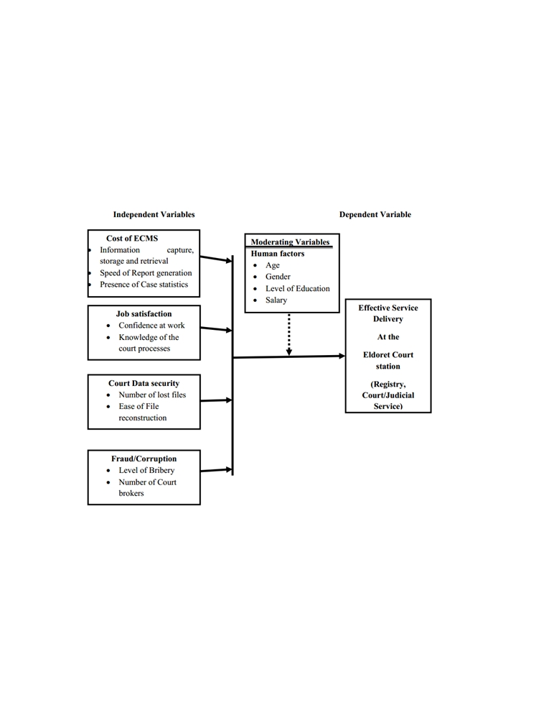

Among the recommendations that the committee put across to curb corruption and fraud was automation of court proceedings and registries, expansion of courthouses and increasing number of judicial officers (Sitienei, 2022). Thus, the implementation of the Eldoret Court station Case Management system in 2010 January cannot be gainsaid.

**2.5.5 CONCEPTUAL FRAMEWORK**

**Figure 1-(Conceptual framework)**

16

**2.6 OVERVIEW OF DATABASES**

The application that will be developed has aspects of managing and storing data of the cases which are brought to the court, there is a need to deploy a database that will be of immense benefit, to store their records.

Database technology has a major impact on the growing use of computer. A database is a collection of related data organized in a way that the stored data can be easily accessed, managed and updated. For example, the storage of case records such as date, suit number, plaintiff, defendant, name of court, name of judge who holds case etc. on the application.

A Database Management System (DBMS) is a software that allows creation, definition and manipulation of database. The DBMS has a number of advantages as compared to traditional computer file processing approach. The database administrator must keep in mind the benefits or capabilities of DBMS during designing databases, coordinating and monitoring the DBMS. Some of these benefits are as follows:

1) Controlling Data Redundancy: In the traditional way of managing records, books were used to store record changes and updates of cases. This may cause the duplication of copies of the same data but in the proposed system all the data will be integrated into a single database. The data is recorded at only one place in the database and it is not duplicated.

2) Data Consistency: By controlling the data redundancy, the data consistency is obtained. If a data item appears only once, any update to its value will be done only once and that updated value will be available to authorized users.

3) Data Sharing: In DBMS, data can be shared by authorized users of the clinic. The database administrator manages the data and gives rights to users to access the data. Many users can be authorized to access the same set of information simultaneously. The remote users can also share same data. Similarly, the data of same database can be shared between different application programs.

17

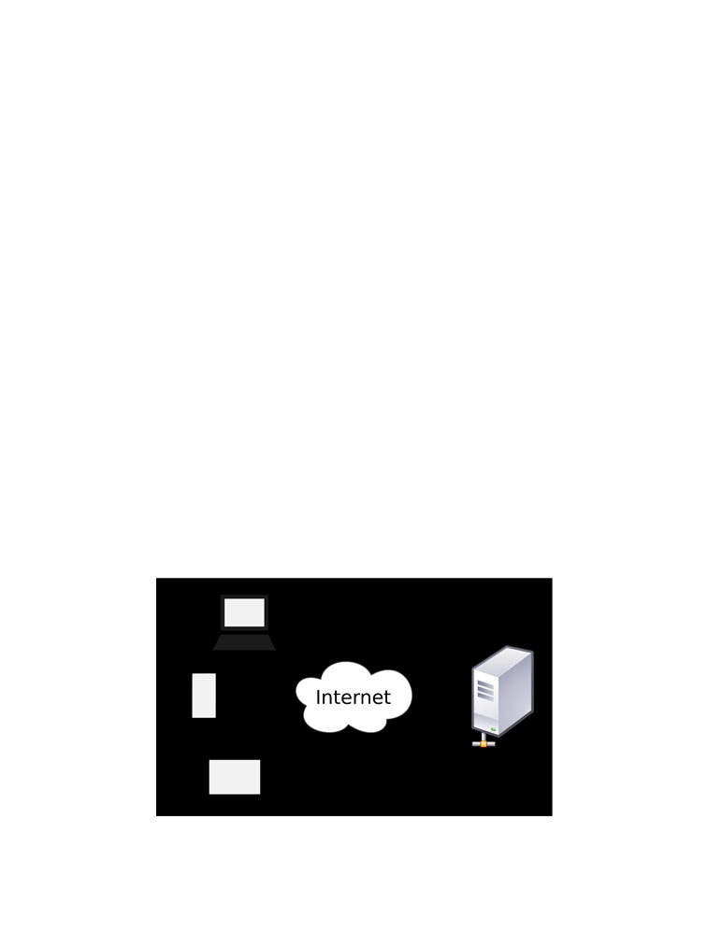

**2.7 THE ROLE OF THE CURRENT ECCMS**

The system plays a major role in judiciary system. This is mainly because it takes care of most of the functions in Legal Department. The uniqueness of the eCCMS is that it simplifies most of the communication aspects within the Legal sector to both the court and public.

**2.7.1 USER**

The system will be used for case registration and data processing (data storage and data retrieval)   
it involves creation, modification and updating information through user interface. The user will   
be required credentials that is needed to control the access of the application in terms of security.

**2.7.2 PUBLIC ACCESS**

The eCCMS will show new case arrivals, session appointments, case date of start, Reservation of courtrooms and the judge who will take the case, which the public can view the details on the web and search for a case.

**2.8 HOW WEB APPLICATIONS WORK**

Web applications use the client/server architecture. The Web application resides on a server and responds to requests from multiple clients over the Internet.

Figure 2-(how web applications work)

18

**2.9 SUMMARY OF THE CHAPTER**

This chapter describes the use of ICT in the delivery of justice considering the different judicial systems, with examples of Russia, Australia, Venezuela, Kenya and Nigeria. The factors that influence effective judicial service delivery in Nigeria are also restated. In addition with the current system and how the web application works.

19

**CHAPTER THREE: SYSTEM DESIGN AND SPECIFICATION**

**3.1 INTRODUCTION**

This chapter tackles the approaches that were used to achieve the objective of the project. It also   
demonstrates mainly the techniques to be used to capture user requirements and specification.

**3.2 RESEARCH DESIGN**

Parahoo (1997:142) describes a research design as “a plan that describes how, when and where data are to be collected and analyzed”. This study focuses on the plaintiff and defendant who are involved in the case, the date which the case will be held, the judge who will be taking the case and the court which the case will be held.

**3.3 DEVELOPMENT METHODOLOGY**

Methodologies in System development are principles or rules from which specific methods or   
procedures may be derived to solve different problems within the scope of a particular discipline.   
It can also be said to be a framework, since is used to structure, plan and control the development   
of an information system. Typically, it encompasses concepts such as theoretical model, phases   
and quantitative or qualitative techniques. In system development selecting right methodology   
approach and following through to deliver the intended system can be a bane for system   
developers.

The agile development methodology was deployed in the development of the system. Agile method proposes incremental and iterative approach to software design rather that waterfall model where development of the software flows sequentially from start point to end point. This model enables the customer to have early and frequent opportunities to look at the product and make decision and changes to the project.

20

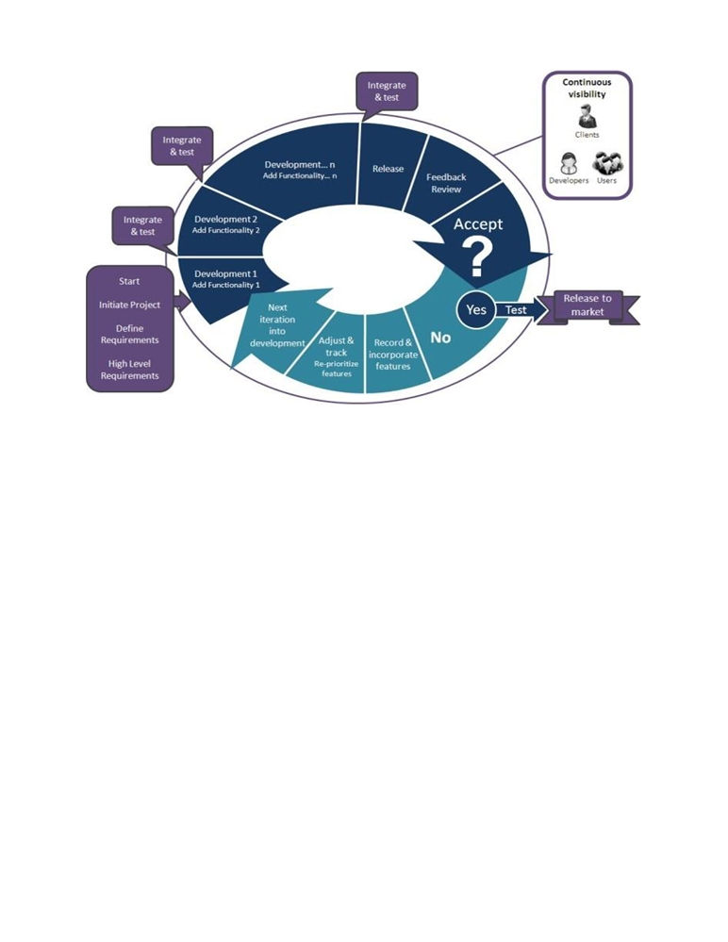

**Figure 3-(Agile Model Process)**

**3.3.1 WHY AGILE DEVELOPMENT METHODOLOGY**

The agile methodology gives the need to develop a system based on the requirements of the users,   
and enable to add up various units of the system pertaining the various feedbacks received from   
the users.

It provides face-to-face conversation between the developer and the client. Active participation   
with clients improves communication and helps client to be aware of every details and steps of the   
way.

The agile process promotes and requires that functionalities with higher business value which are ought to be done first and to deliver the features that provide the most business value.

It provides a breakdown of project into manageable units, where the team can focus on high-quality development, testing, and collaboration.

21

By help of time-boxed, news features are delivered quickly and frequently, with a high level of predictability, which provides the opportunity to release the software earlier then planed if there is sufficient business value.

**3.4 FACT FINDING TECHNIQUES**

Fact finding techniques aid in collecting information about system problems requirements and preference. It is the process of collecting data and in formation based on techniques which contains sampling of existing documents, research, observation, questionnaires, interviews, prototyping and joint requirements planning. (Essays, 2015). In this project, research, interview and observation are the fact finding techniques that were deployed.

**3.4.1 RESEARCH**

Information such as background information, technical materials and news about the Judicial Service trends and development which were gathered to publish this topic were obtained in sources like newspapers, journals and internet.

**3.4.2 INTERVIEWS**

Interview is the most commonly used techniques to collect information from the face-to-face   
interviews and also one of the key research tools for finding out new accurate data. I had the   
opportunity to move to the Law Courts Complex, Supreme Court and schedule interview sessions   
with both the clients and registrars in some courts in order to gather vital information about their   
daily activities and problems they face. This information will helps me in the development of the   
system to solve problems which are incurred in their daily activities such as follow up cases after   
registration, paper works etc. The system will be solely for the Judicial Service thus The Law Court   
Complex. The information gathered gave me the guidelines as to how to go about the system and   
what to do.

22

**3.4.3 OBSERVATION**

The observation is another fact finding techniques that was adopted, which I paid close attention to the day to day activities which provided another perspective and better understanding of procedures.

**3.5 SYSTEM CATEGORY**

The proposed system is categorized as a web based application.

**3.6 REQUIREMENT SPECIFICATION**

A requirement is a formal definition for the functionality of a system. It contains conditions about the performance and functionality of the entire system. The functionality can be classified into two main groups;

* Functional Requirement
* Nonfunctional Requirement

**3.6.1 FUNCTIONAL REQUIREMENTS**

The functional requirement describes how the system will work in terms of its inputs, the behavior, and outputs. The functional requirements of the system for users are:

* Login Module: This shall be developed to have a centralized rights and authentication   
   facility to ensure only authorized users have access to the system providing a security   
   standard to protect vital information.
* Adding and Removing Cases: This will provide the registrar the authority to add   
   new cases and to terminate cases if they pass away.
* A Database Facility: This shall be developed to store, record, information about users,   
   (date, suit number, plaintiff, defendant, judge etc.)
* Edit or Update Module: This shall be developed to ensure easy corrections of mistakes.   
   Only registrar can access this feature.
* Reporting Facility: At the end of every day’s activities a report will be printed out. So as   
   to keep track of events.
* Backup: This shall be develop to backup data periodically.

23

**3.6.2 NON FUNCTIONAL REQUIREMENTS**

Non-functional requirement describe how a system should behave and what limits there are on its functionality.

* Performance: The system shall allow several case registration at the same time without   
   downgrading performance.
* Availability: The system shall be available to all court and can be access anywhere.
* Usability: The system shall be easy to learn and use by all users including registrar and   
   administrator.
* Reliability: The system have low system failure occurrence and low risk. And will not   
   take much time to resolve it.
* ccuracy: The system shall work accurately without high failure or error.
* Security: each user is required to login. The system shall allow people with assigned   
   user names and passwords. The system shall be designed to make it impossible for   
   unauthorized people to logon without valid usernames or password.

**3.6.3 HARDWARE REQUIREMENTS**

**a)** Processing speed of 1.2 GHZ and above.

**b)** RAM of 1GB and above.

**c)** HDD of 30GB and above.

**d)** Operating system: Linux, Windows operating system all version.

This is the first phase in the system development process. Describe desire features and operations in details, thus it identifies whether or not there is a need for a new system to achieve a business strategic objectives. The project take shape in this phase by outlining the project and phases in the life cycle. The purpose of this phase is to find out the scope of the problem and determine the solution. Resources, time, cost and other items are considered at this stage.

24

**3.7 SYSTEM MODELING**

System model is a conceptual model that shows the representation and describes a system. A system comprises multiple views such as planning, requirement, design, implementation, deployment, structure, behavior, input data and output data. To fully develop the systems, conceptual models and structures such as these were used:

* Class Diagram
* Use Case Diagram
* Entity Relationship Diagram
* Activity Diagram
* Architectural Diagram

**3.7.1 SYSTEM MODELLING USING UNIFIED MODELING LANGUAGE**

Unified Modeling Language (UML) is a language used for visualizing, specifying, constructing and documenting artifacts of a software intensive development project. UML is a graphical language where graphical notation is used to express the ideas rather than using in a textual notation for modeling system. There are three types of UML namely Structural Modeling, Behavioral Modeling and Architectural Modeling.

**3.8 UML: STRUCTURAL MODELING**

Show the things in a system being modeled. In a more technical term, they show different objects in a system. The structures which were used are:

* Class Diagram

**3.8.1 CLASS DIAGRAM**

A class diagram is a type of static structure model (diagram) that describes the structure of a system   
by showing the system's classes, their attributes, methods, and the relationships between the classes. Attributes identifies the characteristics of a class while methods identify the behavior of it. Relationships are the logical links between classes and can be in different flavors.

25

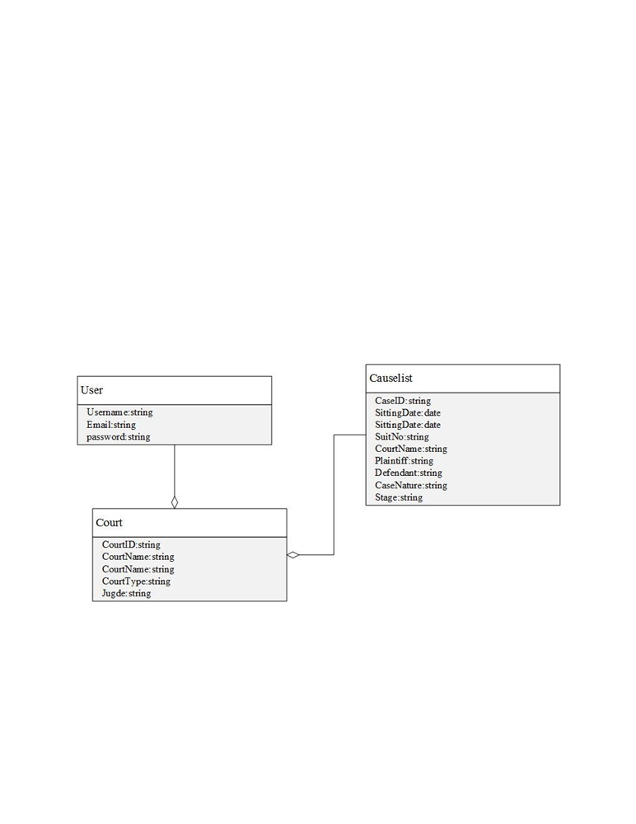

UML diagrams like activity diagram, sequence diagram can only give the sequence flow of the application, however class diagram is a bit different. It is the most popular UML diagram in the coder community.

The purpose of the class diagram can be summarized as −

* Analysis and design of the static view of an application.
* Describe responsibilities of a system.
* Base for component and deployment diagrams.
* Forward and reverse engineering.

**Figure 4-(Class Diagram)**

26

**3.9 UML: BEHAVIORAL MODELING**

Shows what should happen in a system. They describe how the objects interact with each other to create a functioning system. The structures which were used are:

* Use Case Diagram
* Entity Relationship Diagram
* Activity Diagram

**3.9.1 USE CASE DIAGRAM**

A use case diagram includes a set of use cases (including cases, actors and their relationships)

where each use case is a description of the functionality of the system from the user’s perspective.   
Use case diagrams are used to show the functionality that the system will provide and to show   
which users will communicate with the system in some ways to use that functionality. Use case

diagrams are a set of use cases, actors and their relationships. They represent the use case view of a system. The use diagram would specify and show the following:

* Chief Registrar
* Registrar
* Client

27

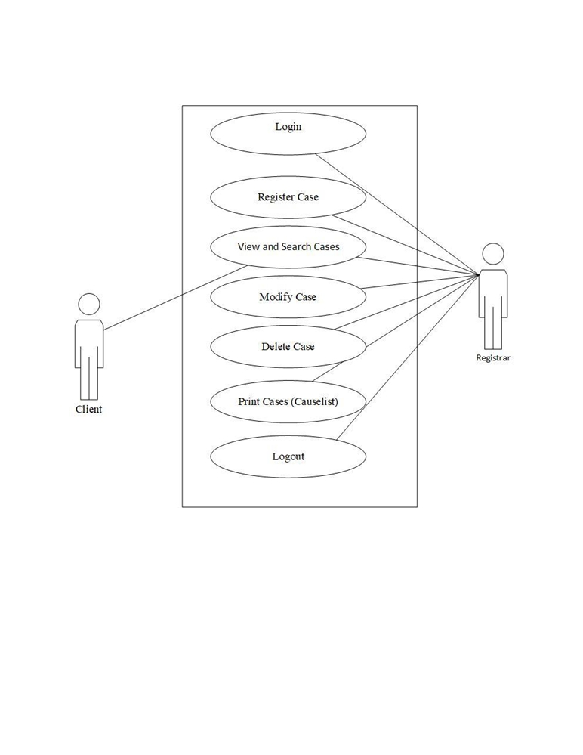

**3.9.2 USE CASE DIAGRAM**

**Figure 5-(Use Case Diagram for Client and Registrar)**

28

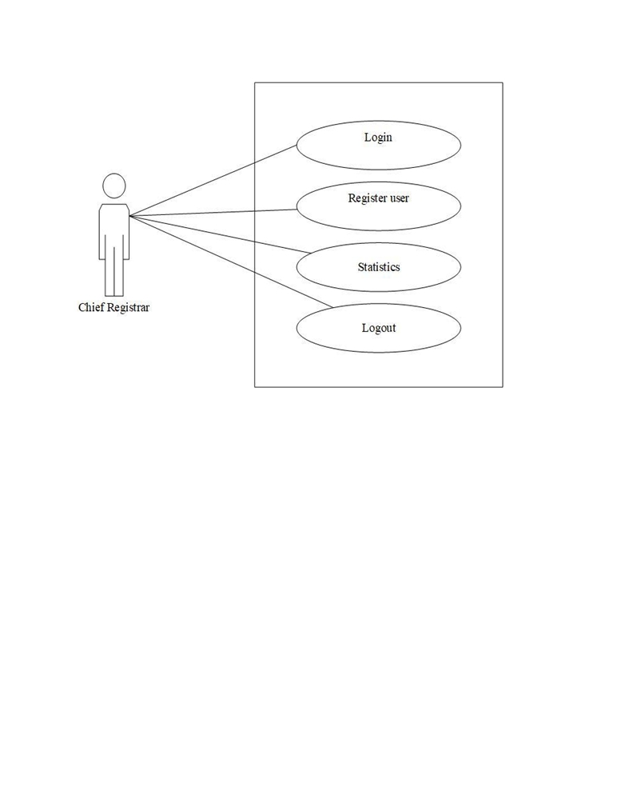

**Figure 6-(Use Case Diagram for Chief Registrar)**

**3.9.3 ENTITY RELATIONSHIP DIAGRAM**

An entity relationship model, also called an entity-relationship (ER) diagram, is a graphical representation of entities and their relationships to each other, typically used in computing in regard to the organization of data within databases or information systems. An entity is a piece of data-an object or concept about which data is stored. (Beal, 2019)

29

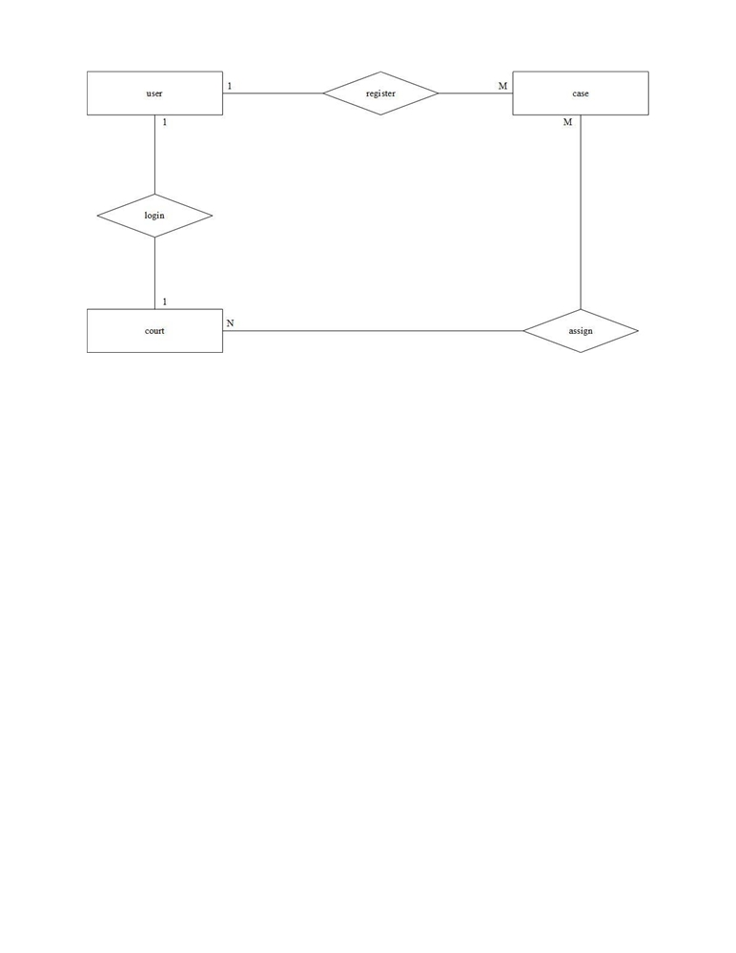

**Figure 7-(Entity Relationship Diagram)**

**3.9.4 ACTIVITY DIAGRAM**

Activity diagram is basically a flowchart to represent the flow from one activity to another activity.   
The activity can be described as an operation of the system. The control flow is drawn from one   
operation to another. (Tutorialspoint, 2023) It captures the dynamic behavior of the system.

30

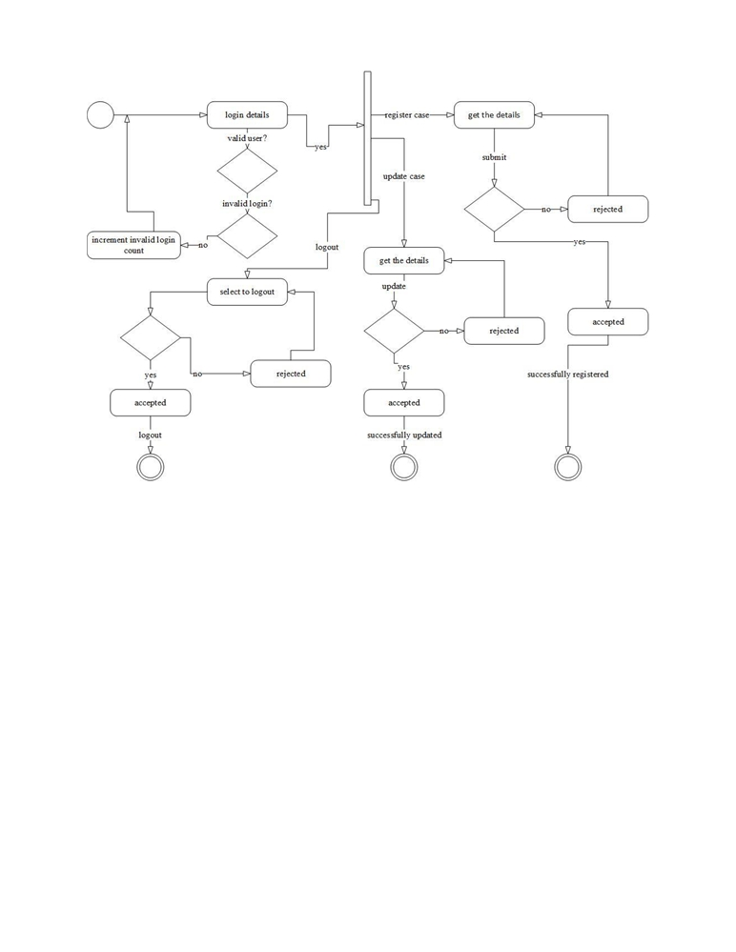

**Figure 8-(Activity Diagram)**

**3.10 UML: Architectural Modeling**

Architectural diagram represents the overall framework of the system. It contains both structural and behavioral elements of the system. Architectural model can be defined as the blueprint of the entire system. The structure which was used is:

* Architectural Diagram

31

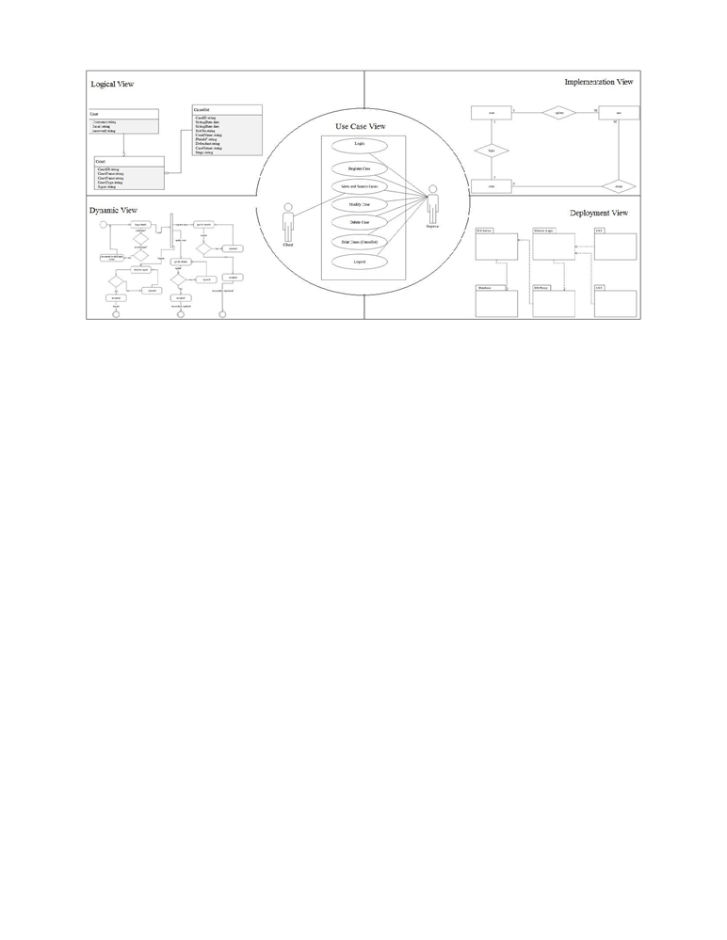

**Figure 9-(Architectural Model)**

32

**REFERENCE**

Architects, I., 2023. The Seven Phases of the System-Development Life Cycle. [Online]   
Available at: https://www.innovativearchitects.com/KnowledgeCenter/basic-IT-systems/system-development-life-cycle.aspx .

B., L., 2022. Courts of the future’ Law and Information Technology. p. 225-238.

Beal, V., 2017. Entity-Relationship Diagram (model). [Online]

Available at: <http://www.webopedia.com/TERM/E/entity_relationship_diagram.html>

Bockweg, J. M. G. a. G., 2021. Insights to Building a Successful E-Filing Case

Management Service: U.S.. International Journal For Court Administration, pp. 1-9.

Chrisphine, M. K., 2020. Mbugua_Electronic case management system.pdf. [Online]

Available at:

http://erepository.uonbi.ac.ke/xmlui/bitstream/handle/11295/10911/Mbugua_Electronic% 20case%20management%20system.pdf?sequence=4&isAllowed=y

Christian, 2024. The seven phases of the systems development life cycle. [Online]   
 Available at: http://petersheehan.blogspot.com/2009/01/seven-phases-of-systems-  
 development_11.html [Accessed 13 02 2021].

Dickson, O. B., 2019. The Structure and Jurisdiction of Court the Courts. [Online]

Available at:

<https://www.academia.edu/12694626/THE_STRUCTURE_AND_JURISDICTION_OF_>

THE_COURTS

Essays, U., 2022. Definition Of Fact Finding Techniques Information Technology Essay.[Online]

Available at: <https://www.ukessays.com/essays/information-technology/definition-of-fact-finding-techni>

ques-information-technology-essay.php