

Raymond Kumah

**AN E-COMMERCE SHOPPING WEB-SITE**

School of Technology

2018

1

**Acknowledgment**

My journey to this point has been a rocky one and through it all, I have had some people who have been there for me through it all. I would like to thank my super-visor Pirjo Prosi who have been of great help to me.

I would like to thank, Ph.D. Seppo Mäkinen for helping me to finish my degree program finally. He has been instrumental in my thesis process, and I appreciate that very much.

A big thank you to Mr. and Mrs. Kumah, Kingsley Kumah,Bright Kumah, Pastor Stefan Sigfrids, Marina Sigfrids.

2

VAASAN AMMATTIKORKEAKOULU

UNIVERSITY OF APPLIED SCIENCES

Information Technology

**ABSTRACT**

|  |  |
| --- | --- |
| Author | Raymond Kumah |
| Title | An eCommerce shopping website |
| The year | 2018 |
| Language | English |
| Pages | 44 |
| Name of Supervisor | PirjoProsi |
|  |  |

The thesis aimed to develop an online shop using open source technologies (PHP, HTML5, CSS3, JavaScript, MySQL and Apache Web Server) for electronics products in Ghana where customers will be able to buy products online.

The designed application will have an admin view and the public or guest view. The admin view is meant for the administrator to update the products, change prices, remove and add products and also manage customers. The customer view will be accessible to the customers, and they will be able to handle their information such as their name, ad-dress, and contact. Also, the customer will be able to order for products from the shop.



Keywords Customer, User,PHP, MySQL, HTML5, CSS3

3

**TABLE OF CONTENTS**

|  |  |  |  |
| --- | --- | --- | --- |
| **ACKNOWLEDGMENT** ....................................................................................... | | | 2 |
| ABSTRACT............................................................................................................. | | | 2 |
| 1 | INTRODUCTION ............................................................................................ | | 7 |
| 2 | TOOLS AND TECHNOLOGIES ..................................................................... | | 8 |
|  | 2.1 | Html/Html5 ............................................................................................... | 8 |
|  | 2.2 | PHP ........................................................................................................... | 9 |
|  | 2.3 | CSS 3 ......................................................................................................... | 9 |
|  | 2.4 | JAVASCRIPT ......................................................................................... | 10 |
|  | 2.5 | MySQL .................................................................................................... | 11 |
|  | 2.6 | UML ........................................................................................................ | 12 |
|  | 2.7 | XAMPP ................................................................................................... | 12 |
|  | 2.8 | Bracket(Editor) ........................................................................................ | 12 |
|  | 2.9 | PhpMyAdmin .......................................................................................... | 12 |
| 3 | APPLICATION AND DESCRIPTION .......................................................... | | 13 |
|  | 3.1 | Overview of the Various Parts ................................................................ | 13 |
|  | 3.2 | Administrators Detailed Attribute ........................................................... | 13 |
|  | 3.3 | Customer Detailed Attribute ................................................................... | 14 |
|  | 3.4 | The Various Management Unit ............................................................... | 15 |
| 4 | MVC UNIT OF SHOPPING CART .............................................................. | | 20 |
|  | 4.1 | Back-end Module layout ......................................................................... | 20 |
| 5 | DATABASE GUI DESIGN ........................................................................... | | 22 |
|  | 5.1 | Database .................................................................................................. | 22 |
|  | 5.2 | Customer Interface layout ....................................................................... | 24 |
|  | 5.3 | Management Interface design ................................................................. | 29 |
| 6 | IMPLEMENTATION ..................................................................................... | | 32 |
|  | 6.1 | Description .............................................................................................. | 32 |
|  | 6.2 | Implementation of functions ................................................................... | 32 |
|  |  | 6.2.1 Basic HTML of the shop ............................................................. | 33 |
|  |  | 6.2.2 Basic CSS of the shop ................................................................. | 34 |
|  |  | 6.2.3 Available products in the shop .................................................... | 34 |
| 4 |  |  |  |

|  |  |  |  |
| --- | --- | --- | --- |
|  |  | 6.2.4 User Registration ......................................................................... | 35 |
| 7 | TESTING ........................................................................................................ | | 37 |
|  | 7.1 | Testing shopping cart .............................................................................. | 37 |
|  | 7.2 | Customer checking out ............................................................................ | 38 |
| 8 | CONCLUSION ............................................................................................... | | 41 |
| 9 | FUTURE IMPROVEMENT ........................................................................... | | 42 |

5

**Figure 1**: The structure of the Html/Html5 webpage**8**

**Figure 2**: Demonstrating how the web server Operates using PHP**9**

**Figure 3**:CSS code style**10**

**Figure 4**:Basic Javascript format code**11**

**Figure 5**: A diagram showing the concept of MySQL**11**

**Figure 6**: Use case diagram of the shop**14**

**Figure 7**: User registration function**16**

**Figure 9**: Customer login function**17**

**Figure 10**:Administration registration diagram**18**

**Figure 11**: Administrator Login diagram**19**

**Figure 12**: MVC diagram of the online shop**20**

**Figure 13**: Module of Sale **Error! Bookmark not defined.**

**Figure 14**: Back-end system management diagram**21**

**Figure 15**: ER-diagram of the shop**22**

**Figure 16**: Database table showing various brands**23**

**Figure 17**: Customer registered to the store**24**

**Figure 18**: The homepage of the shop**25**

**Figure 19**: Customer registration page**26**

**Figure 20**: Customer login page**27**

**Figure 21**: Customer account page**28**

**Figure 22**: Shopping Cart**29**

**Figure 23**: Paypal checkout**29**

**Figure 24**: Admin registration page**30**

**Figure 25**: Admin content management**31**

**Figure 26**: Product display code**35**

**Figure 27**: Code for product display**35**

**Figure 28**:User registration code**36**

**Figure 29**: Product in a shopping cart**38**

**Figure 30**: Paypal checkout**39**

**Figure 31**: Detailed Paypal payment**40**

6

**1 INTRODUCTION**

E-commerce (electronic commerce or EC) is the buying and selling of goods and ser-vices, or the transmitting of funds or data, over an electronic network, primarily the in-ternet. These business transactions occur either as business-to-business, business-to-consumer, consumer-to-consumer or consumer-to-business.

E-commerce shops have become part of our daily lives. Technological advancement has made it possible for people to sit in the convenience of their homes and still shop online without going to a physical shop. Africans have also joined the trend of e-commerce business, so this project is meant to design an eCommerce online shop so that the peo-ple in Ghana (Africa)will be able to purchase their goods and services online.

This project is mainly divided into two main categories: The Administrators and the Customers/Users.

The store manager and the staff members operate as the administrators. They can add, edit, update products or, delete products thus they able to change the names of products, change prices and, add or remove products.

The customer can search for products selection, update the cart, remove products from the cart and check out from the shop. The customer is also able to update his infor-mation such as names, address and other data.

The User is only able to browse the online shop and add a product to the cart. The user is limited to the use of the shop.

This thesis contains eight chapters to explain the project. The first chapter introduces the project; the second chapter defines the tools and technology used for the project, and the third chapter describes the application and description of the process. The fourth chapter represents the MVC layout, the fifth defines the database and the Gui designs, the sixth chapter explains the implementation process,and the seventh chapter describes the testing of the shop and its features,the eight chapter describes the conclusion of the whole project. The ninth chapter illustrates possible future improvement to the shop.

7

**2 TOOLS AND TECHNOLOGIES**

These are the necessary tools and materials needed to build the website both the front-end and the back-end. These include software and open source materials.

**2.1** **Html/Html5**

HTML means Hypertext Markup Language. This language is used in creating web pag-es. This language also supports other languages such CSS, PHP, JAVASCRIPT, etc. in creating interactive and responsive pages on the pages. HTML5 is just an updated ver-sion of the HTML. It supports new features, new attributes, new HTML elements, full CSS3 support, video and audio, 2D/3D graphics that help users and also help web de-velopers to create new features easily on the website.The structure of HTML5 is shown in figure 1./1/

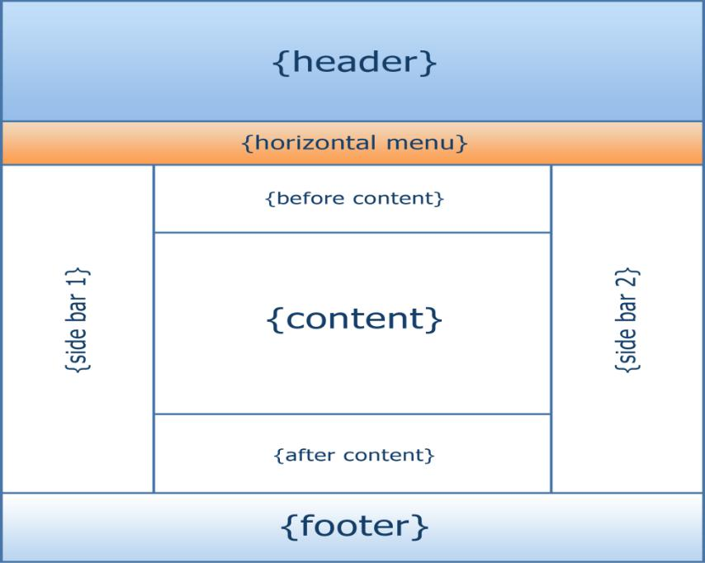

**Figure 1**:The structure of the Html/Html5 webpage/11/

8

**2.2 PHP**

PHP is a server-side scripting language that is used to develop Static websites or Dy-namic websites or Web applications. It is designed for web development to implement dynamic web pages and can be embedded into HTML for it to be displayed.Figure 2 demostrates how the web server operates./2/

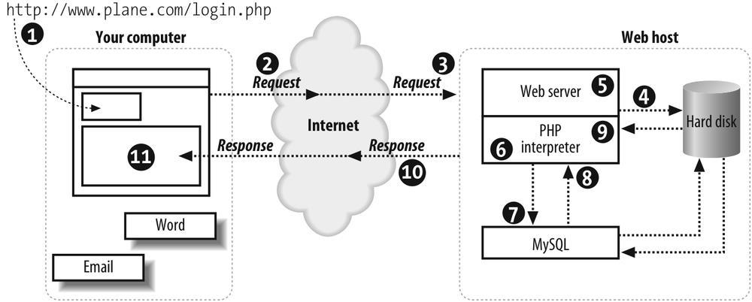

**Figure 2**:Demonstrating how the web server Operates using PHP/12/

**2.3** **CSS 3**

CSS is simply referred to as Cascading Style Sheets.CSS is used to define styles for web pages, including the design, layout, and variations in the display for different de-vices and screen sizes./3/

The general structure of CSS

Basic syntax:

selector{property: value}

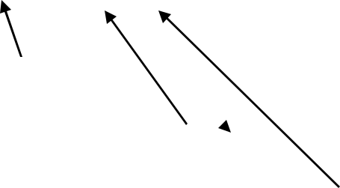

HTML tag you want to modify

the property you want to change

The value you want the property to take

9

Example:

*p{text-align: center;*

*color: black;*

*font-family: arial}*

CSS can be used in a separate style sheet or used in the webpage

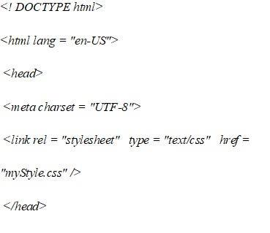

**Figure 3**: CSS code style

**2.4 JAVASCRIPT**

Javascript is a high-level language which could be used independently or inculcated into the webpage. It can be used to, handle requests and responses and also add dynamic be-havior and also store information on a website./4/

10

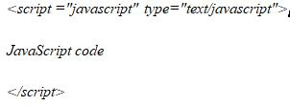

**2.5** **MySQL**

MySQL is a free source database system, and it enables the cost-effective delivery of reliable and a high-performance and scalable Web-based and embedded database appli-cations. It is a relational database system(RDBMS). It is a high performing program and scalable to meet the demands of users and data. MySQL is written in C and C++, so it is compatible with most of the operating systems available around the world./5/

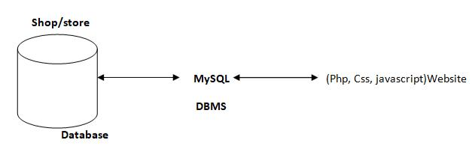

**Figure 4**: A diagram showing the concept of MySQL

11

**2.6 UML**

(Unified module language)UML. It is used for constructing and documenting a system or a project. This is widely used by people such as engineers to make module structures of what they want to build./6/

**2.7** **XAMPP**

XAMPP is an integrated development surrounding, which incorporates Apache HTTP Server, MySQL Database, and PHP, Mercury, PERL or Python on a home Windows-based computer. Apache is a free web server. MySQL is an open source database.

XAMPP is used in collaboration with, PHP, MySQL and, Windows 8 operating sys-tem./7/

**2.8 Bracket(Editor)**

Brackets is a free-source editor written in HTML, CSS, and JavaScript. It is created via Adobe structures, certified underneath the MIT License, and is presentlymaintained on GitHub. Brackets are compatiblewith Mac, Windows, and Linux operating sys-tem./8/

**2.9** **PhpMyAdmin**

PhpMyAdmin is a free and open source MySQL managementprogram applicationwrit-ten in PHPand was first launched in 1998 under the GNU preferred Public License. It is cross-platform help for the essential working structures and helps management of more than one servers. It supports most MySQL capabilities and has an intuitive net interface. It additionally has supports developing PDF graphics of data-

base layout, importing information from CSV and SQL formats as well

as exporting records to various codecs such as SQL, XML, PDF and, CSV./9/ 12

**3 APPLICATION AND DESCRIPTION**

**3.1** **Overview of the Various Parts**

This project has several parts to it, but the most essential are three listed in Table 1.

**Table 1**: The overview of the three major parts of the shop

|  |  |  |
| --- | --- | --- |
| **Administrators** | **Customers** | **User** |
|  |  |  |
| *Login access* | *Login access* | *Cannot login* |
|  |  |  |
| *Can add products* | *Can add to cart* | *Can add to cart* |
|  |  |  |
| *Can edit products* | *Can edit product in carts* | *Can edit product in carts* |
|  |  |  |
| *Can view products* | *Can checkout* | *Cannnot check out* |
|  |  |  |
| *Can delete customer* | *None* | *None* |
|  |  |  |

**3.2** **Administrators Detailed Attribute**

* **Admin register**

The administrator needs to register before they can have access to the core data of the shop.

* **Admin login**

The admin logs in and can view, add products, manage customers.

* **Admin Edit**

The Admin can make changes to the shop such as delete customers, add a customer or, upload new products.

* **Manage Customer**

The administrator has the authority to delete or add a customer.

13

**3.3** **Customer Detailed Attribute**

* **sign up**

This refers to registering as a customer. The registered member has a lot of privileges associated with the shop when one becomes a customer.

* **Login**

After the user has registered, the user becomes a customer, and he or she can log in with their personal information.

* **View**

The customer can see all the products in the catalog and able to look at the products and some features on the homepage.

* **Edit**

The customer can make changes to their data displayed on the customer page.

* **Update Cart**

This refers to putting or removing products from ashopping cart.

Figure 5 is the use case diagram of the shop. One can see the essential attributes associ-ated with both Administrator and Customers/Users.

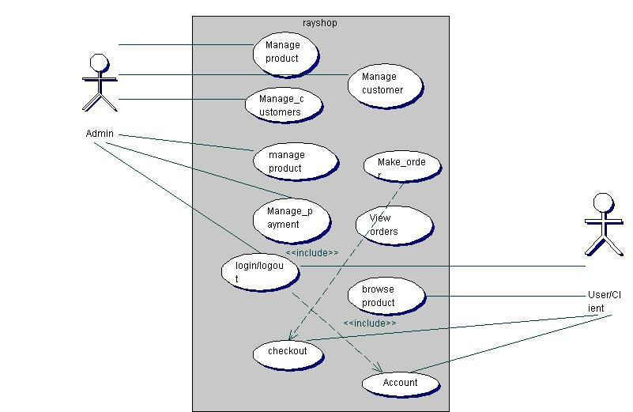

**Figure 5**: Use case diagram of the shop

14

**3.4** **The Various Management Unit**

The Administrators play the management role. They make sure everything in the shop runs smoothly. Table 2 lists the various management units.

**Table 2**: Administrators management table

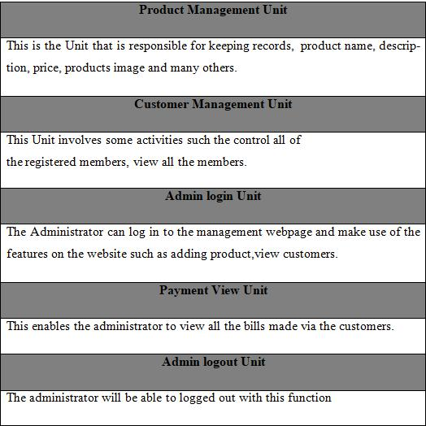

* **User registration**

The Users will use their exclusive information to register. After filling the

form and submitting it, the html5 checks to see if all the fields entered by the user are 15

correct. If the area is not correctly filled the user remains on the same pagebut if the re-quirements are met the data goesto the database (table "customers") and saves the in-formation of the User. The User then becomes a customer, and he or she is then directed to the login webpage of the shop. Figure 6 is the diagram that shows the flow of the Us-er's registration.

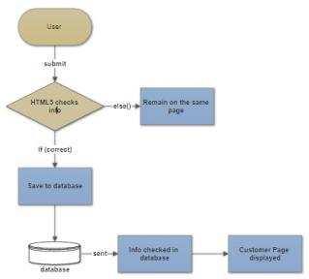

**Figure 6**: User registration diagram

* **Customer login**

The customer will use his particular data e-mail and passwordto log into the shop. After submitting the form, the html5 checks if all the fields have been filled correctly. If the condition is not met the customer remains on the same page but if the fields are correct-ly filled the customer login information is sent to the database to check if the data en-

tered into the areas are same as the ones used to register to the database. If it is correct, 16

the customer is redirected to his homepage, and he can successfully pick products and check out if they are done shopping. Figure 7 shows the flow diagram of customer log-in.

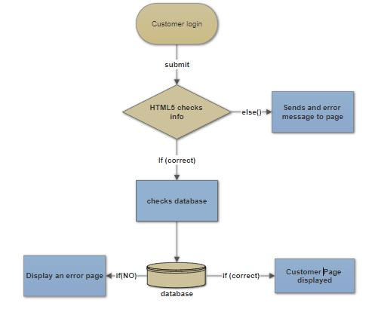

**Figure 7**: Customer login function

* **Administrator Registration**

The Administrator will use his particular data such as name, e-mail, and password. Af-ter submitting the form, the html5 checks to see if all the fields entered by the adminis correct. If the filed are not correctly filed, or conditions are not met the admin remains on the same page but if all requirements are met admin's information goesto

the database and saves the data in the "*Admins*" in the database. After that, the adminis-trator is directed to the admin webpage to log in. The Figure 8 shows the administrator registration diagram.

17

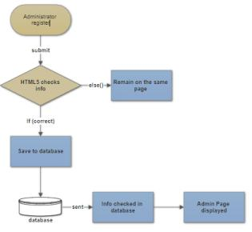

**Figure 8**:Administration registration diagram

* **Administrator Login**

When the admin logs into the Administrators webpage the html5 checks to see if condi-tions are met when logging in. If all the information provided are correct, the data is sent to the database to check if the data corresponds to the information used to register. If it matches to the information provided by the Administrator, a page opens, and the admin can have access to the administrator's webpage if not the administrator is restrict-ed from having access to management webpage. The Figure 9 shows the administrator log in diagram.

18

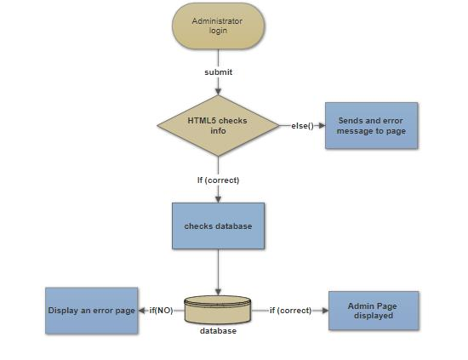

**Figure 9**: Administrator Login diagram

19

**4 MVC UNIT OF SHOPPING CART**

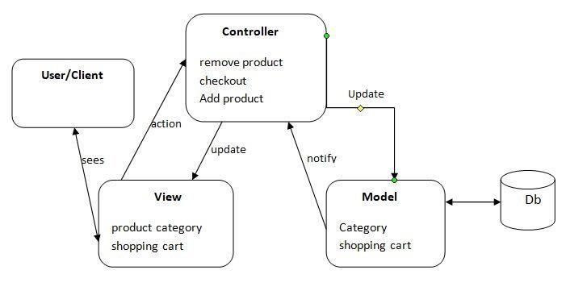

**Figure 10**: MVC diagram of the online shop

The three parts of the MVC software structure perform the following:

**View** – shows the interface that the person sees (usually, a webpage). The

view additives provide records to the user and moves to the Controller for manipulat-ing data.

**Model** – defines the statistics for the software (typically, the facts is saved in a data-base(DB)). **The controlle**r provides the interface between the View and the model.

**4.1** **Back-end Module layout**

This includes Units such as products, brand, category, orders and, customer manage-ment modules. Figure 11 shows the diagram of the back-end module.

20

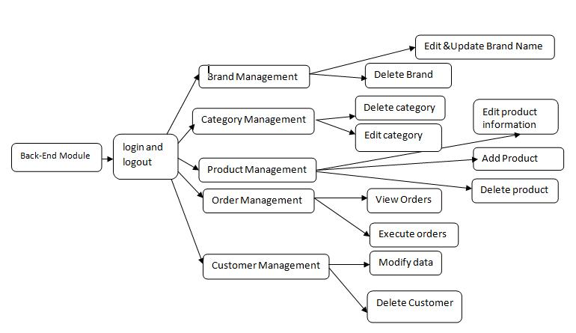

**Figure 11**: Back-end system management diagram.

The back-end module/Unit is used to manage the backend of the shop. This is only available to the administrators. They can manipulate the shop to suit the conditions they have set for the shop. They also make sure that customers have a good experience when visiting the shop by updating products, deleting products, executing orders to ware-houses, and managing customers.

21

**5 DATABASE GUI DESIGN**

Design for database and GUI application

**5.1** **Database**

MySQL database is used to save software data for this project. MySQL is relational da-tabase management, and it is free of charge. All of the informationis kept in a select-edtable, and every table has particular range columns and rows. It has eight tables named as admins, brands, cart, categories, customers, orders, payments and products. Figure 12 shows the ER-diagram of the eight tables in the database.

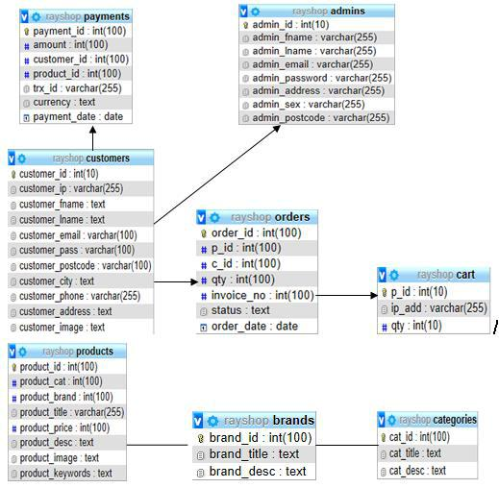

**Figure 12**:ER-diagram of the shop

22

The ER-diagram has a specific name and it consists of columns and rows.

For each table, we need to mark at the least one area as a primary key. The primary key is usually specified in a particular table. The table "admins" is created to store all

the Admin’ information. It consists of eight distinctive fields referred to as columns to shop admin id, first name, last name, email, and password. The email and the password are essential because they are needed for one to login into the shop. "*admin_id*" is the primary KEY. Many columns of one table may

be described as primary KEY. Each column has a name, a datatype and different non-obligatory attributes. Figure 13 only displays different brands of products, brand identi-ty and also the descriptions of the multiple brands.

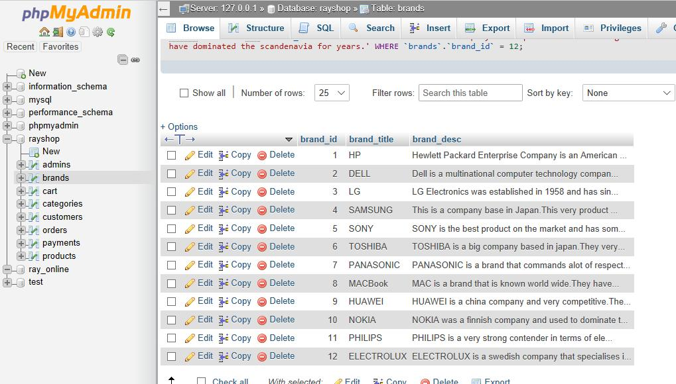

**Figure 13**: Database table showing various brands

23

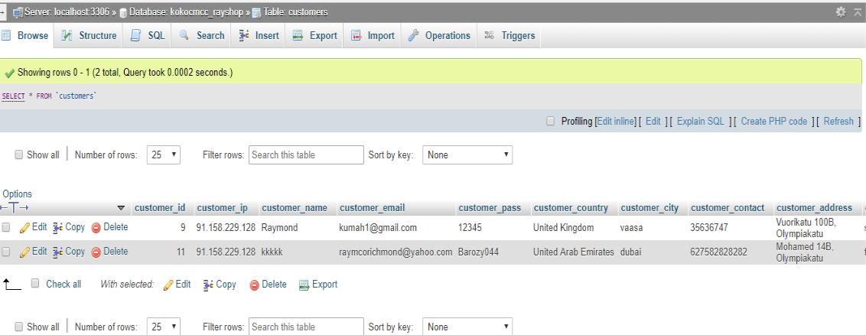

**Figure 14**: registered customer's in the store

The customers who have registered to the online shop have their data automatically stored in the database. This information is only available to the technical administrators. The administrator can delete, edit, and update customer information.

**5.2** **Customer Interface layout**

Consumer refers to customers and non-customers. These are individuals who visit the shop either to buy products or to browse. There are two categories of interfaces namely the Consumer and the Administrator interface. The administrator has higher authority over the customer in the shop. The admin can edit, replace a product and, manipulate data in the shop. The customer can browse a product, add a product to thecart, change personal information, check shopping history and checkout or log out. The User, on the other hand, can only browse and add a product to cart.The homepage or interface is the index page of the shop so can be accessed when the address is typed into a browser. The webpage hasproducts images, names, prices, product categories and product brands. The webpage has a registration link, login link, cart, company contact information. A picture of the homepage is shown in Figure 15.

24

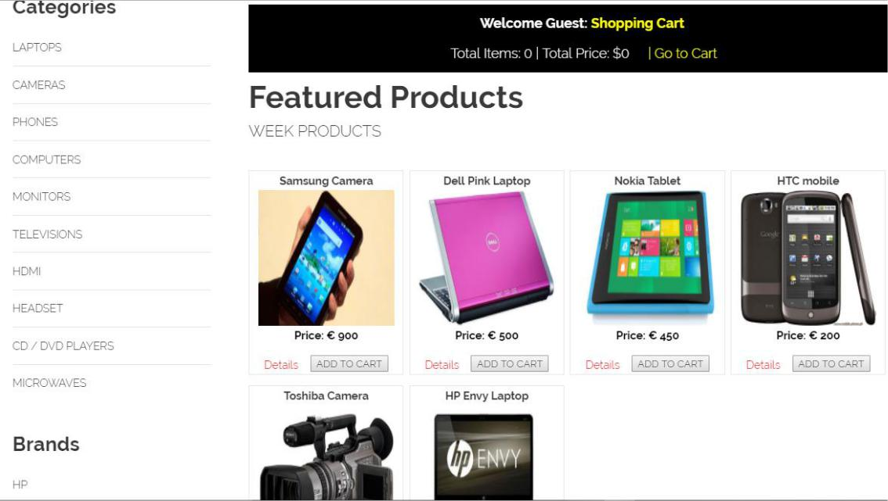

**Figure 15**: The homepage of the shop

* **Registration web page**

This registration page is only for users who wish to become customers. They have to meet the required filled standard for them to register successfully; otherwise, they will remain on the same page. When they register, their information is saved directly to the "*customer"*. This registration file "*customer_registration.php*" is run with a code editor. The Figure 16 shows the diagram of the customer registration form.

25

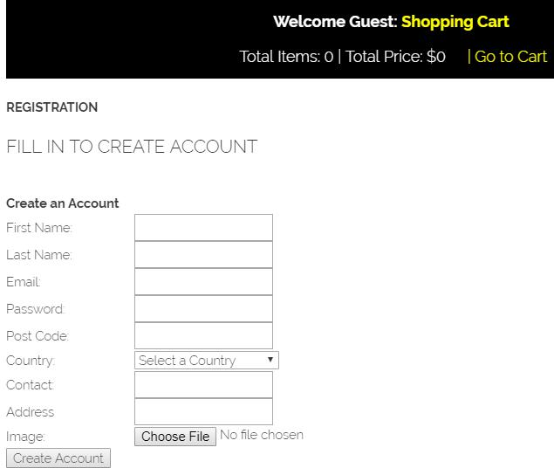

**Figure 16**: Customer registration page

* **Login web page**

Customers will have the right to log in with their information such as e-mail and pass-word. The information is sent to the database to check for a match. If no match is found the customer remains on the same page, otherwise he is directed to the customer page. This can be accessed by running "*customer_login.php*" file with an editor. Figure 17 is the customer login page snippet.

26

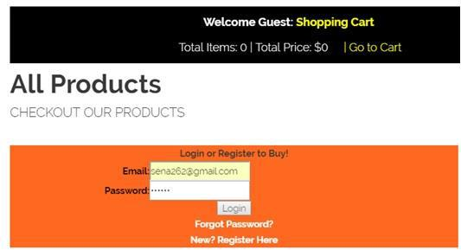

**Figure 17**: Customer login page

* **Customer purchasing product**

Figure 18 shows the link involved when the customer is making a purchase of a product in the shop.

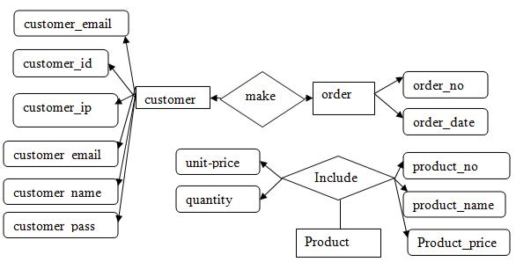

**Figure 18**: Diagram of the customer making a purchase

27

* **Customer Account page**

This web page can be accessed if customer information matches with the one in the da-tabase that was used to initially register. The customer is able to edit his data, orders, orders, password, log out.

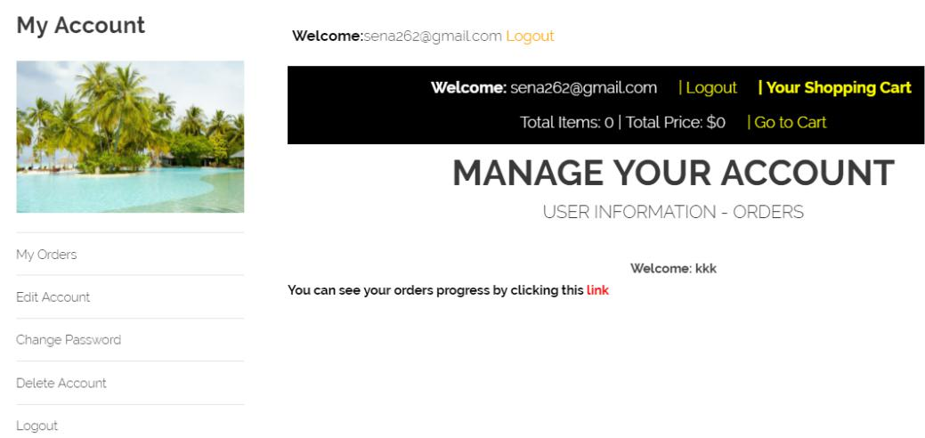

**Figure 19**: Customer account page

* **Shopping Cart**

The customer can add products to the shopping cart. They can also update the shopping cart from time to time until they are done shopping. After that, they can check out by clicking on the checkout button.

28

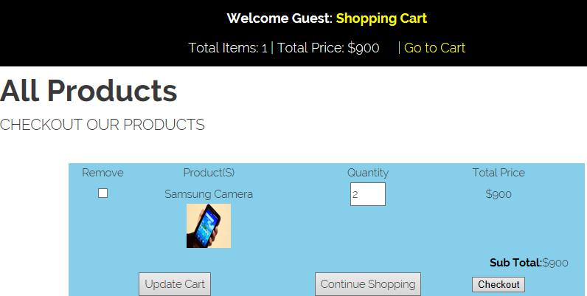

**Figure 20**: Shopping Cart

* **Payment**

This is the final stage of the shopping experience. The customer who is satisfied with

their choice of product and price can now pay with

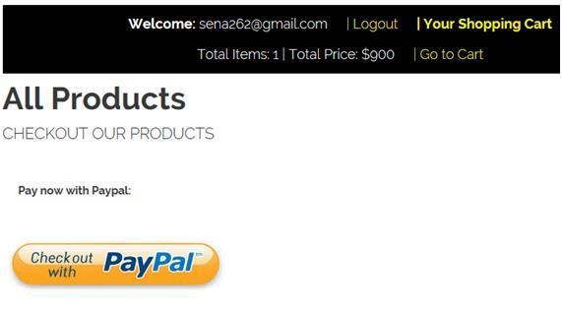

**Figure 21**: PaypalPayment

**5.3 Management Interface design**

The administrator must enter his username, email, and password. The html5 will check if all the fields are filled. If field conditions are not met the admin remains on the same

29

page; otherwise, his information is saved in the database. He is directed to the login page to login. Figure 22 shows the administrator registration form.

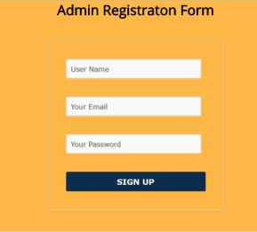

**Figure 22**:Administrators registration page

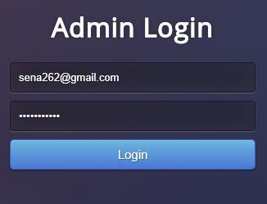

**Figure 23**: Admin login page

The administrators canlog in with theiremail and password. If there is no match for the information provided he or she will remain on the same page until the correct data are inserted into the login space.

30

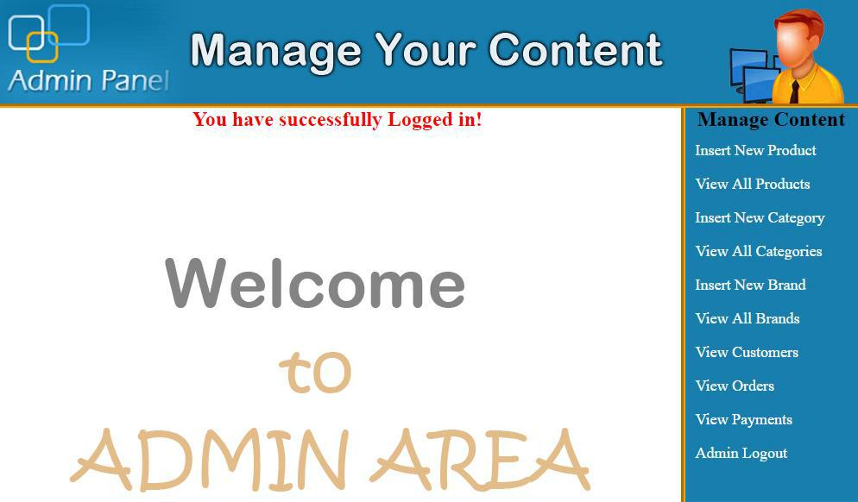

**Figure 24**: Admin content management

When the administrator has finally succeeded to log in the admin's content management area will emerge for the admin to have access to the webpage.

31

**6 IMPLEMENTATION**

This chapter contains the functions for implementation.

**6.1** **Description**

The created online store is based entirely on free source applications and with the inten-tion to cut cost. All of the functionalities need to be carried out in an orderly manner. The customer or user interfaces are critical because the administrator interface will be used to manage the activities on the customer interface. The technologies used for the project is HTML5, CSS3, PHP, and MySQL.

**6.2** **Implementation of functions**

Customer interface and administrator interface are the main interfaces created in this project. With the customer and admins interface, I used HTML5 and CSS3. The HTML5 was used to create the structure of the page whiles the CSS was used to style the page. PHP is a dynamic language,so I used it to automatically fetch information from the database unto the web pages without rewriting every data by hand.

32

**6.2.1** **Basic HTML of the shop**

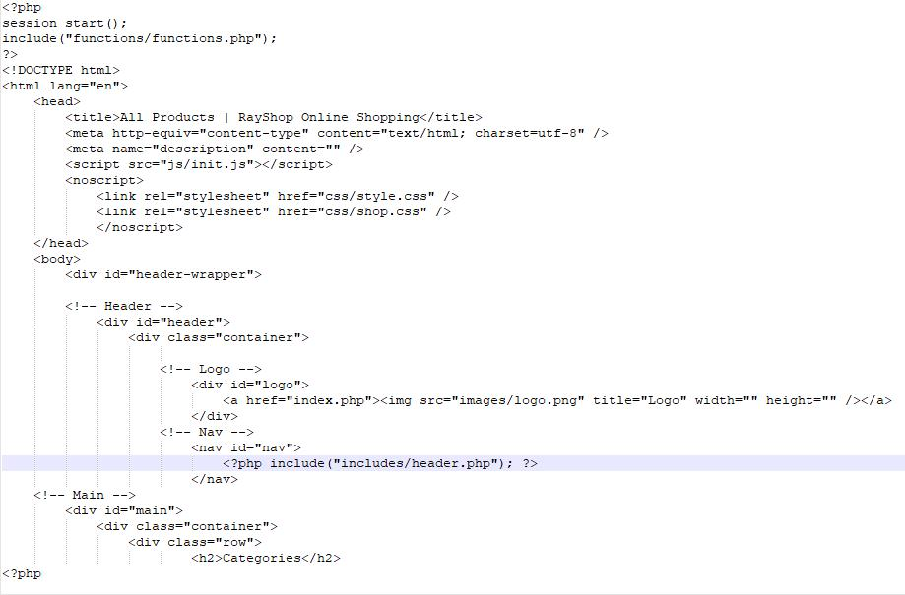

**Figure 25**: The fundamental part of the HTML5

This is the basic HTML of the shop. PHP is used to enclose the file because the project will use PHP in most of the project otherwise the system will fail to work with the data-base. The DOCTYPE declaration is a simple indication that the page is written in HTML5.The content of the page shows the title, links, logos, and the CSS used in styl-ing the webpage.

33

**6.2.2** **Basic CSS of the shop**

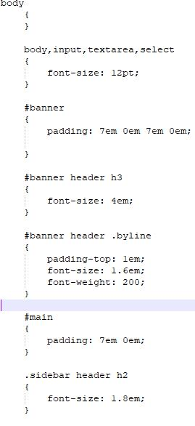

**Figure 26**: Basic CSS font of the shop

Figure 26 is the basic CSS used for the project. It has the body, banner, main and side-bars frames. They are also padded whiles the sidebar headers font size are sized to be 1.8em(29px).

**6.2.3** **Available products in the shop**

Any user with an internet connection can access the online shop. The user can surf the webpage to see what is available on the website. To get the product, we create a func-tion called "*get prod()"* which also has a connection to the database. When *"get prod()"* function is called a relationship is established in the database to retrieve products from

34

the table product in the database. The quantity of the products was restrict-ed to display six on the webpage.

$get_pro = "select * from products order by RAND() LIMIT 0,6"

Figure 27 shows the code for displaying products. "echo" is used to display the products with its details, beneath is the code.

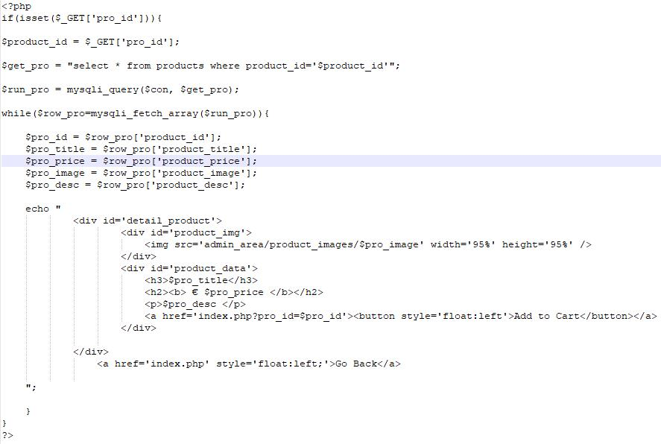

**Figure 27**: Displaying products with details

**6.2.4** **User Registration**

The User will insert his personal information including an image into the registration form. After submitting the form, a connection is established with the database which

35

saves the data. The IP address of the customer is also sent to the database to be kept.

Figure 28 is the code that shows how User's registration is processed.

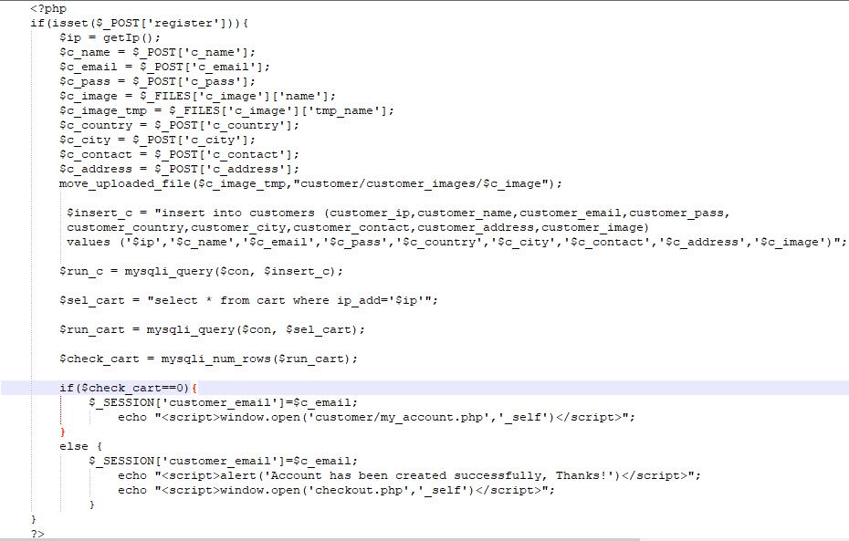

**Figure 28**: User registration code

The user is expected to provide the necessary information shown in the Figure 28. Any missing space or wrong information may lead to the customer not being able to register.

36

1. **TESTING**

To affirm the online store assessments had been made at distinct stages of the task; I checked the reliability of all of the functions. The test is built on the customer/user and Management Unit. The customer test proved that an account could be created, login can be established, the cart can be loaded with products and the customer can check out when done shopping. The administrator can create an account and log in afterward. The admin can then manage all the content in the shop.

**7.1** **Testing shopping cart**

Some quantity of products was inserted into the shopping cart, and then I proceeded to check out. When I checked out and tested with Paypal, the cart became empty. This in-dicates that the cart works appropriately as it should. The "*cart.php*" file is responsible for handling the cart of the shop. When an editor runs the file "*cart.php*" the *cart()* func-tion is called which insert products into the database. After that, the view *cart()* function can also be invoked to show the product in the cart. The customer can manipulates his cart such as updating the cart or, adding a product to cart.

37



**Figure 29**: Product in a shopping cart.

**7.2 Customer checking out**

The customer can only check out if he has logged in as a customer. Without being a customer, he is unable to checkout successfully.

38

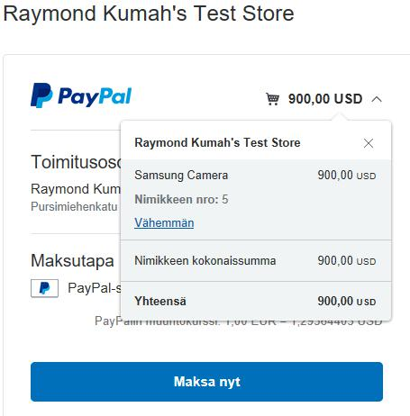

**Figure 30**: Paypal checkout

Figure 30 shows how Paypal works with the shop when the customer is about to com-pletely check out out of the shop using paypal.

39

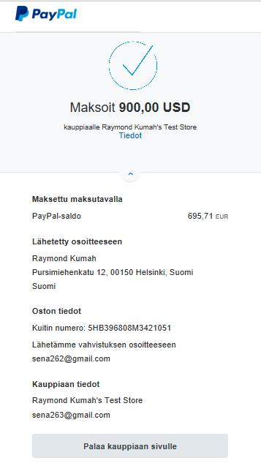

**Figure 31**: Detailed Paypal payment

Figure 31 shows how Paypal works with the shop after the customer has finally checked out of the shop. The name of the product, amount, email and the destination of the product are all displayed for the customer to view. The customer will then receive an email indicating that the product ordered was a success.

40

**8 CONCLUSION**

The electronic shop was developed using PHP, MySQL, HTML5 and CSS3 technology.

Any consumer can browse products, add, replace or delete a product from the cart. The consumer can log in, with his information such as his email and password. If the logindoes not go through, the user can re-register or ask to change the password. After login, the user cansee the product in the cart and proceed onwards. The product can be paid with PayPal. The administrator can verify the order, However

the consumer can still look at the orders in his or heraccount. The ordered price is saved in the database.

41

**9 FUTURE IMPROVEMENT**

Invoices need to be implemented in the shop, emails and notifications need's to be sent to customers for new arrivals or discount. The shop hasto have a search engine where users and customers can search for the various product from the shop. Debit and credit cards need's to be implemented in the shop as well. There have to be language varieties so that none-English users and customers can shop easily without any difficulty.

42

**REFERENCE**

/1/www.w3school.com

/3/CSS3 characteristic and attributes 3.05.2018 /2/php features. 08.03.2018

http://www.biogem.org/downloads/notes/PHP%20-%20Hypertext%20Preprocessor.pdf/4/Javascript academic. Accessed 09.03.2018

/4/http://www.w3schools.com/js/default.asp https://dev.mysql.com/doc/apis-php/en/apis-php-pdo-mysql.html /5/Documentation for mysql/ 05.01.2018 /6/UML idea. access 1.05.2018

https://en.wikipedia.org/wiki/Unified_Modeling_Language

/7/XAMPP 2.05.2018

https://www.apachefriends.org/index.html

/9/PhpMyAdmin. 5.05.2018

https://www.phpmyadmin.internet/

/8/Bracket editor 5.05.2018

https://en.wikipedia.org/wiki/Brackets_(text_editor)

/10/PayPal developer and Sandbox account 5.05.2018

https://developer.paypal.com/developer/accounts/

/11/The basic diagram of the HTML/HTML5 5/24/2018

43

http://www.modelrumahminimalis.co/html-menu-templates-free-download/69033.html/top-result-html-menu-templates-free-download-inspirational-generous-menu-template-html-images-entry-level-resume-templates-picture-2017-hdj5

/12/Demonstrating how the web server Operates using PHP5/24/2018

https://www.safaribooksonline.com/library/view/learning-php-and/0596101104/ch01s04.html

44