CHAPTER 1

Introduction

1.1 Introduction

Student Management System deals with all kind of student details, academic related reports, college details, course details, curriculum, batch details and other resource related details too. It tracks all the details of a student from the day one to the end of his course which can be used for all reporting purpose, tracking of attendance, progress in the course, completed semesters years, coming semester year curriculum details, exam details, project or any other assignment details, final exam result etc.

my design can facilitate us to explore all the activities happening in the university, college, even we can get to know which faculty is assigned to which course, the current status of a student, attendance percentage of a student and upcoming requirements of a student. The student management system is an automated version of manual Student Management System. It can handle all details about a student. The details include college details, subject details, student personnel details, academic details, exam details etc.

In case of manual system, they need a lot of time, manpower etc. Here almost all work is computerized. So, the accuracy is maintained. Maintaining backup is very easy. It can do within a few minutes. Our system has two type of accessing modes, administrator and user. Student management system is managed by an administrator. It is the job of the administrator to insert

update and monitor the whole process. When a user log in to the system. He/she would only view details of the student. He/she can’t perform any changes. my system has seven modules, they are

administrator, student, course, department, exam, attendance, and section. These modules and its attributes with entity relationship module presented in the ER diagram section.

1.2 Objectives

1.To develop a central information system which will works as a shared platform for all the University management information, Admin department, and Faculty department.

- To give a user-friendly interface to Admin department and faculty department from where they can see their all information.

- One system operator will be enough for deploying and maintaining data thus reduces the number of workers in the office staff. Easily we can modify all information.

1
1.3 Justification of study

The World is going to technology era. Now-a-days Most of the Country, they are used modern technologies for information management system. Everything is done in pen and paper still in 21st century. Software and Applications are developed for enhance our life.

for example, using Database information system and storage, retrieve we can save money and Time. Then there are many simulators which are also one kind of software which is used to test before any physical Implementation. So, software is very Important In our Life.

It is a recognized fact that the application of software Information Technology in our daily life has changed dramatically over the past couple of years. Software is used in every sphere of life like education, communication, business, commerce, treatment and banking etc. Businesses are investing heavily into new technological trends as well as offering businesses the chance to operate more effectively through the application of software technology. As you can see, the application of software technology in our daily life has definitely changed the way we live our lives. Long have the days we needed to invest in servers for our business. The application of software has definitely changed the way communication, commerce, business, education as well as the way we lead our lives.

1.4 Scope of study

University database management system is one of the most important and enriching field which is changing and evolving at a very fast pace. The area and application of University database management systemic huge. In this project we first studied how present academic information systems works and what are the advantages and disadvantages of existing university database management information system. Then we have built a simple university database management information system which stores student data, give student an interface for using the stored data for future analysis.

- Subscription of a web based UDMS, either off-the-shelf or designed & developed from scratch, that fulfills the requirements outlined in this document,

- Software implementation, configuration and customization according to the University requirements

Project scope is the part of project planning that involves determining and documenting a list of specific project goals, deliverables, tasks, costs and deadlines.

2
CHAPTER 2

Literature review

2.1 Introduction

This chapter presented/outlined the sections in this chapter that is to say Introduction, Theoretical underpinning of the study, and literature review of computerized data collection and student record, information protection and on student records, and record management on the student records. This section presents a review of related literature to the study of management information system and student records: the review has been done in accordance with the research objectives which are impact of computerized data collection on maintenance of student record, computerized information protection on student record and computerized record management in maintenance of student records in Ayesha University of Mymensingh.

2.2 Theoretical Under-pinning of the Study

According to the university of Florida (2012) explained that a student is an individual who is registered for a university credit course or program. A student record, also known as an education record, contains information directly related to a student, which means that the record is personally identifiable. Personal identifiers that relate a record to a student include student name, student ID/social security number, student address, parent/family member names, and a list of personal

characteristics. Student records are Maintained in multiple media including handwriting, print, computer’s main memory, magnetic tape, cassette, disk or CD. Student records may be presented

by the student, submitted on behalf of the student, or created by the University. These records are used to assist offices in their support of basic institutional objectives and to document student progress and achievement in the educational process of the University.

2.3 Computerized Data Collection on Maintenance of Student Records

According to Sharapova (2014) noted that systematic literature review was employed as follows:

- A variety of combinations of search strings were applied to selected scientific databases and search engines. The search string matrix was developing continually throughout the review process.

  - Papers pre-selected on the basis of their title and abstract were downloaded to the citation manager, together with their full text

- All duplicates, multiple entries and irrelevant papers were removed; remaining papers were scanned for the information of interest.

- When a relevant document was cited that had not been previously identified by database queries, it was downloaded.

3
2.4 Computerized Information Protection on Student Record.

According to kyobe, South African university (2009) explained that computerized Information security issues (e.g. access to information, cyber-crime, privacy, and virus Attacks, and commercial data mining) are of major concern in academia today Myler and Broadbent (2006). According to Wamukoya and Mutual (2005) noted that poor security 13 and confidentiality controls have been identified as major factors contributing to the failure of capturing and preservation of electronic records in eastern and southern African institutions of education. Chinyemba and Ngulube (2005) found that 89% of the academics surveyed at the University of KwaZulu-Natal did not adequately protect and secure their electronic records. Jones and Soltren (2005) found that 58% of the students surveyed were not concerned at all about risks to privacy on social network systems. However, little protection of the information of student records is not serious because other students access the information about other students or colleagues without permission hence the need for proper protection for the student records well.

2.5 Computerized Record/Data Management on Maintenance of Student Record.

According to student records manual prepared by University of South Florida (office of the registrar) the creation and maintenance of records relating to the students of an institution are essential to:

- Managing the relationship between the institution and the student;

- Providing support and other services and facilities to the student;

- Controlling the student’s academic progress and measuring their achievement, both

- at the institution and subsequently.

- Providing support to the student after they leave the institution. In addition, student records contain data which the institution can aggregate and analyze to inform future strategy, planning and service provision. A student is an individual who is registered for university credit course or program. A student record/data contains information directly related to a student, which means that the record is personally identifiable. Personal identifiers that relate record to a student include student name, student ID, student address, parent/family

member names, and a list of personal characteristics. Student records could be maintained in multiple media including handwriting, print, microfilm/fiche, computer’s main memory, magnetic tape, cassette, disk or diskette. Student records/data may be presented by the student, submitted on behalf of the student, or created by the University. These records are used to assist offices in their support of basic institutional objectives and to document student progress and achievement in the educational process of the University. Educational institutions and agencies are required to conform to fair information practices. This means that persons who are subjects of data systems

- Be informed of the existence of such systems

- Have identified for them what data about them are on record,

- Be given assurances that such data are used only for intended purposes

4

- Be given the opportunity to request an amendment or correction to their record.

- Be certain that those responsible for data systems take reasonable precautions to

- prevent misuse of the data.

According to Allen (1989) analyzed some studies undertaken to analyze patron’s response to using bibliographic databases on CD-ROM in academic libraries and found that patrons prefer CD-ROM to comparable printed reference tools. Lombardo and Condic (2000) set out to determine user acceptance of the On-line Public Access Catalogue (OPAC) and found that users overwhelmingly preferred the OPAC and found it easy to use. Similarly, Isman (2004) found that students in Eastern Mediterranean University have very positive attitude towards Internet use; just as Allen (1997) found that the students surveyed were receptive towards electronic information resources while the internet was their most used of these resources available to them. Even Idowu (1997) found that the Nigerian university librarians have a positive disposition towards the computerized systems. On the other hand, computerized records management may be defined as that part of records management that deals with records in electronic form. According to Johnston and Bowen (2005) computerized record management includes 'the creation, use, maintenance and disposal of

electronically created records for the purposes of providing evidence of 15 business activities'. Archivists’ emphasis that the term 'record' does not simply refer to a collection of data, but to a

product or an event. It is a specific type of information reflecting and providing evidence of business processes or individual activities (Bantin 2001) On the other hand according to Scottish Government of Scotland (2008) noted that computerized records management is the process of managing records throughout their life cycle, from their creation, usage, maintenance and storage to their ultimate destruction or permanent preservation. According to Muhenda (2000) Proper records management underpins policy formulation, decision making, protects interests of organization, and protects rights of employers and students in addition to helping Institutions conduct business and deliver services in a consistent and equitable manner. Little is yet known about the management of computerized records management and compliance with electronic communication regulations by academics and students in Livingstone international university.

2.6 Summary of relevant literature

Finally, since the data generated in day to day transactions by School of information Technology. Formal according to the registrar, it is worthwhile and full to develop strong student information management system for the school to hold the large amount of data that is generated. The proposed system, SIMS, should be able to stand the test of time because student records should be kept as long as is necessary to:

- Fulfill and discharge the contractual obligations established between the institution and the student, including the completion of any non-academic disciplinary action;

2.Provides information on the academic career and achievements of the student to employers, licensing/regulatory bodies and other organizations, as well as to the student as part of their lifelong

5

learning record. The information gathered whilst reviewing existing. 16 Literature on student information management system has been very useful in the development of the proposed system. The project when completed will provide an efficient way to store and organize data than spreadsheet. It will also serve as a centralized facility that can easily be modified and quickly shared among multiple users. The proposed system will have a well-designed interface that allows users to interact with the system. Therefore the study from different countries and nations explained management information system on student record has helped in improving and providing efficient information and timely to the information needed to all the student and administration and when comes to Livingstone international university has always been problematic for example Cases of lost marks, incorrect grades, delays in issuing academic awards have all been too common therefore findings will reveal poor records management as the biggest problem facing Universities especially Livingstone.

2.7 Review of relevant literature

The evolution of the modern information system starts with the utilization of computers in a few industries in 1950’s. Gradually their integrations moved into the business environments of almost

all industries. Perhaps among the most significant integrations is their impact on computerizing the university, college, school, medical, public and private industries. Lately the governments of some countries in the world are moving to require the upgrading of information technologies in digital information systems such as the conversion of paper database records covert to paperless database system.

- (Peter H. Chang) in his paper "Modeling the Management of Digital Information Systems" published by IEEE in 2011 describes the concept of a system stack to show the relationship between the information technology and the database information system. He also pointed out the Enterprise resource planning (ERP) system can be used to store data from different source. The ERP system contains application modules and middleware software packages. Application modules support business functions that include but not limited to accounting, supply chain, distribution, finance human resource management, marketing, and production. (L.Motiwalla), (J. Thompson), Enterprise Systems for Management, Prentice Hall, 2008 provides detailed

descriptions of the architecture and management processes of ERP systems. One of the important characteristics of an ERP system is that it has a centralized database that supports all the ERP’s

application modules. The database software is a part of the system stack that manages data needed by the middleware and applications. In an enterprise environment, business activities in one division may start a chain of business activities in other divisions. Utilizing a centralized database may automate the process in coordinating and executing this chain of activities and thereby save time and cost. ERP systems created by vendors such as SAP, Oracle/PeopleSoft, Invensys, Epicor, Lawson, and QAD have been implemented in many private or public organizations of various sizes in the world. Properly selecting and successfully implementing an ERP can also be used as a university database management information system for storing data.

6

In the last decade, with the fast development in C# (.net framework) and internet technologies, smart university database system have developed manifest in our lives. Advancement in the technology has changed the world along with thinking of the world due to the development of smart phones and other handheld gadgets. Good health is the basic necessity of good life. Several technologies and gadgets in last few years have been developed and have promoted to monitor the modern technology and other Service critical issues.

(Dr. K. Venkata Subbiah). in their paper "Development of a Student Database Management System for a University" published by IEEE in 2016 which is mainly focused on this scholarly thesis pertinent to the setting up of a automated student performance record management system which enables the users of a university like student and faculty to access the important information with ease through a user friendly software application. This proposed system aims at eliminating the practice of time consuming and vulnerable tradition of manual maintenance of student information in paper at the very basic level. In a university there are many departments all these departments provide various records regarding student. Most of these track records need to maintain information about the students. Thus, by proposing a computerizes student record management system will enable the users to access data at any time and any place. The student web portal enables huge storage of data and easy retrieval. There are many departments in a university, college thus but introducing a student application portal will centralize the administration and the entire system will work as one single entity. The paper work would be reduced and number of workers in each department staff also reduces as one single operator can run this software application. University Database Management System creates, manages and performs all the activities related to the database of a given university. The database consists of information about the university, colleges, students, faculties, academic and research programs. The main aim of this project is to manage the database in such a way that information about academic and research activities can be retrieved easily, efficiently and accurately. Languages Backend-SQL (SQL SERVER).

(Ajay Shankar Bidyarthy) in their paper " Design and Development of Student Database Management System for a University" published by IEEE in November 13, 2012 which is mainly focused on Our work is useful for easy user interface. We are planning to utilize the powerful database management, data retrieval and data manipulation. We will provide more ease for managing the data than manually maintaining in the documents. Our work is useful for saving valuable time and reduces the huge paper work. There are many departments of administration for the maintenance of University information and student databases in any institution. All these departments provide various records regarding students.

Provides a framework to help create and implement systems and processes that improve operational effectiveness and advance positive health outcomes [2]

P. Loborg, T. Risch, M. Sköld, and A. Törne: Active Object-Oriented Databases in Control Applications, in Proceedings of the 19th Euro micro Conference, Barcelona, September 1993

7
CHAPTER 3

Methodology

3.1 Methodology

Methodology is the systematic, theoretical analysis of the methods applied to a field of study. It comprises the theoretical analysis of the body of methods and principles associated with a branch of knowledge. Typically, it encompasses concepts such as paradigm, theoretical model, phases and quantitative or qualitative techniques.

A methodology does not set out to provide solutions - it is, therefore, not the same as a method.

Instead, a methodology offers the theoretical underpinning for understanding which method, set of methods, or so-called “best practices” can be applied to specific case, for example, to calculate
a specific result.

3.2 Justification of Methodology

1.The software designer and implementer can obtain feedback from the users early in the project

2.The client and the contractor can compare if the software made matches the software specification, according to which the software program is built.

3.It also allows the software engineer some insight into the accuracy of initial project estimates and whether the deadlines and milestones proposed can be successfully met.

3.3 Description of methodology

The Prototyping Model is a systems development method (SDM) in which a prototype (an early approximation of a final system or product) is built, tested, and then reworked as necessary until an acceptable prototype is finally achieved from which the complete system or product can now be developed.
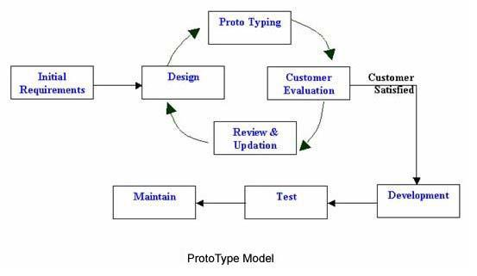

Figure: 3.3 Prototype Model

8
3.4 Advantages and Disadvantages of methodology

Advantages:

- Users are actively involved in the development.

- Since in this methodology a working model of the system is provided, the users get a better understanding of the system being developed.

- Errors can be detected much earlier.

- Quicker user feedback is available leading to better solutions.

- Missing functionality can be identified easily.

- Confusing or difficult functions can be identified.

- Requirements validation, Quick implementation of, incomplete, but functional, application.

- Organization will have source code.

- Only contains those features that are needed

- Provides exact requirements

Disadvantages:

- Leads to implementing and then repairing way of building systems.

- Practically, this methodology may increase the complexity of the system as scope of the system may expand beyond original plans.

- Incomplete application may cause application not to be used as the full system was designed

- Incomplete or inadequate problem analysis.

- May be excessively costly.

- Untried software may have performance problems.

- Untried software may have compatibility problems.

- First generation software is usually immature.

- Will generally require development of training and help material from scratch.

- May not meet user requirements because of poor analysis or design specifications.

9
CHAPTER 4

Analysis Design and Development

4.1 Requirement gathering Techniques

Requirement gathering technique of resource availability that may affect the ability to achieve an acceptable system. This evaluation determines whether the technology needed for the proposed system is available or not.

1.Can the work for the project be done with current equipment existing software technology & available personal?

2.Can the system be upgraded if developed?

3.If new technology is needed then what can be developed?

This is concerned with specifying equipment and software that will successfully satisfy the user requirement. The technical needs of the system may include:

- Front-end Selection (UI design).

- Back-end Selection (apply code).

- Database SQL Server.

- Crystal Report.

Front end Selection

1.It must have a graphical user interface that assists employees that are not from IT backgrounds.

2.Scalability and extensibility.

3.Flexibility

4.Robustness

5.According to the organization requirement and the culture

6.Must provide excellent reporting features with good printing support

7.Platform independent

8.Easy to debug and maintain

9.Event driven programming facility

10.Front end must support some popular back end like SQL Server. According to the above features we selected C# (.NET Framework) as the front end for developing my project.

10
Back end selection

1.Multiple user support

2.Efficient data handling

3.Provide inherent features for security

4.Efficient data retrieval and maintenance

5.Stored procedure

6.Popularity

7.Operating system compatible

8.Easy to install

9.Easy to implement with the front end

10.According to above stated features we selected SQL Server as the backend.

The technical feasibility is frequently the most difficult area encountered at this stage. It is essential that the process of analysis and definition be conducted in parallel with an assessment to technical feasibility. It centers on the existing computer system (hardware, software etc.) and to what extent it can support the proposed system.

4.2 Analysis of Requirements

Hardware requirements:

Processor: Core i3 or Above

Operating System: Windows XP/7/8/10

RAM: Minimum 4GB or Above

Hard Disk: 500 GB or Above

Software requirements:

Front End: MS-Visual Studio, Crystal Report, MS-SQL Server.

Back End: MS-Visual Studio, MS-SQL Server, Crystal Report.

11
4.3 Entity Relationship Diagram (ERD)

An entity-relationship diagram (ERD) is a data modeling technique that graphically illustrates an

information system’s entities and the relationships between those entities. An ERD is a conceptual

and representational model of data used to represent the entity framework infrastructure.

The elements of an ERD are: Entities, Relationships, Attributes.

Steps involved in creating an ERD include:

1.Identifying and defining the entities

2.Determining all interactions between the entities

3.Analyzing the nature of interactions/determining the cardinality of the relationships

4.Creating the ERD
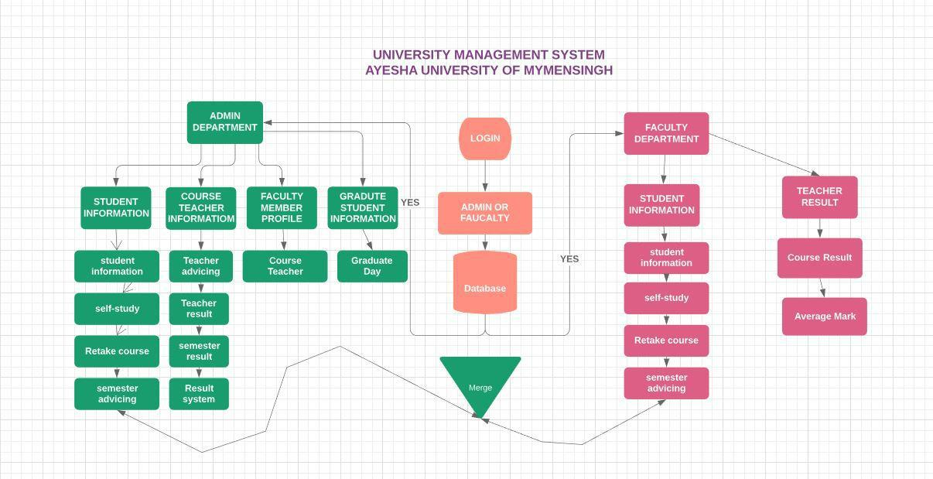

Figure: 4.3 Entity Relationship Diagram (ERD)

12
4.4 Data Flow Diagram (DFD)

The data flow diagram is a graphical representation of the flow of data through an information system. It enables you to represent the process in your information system from the viewpoint of data.
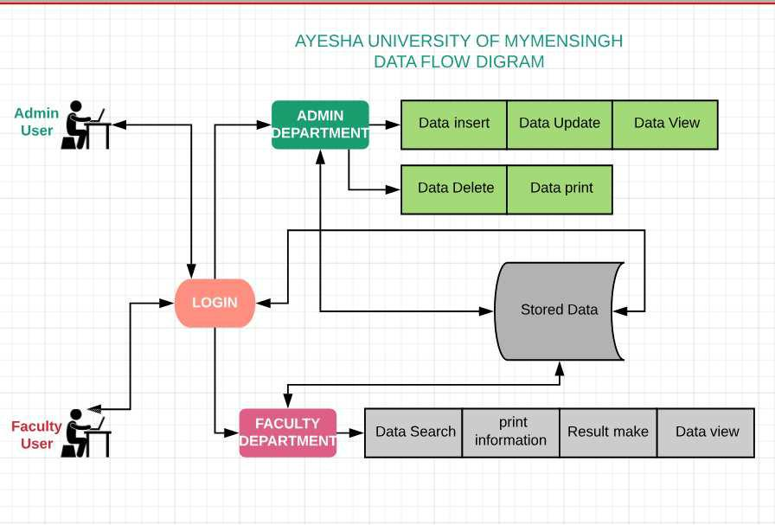

Figure: 4.4 Data Flow Diagram (DFD)

13

4.5 Database Table Design

4.5.1 login Table

Column Name | Data type | Allow Null
Username | Varchar(50) | No
Password | Varchar(50) | No
Type | Varchar(50) | No
4.5.2 Student Table
Column_Name | Data type | Allow Null
Student_name | Varchar(50) | No
Father_name | Varchar(50) | No
Mather_ name | Varchar(50) | No
Department | Varchar(50) | No
Address | Varchar(50) | No
Country | Varchar(50) | No
Mobile | Varchar(50) | No
Gender | Varchar(50) | No
Date | Varchar(50) | No
CGPA | Varchar(50) | No
Grade | Varchar(50) | No
Passing_year | Varchar(50) | No

14

4.5.3 Advising Table

Column Name | Data type | Allow Null
Student_ID | Varchar(50) | No
Student_Batch | Varchar(50) | No
Semester | Varchar(50) | No
Faculty_Name | Varchar(50) | No
Course1 | Varchar(50) | No
Course2 | Varchar(50) | No
Course3 | Varchar(50) | No
Course4 | Varchar(50) | No
Course5 | Varchar(50) | No
Total_Credit | Varchar(50) | No

4.5.4 Self-Study Table
Column Name | Data type | Allow Null
Student_Name | Varchar(50) | No
Student_ID | Varchar(50) | No
Faculty_Name | Varchar(50) | No
Semester | Varchar(50) | No
Faculty_Member | Varchar(50) | No
Course_Code | Varchar(50) | No
Course_Name | Varchar(50) | No
Course_Hour | Varchar(50) | No
Date | Date | No

15

4.5.5 Retake Course Table

Column Name | Data type | Allow Null
Student_Name | Varchar(50) | No
Student_ID | Varchar(50) | No
Student_Batch | Varchar(50) | No
Semester | Varchar(50) | No
Faculty_Name | Varchar(50) | No
Faculty_Member | Varchar(50) | No
Course_Code | Varchar(50) | No
Course_Name | Varchar(50) | No
Exam_Type | Varchar(50) | No
Credit-Hour | Varchar(50) | No
Date | Date | No
4.5.6 Teacher Result Table
Column Name | Data type | Allow Null
ID | Varchar(50) | No
Subject1 | Varchar(50) | No
Mark | Varchar(50) | No
Grade | Varchar(50) | No
Subject2 | Varchar(50) | No
Mark2 | Varchar(50) | No
Grade2 | Varchar(50) | No
Subject3 | Varchar(50) | No

16

Mark3

Grade3

Varchar(50) | No
Varchar(50) | No

4.5.7 Teacher Profile Table

Column Name | Data type | Allow Null
ID | int | No
Name | Varchar(50) | No
Designation | Varchar(50) | No
Faculty | Varchar(50) | No
IMAGE | image | No
4.5.8 Graduate Student Profile Table
Column Name | Data type | Allow Null
ID | int | No
Name | Varchar(50) | No
Batch | Varchar(50) | No
Faculty | Varchar(50) | No
Grade | Varchar(50) | No
Image | image | No

17

4.6 Use Case Diagram and Narratives
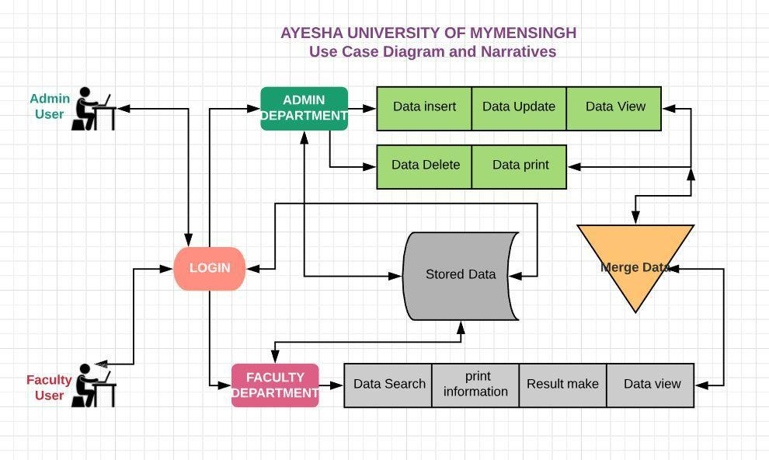

Figure :4.6 Use Case Diagram and Narratives

18
CHAPTER 5

Project Description

Several development activities are carried out during the structured design. They are database design, implementation planning, system test preparation, system interface specification, and user documentation.

5.1 Project Description

Project description provides the following details of the system. The problem will address the goals for the project, the overall description for the project, as well as a project plan that describes the activities the members will undertake. The overall activities of this project that contains as pages describes below.

my project “Design and Development University Database management system” is a large-scale project for student information as well as academic information store, retrieve, modify. The basic idea is that the management system. The database will maintain the student and Teacher, administration details information.

- User/Faculty Member.

- User/Administrator.

5.2 Database System

A database is an organized collection of data for one or more purposes, usually in digital form. The data are typically organized to model relevant aspects of reality (for example, the availability of rooms in hotels), in a way that supports processes requiring this information (for example, finding a hotel with vacancies). The term "database" refers both to the way its users view it, and to the logical and physical materialization of its data, content, in files, computer memory, and computer data storage. This definition is very general, and is independent of the technology used. However, not every collection of data is a database, the term database implies that the data is managed to some level of quality (measured in terms of accuracy, availability, usability, and resilience) and this in turn often implies the use of a general-purpose Database management system

(DBMS). A general-purpose DBMS is typically a complex software system that meets many usage requirements, and the databases that it maintains are often large and complex. “Design and

Development University Database management system” System uses SQL Server database because it is one of the most widely used database systems and has a long standing connection with C#(.Net framework), with built in SQL Server functions and extremely simple integration into any system. Similar to the validation, there is a list of Database Functions the system uses to

connect to a relational database, most of which again provide built in C# functions with a more usable name such as query row instead of “mysql fetch_array”. The C# SQL Server functions

require a connection instance to be used when performing most queries, giving a warning if one is

19

not provided. Instead of imposing this on the developer, all of the functions in database Functions

automatically include the instance of connection created when the file is used to connect to a database. There is one system specific function called “get_all_user”, however. This takes any username and performs a query returning all of the information found in the “user” table of the

database (Such as real names, account type and so on). This provides a simple method of performing a query that is used multiple times throughout the system when information about a user is needed.

The design and maintenance of a complex database requires specialist skills: the staff performing this function are referred to as database application programmers (different from the DBMS developers/programmers) and database administrators, and their task is supported by tools provided either as part of the DBMS or as free-standing (stand-alone) software products. These tools include specialized Database languages including Data Description Languages, Data Manipulation Languages, and Query Languages. These can be seen as special-purpose programming languages, tailored specifically to manipulate databases; sometimes they are provided as extensions of existing programming languages, with added special database commands. These languages are generally specific to one data model, and in many cases they are specific to one DBMS. The most widely supported standard database language is SQL, which combines the roles of Data Description Language, Data manipulation language, and a Query language.

5.3 Screenshot of Admin modules of the project and their description

My project is Design and Development University Database Management System in C# (.Net Framework) Programming Language & Using SQL Server. It can manage all kinds of Information University Database Management Easily Also It Can Data storage, Data view, Data update, Data delete, Data print from Database.
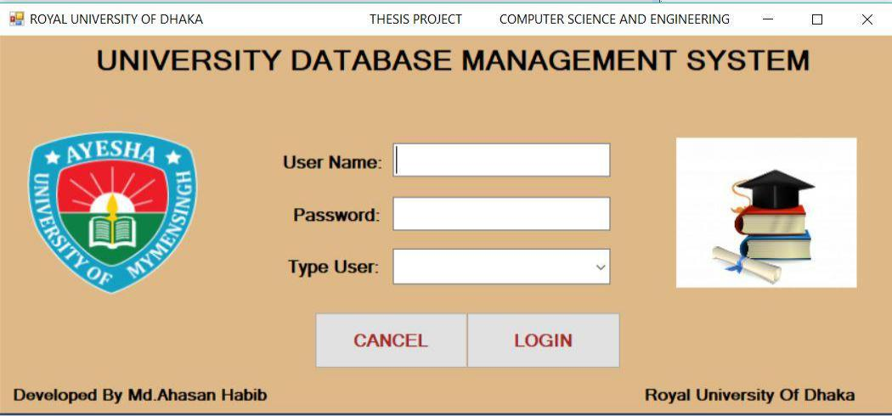

Figure 5.3.1: logging form

20

First of all, execute logging Form then Write down User Name, Password and Select Type User, my project has three Type users, ADMIN, FACULTY, CLIENT

Now you have to insert your requirement and click LOGIN Button to Execute Admin Form.
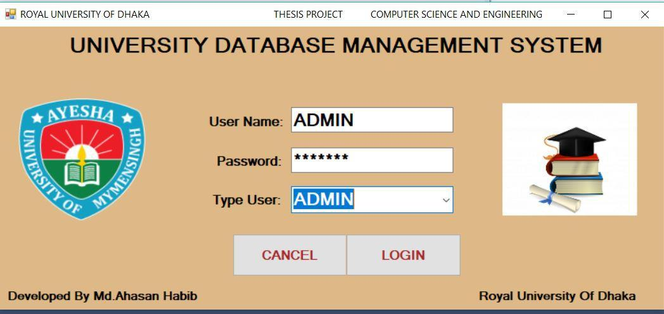

Figure 5.3.2: logging form

Now you can see Admin Department Form, Admin department can create information, update information, delete information here. According to their requirement
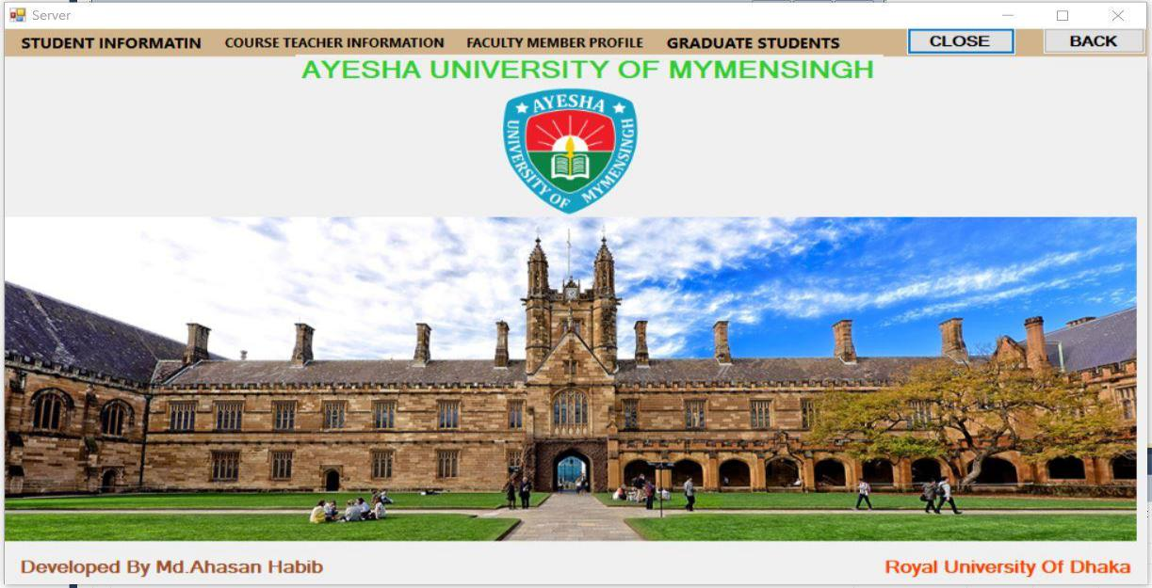

Figure 5.3.3: Admin Department Form

21

Here is student information, course teacher information, faculty member profile, graduate students, admin department gets information, storage & modify information.
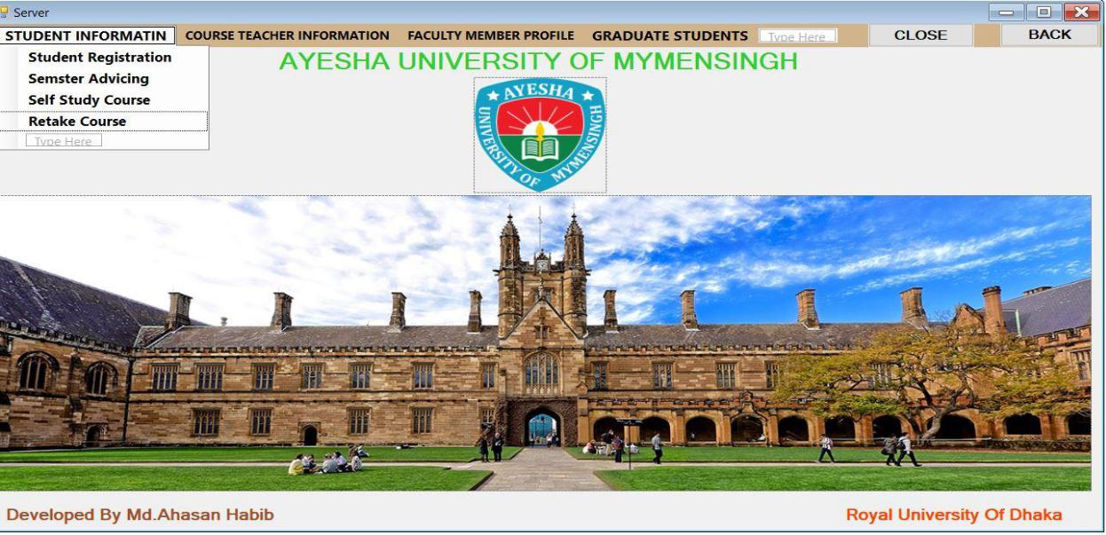

Figure 5.3.4: Show child Menu bar Admin Department form

5.3.5: Student Information Form

Student information form is used for data save, update, delete, view. all data print, clear, close
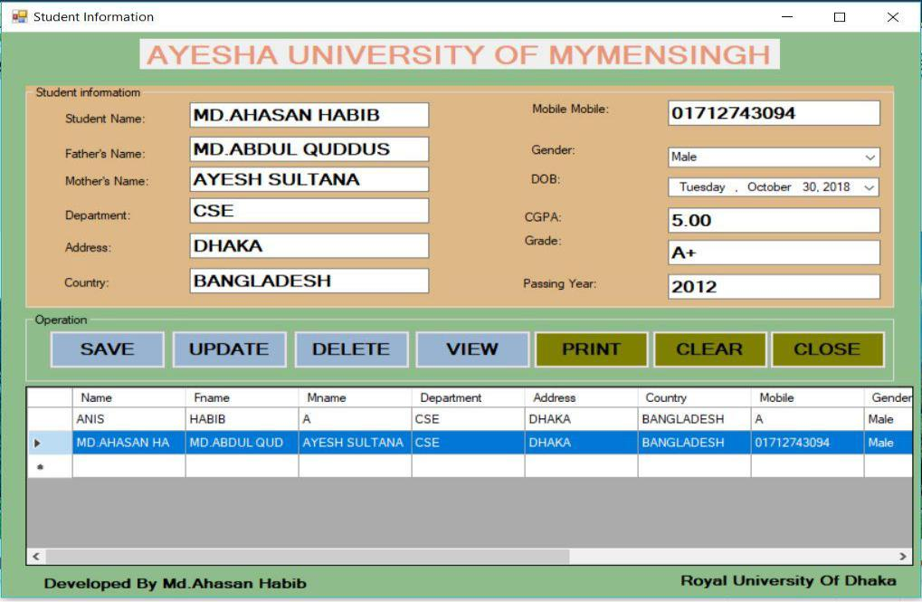

Figure 5.3.5: Student Information Form

22

5.3.6: Semester Advising form

it is used for data save, update, delete, view. all data print, clear, close. Here is used level, textbox, Button, DataGrid View.
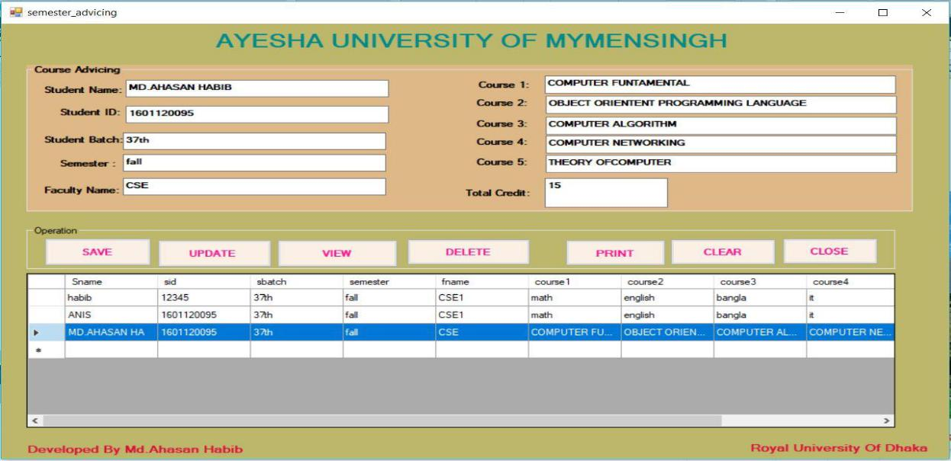

Figure 5.3.6: Semester Advising form

5.3.7: Self Study form

it is used for data save, update, delete, view. all data print, clear, close. Here is used level, textbox, Button, DataGrid View.
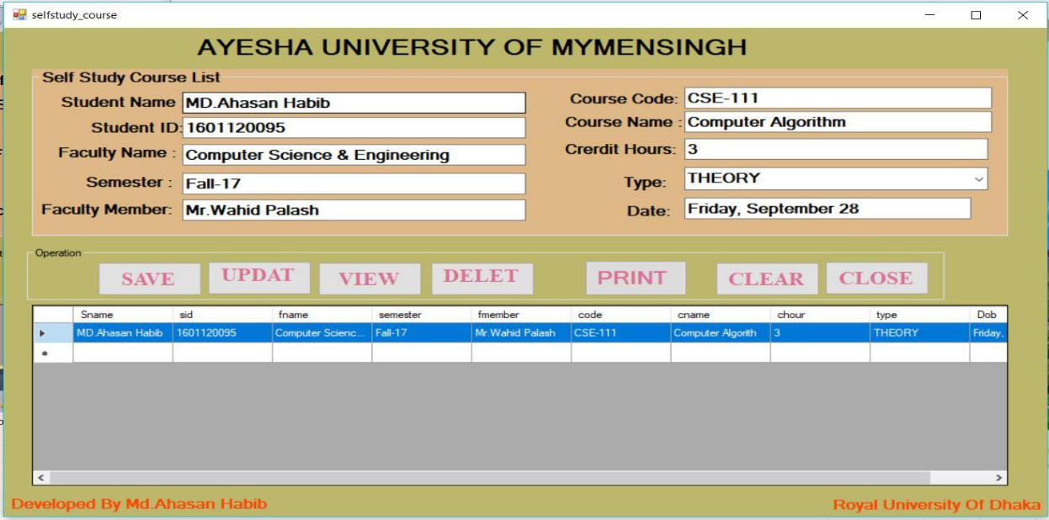

Figure 5.3.7: Self Study form

23

5.3.8: Retake Exam form

it is used for data save, update, delete, view. all data print, clear, close. Here is used level, textbox, Button, DataGrid View.
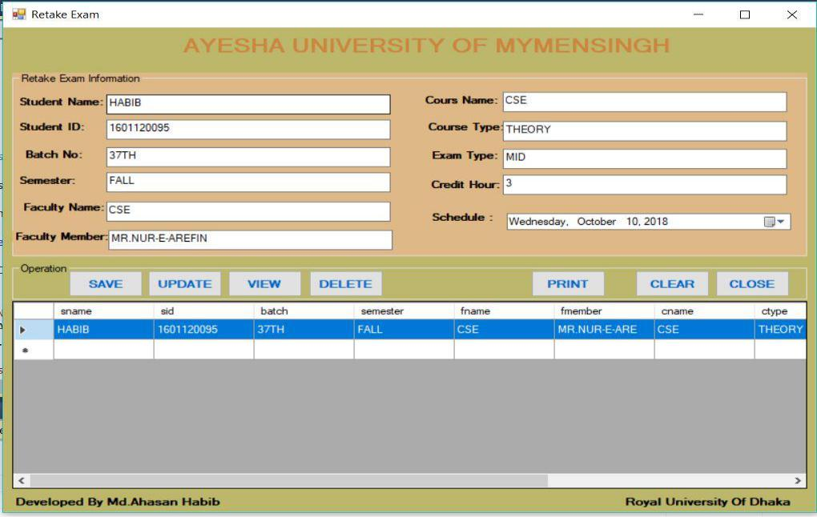

Figure 5.3.8: Retake Exam form

5.3.9: Teacher Advising form

it is used for data save, update, delete, view. all data print, clear, close. Here is used level, textbox, Button, DataGrid View.
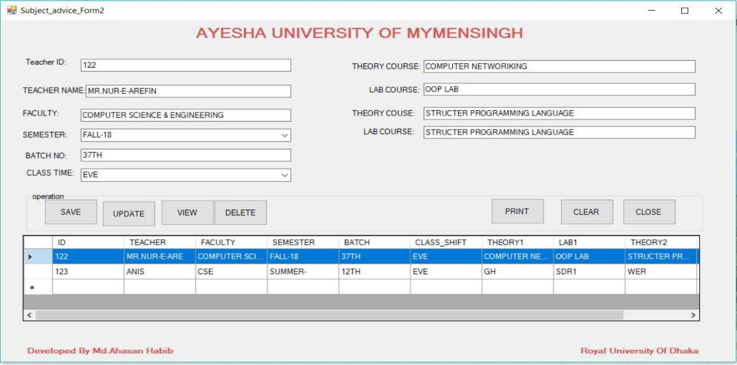

Figure 5.3.9: Teacher Advising form

24

5.3.10: Course Teacher result form

it is used for data save, update, delete, view. all data print, clear, close. Here is used level, textbox, Button, DataGrid View.
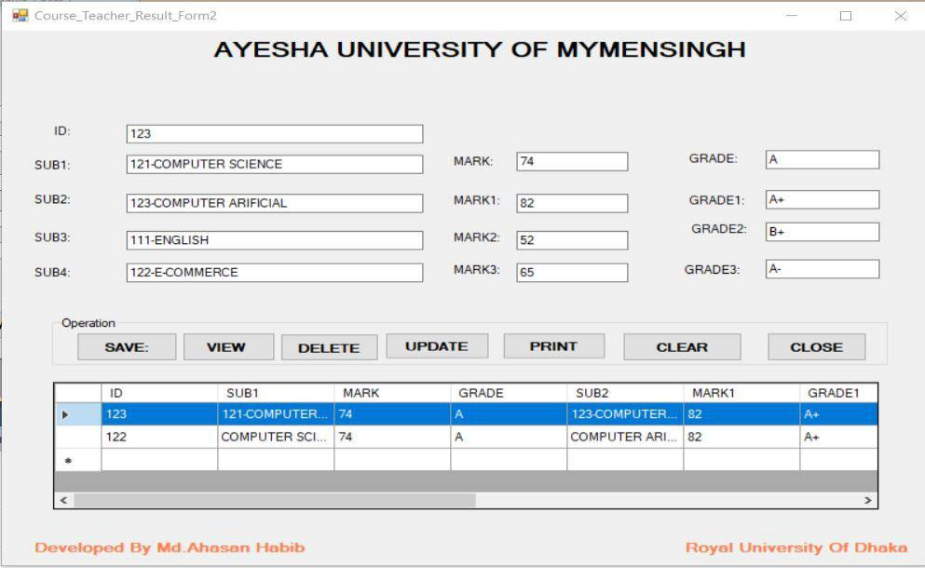

Figure 5.3.10: Course Teacher result form

5.3.11: Teacher Making result form

it is used for adding attendance mark, class test mark, exam mark, when you click show CGPA Button then you can see total mark, average mark and total Grade.
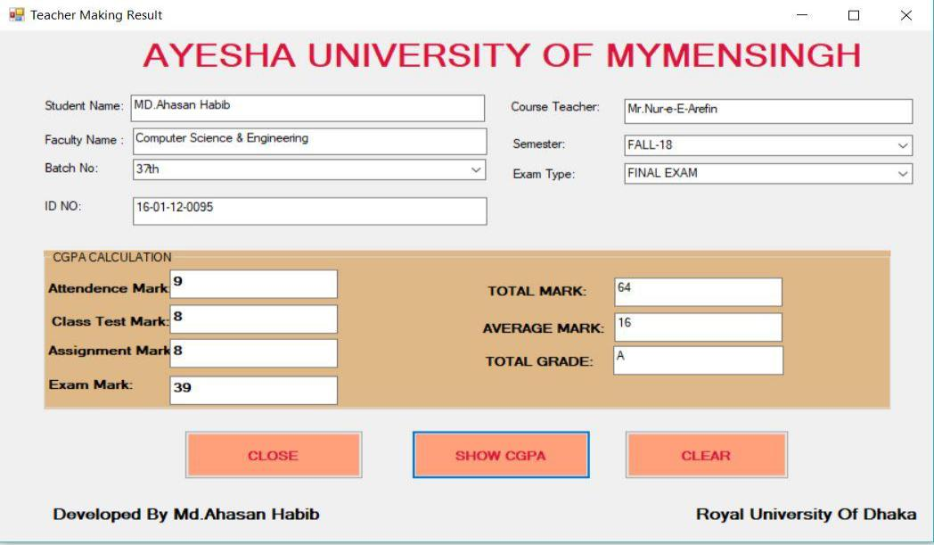

Figure 5.3.11: Teacher Making result form

25

5.3.12: Result System Calculation form

it is used for Inserting course and name, credit hours, marks, when you click show CGPA Button then you can see grade, point, also it can show cumulative point, grade point average, overall grade point.
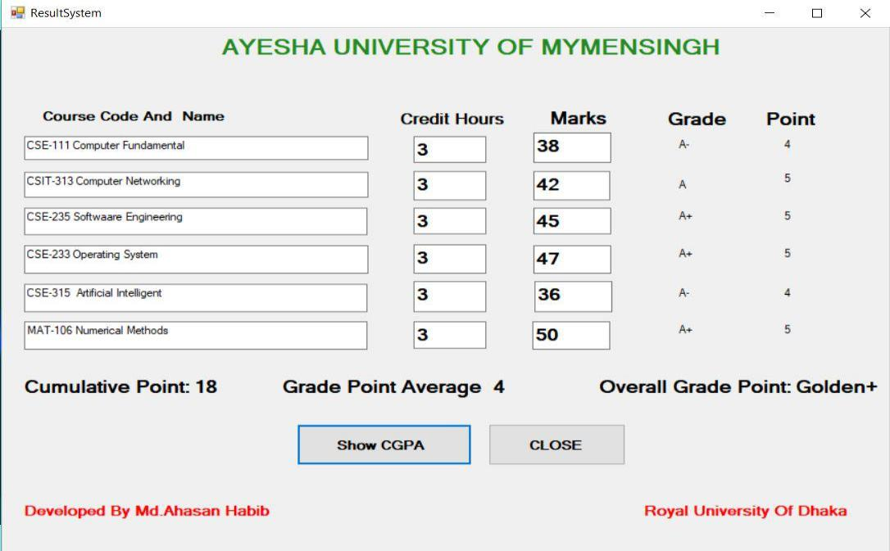

Figure 5.3.12: Result System Calculation form

5.3.13: Teacher Logging form

You can insert user name, password then click log in. after that, it shows teacher profile.
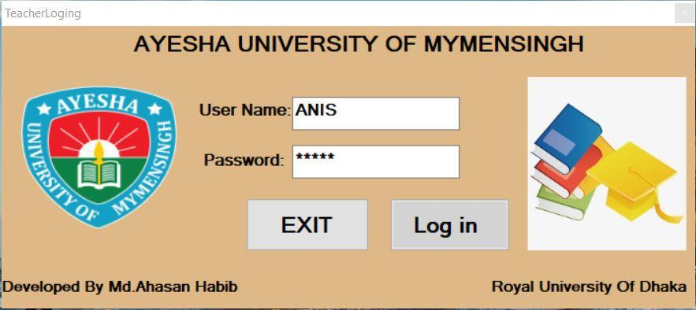

Figure 5.3.13: Teacher Logging form

26

5.3.14: Teacher Profile form

here we can do inert teacher picture, information, data save, data view and close application. write id number then click view button, next display all information.
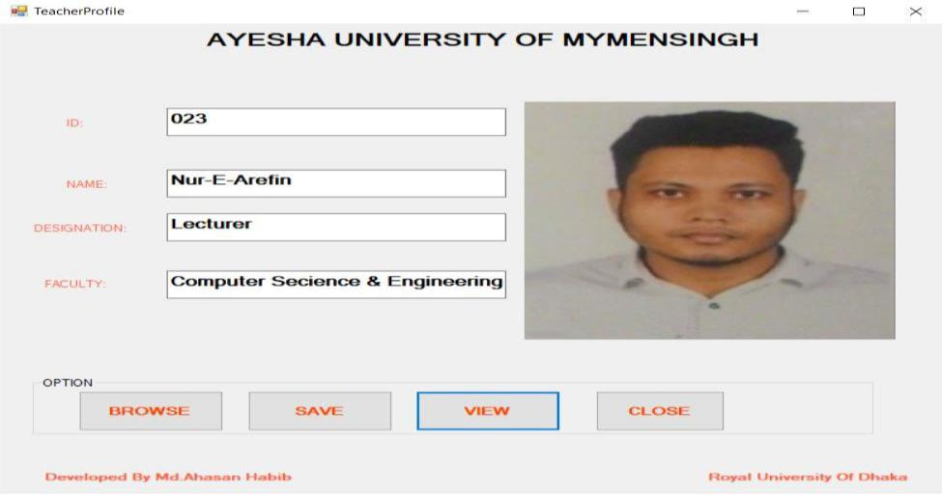

Figure 5.3.14: Teacher Profile form

5.3.15: Graduate Student List form

Here we can do inert student picture who are graduate student, information, data save, data view and close application. write id number then click view button, next display all information.
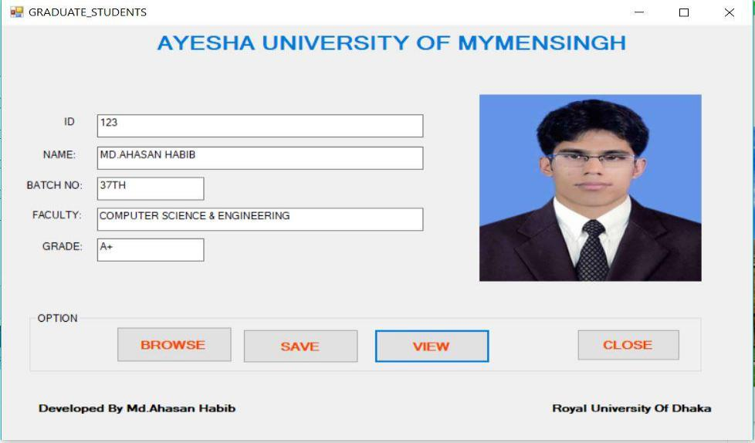

Figure 5.3.15: Graduate Student List form

27
5.4 Screenshot of Faculty Department modules of this project and their description

My project is Design and Development University Database Management System in C# (Net Framework) Programming Language & Using SQL Server. It can manage all kinds of Information University Database Management Easily Also It Can, Data view, Data Searching, Data print from Database.

5.4.1: Faculty Department Form

First of all, execute logging Form then Write down User Name, Password and Select Type User, then click logging Button to execute Faculty Department Form
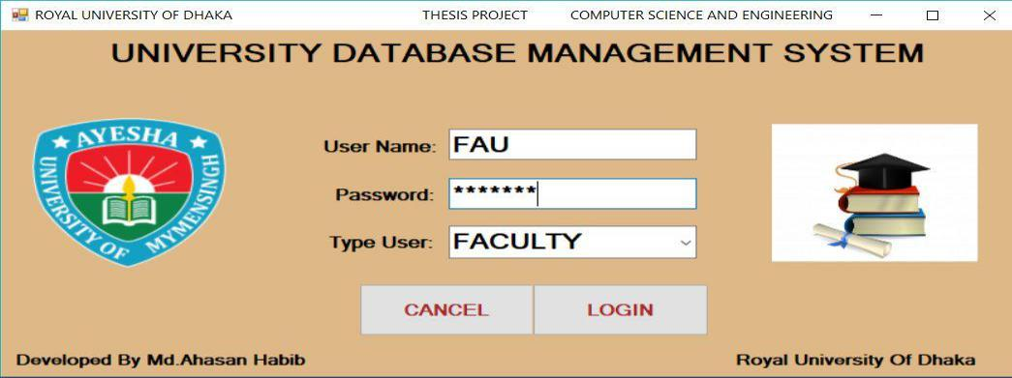

Figure 5.4.1: Faculty Department login Form

5.4.2: Faculty Department Form

Faculty department form has parent’s & child menu bar It Can do Data view, Data Searching, Data print from Database. According to their requirement.
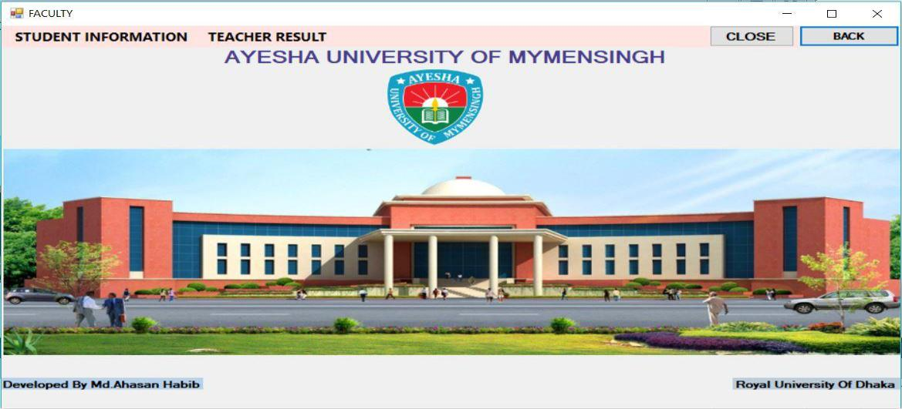

Figure 5.4.2: Faculty Department Form

28

5.4.3: Show child Menu bar Faculty Department form

When we click Student information Menu bar, then show more child Menu of parent’s every child menu has specific task from.
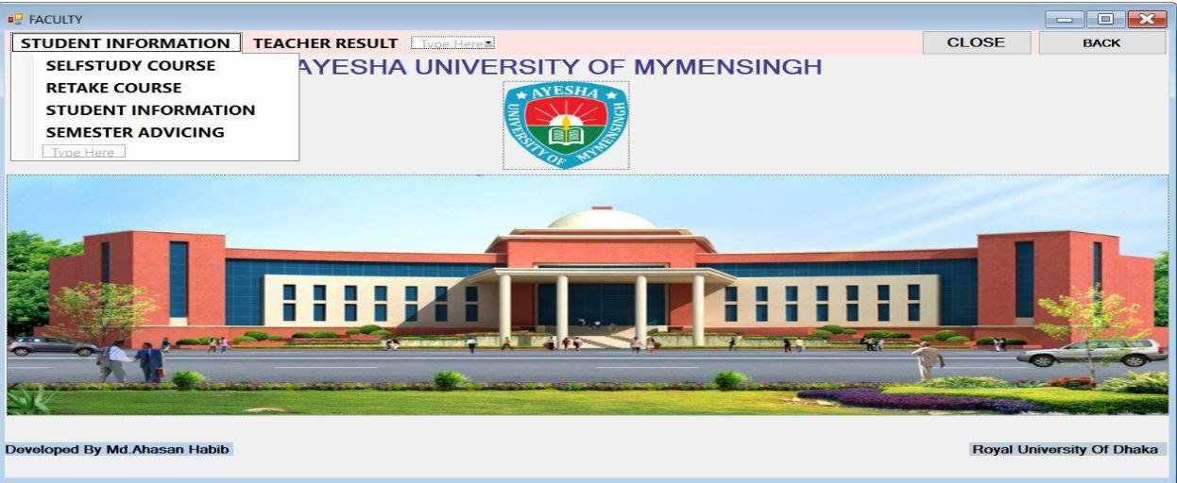

Figure 5.4.3: Show child Menu bar Faculty Department form

5.4.4: Faculty Student Form

Faculty Member can Search certain data from this application as well as print, view data. type specific Name & Click search button then display student information from database. if you want to print information, click to print button after that display.
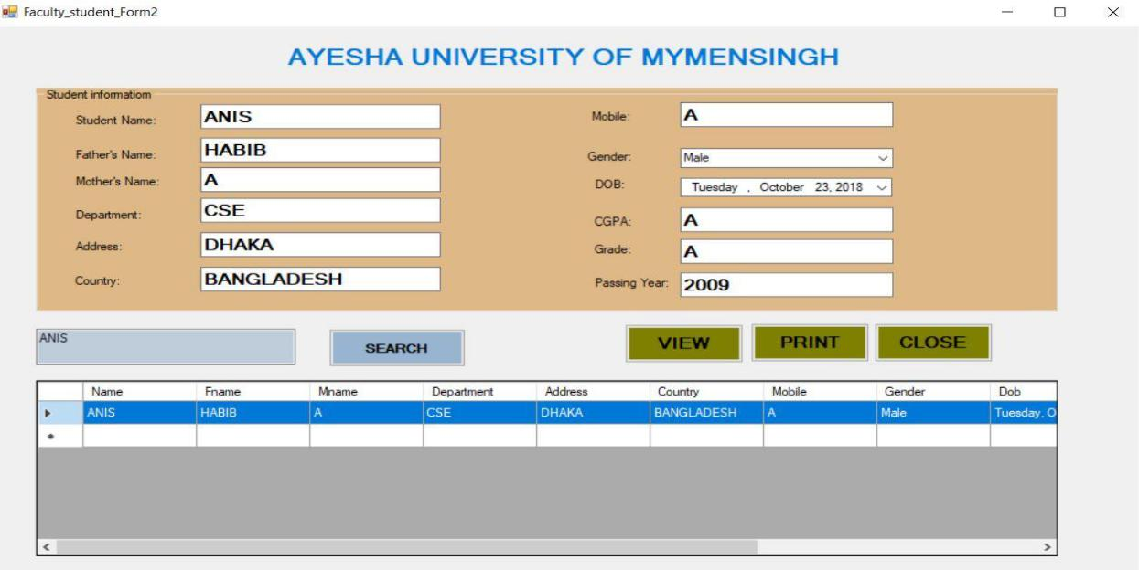

Figure 5.4.4: Faculty Student Form

29

5.4.5: Faculty Advising Form

Faculty Member can search certain data from this application as well as print, view data. type specific Name & Click search button then display student advising information from database. if you want to print information, click to print button after that display.
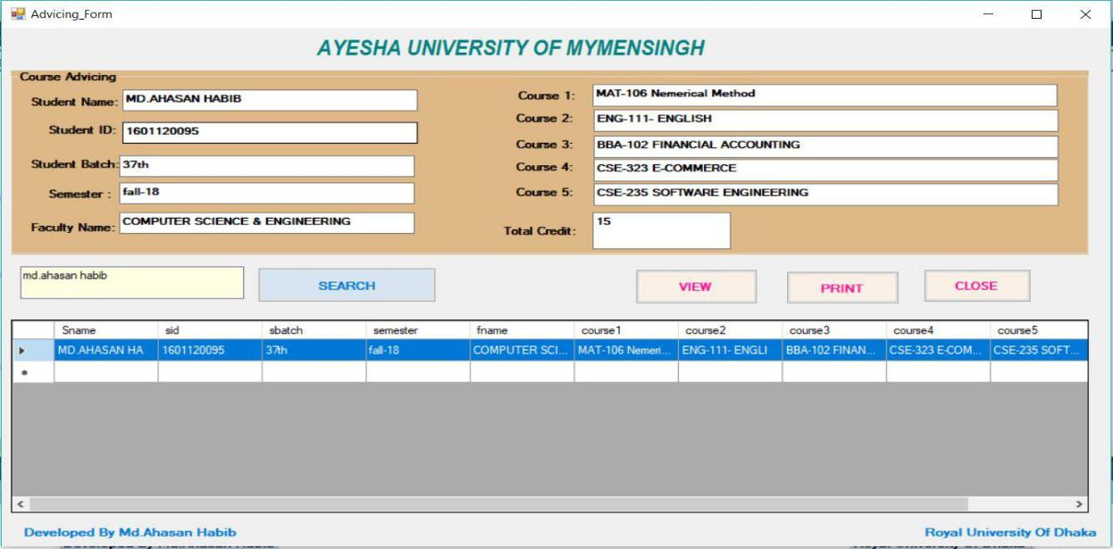

Figure 5.4.5: Faculty Advising Form

5.4.6: Faculty Retake Exam Form

Faculty Member can search certain data from this application as well as print, view data. Type specific Name & Click search button then display student retake information from database. if you want to print information, click to print button after that display.
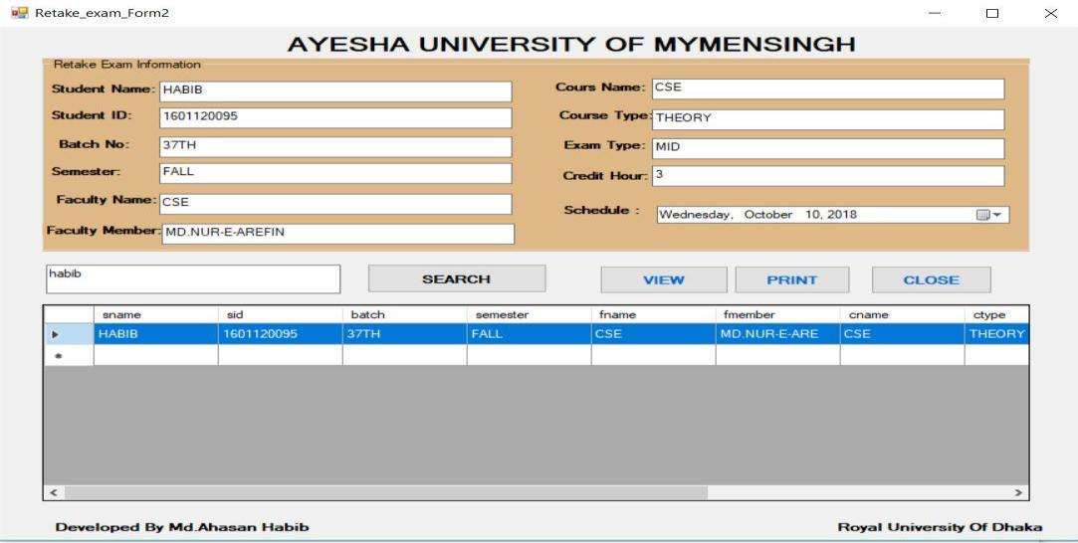

Figure 5.4.6: Faculty Retake Exam Form

30

5.4.7: Faculty Self-study Form

Faculty Member can search certain data from this application as well as print, view data. Type specific Name & Click search button then display student Self-study information from database. if you want to print information, click to print button after that display.
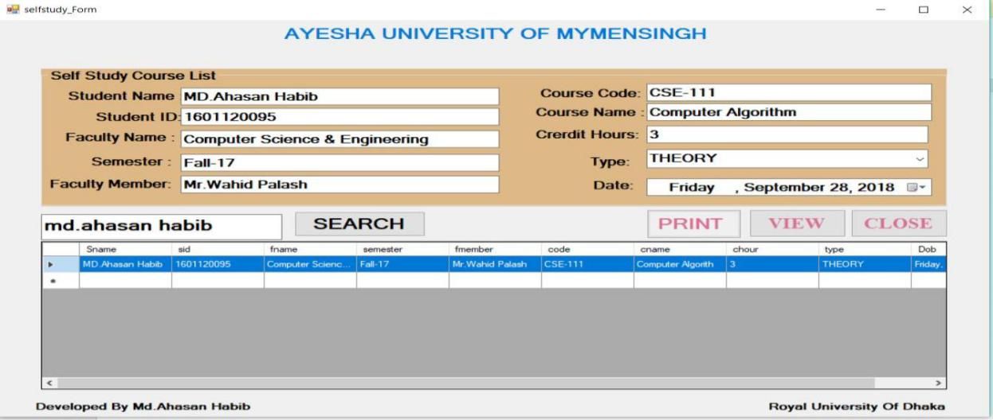

Figure 5.4.7: Faculty Self-study Form

5.4.8: Student Academic Searching Form

Faculty Member can search certain data, Specific course teacher advising list from this application as well as teacher result, combined teacher result as well. If faculty member wants to find out their semester information. just apply their id number and click Button according to their information, then show information.
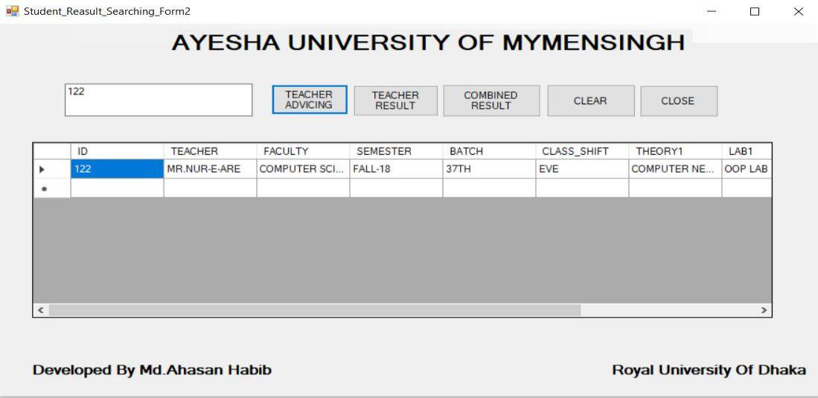

Figure 5.4.8: Student Academic Searching Form

31

If faculty member wants to find out their semester information. just apply their id number and click Button according to their information, then show information.
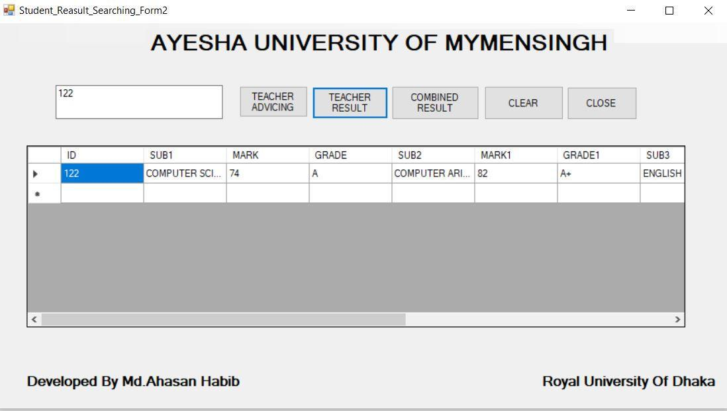

Figure 5.4.9: Teacher Result Searching Form

If faculty member wants to find out their semester information. just apply their id number and click Button according to their information, then show information.
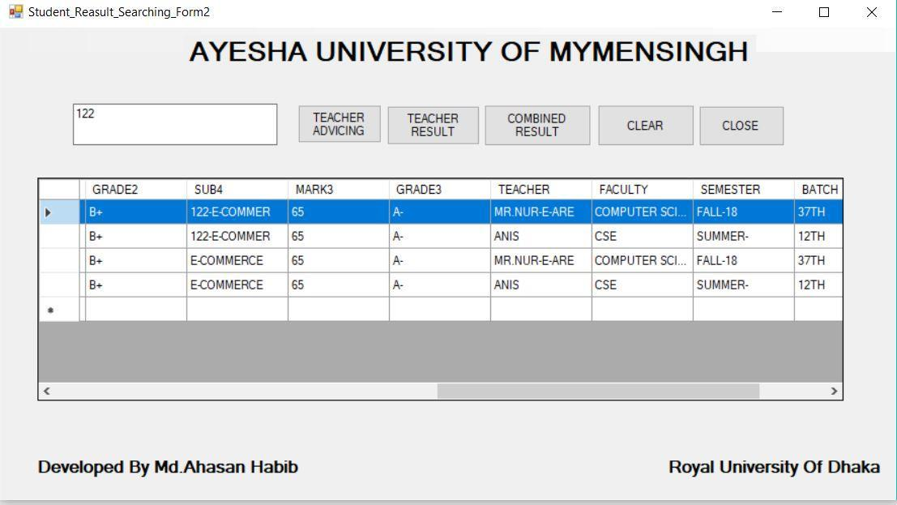

Figure 5.4.10: Teacher Combined Result

32
5.5: Screenshot of Crystal Report modules of the project

Crystal Reports is a popular Windows based report writing application which allows a developer to create reports. The applications allow you to connect to various data sources to obtain data such as SQL Server or Oracle as an example. This is basically how Crystal Reports works in its simplest terms.

5.5.1: Student Design by Crystal Report
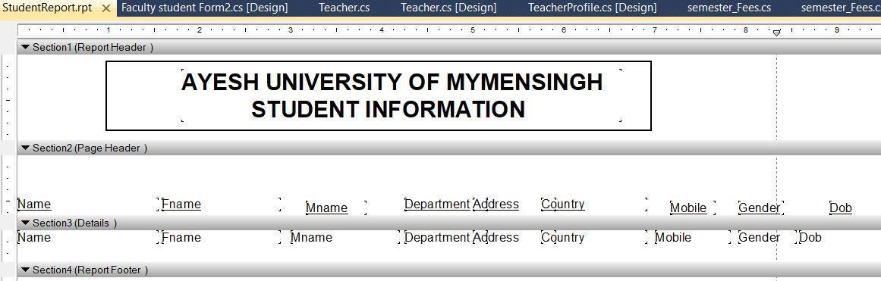

Figure 5.5.1: Student Table Design Crystal Report

5.5.2: Student Print Preview by Crystal Report
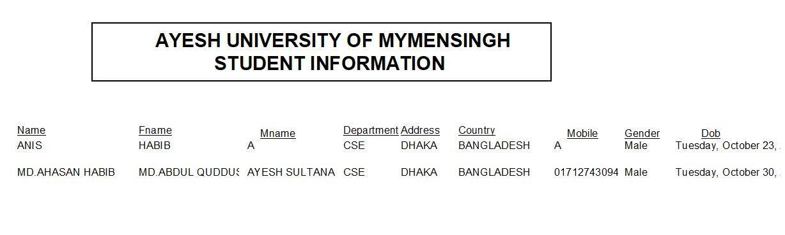

Figure 5.5.2: Student Print Preview by Crystal Report

33

5.5.3: Advising Student Design by Crystal Report
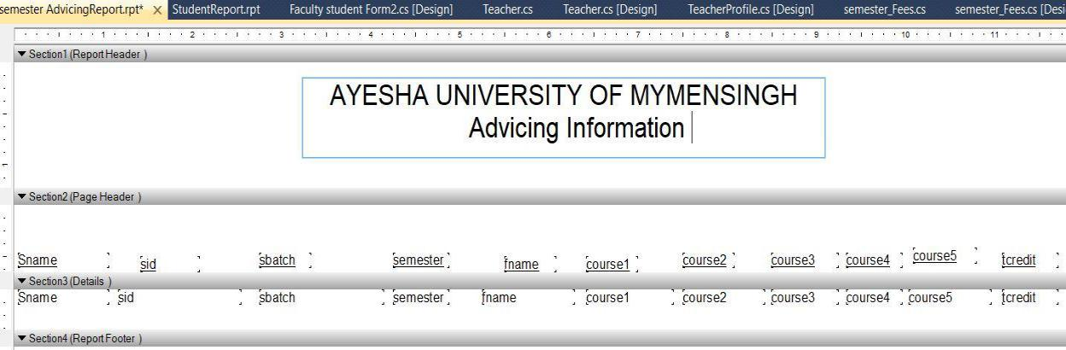

Figure 5.5.3: Advising Student Design by Crystal Report

5.5.4: Advising Student Print Preview by Crystal Report
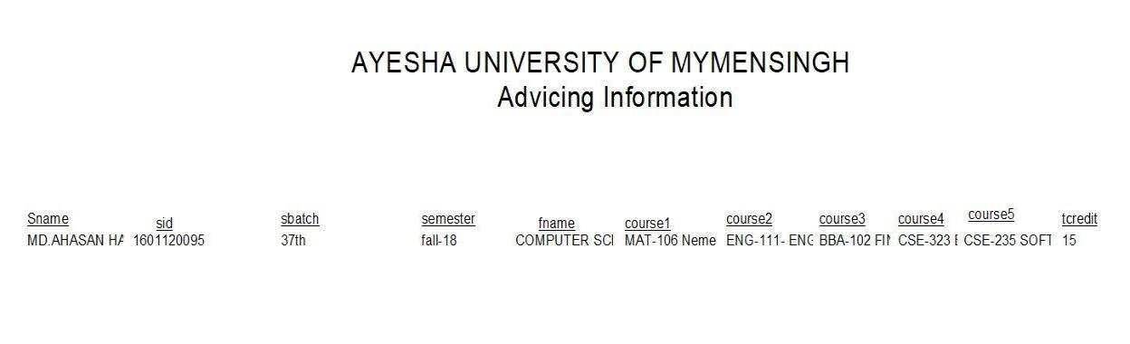

Figure 5.5.4: Advising Student Print Preview by Crystal Report

34

5.5.5: Retake Exam Design by Crystal Report
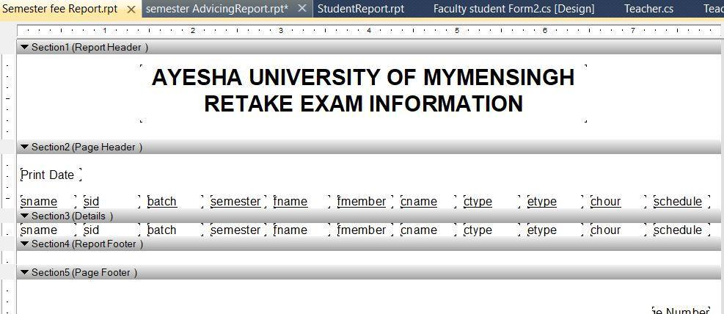

Figure 5.5.5: Retake Exam Design by Crystal Report

5.5.6: Retake Exam Print Preview by Crystal Report
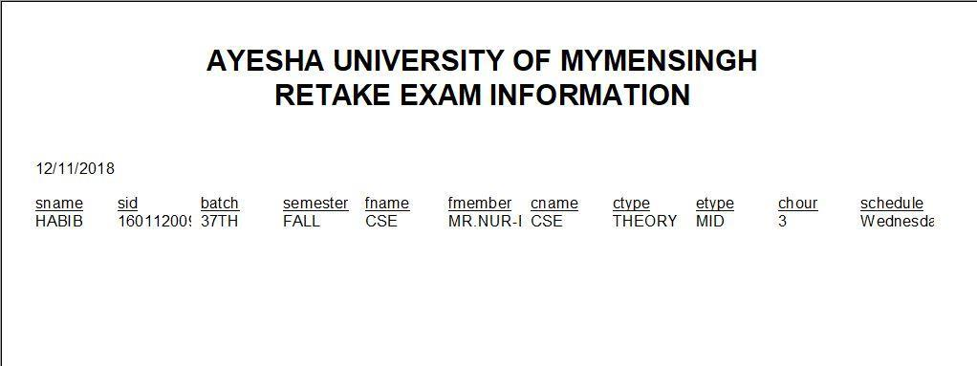

Figure 5.5.6: Retake Exam Print Preview by Crystal Report

35

5.5.7: Self-study Design by Crystal Report
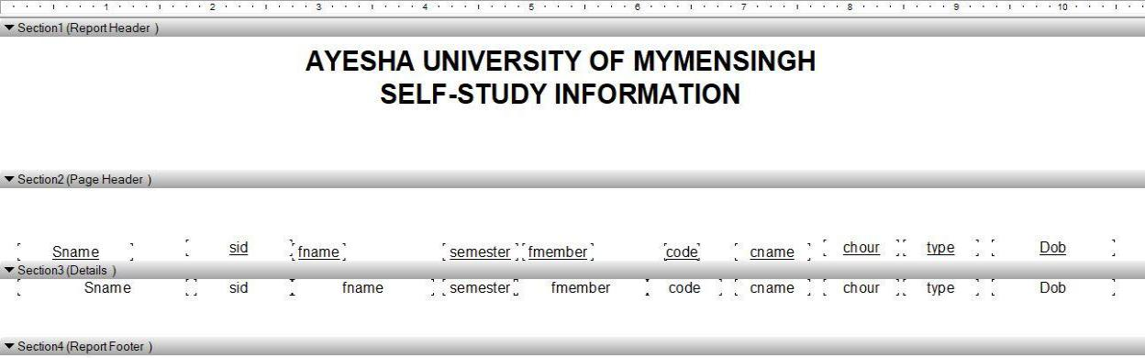

Figure 5.5.7: Self-study Design by Crystal Report

5.5.8: Self-study Print Preview by Crystal Report
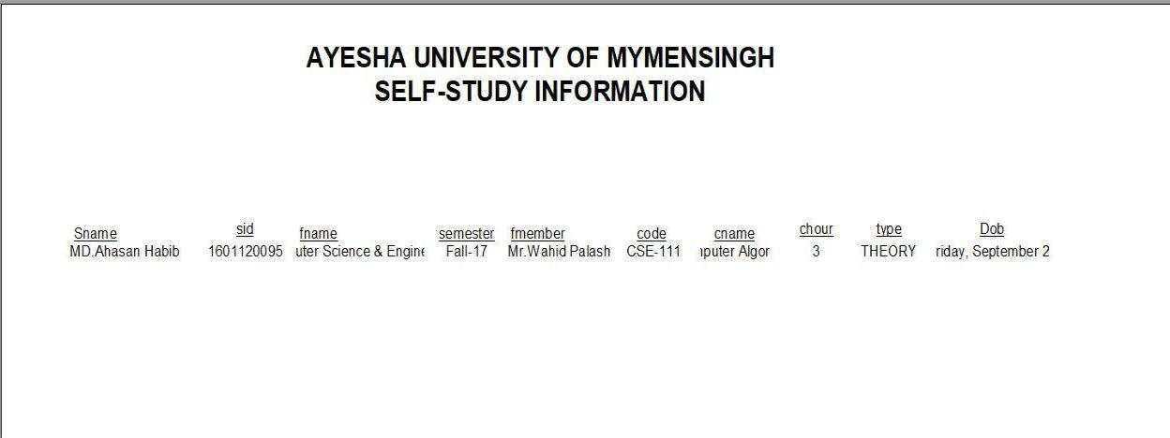

Figure 5.5.8: Self-study Print Preview by Crystal Report

36
CHAPTER 6

CONCLUSION

6.1: Conclusion

With the economic and social developments, people's living standards have been increased with higher standards. After improving living, people desire to improve their daily life and have more demand for technology services. In the past, most of information services are individual or hand-writing based. There lacks of either internal system integration or cross boundary sharing and collaborations. But now, people are very conscious about time, and also to increase the awareness of people become dependent on the management of modern technology services because new technology of the people brings a good opportunity.

6.2: Limitation

We have to face many different problems while implementing this project. At the same time, we try to make an adjustment while those problems occurred such as:

- Online payment is not currently available in this system.

- This application does not yet provide any functionality to process the stored data for future use.

- It does not also include complete university database management system.

6.3: Future Work

I can consider much future work scope to this project. The following areas that can be implemented are:

- In future live information system for database will be developed.

- It will be covert from C# (.net framework) to online base asp.net.

- It can be used any kind of educational organization.

- It can be modified PHP Server script Language.

- In future instead of SOL Server, it will be used Oracle database.

37
CHAPTER 7

REFERENCE

- (Dr. K. Venkata Subbiah). in their paper "Development of a Student Database Management System for a University" published by IEEE in 2016.

- (Peter H. Chang) in his paper "Modeling the Management of Digital Information Systems" published by IEEE in 2011.

- (Ajay Shankar Bidyarthy) in their paper " Design and Development of Student Database Management System for a University" published by IEEE in November 13, 2012.

- P. Loborg, T. Risch, M. Sköld, and A. Törne: Active Object-Oriented Databases in Control Applications, in Proceedings of the 19th Euro micro Conference, Barcelona, September 1993.

- Alpar, G. and Jacobs, B. (2013). Credential design in attribute-based identity management. In Bridging distances in technology and regulation, 3rd Tilting Perspectives Conference.

- T. Risch and M. Sköld: Active Rules based on Object-Oriented Queries, in special issue on Active Databases in Data Engineering Bulletin in 1992.

- Cornelius, Barry (December 1, 2005). "Java 5 catches up with C#". University of Oxford Computing Services. Retrieved June 18, 2014. In my opinion, it is C# that has caused these radical changes to the Java language. (Barry Cornelius)

- Naugler, David (May 2007). "C# 2.0 for C++ and Java programmer: conference workshop". Journal of Computing Sciences in Colleges. 22 (5). Although C# has been strongly influenced by Java it has also been strongly influenced by C++ and is best viewed as a descendant of both C++ and Java.

[9]"Microsoft Releases SQL Server 2012 to Help Customers Manage "Any Data, Any Size, Anywhere"". Microsoft News Center. Microsoft. March 6, 2012. Retrieved March 7, 2012.

- Peck, George (2008). Crystal Reports 2008: The Complete Reference. McGraw-Hill Professional. p. 566. ISBN 978-0-07-159098-3. Retrieved 2009-07-09. Not only was Crystal Reports bundled with earlier versions of Visual Basic..., but every Professional or higher version of VS.NET, up to and including Visual Studio 2017, includes an option to install Crystal Reports as well.

- Lam, Rohan. "Microsoft is Aligning with ODBC for Native Relational Data Access — FAQ". SQL Server Forums. Microsoft Corporation. Retrieved March 7, 2012.

38
CHAPTER 8

APPENDIX

Database connection with project interface

SqlConnection con = new SqlConnection(@"Data Source=DESKTOP-B6H6NLC\SQL2008;Initial Catalog=Employee;Integrated Security=True");
login code of this project

private void login_Click(object sender, EventArgs e)
{

SqlConnection con=new SqlConnection(@"Data Source=DESKTOP-B6H6NLC\SQL2008;Initial Catalog=Employee;Integrated Security=True;"); SqlDataAdapter sda = new SqlDataAdapter("Select Count(*) from tbl_ln Where UserName='"+textBox1.Text+"' and Password='"+textBox2.Text+"' and Type='"+comboBox1.Text+"'",con);

DataTable dt = new DataTable();
sda.Fill(dt);
if (dt.Rows[0][0].ToString() == "1")
{

SqlDataAdapter sda1 = new SqlDataAdapter("Select Type from tbl_ln Where UserName='" + textBox1.Text + "' and Password='" + textBox2.Text + "'", con);

DataTable dt1 = new DataTable();
sda1.Fill(dt1);

if (dt1.Rows[0][0].ToString() == "CLIENT")
{

Client ss = new Client();
ss.Show();
}
if (dt1.Rows[0][0].ToString() == "FACULTY")
{

FACULTY WW = new FACULTY();

WW.Show();
}
if (dt1.Rows[0][0].ToString() == "ADMIN")
{

Server ss = new Server();
ss.Show();

}

39

Code of Data insert

private void Save_Click(object sender, EventArgs e)
{
con.Open();
String query = "INSERT INTO

Student_tbl(Name,Fname,Mname,Department,Address,Country,Mobile,Gender,Dob,Cgpa,Grade ,Pyear)VALUES('" + textBox1.Text + "','" + textBox2.Text + "','" + textBox3.Text + "','" + textBox4.Text + "','" + textBox5.Text + "','" + textBox6.Text + "','" + textBox7.Text + "','" + comboBox1.Text + "','" + dateTimePicker1.Text + "','" + textBox10.Text + "','" + textBox11.Text + "','" + textBox13.Text + "')";

SqlDataAdapter SDA = new SqlDataAdapter(query, con); SDA.SelectCommand.ExecuteNonQuery(); con.Close();
MessageBox.Show("save data successfully");
}

Code of Data View

private void view_Click(object sender, EventArgs e)
{
con.Open();
String query = "SELECT * FROM Student_tbl";
SqlDataAdapter SDA = new SqlDataAdapter(query, con);
DataTable dt = new DataTable();
SDA.Fill(dt);
dataGridView1.DataSource = dt;
con.Close();

}

Code of Data Delete

private void delete_Click(object sender, EventArgs e)
{

con.Open();

String query = "DELETE FROM Student_tbl where Name='" + textBox1.Text + "'"; SqlDataAdapter SDA = new SqlDataAdapter(query, con); SDA.SelectCommand.ExecuteNonQuery(); con.Close();

MessageBox.Show("Deleted data successfully");
}

40

Code of Data Update

private void update_Click(object sender, EventArgs e)
{
con.Open();

String query = "UPDATE Student_tbl SET Fname='" + textBox2.Text + "',Mname='" + textBox3.Text + "',Department='" + textBox4.Text + "',Address='" + textBox5.Text + "',Country='" + textBox6.Text + "',Mobile='" + textBox7.Text + "',Gender='" + comboBox1.Text + "',Dob='" + dateTimePicker1.Text + "',Cgpa='" + textBox10.Text + "',Grade='" + textBox11.Text + "',Pyear='" + textBox13.Text + "' WHERE Name='" + textBox1.Text + "'";

SqlDataAdapter SDA = new SqlDataAdapter(query, con); SDA.SelectCommand.ExecuteNonQuery(); con.Close();
MessageBox.Show("Update data successfully");
}

Code of Data Clear

private void clear_Click(object sender, EventArgs e)
{
textBox1.Clear();
textBox2.Clear();
textBox3.Clear();
textBox4.Clear();
textBox5.Clear();
textBox6.Clear();
textBox7.Clear();
textBox10.Clear();

textBox11.Clear();
textBox13.Clear();
}

Code of View crystal report

private void View crystal report_Click(object sender, EventArgs e)

{

crystalreport m = new crystalreport();
m.Show();
}

41

Code of Data Grid View

private void dataGridView1_MouseDoubleClick(object sender, MouseEventArgs e)

{

textBox1.Text = dataGridView1.SelectedRows[0].Cells[0].Value.ToString();

textBox2.Text = dataGridView1.SelectedRows[0].Cells[1].Value.ToString();

textBox3.Text = dataGridView1.SelectedRows[0].Cells[2].Value.ToString();

textBox4.Text = dataGridView1.SelectedRows[0].Cells[3].Value.ToString();

textBox5.Text = dataGridView1.SelectedRows[0].Cells[4].Value.ToString();

textBox6.Text = dataGridView1.SelectedRows[0].Cells[5].Value.ToString();

textBox7.Text = dataGridView1.SelectedRows[0].Cells[6].Value.ToString();

comboBox1.Text = dataGridView1.SelectedRows[0].Cells[7].Value.ToString();

dateTimePicker1.Text = dataGridView1.SelectedRows[0].Cells[8].Value.ToString();

textBox10.Text = dataGridView1.SelectedRows[0].Cells[9].Value.ToString();

textBox11.Text = dataGridView1.SelectedRows[0].Cells[10].Value.ToString();

textBox13.Text = dataGridView1.SelectedRows[0].Cells[11].Value.ToString();

}

Code of Data Search

private void button2_Click(object sender, EventArgs e)
{

SqlConnection con = new SqlConnection(@"Data Source=DESKTOP-B6H6NLC\SQL2008;Initial Catalog=Employee;Integrated Security=True");

DataTable dt = new DataTable();

SqlDataAdapter sda= new SqlDataAdapter("SELECT * FROM tbl_teacheradvicing WHERE ID='" + textBox1.Text + "'", con);

sda.Fill(dt);
dataGridView1.DataSource = dt;
}

42

Code of Result System
private void button1_Click(object sender, EventArgs e)
{
int m1, m2, m3, m4, m5, m6;
int u1, u2, u3, u4, u5, u6;
m1 = int.Parse(txts1.Text);
m2 = int.Parse(txts2.Text);
m3 = int.Parse(txts3.Text);
m4 = int.Parse(txts4.Text);
m5 = int.Parse(txts5.Text);
m6 = int.Parse(txts6.Text);

u1 = int.Parse(txtu1.Text);
u2 = int.Parse(txtu2.Text);
u3 = int.Parse(txtu3.Text);
u4 = int.Parse(txtu4.Text);
u5 = int.Parse(txtu5.Text);
u6 = int.Parse(txtu6.Text);

int cgp = point(m1) * u1 + point(m2) * u2 + point(m3) * u3 + point(m4) * u4 + point(m6) * u6;

int tu = u1 + u2 + u3 + u4 + u5 + u6;
int ggpa = cgp / tu;
string grade1 = GPA(ggpa);

lg1.Text = Grade(m1);
lg2.Text = Grade(m2);
lg3.Text = Grade(m3);
lg4.Text = Grade(m4);
lg5.Text = Grade(m5);
lg6.Text = Grade(m6);

lp1.Text = Convert.ToString(point(m1));
lp2.Text = Convert.ToString(point(m2));
lp3.Text = Convert.ToString(point(m3));

lp4.Text = Convert.ToString(point(m4));
lp5.Text = Convert.ToString(point(m5));
lp6.Text = Convert.ToString(point(m6));

lcp.Text = Convert.ToString(tu);
lgpa.Text = Convert.ToString(ggpa);

logp.Text = grade1;
}

43

int point(int mark)
{
int p = 0;
if (mark < 10)
{
p = 0;
}
else if (mark >= 10 && mark < 20)
{
p = 1;
}

else if (mark >= 21 && mark < 30)
{
p = 2;
}

else if (mark >= 31 && mark < 35)
{
p = 3;
}

else if (mark >= 36 && mark < 40)
{
p = 4;
}

else if (mark >= 41 && mark <=50)
{
p = 5;
}

return p;
}

String Grade (int mark)
{

String p = "";
if (mark < 10)
{
p = "F";
}
else if (mark >= 10 && mark <15)
{
p = "C";
}

44

else if (mark >= 26 && mark < 34)
{
p = "B";
}

else if (mark >= 35 && mark < 39)
{
p = "A-";
}

else if (mark >= 40 && mark < 44)
{

p ="A";
}

else if (mark >= 45 && mark <= 50)
{
p = "A+";
}

return p;
}

String GPA(int mark)
{
String p = "";
if (mark <0)
{
p = "ANIS";
}
else if (mark <1)
{
p = "Pass";
}
else if (mark <2)
{
p = "credit";

}

else if (mark <3)
{
p = "Merit";
}

else if (mark <4)
{

45

p = "Golden";
}

else if (mark <5)
{
p = "Golden+";
}

return p;
}

Code of Image Upload

private void button1_Click(object sender, EventArgs e)
{
try
{
OpenFileDialog dlg = new OpenFileDialog();

dlg.Filter = "JPG Files(*.jpg)|*.jpg|GIF Files(*.gif)|*.gif|All Files(*.*)|*.*"; dlg.Title = "Select GRADUATE STUDENTS ";

if (dlg.ShowDialog() == DialogResult.OK)
{

imgLoc = dlg.FileName.ToString();
pictureBox1.ImageLocation = imgLoc;
}

}
catch (Exception ex)
{

MessageBox.Show(ex.Message);
}
}

Code of Image insert

private void button2_Click(object sender, EventArgs e)
{
try
{
byte[] img = null;

FileStream fs = new FileStream(imgLoc, FileMode.Open, FileAccess.Read); BinaryReader br = new BinaryReader(fs); img = br.ReadBytes((int)fs.Length);

46

string sql = "INSERT INTO
tbl_Gradestudent(ID,NAME,BATCH,FACULTY,GRADE,IMAGE)VALUES(" +
textBox1.Text + ",'" + textBox2.Text + "','" + textBox3.Text + "','" + textBox4.Text + "','" +
textBox5.Text + "',@img)";
if (con.State != ConnectionState.Open)
con.Open();

command = new SqlCommand(sql, con); command.Parameters.Add(new SqlParameter("@img", img)); int x = command.ExecuteNonQuery(); con.Close();

MessageBox.Show(x.ToString() + "record(s)saved.");
textBox1.Text = "";

textBox2.Text = "";
textBox3.Text = "";
textBox4.Text = "";
textBox5.Text = "";
pictureBox1.Image = null;

}
catch (Exception ex)
{
con.Close();
MessageBox.Show(ex.Message);
}
Code of image view information

private void button1_Click(object sender, EventArgs e)
{
try
{
OpenFileDialog dlg = new OpenFileDialog();

dlg.Filter = "JPG Files(*.jpg)|*.jpg|GIF Files(*.gif)|*.gif|All Files(*.*)|*.*"; dlg.Title = "Select GRADUATE STUDENTS ";

if (dlg.ShowDialog() == DialogResult.OK)
{

imgLoc = dlg.FileName.ToString();

pictureBox1.ImageLocation = imgLoc;
}

}
catch (Exception ex)
{

MessageBox.Show(ex.Message);
}
}

47

private void button3_Click(object sender, EventArgs e)
{
try
{

string sql = "SELECT NAME,BATCH,FACULTY,GRADE,IMAGE FROM tbl_Gradestudent WHERE ID=" + textBox1.Text + "";

if (con.State != ConnectionState.Open)
con.Open();

command = new SqlCommand(sql, con); SqlDataReader reader = command.ExecuteReader(); reader.Read();

if (reader.HasRows)
{
textBox2.Text = reader[0].ToString();
textBox3.Text = reader[1].ToString();
textBox4.Text = reader[2].ToString();
textBox5.Text = reader[3].ToString();

byte[] img = (byte[])(reader[4]);
if (img == null)
pictureBox1.Image = null;
else
{

MemoryStream ms = new MemoryStream(img);
pictureBox1.Image = Image.FromStream(ms);
}
}
else
{
MessageBox.Show("This is dose not exist");

}
con.Close();

}

catch (Exception ex)
{

con.Close() MessageBox.Show(ex.Message
}

Code of Search
private void btn_Search_Click(object sender, EventArgs e)
{

48

SqlConnection con = new SqlConnection(@"Data Source=DESKTOP-B6H6NLC\SQL2008;Initial Catalog=Employee;Integrated Security=True");

DataTable dt = new DataTable();

SqlDataAdapter SDA = new SqlDataAdapter("SELECT * FROM tbl_retake WHERE sname='" + textBox11.Text + "'", con);

SDA.Fill(dt);
dataGridView1.DataSource = dt;
}
Code of Teacher Login

private void button1_Click(object sender, EventArgs e)

{

SqlConnection cn = new SqlConnection(@"Data Source=DESKTOP-B6H6NLC\SQL2008;Initial Catalog=Employee;Integrated Security=True");

cn.Open();

SqlCommand cmd=new SqlCommand("Select * from teacherlog_tbl where username='"+textBox1.Text+"' and pw='"+textBox2.Text+"'",cn);

SqlDataReader dr;
dr=cmd.ExecuteReader();
int count =0;
while(dr.Read())
{
count+=1;
}
if(count==1)
{
MessageBox.Show("You Have Access");
TeacherProfile ha = new TeacherProfile();
ha.Show();
}
else if (count>0)
{
MessageBox.Show("Duplicate username and Password");
}
else
{

MessageBox.Show("username or password not correct");
}

Code of Interface Add
private void button1_Click(object sender, EventArgs e)
{
Student form = new Student();
form.Show();

49

}

private void label1_Click(object sender, EventArgs e)
{

}

private void button5_Click(object sender, EventArgs e)
{
Teacher form1 = new Teacher();
form1.Show();

}

private void button4_Click(object sender, EventArgs e)
{
ResultSystem r1 = new ResultSystem();
r1.Show();
}

private void button6_Click(object sender, EventArgs e)
{
selfstudy_course t1 = new selfstudy_course();
t1.Show();

}

private void button2_Click(object sender, EventArgs e)
{

semester_advicing a1 = new semester_advicing(); a1.Show();

}

private void button3_Click(object sender, EventArgs e)
{
Re b1 = new Re();

b1.Show();
}

private void button7_Click(object sender, EventArgs e)
{

Subject_advice_Form2 BB = new Subject_advice_Form2(); BB.Show();

}

50

private void button8_Click(object sender, EventArgs e)
{

Course_Teacher_Result_Form2 ll = new Course_Teacher_Result_Form2(); ll.Show();

}

private void studentRegistrationToolStripMenuItem_Click(object sender, EventArgs e)
{
Student form = new Student();
form.Show();
}

private void semsterAdvicingToolStripMenuItem_Click(object sender, EventArgs e)
{

semester_advicing a1 = new semester_advicing(); a1.Show();

}

private void retakeCourseToolStripMenuItem_Click(object sender, EventArgs e)
{
Re b1 = new Re();
b1.Show();
}

private void selfStudyCourseToolStripMenuItem_Click(object sender, EventArgs e)
{
selfstudy_course t1 = new selfstudy_course();
t1.Show();
}

private void teacherAdvicingToolStripMenuItem_Click(object sender, EventArgs e)
{

Subject_advice_Form2 BB = new Subject_advice_Form2(); BB.Show();

}

private void teacherResultToolStripMenuItem_Click(object sender, EventArgs e)
{

Course_Teacher_Result_Form2 ll = new Course_Teacher_Result_Form2(); ll.Show();

}

private void semesterResultToolStripMenuItem_Click(object sender, EventArgs e)
{
ResultSystem r1 = new ResultSystem();

51

r1.Show();
}

private void courseTeachersToolStripMenuItem_Click(object sender, EventArgs e)
{
Teacher form1 = new Teacher();
form1.Show();
}

private void button2_Click_1(object sender, EventArgs e)
{
Form1 NNN = new Form1();

NNN.Show();
}

private void button1_Click_1(object sender, EventArgs e)
{
this.Close();
}

private void gRADUATEDAYToolStripMenuItem_Click(object sender, EventArgs e)
{

GRADUATE_STUDENTS PP = new GRADUATE_STUDENTS(); PP.Show();

}

private void rESULTToolStripMenuItem_Click(object sender, EventArgs e)
{

}

private void cGPACalculationToolStripMenuItem_Click(object sender, EventArgs e)
{
teacher1 vv = new teacher1();
vv.Show();
}

public partial class FACULTY : Form
{
public FACULTY()
{

52

InitializeComponent();
}

SqlConnection con = new SqlConnection(@"Data Source=DESKTOP-B6H6NLC\SQL2008;Initial Catalog=Employee;Integrated Security=True");
private object dt;

private void button1_Click(object sender, EventArgs e)
{
Advicing_Form tt = new Advicing_Form();
tt.Show();
}

private void button2_Click(object sender, EventArgs e)
{
selfstudy_Form rr = new selfstudy_Form();
rr.Show();
}

private void FACULTY_Load(object sender, EventArgs e)
{

}

private void button3_Click(object sender, EventArgs e)
{

Retake_exam_Form2 jj = new Retake_exam_Form2(); jj.Show();

}

private void button5_Click(object sender, EventArgs e)
{
teacher1 t1 = new teacher1();
t1.Show();
}

private void button8_Click(object sender, EventArgs e)

{

Faculty_student_Form2 cc = new Faculty_student_Form2(); cc.Show();

}

private void button4_Click(object sender, EventArgs e)
{

Student_Reasult_Searching_Form2 xx = new Student_Reasult_Searching_Form2(); xx.Show();

53

}

private void sEMESTERADVICINGToolStripMenuItem_Click(object sender, EventArgs
e)
{

}

private void sTUDENTINFORMATIONToolStripMenuItem_Click(object sender, EventArgs e)

{

}

private void rETAKECOURSEToolStripMenuItem_Click(object sender, EventArgs e)
{

Retake_exam_Form2 jj = new Retake_exam_Form2(); jj.Show();

}

private void sTUDENTINFORMATIONToolStripMenuItem1_Click(object sender, EventArgs e)

{

Faculty_student_Form2 cc = new Faculty_student_Form2(); cc.Show();

}

private void sELFSTUDYCOURSEToolStripMenuItem_Click(object sender, EventArgs e)
{
selfstudy_Form rr = new selfstudy_Form();
rr.Show();
}

private void sEMESTERADVICINGToolStripMenuItem1_Click(object sender, EventArgs
e)
{

Advicing_Form tt = new Advicing_Form();
tt.Show();
}

private void cOURSERESULTToolStripMenuItem_Click(object sender, EventArgs e)
{

Student_Reasult_Searching_Form2 xx = new Student_Reasult_Searching_Form2(); xx.Show();

}

54

private void aVERAGEMARKToolStripMenuItem_Click(object sender, EventArgs e)
{
teacher1 t1 = new teacher1();
t1.Show();
}

private void button1_Click_1(object sender, EventArgs e)
{
Form1 NNN = new Form1();
NNN.Show();
}

Code of CGPA Caculation

int Attendence, Class_test, Assignment, Exam,tot,avg; private void button2_Click(object sender, EventArgs e)

{
Attendence = int.Parse(textBox5.Text);
Class_test = int.Parse(textBox6.Text);
Assignment = int.Parse(textBox7.Text);
Exam = int.Parse(textBox8.Text);

tot = Attendence + Class_test + Assignment + Exam; textBox9.Text = tot.ToString(); avg = tot / 4;

textBox10.Text = avg.ToString();
if (avg > 18)
{
textBox11.Text = "A+";
}
else if (avg > 12)
{
textBox11.Text = "A";
}

else if (avg > 10)
{
textBox11.Text = "A-";
}
else if (avg > 9)
{
textBox11.Text = "B+";
}
else if (avg > 7)
{

55

textBox11.Text = "B";
}
else if (avg > 6)
{
textBox11.Text = "C";
}
else if (avg > 5)
{
textBox11.Text = "FAIL";
}

Code of class Program

using System;
using System.Collections.Generic;
using System.Linq;
using System.Windows.Forms;

namespace loging
{
static class Program
{
- <summary>
- The main entry point for the application.
- </summary>
[STAThread]
static void Main()
{
Application.EnableVisualStyles();

Application.SetCompatibleTextRenderingDefault(false); Application.Run(new Form1());

}

56

