 | This file could be detected as Trojan:O97M/Foretype.A!ml but it is not harmful!  Victim executed this code

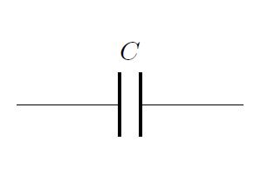
CyberCapacitor.IT

 |  | Invoice
Bill From  CyberCapacitor.IT  invoice@cybercapacitor.it | Bill To  Mr Pioppo  pioppo@bobb.io |  | Invoice # 100  Invoice Date: Feb 23, 2020  Due Date: Mar 10, 2020

ID | Description | Qty | Price | Total
01 | Pellentesque habitant morbi tristique senectus | 25 | $250.00 | $6,250.00
02 | Et netus et malesuada fames ac turpis egestas | 8 | $240.00 | $1.920.00
03 | Sed velit urna, interdum vel | 6 | $500.00 | $3,000.00
Sub Total |  |  |  | $11,170.00
Sales Tax 8% |  |  |  | $893.60
Shipping & Handling |  |  |  | $500.00
Total |  |  |  | $12,563.60

Terms and conditions
Please send payment within 30 days of receiving this invoice. There will be a 1.5% interest charge per month on late invoices.

PLEASE MAKE A PAYMENT TO
Beneficiary Name: [Company Name]
Beneficiary Account Number: [1234567890]
Bank Name and Address: [Bank Name and Address]
Bank Swift Code: [1234567890]
IBAN Number: [1234567890]

Thank you for your business!

