­­­­­­­Part 1

1. Yes, only very basic HTML. Haven’t built anything with it yet.
2. My interest in programming started with and interest in gaming and game development. Through researching how to become involved in game development I discovered that the two basic options were to do a game development course or a computer programming course. I researched both and thought that computer science would give me a more rounded education about all things computers.
3. My favourite website is IGN.com. It’s a website primarily about gaming but also has a lot about other things that interest me such as films, TV series’, etc.

My favourite app is my music app on my iPod. It is very simple and does its job perfectly.

My favourite software is my web browser. It connects me to the world!

1. I would like to create a game based on the Pokémon but in a much more open world and with real time battle based gameplay.
2. I play games, cycle everywhere, and watch a lot of TV and films
3. 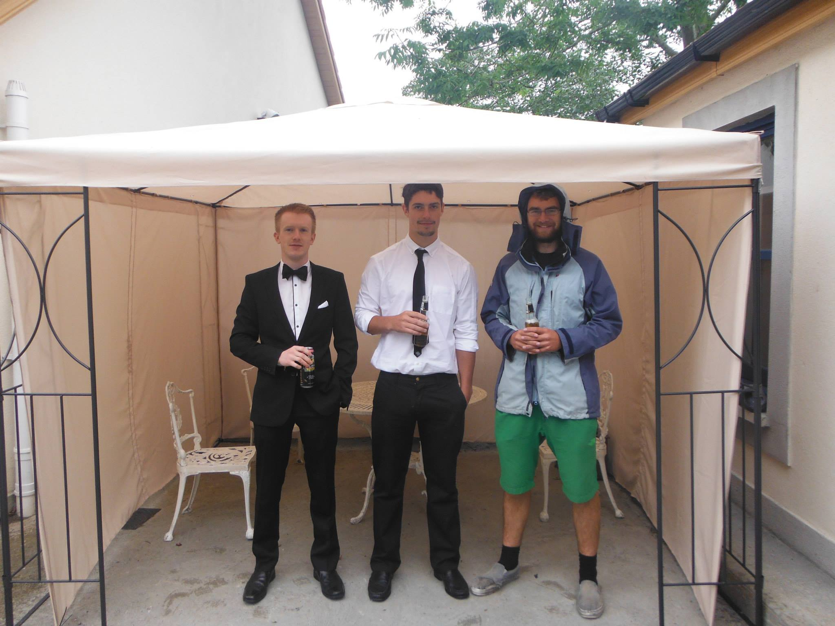I have studied architecture for the past 3 years.

Aidan Devlin

Part 2

1. There was a man going to market with a pig, wolf, and a sack of lettuce. He encounters a river with a small boat. There is only room in the boat for the man and one of the three things he has brought to market. The pig cannot be left alone with the lettuce and the wolf cannot be left with he pig. The answer to this is to bring the pig across first and then go back and get the wolf. Bring the pig back to the first side and then bring the cabbage across to the to wolf’s side. Then go back and get the pig.
2. There are three marries couples who want to cross a river in a boat that cannot hold more than 2 passengers at once. None of the women can be in the presence of another man unless her husband is also there. The boat cannot cross the river without any passengers.
3. On a TV game show a contestant is asked to pick one of three doors; A, B, and C. Behind 2 of the doors is a goat and behind one is a new car. After choosing a door the contestant is shown a goat behind one of the doors that they did not pick (eliminating one of the doors) and asked if they want to change their mind. What whould the contestant do?

Part 2 answers

|  |  |  |  |
| --- | --- | --- | --- |
| **Trip Number** | **Starting Bank** | **Travel** | **Ending Bank** |
| start | M1, W1, M2, W2, M3, W3 |  |  |
| 1 Over | M2, W2, M3, W3 | M1, M2, |  |
| 2 Back | M2, W2, M3, W3 | M1 | W1 |
| 3 Over | M1, M2, M3 | W2, W3 | W1 |
| 4 Back | M1, M2, M3 | W1 | W2, W3 |
| 5 Over | M1, W1 | M2, M3 | W2, W3 |
| 6 Back | M1, W1 | M2, W2 | M3, W3 |
| 7 Over | W1, W2 | M1, M2 | M3, W3 |
| 8 Back | W1, W2 | W3 | M1, M2, M3 |
| 9 Over | W2 | W1, W3 | M1, M2, M3 |
| 10 Back | W2 | M2 | M1, W1, M3, W3 |
| 11 Over |  | M2, W2 | M1, W1, M3, W3 |
| finish |  |  | M1, W1, M2, W2, M3, W3 |

|  |  |  |  |
| --- | --- | --- | --- |
| **Trip Number** | **Starting Bank** | **Travel** | **Ending Bank** |
| 1 Across | Pig, Wolf, Cabbage | Pig |  |
| 2 Back | Wolf, Cabbage |  | Pig |
| 3 Across | Cabbage | Wolf | Pig |
| 4 Back | Cabbage | Pig | Wolf |
| 5 Across | Pig | Cabbage | Wolf |
| 6 Back | Pig |  | Cabbage, Wolf |
| 7 Across |  | Pig | Cabbage, Wolf |

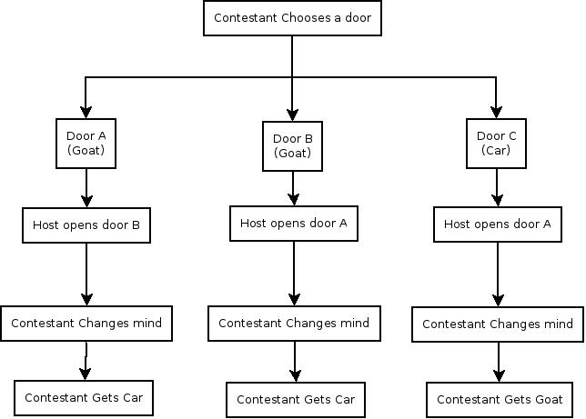

Lab 2

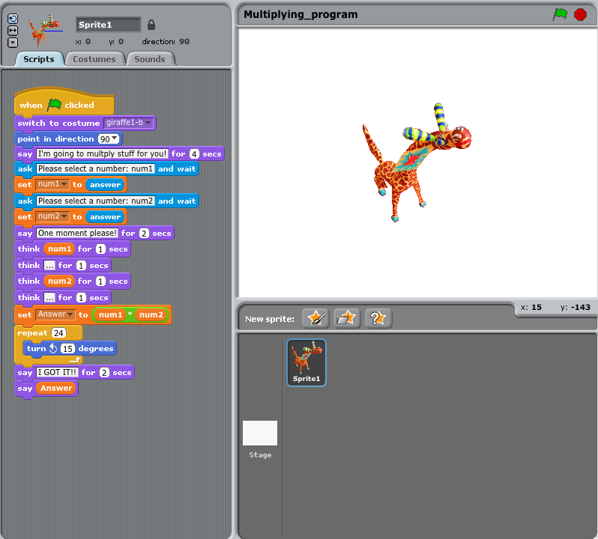Part 1

Part 2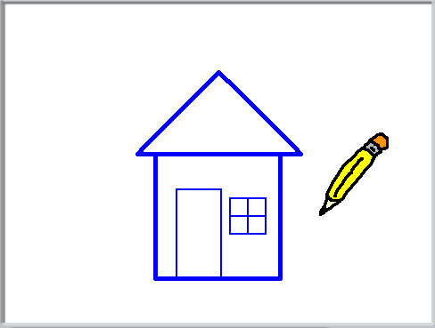

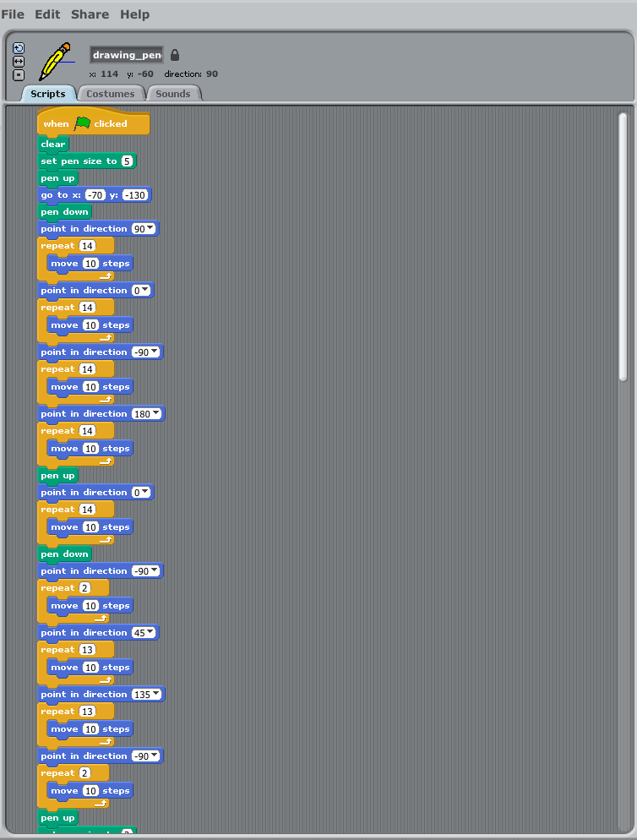

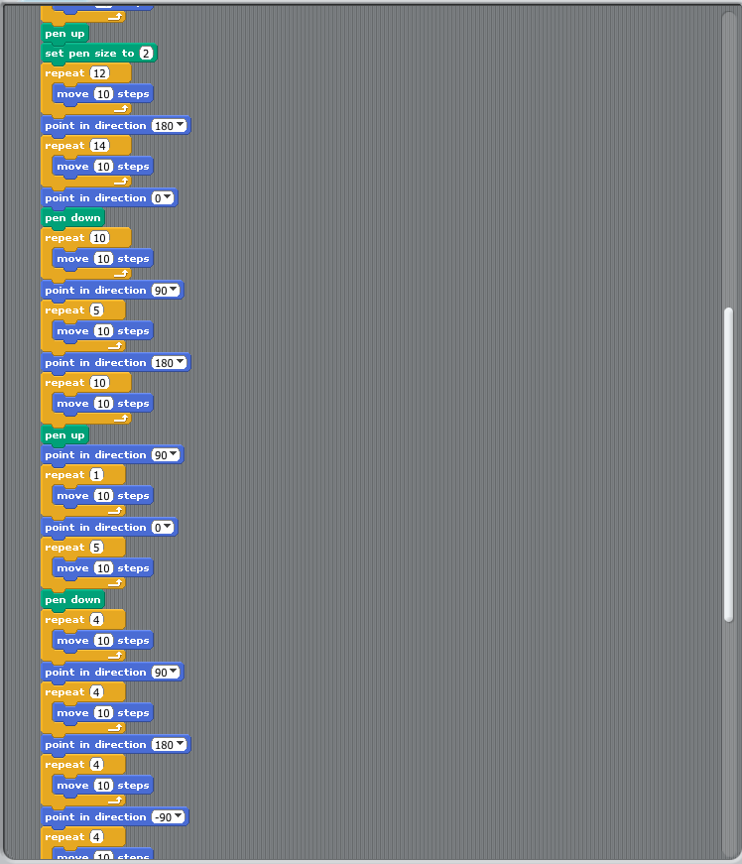

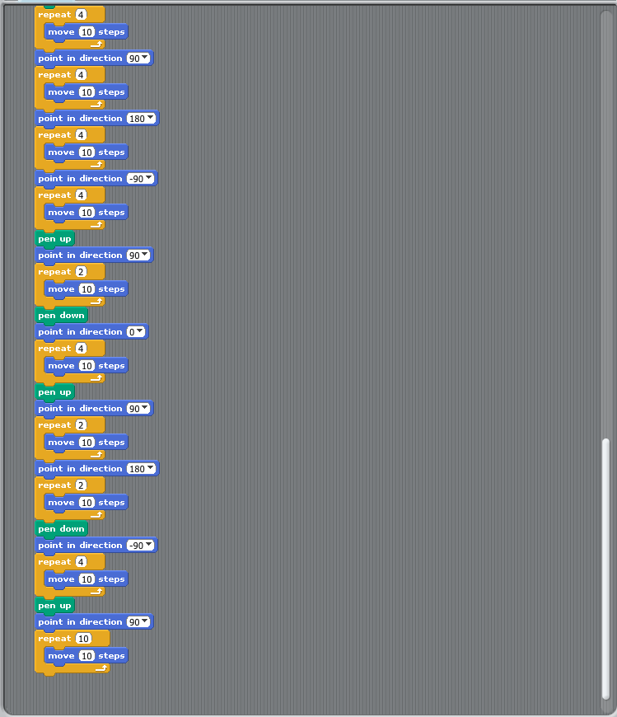

Lab 3

Part 3

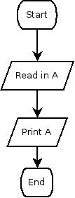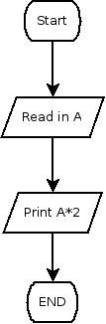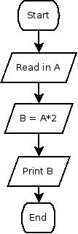

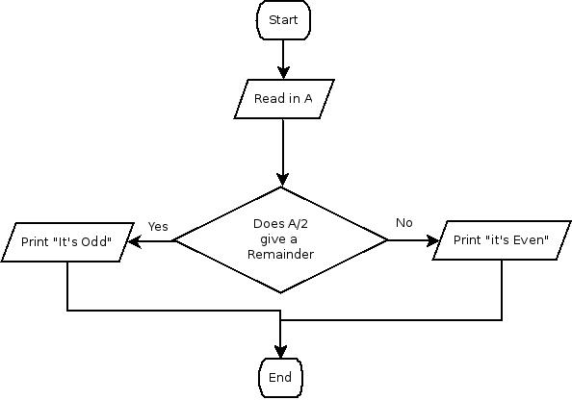

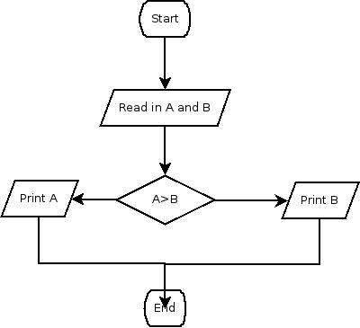

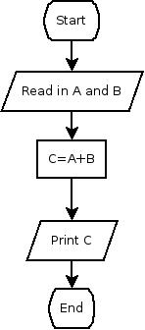

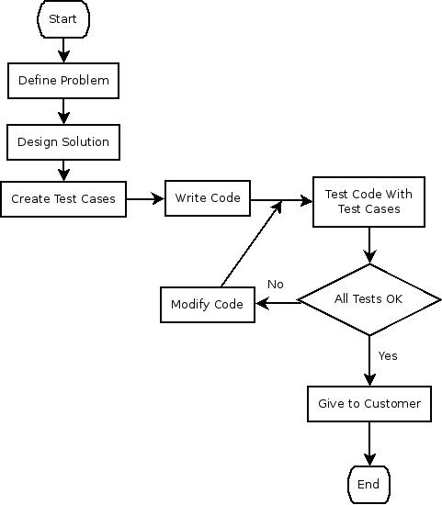

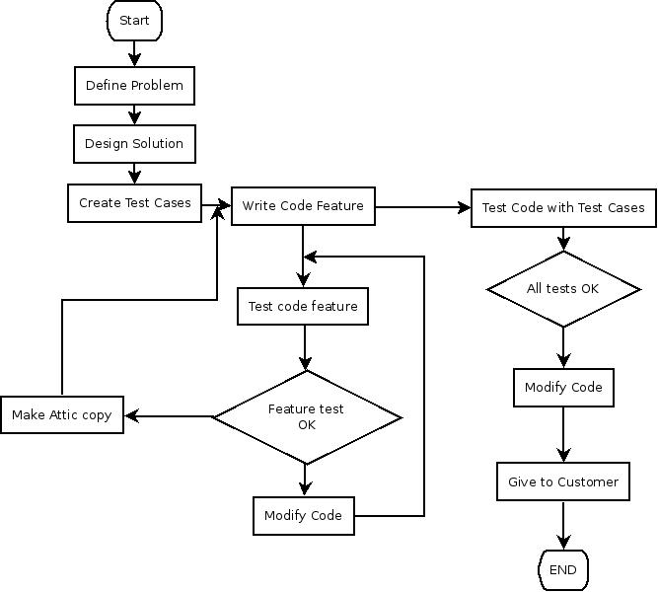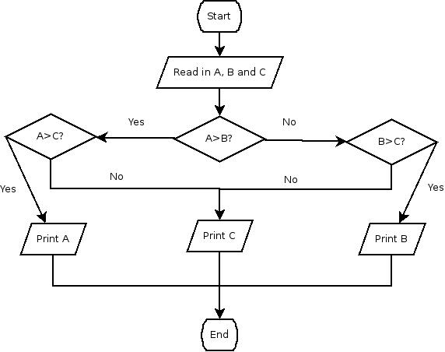

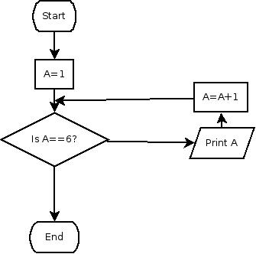

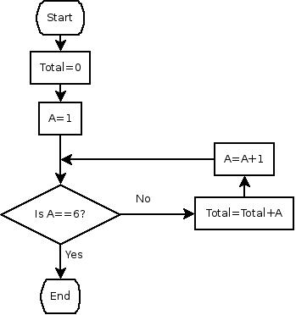

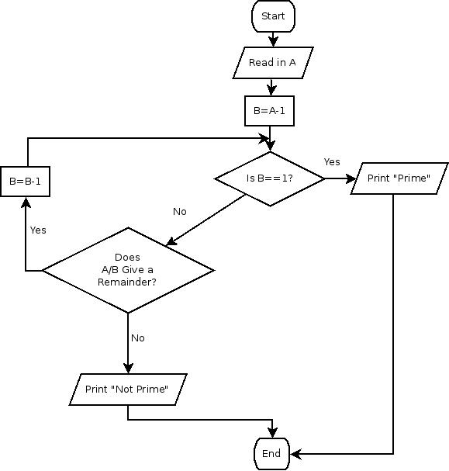

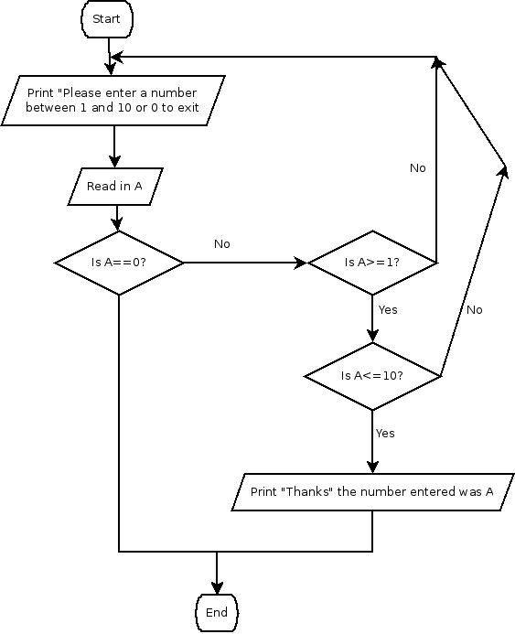

Lab 4

Part 2

1. Print C
2. Adds 10 numbers the user inputs

Part 3

