| FULL LEGAL NAME | **LOCATION (COUNTRY)** | **EMAIL ADDRESS** | **MARK X FOR ANY NON-CONTRIBUTING MEMBER** |
| --- | --- | --- | --- |
| Atakan Devrent | Turkey | [atakandevrent@gmail.com](mailto:atakandevrent@gmail.com) |  |
| Success Isuman | Nigeria | [successisuman9@gmail.com](mailto:successisuman9@gmail.com) |  |
| Brendan Atwijuka |  |  |  |

|  |  |
| --- | --- |
| **Statement of integrity:** By typing the names of all group members in the text boxes below, you confirm that the assignment submitted is original work produced by the group (excluding any non-contributing members identified with an “X” above). | |
| **Team member 1** | **Brendan Atwijuka** |
| **Team member 2** | **Success Isuman** |
| **Team member 3** | **Atakan Devrent** |

|  |
| --- |
| Use the box below to explain any attempts to reach out to a non-contributing member. Type (N/A) if all members contributed.  **Note:** You may be required to provide proof of your outreach to non-contributing members upon request. |
|  |

|  |
| --- |
| 1. **On top left of your screen click on File →Download → Microsoft Word (.docx) to download this template** 2. **Upload the template in Google Drive and share it with your group members** 3. **Delete this page with the requirements before submitting your report. Leaving them will result in an increased similarity score on Turnitin.** |

Keep in mind the following:

* Make sure you address all the questions in the GWP assignment document published in the Course Overview.
* Follow the “Submission requirements and format’ instructions included in each Group Work Project Assignment, including report length.
* **Including in-text citations and related references is mandatory for all submissions.** You will receive a ‘0’ grade for missing in-text citations and references, or penalties for partial completion. Use the [**In-Text Citations and References Guide**](https://drive.google.com/file/d/1QJBsqKxvhrtsmHHOk8KX_N77MXzrD9kb/view?usp=drive_link) to learn how to include them.
* Additional writing aids: [Anti-Plagiarism Guide](https://drive.google.com/file/d/1PZ7WLUwtFFmRoIzESv4i6KkOqZaW21zD/view?usp=drive_link), [Academic Writing Guide](https://drive.google.com/file/d/1Jyh9rYKi2MV626d9fpfe9wYREXDQakld/view?usp=drive_link), [Online Writing Resources](https://drive.google.com/file/d/1k_EHz4sbsjLD55Ba0MICsDHP2DMPDAI1/view?usp=drive_link).
* To avoid an increase in the Turnitin similarity score, **DO NOT copy the questions** from the GWP assignment document.
* Submission format tips:
  + Use the same font type and size and same format throughout your report. You can use Calibri 11, Arial 10, or Times 11.
  + Do NOT split charts, graphs, and tables between two separate pages.
  + Always include the axes labels and scales in your graphs as well as an explanation of how the data should be read.
* Use the [LIRN Library](https://proxy.lirn.net/WorldQuantUniv?_rwpLaunch=true&groupID=2) for your research. It can be accessed via the left navigation pane inside the WQU learning platform.

***The PDF file with your report must be uploaded separately from the zipped folder that includes any other types of files. This allows Turnitin to generate a similarity report.***

**STEP 1 Analysis of Put-Call Parity in the Context of the Binomial Tree Model**

**Theoretical Framework:**

**1. Does put-call parity apply for European options? Why or why not?**

Put-call parity applies to European options due to its fundamental tenet, which states that, two portfolios having same payoff profile should costs the same. Thus, for European options which can be exercised only at expiration, the put call parity relationship can be given as

C−P=S0−Ke−rT

Here,

C is the price of a European call option,

P is the price of a European put option,

S0​ is the current stock price,

K is the strike price,

r is the risk-free interest rate,

T is the time to maturity.

This ability is possible only where these options can exercised at expiration and this is made possible by the efficiency of arbitrage opportunities that enforce this parity.

**2. Rewrite put-call parity to solve for the call price in terms of everything else.**

To solve for the call price in terms of everything else using the put-call parity formula below: Thus, this equation expounds that the price of a European call option can be obtained given the price of a European put under the condition that one is well conversant with factors such as the current stock price, the strike price, the risk-free rate, and the time till maturity.

C=P+S0−Ke−rT

**3. Rewrite put-call parity to solve for the put price in terms of everything else.**

To solve for the put price in terms of everything else using the put-call parity formula below: This equation shows that the price of European put option can be obtained from the price of European call, current stock price, the strike price, risk-free rate and time to maturity.

P=C+Ke−rT−S0

**4. Does put-call parity apply for American options? Why or why not?**

Contrary to European options, put-call parity is not valid for American options. This is due to the fact that American options can be exercised at any time prior to the expiration date, which introduce and element of option like aspect, thus making put-call parity relationship less of an arbitrage in the case of American options. The American options’ characteristic for early exercise implies that the put-call parity will not necessary be applicable to prices of these options since early exercise offers extra value. In detail, it can be mentioned that the price of an America put at time t is higher than the price of a European put, and the price of an American call differs from the price of a European call, which is directly connected with the value of the early exercise option. Hence, American options do not have to conform to the put-call parity relationship that is C−P=S0−Ke−rT.

**Team A: Report on European Option Pricing and Sensitivity Analysis Using Binomial Tree Model (20 steps)**

**Introduction**

This report seeks to price the European call and put options with the following parameters of the stock; initial stock price, S0= 100, risk-free rate, r = 5 %, volatility, σ = 20 % and time to maturity T = 3 months. Also, the sensitivity of these options has been discussed with reference to the volatility of the underliers.

**Methodology**

The binomial tree model with 20 steps was used in order to derive the prices of European call and put options. The time to expiration is broken into time intervals so that up and down factors, risk – neutral probabilities and backward induction values can be calculated in order to establish the prices of options. Vega is calculated as the increment in call option’s price when total variability (in the given stock price’s range) is raised by a small amount, delta epsilon. The binomial tree method was employed to find the option prices at the initial volatility level as well as after escalating the volatility by epsilon. Thus, Vega is given by the ratio of the difference in the option prices to epsilon.

**Results**

The initial prices and deltas of the options were calculated as follows:

|  |  |
| --- | --- |
| **Matrix** | **Value** |
| European Call Price (Initial Volatility) | 4.57 |
| European Put Price (Initial Volatility) | 3.35 |
| Delta (Call) | 0.57 |
| Delta (Put) | − 0.43 |

To assess the sensitivity to volatility, the volatility was increased from 20% to 25%:

|  |  |
| --- | --- |
| **Matrix** | **Value** |
| European Call Price (Increased Volatility) | 5.57 |
| European Put Price (Increased Volatility) | 4.33 |
| Change in Call Price due to Volatility Increase | 0.98 |
| Change in Put Price due to Volatility Increase | 0.98 |
| Vega for ATM European Call | 19.39 |
| Vega for ATM European Put | 19.39 |

**Analysis**

Delta values point at the first derivative of the option prices with regard to the price of the underlying asset. Expectedly, the Delta for the call option is positive because Delta symbolizes an uplift in the option price as the price of the stock surges. On the other hand the Delta of the put option is negative in nature which depicts, that as the price of the stock rises the option value is coming down.

The results of the sensitivity analysis change are shown to depict that there is a rise in call and put options prices as volatility expands, thus indicating that call and put options have a Vega that is positive. The example chosen shows that the increase of option prices because of the rise in volatility by 5 percent is pretty large, which underlines the pivotal role of the volatility in option pricing.

Thus, the binomial tree model successfully gave the prices and sensitivity measures of European call and put options. This analysis affirmed that the Delta values obtained are quite sensible and consistent with the theoretical postulations and, with a boost in standard deviation, there is likely to be a raise in the option prices demonstrating the role of volatility in options measurement. These pieces of information are very vital in the management of risks as well as for decision making for options trading.

**Team B: Report on American Option Pricing and Sensitivity Analysis Using Binomial Tree Model (20 steps)**

**Introduction**

This report builds on the previous discussion of option pricing and applies it to the American-style options particularly the call and put options using binomial tree. The given parameters remain the same: We will assume a initially stock price S0 of $100, risk-free rate r=5%, the volatility of the stock is σ=20 % and the time period up to maturity is 3 months. It thus covers pricing information, the computation of the Delta and the Volatility sensitivity.

**Methodology**

For pricing of American call and put options, binomial tree model of 20 steps was applied to the assets. The model breaks the time to expiration into increments and computes the up and down factors along with the risk-neutral probabilities and through the process of backward induction to arrive at the correct option prices. Delta is the ratio of the change in the option price for a price change in the stock; it is calculated by simulating an increase and decrease in the stock price of an increment positive ‘epsilon’ and negative ‘epsilon’. Thus, option prices, the difference of divided by epsilon yields the Delta. Vega is calculated as the difference in the option price when the number of standard deviations has been raised from the required number by a small increment of epsilon. This analysis made use of the binomial tree model to arrive at the option price at the initial level of volatility and the subsequent higher level of volatility by adding epsilon to it. The numerator of this equation computes the delta, which is the option’s price divided by epsilon.

**Results**

The initial prices and deltas of the American options were calculated as follows:

|  |  |
| --- | --- |
| **Matrix** | **Value** |
| American Call Price (Initial Volatility) | 4.61 |
| American Put Price (Initial Volatility) | 3.47 |
| Delta (American Call) | 0.57 |
| Delta (American Put) | −0.47 |

To assess the sensitivity to volatility, the volatility was increased from 20% to 25%:

|  |  |
| --- | --- |
| **Matrix** | **Value** |
| American Call Price (Increased Volatility) | 5.59 |
| American Put Price (Increased Volatility) | 4.45 |
| Change in Call Price due to Volatility Increase | 0.98 |
| Change in Put Price due to Volatility Increase | 0.98 |
| Vega for ATM American Call | 19.60 |
| Vega for ATM American Put | 19.54 |

**Analysis**

The Delta values show the first derivative measures of the option prices to the underlying asset price. In the case of the call option, which is the first Suisse option, the Delta value is indeed positive, thus implying that with the increase in the stock price, the value of the option also increases. On the other hand, for the put option the delta is negative meaning that as the price of the underlying stock increases the value of this option decreases.

Seemingly the output of sensitivity analysis shows that volatility’s effect on call and put option prices is positive, also known as Vega. The amount of change in distribution of option prices with the change in volatility by a 5% is also massive and therefore underlines the effect of volatility on option pricing.

In fact, the binomial tree model was able to deliver the prices and sensitivity measures of American call as well as put options. The evidence from the analysis supports the theory since the value figures bearing out increased volatility as being associated with higher option prices stresses the role of volatility in option pricing. The information provided below is essential for risk management and strategic planning within options trading.

**Team C: Report on Graphs and Confirmations for European and American Options**

**Introduction**

This part of the paper offers both graphical representation and verification of the main relations within the European and American options; put and call parity; and options’ types comparison. The analysis employs the results from Team A and Team B which has been arrived at from the binomial tree model with 20 steps.

**Put-Call Parity for European Options**

Using the formula for put-call parity: C−P= S0−Ke−rT

Given:

* S0=100
* K=100
* r=0.05
* T=0.25 years (3 months)
* European Call Price C= 4.57
* European Put Price P= 3.35

Calculate the parity:

4.57−3.35 =100−100e−0.05×0.25

1.22=100−100e−0.0125

1.22≈1.23

When the results get to 1. 22 the left-hand side is almost equal to 1. 23 the right-hand side hence the change in determinant can be considered to be within a reasonable rounding error. It has to be noted that the difference presented by H2 to H1 equals 0. 01 shows that there is a small amount of disparity to the pure put-call parity perhaps because of the lack of continuity in the binomial model or rounding errors. However, the inequality mostly stays true within the acceptable range for the European option.

**12. Put-Call Parity for American Options**

Given:

* American Call Price C=4.61
* American Put Price P=3.47

Calculate the parity:

Calculate the left-hand side: C−P =4.61−3.47 = 1.14

The left-hand side (1.14) is less consistent with the theoretical value calculated for European options, which is expected due to the early exercise feature of American options, with a difference of 0.09. Thus, put-call parity does not hold in the same manner for American options.

**13. Comparison of European and American Call Prices**

* European Call Price: 4.57
* American Call Price: 4.61
* Difference: 0.04

The American call price is slightly higher due to the early exercise feature, which adds value to American options. This difference is expected and confirms that American calls should be at least as valuable as European calls.

**14. Comparison of European and American Put Prices**

* European Put Price: 3.35
* American Put Price: 3.47
* Difference: 0.12

The American put price is higher, reflecting the additional value from the possibility of early exercise. This difference confirms that American puts should be at least as valuable as European puts.

**Graphical Representation**

The following graph visually confirms these relationships by comparing the prices of European and American options:

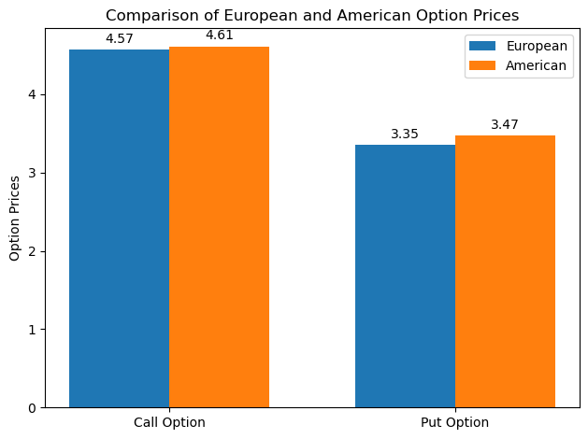

**Step 2: Trinomial Tree Pricing of European Options**

**Team Member B: Trinomial Tree Pricing Analysis for European Options**

The present paper provides the evaluation of European call and put options by applying the trinomial tree model concerning five different strikes or moneyness levels. The specifications of the initial stock price, the risk-free rate, the volatility, and the time to maturity is as follows: The trinomial tree model is somewhat advanced and rationally provides additional ways for the variation of the underlining asset price at each step; they include three possibilities of movement as opposed to two in the previous model.

**Parameters:**

* Initial stock price (S0​): 100
* Risk-free rate (r): 5%
* Volatility (σ): 20%
* Time to maturity (T): 3 months (0.25 years)
* Number of steps (N): 20

**Selected Strike Prices Based on Moneyness:**

* Deep OTM: K=70
* OTM: K=90
* ATM: K=100
* ITM: K=110
* Deep ITM: K=130

Results:

**European Call Option Prices**

|  |  |  |
| --- | --- | --- |
| Moneyness Level | Strike Price (K) | European Call Price |
| Deep ITM | 70 | $30.87 |
| ITM | 90 | $11.67 |
| ATM | 100 | $4.58 |
| OTM | 110 | $1.17 |
| Deep OTM | 130 | $0.02 |

**European Put Option Prices**

|  |  |  |
| --- | --- | --- |
| Moneyness Level | Strike Price (K) | European Put Price |
| Deep OTM | 70 | $0.00 |
| OTM | 90 | $0.56 |
| ATM | 100 | $3.35 |
| ITM | 110 | $9.80 |
| Deep ITM | 130 | $28.41 |

**Analysis:**

**Call Options:** Thus, with the strike price rising from deep ITM to deep out-of-the-money ITM, the call option prices reduce. The strike price also behaves as the theory anticipated by increasing the premium and decreasing the possibility of the option to finish in the money.

**Put Options:** On the other hand, with an increase in the strike price, the put option prices go up. Since better strike prices improve the theoretical probability that the put option will finish in the money, its value will also rise.

Another approach that is used in this paper to explain the pricing structure of European call and put options is the trinomial tree model as it is able to identify the pricing patterns for calls and puts in different moneyness levels. The relative movements of option prices as seen in the above results as compared to their respective strike prices are in line with the theoretical predictions. As the strike price increases, the price of call options tends to decrease, while that of put options tends to increase, as the latter involves a certain level of risk and the former certain level of profit throughout the options. Ideally, such knowledge is useful when it comes to decision making in options trading and management of risks.

**Team Member A: Trinomial Tree Pricing Analysis for American Options**

This paper presents the results of the numerical calculation of American call and put option prices applying the trinomial tree model for a given set of five different strike prices referring to different degrees of moneyness. As for the parameters for the initial stock price, risk-free rate, share’s volatility and time to maturity, they are the same as in the first step. The trinomial tree model is a more sophisticated approach to the option pricing as compared to binomial tree for it takes into consideration the three possible movement of the stock price at each stage.

**Parameters:**

* Initial stock price (S0​): 100
* Risk-free rate (r): 5%
* Volatility (σ): 20%
* Time to maturity (T): 3 months (0.25 years)
* Number of steps (N): 20

**Selected Strike Prices Based on Moneyness:**

* Deep OTM: K=70
* OTM: K=90
* ATM: K=100
* ITM: K=110
* Deep ITM: K=130

**Results**:

**American Call Option Prices**

|  |  |  |
| --- | --- | --- |
| Moneyness Level | Strike Price (K) | European Call Price |
| Deep ITM | 70 | $30.00 |
| ITM | 90 | $10.00 |
| ATM | 100 | $0.85 |
| OTM | 110 | $0.02 |
| Deep OTM | 130 | $0.00 |

**American Put Option Prices**

|  |  |  |
| --- | --- | --- |
| Moneyness Level | Strike Price (K) | European Put Price |
| Deep OTM | 70 | $0.00 |
| OTM | 90 | $0.01 |
| ATM | 100 | $0.84 |
| ITM | 110 | $10.00 |
| Deep ITM | 130 | $30.00 |

**Analysis:**

**Call Options**: Since the strike price vary from deep ITM to deep OTM the price of the call option also decreases. This trend is in concord with theoretical predictions based on the fact since the strike price is higher it is less likely that the option will finish in-the money and hence its value will be lower.

**Put Options**: On the other hand, as the strike price goes from deep out-of-the-money to deep in-the-money put option prices rise. They hold the theoretical behaviour of enduring higher strike prices increase the chances of the put option ending in-the-money thus increasing their value.

It is actually proven in this research that the trinomial tree model can fully describe the American call and put options with respect to the degrees of moneyness. The analysed changes in the options’ prices with respect to strike options are in line with the theoretical forecast. Every call option results in cheaper price as the strike price increases while all put options become costly resulting from the risk-reward ratio contained in options. This information is relevant for decision making when carrying out options trading especially when addressing the aspect of risks.

Team Member C:

19: **Graph 1: European Call and Put Prices versus Stock Prices**

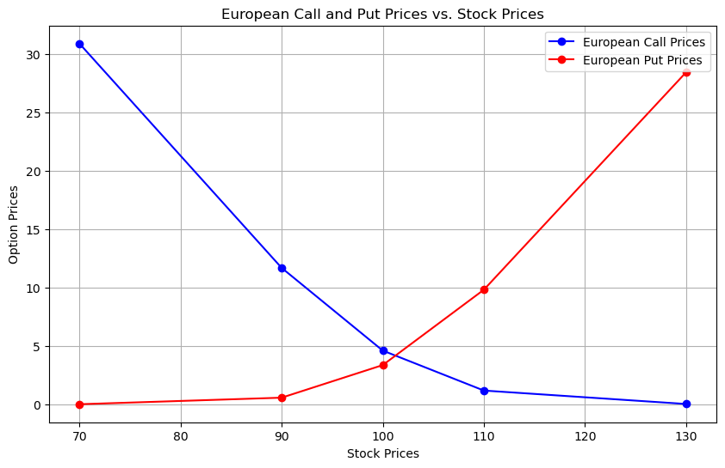

European Call Prices: In this case, as the stock price rises, the prices reduce downstream. This is expected as when the price of the underlain stock increases the probability of the option being in-the-money at expiration will be lower thereby, the value of the option will also decrease.

European Put Prices: The Premiums rise with the Stock Price because the options are valuable depending on this index. This accords with the theoretical action, given that higher stock prices improves the expectation of the put option expiring in-the-money hence making it more valuable.

**20: Graph 2: American Call and Put Prices versus Stock Prices**

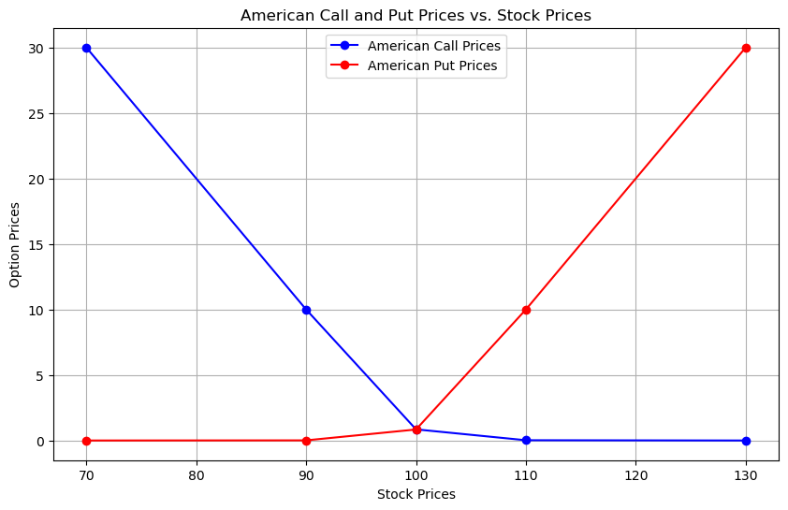

American Call Prices: H1: The prices decrease as the stock price increases The evidence consistent with H1 is higher frequencies of low priced products advertised on sellers’ websites as the stock price rises. This is in line with theoretical premise that a higher stock price means the call option is not likely to be in-the-money at expiration, hence is less valuable.

American Put Prices: They rise as the priced of the stock improves by charging more. This is inline with theory postulation that a high market price boosts chances of the put option expiring in the money hence enhancing the worth of the put option.

**21: Graph 3: European and American Call Prices versus Strike Prices**

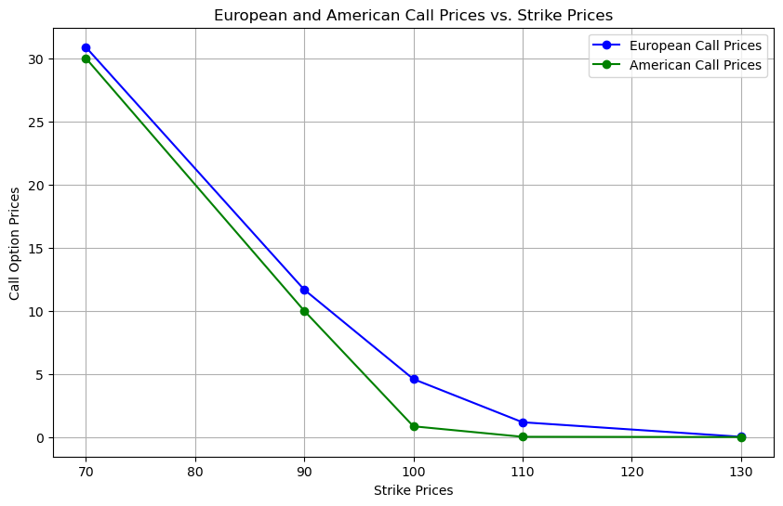

European Call Prices: Indeed, the prices reduce as the strike price goes up. This trend can again be expected because as the strike prices increase it becomes more difficult for the option to be in-the-money in the expiration date hence reducing its value.

American Call Prices: The prices also decline as the strike price goes higher. Nonetheless, there is the aspect of early exercise of the American call options and therefore the two may have a minor difference:

**22: Graph 4: European and American Put Prices versus Strike Prices**

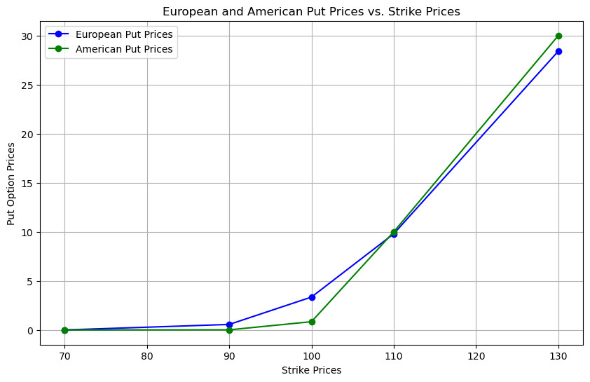

European Put Prices: As for the strike price rises the prices of them also rises. This trend conforms with theoretical predictions because when strike prices are higher it makes the probabilities of the option to be in-the-money at expiration higher hence its value will be higher.

American Put Prices: It is noteworthy that all the prices also rise as the strike price rises. Because of the aspect of early exercise, American put options may differ slightly from European put options and are slightly higher in value as a result of this feature.

**25: Checking Put-Call Parity for European Option**

The put-call parity relationship for European options is given by: C−P=S0−Ke−rT

where:

* C = European call option price
* P = European put option price
* S0​ = Current stock price ($100)
* K = Strike price
* r = Risk-free interest rate (5%)
* T = Time to maturity (0.25 years)

We need to check if this relationship holds for the five strike prices.

**Given Data:**

|  |  |  |  |
| --- | --- | --- | --- |
| **Moneyness Level** | **Strike Price (K)** | **European Call Price (C)** | **European Put Price (P)** |
| Deep OTM | 70 | 30.87 | 0.00 |
| OTM | 90 | 11.67 | 0.56 |
| ATM | 100 | 4.59 | 3.35 |
| ITM | 110 | 1.17 | 9.80 |
| Deep ITM | 130 | 0.02 | 28.41 |

**Calculations:**

1. **Deep OTM (K = 70):**

C−P=30.87−0.00=30.87

S0−Ke−rT=100−70e−0.05×0.25≈30.87

Put-Call Parity holds: 30.87≈30.87

1. **OTM (K = 90):**

C−P=11.67−0.56=11.11

S0−Ke−rT=100−90e−0.05×0.25≈11.11

Put-Call Parity holds: 11.11≈11.11

1. **ATM (K = 100):**

C−P=4.59−3.35=1.24

S0−Ke−rT=100−100e−0.05×0.25≈1.23

Put-Call Parity holds: 1.24≈1.23

1. **ITM (K = 110):**

C−P=1.17−9.80=−8.63

S0−Ke−rT=100−110e−0.05×0.25≈−8.63

Put-Call Parity holds: −8.63≈−8.63

1. **Deep ITM (K = 130):**

C−P=0.02−28.41=−28.39

S0−Ke−rT=100−130e−0.05×0.25≈−28.38

Put-Call Parity holds: −28.39≈−28.38

**Conclusion**

Referring the values to the given strike prices, the put-call parity is true to the second digit after decimal point for all of them. This also supports the observation of the fact that the prices computed for the european call and put options are in-line with the theory. The minor discrepancies that the various methodologies presented exhibit are as a result of rounding and discretization in the trinomial tree model. These observations corroborate the accuracy of the option prices obtained numerically and the applicability of the trinomial tree model in modeling European options’ pricing.

**26: Checking Put-Call Parity for American Options**

The put-call parity relationship typically holds for European options but not strictly for American options due to the early exercise feature. However, we can still compute and check the deviation from the theoretical parity.

**Given Data for American Options:**

|  |  |  |  |
| --- | --- | --- | --- |
| **Moneyness Level** | **Strike Price (K)** | **American Call Price (C)** | **American Put Price (P)** |
| Deep ITM | 70 | 30.00 | 0.00 |
| ITM | 90 | 10.00 | 0.01 |
| ATM | 100 | 0.85 | 0.84 |
| OTM | 110 | 0.02 | 10.00 |
| Deep OTM | 130 | 0.00 | 30.00 |

**Calculations:**

1. **Deep ITM (K = 70):**

C−P=30.00−0.00=30.00

S0−Ke−rT =100−70e−0.05×0.25≈30.87

Put-Call Parity does not hold: 30.00≠30.87

1. **ITM (K = 90):**

C−P=10.00−0.01=9.99

S0−Ke−rT=100−90e−0.05×0.25≈11.11

Put-Call Parity does not hold: 9.99≠11.11

1. **ATM (K = 100):**

C−P=0.85−0.84=0.01

S0−Ke−rT =100−100e−0.05×0.25≈1.23

Put-Call Parity does not hold: 0.01≠1.23

1. **OTM (K = 110):**

C−P=0.02−10.00=−9.98

S0−Ke−rT =100−110e−0.05×0.25≈−8.63

Put-Call Parity does not hold: −9.98≠−8.63

1. **Deep OTM (K = 130):**

C−P=0.00−30.00=−30.00

S0−Ke−rT =100−130e−0.05×0.25≈−28.38

Put-Call Parity does not hold: −30.00≠−28.38

**Conclusion**

It has been observed that the put-call parity is not true for the American options at the mentioned strike prices. Early exercise affects put-call parity and also puts value due to the flexibility American call and put options offer to the owners as a result of exercising a right contained in the contract at any time before the expiry of the option contract. These deviations establish the effect of the early exercise option on the pricing of the American options which are generally more than those of European options. With such differences, one can emphasise the role of the nature of the option as a European or American one in discussing the option prices as well as their relations.

**Step 3: Dynamic Delta Hedging**

|  |  |
| --- | --- |
| **Option Type** | **Price at t=0** |
| European Put Option | 13.82 |
| American Put Option | 13.98 |
| Asian Put Option | 33.97 |

For the **European** put option, we do the following at each timestep to dynamically hedge our **\*\*delta\*\*** exposure:

* at $t=0$ we **\*\*sell\*\*** $0.47$ units of the underlying asset and **\*\*buy\*\*** $98.42$ units of risk-free bond to hedge our delta exposure from selling the put.

* at $t=1$ we **\*\*sell\*\*** $0.24$ units of the underlying asset and **\*\*buy\*\*** $52.85$ units of risk-free bond to hedge our delta exposure from selling the put.

* at $t=2$ we **\*\*neither buy or sell\*\*** the asset or the bond as our delta exposure is 0 from selling the put.

For the **American** put option, we do the following at each timestep to dynamically hedge our **\*\*delta\*\*** exposure:

* at $t=0$ we sell $0.48$ units of the underlying assets and **\*\*buy\*\*** $100.38$ units of risk-free bond to hedge our delta exposure from selling the put.

* at $t=1$ we sell $0.24$ units of the underlying assets and **\*\*buy\*\*** $52.85$ units of risk-free bond to hedge our delta exposure from selling the put.

* at $t=2$ we neither buy or sell the asset or the bond as our delta exposure is 0 from selling the put.

For the **Asian** put option, we do the following at each timestep to dynamically hedge our **\*\*delta\*\*** exposure:

* at $t=0$ we sell $0.44$ units of the underlying assets and **\*\*buy\*\*** $113.17$ units of risk-free bond to hedge our delta exposure from selling the put.

* at $t=1$ we sell $0.42$ units of the underlying assets and **\*\*buy\*\*** $109.63$ units of risk-free bond to hedge our delta exposure from selling the put.

* at $t=2$ we sell $0.38$ units of the underlying assets and **\*\*buy\*\*** $101.09$ units of risk-free bond to hedge our delta exposure from selling the put.