Healthcare Management System

line 1: 1st Given Name Surname
line 2: dept. name of organization
(of Affiliation)
line 3: name of organization
(of Affiliation)
line 4: City, Country
line 5: email address or ORCID

Abstract— The Healthcare Management System (HMS) presented in this study is a web-based application aimed at improving the interaction between patients and healthcare providers. By leveraging modern technologies such as Next.js, Appwrite, TailwindCSS, Twilio, and Sentry, the system streamlines patient registration, appointment booking, and management. The system also includes features for real-time SMS notifications, allowing patients to receive updates regarding their appointments, while administrators can efficiently manage appointments. Designed to enhance healthcare accessibility, the HMS supports secure file uploads and provides performance monitoring for system reliability. This paper details the design, development, and implementation of the system, including its architecture, key features, and the real-world impact it can have in healthcare settings.

Introduction
The project is a modern blogging platform designed using Next.js and TypeScript. It focuses on delivering a seamless and engaging experience for both content creators and readers. The platform ensures robust and scalable performance by leveraging advanced web technologies such as Prisma for efficient database management and Next Auth for secure user authentication. The website features a dynamic homepage that lists blogs in visually appealing card layouts, displaying essential details like titles, thumbnails, and short descriptions. Readers can access detailed blog pages with enriched content, including images, code snippets, and topics covered, offering a comprehensive reading experience. Tailwind CSS ensures a clean, responsive design adaptable to light and dark modes, catering to diverse user preferences. The integration with Cloudinary enables efficient image management, improving performance and user satisfaction. For content creators, the platform plans to incorporate Draft.js, a rich text editor, simplifying the blog creation process with support for multimedia and formatting options.
This project aims to create a robust blogging ecosystem, prioritizing user engagement, scalability, and maintainability, while providing a secure, feature-rich platform for showcasing creative content.

Ease of Use

Literature Review
Existing healthcare management systems often face challenges such as suboptimal user experiences, limited scalability, and communication gaps among stakeholders. By adopting modern web technologies like Next.js, Prisma, and NextAuth, the proposed Healthcare Management System addresses these issues, ensuring a seamless, scalable, and secure platform for efficient management and improved collaboration.

System Architecture
The Healthcare Management System (HMS) features a modern architecture. The front-end uses Next.js for server-side rendering and Tailwind CSS for responsive design, ensuring speed and user-friendliness. The back-end leverages Appwrite for secure database management and file storage. Twilio integration enables real-time SMS notifications for appointments and updates, while Sentry monitors performance and ensures system reliability. This scalable and modular design addresses healthcare challenges with robust functionality, seamless communication, and enhanced user experience.

Data Flow and Entity Relationships
The HMS data flow ensures that all system components work together seamlessly. Users interact with the front-end, which communicates with the Appwrite-powered back-end that handles authentication, data retrieval, and changes. Twilio supports real-time SMS notifications for appointment reminders and updates. The system's Entity Relationship (ER) paradigm separates data into entities such as Users, Appointments, Medical Records, and Notifications while preserving relational integrity. Key linkages include "User-Appointment" and "Doctor-Patient" improve data management and access. This design prioritizes scalability, security, and user experience, guaranteeing that the system can handle growing data loads while safeguarding sensitive information and delivering speedy interactions. The architecture is designed for expansion and dependable performance, providing a complete solution for managing healthcare operations.

DFD (level 0)
Level 0 - Context Diagram: Patient: Registers, books, and manages appointments. Administrator: Manages the appointment schedules and confirms/cancels appointments. Twilio API: Sends SMS notifications for appointment confirmations.
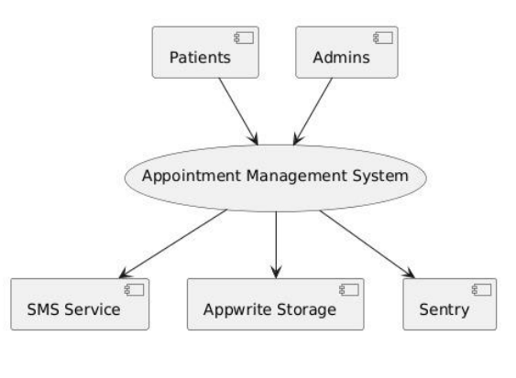

DFD (level 1)
Patient Registration: Input: Patient provides details. Process: Patient data is validated and stored in the database. Output: Registration successful, patient profile created.
Appointment Booking: Input: Patient selects available time slots with doctors. Process: System validates the availability and books an appointment. Output: Appointment confirmation (SMS notification sent).
Admin Appointment Management: Input: Admin views scheduled appointments. Process: Admin confirms, reschedules, or cancels the appointments. Output: Appointment status updated (SMS notification sent to the patient).
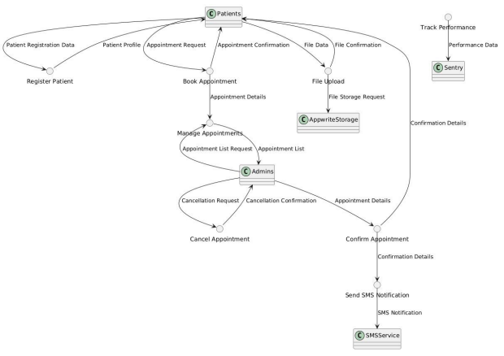

ER Diagram
Entities:
Patient: Attributes: PatientID, Name, Age, Gender, Contact Info, Address, Medical History.
Doctor: Attributes: DoctorID, Name, Specialization, Available Slots.
Appointment: Attributes: AppointmentID, PatientID, DoctorID, AppointmentDate, Time, Status.
Admin: Attributes: AdminID, Name, Email, Role. Relationships: A Patient can book multiple Appointments. An Appointment is associated with one Doctor and one Patient. An Admin manages many Appointments
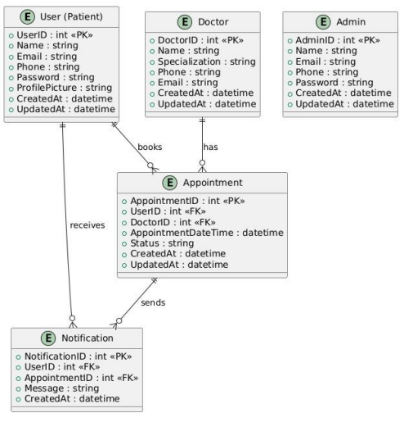

System Features
- Patient Registration and Appointment Booking: Intuitive process for users to register and easily schedule appointments through a user-friendly interface.
- Administrative Functionalities: Allows administrators to manage, reschedule, and cancel appointments, providing flexibility for both patients and healthcare providers.
- Real-time SMS Notifications: Integrated with Twilio to send real-time SMS updates regarding appointments, changes, and reminders to patients, improving communication.
- Secure File Upload for Medical Records: Enables secure uploading and storage of medical records, ensuring data privacy and authorized access.
- Performance Monitoring with Sentry: Proactively detects and addresses errors, ensuring system reliability and performance through real-time error monitoring.
- User Authentication and Data Security: Appwrite-powered backend ensures secure user authentication and protection of sensitive data with encryption.
- Scalable Architecture: Designed to scale efficiently as the number of users and data increases, maintaining optimal performance and security.

Implementation and Deployment
The implementation of the Healthcare Management System (HMS) follows a structured process, from development to deployment, ensuring stability and scalability.
- Front-End Development: The user interface is designed for simplicity and responsiveness, using modern front-end technologies. It allows patients to register, book appointments, and receive notifications. Administrators can manage appointments, reschedule, and cancel through an intuitive dashboard.
- Back-End Development: Powered by Appwrite, the back-end handles user authentication, data management, and API integration. The system manages patient data, appointment scheduling, medical records, and SMS notifications through Twilio. The data integrity is maintained through an Entity Relationship (ER) model.
- Testing: Comprehensive testing is performed to ensure the system’s stability:
  - Unit Testing: Each function and component, like front-end actions and backend processes, is tested individually to ensure they perform correctly.
  - Integration Testing: The interaction between front-end, back-end, and Twilio services is tested to confirm seamless data flow and interaction across the system.
  - Performance Testing: Stress and load testing are conducted to assess the system's ability to handle a high number of concurrent users, ensuring that performance remains stable under heavy traffic.
- Deployment: After successful development and testing, the system is deployed to cloud platforms to ensure scalability and high availability. Tools like Sentry are used for performance monitoring and error detection, allowing proactive issue resolution post-deployment.

Result and discussion
- Patients and administrators have both provided excellent feedback on the Healthcare Management System (HMS). Patients enjoy using Twilio for registration, appointment booking, and SMS notifications, while administrators appreciate the fast appointment management capabilities. The technology has increased healthcare accessibility by allowing patients to manage appointments and view medical records remotely, resulting in better communication between patients and doctors.
The system has performed consistently, with stress and load testing showing its capacity to manage additional traffic without performance concerns. Sentry provides real-time monitoring to enable proactive error identification and system stability. The implementation of Appwrite for secure authentication and Twilio for real-time notifications has improved security and dependability.
Overall, the HMS has improved the user experience, accessibility, and communication while remaining stable under stress. Future developments could focus on adding features and scaling the system to accommodate larger user bases.

Conclusion
The Healthcare Management System (HMS) effectively addresses key problems in healthcare management, enhancing appointment booking, medical record management, and communication between patients and administrators. By integrating real-time SMS notifications and secure file uploads, the system improves accessibility and efficiency. Future improvements could include advanced features like telemedicine integration and AI-driven appointment scheduling. The HMS has a significant impact on healthcare accessibility, empowering patients to manage their health remotely, while also improving the overall patient experience through streamlined processes and real-time updates, making healthcare more accessible and user-friendly.

References
- S. Dash, S. K. Shakyawar, M. Sharma, and S. Kaushik, "Big data in healthcare: management, analysis and future prospects," J. Big Data, vol. 6, no. 1, pp. 1-25, 2019.
- K. A. Wager, F. W. Lee, and J. P. Glaser, Health Care Information Systems: A Practical Approach for Health Care Management. Hoboken, NJ, USA: John Wiley & Sons, 2021.
- A. Khatoon, "A blockchain-based smart contract system for healthcare management," Electronics, vol. 9, no. 1, p. 94, 2020.
- L. Ismail, H. Materwala, and S. Zeadally, "Lightweight blockchain for healthcare," IEEE Access, vol. 7, pp. 149935-149951, 2019.
- H. B. Sharma, K. R. Vanapalli, B. Samal, V. S. Cheela, B. K. Dubey, and J. Bhattacharya, "Circular economy approach in solid waste management system to achieve UN-SDGs: Solutions for post-COVID recovery," Sci. Total Environ., vol. 800, p. 149605, 2021.
- I. S. Jacobs and C. P. Bean, “Fine particles, thin films and exchange anisotropy,” in Magnetism, vol. III, G. T. Rado and H. Suhl, Eds. New York: Academic, 1963, pp. 271–350.
- H. Pallathadka, M. Mustafa, D. T. Sanchez, G. S. Sajja, S. Gour, and M. Naved, "Impact of machine learning on management, healthcare and agriculture," Mater. Today: Proc., vol. 80, pp. 2803-2806, 2023.
- M. Rasmi, M. B. Alazzam, M. K. Alsmadi, I. A. Almarashdeh, R. A. Alkhasawneh, and S. Alsmadi, "Healthcare professionals’ acceptance of Electronic Health Records system: Critical literature review (Jordan case study)," Int. J. Healthcare Manag., 2020.

