Healthcare Management System

line 1: 1st Given Name Surname
line 2: dept. name of organization
(of Affiliation)
line 3: name of organization
(of Affiliation)
line 4: City, Country
line 5: email address or ORCID

Abstract— This paper introduces the Healthcare Management System (HMS), an online resource intended to enhance communication between medical staff and patients. Using cutting-edge technologies like Next.js, Appwrite, TailwindCSS, Twilio, and Sentry, the solution streamlines patient registration, appointment scheduling, and administration. The system also includes features for real-time SMS notifications, allowing patients to receive updates regarding their appointments, while administrators can efficiently manage appointments. Designed to enhance healthcare accessibility, the HMS supports secure file uploads and provides performance monitoring for system reliability. This paper details the design, development, and implementation of the system, including its architecture, key features, and the real-world impact it can have in healthcare settings.

Introduction
The project is a modern blogging platform designed using Next.js and TypeScript. It focuses on delivering a seamless and engaging experience for both content creators and readers. The platform ensures robust and scalable performance by leveraging advanced web technologies such as Prisma for efficient database management and Next Auth for secure user authentication. The website features a dynamic homepage that lists blogs in visually appealing card layouts, displaying essential details like titles, thumbnails, and short descriptions. Readers can access detailed blog pages with enriched content, including images, code snippets, and topics covered, offering a comprehensive reading experience. Tailwind CSS ensures a clean, responsive design adaptable to light and dark modes, catering to diverse user preferences. The integration with Cloudinary enables efficient image management, improving performance and user satisfaction. For content creators, the platform plans to incorporate Draft.js, a rich text editor, simplifying the blog creation process with support for multimedia and formatting options.
This project aims to create a robust blogging ecosystem, prioritizing user engagement, scalability, and maintainability, while providing a secure, feature-rich platform for showcasing creative content.

Ease of Use

Literature Review
Existing healthcare management systems often face challenges such as suboptimal user experiences, limited scalability, and communication gaps among stakeholders. By adopting modern web technologies like Next.js, Prisma, and NextAuth, the proposed Healthcare Management System addresses these issues, ensuring a seamless, scalable, and secure platform for efficient management and improved collaboration.

System Architecture
The Healthcare Management System (HMS) features a modern architecture. The front-end uses Next.js for server-side rendering and Tailwind CSS for responsive design, ensuring speed and user-friendliness. The back-end leverages Appwrite for secure database management and file storage. Twilio integration enables real-time SMS notifications for appointments and updates, while Sentry monitors performance and ensures system reliability. This modular and adaptable design offers improved user experience, smooth communication, and strong functionality to meet healthcare concerns.

Data Flow and Entity Relationships
The HMS data flow ensures that all system components work together seamlessly. Users interact with the front-end, which communicates with the Appwrite-powered back-end that handles authentication, data retrieval, and changes. Twilio supports real-time SMS notifications for appointment reminders and updates. The system's Entity Relationship (ER) paradigm separates data into entities such as Users, Appointments, Medical Records, and Notifications while preserving relational integrity. Key linkages include "User-Appointment" and "Doctor-Patient" improve data management and access. This design prioritizes scalability, security, and user experience, guaranteeing that the system can handle growing data loads while safeguarding sensitive information and delivering speedy interactions. The architecture is designed for expansion and dependable performance, providing a complete solution for managing healthcare operations.

DFD (level 0)
Level 0 - Context Diagram: Patient: Registers, books, and manages appointments. Administrator: Manages the appointment schedules and confirms/cancels appointments. Twilio API: Sends SMS notifications for appointment confirmations.
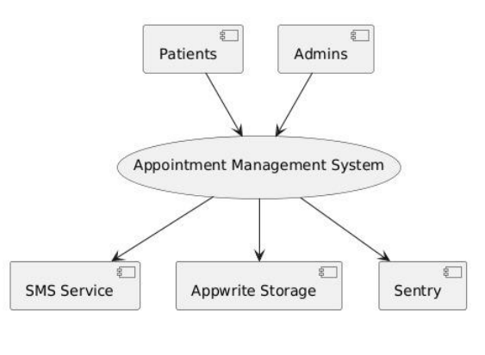

DFD (level 1)
Patient Registration: Input: Patient provides details. Process: Patient data is validated and stored in the database. Output: Registration successful, patient profile created.
Appointment Booking: Input: Patient selects available time slots with doctors. Process: System validates the availability and books an appointment. Output: Appointment confirmation (SMS notification sent).
Admin Appointment Management: Input: Admin views scheduled appointments. Process: Admin confirms, reschedules, or cancels the appointments. Output: Appointment status updated (SMS notification sent to the patient).
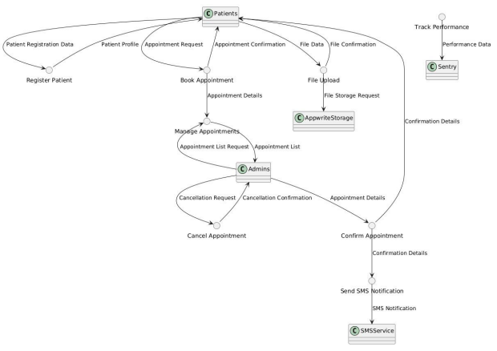

ER Diagram
Entities:
Patient: Attributes: PatientID, Name, Age, Gender, Contact Info, Address, Medical History.
Doctor: Attributes: DoctorID, Name, Specialization, Available Slots.
Appointment: Attributes: AppointmentID, PatientID, DoctorID, AppointmentDate, Time, Status.
Admin: Attributes: AdminID, Name, Email, Role. Relationships: A Patient can book multiple Appointments. An Appointment is associated with one Doctor and one Patient. An Admin manages many Appointments
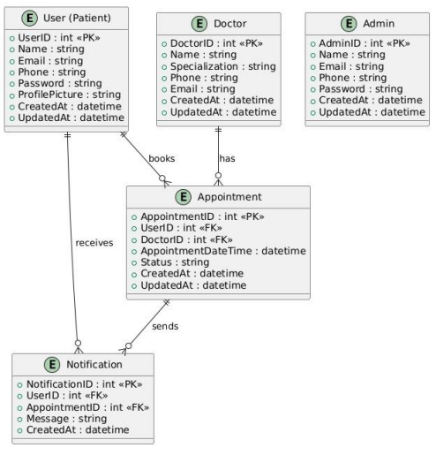

System Features
- • Patient Registration and Appointment Scheduling: A user-friendly interface makes it simple for users to register and make appointments.
• Administrative Functionalities: Gives patients and healthcare providers flexibility by enabling administrators to schedule, manage, and cancel appointments.
• Real-time SMS Notifications: Integrated with Twilio to send real-time SMS updates regarding appointments, changes, and reminders to patients, improving communication.
• safe File Upload for Medical Records: Enables safe uploading and storage of medical records, protecting data protection and permitted access.
• Performance Monitoring with Sentry: Proactively discovers and addresses issues, ensuring system reliability and performance with real-time error monitoring.
- User Authentication and Data Security: Appwrite-powered backend ensures secure user authentication and protection of sensitive data with encryption.
- Scalable Architecture: Designed to scale efficiently as the number of users and data increases, maintaining optimal performance and security.

Implementation and Deployment
The Healthcare Management System (HMS) is implemented using a disciplined procedure, from development to deployment, to ensure stability and scalability.
• Front-End Development: Modern front-end technologies are used to create a user experience that is both simple and responsive. It allows patients to sign up, schedule appointments, and receive notifications. Administrators may use a simple dashboard to manage appointments, reschedule, and cancel.
• Backend Development: The backend is powered by Appwrite and handles user authentication, data management, and API integration. The system maintains patient data, appointment scheduling, medical records, and SMS notifications using Twilio.

Result and discussion
- Patients and administrators have both provided excellent feedback on the Healthcare Management System (HMS). Patients enjoy using Twilio for registration, appointment booking, and SMS notifications, while administrators appreciate the fast appointment management capabilities. The technology has increased healthcare accessibility by allowing patients to manage appointments and view medical records remotely, resulting in better communication between patients and doctors.
The system has performed consistently, with stress and load testing showing its capacity to manage additional traffic without performance concerns. Sentry provides real-time monitoring to enable proactive error identification and system stability. The implementation of Appwrite for secure authentication and Twilio for real-time notifications has improved security and dependability.
Overall, the HMS has improved the user experience, accessibility, and communication while remaining stable under stress. Future developments could focus on adding features and scaling the system to accommodate larger user bases.

Conclusion
The Healthcare Management System (HMS) effectively addresses key problems in healthcare management, enhancing appointment booking, medical record management, and communication between patients and administrators. By integrating real-time SMS notifications and secure file uploads, the system improves accessibility and efficiency. Advanced features like AI-driven appointment scheduling and telemedicine integration may be added in the future. By enabling patients to remotely control their health and enhancing the overall patient experience through faster procedures and real-time information, the HMS significantly improves healthcare accessibility and user-friendliness.

References
- S. Dash, S. K. Shakyawar, M. Sharma, and S. Kaushik, "Big data in healthcare: management, analysis and future prospects," J. Big Data, vol. 6, no. 1, pp. 1-25, 2019.
- K. A. Wager, F. W. Lee, and J. P. Glaser, Health Care Information Systems: A Practical Approach for Health Care Management. Hoboken, NJ, USA: John Wiley & Sons, 2021.
- A. Khatoon, "A blockchain-based smart contract system for healthcare management," Electronics, vol. 9, no. 1, p. 94, 2020.
- L. Ismail, H. Materwala, and S. Zeadally, "Lightweight blockchain for healthcare," IEEE Access, vol. 7, pp. 149935-149951, 2019.
- H. B. Sharma, K. R. Vanapalli, B. Samal, V. S. Cheela, B. K. Dubey, and J. Bhattacharya, "Circular economy approach in solid waste management system to achieve UN-SDGs: Solutions for post-COVID recovery," Sci. Total Environ., vol. 800, p. 149605, 2021.
- I. S. Jacobs and C. P. Bean, “Fine particles, thin films and exchange anisotropy,” in Magnetism, vol. III, G. T. Rado and H. Suhl, Eds. New York: Academic, 1963, pp. 271–350.
- H. Pallathadka, M. Mustafa, D. T. Sanchez, G. S. Sajja, S. Gour, and M. Naved, "Impact of machine learning on management, healthcare and agriculture," Mater. Today: Proc., vol. 80, pp. 2803-2806, 2023.
- M. Rasmi, M. B. Alazzam, M. K. Alsmadi, I. A. Almarashdeh, R. A. Alkhasawneh, and S. Alsmadi, "Healthcare professionals’ acceptance of Electronic Health Records system: Critical literature review (Jordan case study)," Int. J. Healthcare Manag., 2020.

