This file is to be extracted.

Section 1 – docx_testing:
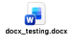

Section 2 – xlsx_testing:
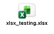

Section 3 – pdf_testing:
Section 4 – eml_testing:
Section 5 – csv_testing:

Section 6 – The End!

