A. Object Information
Object Id | 123456
Object Name | XYZ
Object Developer | Akash
Object Reviewer | Akash

Instructions
- This is a sample ODD-ORR template for testing.
- This is created for testing purpose.
- The template is similar to the non-tabular version of the GenAI ODD-ORR.

Disclosure
CONFIDENTIALITY & MODEL RISK MANAGEMENT DISCLOSURE STATEMENT: The information contained in this document is strictly proprietary, legally privileged, and intended solely for internal risk assessment, governance, and validation purposes by authorized institutional bodies. Certain architectural components of this system leverage pre-trained foundational technologies and API infrastructure provided by external third-party vendors; due to the proprietary nature and inherent black-box characteristics of these base models, detailed training methodologies, weights, and data subsets remain undisclosed. This system is classified strictly as an assistive, non-model tool designed to enhance internal productivity under a mandatory 100% human-in-the-loop operational constraint, meaning all generated outputs must be manually reviewed by an internal operator before any downstream reliance or implementation. Performance data, stability thresholds, and safety guardrail metrics (including hallucination and toxicity negative testing) reflect specific empirical development and User Acceptance Testing (UAT) conditions verified by Subject Matter Experts (SMEs); actual operational results remain subject to data drift, third-party updates, and ongoing monitoring compliance. Unauthorized review, duplication, or distribution of this document, in whole or in part, without explicit written authorization from the designated Sponsor or Model Risk Management body is strictly prohibited, and continued access constitutes formal agreement to these operational boundaries and disclosure conditions.

Information Checklist
This | Is | A
Dummy | Table | .

B. Summary – Review Outcome (to be completed by Object Reviewer)

Object Approval Status
[Checkboxes]

Object Risk Rating
[Checkboxes]
[Detailed risk rating in a table]

Summary of Review Outcome
[Some instructions for reviewer on what to fill in this section]
<review_summary_and_limitation_table>

Limitations Identified (please add as applicable)
Limitation ID
Limitation Type
Limitation Description

C. Object Development Document and Object Reviewer Commentary

1.0 Object Scope, Purpose, and Use [To be completed by Object Sponsor]
Every technology shift is an opportunity to advance scientific discovery, accelerate human progress, and improve lives. I believe the transition we are seeing right now with AI will be the most profound in our lifetimes, far bigger than the shift to mobile or to the web before it. AI has the potential to create opportunities — from the everyday to the extraordinary — for people everywhere. It will bring new waves of innovation and economic progress and drive knowledge, learning, creativity and productivity on a scale we haven’t seen before.
That’s what excites me: the chance to make AI helpful for everyone, everywhere in the world.
Nearly eight years into our journey as an AI-first company, the pace of progress is only accelerating: Millions of people are now using generative AI across our products to do things they couldn’t even a year ago, from finding answers to more complex questions to using new tools to collaborate and create. At the same time, developers are using our models and infrastructure to build new generative AI applications, and startups and enterprises around the world are growing with our AI tools.
This is incredible momentum, and yet, we’re only beginning to scratch the surface of what’s possible.
We’re approaching this work boldly and responsibly. That means being ambitious in our research and pursuing the capabilities that will bring enormous benefits to people and society, while building in safeguards and working collaboratively with governments and experts to address risks as AI becomes more capable. And we continue to invest in the very best tools, foundation models and infrastructure and bring them to our products and to others, guided by our AI Principles.
Now, we’re taking the next step on our journey with Gemini, our most capable and general model yet, with state-of-the-art performance across many leading benchmarks. Our first version, Gemini 1.0, is optimized for different sizes: Ultra, Pro and Nano. These are the first models of the Gemini era and the first realization of the vision we had when we formed Google DeepMind earlier this year. This new era of models represents one of the biggest science and engineering efforts we’ve undertaken as a company. I’m genuinely excited for what’s ahead, and for the opportunities Gemini will unlock for people everywhere.

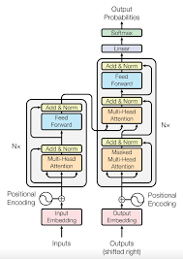

ORR Section 1.0 (to be completed by Object Reviewer)
[Instructions for Object Reviewers]
<section_1_reviewer_assessment>

2.0 Object Methodology

2.1 Object Design
We've been rigorously testing our Gemini models and evaluating their performance on a wide variety of tasks. From natural image, audio and video understanding to mathematical reasoning, Gemini Ultra’s performance exceeds current state-of-the-art results on 30 of the 32 widely-used academic benchmarks used in large language model (LLM) research and development.
With a score of 90.0%, Gemini Ultra is the first model to outperform human experts on MMLU (massive multitask language understanding), which uses a combination of 57 subjects such as math, physics, history, law, medicine and ethics for testing both world knowledge and problem-solving abilities.
Our new benchmark approach to MMLU enables Gemini to use its reasoning capabilities to think more carefully before answering difficult questions, leading to significant improvements over just using its first impression.
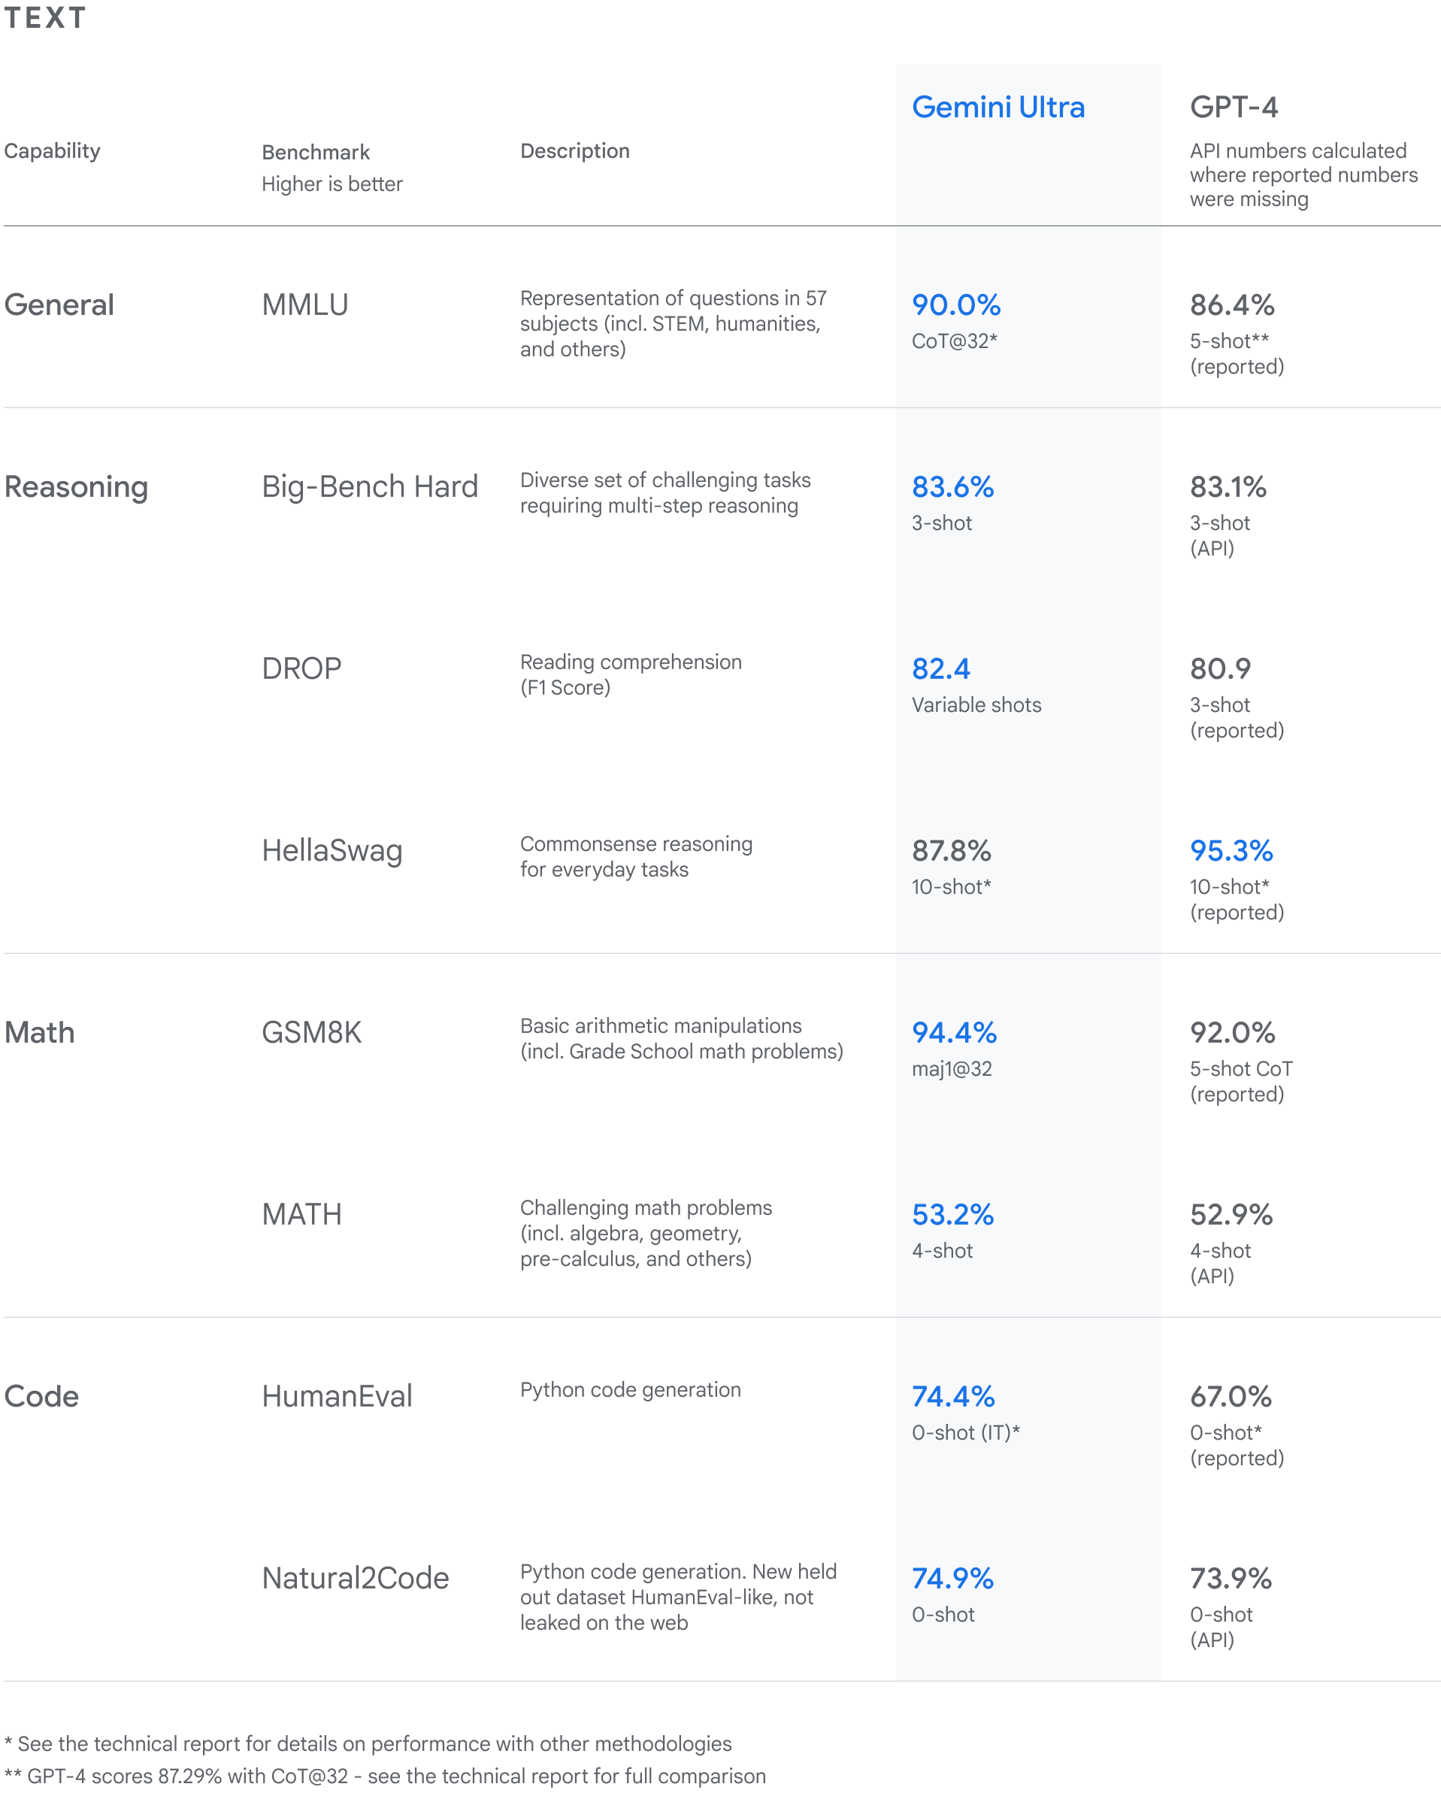
Gemini surpasses state-of-the-art performance on a range of benchmarks including text and coding.
Gemini Ultra also achieves a state-of-the-art score of 59.4% on the new MMMU benchmark, which consists of multimodal tasks spanning different domains requiring deliberate reasoning.
With the image benchmarks we tested, Gemini Ultra outperformed previous state-of-the-art models, without assistance from optical character recognition (OCR) systems that extract text from images for further processing. These benchmarks highlight Gemini’s native multimodality and indicate early signs of Gemini's more complex reasoning abilities.
See more details in our Gemini technical report.

2.2 Data
Gemini 3 is our most intelligent model family to date, built on a foundation of state-of-the-art reasoning. It is designed to bring any idea to life by mastering agentic workflows, autonomous coding, and complex multimodal tasks. This guide covers key features of the Gemini 3 model family and how to get the most out of it.
Explore our collection of Gemini 3 apps to see how the model handles advanced reasoning, autonomous coding, and complex multimodal tasks.
Get started with a few lines of code:
from google import genai

client = genai.Client()

interaction = client.interactions.create(
model="gemini-3.1-pro-preview",
input="Find the race condition in this multi-threaded C++ snippet: [code here]",
)

print(interaction.output_text)

Meet the Gemini 3 series
Gemini 3.1 Pro is best for complex tasks that require broad world knowledge and advanced reasoning across modalities.
Gemini 3 Flash is our latest 3-series model, with Pro-level intelligence at the speed and pricing of Flash.
Nano Banana Pro (also known as Gemini 3 Pro Image) is our highest quality image generation model, and Nano Banana 2 (also known as Gemini 3.1 Flash Image) is the high-volume, high-efficiency, lower price-point equivalent.
Gemini 3.1 Flash-Lite is our workhorse model built for cost-efficiency model and high-volume tasks.
All Gemini 3 models are currently in preview.
Model ID | Context Window (In / Out) | Knowledge Cutoff | Pricing (Input / Output)*
gemini-3.1-flash-lite | 1M / 64k | Jan 2025 | $0.25 (text, image, video), $0.50 (audio) / $1.50
gemini-3.1-flash-image-preview | 128k / 32k | Jan 2025 | $0.25 (Text Input) / $0.067 (Image Output)**
gemini-3.1-pro-preview | 1M / 64k | Jan 2025 | $2 / $12 (<200k tokens)  $4 / $18 (>200k tokens)
gemini-3-flash-preview | 1M / 64k | Jan 2025 | $0.50 / $3
gemini-3-pro-image-preview | 65k / 32k | Jan 2025 | $2 (Text Input) / $0.134 (Image Output)**
* Pricing is per 1 million tokens unless otherwise noted. ** Image pricing varies by resolution. See the pricing page for details.
For detailed limits, pricing, and additional information, see the models page.

ORR Section 2.0 (to be completed by Object Reviewer)
[Instructions for Object Reviewers]
<section_2_reviewer_assessment>

3.0 Object Testing/ Performance [To be completed by Object Sponsor]
We've been rigorously testing our Gemini models and evaluating their performance on a wide variety of tasks. From natural image, audio and video understanding to mathematical reasoning, Gemini Ultra’s performance exceeds current state-of-the-art results on 30 of the 32 widely-used academic benchmarks used in large language model (LLM) research and development.
With a score of 90.0%, Gemini Ultra is the first model to outperform human experts on MMLU (massive multitask language understanding), which uses a combination of 57 subjects such as math, physics, history, law, medicine and ethics for testing both world knowledge and problem-solving abilities.
Our new benchmark approach to MMLU enables Gemini to use its reasoning capabilities to think more carefully before answering difficult questions, leading to significant improvements over just using its first impression.

Gemini surpasses state-of-the-art performance on a range of benchmarks including text and coding.
Gemini Ultra also achieves a state-of-the-art score of 59.4% on the new MMMU benchmark, which consists of multimodal tasks spanning different domains requiring deliberate reasoning.
With the image benchmarks we tested, Gemini Ultra outperformed previous state-of-the-art models, without assistance from optical character recognition (OCR) systems that extract text from images for further processing. These benchmarks highlight Gemini’s native multimodality and indicate early signs of Gemini's more complex reasoning abilities.
See more details in our Gemini technical report.

ORR Section 3.0 (to be completed by Object Reviewer)
[Instructions for Object Reviewers]
<section_3_reviewer_assessment>

D. Relevant Documentation [To be completed by Object Sponsor]
[Attachments]

Template Version Control
Version | Date | Approved By
1.0 | June | Akash

