**Think and Answer**

**<eYRC#2557>**

|  |  |
| --- | --- |
| **Team leader name** | ARUNAVA DEY |
| **College** | B.P. PODDAR INSTITUTE OF MANAGEMENT & TECHNOLOGY |
| **Email** | adey26003@gmail.com |
| **Date** | 25.11.2019 |

Please answer all the questions given below. You are allowed to use figures or diagrams to support your answer. Since these questions test your understanding of the whole subject, please refrain from directly asking for answers on Piazza.

**Section 1 - Simple Pendulum**

Q1) Find the eigenvalues of Simple Pendulum at equilibrium point (0,0). Is the system stable or unstable at this point? (2)

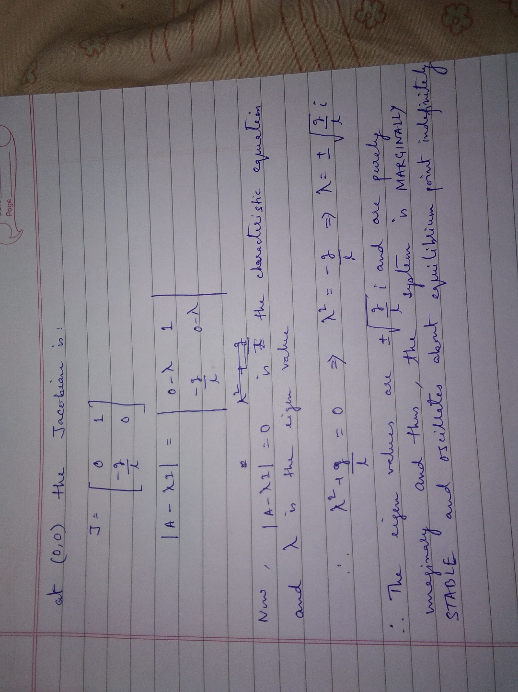

Q2) Can the Pendulum be balanced at an arbitrary point such as (2π/3,0) using the Pole Placement or LQR controller? Why? Why Not? Justify your answer. (3)

Ans: No, the pendulum cannot be balanced at an arbitrary point (2π/3,0) using the Pole Placement or LQR controller since the system can only be balanced at an equilibrium point and (2π/3,0) is not such a point

**Section 2 - Mass Spring System**

Q3) Derive the equations of Mass Spring system. (3)

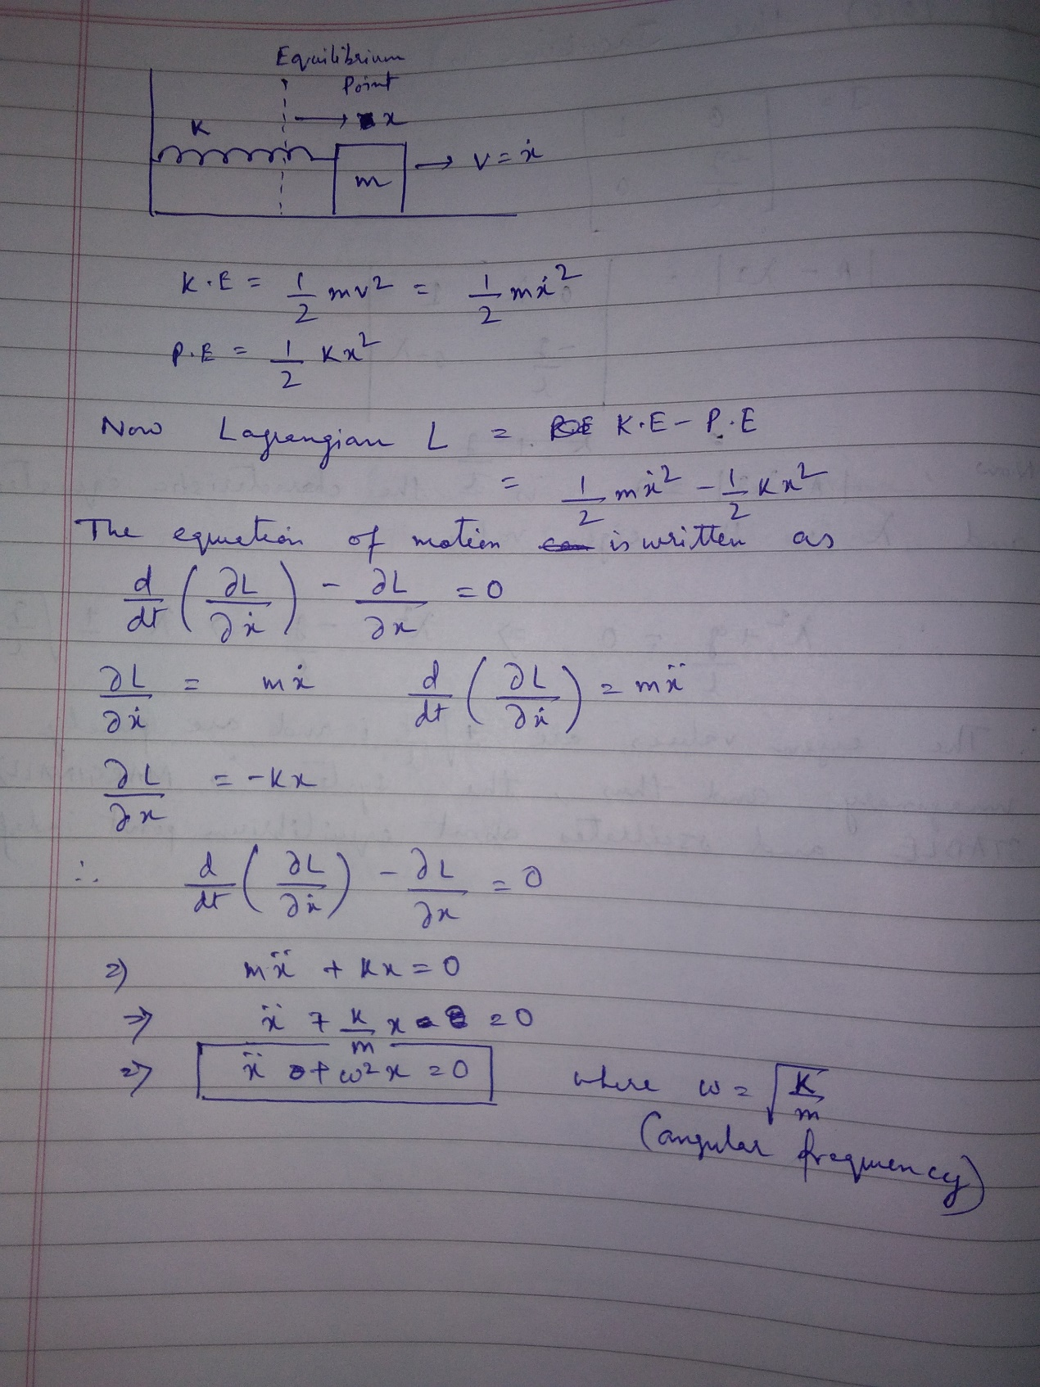

Q4) Is the mass spring system a linear system or non-linear? Justify your answer. (1)

Ans: Mass Spring system is a linear system since the equations satisfy the principle of superposition (i.e. both law of additivity and law of homogeneity).

Q5) Can the mass spring system be driven to arbitrary state (0.8, 0) using pole placement controller? (Assuming 0.8 is the position and 0 is the velocity). (1)

Ans: Yes, the mass spring system can be driven to arbitrary state (0.8,0) using pole placement controller by adjusting the eigenvalues to be used in place () function.

**Section 3 - Simple Pulley**

Q6) Under what conditions, will the system remain perfectly at rest? Justify your answer. (1)

Ans: The system will be perfectly at rest if the pulley has masses of equal magnitude (say m) and they are suspended from the pulley at equal distance from the pulley (i.e. if the string is of length L then the masses will be suspended with L/2 length of string on each side). This way, the masses will have same Potential Energy (i.e. mgL/2)

Q7) How many equilibrium points does the system have? Are they stable or unstable? Justify your answer. (2)

Ans: The system has only one equilibrium point that is (0,0) i.e. velocity=0 m/s and acceleration=0 m/s^2, the position of blocks is a free variable. This point is marginally stable and is sensitive to any external force and a little force will result in disturbance in equilibrium state.

**Section 4 - Complex Pulley**

Q8) Derive the equations of motion for the complex pulley system. (5)

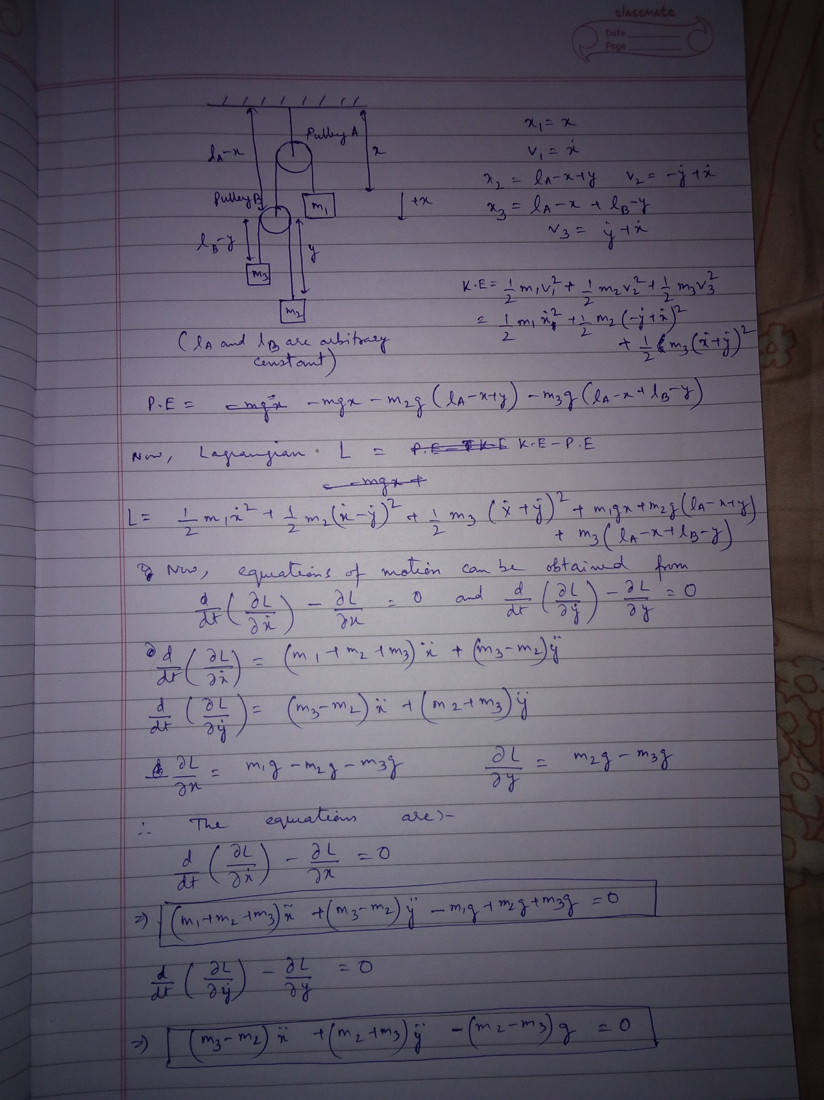

Q9) Derive the A and B matrices for the complex pulley system. Is the system linear or non linear? (4)

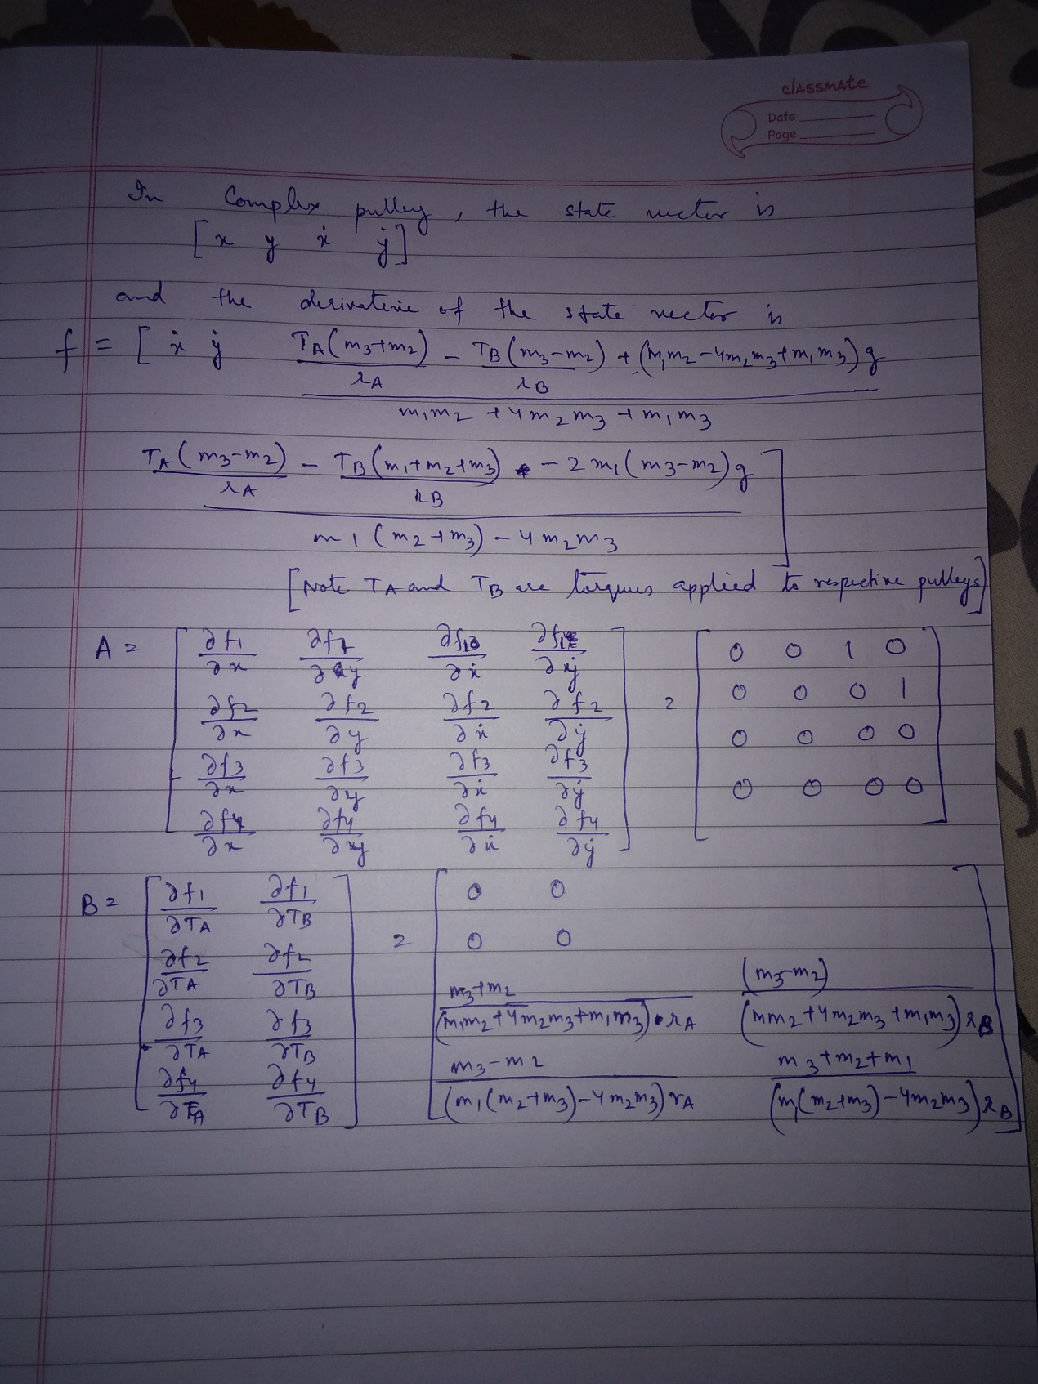

The system is non-linear since the output depends on more than one input parameters and thus does not follow principle of homogeneity.

Q10) Under what conditions, will the system remain perfectly at rest? Justify your answer. (3)

Ans: The system will be at rest when potential energy on both sides of the pulleys will be equal. This will happen when m1=m2+m3 and m2=m3 and if the length of the string is L then each mass should be suspended through a string of length L/2.

In that case, at Pulley A,

m1gL/2 = (m2+m3)gL/2 [since m1=m2+m3]

at Pulley B,

m2gL/2 = m3gL/2 [since m2 = m3]

**Section 5 - Inverted Cart Pendulum**

Q11) Derive the equations of motion for the inverted cart pendulum system. Is this system linear or non-linear? Why? (7)

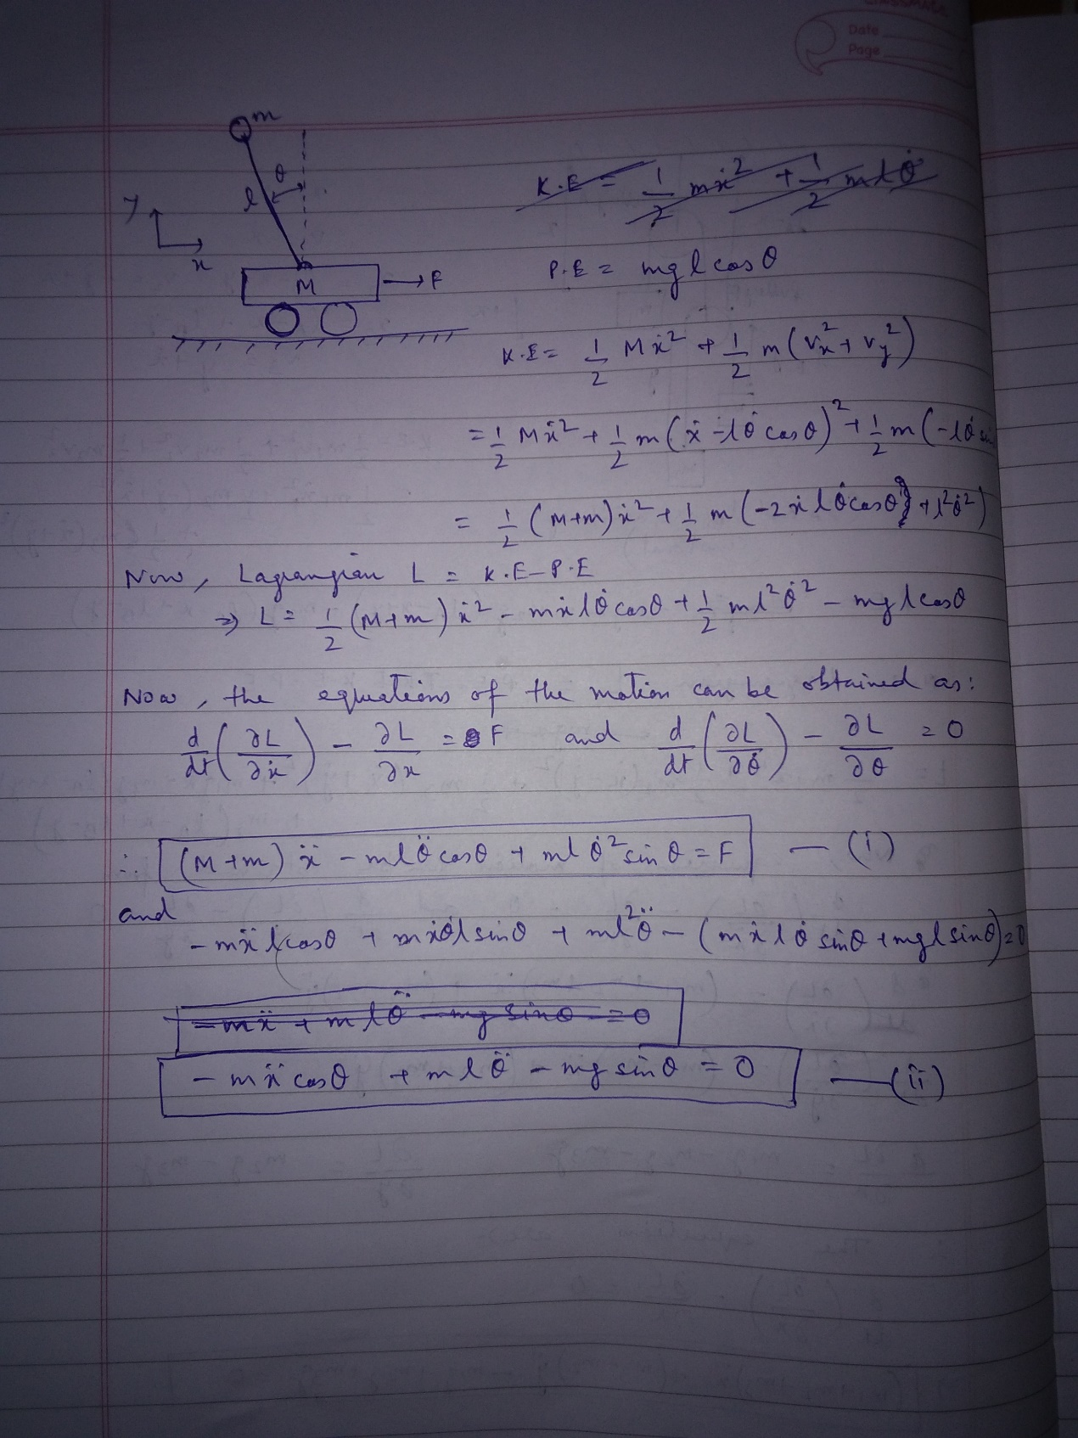

Q12) How many equilibrium points does the inverted cart pendulum system have? Categorize them as stable or unstable? (3)

Ans:There are two equilibrium states for Inverted Pendulum system, vertical up and vertical down, in which the vertical up is the unstable equilibrium point and vertical down is the stable equilibrium point.