**PROBLEM STATEMENT:**

1. Solve the following problem using Prolog using the family tree diagram given below:

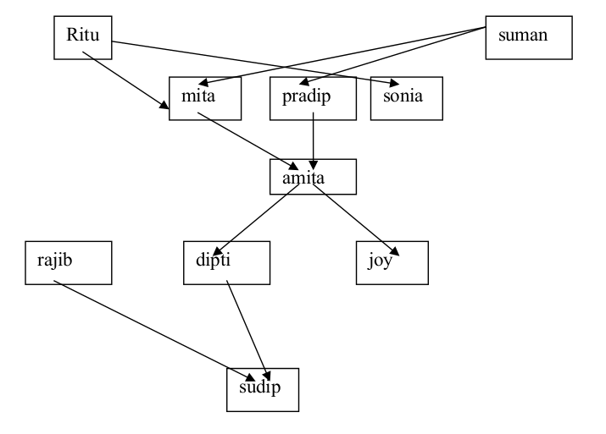

Consider ritu, mita, amita, sonia, dipti are female and rest all are male.

Write appropriate clauses and goals to answer the following queries:

● Who is the grandmother of sudip?

● Who is the grandson of mita?

● Who is the grandfather of dipti?

● Who is the aunt of amita?

**Solution:**

parent(ritu,mita).

parent(ritu,sonia).

parent(suman,mita).

parent(suman,pradip).

parent(pradip,amita).

parent(mita,amita).

parent(amita,joy).

parent(amita,dipti).

parent(rajib,sudip).

parent(dipti,sudip).

male(suman).

male(pradip).

male(rajib).

male(joy).

male(sudip).

female(ritu).

female(mita).

female(sonia).

female(amita).

female(dipti).

grandparent(X,Y):-parent(X,Z),parent(Z,Y).

sister(X,Y):-parent(Z,X),parent(Z,Y),female(X),not(X=Y).

**OUTPUT:**

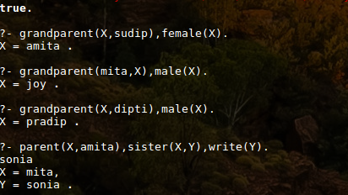

1. Write a prolog program to find out the n-th term of the Fibonacci series.

**Solution:**

fib(0,1).

fib(1,1).

fib(N,F):-N>1,N1 is N-1,fib(N1,F1),N2 is N-2,fib(N2,F2),F is F1+F2.

**OUTPUT:**

