UBA FRAUD DETECTION ANALYSIS
Data Quality, Behavioral Pattern, and Risk Exposure Report
Prepared by Adeyemi Tomiwa
Data Analyst | Financial Data Analysis

Executive Summary
This report analyzes 200,000 transactions from the UBA Fraud Detection dataset to identify behavioral patterns and risk indicators tied to fraudulent activity. After a full data quality and privacy review, the dataset showed a fraud rate of 5.04 percent against 94.96 percent legitimate transactions. Across account type, transaction type, channel, device, geography, transaction amount, and account balance, no single feature strongly separates fraud from legitimate activity. Fraud rate stayed within a narrow 4.9 to 6.2 percent band across every dimension tested. This points to a fraud pattern that is diffuse rather than concentrated, and the recommendations in this report focus on combined-condition monitoring and closing structural data gaps rather than a single high-risk rule.

1. Data Quality Review and Privacy Compliance
The raw file contained 200,002 rows and 22 columns. Two rows were fully blank across every field and were removed, leaving 200,000 complete, usable rows. No partial nulls were found anywhere else in the dataset, and zero duplicate Transaction_IDs were found after the blank rows were removed.
All categorical fields, including Gender, Account_Type, Transaction_Type, Merchant_Category, and Device_Type, were already consistently labeled with no spelling variants or case mismatches. Transaction_Amount and Account_Balance were stored as text with a naira symbol and thousands separators and were converted to proper decimal numbers. Transaction_Date and Transaction_Time were parsed into true date and time types. All 19 remaining columns were standardized to lower_snake_case naming.
Three direct personal identifiers were found: Customer_Name, Customer_Contact, and Customer_Email. All three were removed entirely from the analysis dataset. Customer_ID was retained because it is a system-generated identifier with no reversible link to a real name, allowing behavioral tracking without exposing anyone's identity. The full SQL documentation of every step is included in the supporting files submitted alongside this report.

2. Key Findings
Class Distribution | Fraud accounts for 5.04% of transactions (10,088 of 200,000), legitimate transactions for 94.96%, a ratio of roughly 19 to 1. This imbalance means accuracy alone would be a misleading metric for any future model; a model predicting “not fraud” every time would still score above 94% while catching zero fraud.
Account & Transaction Risk | Fraud rate holds in a tight 4.9% to 5.2% band across every account type (Business, Savings, Checking) and every transaction type. No category is meaningfully riskier than another.
Temporal Patterns | Data covers a single month, January 2025. No day of week or hour of day shows a real spike; daily fraud rate fluctuates around the 5.04% baseline throughout, with no sustained upward or downward trend.
Device & Channel Risk | Debit/Credit Card (5.50%), Virtual Card (5.45%), and Biometric Scanner (5.39%) channels sit modestly above baseline. Payment Gateway Device (5.36%) and QR Code Scanner (5.18%) sit close to baseline. Spread across all channels is under half a point.
Geographic Concentration | Enugu is the highest state at 5.40%, Port Harcourt the lowest at 4.36%. At branch level, Atimbo (6.15%), Itam (6.14%), and Lafenwa (6.14%) run highest of all branches with at least 500 transactions. The overall spread remains narrow.
Financial Behavior | Transaction amount and account balance show almost no relationship to fraud, with fraud rate flat across every quintile of both.
3. Operational Risk Monitoring Dashboard
An interactive Power BI dashboard was built to support fraud operations and compliance review. It has four pages: Overview, Risk by Segment, Geographic Hotspots, and Financial Behaviour, each with Account_Type, Transaction_Type, and a Fraud Only toggle for filtering.
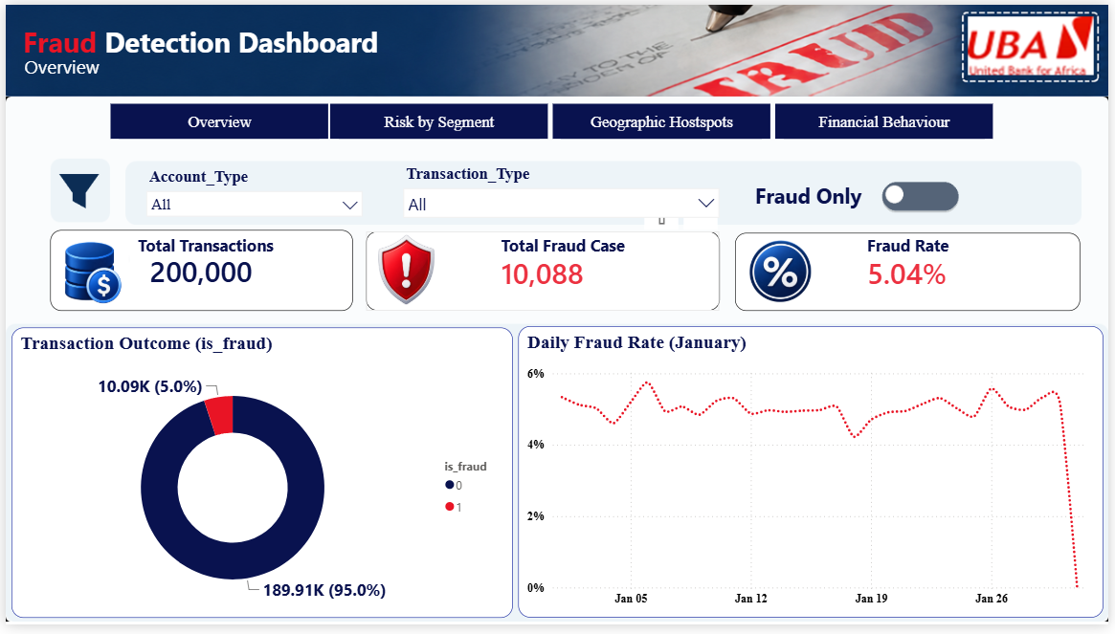
Figure 1. Overview — total transactions, fraud rate, transaction outcome split, and daily fraud rate trend.
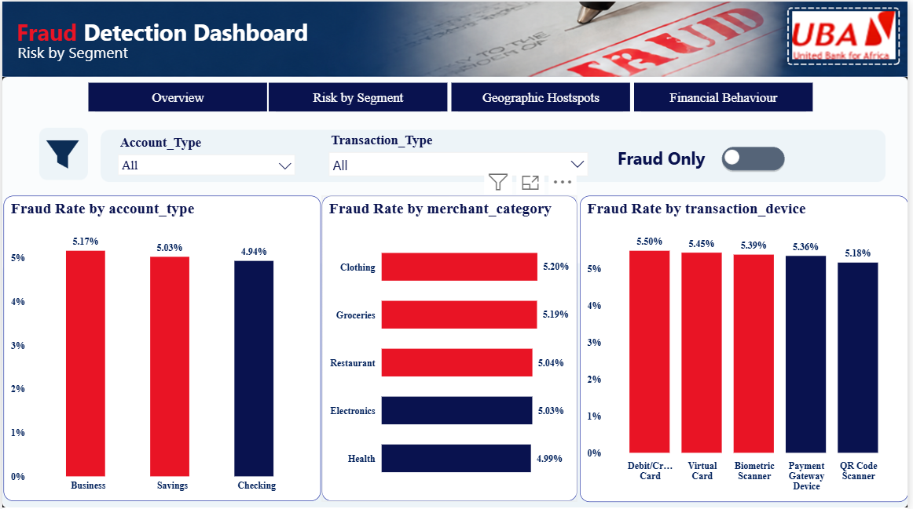
Figure 2. Risk by Segment — fraud rate by account type, merchant category, and transaction device.
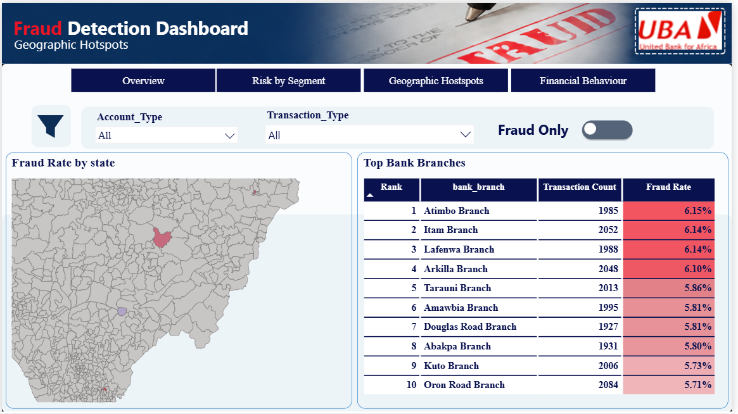
Figure 3. Geographic Hotspots — fraud rate by state and top bank branches by fraud rate.
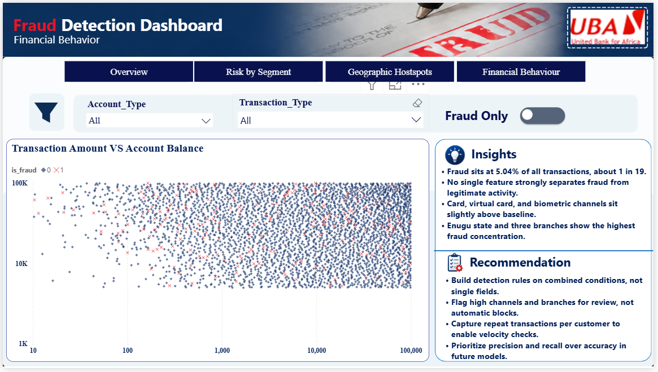
Figure 4. Financial Behaviour — transaction amount vs. account balance, colored by fraud outcome.

4. Business Insights and Risk Mitigation Recommendations

Key Insights
- Fraud sits at 5.04% of all transactions, about 1 in 19.
- No single feature strongly separates fraud from legitimate activity.
- Card, virtual card, and biometric channels sit slightly above baseline.
- Enugu state and three branches show the highest fraud concentration.

Recommendations
- Build detection rules on combined conditions, not single fields.
- Flag high channels and branches for review, not automatic blocks.
- Capture repeat transactions per customer to enable velocity checks.
- Prioritize precision and recall over accuracy in future models.

5. Limitations
Two structural constraints limit how much behavioral pattern this dataset can reveal. First, it spans a single calendar month, which is not enough to confirm seasonal or long-term trends. Second, every customer_id appears exactly once, which rules out velocity checks and deviation-from-normal-behavior analysis, two of the strongest signals used in real fraud detection systems. Both gaps are noted here for transparency and should be addressed in future data collection before a production fraud model is built on this data.

