Adaptive and Interpretable Model Simplification Under Dataset Variation: A Heuristic Framework for Feature Selection

Introduction
Feature selection (FS) remains a central step in machine learning because high-dimensional data can increase computational burden, amplify noise, and weaken generalisation when irrelevant or redundant variables are retained (Bolón-Canedo, Sánchez-Maroño and Alonso-Betanzos, 2015; Li et al., 2017). Across domains such as healthcare, finance, and computer vision, practitioners often need models that are not only accurate, but also efficient and interpretable. In such settings, FS can support dimensionality reduction, faster learning, and clearer model interpretation, but the success of any FS strategy depends strongly on the structure of the dataset itself.
Traditional FS methods are commonly grouped into three families: filter, wrapper, and embedded approaches. Filter methods are computationally efficient and scalable, but they often evaluate variables independently and may therefore miss interaction effects. Wrapper methods can capture interactions more effectively because they evaluate feature subsets in relation to a predictive model, but they are computationally expensive and can become impractical as dimensionality increases. Embedded methods offer a compromise by performing selection during model fitting, yet they remain dependent on model assumptions and may not transfer equally well across tasks (Guyon and Elisseeff, 2003; Kohavi and John, 1997; Tibshirani, 1996). As a result, no single FS family is consistently optimal across heterogeneous datasets, and method choice remains highly context dependent.
Recent work has increasingly explored automated and adaptive FS through AutoML, meta-learning, and reinforcement-learning-based methods. These approaches aim to reduce manual trial and error by selecting or learning suitable strategies from data, but they often introduce substantial computational overhead and reduced transparency. In practice, this creates a persistent tension: highly automated systems may improve flexibility, yet they can obscure why a particular FS strategy was selected, while simpler static approaches remain interpretable but adapt poorly to dataset variation (Zöller and Huber, 2021; Ren et al., 2022; Salehin et al., 2024). Existing literature therefore points to an unresolved problem: the need for FS approaches that are simultaneously adaptive, computationally feasible, and explainable.
This problem is especially important in applied domains where deployment constraints matter as much as benchmark performance. In healthcare-style tabular settings, unnecessarily aggressive selection may remove clinically meaningful predictors without improving already strong models. In imbalanced business datasets, a selector may appear successful under overall accuracy while failing badly on minority-class performance. In very high-dimensional settings, aggressive filtering may improve tractability but at the cost of discarding interaction-rich or semantically meaningful structure. These practical trade-offs suggest that FS should not be treated only as a search for higher predictive accuracy, but as a problem of model simplification under varying data conditions.
This paper addresses that gap by proposing a lightweight, rule-based framework for adaptive feature selection. Rather than relying on opaque optimisation, the framework uses measurable dataset meta-features, including the features-to-samples ratio, correlation structure, sparsity, and class imbalance, to select an appropriate FS family from filter, wrapper, and embedded methods. The design goal is not universal performance improvement, but transparent and evidence-based method selection that can support practical decision-making across heterogeneous datasets. In this sense, the framework is better understood as an interpretable mechanism for adaptive model simplification than as a claim that one automated pipeline can outperform all alternatives in all regimes.
The empirical contribution of the study lies in evaluating this framework across three contrasting benchmark settings: low-dimensional correlated healthcare data, sparse and severely imbalanced finance data, and high-dimensional vision-derived tabular data. The framework is assessed not only by predictive performance, but also by runtime, feature-subset stability, and SHAP-based interpretability. This broader evaluation perspective is important because the results show that adaptive FS is condition-dependent: it can behave safely in low-dimensional correlated data, fail systematically under imbalance and leakage, and trade predictive quality for tractability in extreme-dimensional settings. These outcomes highlight a critical methodological point: theoretically sensible family selection does not automatically guarantee useful downstream behaviour, and stability can coexist with invalid or misleading selection.
Accordingly, the main contribution of this paper is a transparent, rule-based framework for adaptive FS that treats runtime, stability, interpretability, and predictive performance as joint outcomes. The work contributes, first, a lightweight decision architecture that maps dataset characteristics to FS family choices; second, an evaluation perspective that goes beyond accuracy alone; third, the use of SHAP as an auditing mechanism for diagnosing failure modes such as leakage-prone dominance; and fourth, empirical evidence showing when adaptive selection behaves safely, when it fails, and why representation quality constrains FS success in non-tabular contexts. Taken together, the paper argues for a more cautious and evidence-based view of adaptive FS: one centred on diagnosable trade-offs and context-sensitive simplification rather than universal optimisation claims.

Related Work
Feature selection (FS) has long been used to improve machine-learning performance by reducing dimensionality, removing redundant predictors, and improving model interpretability. Its importance becomes especially clear in high-dimensional settings, where large feature spaces can increase computational burden, amplify noise, and reduce generalisation performance (Bolón-Canedo, Sánchez-Maroño and Alonso-Betanzos, 2015; Li et al., 2017). However, despite extensive research, FS remains a context-dependent problem because the effectiveness of any given method depends strongly on dataset structure, including dimensionality, sparsity, redundancy, and class distribution.
Traditional FS methods are typically grouped into three main families: filter, wrapper, and embedded approaches. Filter methods rank variables using statistical criteria such as correlation, ANOVA, chi-square, or mutual information, without fitting a predictive model. Their main strength lies in speed, scalability, and model independence, which makes them attractive for large feature spaces (Bolón-Canedo, Sánchez-Maroño and Alonso-Betanzos, 2015). Their main limitation, however, is that they often assess variables independently and may therefore discard features that are weak in isolation but informative in combination. In contrast, wrapper methods evaluate feature subsets using a predictive model and can therefore capture interactions more effectively, but this comes at substantial computational cost and greater susceptibility to overfitting, especially in moderate-to-high-dimensional settings (Kohavi and John, 1997). Embedded methods integrate selection into model training, often through regularisation or model-specific importance measures, providing a compromise between efficiency and predictive usefulness. Yet they remain dependent on model class and may not transfer equally well across tasks or data regimes (Tibshirani, 1996; Guyon and Elisseeff, 2003). As a result, no single FS family is universally optimal across heterogeneous datasets.
This lack of universal optimality has motivated growing interest in automated and adaptive FS methods. AutoML systems attempt to reduce manual trial-and-error by automating parts of the machine-learning pipeline, including preprocessing and model selection, and in some cases incorporating FS within larger optimisation loops. While such systems can improve reproducibility and reduce practitioner effort, they often treat FS as a secondary pipeline component rather than as a central decision problem. More importantly, the computational cost of large-scale search across models, preprocessing steps, and hyperparameters can be substantial, and the resulting pipeline choices may be difficult to interpret (Zöller and Huber, 2021). In settings where explainability, resource constraints, or deployment accountability matter, this level of opacity can be a practical weakness rather than an advantage.
To address the limitations of full automation, some researchers have proposed heuristic or rule-based adaptive strategies that use simple dataset descriptors to guide FS choice. Such descriptors include the features-to-samples ratio, inter-feature correlation, sparsity, and class imbalance. These approaches are attractive because they preserve interpretability: the rationale for choosing a particular FS family can be expressed explicitly in human-readable decision rules rather than learned implicitly through a black-box optimiser (Saeys, Inza and Larrañaga, 2007). However, rule-based systems also depend on the quality of the underlying design assumptions. If rules do not account for important risks such as imbalance distortion or leakage-prone predictors, a theoretically plausible method choice may still produce poor downstream behaviour. This suggests that transparency alone is not sufficient; the decision logic must also be empirically robust across different data regimes.
Beyond heuristics, more sophisticated adaptive approaches have emerged through meta-learning and reinforcement learning. Meta-learning methods attempt to infer which FS strategy is likely to work best on a new dataset by learning from prior experiments across many tasks. Reinforcement-learning-based methods instead frame FS as a sequential decision process, learning policies that add, remove, or rank features in ways that optimise predictive performance (Fan et al., 2020; Ren et al., 2022; Salehin et al., 2024). These methods can outperform simpler baselines in some settings, but they also require more infrastructure, larger experimental budgets, and, in many cases, access to sufficiently rich meta-datasets for training. Their practical use may therefore be limited in resource-constrained environments or in settings where the interpretability of the selection process is a first-order requirement rather than a secondary concern.
A related strand of work has explored hybrid and ensemble FS strategies. Hybrid approaches combine the strengths of different method families, for example by using a fast filter stage to reduce dimensionality before applying a wrapper or embedded step to refine the subset. Ensemble approaches aggregate outputs from multiple selectors to improve robustness and reduce sensitivity to perturbations in the data. Studies have shown that these methods can improve predictive performance and feature-subset stability across biomedical and benchmark datasets (Albattah et al., 2022; Mohtasham et al., 2024; Lin, Zhou and Huang, 2024; Le et al., 2024). Yet these gains often come at the cost of increased design complexity, higher computational burden, and reduced transparency in how final subsets are produced. In other words, hybrid and ensemble strategies improve robustness, but they do not fully resolve the tension between adaptability, efficiency, and interpretability.
The evaluation literature also shows that predictive accuracy alone is an inadequate criterion for judging FS quality. Stability, computational efficiency, and interpretability are increasingly recognised as important dimensions of evaluation, particularly in high-dimensional or high-stakes applications (Khaire and Dhanalakshmi, 2022). Stability refers to the reproducibility of selected features across perturbations such as different folds or resamples and is often measured using indices such as the Kuncheva Index. Stable selection is desirable because it supports reproducibility and trust. However, stability should not be confused with correctness. A method can repeatedly select the same subset and still be systematically wrong if it is driven by artefacts, leakage, or majority-class bias. Similarly, high overall accuracy can be misleading in imbalanced settings, where poor minority-class performance may be hidden behind strong majority-class predictions (He and Garcia, 2009). These concerns suggest that FS should be evaluated as part of a broader decision framework that includes runtime, stability, and domain plausibility rather than as a narrow optimisation problem centred on benchmark scores alone.
Domain-specific evidence reinforces this point. In healthcare and biomedical datasets, FS is often used to improve interpretability and reduce redundancy, but aggressive reduction may offer little benefit when the feature space is already compact and informative (Pudjihartono et al., 2022). In financial and business datasets, encoded categorical features and severe class imbalance can distort selection objectives, particularly when models optimise for accuracy rather than minority-class utility. In image-derived tabular data, univariate filters can reduce dimensionality efficiently, but they may fail to preserve the interaction-rich or spatially meaningful structure needed for strong predictive performance. These examples indicate that FS success depends not only on algorithm family, but also on whether the representation and evaluation criteria are aligned with the underlying problem.
Taken together, the literature reveals a persistent unresolved problem. Classical methods each provide useful but partial solutions; automated and learning-based methods improve adaptability but often at the cost of transparency and computational feasibility; and hybrid or ensemble methods improve robustness but add further complexity. Although substantial progress has been made, no single approach adequately combines dataset-aware adaptation, computational tractability, interpretability, and explicit diagnosis of failure modes across heterogeneous data conditions. This gap motivates the present study, which proposes a lightweight, rule-based framework for adaptive FS that uses measurable dataset meta-features to guide method choice and evaluates outcomes using predictive performance, runtime, stability, and SHAP-based interpretability together rather than in isolation

Method
This study proposes a lightweight, rule-based framework for adaptive feature selection (FS) that selects an appropriate FS family according to measurable dataset characteristics. The method is designed as a transparent alternative to heavier automated selection pipelines, with the aim of supporting model simplification under dataset variation rather than universal predictive improvement. The framework uses dataset meta-features, including the features-to-samples ratio, correlation structure, sparsity, and class imbalance, to choose among filter, wrapper, and embedded FS strategies. Its performance is then assessed using predictive performance, runtime, stability, and SHAP-based interpretability as joint outcomes rather than relying on accuracy alone.

Study design
The study follows a comparative experimental design. For each dataset and classifier, two conditions are evaluated: a No-FS baseline, in which models are trained on the complete feature set, and a heuristic-FS condition, in which the proposed framework selects an FS family and produces a reduced subset before model training. This baseline-comparison structure isolates the contribution of feature selection by holding data splits, preprocessing, and model configurations constant across both conditions. The design therefore allows observed changes in predictive performance, runtime, or stability to be attributed primarily to the feature-selection decision rather than to unrelated optimisation choices.
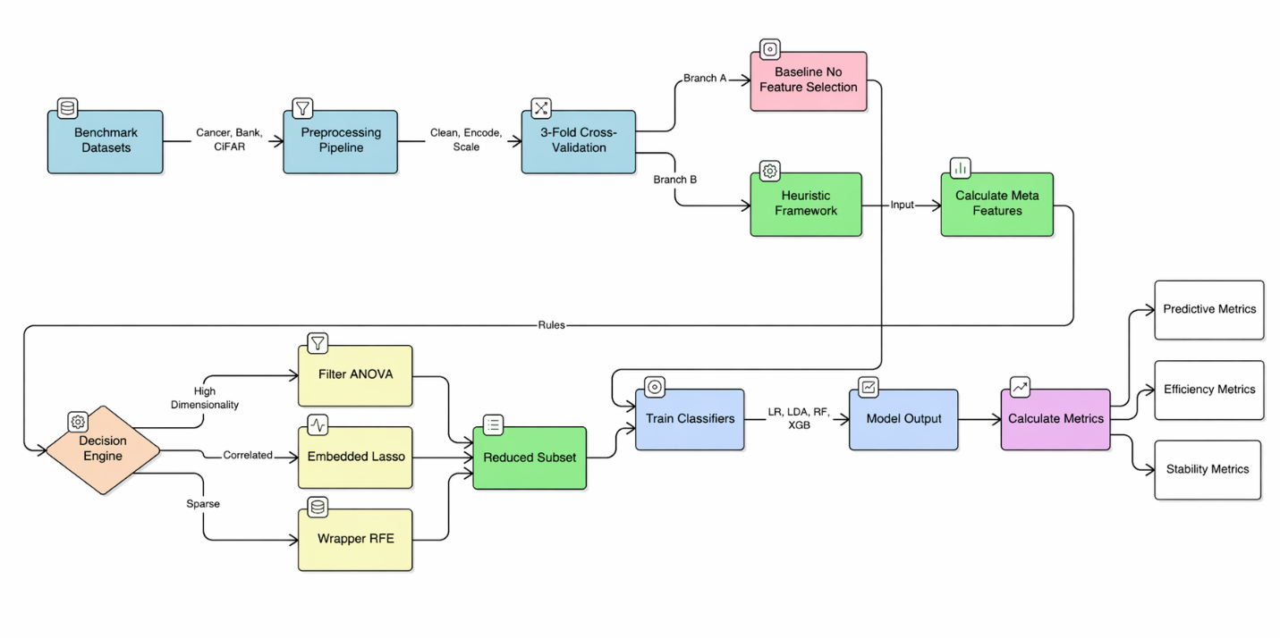
Figure 1. Overall experimental workflow for baseline and heuristic-adaptive feature-selection evaluation.

Heuristic framework
The proposed framework consists of three components: a dataset profiler, a heuristic decision module, and a feature-selection engine. Together, these components form an auditable decision architecture in which the same dataset profile leads to the same FS choice. This is important because the goal of the method is not black-box optimisation, but explicit and reproducible decision-making under heterogeneous data conditions.

Dataset profiler
The dataset profiler computes a compact set of meta-features from the training data only. These meta-features are intended to capture the structural properties most relevant to FS family choice. The profiler records:
- the features-to-samples ratio $\left(p/n\right)$, used as an indicator of dimensionality pressure and search feasibility;
- mean absolute correlation, used to summarise redundancy and multicollinearity among numeric predictors;
- class imbalance, summarised from the empirical target distribution;
- sparsity, particularly relevant after one-hot encoding;
- and dataset-specific dispersion summaries where necessary, such as pixel-intensity variance in flattened image data.
These variables were chosen because they map directly onto established FS trade-offs. High-dimensional settings tend to favour scalable filter methods; correlated numeric spaces often favour embedded selection through regularisation; and moderate-dimensional spaces with weaker univariate structure may justify wrapper search where interactions are expected (Guyon and Elisseeff, 2003; Kohavi and John, 1997; Tibshirani, 1996). The profiler therefore acts as the empirical basis for rule-based method selection rather than as a descriptive add-on.

Heuristic decision rules
The heuristic decision module maps profiler outputs to an FS family using explicit if-then rules. The rules are intentionally simple so that the method remains interpretable, computationally light, and easy to audit.
The core rules are as follows:
- High dimensionality $\left(p/n > 1.5\right)$triggers a filter method.
This rule is motivated by the infeasibility of repeated wrapper search when the number of predictors is large relative to the number of observations. In such settings, a fast univariate screen offers a practical way to reduce search space and model cost before fitting classifiers (Bellman, 1961; Guyon and Elisseeff, 2003; Bommert et al., 2022).
- Substantial multicollinearity triggers an embedded method.
Where numeric predictors are strongly correlated, regularised embedded approaches are attractive because they can shrink redundant variables during model fitting without requiring an external subset search. This provides a more efficient and interpretable response to redundancy than wrapper elimination in compact correlated spaces (Tibshirani, 1996; Guyon and Elisseeff, 2003).
- Moderate dimensionality with lower correlation, especially in sparse encoded feature spaces, triggers a wrapper method.
The rationale is that weak individual predictors may still be useful in combination, and wrapper search can evaluate such multivariate effects directly. However, this option is reserved for settings where dimensionality remains low enough for iterative search to be computationally feasible (Kohavi and John, 1997).
Because the rules are deterministic, the same training-fold profile always produces the same FS choice. This improves reproducibility and makes the framework easier to interpret than selection systems based on extensive search or learned policies.
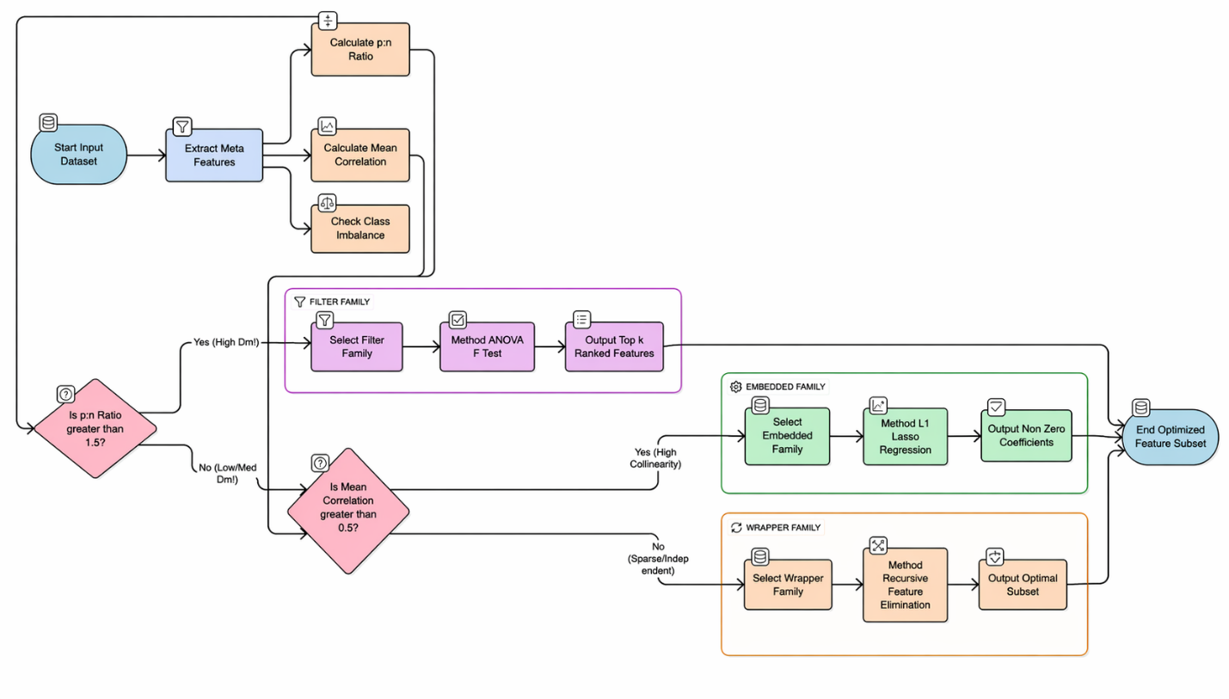
Figure 2. Internal architecture of the heuristic-adaptive feature-selection framework.

Feature-selection engine
Once an FS family is selected, the feature-selection engine applies a concrete operational method. In this study, three implementations were used.
For filter selection, the framework uses ANOVA F-test ranking via SelectKBest. This is suitable for high-dimensional settings because it is computationally efficient and does not require repeated model fitting. The method ranks features independently and retains the top $k$variables according to their class association.
For embedded selection, the framework uses L1-regularised logistic regression. Features are ranked using the absolute magnitude of learned coefficients, allowing the model to shrink redundant or weak predictors during fitting while preserving interpretability through direct parameter-based selection (Tibshirani, 1996).
For wrapper selection, the framework uses recursive feature elimination (RFE) with logistic regression as the base estimator. RFE iteratively fits the model, ranks predictors, and removes the least useful variables until the target subset size is reached. This method is computationally more expensive but can capture multivariate relevance in ways that univariate filters cannot (Kohavi and John, 1997).
Subset size is also determined by simple rules. In very high-dimensional settings, approximately 5% of features are retained, bounded to remain computationally feasible. In low-to-moderate dimensional settings, the framework uses more conservative subset sizes to avoid over-pruning, including no forced reduction when the feature space is already compact and informative. This design reflects the study’s broader principle that FS should simplify models where useful but should not impose reduction for its own sake.

Experimental Setup

Datasets
The framework was evaluated on three benchmark datasets chosen to represent contrasting data regimes. These datasets were selected deliberately to test whether a rule-based FS strategy could generalise across heterogeneous domains rather than only within one tabular setting.
The Breast Cancer Wisconsin dataset represents a low-dimensional biomedical classification task with numeric predictors and moderate inter-feature correlation. In this setting, the main role of FS is expected to be redundancy control and interpretability rather than aggressive dimensionality reduction.
The Bank Marketing dataset represents a mixed-type business dataset that becomes sparse after one-hot encoding and includes severe class imbalance. This creates a more difficult environment in which minority-class detection, sparsity, and leakage sensitivity become important concerns for both FS and evaluation.
The CIFAR-10 tabular subset represents an extreme-dimensional setting in which each 32 × 32 × 3 image is flattened into a 3,072-dimensional vector. This representation is not the natural form for vision tasks, but it provides a useful stress test for classical FS under very high dimensionality. In this regime, the main motivation for FS is tractability rather than semantic interpretability of isolated variables.
Table 1. Summary of benchmark datasets used to evaluate the heuristic-adaptive framework.
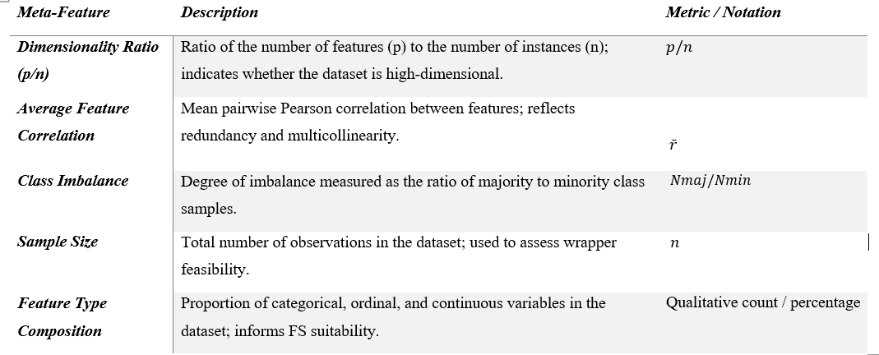

Preprocessing
A unified preprocessing pipeline was used to support fair comparison across datasets. Structured datasets were checked for duplicates, invalid labels, and datatype inconsistencies before modelling. Missing values were handled using simple reproducible imputations, with mean imputation for numeric variables and mode imputation for categorical variables where necessary.
For Bank Marketing, categorical variables were converted using one-hot encoding, which increased dimensionality and sparsity but avoided imposing artificial ordinality on categories. Because the dataset is severely imbalanced, SMOTE was applied within the training folds only. This design prevented information leakage from the test data while improving minority-class representation during learning.
For Breast Cancer and the structured numeric portions of the other data, continuous features were standardised where required to support coefficient-based and distance-sensitive models. For CIFAR-10, pixel intensities were normalised to the $\left[0 , 1\right]$range after flattening. A controlled subset of images was used to maintain computational feasibility under the available hardware budget.
A key design choice was that preprocessing transformations and FS were fitted only on the training split or training fold and then applied to the corresponding test fold. This ensured that model evaluation reflected a realistic deployment pipeline and reduced the risk of optimistic bias caused by leakage.

Classifiers
To examine whether the effects of FS differ across modelling assumptions, four classifiers were evaluated: Logistic Regression, Linear Discriminant Analysis, Random Forest, and XGBoost. These models were chosen to cover both linear and non-linear learners and to test whether the benefits or risks of FS depend on learner class.
Logistic Regression and LDA provide interpretable linear baselines, while Random Forest and XGBoost allow interaction-sensitive, non-linear modelling. Hyperparameter tuning was deliberately kept minimal so that observed differences between No-FS and heuristic-FS conditions would reflect the impact of feature selection rather than extensive model optimisation. Minor adjustments, such as convergence-related settings and fixed random seeds, were applied only where necessary for stable execution and reproducibility.

Validation procedure
Model evaluation used 3-fold stratified cross-validation, repeated across multiple random seeds to reduce sensitivity to a single partition. This produced six evaluation runs per configuration. Within each fold, the FS step was fitted only on the training data, after which the transformed subset was passed to the classifier and evaluated on the held-out fold.
This validation design was chosen to balance computational feasibility with statistical reliability. In particular, it allowed wrapper methods such as RFE to remain tractable while still producing repeated estimates of predictive performance, runtime, and stability. The repeated-seed design also provided a basis for estimating variation across runs, which is important when evaluating whether FS decisions are reproducible rather than accidental.

Evaluation metrics
The framework was evaluated using a multi-criteria perspective. Predictive performance was measured using Accuracy, F1-score, and Area Under the ROC Curve (AUC). Accuracy was retained for broad comparability, but F1-score and AUC were treated as especially important in imbalanced settings, where accuracy alone can obscure weak minority-class performance.
Computational efficiency was measured using total runtime, defined as the combined cost of the FS step and subsequent model fitting. This was necessary because FS does not automatically reduce overall cost; a selection step can itself be expensive enough to outweigh downstream savings. End-to-end runtime was therefore treated as a first-class outcome rather than as a secondary implementation detail.
Feature-subset reproducibility was measured using the Kuncheva Index, which adjusts overlap-based stability for chance agreement. Stability is important because a method that selects very different subsets across folds may be difficult to justify in applied settings. At the same time, the study explicitly treats stability as a separate quality dimension rather than as proof of correctness, since a selector can be consistently wrong if it repeatedly chooses leakage-prone or majority-class-biased variables.
Finally, SHAP was used as a post-hoc interpretability layer to audit feature importance under the heuristic-FS condition. SHAP was included not only to explain model behaviour, but also to help diagnose failure modes, such as the dominance of leakage-prone features or semantically weak isolated predictors in high-dimensional settings.
Table 2. Evaluation metrics used to assess predictive performance, efficiency, stability, and interpretability.
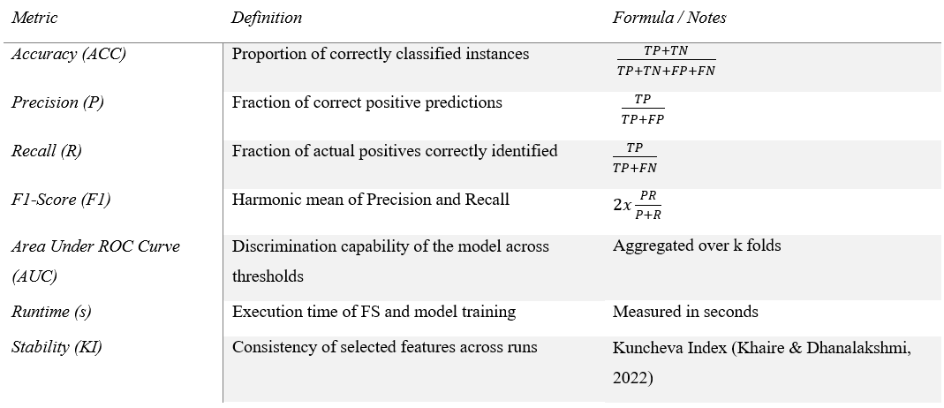

Statistical analysis
To assess whether differences between No-FS and heuristic-FS were systematic rather than random, inferential statistics were applied to repeated cross-validation results. One-way ANOVA was used to test whether there were significant performance differences across conditions at the dataset level. Where appropriate, paired t-tests were used at the classifier level to examine specific contrasts between No-FS and heuristic-FS outcomes. All tests were conducted at the 95% confidence level.
The purpose of this statistical layer was not merely to confirm whether performance changed, but to distinguish between safe non-effects, systematic degradation, and unstable behaviour across data regimes. This is especially important in a study where the main claim concerns condition-dependent behaviour rather than universal improvement.

