**1. What is a Large Language Model (LLM)**

A **large language model** (**LLM**) is a type of [machine learning](https://en.wikipedia.org/wiki/Machine_learning) [model](https://en.wikipedia.org/wiki/Model#Conceptual_model) designed for [natural language processing](https://en.wikipedia.org/wiki/Natural_language_processing) tasks such as language [generation](https://en.wikipedia.org/wiki/Generative_artificial_intelligence). LLMs are [language models](https://en.wikipedia.org/wiki/Language_model) with many parameters, and are trained with [self-supervised learning](https://en.wikipedia.org/wiki/Self-supervised_learning) on a vast amount of text. The largest and most capable LLMs are [generative pretrained transformers](https://en.wikipedia.org/wiki/Generative_pre-trained_transformer) (GPTs). Modern models can be [fine-tuned](https://en.wikipedia.org/wiki/Fine-tuning_(deep_learning)) for specific tasks or guided by [prompt engineering](https://en.wikipedia.org/wiki/Prompt_engineering). These models acquire [predictive power](https://en.wikipedia.org/wiki/Predictive_learning) regarding [syntax](https://en.wikipedia.org/wiki/Syntax), [semantics](https://en.wikipedia.org/wiki/Semantics), and [ontologies](https://en.wikipedia.org/wiki/Ontology_(information_science))inherent in human language corpora, but they also inherit inaccuracies and [biases](https://en.wikipedia.org/wiki/Algorithmic_bias) present in the [data](https://en.wikipedia.org/wiki/Training,_validation,_and_test_data_sets) they are trained in. A large language model (LLM) is a type of [artificial intelligence (AI)](https://www.cloudflare.com/learning/ai/what-is-artificial-intelligence/) program that can recognize and generate text, among other tasks. LLMs are trained on [huge sets of data](https://www.cloudflare.com/learning/ai/big-data/) hence the name "large." LLMs are built on [machine learning](https://www.cloudflare.com/learning/ai/what-is-machine-learning/): specifically, a type of [neural network](https://www.cloudflare.com/learning/ai/what-is-neural-network/) called a transformer model.

In simpler terms, an LLM is a computer program that has been fed enough examples to be able to recognize and interpret human language or other types of complex data. Many LLMs are trained on data that has been gathered from the Internet — thousands or millions of gigabytes' worth of text. But the quality of the samples impacts how well LLMs will learn natural language, so an LLM's programmers may use a more curated data set.

**2. How do LLMs like GPT work**

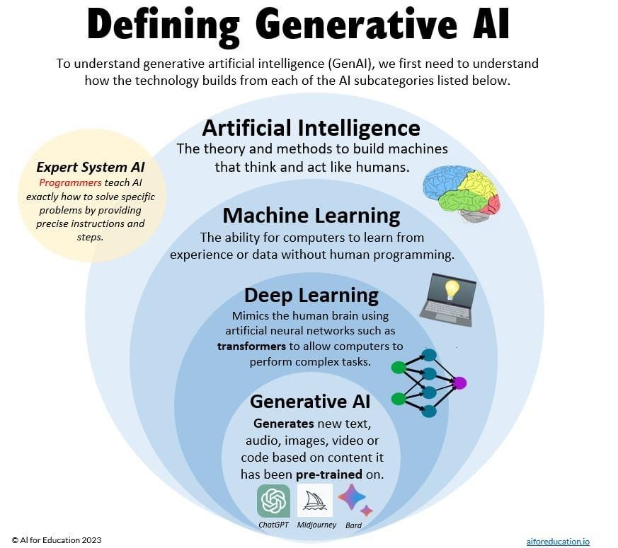

**Venn diagram showing the various forms of AI.**

1. **Data Curation**: AI companies first select the data they want to train the neural network on. Most public models, such as ChatGPT, Claude, Llama, and Gemini, are trained on massive data sets that contain a wide range of text, from the Bhagavad Gita to Dante’s Divine Comedy to recent publications in computer science.
2. **Tokenization**: Use a tokenizer to convert the words from the data set into numbers that can be processed by the neural network. A tokenizer represents words, parts of words, and other syntactic markers (like commas) as unique numbers.
3. **Create Embeddings**: Once the dataset is converted into a series of distinct numbers, the model creates embeddings that represent words as distinct vectors within a larger field.
4. **Attention Mechanisms**: The “learning” part happens when these models, which are large neural networks, use mathematical algorithms (based on matrix multiplication) to establish the relationships between tokens. The model “learns” by discovering patterns in the data.
5. **Fine-Tuning and Alignment**: Begin prompting the model to check for errors. Use fine-tuning methods to make sure the outputs are useful.

**3. What are the advantages of using LLMs in real-world applications?**

**Scale of Data**: Training on extensive datasets enhances LLMs' context understanding, leading to more nuanced outputs.

**Transfer Learning:** Similar to learning different sports, LLMs apply knowledge across tasks without starting anew.

**Contextual Understanding:** They perceive larger text contexts, not just isolated words or sentences.

**Multi-Tasking Capability:** Capable of handling diverse NLP tasks, unlike specialized traditional networks.

**4. What are some common challenges or limitations of LLMs?**

**What are the Limitations of LLMs?**

**1. Hallucinations (Making Up Information)**

One weird thing about LLMs is that when they don’t know the answer, they often won’t admit it. Instead, they’ll confidently make up something that sounds believable. This is called a "hallucination." For example, if you ask for a fact about a historical event that wasn’t in the data it was trained on, the LLM might invent details or events that never happened.

**2. Limited Reasoning Skills**

Even though LLMs can seem very smart, they often struggle with basic math. This is because they weren’t really designed to solve math problems. While LLMs are good at understanding and generating sentences, they’re not great at solving complex problems. For example, if you ask an LLM to solve a multi-step math problem or a puzzle, it might get confused and make mistakes along the way.

**3. Limited Long-Term Memory**

Each time you use an LLM, it starts with a blank slate, it doesn’t remember your previous conversations unless you remind it in the current session..

**4. Limited Knowledge**

LLMs are trained on data from the past. It means that if LLMs don’t have access to the internet or any way to look up information in real time, they don’t know anything that happened after their training data was collected. If you ask about recent events, they won’t be able to provide accurate answers.

**5. Bias**

LLMs learn from the text they’re trained on, and that text comes from the internet, a place that can contain biased, harmful, or prejudiced content. As a result, LLMs can sometimes reflect the same biases in their responses. For example, they might produce content that is sexist, racist, or otherwise problematic.

**6. Prompt Hacking**

LLMs can be tricked or “hacked” by clever users who know how to manipulate prompts. This is called [prompt hacking](https://learnprompting.org/docs/category/-prompt-hacking). For example, someone might be able to word a prompt in such a way that it gets the LLM to generate inappropriate or harmful content, even if the system is supposed to block such responses.

**5. What is Fine-tuning in LLMs?**

A Large Language Model, like GPT-3 or BERT, is a general-purpose tool trained on an extensive text corpus consisting of various text sequences from diverse sources. Using it directly to perform a specific job, such as generating a summary of a medical document, can lead to sub-optimal outputs.

LLM fine-tuning is essentially adapting a pre-trained LLM to suit a particular task or application by further training it on a domain-specific dataset. This adjusts the LLM's parameters to suit the new domain-specific data and improves the model performance for a better user experience

**6. What is the difference between training and inference in LLMs?**

* **Training** is the first phase for an AI model. Training may involve a process of trial and error, or a process of showing the model examples of the desired inputs and outputs, or both.
* **Inference** is the process that follows AI training. The better trained a model is, and the more fine-tuned it is, the better its inferences will be although they are never guaranteed to be perfect.
* Inference involves using the model to analyze new input data and produce a relevant output. An LLM has been trained on a vast amount of data, all for the purpose of being able to generalize, applying that knowledge when it encounters new data. Inference is this application and response generation process that occurs when you ask an LLM a question. This phase leverages the model’s learned knowledge to understand and respond to new queries.
* Practically speaking, let’s consider a chatbot that is used in a customer service context. When a customer submits an inquiry, the model processes the customer’s question and then uses inference to generate a helpful answer in real time.

**Importance of efficient inference**

* Efficient inference is important for real-time applications. In most use cases, you’ll need a model that can respond quickly (and, of course, accurately) to user queries. If we take the customer service example from above, you can imagine how needing to wait 20 seconds for a response can cripple the user experience. LLMs need fast and efficient performance to be useful.

**Practical implications**

* When an enterprise is building a GenAI application and it’s time to deploy their LLM, then there are special considerations to bear in mind for efficient inference.
* Hardware: Powerful GPUs or NPUs can speed up inference times. These resources are necessary to handle the computational load, especially when you’re working with large models with parameters numbering in the billions.
* Software: The software environment for implementing a model—including libraries, frameworks, and runtime—should be optimized for efficient inference. This means ensuring compatibility and performance by using the latest versions of AI frameworks (like TensorFlow or PyTorch).
* Unless you’re doing the low-level design or creation of an LLM, your main concern for ensuring [inference optimization](https://outshift.cisco.com/blog/llm-inference-optimization) comes down to investing in the right hardware and software resources. This is essential for applications that demand real-time or near-real-time responses.

**7. How do LLMs handle long sequences of text or context?**

To create a LLM that has a big context length, researchers are training the model using long sequences. Long sequences in the context of LLMs typically refer to input texts that are significantly longer than the standard training examples, often ranging from thousands to tens of thousands of tokens. Training on these long sequences is crucial for increasing the model’s context length.

Methods specifically used for training on longer sequences include:

1. **Gradient Accumulation:** This technique allows processing of long sequences by breaking them into smaller chunks, accumulating gradients before updating weights. It’s essential for handling sequences that exceed GPU memory capacity.
2. **Efficient Attention Mechanisms:** Algorithms like sparse attention or sliding window attention are crucial for processing long sequences, as they reduce the quadratic complexity of standard attention.
3. **Memory-Efficient Training:** Using techniques like reversible layers, activation check pointing, or memory-efficient optimizers to manage the increased memory demands of long sequences.
4. **Positional Encoding Adaptation:** Extending or modifying positional encodings to accommodate longer sequences, such as using relative positional embeddings or rotary position embeddings.
5. **Curriculum Learning for Sequence Length:** Gradually increasing the length of training sequences throughout the training process, allowing the model to adapt to longer contexts progressively.
6. **Specialized Data Preprocessing:** Preparing training data with longer contiguous passages, ensuring the model sees truly long sequences during training.

**8. Give an example of a task where LLMs might fail or produce incorrect results.**

* All LLMs share issues like incorrect conditions and wrong logical directions, indicating they struggle with handling complex logic conditions regardless of model size and capability.
* Smaller models (InCoder and CodeGen) were more likely to generate meaningless code and/or code that missed multiple steps.
* Larger models (GPT-3.5 and GPT-4) tended to make more constant value errors and arithmetic operation errors.
* Overall, GPT-4 performed the best, exhibiting only 7 of the 13 semantic characteristics, while the other, smaller models exhibited all or most of the error types. More parameters, less problems

**9.What role do attention mechanisms play in LLMs?**

**Attention mechanisms**

An attention mechanism is a technique or method in an LLM that is related to how the model focuses its attention on a piece of text to determine which parts are more or less relevant or important. As humans, when we read a piece of text or hear a statement spoken to us, we naturally assign different values of importance to the different parts of the statement. We don’t treat every word in a sentence equally.

In the same way, the attention mechanism of an LLM assigns different levels of importance to different words based on the context.

**How attention mechanisms work**

As an example, The cat sat on the mat because it was warm. The attention mechanism helps the model understand that "it" refers to "the mat" and not "the cat" by considering the context provided by the surrounding words. With this ability to focus on relevant parts of the text, an LLM can generate more accurate and contextually appropriate responses.

**Grouped-query attention**

Grouped-query attention (GQA) is closely related to the concept of attention mechanism. Think of it like going through a stack of questions that you need to answer, with many of them being similar. Instead of handling each question one by one, you group the similar ones together and answer them all at once. This saves time and makes your process more efficient.

In an LLM, GQA works similarly. When a model receives multiple queries that are all related, it groups them together and processes them simultaneously. This approach makes the model’s response time faster. It also takes less memory than handling each query separately.

**Sliding-window attention**

Sliding-window attention (SWA) is another variation of attention mechanism. It’s like reading a long book but only focusing on a few pages at a time. Imagine you have a very long document to read. Instead of trying to understand the whole thing at once, you break it down into smaller sections, or “windows”. You read one section, understand it, and then “slide” over to the next, slightly overlapping section, all the while maintaining context.

SWA breaks long texts into smaller, manageable segments. The model processes each segment separately while ensuring that each segment overlaps with the next. This overlap helps the model maintain the overall context and understand the document better.

SWA is a particularly useful technique when an LLM has tasks such as summarizing a long document, where the model needs to keep track of the information spread across many pages.

**Context window**

Related to all of these concepts is a term that you will probably see most often: context window.

The context window is sometimes referred to in the tech spec for an LLM. It defines the maximum length of text (or number of tokens) that the model can consider at once. This is basically how much text the model can process in a single input.

For example, an LLM with a context window of 32,000 tokens means it can handle and generate text that includes up to ~32,000 tokens of context at a time. A larger context window is crucial for tasks where the model needs to understand or generate long pieces of text.

**Here’s how context window numbers break down for some popular models:**

[GPT-3](https://arxiv.org/pdf/2005.14165): Typically has a context window of 2,048 tokens. This means it can consider up to 2048 tokens of text when generating a response, making it suitable for most conversational applications.

Gemma 2B: Similar to GPT-3, Gemma 2B also has a context window of 2,048 tokens, which is adequate for a wide range of applications without excessive computational demands.

Mistral 7B: Mistral AI models usually have context windows around 4,096 tokens, balancing the ability to handle moderately long texts while maintaining efficiency.

GPT-4: Up to 32,000 tokens. This allows it to handle much larger contexts, making it more effective for lengthy documents or complex conversations.

**10. Explain how LLMs can be used for sentiment analysis.**

Sentiment analysis is the process of **analyzing emotions or sentiments in text.** Typically, this task is done using a supervised learning model, which requires labeled data for training. The traditional text classification workflow is illustrated below.

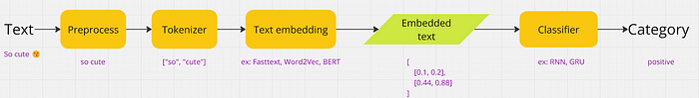

Traditional text classification

When applying a supervised model, factors such as the amount of data, model optimization, and the quality of both data and labels must be considered.

However, we can utilize **Large Language Model (LLM)** for sentiment analysis task. This approach is incredibly **simple**—**just send your prompt to an API service**, and you’ll receive an answer instantly. In some cases, prompt tuning may be applied for more accurate results.

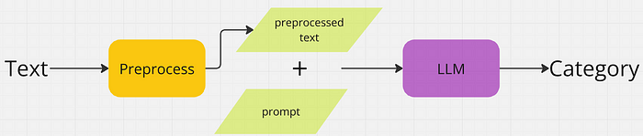

LLM with sentiment analysis workflow

**Benefits of fine-tuning**

Fine-tuning an LLM brings several benefits, especially if your business use case is specialized enough that a general LLM won’t cut it.

Improved performance: Tailored training helps the model understand the nuances and requirements of the task at hand. This enhances a model's performance on specific tasks by providing it with relevant examples and context.

Efficiency: Fine-tuning is more efficient than training a model completely from scratch. You can take advantage of the resources already invested in the model’s initial training. This cuts down your time and costs.

Customization: Do you need a model to handle specialized technical jargon in a particular industry, or to understand a specific language dialect? Fine-tuning gives you that flexibility to adapt your model to these unique requirements.

Practical implications

Fine-tuning can be powerful for enhancing the capabilities of an LLM to help you meet your specific needs. However, it can be a resource-intensive process. Even though you may not be training an LLM from scratch, fine-tuning one still requires significant computational power and expertise. If you’re pursuing GenAI application development and thinking about the potential benefits of fine-tuning, you’ll need to carefully weigh the resources and expertise needed against the performance benefits.

**11. What is zero-shot learning in the context of LLMs?**

## **Zero-Shot Learning**

In zero-shot learning, a model performs a task without having seen any task-specific labeled data. The model relies on the knowledge it has gained from training on other related tasks or from its general understanding of language and concepts.

Consider a model tasked with translating text from English to an obscure language it was never explicitly trained on. Using zero-shot learning, the model can generate plausible translations by leveraging its understanding of language structure and grammar.

**12. What are some ethical considerations when using LLMs?**

#### **Ethical Frameworks and Guidelines**

The LLM development lifecycle requires integrating ethical frameworks beyond technical interventions. Fairness, accountability, and transparency must be ingrained in the model from the beginning when using an ethical-by-design methodology. This entails making sure that bias mitigation techniques are integrated into these procedures and taking ethical considerations into account at every stage, from data curation to deployment.

Iterative improvements and ongoing monitoring are frequently emphasized in proposed ethical frameworks. Models should be regularly evaluated even after they are initially deployed to determine whether new types of bias have surfaced or whether preexisting biases have resurfaced as a result of changes in the underlying data.

In order to guarantee that different viewpoints are represented and that the models are consistent with societal values, ethical guidelines advise proactive stakeholder involvement, especially from marginalized communities.

#### **Best Practices for Developers and Researchers**

It takes both technical expertise and ethical foresight for [LLM developers](https://gaper.io/) and researchers to address bias. Using representative and varied datasets for training is one of the main recommendations. By doing this, the possibility of biased results may be reduced.

In order to take into account how well the model functions across various social groups, developers should also use fairness-aware evaluation metrics, which go beyond accuracy.

Standard procedures should include active debiasing techniques like post-processing techniques that modify model outputs or fine-tuning with fairness constraints.