**1. What is a Neural Network?**

A neural network is a [machine learning](https://www.ibm.com/think/topics/machine-learning) program, or model, that makes decisions in a manner similar to the human brain, by using processes that mimic the way biological neurons work together to identify phenomena, weigh options and arrive at conclusions. Every neural network consists of layers of nodes, or artificial neurons an input layer, one or more hidden layers, and an output layer. Each node connects to others, and has its own associated weight and threshold. If the output of any individual node is above the specified threshold value, that node is activated, sending data to the next layer of the network. Otherwise, no data is passed along to the next layer of the network.

**2. What are Neurons in Neural Networks?**

Typically, from the biological perspective, we find neurons as part of the central nervous system and the human brain.

**Apart from the living world, in the realm of Computer Science’s Artificial Neural Networks, a**neuron is a collection of a set of inputs, a set of weights, and an activation function. It translates these inputs into a single output. Another layer of neurons picks this output as its input and this goes on and on. In essence, we can say that each neuron is a mathematical function that closely simulates the functioning of a biological neuron.

**The following figure shows a typical neural network:**

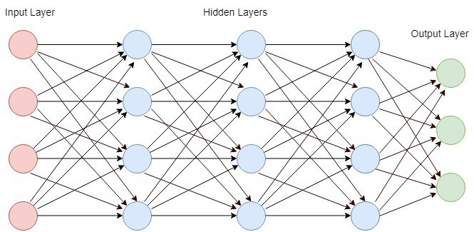

**3. Understanding Neuron**

**3.1. Biological Neuron**

We can define neurons as the information carriers that use electrical impulses and chemical signals to transmit information. The neurons transmit the information in the following two areas:

1. different parts of the brain
2. the brain and the nervous system

Thus, whatever we think, feel, and later do is all due to the working of the neurons.

The following [figure](https://www.ninds.nih.gov/health-information/patient-caregiver-education/brain-basics-life-and-death-neuron) shows a typical biological neuron:

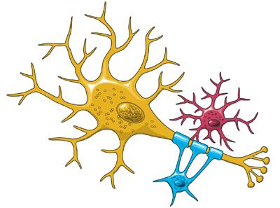

**3. What is an Activation Function?**

The activation function of a node in an [artificial neural network](https://en.wikipedia.org/wiki/Artificial_neural_network) is a function that calculates the output of the node based on its individual inputs and their weights. Nontrivial problems can be solved using only a few nodes if the activation function is *nonlinear*.

Modern activation functions include the logistic ([sigmoid](https://en.wikipedia.org/wiki/Sigmoid_function)) function used in the 2012 [speech recognition](https://en.wikipedia.org/wiki/Speech_recognition) model developed by Hinton the [ReLU](https://en.wikipedia.org/wiki/ReLU" \o "ReLU) used in the 2012 [Alex Net](https://en.wikipedia.org/wiki/AlexNet) computer vision model and in the 2015 [Res Net](https://en.wikipedia.org/wiki/Residual_neural_network) model; and the smooth version of the ReLU, the [GELU](https://en.wikipedia.org/wiki/ReLU#Gaussian-error_linear_unit_(GELU)), which was used in the 2018 [BERT](https://en.wikipedia.org/wiki/BERT_(language_model)) model.

Without activation functions, neural networks would just consist of linear operations like matrix multiplication. All layers would perform linear transformations of the input, and no non-linearities would be introduced.

Most real-world data is non-linear. For example, relationships between house prices and size, income, and purchases, etc., are non-linear. If neural networks had no activation functions, they would fail to learn the complex non-linear patterns that exist in real-world data. Activation functions enable neural networks to learn these non-linear relationships by introducing non-linear behaviors through activation functions. This greatly increases the flexibility and power of neural networks to model complex and nuanced data.

**4. What is Backpropagation?**

Backpropagation is a popular algorithm used in artificial neural networks (ANNs) for training deep learning models. It is a supervised learning technique used to adjust the weights of the neurons in the network to minimize the error between the predicted output and the actual output.

In neural networks, backpropagation is a process that calculates the gradient of the loss function with respect to each weight in the network. This gradient is then used to update the weights in the opposite direction of the gradient, which in turn minimizes the loss function.

The backpropagation algorithm works by computing the error between the predicted output and the actual output for each training example, and then propagating this error back through the layers of the network to adjust the weights. The process is repeated for multiple iterations until the weights converge to a point where the error is minimized.

**Benefits of Backpropagation:**

* It is a powerful optimization algorithm that can efficiently train complex neural networks.
* It can handle large amounts of data and can learn complex patterns.
* It is flexible and can be applied to various neural network architectures.

**Applications of Backpropagation:**

* Image and speech recognition
* Natural language processing
* Fraud detection
* Medical diagnosis
* Stock market prediction

**Backpropagation Algorithm Steps:**

1. Initialize the weights of the network randomly.
2. Forward propagate an input through the network to get the predicted output.
3. Compute the error between the predicted output and the actual output.
4. Backward propagate the error through the network to compute the gradient of the loss function with respect to each weight.
5. Update the weights in the opposite direction of the gradient using an optimization algorithm such as Stochastic Gradient Descent (SGD).
6. Repeat steps 2–5 for multiple iterations until the weights converge.

**5. What are Layers in Neural Networks?**

[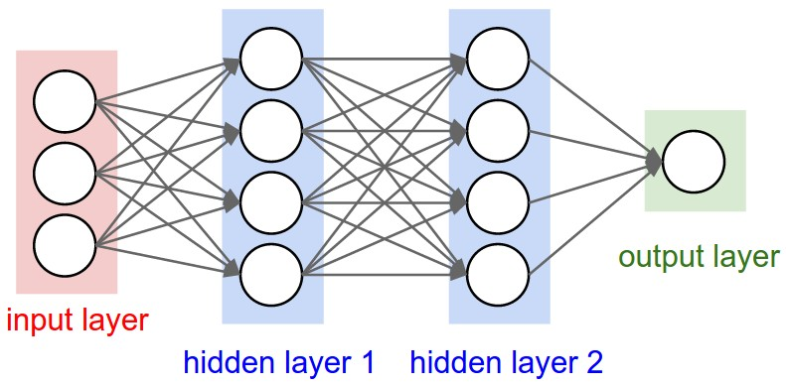](https://i.sstatic.net/Kc50L.jpg)

**Layer is a general term that applies to a collection of 'nodes' operating together at a specific depth within a neural network.**

The **input layer** is contains raw data.

The **hidden layer(s)** are where the black magic happens in neural networks.

Each layer is trying to learn different aspects about the data by minimizing an error/cost function. The most intuitive way to understand these layers is in the context of 'image recognition' such as a face. The first layer may learn edge detection, the second may detect eyes, third a nose, etc. This is not exactly what is happening but the idea is to break the problem up in to components that different levels of abstraction can piece together much like our own brains work (hence the name 'neural networks').

The **output layer** is the simplest, usually consisting of a single output for classification problems. Although it is a single 'node' it is still considered a layer in a neural network as it could contain multiple nodes.

**6. What is the Role of Weights and Biases in Neural Networks?**

## i. The Foundation of Neural Networks: Weights

Imagine a [neural network](https://www.geeksforgeeks.org/artificial-neural-networks-and-its-applications/) as a complex web of interconnected nodes, each representing a computational unit known as a neuron. These neurons work together to process information and produce output. However, not all connections between neurons are created equal. This is where weights come into play.

Weights are numerical values associated with the connections between neurons. They determine the strength of these connections and, in turn, the influence that one neuron's output has on another neuron's input. They can increase or decrease the importance of specific information.

During the training phase of a neural network, these weights are adjusted iteratively to minimize the difference between the network's predictions and the actual outcomes. This process is akin to fine-tuning the network's ability to make accurate predictions.

The weights associated with each pixel determine how much importance the network places on that pixel when making a decision about which digit is represented in the image.

As the network learns from a dataset of labeled digits, it adjusts these weights to give more significance to pixels that are highly correlated with the correct digit and less significance to pixels that are less relevant. Over time, the network learns to recognize patterns in the data and make accurate predictions.

## ii. Biases: Introducing Flexibility and Adaptability

While weights determine the **strength of connections between neurons**, biases provide a critical **additional layer of flexibility** to neural networks. Biases are essentially constants associated with each neuron. Unlike weights, biases are not connected to specific inputs but are added to the neuron's output.

Biases serve as a form of offset or threshold, allowing neurons to activate even when the weighted sum of their inputs is not sufficient on its own. They introduce a level of adaptability that ensures the network can learn and make predictions effectively.

This flexibility is crucial because real-world data is rarely perfectly aligned with specific thresholds. Biases enable neurons to activate in response to various input conditions, making neural networks more robust and capable of handling complex patterns.

During training, biases are also adjusted to optimize the network's performance. They can be thought of as fine-tuning parameters that help the network fit the data better.

## iii. The Learning Process: Forward and Backward Propagation

#### **A. Forward Propagation**

Forward propagation is the initial phase of processing input data through the neural network to produce an output or prediction. Here's how it works:

1. Input Layer: The input data is fed into the neural network's input layer.
2. Weighted Sum: Each neuron in the subsequent layers calculates a weighted sum of the inputs it receives, where the weights are the adjustable parameters.
3. Adding Biases: To this weighted sum, the bias associated with each neuron is added. This introduces an offset or threshold for activation.
4. Activation Function: The result of the weighted sum plus bias is passed through an activation function. This function determines whether the neuron should activate or remain dormant based on the calculated value.
5. Propagation: The output of one layer becomes the input for the next layer, and the process repeats until the final layer produces the network's prediction.

#### **B. Backward Propagation**

Once the network has made a prediction, it's essential to evaluate how accurate that prediction is and make adjustments to improve future predictions. This is where backward propagation comes into play:

1. Error Calculation: The prediction made by the network is compared to the actual target or ground truth. The resulting error, often quantified as a loss or cost, measures the disparity between prediction and reality.
2. Gradient Descent: Backward propagation involves minimizing this error. To do so, the network calculates the gradient of the error with respect to the weights and biases. This gradient points in the direction of the steepest decrease in error.
3. Weight and Bias Updates: The network uses this gradient information to update the weights and biases throughout the network. The goal is to find the values that minimize the error.
4. Iterative Process: This process of forward and backward propagation is repeated iteratively on batches of training data. With each iteration, the network's weights and biases get closer to values that minimize the error.

## iv. Real-World Applications: From Image Recognition to Natural Language Processing

#### A. [**Image Recognition**](https://www.geeksforgeeks.org/image-recognition-using-tensorflow/)

One of the most prominent applications of neural networks is image recognition. Neural networks have demonstrated remarkable abilities in identifying objects, faces, and even handwriting in images.

Consider a neural network tasked with recognizing cats in photographs. The input to the network consists of pixel values representing the image. Each pixel's importance is determined by the weights associated with it. If certain pixels contain features highly indicative of a cat (such as whiskers, ears, or a tail), the corresponding weights are adjusted to give these pixels more influence over the network's decision.

Additionally, biases play a crucial role in this context. They allow neurons to activate even if the combination of weighted pixel values falls slightly below the threshold required to recognize a cat. Biases introduce the flexibility needed to account for variations in cat images, such as differences in lighting, pose, or background.

#### B. [**Natural Language Processing**](https://www.geeksforgeeks.org/natural-language-processing-overview/)

In the realm of natural language processing, neural networks have transformed our ability to understand and generate human language. Applications range from sentiment analysis and language translation to chatbots and voice assistants.

Weights play a critical role in capturing the nuances of language. For instance, in a sentence like "I absolutely loved the movie," the word "loved" should carry more weight in predicting a positive sentiment than the word "absolutely." During training, the network learns these weightings by analyzing a dataset of labeled text examples.

Biases, on the other hand, allow the network to adapt to different writing styles and contexts. They ensure that the network can activate even if the weighted sum of word vectors falls slightly below the threshold for a particular sentiment category.

#### **C. Autonomous Vehicles**

Autonomous vehicles represent an exciting frontier where neural networks, along with their weights and biases, are making a significant impact. These vehicles rely on neural networks for tasks such as object detection, path planning, and decision-making.

Biases in this context allow the network to adapt to different lighting conditions, weather, and variations in pedestrian appearance. They ensure that the network can detect pedestrians even in challenging situations.

**7. What is Overfitting in Neural Networks?**

Overfitting is an undesirable [machine learning](https://aws.amazon.com/what-is/machine-learning/) behavior that occurs when the machine learning model gives accurate predictions for training data but not for new data. When data scientists use machine learning models for making predictions, they first train the model on a known data set. Then, based on this information, the model tries to predict outcomes for new data sets. An overfit model can give inaccurate predictions and cannot perform well for all types of new data.

## Why does overfitting occur?

. Overfitting occurs when the model cannot generalize and fits too closely to the training dataset instead. Overfitting happens due to several reasons, such as:

The training data size is too small and does not contain enough data samples to accurately represent all possible input data values.  
•    The training data contains large amounts of irrelevant information, called noisy data.  
•    The model trains for too long on a single sample set of data.  
•    The model complexity is high, so it learns the noise within the training data.

**Overfitting Examples**

Consider a use case where a machine learning model has to analyze photos and identify the ones that contain dogs in them. If the machine learning model was trained on a data set that contained majority photos showing dogs outside in parks, it may may learn to use grass as a feature for classification, and may not recognize a dog inside a room. Another overfitting example is a machine learning algorithm that predicts a university student's academic performance and graduation outcome by analyzing several factors like family income, past academic performance, and academic qualifications of parents. However, the test data only includes candidates from a specific gender or ethnic group. In this case, overfitting causes the algorithm's prediction accuracy to drop for candidates with gender or ethnicity outside of the test dataset.

## How to detect overfitting

The best method to detect overfit models is by testing the machine learning models on more data with with comprehensive representation of possible input data values and types. Typically, part of the training data is used as test data to check for overfitting. A high error rate in the testing data indicates overfitting. One method of testing for overfitting is given below. **K-fold cross-validation**  
Cross-validation is one of the testing methods used in practice. In this method, data scientists divide the training set into K equally sized subsets or sample sets called folds.

The training process consists of a series of iterations. During each iteration, the steps are:  
1.    Keep one subset as the validation data and train the machine learning model on the remaining K-1 subsets.

2.    Observe how the model performs on the validation sample.  
3.    Score model performance based on output data quality.

Iterations repeat until you test the model on every sample set. You then average the scores across all iterations to get the final assessment of the predictive model.

## How can you prevent overfitting?

**Pruning**  
You might identify several features or parameters that impact the final prediction when you build a model. Feature selection or pruning identifies the most important features within the training set and eliminates irrelevant ones. For example, to predict if an image is an animal or human, you can look at various input parameters like face shape, ear position, body structure, etc. You may prioritize face shape and ignore the shape of the eyes.  
**Regularization**  
Regularization is a collection of training/optimization techniques that seek to reduce overfitting. These methods try to eliminate those factors that do not impact the prediction outcomes by grading features based on importance. For example, mathematical calculations apply a penalty value to features with minimal impact. Consider a statistical model attempting to predict the housing prices of a city in 20 years. Regularization would give a lower penalty value to features like population growth and average annual income but a higher penalty value to the average annual temperature of the city.

**Ensembling**  
Ensembling combines predictions from several separate machine learning algorithms. Some models are called weak learners because their results are often inaccurate. Ensemble methods combine all the weak learners to get more accurate results. They use multiple models to analyze sample data and pick the most accurate outcomes. The two main ensemble methods are bagging and boosting. Boosting trains different machine learning models one after another to get the final result, while bagging trains them in parallel.

**PART TWO**

# **1. Introduction to ReLU and Its Significance in Deep Learning**

The **Rectified Linear Unit (ReLU)** is one of the most widely used **activation functions** in **deep learning models**today. Its popularity stems from its simplicity and remarkable performance in a variety of **neural network architectures**. Unlike traditional **activation functions** such as [**sigmoid**](https://medium.com/ai-enthusiast/build-your-own-sigmoid-activation-function-from-scratch-f3c2c64e1a75) and **tanh**, which can saturate and lead to slower training times, **ReLU** introduces a straightforward mechanism that accelerates the convergence of **neural networks**.

**ReLU** functions by outputting the input directly if it is positive; otherwise, it returns zero. This property not only maintains the **non-linearity**essential for learning complex patterns but also helps to mitigate issues such as the **vanishing gradient problem** that can plague deeper networks. As a result, **ReLU** allows models to learn more effectively, making it a preferred choice among practitioners and researchers alike.

It is defined mathematically as:



**2 ReLU function**

This simple yet effective function outputs the input directly if it is positive; otherwise, it outputs zero. The function can also be expressed in a more compact form:

https://miro.medium.com/v2/resize:fit:700/1*f-PKqPPpcE2ad1jawWya2Q.png

ReLU function

## Graphical Representation of ReLU

The graph of the ReLU function clearly illustrates its behavior:

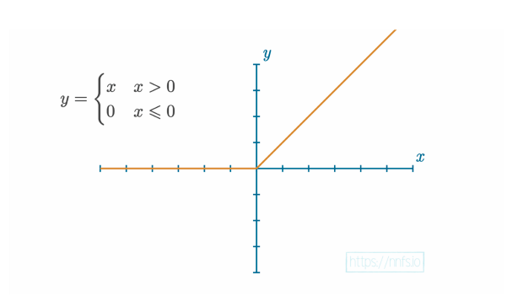

**ReLU Plot**

In this graph:

* The x-axis represents the input x.
* The y-axis represents the output f(x).
* For any positive input, the output is equal to the input (the line y=x).
* For any non-positive input, the output is zero.

**3. Significance of ReLU in Deep Learning:**

1. **Non-Linearity**: Despite being a simple linear function for positive values, **ReLU** introduces non-linearity to the model. This is crucial for neural networks because it allows them to learn complex patterns in the data. Without **non-linear activation functions**, **neural networks** would behave like **linear regression models**, limiting their capacity to fit complex datasets.
2. **Sparsity**: **ReLU** activation leads to sparsity in the activation of neurons. When the input is negative, the output is zero, effectively deactivating those neurons. This sparsity is beneficial as it reduces the number of active neurons, leading to more efficient computations and reduced risk of overfitting.
3. **Computational Efficiency**: **ReLU** is computationally efficient compared to traditional activation functions like [**sigmoid**](https://medium.com/ai-enthusiast/build-your-own-sigmoid-activation-function-from-scratch-f3c2c64e1a75) and **tanh**. This efficiency stems from its simple mathematical operation (comparing and selecting), allowing faster training times, especially in deep networks.
4. **Mitigating the Vanishing Gradient Problem**: Unlike [**sigmoid**](https://medium.com/ai-enthusiast/build-your-own-sigmoid-activation-function-from-scratch-f3c2c64e1a75) and **tanh** functions, which can saturate (output values close to 0 or 1), **ReLU** does not suffer from the **vanishing gradient problem** for positive inputs. This characteristic allows for better gradient flow during **backpropagation**, enhancing the learning capability of deep networks.

# **4. Implementations of ReLU**

1. **Native Python Implementation:**In pure Python, the **ReLU** function can be implemented using a simple conditional statement. Here’s how you can do it:

def relu_native(x):  
 return max(0, x)  
  
# Example usage  
inputs = [-3, -1, 0, 1, 3]  
outputs = [relu_native(x) for x in inputs]  
print(outputs) # Output: [0, 0, 0, 1, 3]

This implementation defines a function relu_native that takes an input x and returns the maximum of zero and x. The example usage demonstrates how to apply the **ReLU** function to a list of inputs.

**2. Implementation using NumPy:**For vectorized operations, **NumPy** provides an efficient way to compute the **ReLU** function over arrays:

import numpy as np  
  
def relu_numpy(x):  
 return np.maximum(0, x)  
  
# Example usage  
inputs = np.array([-3, -1, 0, 1, 3])  
outputs = relu_numpy(inputs)  
print(outputs) # Output: [0 0 0 1 3]

In this implementation, the np.maximum function is used to apply **ReLU** element-wise across the **NumPy** array.

**3. Implementation using PyTorch**In **PyTorch**, the **ReLU** function is readily available as part of the library. Here’s how to implement it:

import torch  
  
def relu_torch(x):  
 return torch.relu(x)  
  
# Example usage  
inputs = torch.tensor([-3.0, -1.0, 0.0, 1.0, 3.0])  
outputs = relu_torch(inputs)  
print(outputs) # Output: tensor([0., 0., 0., 1., 3.])

This implementation uses the built-in torch.relu function, which applies the **ReLU** activation to a **PyTorch** tensor.

**4. Implementation using TensorFlow**In **TensorFlow**, the **ReLU** function can also be easily applied using its built-in operations. Here’s an example:

import tensorflow as tf  
  
def relu_tensorflow(x):  
 return tf.nn.relu(x)  
  
# Example usage  
inputs = tf.constant([-3.0, -1.0, 0.0, 1.0, 3.0])  
outputs = relu_tensorflow(inputs)  
print(outputs.numpy()) # Output: [-0. 0. 0. 1. 3.]

In this implementation, the tf.nn.relu function is used to apply the **ReLU** activation to a **TensorFlow** tensor. The output is converted to a **NumPy** array for easy readability.

These implementations demonstrate how to apply the **ReLU** activation function using different programming approaches. The native Python implementation is straightforward for small datasets, while using libraries like **NumPy**, **PyTorch**, and **TensorFlow** allows for efficient computations, especially with larger datasets and in deep learning models.

# **Limitations of ReLU:**

While the **Rectified Linear Unit (ReLU)** has become a staple in deep learning due to its advantages, it also has notable limitations that can impact the performance of neural networks. Understanding these limitations is essential for effectively utilizing **ReLU** and considering alternative activation functions when necessary.

1. **Dying ReLU Problem**:

One of the most significant drawbacks of **ReLU** is the **“dying ReLU”** problem. This occurs when neurons become inactive and consistently output zero. If a large number of neurons in a network output zero, they do not contribute to the learning process, effectively rendering them useless. This issue can arise when a large number of inputs to a neuron are negative, leading to persistent outputs of zero.

**Example**: During training, if the weights of a neuron are adjusted in such a way that it receives negative inputs most of the time, it will output zero for all subsequent inputs, and the gradient during backpropagation will also be zero. Consequently, the weights of this neuron will not be updated, stunting its learning potential.

1. **Unbounded Output**:

While the linear output for positive values can be an advantage, it can also be a drawback. The output of **ReLU** is unbounded, which means it can take any positive value. In practice, this can lead to numerical instability, especially in deep networks, where the values can grow excessively large, complicating the training process.

**Example**: If a layer produces very large outputs, it can cause gradient explosion during backpropagation, leading to erratic weight updates and making the training process unstable.

1. **Lack of Negative Outputs**:

Since **ReLU** outputs zero for all negative inputs, it can lead to a loss of valuable information. In certain contexts, negative activations may carry significant information that could aid in learning more complex patterns. This limitation may hinder the model’s ability to learn effectively from the data.

**Example**: In cases where features have negative correlations with the target variable, a model relying solely on **ReLU** may struggle to capture these relationships.

1. **Sensitivity to Initialization**:

**ReLU** is sensitive to**weight initialization**. If the weights are initialized poorly, it can exacerbate the **dying ReLU problem**. For instance, if weights are set to very high values, it can lead to outputs that saturate at zero for many neurons, particularly in the early stages of training.  
-> **Example**: Using common initialization techniques (like **Xavier** or **He initialization**) can help, but even with these methods, poor initialization can still cause issues in deep networks.

1. **Comparison to Other Activation Functions**: Although **ReLU** is often preferred, it is not the only option. Alternative **activation functions** like **Leaky ReLU**, **Parametric ReLU (PReLU)**, and **Exponential Linear Unit (ELU)** were developed to address some of the limitations of **ReLU**, particularly the **dying ReLU problem**.