Figures and Tables
Aidan Fauth
This document will contain al the figures found in my SYE paper.
Clean up data frames:
No anthroprogenic noise:

Basic Summary Stats
Total nights of deployment and nights of recording:
tot_deploy | tot_rec
1200 days | 622 days
Total ids and total species richness:
tot_ids | tot_sp
361552 | 101
Total identifications and species richness per AM:
deployment_num | num_ids | num_sp
AM0041 | 10978 | 13
AM0042 | 1076 | 11
AM0043 | 15120 | 22
AM0048 | 26904 | 29
AM0049 | 11021 | 8
AM0050 | 6158 | 11
AM0051 | 8932 | 22
AM0052 | 5496 | 15
AM0053 | 6795 | 17
AM0054 | 9326 | 14
AM0055 | 4051 | 13
AM0056 | 2190 | 5
AM0058 | 1622 | 6
AM0059 | 15473 | 23
AM0072 | 6453 | 10
AM0097 | 28031 | 21
AM0098 | 33492 | 34
AM0099 | 17619 | 14
AM0101 | 24424 | 15
AM0102 | 7510 | 13
AM0103 | 12563 | 8
AM0104 | 11869 | 11
AM0105 | 3962 | 10
AM0106 | 29715 | 27
AM0116 | 8488 | 11
AM0117 | 11776 | 11
AM0118 | 30474 | 21
AM0120 | 10034 | 13

Baggie vs Case Comparisons
Total identifications and species richness:
AM_housing | total_ids | total_sp
Case | 163963 | 75
Ziplock | 197589 | 87
AM_housing | total_ids | total_sp
Case | 163920 | 74
Ziplock | 194832 | 84
Mean and sd:
AM_housing | mean_ids | sd_ids | mean_sp | sd_sp
Case | 10931 | 8611 | 13.33 | 5.996
Ziplock | 15199 | 10231 | 17.54 | 7.838
AM_housing | mean_ids | sd_ids | mean_sp | sd_sp
Case | 10928 | 8612 | 13.2 | 6.026
Ziplock | 14987 | 10189 | 17.15 | 7.712

Baggie & Case Species Comparison
Speices | Common Name | Case | Ziplock
Aegolius acadicus | Northern Saw-whet Owl |  | X
Agelaius phoeniceus | Red-winged Blackbird | X | X
Amblycorypha longinicta | Common Virtuoso Katydid |  | X
Anas platyrhynchos | Mallard | X | X
Anthus rubescens | American Pipit | X | X
Antigone canadensis | Sandhill Crane |  | X
Antrostomus vociferus | Eastern Whip-poor-will | X | X
Ardea herodias | Great Blue Heron | X
Baeolophus bicolor | Tufted Titmouse |  | X
Bombycilla cedrorum | Cedar Waxwing | X | X
Botaurus lentiginosus | American Bittern | X | X
Branta canadensis | Canada Goose | X
Bubo virginianus | Great Horned Owl | X | X
Buteo platypterus | Broad-winged Hawk | X | X
Butorides virescens | Green Heron | X
Canis latrans | Coyote |  | X
Cardellina canadensis | Canada Warbler | X
Cardinalis cardinalis | Northern Cardinal |  | X
Catharus fuscescens | Veery | X | X
Catharus guttatus | Hermit Thrush | X | X
Certhia americana | Brown Creeper | X | X
Charadrius vociferus | Killdeer |  | X
Chordeiles minor | Common Nighthawk | X
Coccyzus americanus | Yellow-billed Cuckoo |  | X
Colaptes auratus | Northern Flicker | X | X
Contopus virens | Eastern Wood-Pewee | X | X
Corvus brachyrhynchos | American Crow | X | X
Cyanocitta cristata | Blue Jay | X | X
Dolichonyx oryzivorus | Bobolink | X | X
Dryobates villosus | Hairy Woodpecker | X | X
Dryocopus pileatus | Pileated Woodpecker | X
Dryophytes versicolor | Gray Treefrog | X | X
Dumetella carolinensis | Gray Catbird |  | X
Empidonax alnorum | Alder Flycatcher | X | X
Empidonax flaviventris | Yellow-bellied Flycatcher |  | X
Empidonax minimus | Least Flycatcher | X | X
Empidonax traillii | Willow Flycatcher |  | X
Engine | Engine | X | X
Euphagus cyanocephalus | Brewer’s Blackbird | X | X
Falco columbarius | Merlin | X
Fireworks | Fireworks |  | X
Gavia immer | Common Loon |  | X
Geothlypis trichas | Common Yellowthroat | X | X
Haemorhous mexicanus | House Finch | X | X
Helmitheros vermivorum | Worm-eating Warbler | X | X
Hylocichla mustelina | Wood Thrush | X | X
Junco hyemalis | Dark-eyed Junco | X | X
Leiothlypis ruficapilla | Nashville Warbler | X
Lithobates catesbeianus | American Bullfrog | X | X
Lithobates clamitans | Green Frog | X | X
Lithobates palustris | Pickerel Frog |  | X
Megaceryle alcyon | Belted Kingfisher | X | X
Meleagris gallopavo | Wild Turkey |  | X
Melospiza georgiana | Swamp Sparrow | X | X
Melospiza melodia | Song Sparrow |  | X
Microcentrum rhombifolium | Greater Angle-wing | X | X
Mniotilta varia | Black-and-white Warbler | X | X
Myiarchus crinitus | Great Crested Flycatcher | X | X
Nycticorax nycticorax | Black-crowned Night-Heron |  | X
Passerculus sandwichensis | Savannah Sparrow | X | X
Passerella iliaca | Fox Sparrow | X
Passerina cyanea | Indigo Bunting | X | X
Pheucticus ludovicianus | Rose-breasted Grosbeak | X | X
Pinicola enucleator | Pine Grosbeak |  | X
Pipilo erythrophthalmus | Eastern Towhee | X | X
Piranga olivacea | Scarlet Tanager | X | X
Podiceps grisegena | Red-necked Grebe |  | X
Poecile atricapillus | Black-capped Chickadee | X | X
Pseudacris crucifer | Spring Peeper |  | X
Quiscalus quiscula | Common Grackle | X | X
Rallus limicola | Virginia Rail |  | X
Regulus satrapa | Golden-crowned Kinglet | X | X
Salpinctes obsoletus | Rock Wren | X | X
Seiurus aurocapilla | Ovenbird | X | X
Setophaga americana | Northern Parula | X | X
Setophaga caerulescens | Black-throated Blue Warbler | X | X
Setophaga castanea | Bay-breasted Warbler | X | X
Setophaga coronata | Yellow-rumped Warbler | X
Setophaga fusca | Blackburnian Warbler | X | X
Setophaga magnolia | Magnolia Warbler | X | X
Setophaga pensylvanica | Chestnut-sided Warbler | X
Setophaga pinus | Pine Warbler | X | X
Setophaga ruticilla | American Redstart | X | X
Setophaga striata | Blackpoll Warbler |  | X
Setophaga virens | Black-throated Green Warbler | X | X
Siren | Siren |  | X
Sitta canadensis | Red-breasted Nuthatch | X | X
Sitta carolinensis | White-breasted Nuthatch |  | X
Sphyrapicus varius | Yellow-bellied Sapsucker |  | X
Spinus tristis | American Goldfinch |  | X
Strix varia | Barred Owl | X | X
Tachycineta bicolor | Tree Swallow | X
Tamias striatus | Eastern Chipmunk | X
Troglodytes hiemalis | Winter Wren | X | X
Turdus migratorius | American Robin | X | X
Tyrannus tyrannus | Eastern Kingbird | X
Vireo flavifrons | Yellow-throated Vireo | X | X
Vireo olivaceus | Red-eyed Vireo | X | X
Vireo solitarius | Blue-headed Vireo | X | X
Zonotrichia albicollis | White-throated Sparrow | X | X
Zonotrichia leucophrys | White-crowned Sparrow | X | X

Durability
AM_housing | num | mean | sd
Case | 321 days | 21.4 days | 6.947
Ziplock | 301 days | 23.15 days | 10.25
AM_housing | num | mean | sd
Case | 132 days | 22 days | 11.58
Ziplock | 194 days | 27.71 days | 10.36
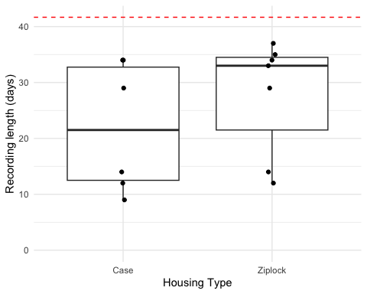

IDs

Plot
species richness
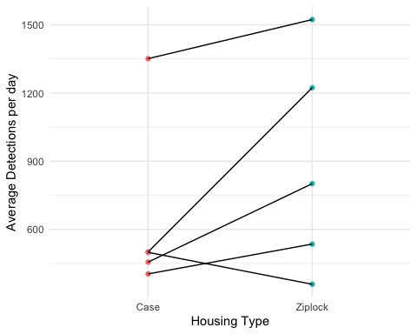

Species Richness
Remove anthroprogenic noises

Plot
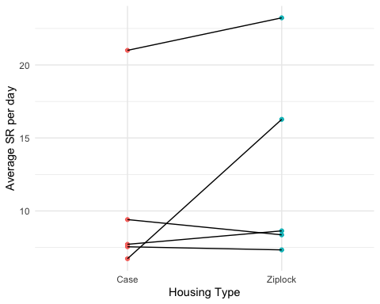

Model
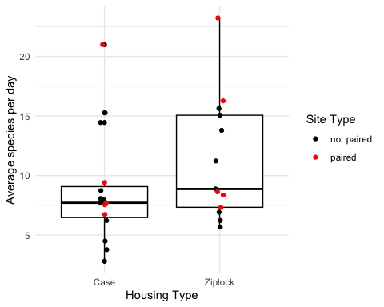
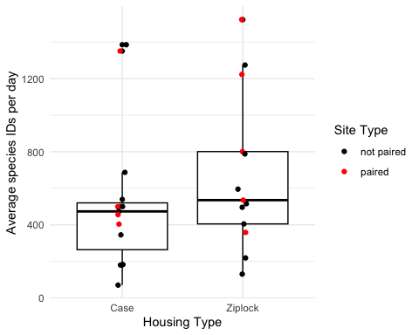

Species Accumulation
Take a look:
Rows: 641
Columns: 6
$ deployment_num <chr> "AM0041", "AM0041", "AM0041", "AM0041", "AM004…
$ date <date> 2025-06-20, 2025-06-21, 2025-06-22, 2025-06-2…
$ num_sp_today <int> 4, 10, 5, 8, 8, 8, 8, 7, 8, 10, 7, 7, 7, 6, 9,…
$ num_sp_shared_yesterday <dbl> 0, 4, 5, 5, 7, 6, 6, 6, 7, 7, 7, 4, 5, 5, 6, 9…
$ num_new_sp <int> 4, 6, 0, 3, 1, 2, 2, 1, 1, 3, 0, 3, 2, 1, 3, 0…
$ cum_num_species <int> 4, 10, 10, 10, 11, 11, 11, 12, 12, 13, 13, 13,…

Paired Accumulation graphs
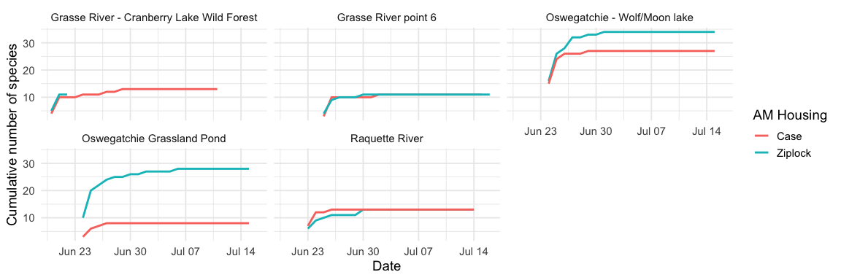

Overall Mean Accumulation by Treatment
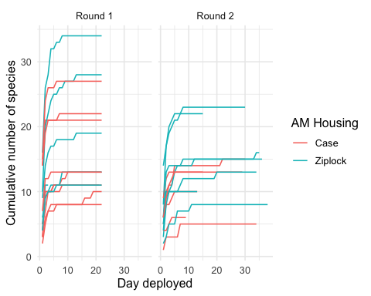

Models

Multilevel Model for SR
First we need to manipulate the the deployment data to have a unique ID for each paried site and re-join with the birdnet output.
Convert this data frame into an sf object using the NAD83 projection (EPSG: 5070):
Now we can use splm() to create the model:
Call:
splm(formula = sr_mean ~ AM_housing + Round, data = sr_mod_sf,
spcov_type = "none", random = ~1 | pair_id)
Residuals:
Min 1Q Median 3Q Max
-6.0910 -3.2735 -0.8366 2.4344 10.4090
Coefficients (fixed):
Estimate Std. Error z value Pr(>|z|)
(Intercept) 10.591 1.407 7.527 5.2e-14 ***
AM_housingZiplock 2.770 1.302 2.128 0.0334 *
RoundRound 2 -3.999 1.816 -2.202 0.0277 *
---
Signif. codes: 0 '***' 0.001 '**' 0.01 '*' 0.05 '.' 0.1 ' ' 1
Pseudo R-squared: 0.2501
Coefficients (none spatial covariance):
ie
6.764
Coefficients (random effects):
1 | pair_id
12.64
significant p-value now that we account for round and average per day!
term | estimate | std.error | statistic | p.value
(Intercept) | 10.59 | 1.407 | 7.527 | 5.196e-14
AM_housingZiplock | 2.77 | 1.302 | 2.128 | 0.03335
RoundRound 2 | -3.999 | 1.816 | -2.202 | 0.02768

Spatial Model for SR
Now we can try the spatial model:
Call:
splm(formula = sr_mean ~ AM_housing + Round, data = sr_mod_sf,
spcov_type = "exponential")
Residuals:
Min 1Q Median 3Q Max
-6.1801 -3.2547 -0.8571 2.4885 10.3199
Coefficients (fixed):
Estimate Std. Error z value Pr(>|z|)
(Intercept) 10.680 1.371 7.789 6.66e-15 ***
AM_housingZiplock 2.627 1.309 2.006 0.0448 *
RoundRound 2 -4.015 1.665 -2.411 0.0159 *
---
Signif. codes: 0 '***' 0.001 '**' 0.01 '*' 0.05 '.' 0.1 ' ' 1
Pseudo R-squared: 0.2524
Coefficients (exponential spatial covariance):
de ie range
12.437 6.944 683.975
Same deal.
Comparison:
$$y=β_{0}+β_{1}(AMHousing)+β_{2}(Round)+ϵ_{site}$$
$$Y=β_{0}+β_{1}(AMHousing)+β_{2}(Round)+τ$$
Table continues below
model | n | p | npar | value | AIC | AICc | BIC | logLik
mixed_mod | 28 | 3 | 2 | 149.7 | 153.7 | 154.2 | 156.4 | -74.86
spatial_mod | 28 | 3 | 3 | 149.3 | 155.3 | 156.3 | 159.3 | -74.67

deviance | pseudo.r.squared
25 | 0.2501
25 | 0.2524
Looks like the the standard mixed model did better and standardizing for recording length seems to have increased the near-significant p-value for the mixed model.

Mixed model for IDs
Convert this data frame into an sf object using the NAD83 projection (EPSG: 5070):
Now we can use splm() to create the model:
Call:
splm(formula = sr_mean ~ AM_housing + Round, data = sr_mod_sf,
spcov_type = "none", random = ~1 | pair_id)
Residuals:
Min 1Q Median 3Q Max
-6.0910 -3.2735 -0.8366 2.4344 10.4090
Coefficients (fixed):
Estimate Std. Error z value Pr(>|z|)
(Intercept) 10.591 1.407 7.527 5.2e-14 ***
AM_housingZiplock 2.770 1.302 2.128 0.0334 *
RoundRound 2 -3.999 1.816 -2.202 0.0277 *
---
Signif. codes: 0 '***' 0.001 '**' 0.01 '*' 0.05 '.' 0.1 ' ' 1
Pseudo R-squared: 0.2501
Coefficients (none spatial covariance):
ie
6.764
Coefficients (random effects):
1 | pair_id
12.64
term | estimate | std.error | statistic | p.value
(Intercept) | 701.1 | 106.4 | 6.592 | 4.34e-11
AM_housingZiplock | 235.3 | 98.41 | 2.391 | 0.01679
RoundRound 2 | -450.6 | 137.3 | -3.282 | 0.001031

