MATH SOC’s

Records Keeper

BSCS 3B

Felix, Adrian S. - Leader

Abawag, Amorlina D.

Balingbing, Jemuel T.

Bocalan, Chinie Ann S.

Milla, Diane Rose D.

Description

Math Society or MathSoc is one of the six clubs under College of Science. It is responsible for organizing events related to math that would benefit its members. Because students have to take math subjects, it is expected for MathSoc to have many members.

The Math SOC’s Records Keeper is a web-based application intended to record the activities done by the Mathematics Society or MathSoc annually. It monitors the money collected from the membership and other things. It also records expenses from events and activities. This system will be helpful in making record keeping and fund monitoring easier and less time-consuming for officers.

Features

The system has the following features:

Log in - Since the application is for MathSoc, the only people who have the access to this application are the members of the said club. Before they log into the system, they must be registered first.

Records of professors - The system lists the professors under the Mathematics Department and include details like their subject load, the course and section they teach. This is important in fund collection for the professor who gets the highest amount of collected fund would receive an award.

Records of members of MathSoc - Because every student takes Math in college, it is expected for MathSoc to have many members. However, listing them individually would be tedious and inefficient. In this system, membership is recorded per section. It can be sorted according to course, college and professor. Since the membership requires fee, there is a record needed for computation.

Records of fund collection - Other than the membership fee, there are other collections done by the MathSoc. Examples are raffle tickets, annual t-shirts and daily calculator rentals. The user can add, delete or update the collection record. The output of this feature is a financial report.

Record of expenses - For transparency in proper allocation of funds, a clear record of expenses is a must-have. It lists the expenses done according to an event, or date and computes the total.

Record of accomplishment reports - The user can create an accomplishment report with a format guide by using the application. Also, the previous accomplishment reports are accessible to the user.

All records are saved in a database. Therefore the user can view, add, modify, and delete any record they want.

Membership Formz

Collection Form



Expense form



Accomplishment Form

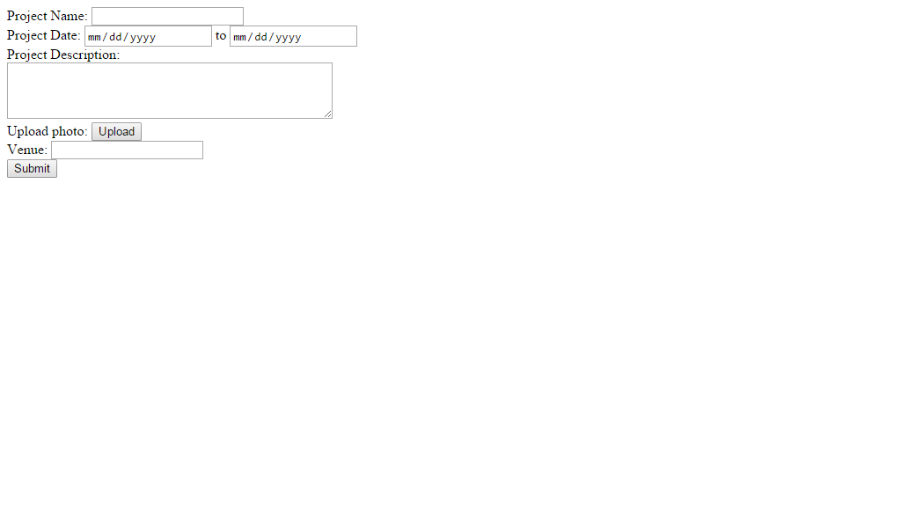

Membership Form

