Parvatibai Chowgule College of Arts & Science

(Autonomous)

MSc-IT-PART-I 2019-20

Advanced Database Management Systems

Max Marks: 20 Duration: 1 Hour

1: Consider the following two statements about database transaction schedules:

I. Strict two-phase locking protocol generates conflict serializable schedules that are also recoverable.

II. Timestamp-ordering concurrency control protocol with Thomas’ Write Rule can generate view serializable schedules that are not conflict serializable

Which of the above statements is/are TRUE?

a. I only

b. II only

c. Both I and II

d. Neither I nor II

2: Consider three data items D1, D2 and D3 and the following execution schedule of transactions T1, T2 and T3. In the diagram, R(D) and W(D) denote the actions reading and writing the data item D respectively.  Which of the following statements is correct?

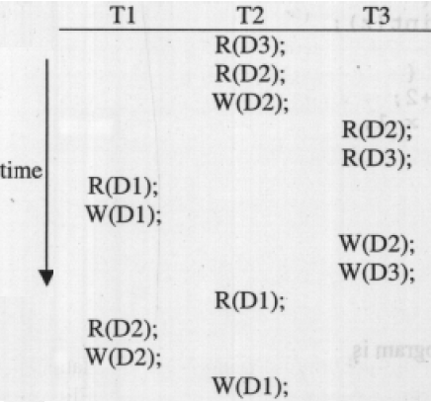

a. The schedule is serializable as T2; T3; T1  
b. The schedule is serializable as T2; T1; T3  
c. The schedule is serializable as T3; T2; T1

d. The schedule is not serializable

3: 11.Which of the following scenarios may lead to an irrecoverable error in a database system ?

a. A transaction writes a data item after it is read by an uncommitted transaction

b. A transaction reads a data item after it is read by an uncommitted transaction

c. A transaction reads a data item after it is written by a committed transaction

d. A transaction reads a data item after it is written by an uncommitted transaction

4: Consider the following database schedule with two transactions, T1 and T2.

**S = r2(X); r1(X); r2(Y); w1(X); r1(Y); w2(X); a1; a2;**

where ri(Z) denotes a read operation by transaction Ti on a variable Z, wi(Z) denotes a write operation by Ti on a variable Z and ai denotes an abort by transaction Ti . Which one of the following statements about the above schedule is TRUE?

a. S is non-recoverable  
b. S is recoverable, but has a cascading abort  
c. S does not have a cascading abort

d. S is strict

5: Consider the following four schedules due to three transactions (indicated by the subscript) using read and write on a data item x, denoted by r(x) and w(x) respectively. Which one of them is conflict serializable.

a. r1(x); r2(x); w1(x); r3(x); w2(x);

b. r2(x); r1(x); w2(x); r3(x); w1(x);

c. r3(x); r2(x); r1(x); w2(x); w1(x);

d. r2(x); w2(x); r3(x); r1(x); w1(x);

a. A  
b. B  
c. C  
d. D

5: A bank offers its account holders 7% interest if their balance is above Rs. 10000, else 6%. To

achieve this, each of the following SQL statements is executed as separate transactions t 1 and

t 2 .

t 1 : update account set balance = balance * 1.6 where balance <= 10000

t 2 : update account set balance = balance * 1.7 where balance > 10000

Then t 1 and t 2

a. must be executed one after the other but either order is acceptable

b. must be executed one after the other but with t 1 going first

c. must be executed one after the other but with t 2 going first

d. can be executed concurrently

6. Given a schedule for transactions t 1 and t 2 we can say that

a. the schedule can be serialized if t 1 and t 2 resulted from the use of two-phase locking

b. the transactions compute the correct result if t 1 executed only after t 2 committed

c. the transactions compute the correct result if t 1 and t 2 executed concurrently but did

not access any common data items

d. all of the above statements are correct

7. ____ ensures that once transaction changes are done, they cannot be undone or lost, even in the event of a system failure.

a. Atomicity

b. Consistency

c. Durability

d. Isolation

8: If several concurrent transactions are executed over the same data set and the second transaction updates the database before the first transaction is finished, the ____ property is violated and the database is no longer consistent.

a. Atomicity

b. Consistency

c. Durability

d. Isolation

9: how many view equivalent serial schedules are possible for the given schedule s: w1(a) r2(a) w3(a) r4(a) w5(a) r6(a)

a. 2

b. 3

c. 6

d. 8

10. State which of the protocol allows the schedule:

T1:R(x), T2:W(x), T1:W(x), T3:R(x), T1: Commit, T2: Commit, T3: Commit

a. Both 2PL and timestamp ordering protocol allows it.

b. Time stamp protocol allows it but not 2PL.

c. Allowed in 2PL but not in Timestamp ordering protocol.

d. Not allowed in both 2PL and Timestamp ordering protocol.

11. Consider the following schedule.

S: R2(A), W1(B), W1(C), R3(B), R2(B), R1(A), C1, R2(C) C2, W3(A), C3.

Consider the following statements:

S1: Schedule S is conflict serilaizable schedule.

S2: Schedule S is allowed by 2PL.

S3: Schedule S is strict recoverable schedule.

S4: Schedule S is allowed by strict 2PL.

How many above statements are correct about above schedule.

a. 1 b.2 c.3 d.4

12: Consider thw following schedules :-

S1 :- W1(A) W2(A) W1(B) W2(B)

S2:- W1(A) R2(A) W2(A) W2(B) W1(B)

Assume that schedule S1 is failed after performing W1(B). Which of the following options are true?

a. S1 and S2 has lost update problem and WW problem.

b. S1 and S2 are free from lost update problem and WW problem

c. S1 has WW problem and S2 has lost update problem

d. S1 has lost update problem and s2 has WW problem.

13: Consider the partial Schedule S involving two transactions T1 and T2. Only the read and the write operations have been shown. The read operation on data item P is denoted by read(P) and write operation on data item P is denoted by write(P).

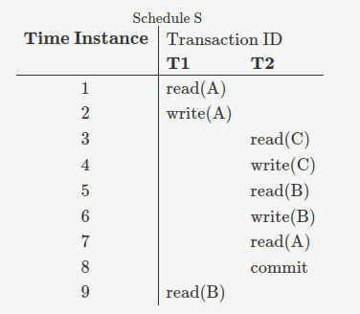

Suppose that the transaction T1 fails immediately after time instance 9. Which of the following statements is correct?

a. T2 must be aborted and then both T1 and T2 must be re-started to ensure transaction atomicity

b. Schedule S is non-recoverable and cannot ensure transaction atomicity.

c. Only T2 must be aborted and then re-started to ensure transaction atomicity.

d. Schedule S is recoverable and can ensure transaction atomicity and nothing else needs to be done.

14: Consider the transactions T1,T2,andT3 and the schedules S1andS2 given below.

T1:r1(X);r1(Z);w1(X);w1(Z)

T2:r2(Y);r2(Z);w2(Z)

T3:r3(Y);r3(X);w3(Y)

S1:r1(X);r3(Y);r3(X);r2(Y);r2(Z);w3(Y);w2(Z);r1(Z);w1(X);w1(Z)

S2:r1(X);r3(Y);r2(Y);r3(X);r1(Z);r2(Z);w3(Y);w1(X);w2(Z);w1(Z)

Which one of the following statements about the schedules is TRUE?

a. Only S1 is conflict-serializable.

b. Only S2 is conflict-serializable.

c. Both S1 and S2 are conflict-serializable.

d. Neither S1 nor S2 is conflict-serializable.

15: Assume that Ti requests a lock held by Tj. The following table summarizes the actions taken for wait-die and wound-wait scheme:

|  |  |  |
| --- | --- | --- |
|  | Wound wait scheme | Wait die scheme |
| Ti is older than Tj | Y | Z |
| Ti is younger than Tj | W | X |

Fill correct status of Ti and Tj at W, Y, X, and Z respectively.

a: Ti dies, Ti waits, Ti waits, and Tj aborts respectively.

b: Ti dies, Ti waits, Ti waits, and Tj aborts respectively.

c: Ti waits, Ti dies, Ti waits, and Tj aborts respectively

d: None of these

16:__________ data structure is used to check the existence of deadlock in the schedule.

a: Precedence Graph

b: Deadlock Graph

c: Cyclic Graph

d: Wait for Graph

17: Transaction processing is associated with everything below except

a: Producing detail, summary, or exception reports

b: Maintaining data.

c: Confirming an action or triggering a response

d: Recording a business activity

18: Which of the following scenarios may lead to an irrecoverable error in a database system?

a: A transaction writes a data item after it is read by an uncommitted transaction  
b: A transaction reads a data item after it is read by an uncommitted transaction  
c: A transaction reads a data item after it is written by a committed transaction

d: A transaction reads a data item after it is written by an uncommitted transaction

19: A transaction T does not release any of its exclusive (write) locks until after it commits or aborts.

a. Strict 2PL

b.Rigorous 2PL

c. Conservative 2PL

d. 2PL

20: Data Structure used to check conflict Serializability of a Schedule.

a: Precedence Graph

b: Deadlock Graph

c: Cyclic Graph

d: Wait for Graph