**MTH 5315**

**MIDTERM 1 REPORT**

**Name:** Bindi Nagda

**Professor:** Dr. Du

**Date submitted:** 19th February, 2019

**Midterm Exam 1**

**Question 1:**

a) The first-order upwinding scheme was applied to the wave equation $u_{t}+u_{x}=0$ over the doman [0, 1] with periodic boundary condition and initial condition $u\left(x,0\right)=\sin^{2}\left(2πx \right).$

First-Order Upwinding Scheme:

$$U_{j}^{k+1}=U_{j}^{k}-Δt\frac{F_{j+\frac{1}{2}}-F_{j-\frac{1}{2}}}{Δx }$$

$F$ is the first-order upwinding flux:

$$F_{j+\frac{1}{2}}=U_{j}^{k}$$

$$F_{j-\frac{1}{2}}=U_{j-1}^{k}$$

The grid size, $Δx=0.01$ and the time step, $Δt=0.75Δx$. This means R = 0.75, and hence the scheme is stable since it satisfies the CFL condition. The exact solution and numerical solution are plotted below at time = 2.

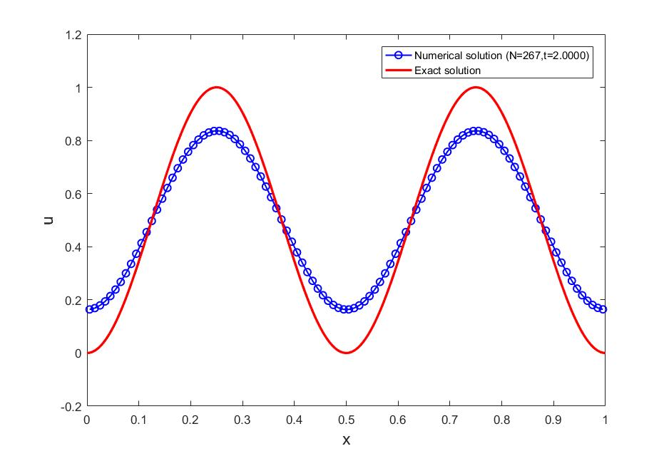

Figure 1 - Numerical and Analytical Solution to the wave equation

From the plot above, it is observed that the numerical solution is smooth, dissipative and non-dispersive. The dissipative behavior of the first-order upwinding scheme with respect to the dimensionless wave number ($βΔx$) is illustrated in figure 2. After analyzing the dissipative qualities of the scheme, it is seen that the scheme damps out high frequency waves (corresponding to high values of $βΔx$) relative to low frequency components, resulting in a smooth solution. The amplitude of the analytical solution at time = 2 is 0.5 while the amplitude of the numerical solution at time = 2 is 0.3361. This means that only 67.22% of the solution remains and hence the amount of damping is ~16.4%.

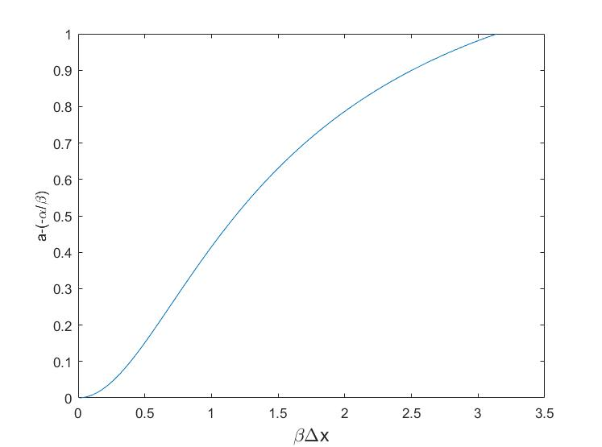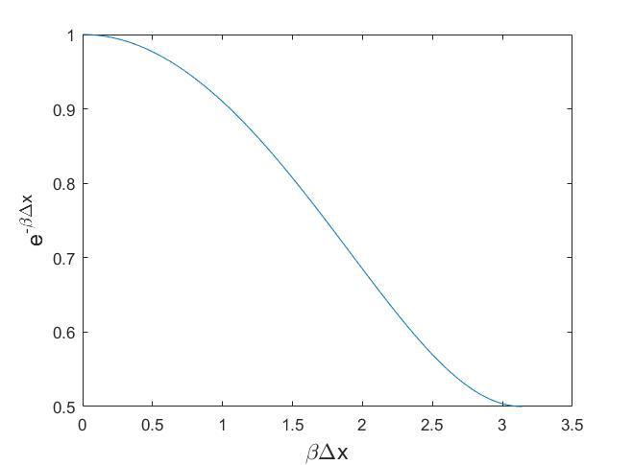It should be noted that although the upwinding scheme is known to be dispersive, with the greatest phase shift happening at high wave number components (see figure 3), the numerical solution above exhibits essentially no dispersion due to the fact that the high wave numbers are damped out.

*Figure 2 – Damping Factor against wave number for first-order upwinding scheme (R = 0.75)*

*Figure 3 – Wave speed error against wave number for first-order upwinding scheme (R = 0.75)*

b) The initial condition is now changed to $u\left(x,0\right)=\sin^{20}\left(2πx \right)$ while all else remains the same.

The exact solution and numerical solution at time = 2 are plotted below.

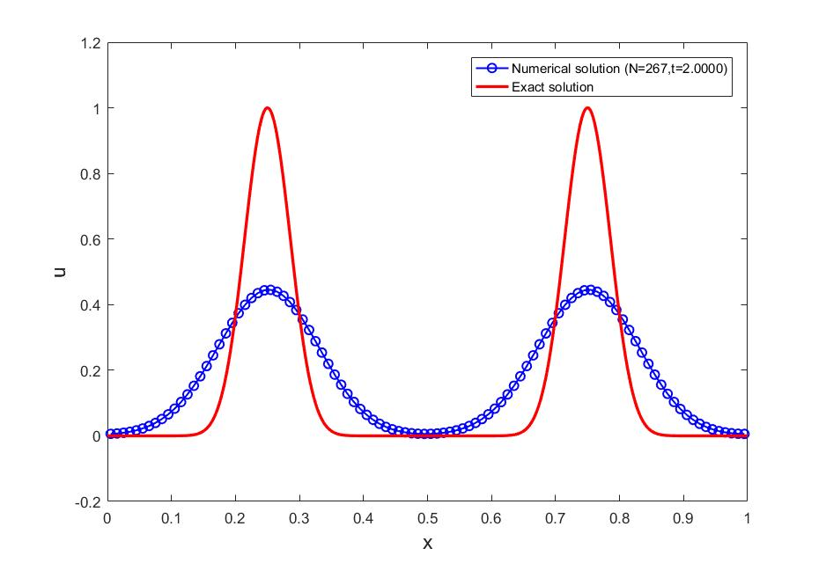  
Figure 4 - Numerical and Analytical Solution to the wave equation

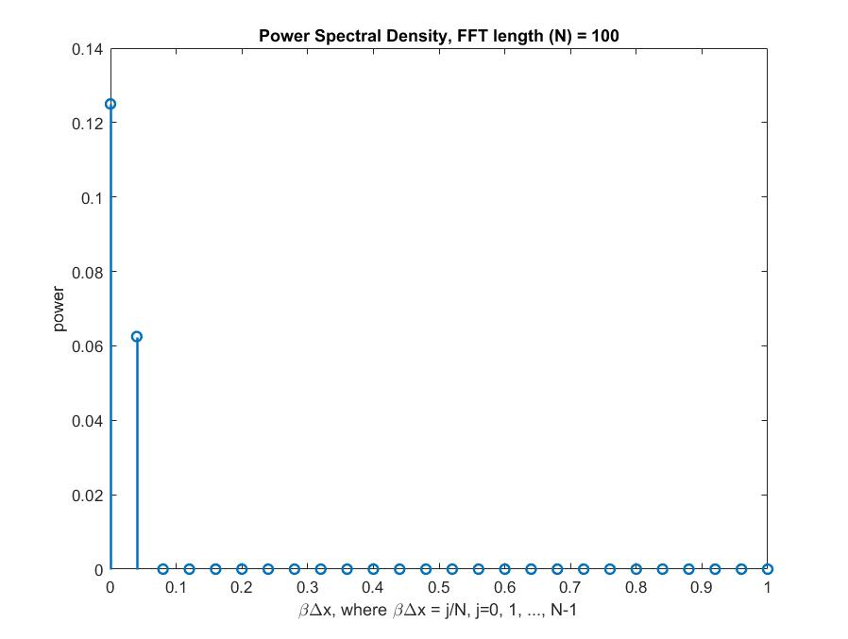From the plot above, it is observed that the numerical solution is smooth and non-dispersive just as before, but it exhibits greater dissipation. At time = 2, the ratio of numerical amplitude to analytical amplitude is 0.446, which means that the amount of damping is ~ 55.4%. The amount of damping when the initial condition is changed to $u\left(x,0\right)=\sin^{20}\left(2πx \right)$ is therefore greater by a factor of 1.69 than when the initial condition was $u\left(x,0\right)=\sin^{2}\left(2πx \right)$. The difference in amount of damping due to different initial conditions can be explained using Power Spectral Density (PSD) plots of the initial conditions.

*Figure 5 – PSD plot of $u\left(x,0\right)=\sin^{2}{(2πx)}$*

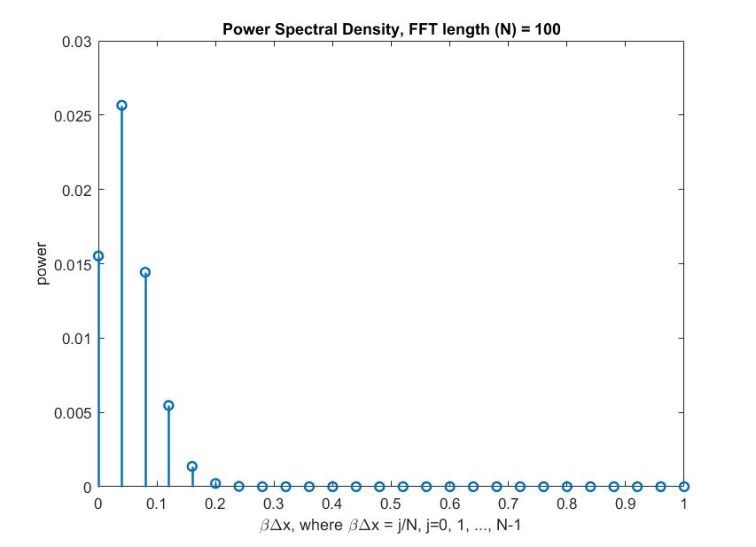

*Figure 6 – PSD plot of $u\left(x,0\right)=\sin^{20}{(2πx)}$*

The power spectral density is a measurement of the energy at various frequencies and is useful in understanding which modes are significantly present in the Fourier representation of U(x, 0). Due to the symmetries in the power spectral density, only half of the FFT’s of u(x, 0) are plotted (which contains information about all the modes present). This is achieved by using the one-sided frequency range for the PSD estimate. In figure 6, it is observed that the nontrivial part of the power spectrum spreads over [0, 0.1]. In figure 5, the nontrivial part of the power spectrum is spread over [0, 0.02]. Hence, it has been shown that the power spectral densities of $u\left(x,0\right)=\sin^{2}{(2πx)}$ are confined to a much smaller interval in the far left of the domain [0, 1] than those of $u\left(x,0\right)=\sin^{20}{(2πx)}$. This means that the significant modes of $u\left(x,0\right)=\sin^{2}{(2πx)}$ are in the region where $βΔx$ is close to 0 where the dissipation is less (see figure 2). But the significant modes of $u\left(x,0\right)=\sin^{20}{(2πx)}$ are in the region of the curve in figure 2 where the dissipation is more, hence the solution in part b has greater amount of damping. Thus, the PSD plots above have been useful in explaining the difference between the amounts of dissipation due to the two different initial conditions.

**Question 2:**

The following scheme was applied to the wave equation $u_{t}+u_{x}=0$ with periodic boundary condition over domain [0, 1] and initial condition $\left(x,0\right)=\sin^{2}{(2πx)}$.

$$U_{k}^{n+1 }+\frac{R}{4}\left(U_{k+1}^{n+1}-U_{k-1}^{n+1}\right)=U_{k}^{n}-\frac{R}{4}\left(U_{k+1}^{n}-U_{k-1}^{n}\right)$$

Where $R=\frac{Δt}{Δx}$

Due to periodic boundary conditions, $U_{0}^{n}=U_{k}^{n}$ and $U_{k+1}^{n}=U_{1}^{n}$ for n, k = 1, 2, …, N.

Looking at the above scheme it is clear that in order to solve it, we must solve a system of linear equations of the form A**u** = **b,** where A is the coefficient matrix.We are solving for the vector **u.**

$A=\left[\begin{matrix}\frac{1}{Δt} & \frac{a}{4Δx} & . & . & . & \frac{-a }{4Δx} \\ \frac{-a }{4Δx} & \frac{1}{Δt} & \frac{a }{4Δx} & . & . & . \\ . & \frac{-a }{4Δx} & . & . & . & . \\ . & . & . & . & . & .\frac{a}{5} \\ . & . & . & . & . & \frac{a }{4Δx} \\ \frac{a }{4Δx} & . & . & . & \frac{-a }{4Δx} & \frac{1}{Δt}\end{matrix}\right]$, **u** = $\left[\begin{matrix}U_{1}^{n+1} \\ . \\ U_{2}^{n+1} \\ . \\ . \\ .\frac{}{3} \\ U_{k}^{n+1}\end{matrix}\right]$, **b** = $\left[\begin{matrix}\frac{a}{4Δx}U_{k}^{n}+\frac{1}{Δt}U_{1}^{n}-\frac{a}{4Δx}U_{2}^{n} \\ . \\ \frac{a}{4Δx}U_{1}^{n}+\frac{1}{Δt}U_{2}^{n}-\frac{a}{4Δx}U_{3}^{n} \\ . \\ . \\ .\frac{.1}{3} \\ \frac{a}{4Δx}U_{k-1}^{n}+\frac{1}{Δt}U_{k}^{n}-\frac{a}{4Δx}U_{1}^{n}\end{matrix}\right]$

Using a grid size, $Δx= 0.01$ and a time step, $Δt=4Δx$, the following numerical solution was generated at time = 4.

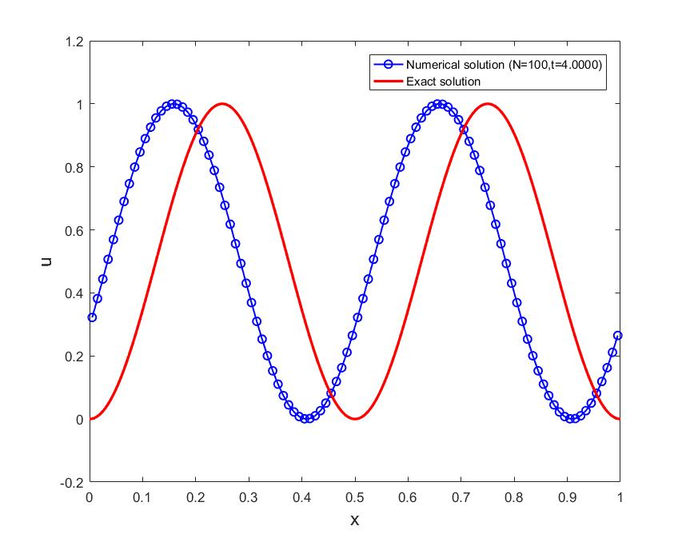

*Figure 7 – Analytical and numerical solution to wave equation at t = 4 after applying Crank-Nicholson Scheme*

b) Quantitatively explaining the error in the numerical solution based on the dispersive nature of the scheme

The Crank-Nicholson scheme exhibits dispersive behavior and has no dissipation ($e^{-bΔt}=1)$. Dispersion occurs when the numerical wave speed is different from the analytical wave speed. For the above scheme, the numerical wave speed is evaluated analytically to be:

$$c= -\frac{α}{β}=-\frac{1}{4βΔx}\arctan\left(\frac{-Rsin\left(βΔx\right)}{1-\frac{R^{2}}{4}\sin^{2}\left(βΔx\right)}\right)$$

The dispersive behavior can easily be observed from the plot above since there is a phase shift between the numerical and exact solution. The phase shift is (0.5005 $-$ 0.405) = 0.0955 to the left. This means that the numerical solution is traveling slower to the right than the exact solution.

c) Dispersion errors arise because components of a solution having different grid resolution requirements may propagate through the grid with slightly different speeds. Hence, the dispersive error of the solution can be reduced by decreasing the grid size. For example, when $Δx$ is changed to 0.005, the following result is generated:

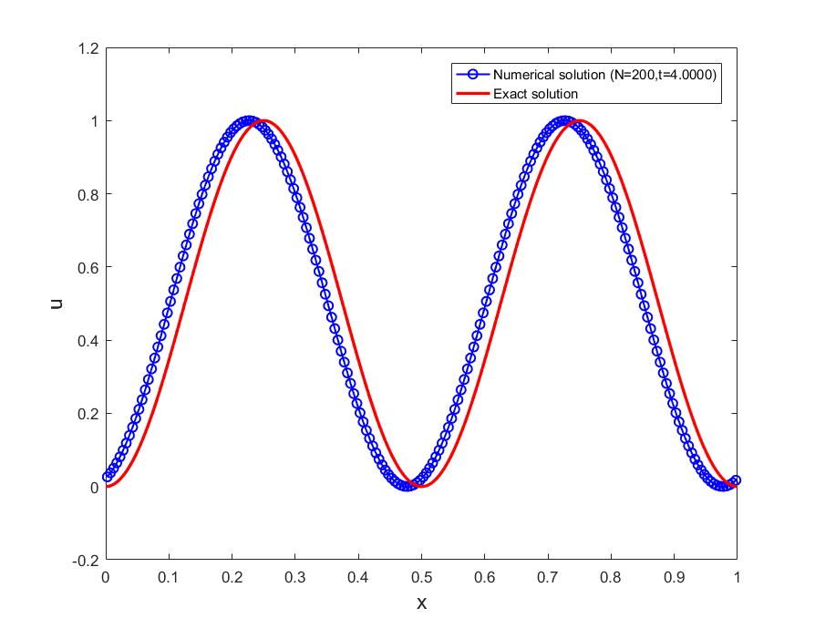

*Figure 7 – Analytical and numerical solution to wave equation at t = 4 after applying Crank-Nicholson Scheme with $Δx=0.005$*

From the above plot, the numerical dispersion has decreased and the phase shift is (0.5015-0.4775) = 0.024 to the left. Therefore the phase shift error has been reduced by a factor of 3.98 as compared to before.

Further reducing the grid size to $Δx=0.001$ generates the following numerical solution:

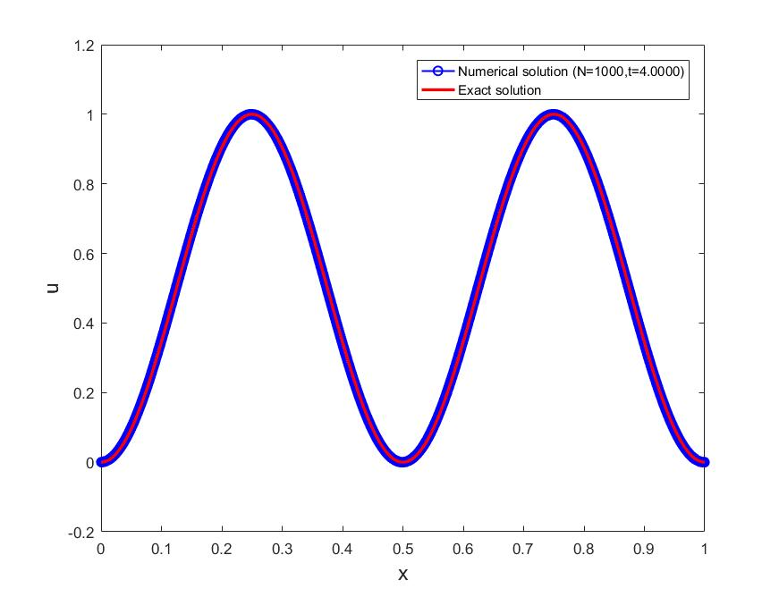

*Figure 7 – Analytical and numerical solution to wave equation at t = 4 after applying Crank-Nicholson Scheme with $Δx=0.001$*

The phase shift is essentially zero as can be seen from the plot. Thus, the error due to numerical dispersion has been eliminated due to the selection of a very fine grid. However, a smaller grid size is computationally expensive and should be avoided in favor of using higher order methods. Note that in the above numerical experiments, the value of R remains unchanged i.e. R = 4 as given before. The Crank-Nicolson scheme is unconditionally stable, and therefore any R value can be chosen. However, it was determined from the above numerical experiments that dispersion was least when R = 4 while $Δx$ was made smaller.