# **### How to download the SMP Analysis Tool ###**

1. Download the SMP Analysis Tool
   1. Go to <https://github.com/adgarnier/smp_analysis_tool>, click “<> Code”, and click “Download ZIP”

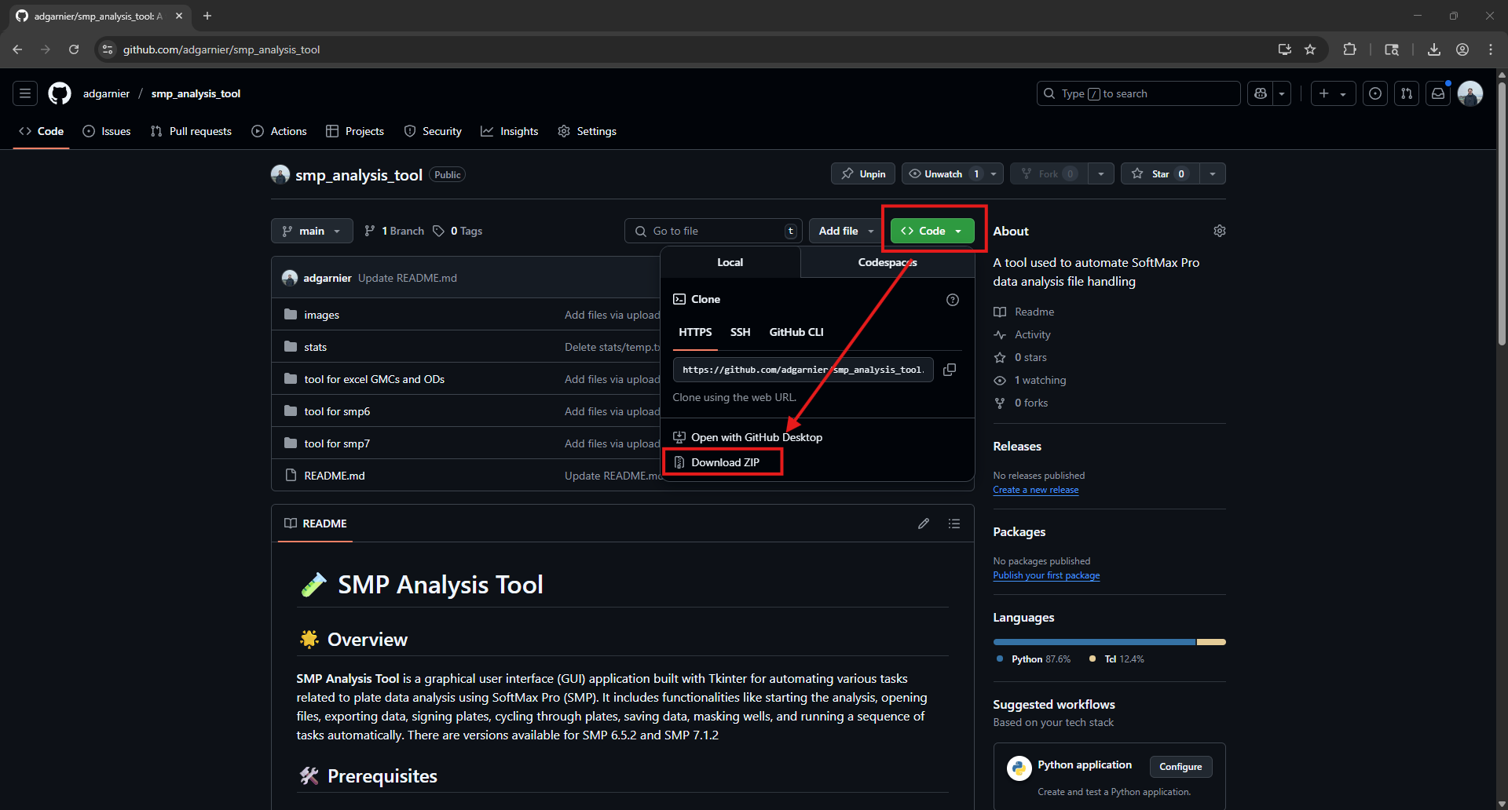

* 1. Move the “smp_analysis_tool-main” file to somewhere on your OneDrive, this is important so you can be able to share it with others

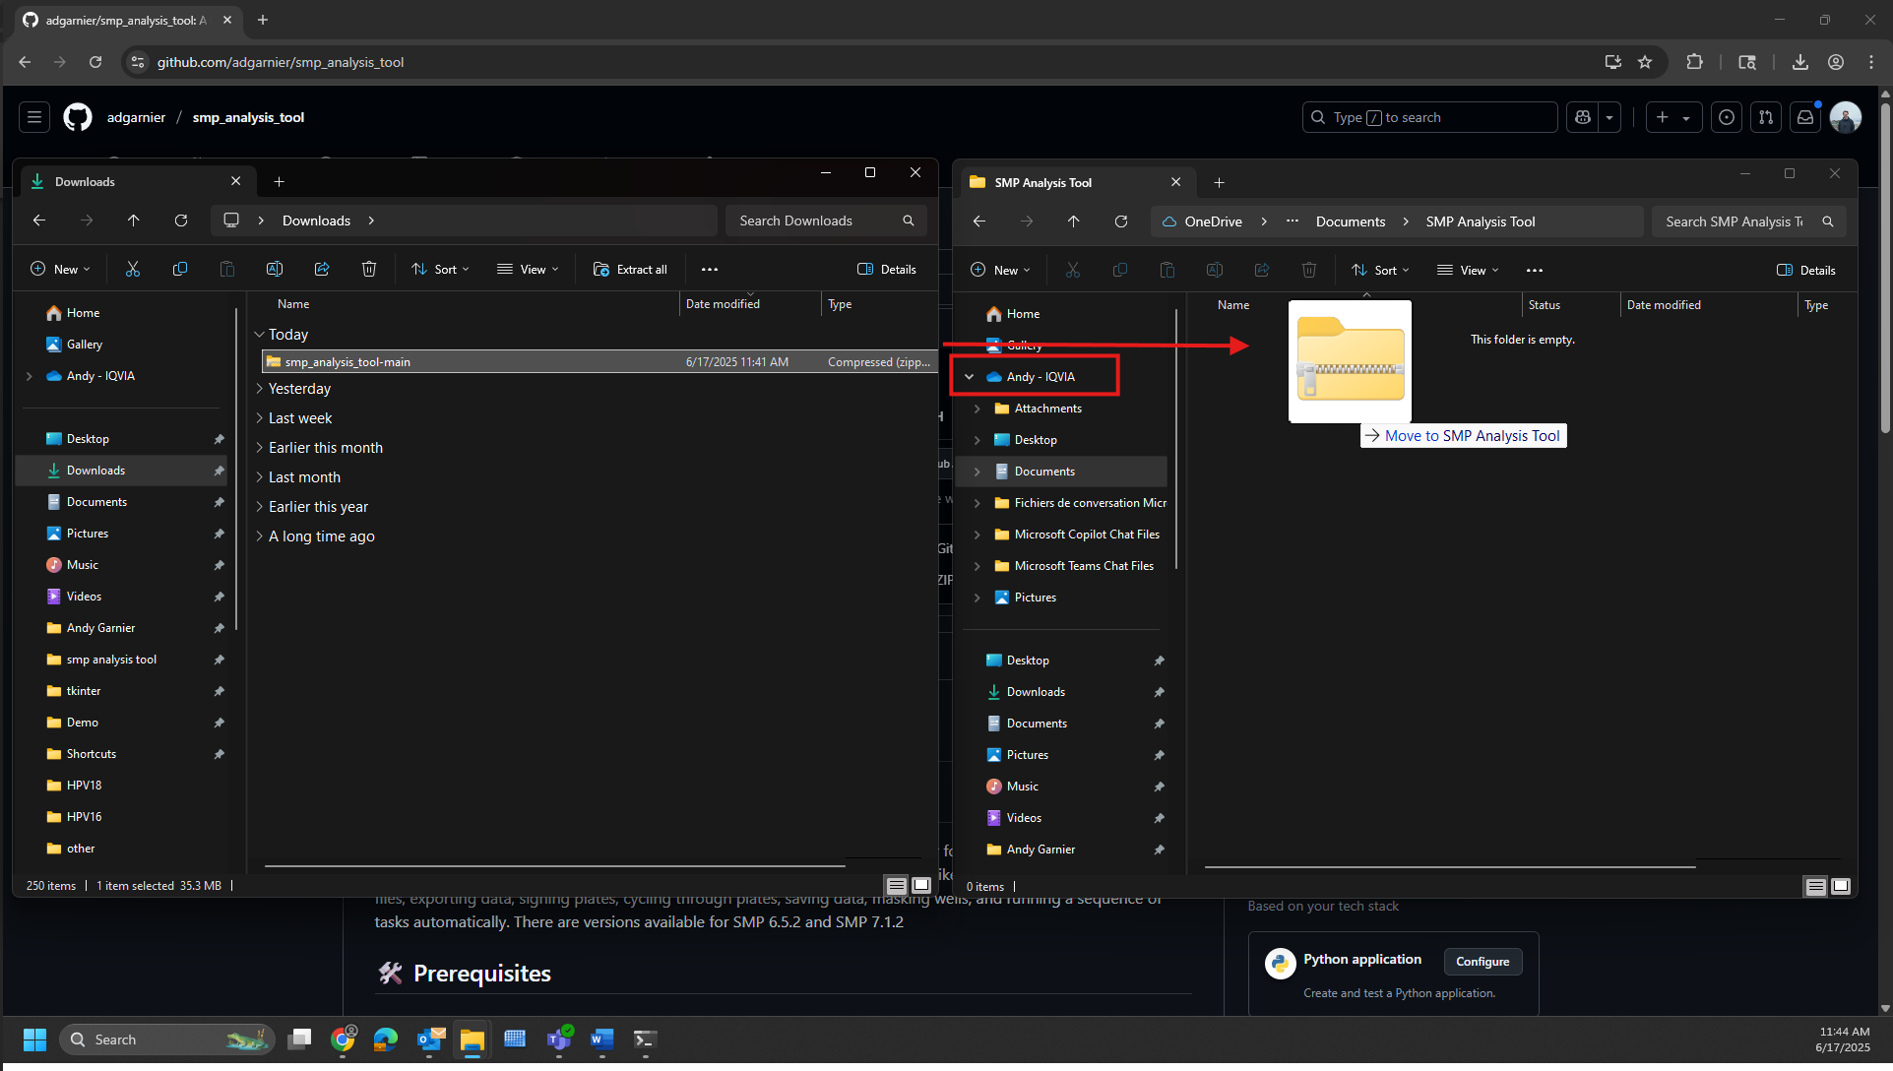

* 1. Right click, click “Extract All…”, then “Extract”

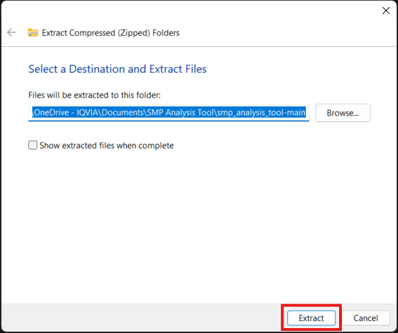

* 1. You will now be able to access the SMP Analysis Tool in the folder! Rename/move the folder as you see fit, just ensure it is in your OneDrive for sharing

# **### How to add users to the SMP Analysis Tool ###**

1. Give users Edit access
   1. Right click the folder, then click “Share”, click the eyeball and then choose “Can Edit”

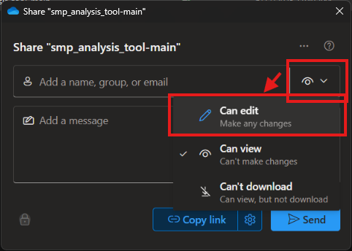

* 1. Click the Gear icon beside “Copy Link”

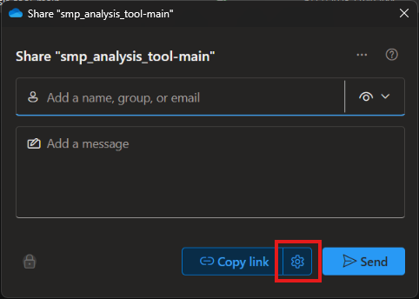

* 1. Select “People in IQVIA”, and click “Apply’

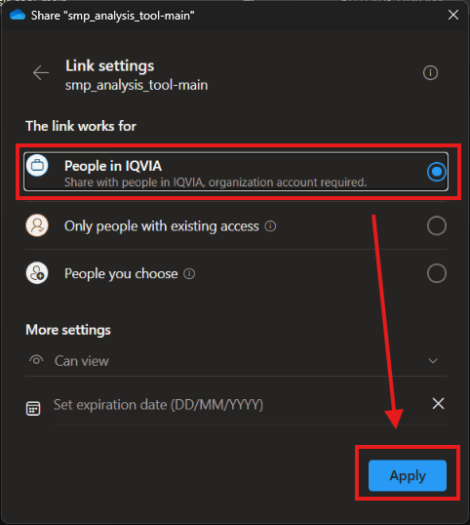

* 1. Click “Copy Link” and send to new user on any platform (e.g. Teams, email)

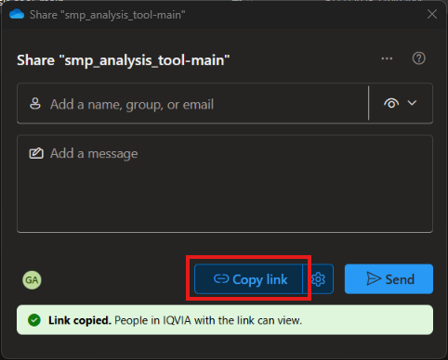

* 1. On their computer, open the link and click “Sync”

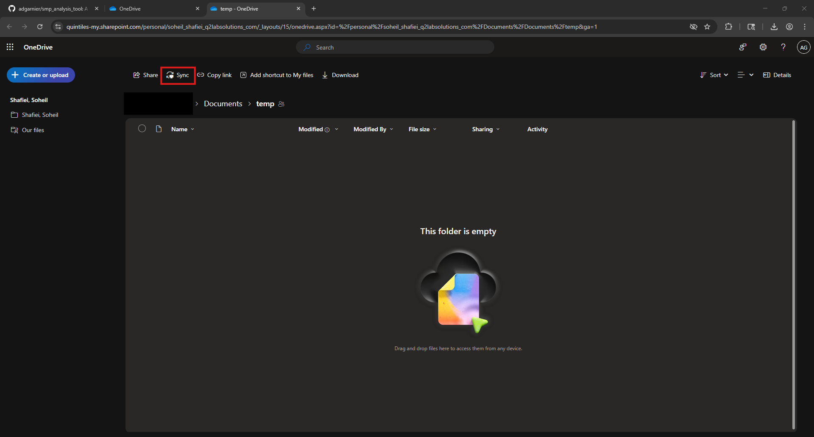

* 1. Click “Open Microsoft OneDrive”

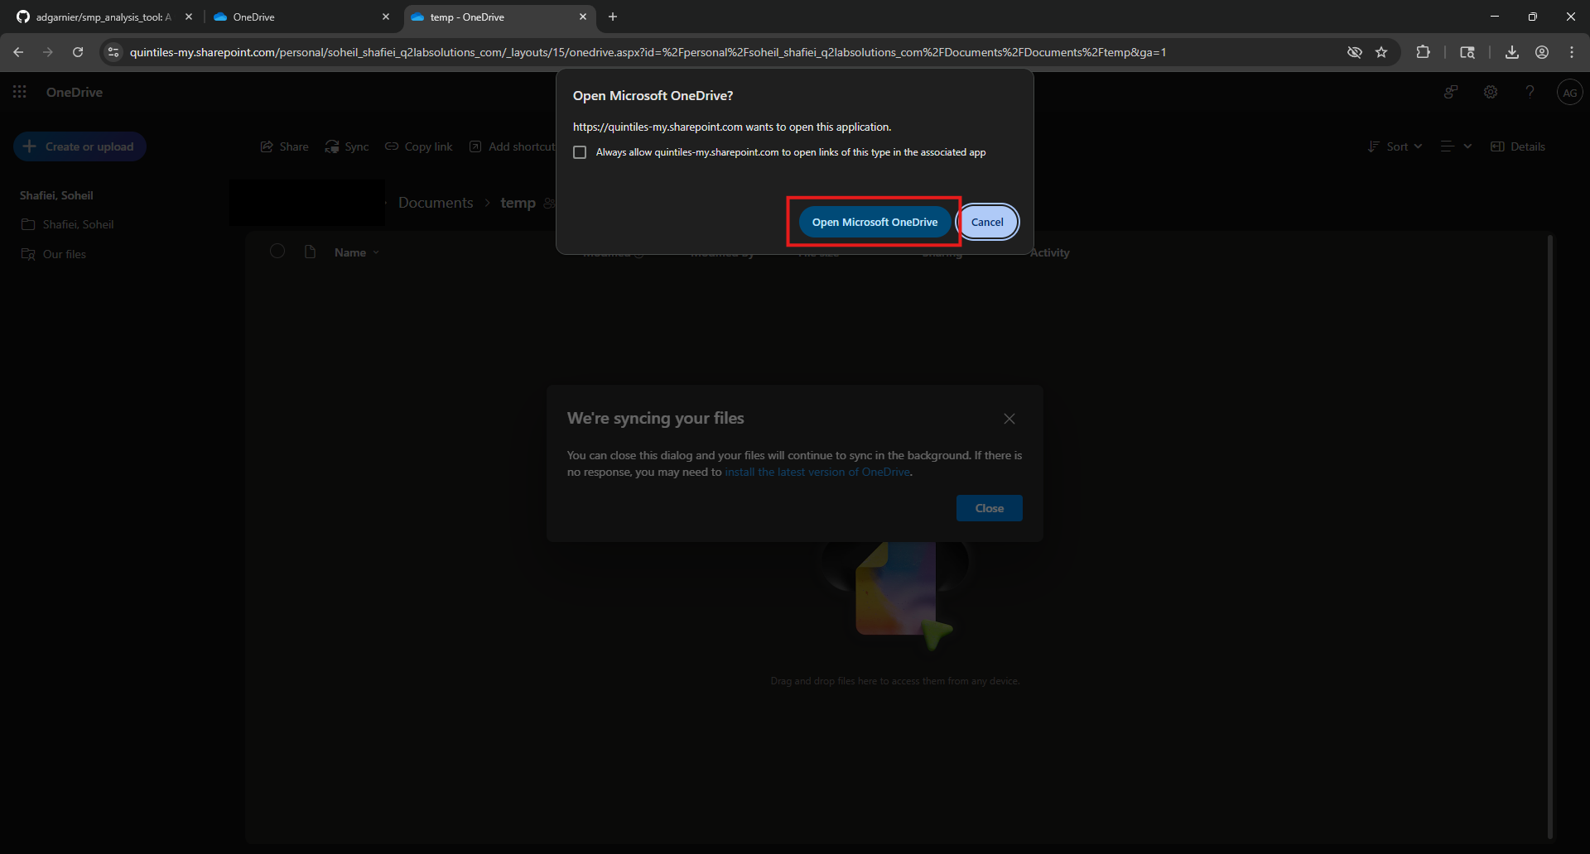

* 1. They will now be able to access the SMP Analysis Tool through the “IQVIA” option towards the bottom of their File Explorer (near Drives)

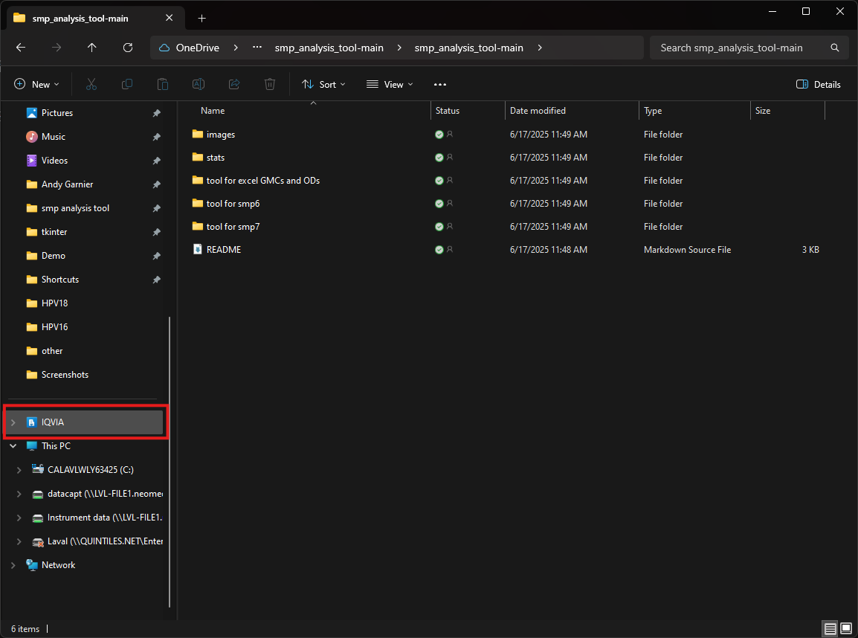

# **### How to install the SMP Analysis Tool for others ###**

1. Download Python through the official website (<https://www.python.org/downloads/>)
   1. Ensure you select the latest version for Windows

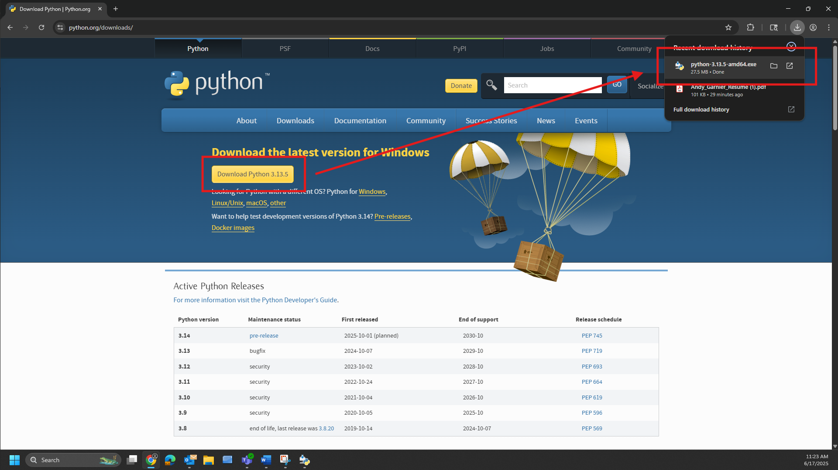

1. Install Python
   1. Ensure to select “Use admin privileges when installing py.exe” and “Add python.exe to PATH”

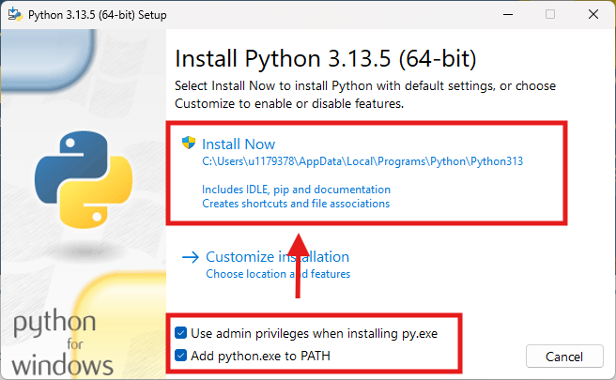

* 1. Once completed close the Setup Launcher

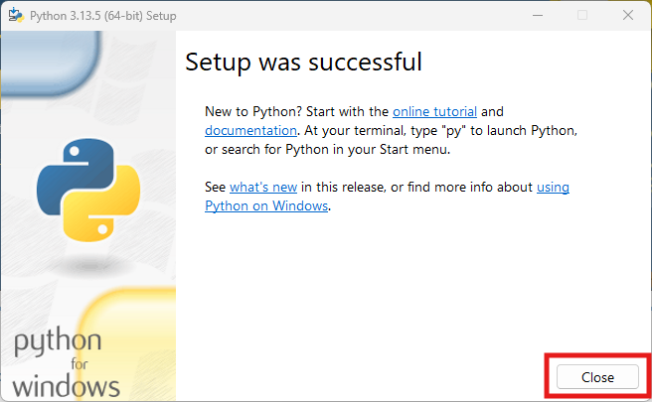

1. Install packages needed for SMP Analysis Tool through Windows PowerShell
   1. Open the Windows PowerShell through the Search bar

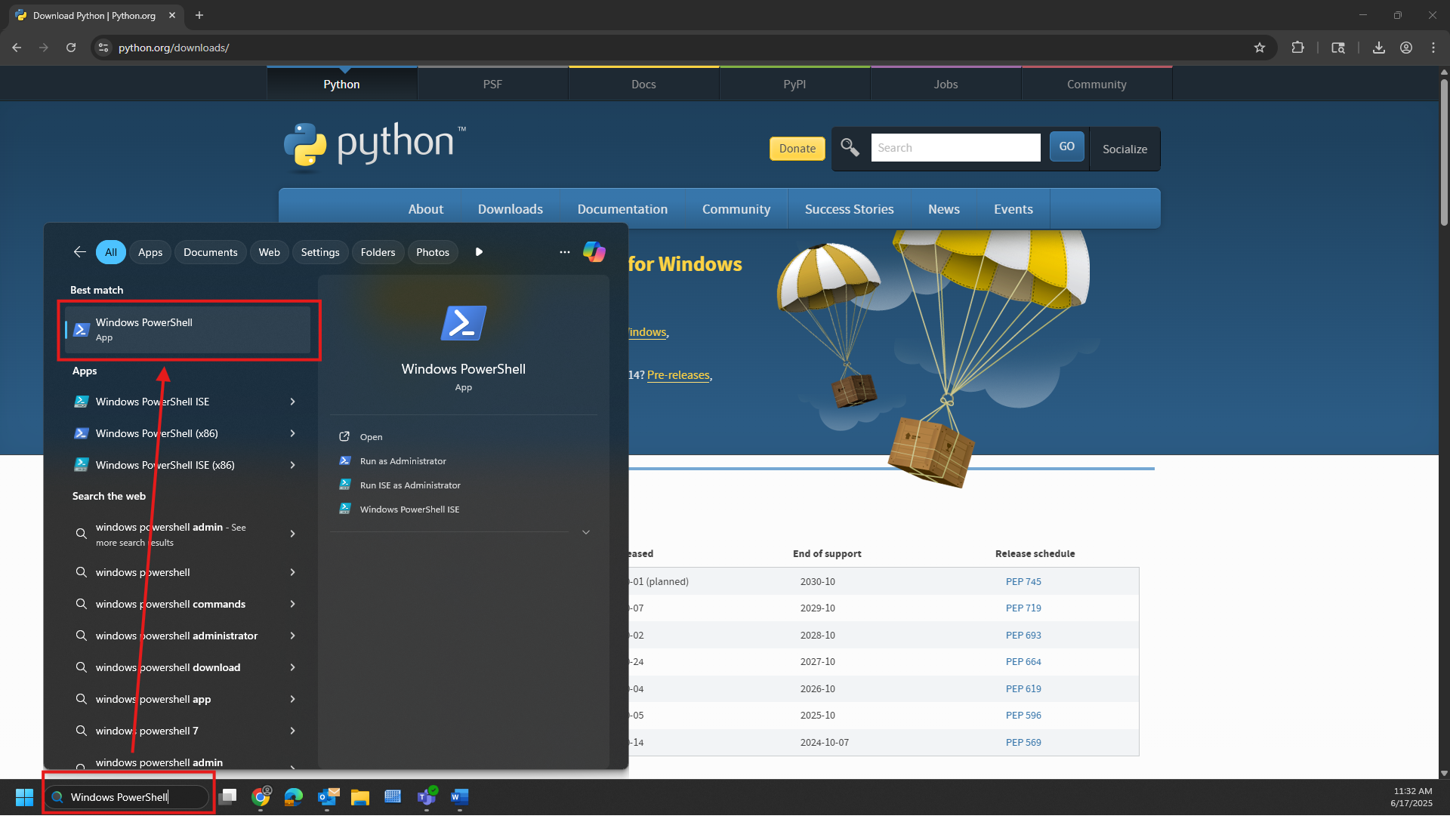

* 1. Type “pip install pyautogui pywin32” and then press enter

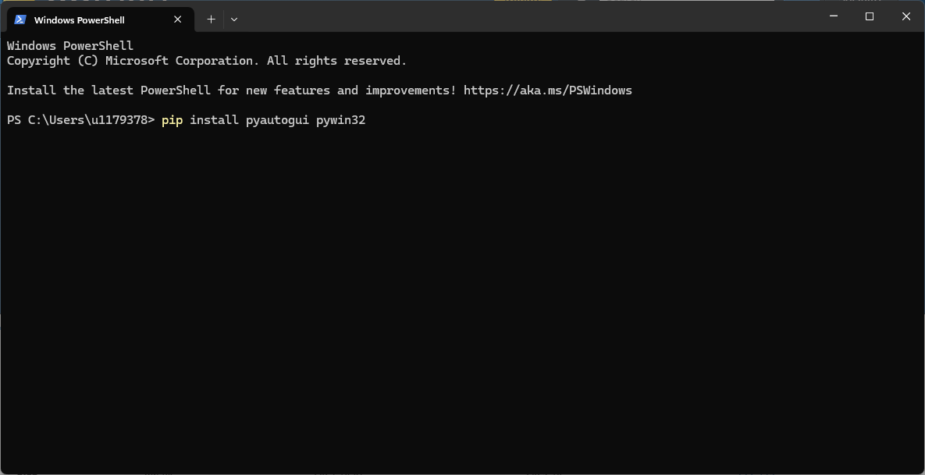

* 1. When everything is done downloading (last line will be “PS C:\Users\{your U ID}>”), you can close the Windows PowerShell

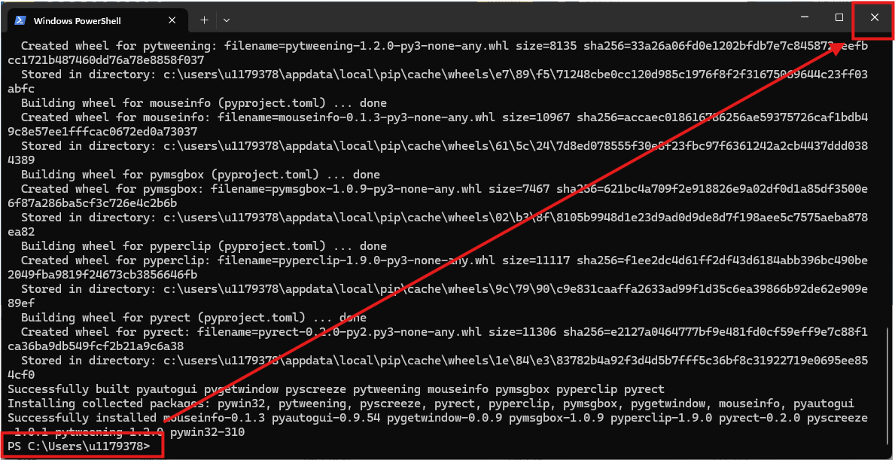

* 1. You will now be able to run the SMP Analysis Tool!