bpp_Res2 User Manual
Using the batch reservoir fitting program and estimating wave intensity and P_{b}/P_{f} using the BP+ device

Alun Hughes
University College London

Version 2.0 (beta 6)

Amendment Record
Version number | Date | Changes Made | Changes made by
1.0 beta 4 | 18/12/23 | - use variable folder_name as path to scan  - Script was not setting typetxt for the case when tmax==ti | ADH
1.0 beta 5 | 13/05/24 | - Expand calculated variables so they match key Sphygmocor variables.  - Use separate functions to read Cardioscope and BP+ files  - Improve detection of end of systole  - Fix bug in Wf1 and Wf2 peak identification  - better identification of problems with fits  - error salvage  - Fix bugs in figures  - Cut number of figures to one per BP+ recording  - Use json configuration file to set default folder rather than hard coding it.  - Miscellaneous minor bug fixes and tidying | ADH
1.0 beta 6 | 25/08/26 | - Fixed duplicate-block bug that overwrote ao.averagePulsePointsIndexes with the wrong source field  - Fixed NIBP mode guard so metadata.mode is now set correctly  - Fixed patienet_id typo (now patient_id)  - Moved Excel results write outside the main loop (was rewriting resdata.xls on every file)  - Removed unused output-folder creation (Processed/Plots/Results)  - Standardised path handling using fullfile  - ao.ed now resolves to NaN (not -1 or []) when duration of systole is unavailable  - Renamed prob to qcaofit and inverted its meaning to represent the aortic fit passing basic checks  - Added regression tests for the file readers, using real anonymised recordings as fixtures  - Moved bppluspoints.m (not part of the pipeline) to a dev folder | ADH

Contents
About BPplus_Res2 4
Using the script 4
Quality control 5
Selected calculations 6
Subendocardial viability ratio (SEVR) 6
Wave intensity 6
Backward and forward pressure 6
Stroke volume and cardiac output 6
Output of results 6
References 7
Appendix 1: Data dictionary 8

About BPplus_Res2
bpp_Res2.m is a MATLAB script that calculates reservoir and excess pressure for USCOM BP+ files. The method is essentially according to that described in Davies et al.¹ for SphygmoCor©-derived files, and similar to that used in the SphygmoCor©-reservoir MATLAB scripts (https://github.com/adh30/Sphygmocor-Reservoir).

Using the script
Put BP+ files (*.xml) to be analysed in the analysis directory, for example
D:\BPPdata
The location of the analysis directory can be specified in the file, bppconfig.json
Open MATLAB and ensure that the working directory is the one that contains the relevant script and function files (in my case this is)
C:\ …\Documents\MATLAB
Type into command line:
>> bpp_Res2
(or highlight bpp_Res2.m) and right click on run, or press F9. After some time (depending on how many files are analysed the run should complete, returning to command prompt. It will show a progress bar while it is running.
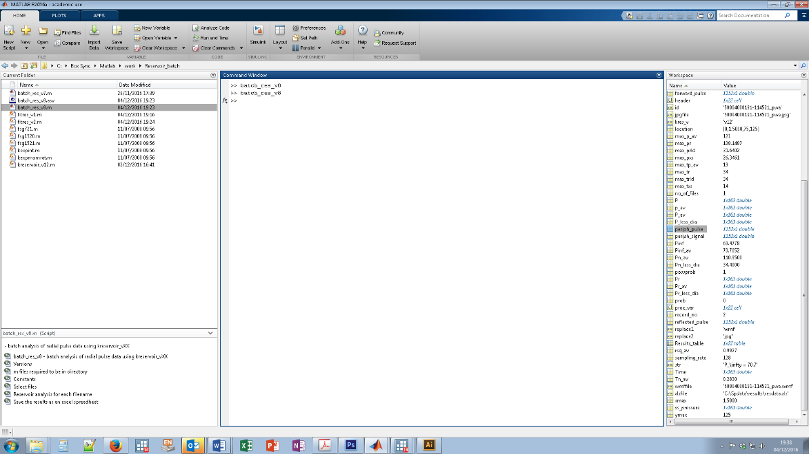
Two new folders should now exist in D:\BPPdata: D:\BPPdata\figures and D:\BPPdata\results.
D:\BPPdata\figures contains figures of key data. These are saved as *.jpg files. These plots are useful for checking quality and for examination of any dubious results.
Figure 1. Example of the figures saved by bpp_Res2.m

D:\BPPdata\results will contain an excel file (resdata.xls) which will contain all the key summary data for each file with its identifier (ID). This can then be imported into Stata (or some other statistics program) for further analysis.

Quality control
This is fairly rudimentary at present. The program checks that P_{inf} ≤ diastolic pressure, that the rate constant b > 0 and that the time of maximum reservoir pressure is or precedes the end of systole. These are coded in re_qcaofit (1 = fit passes, 0 = fit fails). The quality of the reservoir pressure fit is also graded based on the signal to noise ratio (snr): snr ≥12 = excellent; snr ≥9 = good; snr ≥ 6 = acceptable; snr < 6 = poor.

Selected calculations

Subendocardial viability ratio (SEVR)
SEVR (aka Buckberg index) is the ratio of diastolic pressure-time index (DPTI) to systolic pressure-time index (SPTI i.e. tension-time index) and is considered to be a measure of subendocardial blood flow.²
NB: in this script this is calculated assuming maximum –dp/dt marks the end of systole, not the dicrotic notch (Figure 1) and left ventricular end-diastolic pressure is ignored – these considerations may result in some minor differences in magnitude of SEVR compared with invasive measures. Aortic pressure waveforms are known to underestimate SPTI compared with left ventricular pressure measurements, and brachial pressures tend to overestimate SEVR due to pressure amplification.² SEVR calculated from the aortic pressure is provided in the results. This is assumed to be the more relevant measure.

Wave intensity
If it is assumed that excess pressure (P_{xs}) is proportional to aortic flow velocity (U) (essentially a 3-element Windkessel assumption) then the pattern of aortic wave intensity (dI) can be estimated (being proportional to dP x dP_{xs}). If one of aortic wave speed or dU is known then wave intensity can be estimated on the basis of the Zhukovsky (Joukowsky or water hammer) equation. If only pressure has been measured this problem cannot be solved without strong assumptions. In this program, it is assumed that peak mean aortic flow velocity (U_{max}) is 0.65m/s (based on data from^{3,4} and particularly⁵) this does not account for changes with age, sex or other factors. This is clearly not correct, but it may prove an acceptable approximation. Further details about this approach can be found in⁶, although in this article U_{max} was assumed to be 1m/s.

Backward and forward pressure
These are calculated based on the assumption that in the aorta reservoir pressure is 2 x backward pressure (P_{b});⁷ which may be valid if excess pressure is linearly proportional to aortic flow as has been reported in dogs,⁸ and total aortic flow equals aortic inflow (see 3-element Windkessel assumptions above). Based on,⁹ I believe this approach is similar to the ARCSOLVER method, which also uses a 3-element Windkessel assumption to reconstruct forward and backward pressures, but since the algorithm is proprietary it’s difficult to be sure.

Stroke volume and cardiac output
Not implemented yet.

Output of results
Results are saved as an excel (resdata.xls) file. This can be imported into the statistics package of your choice. The outputted results are listed in the Data dictionary in Appendix 1.

References
1. Davies JE, Lacy P, Tillin T, et al. Excess pressure integral predicts cardiovascular events independent of other risk factors in the conduit artery functional evaluation substudy of Anglo-Scandinavian Cardiac Outcomes Trial. Hypertension 2014; 64(1): 60-8.
2. Hoffman JI, Buckberg GD. The myocardial oxygen supply:demand index revisited. J Am Heart Assoc 2014; 3(1): e000285.
3. Lindroos M, Kupari M, Heikkila J, Tilvis R. Prevalence of aortic valve abnormalities in the elderly: an echocardiographic study of a random population sample. J Am Coll Cardiol 1993; 21(5): 1220-5.
4. Kroeger JR, Pavesio FC, Morsdorf R, et al. Velocity quantification in 44 healthy volunteers using accelerated multi-VENC 4D flow CMR. Eur J Radiol 2021; 137: 109570.
5. Garcia J, van der Palen RLF, Bollache E, et al. Distribution of blood flow velocity in the normal aorta: Effect of age and gender. J Magn Reson Imaging 2018; 47(2): 487-98.
6. Hughes AD, Park C, Ramakrishnan A, Mayet J, Chaturvedi N, Parker KH. Feasibility of Estimation of Aortic Wave Intensity Using Non-invasive Pressure Recordings in the Absence of Flow Velocity in Man. Front Physiol 2020; 11: 550.
7. Westerhof N, Westerhof BE. The reservoir wave paradigm discussion. J Hypertens 2015; 33(3): 458-60.
8. Wang JJ, O'Brien AB, Shrive NG, Parker KH, Tyberg JV. Time-domain representation of ventricular-arterial coupling as a windkessel and wave system. Am J Physiol Heart Circ Physiol 2003; 284(4): H1358-68.
9. Hametner B, Wassertheurer S, Kropf J, et al. Wave reflection quantification based on pressure waveforms alone--methods, comparison, and clinical covariates. Comput Meth Prog Bio 2013; 109(3): 250-9.

Appendix 1: Data dictionary
Unless stated otherwise all results refer to aortic pressure
Variable | Definition | Example result | Units
re_file | File identifier |  | No units
re_basbp | Maximum brachial pressure (systolic pressure) | 120 | mmHg
re_tbasbp | Time of maximum brachial (systolic) pressure | 0.1484375 | s
re_minp | Minimum pressure (diastolic pressure) | 76.55 | mmHg
re_intaopr | Integral of aortic reservoir pressure | 112.3308474 | mmHg.s
re_maxaopr | Maximum reservoir pressure | 108.1486734 | mmHg
re_tmaxaopr | Time of maximum reservoir pressure | 0.265625 | s
re_intaoprlessdbp | Integral of reservoir pressure with diastolic pressure subtracted | 16.09752936 | mmHg.s
date | date string | 2021-05-06T12:32:27
re_sam_rate | Sampling rate | 128 | Hz
re_intaoxsp | Integral excess pressure | 4.169230704 | mmHg.s
re_maxaoxsp | Maximum excess pressure | 26.3460721 | mmHg
re_tmaxaoxsp | Time of maximum excess pressure | 0.109375 | s
re_tn | Time of maximum -dp/dt (nominal start of diastole) | 0.283007813 | s
re_pinf | P_{infinity} | 70.70521706 | mmHg
re_pn | Pressure at start of diastole | 110.95 | mmHg
re_fita | Rate constant systolic fit | 10.45715136 | s⁻¹
re_fitb | Rate constant diastolic fit | 1.912785514 | s⁻¹
re_rsq | Coefficient of determination (r²) for fit | 0.992749217 | No units
re_qcaofit | Flag 1 if aortic fit passes basic QC checks, 0 if it fails | 0 | No units
re_version | kreservoir version (for version tracking) | v13 | No units
re_sdsbp_mmhg | Standard deviation of SBP | 6.1 | mmHg
re_rr_interval | Pulse to pulse (RR) interval | 900 | Ms
re_rmssd | Root mean square of differences in successive pulse (RR) intervals | 10 | Ms
re_ssdn | Standard deviation of pulse intervals | 6 | Ms
re_brs | Baroreflex sensitivity (BRS) by the sequence method | 22 | ms.mmHg⁻¹
re_brs_valid | Number of valid BRS measures | 8 | Count
re_pb_pf | Central Pb/Pf | 0.65 | No units
re_ri | Central Reflection index | .4 | No units
re_wf1i | Intensity of forward compression wave 1 (W1) |  | W/m2
re_wf1t | Time of peak of forward compression wave 1 (W1) |  | s
re_wf1a | Area of forward compression wave 1 (W1) |  | J/m²
re_wbi | Intensity of backward compression wave (Wb) |  | W/m²
re_wbt | Time of peak of backward compression wave (Wb) |  | s
re_wba | Area of backward compression wave (Wb) |  | J/m²
re_wf2i | Intensity of forward compression wave 2 (W2) |  | W/m²
re_wf2t | Time of peak of forward compression wave 2 (W2) |  | s
re_wf2a | Area of forward compression wave 2 (W2) |  | J/m²
re_wri | Wave reflection index |  | No units
re_rhoc | Wave speed |  | m/s
re_aosevr | SEVR based on aortic pressure |  | No units
re_basevr | SEVR based on brachial pressure |  | No units
re_quality | Poor; Acceptable; Good; Excellent |  | No units

NB: Since 2020, an improved algorithm for fitting the reservoir in diastole has been used – this excludes any hump or upstroke at the end of diastole from the fit. This results in lower values for P∞ and slightly different values for other reservoir parameters from those described by Davies et al.1. Davies JE, Lacy P, Tillin T, et al. Excess pressure integral predicts cardiovascular events independent of other risk factors in the conduit artery functional evaluation substudy of Anglo-Scandinavian Cardiac Outcomes Trial. Hypertension 2014; 64(1): 60-8.
The location of this folder can be changed by editing the script or files in another directory can be chosen using a dialog box if D:\BPPdata doesn’t exist.
1 = fit passes; 0 = fit fails at least one of: Pinf ≥ diastolic pressure, or Pinf < -12 mmHg, or rate constant a ≤ 0, or rate constant b ≤ 0, or R² < 0.9 for the diastolic fit

