Manual to batch_res_v14

*Using the batch reservoir fitting program and estimating heart rate variability wave intensity and Pb/Pf*

Alun Hughes

University College London

Manual Version 1.4

(11/01/2020)

|  |  |  |  |
| --- | --- | --- | --- |
| Amendment Record | | | |
| Version number | Date | Changes Made | Changes made by |
| 1.1 | 24/12/17 | Added information about program upgrade to v9 that includes HRV | ADH |
| 1.2 | 27/12/17 | Incorporated estimates of wave intensity, backward pressure (Pb) and forward pressure (Pf) from central pulse waveform and used sgolayfilt rather than fsg1521 or fsg721 | ADH |
| 1.21 | 22/10/18 | Minor updates to accompany a few bug fixes in v10 (now v11) | ADH |
| 1.3 | 17/03/19 | Improved reservoir algorithm to prevent upturn of pressure at end of diastole (early systole) affecting fit. Also improved HRV algorithm; adding data to excel output, fixing some other bugs in v11 (now v12) | ADH |
| 1.31 | 12/04/19 | Added progress bar (now v13), bug fix to figure output. | ADH |
| 1.4 | 11/01/20 | Restructuring of functions, minor bug fixes | ADH |

Contents

The script 3

Using the script 3

Heart rate variability (HRV) and baroreceptor sensitivity measures 5

Wave intensity 6

Backward and forward pressure 6

Data dictionary 7

References 8

# The script

batch_res_v14 runs a matlab script that calculates reservoir and excess pressure according to the methods described in Davies et al.1 for Sphygmocor © derived files. A few minor changes have been made since v10. An improved algorithm for fitting the reservoir in diastole has been used – this excludes upstrokes at the end of diastole from the fit (largely due to the next beat?). This results in lower values for P∞ and slightly different values for other reservoir parameters.

# Using the script

Put sphygmocor files to be analysed in the analysis directory

C:\Spdata

Open matlab and ensure that the working directory is the one that contains the relevant script and function files (in my case this is)

C:\Box Sync\Matlab\work\Reservoir_batch

Type into command line:

>>batch_res_v14

(this is the current version)

After some time (depending on how many files are analysed the run should complete, returning to command prompt. It will show a progress bar while it is running.

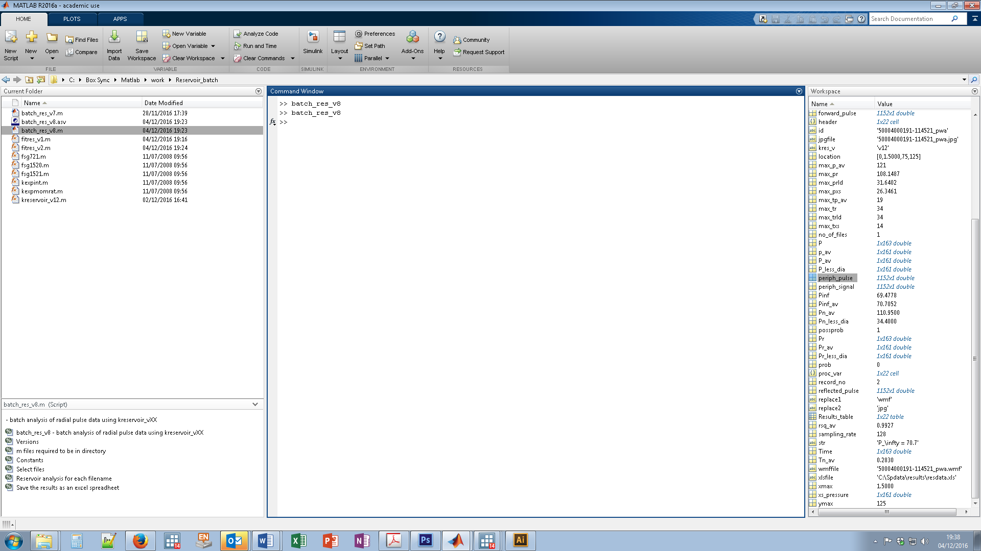

Two new folders should now exist in C:\Spdata - C:\Spdata\figures and C:\Spdata\results.

C:\Spdata\figures contains figures of the signal (all the uncalibrated data) and the pulse (the calibrated ensemble averaged data) with the reservoir pressure shown. These are saved as *.jpg and *.wmf files (the latter being useful for import into Microsoft Word and PowerPoint).These plots are useful for checking quality and any dubious results.

Occasionally, as part of the wave intensity routine, MATLAB will return a warning message:

Warning: Invalid MinPeakHeight. There are no data points greater than MinPeakHeight.

> In findpeaks>removePeaksBelowMinPeakHeight (line 516)

In findpeaks (line 147)

In batch_res_v13 (line 161)

- this can safely be ignored, as it indicates that there was no measurable reflection (which is possible).



*Example of the figure saved by batch_res_v10 – this is similar in v14*

C:\Spdata\results will contain an excel file (resdata.xls) which will contain all the data for each file with its ID. This can then be imported into Stata (or some other stats program) for further analysis.

# Heart rate variability (HRV) and baroreceptor sensitivity measures

NB THESE MEASURES ARE EXPERIMENTAL FOR SPHYGMOCOR DATA

The root mean square of successive differences (RMSSD), the standard deviation of the pulse intervals (SDNN) and baroreflex sensitivity (BRS) are calculated essentially according to Sluyter et al.2[1] The validity of such ultrashort recordings has been studied by Munoz et al.3 Further details on the meaning and interpretation of these measures can be found in Shaffer and Ginsberg.4 It is probably useful to normalise HRV (or adjust it statistically) to mean RR interval due to the correlation between HRV and resting heart rate.5 This can be done as a post-processing step in the statistical package used.

# Wave intensity

NB THESE MEASURES ARE EXPERIMENTAL FOR SPHYGMOCOR DATA

If it is assumed that excess pressure (*Pxs*) is proportional to aortic flow velocity (*U*) (essentially a 3-element Windkessel assumption – see above) then the pattern of aortic wave intensity (*dI*) can be estimated (being proportional to *dP* x *dPxs*). If one of aortic wave speed or *dU* is known then wave intensity can be estimated on the basis of the Waterhammer equation. If only pressure has been measured this problem cannot be solved without strong assumptions. In this case, it is assumed that peak aortic flow (*dU)* is 1m/s (based on data from 6) and doesn’t not vary with age, sex etc. While this is not true, it is may prove an acceptable approximation, but this remains to be tested.

# Backward and forward pressure

NB THESE MEASURES ARE EXPERIMENTAL FOR SPHYGMOCOR DATA

These are calculated based on the assumptions that in the aorta reservoir pressure is 2 x backward pressure (Pb);7 which may be valid if excess pressure is linearly proportional to aortic flow as has been reported in dogs,8 and total aortic flow equals aortic inflow. This approach probably shares similarities with the ARCSOLVER method,9 which uses a 3-element Windkessel assumption[2] to reconstruct forward and backward pressures.

# Data dictionary

|  |  |  |  |
| --- | --- | --- | --- |
| Variable | Definition | Example result | Units |
| re_file | File identifier | xxx_pwa.txt | No units |
| re_maxp | Maximum pressure (systolic pressure) | 120 | mmHg |
| re_tmaxp | Time of maximum (systolic) pressure | 0.1484375 | s |
| re_minp | Minimum pressure (diastolic pressure) | 76.55 | mmHg |
| re_intpr | Integral of reservoir pressure | 112.3308474 | mmHg.s |
| re_maxpr | Maximum reservoir pressure | 108.1486734 | mmHg |
| re_tmaxpr | Time of maximum reservoir pressure | 0.265625 | s |
| re_intprlessdias | Integral of reservoir pressure with diastolic pressure subtracted | 16.09752936 | mmHg.s |
| re_maxprlessdias | Maximum of reservoir pressure with diastolic pressure subtracted | 31.64019694 | mmHg |
| re_sam_rate | Sampling rate | 128 | Hz |
| re_intxsp | Integral excess pressure | 4.169230704 | mmHg.s |
| re_maxxsp | Maximum excess pressure | 26.3460721 | mmHg |
| re_tmaxxsp | Time of maximum excess pressure | 0.109375 | s |
| re_tn | Time of maximum -dp/dt (nominal end of systole) | 0.283007813 | s |
| re_pinf | Pinfinity | 70.70521706 | mmHg |
| re_pn | Pressure at start of diastole | 110.95 | mmHg |
| re_fita | Rate constant systolic fit | 10.45715136 | s-1 |
| re_fitb | Rate constant diastolic fit | 1.912785514 | s-1 |
| re_rsq | Coefficient of determination (r2) for fit | 0.992749217 | No units |
| re_prob | Flag 1 for likely problem[3] | 0 | No units |
| re_version | kreservoir version (for version tracking | v13 | No units |
| re_sdsbp_mmhg | Standard deviation of SBP | 6.1 | mmHg |
| re_rr_interval | Pulse to pulse (RR) interval | 900 | Ms |
| re_rmssd | Root mean square of differences in successive pulse (RR) intervals | 10 | Ms |
| re_ssdn | Standard deviation of pulse intervals | 6 | Ms |
| re_brs | Baroreflex sensitivity (BRS) by the sequence method | 22 | ms.mmHg-1 |
| re_brs_valid | Number of valid BRS measures | 8 | Count |
| re_pb_pf | Central Pb/Pf | 0.65 | No units |
| re_ri | Central Reflection index | .4 | No units |
| re_wf1i | Intensity of forward compression wave 1 (W1) |  | W/m2 |
| re_wf1t | Time of peak of forward compression wave 1 (W1) |  | s |
| re_wf1a | Area of forward compression wave 1 (W1) |  | J/m2 |
| re_wfbi | Intensity of backward compression wave (Wb) |  | W/m2 |
| re_wbt | Time of peak of backward compression wave (Wb) |  | s |
| re_wba | Area of backward compression wave (Wb) |  | J/m2 |
| re_wf2i | Intensity of forward compression wave 2 (W2) |  | W/m2 |
| re_wf2t | Time of peak of forward compression wave 2 (W2) |  | s |
| re_wf2a | Area of forward compression wave 2 (W2) |  | J/m2 |
| wri | Wave reflection index |  | No units |
| rhoc | Wave speed |  | m/s |

# References

1. Davies JE, Lacy P, Tillin T, et al. Excess pressure integral predicts cardiovascular events independent of other risk factors in the conduit artery functional evaluation substudy of Anglo-Scandinavian Cardiac Outcomes Trial. *Hypertension* 2014; **64**(1): 60-8.

2. Sluyter JD, Hughes AD, Camargo CA, Jr., Lowe A, Scragg RKR. Relations of Demographic and Clinical Factors With Cardiovascular Autonomic Function in a Population-Based Study: An Assessment By Quantile Regression. *Am J Hypertens* 2017; **31**(1): 53-62.

3. Munoz ML, van Roon A, Riese H, et al. Validity of (Ultra-)Short Recordings for Heart Rate Variability Measurements. *PLoS One* 2015; **10**(9): e0138921.

4. Shaffer F, Ginsberg JP. An Overview of Heart Rate Variability Metrics and Norms. *Front Public Health* 2017; **5**: 258.

5. van Roon AM, Snieder H, Lefrandt JD, de Geus EJ, Riese H. Parsimonious Correction of Heart Rate Variability for Its Dependency on Heart Rate. *Hypertension* 2016; **68**(5): e63-e5.

6. Lindroos M, Kupari M, Heikkila J, Tilvis R. Prevalence of aortic valve abnormalities in the elderly: an echocardiographic study of a random population sample. *J Am Coll Cardiol* 1993; **21**(5): 1220-5.

7. Westerhof N, Westerhof BE. The reservoir wave paradigm discussion. *J Hypertens* 2015; **33**(3): 458-60.

8. Wang J, Jr., O'Brien AB, Shrive NG, Parker KH, Tyberg JV. Time-domain representation of ventricular-arterial coupling as a windkessel and wave system. *Am J Physiol Heart Circ Physiol* 2003; **284**(4): H1358--68.

9. Hametner B, Wassertheurer S, Kropf J, et al. Wave reflection quantification based on pressure waveforms alone--methods, comparison, and clinical covariates. *Comput Meth Prog Bio* 2013; **109**(3): 250-9.

1. since Sphygmocor data is cropped at the foot of the waveform peak systole has been used as the fiducial point of the waveform to calculate beat to beat intervals.
2. the details of the procedure used by ARCSOLVER are not in the public domain due to commercial considerations
3. 0 = ok; 1 = Pinf > diastolic pressure; 2 = rate constant b < 0; 3 = time of maximum reservoir pressure > end of systole