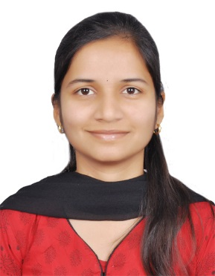

Associate Consultant at Capgemini India Pvt. Ltd.

**Amruta Shriram Dhabale**

**Phone:** +91 9730-896546   
**Email:** dhabaleas10@gmail.com  
**LinkedIN:** Linkedin.com/in/dhabaleamruta

**Address:** Flat no.24 ,6th floor,Sunderbaug Apt. ,Near Darshan hall ,

Link road,Chinchwad 411033

**PROFILE**

* 2.6 years hands-on software development with Angular 2, HTML, CSS, Typescript, JavaScript .
* Working knowledge of front end optimization and performance techniques.
* Experience with Jquery and Chrome Dev Tools
* Knowledge of modern web application design, responsive design (RWD)
* Expert level problem solving skills
* Driven and self-motivated
* Test Driven Development Skills

**PROJECTS**

March 2018 – Current  
**UI Developer**  
**Willis Tower Watson (Energy Losses)**

* Frameworks & Language – Angular 2,HTML,CSS,Customised Toolkit by client
* Project Description – Developing an insurance application for Client in which one can see the estimated claims, reports also visual analytics. Also can submit the application regarding the claim.

October 2017– February 2018  
**UI Developer**  
**Willis Tower Watson (UK Contract and Benefits Statement Harmonization)**

* Frameworks & Language – Angular 2,HTML,CSS,Customised Toolkit by client
* Project Description – Designing UI by referring the UX and integrating them. Developing pages for one of the module in the application.

May 2017 – October 2017  
**UI Developer**  
**Willis Tower Watson (Market Security)**

* Frameworks & Language – Angular 2,HTML,CSS,Customised Toolkit by client
* Project Description – Designing UI by referring the UX and integrating them. Using customized CSS and client toolkit for js and styles.

June 2016 – April 2017  
**UI & UX Developer**  
**Capgemini internal project in ADC (Accelerated delivery Centre)**

* Frameworks & Language – Angular 2,HTML,CSS,Angular 1.5,Karma ,Jasmine, Gulp, Grunt, Axure, Just in mind
* Project Description – Development and maintenance of Tool for designing Web pages. A simple drag and drop tool for UI designing. Writing unit test cases for the same.

**EDUCATIONAL DETAILS**

|  |  |  |  |  |
| --- | --- | --- | --- | --- |
| **Examination** | **Specialization** | **Board/University** | **Year** | **Marks** |
| PG-DAC | CDAC | Infoway technologies,  Kothrud,Pune | 2015 | - |
| B.E. | E &Tc | University Of Pune | 2014 | 60.14% |

**OTHER SKILLS**

|  |  |
| --- | --- |
| **Environment** | Server, client |
| **Database** | Oracle, SQL server |
| **Tools** | *gulp, grunt, yeoman, node, npm, bower,* Visual Studio 2017, VS Code, GIMP, Photoshop, Lightroom, Axure ,Just in mind |
| **Testing** | KARMA, Jasmine, Protractor |

**PERSONAL DETAILS**

Father’s Name: Amruta Dhabale Marital Status: Single  
Birthday: November 10, 1992 Nationality: Indian  
Gender: Female