**Software Development Plan Template**

**TITLE PAGE CONTENT**

**Breakfast Delivery App (Luxor is a smart city)**

**10 / 03 / 2023**

Version1.1

**Presented To:**

Egyptian families, Shops of breakfast and men from the age of 12 to 20.

**Submitted By:**

FCI Students.

**REVISION HISTORY**

| **Date** | **Author** | **Distributed to** | **Version** | **Description** |
| --- | --- | --- | --- | --- |
| 19\3\2023 | Soha | Soha | Team Skills | Adding Team’s skills |

**TABLE OF CONTENTS**

**1. PRODUCT DESCRIPTION**

The program linked those who want breakfast (foul and falafel) with the man who prepares the breakfast, and not any other man .The man from the area surrounding you, and this man also, we will reduce pressure on him and the many requests and problems (who came before whom and so on).

The customer, of course, will not be forgotten, as our program aims to enable him to enjoy his food with the least amount of trouble and money and with the maximum amount of comfort, whether it is at home, university, work, school, or anywhere else.

And we will rely on men from the age of 12 to 20 to deliver breakfast, and this will reduce unemployment and teach children self-reliance at an early age and protect them from vagrancy:

1- Whether you're in a hurry and need a quick breakfast on the go, or you're looking for a more satisfying meal to start your day.

2- We will help you locate the nearest breakfast man so that you can enjoy your food with the least amount of trouble and money and with the utmost comfort.

3- Enjoy the authentic taste of Egyptian cuisine in the comfort of your own place!

**2. TEAM DESCRIPTION**

Mr. Abu Abdullah: Owner of a breakfast shop (SME).

ENG. Reham: You will rely on her excellent skill in creating a mobile application using flutter, dart.

ENG. Adham: He will take care of all the designs to create an application that suits all users, in addition to the logo and the brand.

ENG. Soha and ENG. Ziad: They will rely on their experience in documentation to prepare the work for the rest of the team.

ENG. Naira and ENG. Rawan: They will create a strong database using "firebase" to suit the application.

|  |  |  |  |  |  |  |  |
| --- | --- | --- | --- | --- | --- | --- | --- |
| Team | Skills | | | | | | |
| Project  Management | Problem solving | Firebase | Flutter | Research  skills | Design | Documentation |
| Adham | **🗸** | **🗸** | **🗴** | **🗴** | **🗸** | **🗸** | **🗸** |
| Ziad | **🗴** | **🗸** | **🗴** | **🗴** | **🗸** | **🗴** | **🗸** |
| Soha | **🗸** | **🗸** | **🗴** | **🗴** | **🗸** | **🗸** | **🗸** |
| Reham | **🗴** | **🗸** | **🗴** | **🗸** | **🗸** | **🗸** | **🗴** |
| Rawan | **🗸** | **🗸** | **🗸** | **🗴** | **🗸** | **🗴** | **🗴** |
| Naira | **🗸** | **🗸** | **🗸** | **🗴** | **🗸** | **🗴** | **🗴** |

Missing skills:

*The database is new to us.

*Design and color selection.

*Remote work.

*Lack of experience with the environment in which the program will operate.

*Artificial Intelligence.

**3. SOFTWARE PROCESS MODEL DESCRIPTION**

The model of this project is agile methodology (Extreme programming) to produce high-quality software and adapt to evolving and changing requirements with mid-sized team. We want to reduce project risk, especially around tight deadlines. We focus on coding and two developers team together on one computer.

**4. PRODUCT DEFINITION**

Describe the users and user environment.

**Context Diagram**

The software system should provides delivery to bring the breakfast meal from the breakfast store and present it to the customer and take the price of the order, Where the user logs in to the application and discovers the breakfast shops around it, determines the suitable breakfast place for him, chooses the meals and the required number, presses to confirm the request, then gets a code, then the owner of the shop determines if he will accept or reject it, if he accepts it, he prepares it according to a specific period and the number of requests In one period, then he sends a delivery worker for each period to the customers, who sees through the application the customers’ places and goes in the shortest way, then he writes the code to finish the delivery process and confirm the arrival successfully.

**Personas / User Characteristics**

*The system users (Egyptian family / Delivery) should not require special training.

*The owner of the breakfast shop does not need training, he has a tablet that only shows orders.

**User Stories**

Defines the high level user stories for the product

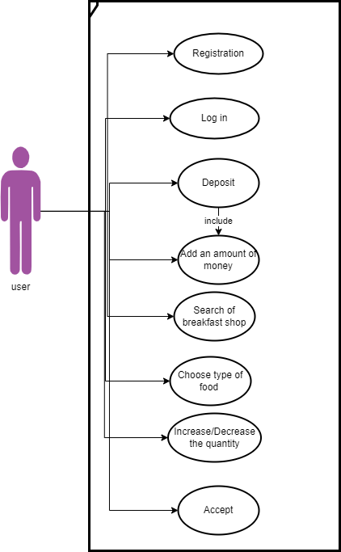

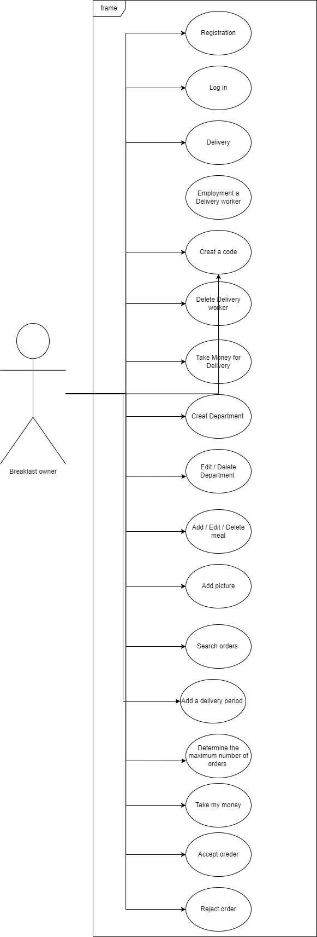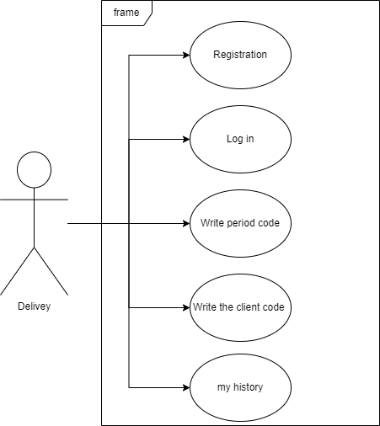

**High Level Use Cases**

Defines the high level user stories for the product. Goal is to paint a picture of the product, not define the whole solution. Includes diagram and use case descriptions.

**Use Case Descriptions**

Defines the high level descriptions

Be sure to the textual use case description consists of 6 parts:

1. **Unique name**
2. **Participating actors**
3. **Entry conditions**
4. **Exit conditions**
5. **Flow of events: 5 - 7 steps describing the Happy Path**
6. **Special requirements.**

Below are the high level use cases for the Application, based on the above use case diagram.

**5. USER EXPERIENCE WIREFRAMES**

Initial prototype screens to validate initial understanding of the product.

**6. PROJECT ORGANIZATION**

Breakdown of major tasks and schedule

**Matrix of Responsibilities**

Defines the high level which team members are responsible for which tasks

**PERT / Gantt Chart**

First cut at schedule

**7. VALIDATION PLAN**

**Test Strategy**

What is the definition of done?

What does success look like?

**8. FEASIBILITY STUDY**

What are the known risks and how will they be handled?

**Risk Identification**

Description of the risks

**Risk Prioritization**

Prioritized list (biggest risk -> lowest risk)

**Risk Mitigation**

How will risk factors be addressed? By when?

What are you going to prototype?

**9. CONFIGURATION AND VERSION CONTROL**

Specify the process and attributes for version control for all project and product artifacts

**10. TOOLS**

Provide a list of tools required for the project and their use

**11. ARCHITECTURE**

List of hardware or other subsystems required for the product.