[1]

Non-Volatile Memory Integrity using Merkle Trees.

Maher Sanalla, Adham Khalil, Meni Orenbach

*Abstract*-- With the advance of technology, the amount of personal data that is stored on computer-devices increased substantially, such data can be easily manipulated or lost. Non-Volatile memory is very commonly used by those computer devices. Non-Volatile memory system is vulnerable to many attacks that vary from faulty operating system to data manipulation and disruption, Thus the demand for ways to ensure the integrity of NV-memory has increased correspondingly. Many solutions were proposed to provide data integrity of the memory values, each with its pros and cons. In this paper we will analyze the Merkle-Tree Integrity system, which provides security, confidentiality, and authentication of the memory values, and prevents malicious acts of manipulations or damage to the memory data. The use of Merkle-Tree authentication has been widely adopted to various applications, such as blockchain technologies, e.g., Bitcoin industry. We will analyze its benefits, cost, and performance thoroughly.

*Index Terms*-- Merkle Tree, Integrity Tree, Non-Volatile RAM, Memory authentication, Memory security, memory integrity, Attack-prevention, Oblivious-NVRAM.

# Introduction

A

As we know, secure processors do not trust the main memory of the system because it’s prone to tampering, e.g., an attacker with physical access to the system can read/modify memory content without the right permissions, therefore the processor is required to secure the content of the memory, various technologies has been used to accomplish this goals, for example Intel’s Software Guard Extensions (SGX) was built on CPU’s to enclave certain regions of the memory and secure it in a way that no other process is allowed to access it.

Since a computer system’s memory (DRAM) is prone to attacks, all security principals should be addressed, that is, the integrity, confidentiality and availability of the DRAM content, in our project we’ll be focusing on integrity and confidentiality, various approaches has been done regarding data leakage and integrity problem, we will be using merkle tree, the data blocks will be encrypted instead of hashed so that we can perform read/write operations without the need of data in our memory (for confidentiality purposes), instead we’ll be saving the ciphertexts and tags (HMAC), we also assume that we have a trusted memory region, inside it we will save our encryption keys, nonces and merkle root.

# Functionality

The NV-RAM which uses Merkle-Tree Integrity system differs substantially from the typical RAM that we know. The use of Merkle-Tree changes the functionality of RAM Read/Write operations, and provides a new function called “Verify Integrity”, which verifies that the memory content is valid and not corrupted at any given time.

Since the NV-RAM cannot be trusted, Merkle-Tree needs a storage that can be trusted, Otherwise - if there is no such trusted memory area - then the whole idea of integrity could be compromised by an attacker.

Thus, hardware support is needed. Our system requires a small memory area on the microprocessor, which cannot be accessed or corrupted by an attacker, and its content integrity is guaranteed presumably. This area will store the secrets of the NV-RAM content on it, such as encryption-keys, Merkle tree root, and other data that we will discuss thoroughly later.

The operation of this system begins with partitioning the whole memory segment into size-identical blocks. then it proceeds to encrypt every single block with a strong unique key and a random nonce using AES-GCM encryption method, each encryption process yields a ciphertext (which overwrites the original block plaintext) and a tag (HMAC). The encryption key and the corresponding nonce are stored in the trusted area and are not accessible by anyone other than the superuser.

At this point, the whole memory data is encrypted and secured, the ciphertext overwrites the plaintext, thus even if memory leaks happen now, they are useless to the attacker. The forming of the Merkle tree begins where the trees’ leaves are the blocks hmacs that we calculated earlier. Now, for every two consecutive hmacs/blocks “A” and “B”, we calculate the SHA-256 of their concatenation and the result will be the data of their parent in the tree.

This process is repeated recursively on each level of the tree, until we reach the first level of the proposed tree where there are only two nodes. Then, we calculate the SHA of their concatenation and that will the root of the tree. The root of the tree is the ambassador of the memory content. Later, we will see how it is used to decide if memory data is corrupted or valid. We store the root of the tree in the trusted area, so that no one can modify it or read it.

In the upcoming sections, we will discuss the functions of the Merkle-tree NV-RAM system and how they operate. Such as Read/Write/Verify.

## Verify Integrity

After the initiation process is over, we can check if the memory integrity is maintained at any given time in the future. The verify integrity method is the function that checks the integrity of the memory at any given time. The way it functions is as follows: if at a given time t>0 in the future, this function is called, it will calculate the “status-quo” Merkle tree whose leaves are the current-memory blocks. Using the same tree-building process as we discussed earlier, the function will obtain the current-status Merkle-tree root. This root is an indicator of the current status of the memory, if its equal to the root that we trust, which is stored in the trusted-area, then the current-status of the memory is as it was before, thus we deduce that the memory integrity is kept and it wasn’t corrupted or manipulated. Otherwise, if the current-status root differs from the trusted-area root, then the current-memory is assumed to be corrupt and not valid.

To prove the correctness of this algorithm, let us assume that after the initiation of the Merkle-tree system is done, an attacker came and changed block A data for malicious purposes to A’. Then when verify integrity method is called, it will build the Merkle-tree Bottom-up. It will begin with taking the current memory-blocks as leaves and calculate the higher levels recursively. Let B be the neighboring block to A’, When the parent of A’ and B is calculated, it will be the outcome of SHA-256(A’ || B). But since A’ differs from A, then A’ || B differs from A || B, due to the collision-resistance characteristic of SHA-256 function, the outcome of the SHA(A||B) is different than SHA(A’||B). Meaning the current parent of A’ and B is different from what it was before when the trusted tree-building process was performed.

Using Induction, we can prove that the grandfather of A and B will differ from its previously calculated value, and so on, till reaching the root. So, we deduce, that changing the content of any memory block will cause a direct change in the root of Merkle-tree. Thus, calculating the current-memory Merkle tree root and comparing it to the previously calculated and trusted root, we can infer directly if the memory blocks were changed from their previous values, or not.

## Read Block

When the user wants to read a block, he provides the corresponding block index. Before supplying the user with the data, he wants, we must verify the integrity of the tree in order to be sure that the data that we supply him isn’t corrupted. Thus, we call the verify integrity and continue to read the block only in case the tree’s’ integrity is kept.

When the integrity is assured, we extract the corresponding key and nonce for the requested block from the trusted area, then we decrypt the block and return the plaintext to the user.

In case the integrity of the block is manipulated, then we inform the user that the block data was corrupted and do not supply him with the data.

The correctness of this method is deduced straightforwardly from the verify integrity correctness.

TABLE I

Samples of Times Roman Type Sizes and Styles

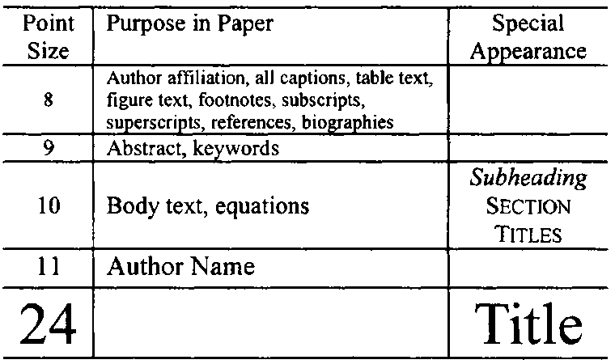

## Write Block

Let’s assume that the user wants to update block “A”, he provides the corresponding index of the block with the new plaintext/data. We generate a new encryption-key with nonce for the new plaintext, encrypt it using AES-GCM which generates new ciphertext and new HMAC. We overwrite the previously stored cipher and HMAC with the new ones and also update the blocks’ nonce value in the trusted area.

After that we calculate the new Merkle tree root using the same methodology as before – traversing the tree bottom up.

At last, we update the stored root in the trusted area with the new root, then inform the user that the write operation was successfully completed.

## Numbering

Number reference citations consecutively in square brackets [1]. The sentence punctuation follows the brackets [2]. Multiple references [2], [3] are each numbered with separate brackets [1]-[3]. Refer simply to the reference number, as in [3]. Do not use “Ref. [3]” or “reference [3]” except at the beginning of a sentence: “Reference [3] shows….”

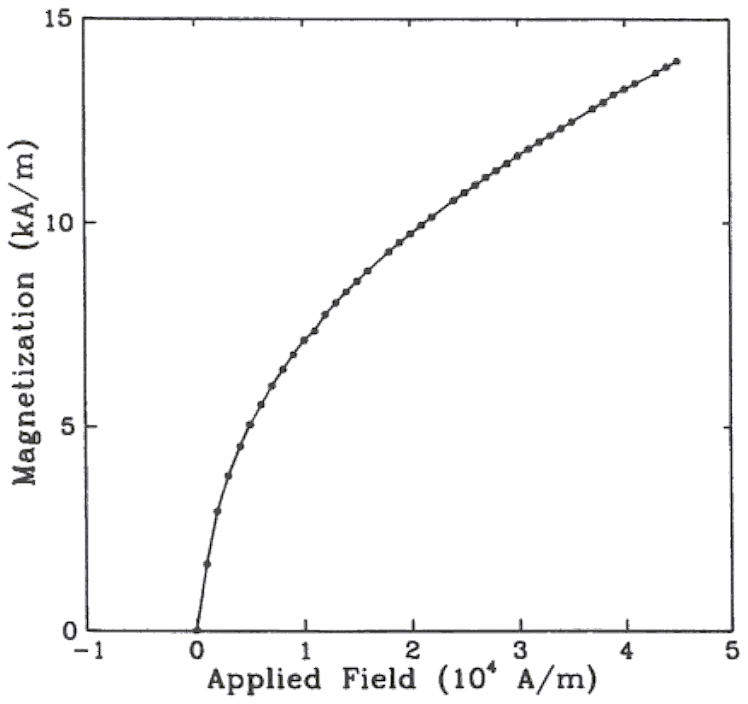

Fig. 1. Magnetization as a function of applied field. (Note that “Fig.” is abbreviated and there is a period after the figure number followed by two spaces.)

Number footnotes separately with superscripts (References | Insert Footnote). Place the actual footnote at the bottom of the column in which it is cited. Do not put footnotes in the reference list. Use letters for table footnotes.

Check that all figures and tables are numbered correctly. Use arabic numerals for figures and Roman numerals for tables.

Appendix figures and tables should be numbered consecutively with the figures and tables appearing in the rest of the paper. They should not have their own numbering system.

## Units

Metric units are preferred for use in IEEE publications in light of their global readership and the inherent convenience of these units in many fields. In particular, the use of the International System of Units (Systeme Internationale d'Unites or SI Units) is advocated. This system includes a subsystem of units based on the meter, kilogram, second, and ampere (MKSA). British units may be used as secondary units (in parentheses). An exception is when British units are used as identifiers in trade, such as 3.5-inch disk drive.

## Abbreviations and Acronyms

Define less common abbreviations and acronyms the first time they are used in the text, even after they have been defined in the abstract. Abbreviations such as IEEE, SI, MKS, CGS, ac, dc, and rms do not have to be defined. Do not use abbreviations in the title unless they are unavoidable.

See Appendix A of the Author’s Kit for additional information and standard abbreviations.

## Math and Equations

Use either the Microsoft Equation Editor or the *MathType* commercial add-on for MS Word for all math objects in your paper (Insert | Equation *or* MathType Equation).

To make your equations more compact, you may use the solidus ( / ), the exp function, or appropriate exponents. Italicize Roman symbols for quantities and variables, but not Greek symbols. Use a long dash rather than a hyphen for a minus sign. Use parentheses to avoid ambiguities in denominators.

Number equations consecutively with equation numbers in parentheses flush with the right margin, as in (1). Be sure that the symbols in your equation have been defined before the equation appears or immediately following.

where *IF* is the fault current.

Use “(1),” not “Eq. (1)” or “equation (1),” except at the beginning of a sentence: “Equation (1) is .…”

# Appendix

Appendixes, if needed, appear before the acknowledgment.

# Acknowledgment

The following is an example of an acknowledgment. (Please note that financial support should be acknowledged in the unnumbered footnote on the title page.)

The authors gratefully acknowledge the contributions of I. X. Austan, A. H. Burgmeyer, C. J. Essel, and S. H. Gold for their work on the original version of this document.

# References

References are important to the reader; therefore, each citation must be complete and correct. There is no editorial check on references; therefore, an incomplete or wrong reference will be published unless caught by a reviewer or discusser and will detract from the authority and value of the paper. References should be readily available publications.

List only one reference per reference number. If a reference is available from two sources, each should be listed as a separate reference. Give all authors' names; do not use *et al.*

Samples of the correct formats for various types of references are given below.

*Basic format for books:*

1. J. K. Author, “Title of chapter in the book,” in *Title of His Published Book,* xth ed. City of Publisher, Country if not USA: Abbrev. of Publisher, year, ch. x, sec. x, pp. xxx–xxx.

*Examples:*

1. G. O. Young, “Synthetic structure of industrial plastics,” in *Plastics,* 2nd ed., vol. 3, J. Peters, Ed. New York: McGraw-Hill, 1964, pp. 15–64.
2. W.-K. Chen, *Linear Networks and Systems.* Belmont, CA: Wadsworth, 1993, pp. 123–135.

*Basic format for periodicals:*

1. J. K. Author, “Name of paper,” *Abbrev. Title of Periodical,* vol. x, no. x, pp. xxx–xxx, Abbrev. Month, year.

Examples:

1. J. U. Duncombe, “Infrared navigation—Part I: An assessment of feasibility,” *IEEE Trans. Electron Devices,* vol. ED-11, no. 1, pp. 34–39, Jan. 1959.
2. E. P. Wigner, “Theory of traveling-wave optical laser,” *Phys. Rev.,* vol. 134, pp. A635–A646, Dec. 1965.
3. E. H. Miller, “A note on reflector arrays,” *IEEE Trans. Antennas Propagat.,* to be published.

*Basic format for reports:*

1. J. K. Author, “Title of report,” Abbrev. Name of Co., City of Co., Abbrev. State, Rep. xxx, year.

*Examples:*

1. E. E. Reber, R. L. Michell, and C. J. Carter, “Oxygen absorption in the earth’s atmosphere,” Aerospace Corp., Los Angeles, CA, Tech. Rep. TR-0200 (4230-46)-3, Nov. 1988.
2. J. H. Davis and J. R. Cogdell, “Calibration program for the 16-foot antenna,” Elect. Eng. Res. Lab., Univ. Texas, Austin, Tech. Memo. NGL-006-69-3, Nov. 15, 1987.

*Basic format for handbooks:*

1. *Name of Manual/Handbook,* x ed., Abbrev. Name of Co., City of Co., Abbrev. State, year, pp. xxx–xxx.

*Examples:*

1. *Transmission Systems for Communications,* 3rd ed., Western Electric Co., Winston-Salem, NC, 1985, pp. 44–60.
2. *Motorola Semiconductor Data Manual,* Motorola Semiconductor Products Inc., Phoenix, AZ, 1989.

*Basic format for books (when available online):*

1. Author. (year, month day). *Title.* (edition) [Type of medium]. *volume (issue).* Available: site/path/file

*Example:*

1. J. Jones. (1991, May 10). *Networks.* (2nd ed.) [Online]. Available: http://www.atm.com

*Basic format for journals (when available online):*

1. Author. (year, month). Title. *Journal.* [Type of medium]. *volume (issue),* pages. Available: site/path/file

*Example:*

1. R. J. Vidmar. (1992, Aug.). On the use of atmospheric plasmas as electromagnetic reflectors. *IEEE Trans. Plasma Sci.* [Online]. *21(3),* pp. 876–880. Available: http://www.halcyon.com/pub/journals/21ps03-vidmar

*Basic format for papers presented at conferences (when available online):*

1. Author. (year, month). Title. Presented at Conference title. [Type of medium]. Available: site/path/file

*Example:*

1. PROCESS Corp., MA. Intranets: Internet technologies deployed behind the firewall for corporate productivity. Presented at INET96 Annual Meeting. [Online]. Available: http://home.process.com/Intranets/wp2.htp

*Basic format for reports and handbooks (when available online):*

1. Author. (year, month). Title. Company. City, State or Country. [Type of medium]. Available: site/path/file

*Example:*

1. S. L. Talleen. (1996, Apr.). The Intranet Architecture: Managing information in the new paradigm. Amdahl Corp., CA. [Online]. Available: http://www.amdahl.com/doc/products/bsg/intra/infra/html

*Basic format for computer programs and electronic documents (when available online):* ISO recommends that capitalization follow the accepted practice for the language or script in which the information is given.

*Example:*

1. A. Harriman. (1993, June). Compendium of genealogical software. *Humanist.* [Online]. Available e-mail: HUMANIST@NYVM.ORG Message: get GENEALOGY REPORT

*Basic format for patents (when available online):*

1. Name of the invention, by inventor’s name. (year, month day). *Patent Number* [Type of medium]. Available: site/path/file

*Example:*

1. Musical toothbrush with adjustable neck and mirror, by L. M. R. Brooks. (1992, May 19). *Patent D 326 189* [Online]. Available: NEXIS Library: LEXPAT File: DESIGN

*Basic format for conference proceedings (published):*

1. J. K. Author, “Title of paper,” in *Abbreviated Name of Conf.,* City of Conf., Abbrev. State (if given), year, pp. xxx–xxx.

*Example:*

1. D. B. Payne and J. R. Stern, “Wavelength-switched passively coupled single-mode optical network,” in *Proc. IOOC-ECOC,* 1985, pp. 585–590.

*Example for papers presented at conferences (unpublished):*

1. D. Ebehard and E. Voges, “Digital single sideband detection for interferometric sensors,” presented at the 2nd Int. Conf. Optical Fiber Sensors, Stuttgart, Germany, Jan. 2–5, 1984.

*Basic format for patents:*

1. J. K. Author, “Title of patent,” U.S. Patent x xxx xxx, Abbrev. Month, day, year.

*Example:*

1. G. Brandli and M. Dick, “Alternating current fed power supply,” U.S. Patent 4 084 217, Nov. 4, 1978.

*Basic format for theses (M.S.) and dissertations (Ph.D.):*

1. J. K. Author, “Title of thesis,” M.S. thesis, Abbrev. Dept., Abbrev. Univ., City of Univ., Abbrev. State, year.
2. J. K. Author, “Title of dissertation,” Ph.D. dissertation, Abbrev. Dept., Abbrev. Univ., City of Univ., Abbrev. State, year.

*Examples:*

1. J. O. Williams, “Narrow-band analyzer,” Ph.D. dissertation, Dept. Elect. Eng., Harvard Univ., Cambridge, MA, 1993.
2. N. Kawasaki, “Parametric study of thermal and chemical nonequilibrium nozzle flow,” M.S. thesis, Dept. Electron. Eng., Osaka Univ., Osaka, Japan, 1993.

*Basic format for the most common types of unpublished references:*

1. J. K. Author, private communication, Abbrev. Month, year.
2. J. K. Author, “Title of paper,” unpublished.
3. J. K. Author, “Title of paper,” to be published.

*Examples:*

1. A. Harrison, private communication, May 1995.
2. B. Smith, “An approach to graphs of linear forms,” unpublished.
3. A. Brahms, “Representation error for real numbers in binary computer arithmetic,” IEEE Computer Group Repository, Paper R-67-85.

*Basic format for standards:*

1. *Title of Standard,* Standard number, date.

*Examples:*

1. *IEEE Criteria for Class IE Electric Systems,* IEEE Standard 308, 1969.
2. *Letter Symbols for Quantities,* ANSI Standard Y10.5-1968.

# Biographies

A technical biography and photograph for each author may be included. The photo should be 2.54 centimeters (1 inch) wide by 3.18 centimeters (1.25 inches) high. The head and shoulders should be centered, and the photo should be flush with the left margin. The space required for the biographies and photos is included in the eight-page limit.

The first paragraph should begin with the author’s name (as it appears in the byline) and IEEE membership history. A place and/or date of birth may be included (list place, then date). Next, the author’s educational background is listed. The degrees should be listed with type of degree in what field, which institution, city, state, and country, and year the degree was earned. The author’s major field of study should be lower-cased.

The second paragraph uses the pronoun of the person (he or she) and not the author’s last name. It lists military and work experience, including summer and fellowship jobs. Job titles are capitalized. The current job must have a location; previous positions may be listed without one. Information concerning previous publications may be included. Try not to list more than three books or published articles. The format for listing publishers of a book within the biography is: title of book (city, state: publisher name, year) similar to a reference. Current and previous research interests end the paragraph.

The third paragraph begins with the author’s title and last name (e.g., Dr. Smith, Prof. Jones, Mr. Kajor, Ms. Hunter). List any memberships in professional societies other than the IEEE. Finally, list any awards and work for IEEE committees and publications.

The following is a biography of Nikola Tesla as an example.

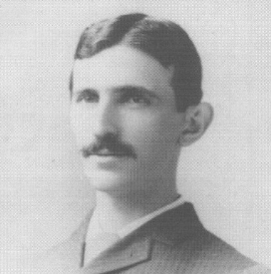**Nikola Tesla** (M’1888, F’17) was born in Smiljan in the Austro-Hungarian Empire, on July 9, 1856. He graduated from the Austrian Polytechnic School, Graz, and studied at the University of Prague.

His employment experience included the American Telephone Company, Budapest, the Edison Machine Works, Westinghouse Electric Company, and Nikola Tesla Laboratories. His special fields of interest included high frequency.

Dr. Tesla received honorary degrees from institutions of higher learning including Columbia University, Yale University, University of Belgrade, and the University of Zagreb. He received the Elliott Cresson Medal of the Franklin Institute and the Edison Medal of the IEEE. In 1956, the term “tesla” (T) was adopted as the unit of magnetic flux density in the MKSA system. In 1975, the Power Engineering Society established the Nikola Tesla Award in his honor. He died on January 7, 1943.

1.