FINAL PROJECT
Video Explanation Submission

Student Name | Adham Muayad Hashem
Student ID | 1320231720
Scan the QR code below or click the image/link to watch the project explanation video.
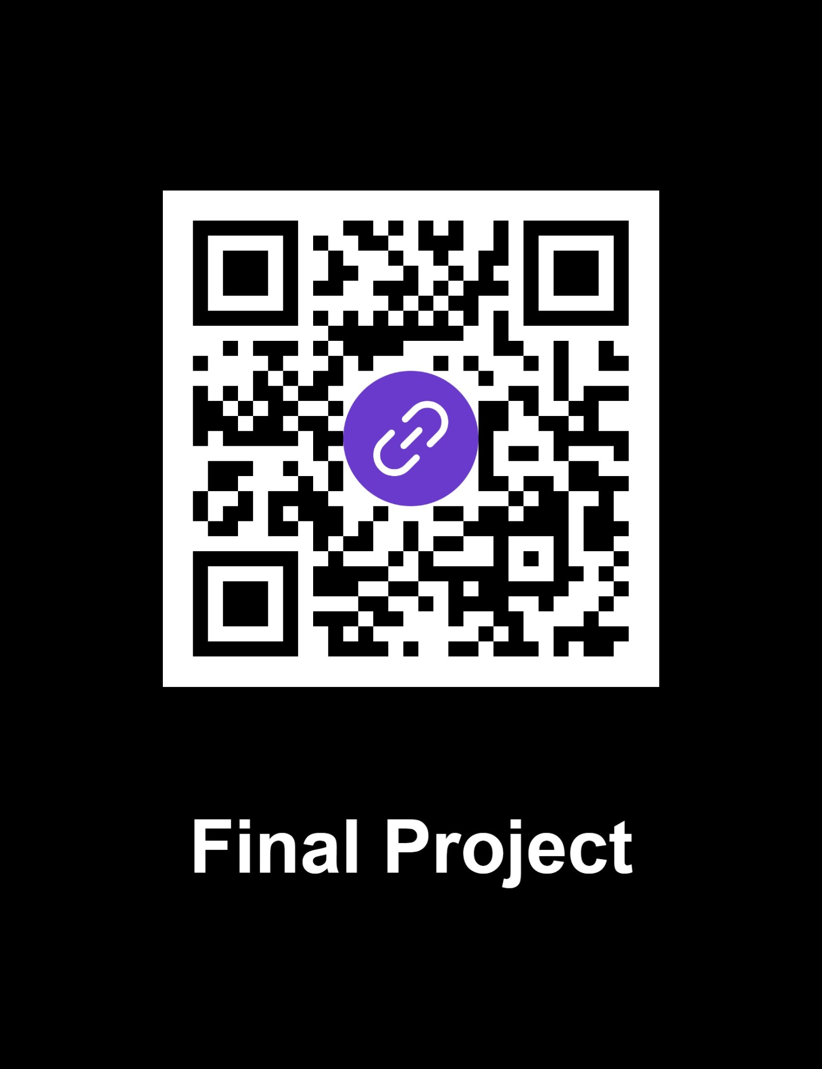
https://youtu.be/CXXiTfmGGpQ?si=NB2N-vCmPj_Wh6CA

