

Adham sakr group ID:

Adam shawky 17

Table of Contents

Introduction**1**

Objectives2

File Structure3

Functional requirements4

Non-functional requirements5

Sequence Diagram6

**Introduction:**

Our web application will be a formula one ticket booking website, where you can see the available races, you can watch and book them. You will be one step closer to experience the world of motorsports.

**Objectives:**

the website will include the following pages:

sign-up: to create a free account with your personal credentials (first-name, last-name, username, Email-address, phone number, and password).

Login: enter website with your pre-registered account.

View-profile: in this page you can view all of your account information.

Dashboard: will allow you to view your own profile and a schedule for the available races you can enjoy, and it transfers you to the race ticket booking page.

Schedule: contains a table of all the races you can book through the whole season, it also shows the location of the race and its timing.

Ticket-booking: through this page you can book your own ticket for the race you desire and specify the number of tickets you wish to purchase.

MySQL database: we used php my admin to create tables of users, races, tickets, and customers and access these data using node.js.

**File structure:**

images(folder)

-all images

Public(folder)

-sign up.html

-sign_up_script.css

-login.html

-login_script.css

App.js

Dashboard.html

Dash.css

Schedule.html

Schedule.css

View_profile.html

View_profile_script.css

Ticket_booking.html

Ticket.css

**Functional requirements:**

Html pages

Backend functionalities:

* Routing
* authentications
* validations
* data storage

**Non-functional requirements:**

CSS (page styling)

Performance

Page responsiveness

Usability

Maintainability

Availability

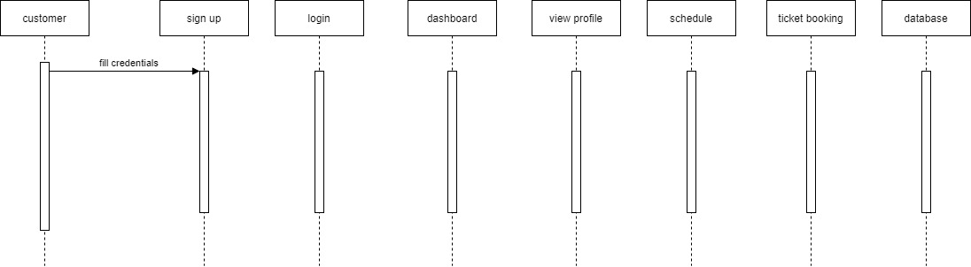 **Sequence diagram:**