1. Data Engineering & Ingestion Architecture
Dim_Product & Dimensions (Star Schema)
Overview: The data architecture maps four key source collections into an optimized analytical dataset, structuring primary keys and structural validation within Power Query.
Data sources used:
- • dim_product — catalog metrics (category, descriptive dimensions)
- • dim_customer — unique purchaser accounts and physical metrics
- • dim_date — temporal dimensional tracking for analysis
- • fact_order_items — granular line-item order performance tracking
Design decision: star schema mapping: Data types, primary keys, and relationships undergo validation within the Power Query engine. Implemented a robust star schema data model featuring one-to-many (*) cardinality relationships bridging the central fact_order_items table to all associated dimensions.
2. Analytical Methodology & Problem-Solving Framework
Core Architectural Paradigm
Overview: A structural evaluation strategy built around continuous operation analysis and macro-scale business metric discovery.
Problem-solving vectors used:
- • Comprehensive Data Extraction: Surface as many quantifiable KPIs as possible from underlying database entities to establish complete macro visibility.
- • Targeted Problem-Solving: Isolate metrics explicitly required to answer core operational challenges and address underlying risk factors.
Strategic alignment: swot application: Operational issues are systematically resolved through dual vectors: driving business growth opportunities and neutralizing enterprise threats using structured SWOT analysis frameworks.
3. Core DAX Measures Catalog
Primary Technical Metrics
Overview: Custom calculated models deployed inside the engine layer to deliver clean, scalable visual definitions.
Data formulas tracked:
- • Customer Count — unique customer volume across dimension scopes
- • Total Monetary Value — cumulative customer spend aggregated for tier ranking
- • Full Date — standardized temporal time-intelligence anchor
- • Average Price (Avg Price) — mean product valuation across the catalog inventory
- • Average Order — transaction scale and average basket size metrics
- • Freight-to-Revenue Ratio — logistical shipping cost efficiency relative to top-line sales
- • Total Customers — aggregated active customer base count
- • Total Orders — cumulative order transaction volume
- • Total Sales — gross revenue generation across timeline and categories
- • Total Freight — total shipping expenditure tracking
4. Dashboard Architecture & Functional Buckets
Bucket 1: Executive Performance & Financial Overview
Overview: Provides leadership with an immediate snapshot of enterprise health, revenue generation, and transaction volume.
Visual components used:
- • Summary KPI Cards — displays core metrics ([Total Sales], [Total Orders], [Total Customers])
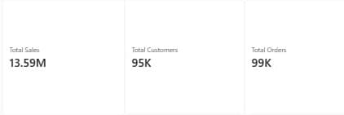
- • Monthly Sales & Order Trend — dual time-series charts tracking revenue trajectory alongside order volume over months and years

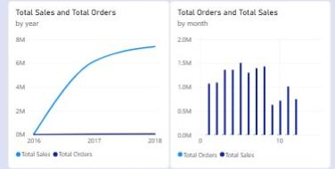
- • Sales Evolution by Category — area and stacked column distributions mapping monthly revenue contributions per product line
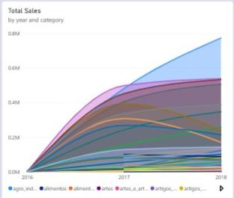
Bucket 2: Product Portfolio & Catalog Analytics
Overview: Analyzes product revenue drivers, physical inventory movement, and catalog pricing strategies.
Visual components used:
- • Category Performance Comparison — side-by-side clustered bar charts contrasting total revenue against physical units sold
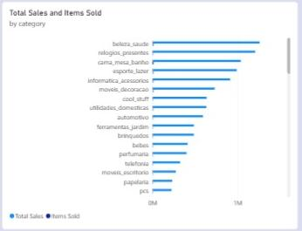
- • Top 10 Products Leaderboard — filtered tabular view isolating top-performing inventory items by total sales

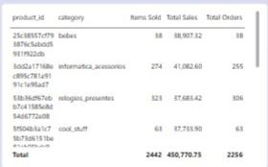
- • Category Pricing Spread — analytical distribution showing minimum, maximum, and average prices within categories
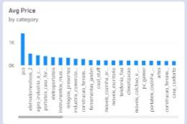
Bucket 3: Customer Insights & Geographic Distribution
Overview: Explores buyer demographics, regional purchasing footprints, and quantitative customer behavioral tiers.
Visual components used:
- • Geographic Sales — filled map configuration visualizing state-level revenue distribution via color saturation
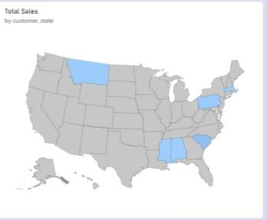

- • RFM Score Distribution — matrix views segmenting users via Recency, Frequency, and Monetary scores
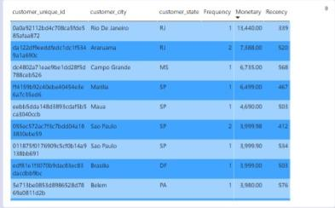

5. Advanced Diagnostics & Logistics Protection
Performance Controls
Overview: Integrates risk mitigation scripts into active logs to shield net profitability margins.
Operations diagnostics track:
- • Freight-to-Revenue Ratio — evaluates shipping expense efficiency relative to gross revenue to protect operational margins
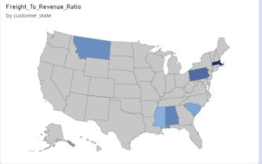

- • Margin Dilution Analysis — isolates category-specific shipping cost burdens that erode product-level profitability

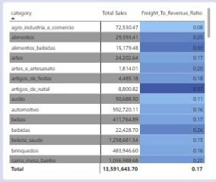

• VIP & At-Risk Watchlists — tabular filters highlighting top monetary buyers and dormant accounts meeting high recency thresholds (≥ 300 days) for targeted churn mitigation
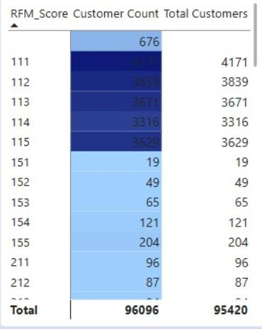

6. Strategic Decision-Making Framework
Execution Priorities
Overview: Defines systematic operational moves dictated by final dashboard evaluations.
Core execution targets:
- • Financial Oversight — track real-time revenue trajectories against enterprise targets using structured time-series and executive KPI summaries
- • Inventory & Pricing Adjustments — reallocate marketing capital toward high-margin product categories while optimizing catalog pricing spreads
- • Logistics Optimization — address shipping cost inefficiencies by reviewing category freight burdens, renegotiating carrier rates, or adjusting free shipping thresholds
- • Targeted Retention & Churn Prevention — isolate dormant high-value accounts via RFM matrices and execute automated win-back campaigns
- • Regional Market Expansion — identify top and lagging regions using geographic sales maps to optimize regional marketing spend and logistics hubs
- • Inventory & Catalog Strategy — track high-demand lines and stale stock to direct capital into profitable inventory items while phasing out laggards

