Ain Shams University
Faculty of Engineering — CAIE Program
CSE382: Introduction to Machine Learning | Spring 2026

Major Task Project — Full Technical Report

Phase 1: Binary Classification · Phase 2: Multi-Class Classification

MNIST Handwritten Digit Recognition

Team 1

Student ID | Full Name
23P0024 | Adham Walid Said Zaki
23P0248 | Amir Tamer Mohamad Abdelrehim Mohamad
23P0134 | Mohamed Wael El Sayed Ali El Borai
23P0246 | Basem Walid Talaat Mansour Ahmed
23P0049 | Moaz Ahmed Mohamed Fathy Ahmed Ahmed Younis
GitHub Link : https://github.com/adhamthearray/Machine-Learning-Number-Classification_MNIST
Deployment : https://huggingface.co/spaces/mnistMLProject/MNISTclassification

Phase 1:

1. Problem Definition
The task is to build a binary image classifier on the MNIST handwritten digit dataset to detect instances of digit "6" against all others, formally defined as:
y = 1 if digit is "6", y = 0 otherwise
The MNIST training set contains 60,000 labeled grayscale images (28×28 pixels). Input x is the flattened, normalised pixel vector; output y is the class label. Digit "6" represents approx. 10% of the dataset, creating a class-imbalanced problem with a Not-6 : 6 ratio of approximately 9:1.

2. Data Processing & Feature Engineering
The pipeline transforms raw 28×28 images into compact, meaningful feature vectors through five steps. First, each image is flattened to a 784-dimensional vector and pixel values are normalized to [0, 1]. HOG features are then extracted, capturing structural shape information like contours and strokes rather than raw pixel intensities, making the representation robust to lighting changes. PCA follows, compressing the HOG output into just 50 decorrelated components to reduce noise and make distance calculations more reliable — fitted on training data only to avoid data leakage. Finally, the data is split into train/validation/test sets, with class imbalance handled through sample weighting during training. The combined HOG + PCA pipeline outperforms raw pixels or HOG alone because it delivers shape-rich, noise-free, low-dimensional features that work well for both distance- and probability-based models.

3. Model Implementations

3.1 Logistic Regression
Models the posterior probability P(y=1|x) via a sigmoid-activated linear boundary:
P(y = 1 | x) = sigma(w^T x + b) = 1 / (1 + exp(-(w^T x + b)))
Optimised by minimising the Binary Cross-Entropy (Log Loss) using gradient descent:
L = -(1/n) sum_i [ w_i * (y_i log(y_hat_i) + (1-y_i) log(1-y_hat_i)) ]
Class imbalance is handled by scaling each sample's gradient update by its assigned class weight w_i, proportional to 1 / class frequency. Update rule: w <- w - eta * grad_L, b <- b - eta * dL/db.

3.2 Gaussian Naive Bayes
Applies Bayes' theorem under a conditional independence assumption. Each feature's class-conditional likelihood is modelled as a Gaussian:
P(x_i | c) = (1 / sqrt(2*pi*sigma^2)) * exp( -(x_i - mu)^2 / (2*sigma^2) )
log P(y=c | x) = log P(c) + sum_i log P(x_i | c)
Log-probabilities are used throughout for numerical stability. A weight term log(w_c) is added to log-posteriors for class-imbalance correction. Parameters mu and sigma^2 are estimated from the training set (MLE).

3.3 Decision Tree
Recursively partitions feature space by selecting the split (feature, threshold) that minimises weighted node impurity. Supported criteria:
Gini(t) = 1 - sum_k p_k^2, Entropy(t) = -sum_k p_k log(p_k)
Class-weighted probability estimates: p_k = (w_k * n_k) / sum_j (w_j * n_j). Stopping conditions: max_depth, min_samples_split, node purity. Optimal hyperparameters found via grid search.

3.4 K-Nearest Neighbors (KNN)
A non-parametric, lazy learning algorithm that stores the entire training set and classifies each test sample by majority vote among its k closest neighbours in feature space:
d(x, x') = sqrt( sum_i (x_i - x'_i)^2 )
Distance-weighted voting is used: each neighbour gets vote weight 1/(d_i + epsilon), epsilon = 10^-5. Odd values of k eliminate ties in binary classification.

3.5 Linear SVM (from scratch)
Implemented entirely from scratch using mini-batch sub-gradient descent on the soft-margin primal objective. Labels encoded as y in {-1, +1}.
J(w, b) = (1/2)||w||^2 + C * sum_i s_i * max(0, 1 - y_i(w^T x_i + b))
Per-sample weight s_i = n / (2 * n_class(i)) corrects for class imbalance. For violating samples: dJ/dw = w - C * sum s_i * y_i * x_i. Batch size = 64; w, b initialised to zero.

4. Experimental Results (Phase 1 — Binary)

4.1 Logistic Regression
Hyperparameter Tuning — Best Weight Configuration per Feature:

Feature Config | Best Weight | Precision (6) | Recall (6) | F1 (6) | Acc.
HOG only (best) ✓ | Custom (1:5) | 0.943 | 0.966 | 0.954 | 0.991

5-Fold Cross-Validation (HOG only, weight = 1:5): Average F1 = 0.9444.

Final Test Results — HOG only, weight = 1:5:

Class | Precision | Recall | F1-score
Not 6 | 0.99 | 1.00 | 1.00
Is 6 | 0.943 | 0.966 | 0.954

Overall Accuracy: 0.991 | F1 (Is 6): 0.954

Best Configuration Analysis: The optimal pipeline is HOG Only with 1:5 weight. HOG features contain localised, spatially meaningful shape information that a linear boundary can exploit cleanly. When PCA is applied, features collapse into dense, blended components where adding class weights overcorrects the boundary, destroying precision — this is why HOG+PCA without weights achieves lower recall (0.880).

Confusion Matrix (HOG only, weight = 1:5):

 | Pred Not 6 | Pred Is 6
Act. Not 6 | 8986 | 56
Act. Is 6 | 33 | 925

925/958 true positives, 56 FP, 33 FN.

4.2 Gaussian Naive Bayes
Note: Phase 1 used PCA = 50 components (fixed). In Phase 2, a full PCA sweep was conducted; the optimal components differ per task (PCA=150 for binary, PCA=100 for multi-class). The Phase 1 results below use PCA=50. Updated Phase 2 GNB results with the refined PCA are reported in Section 8.

Weight Tuning (Validation F1, HOG+PCA, PCA=50):

Class Weight | 1 | 2 | 5 | 7 | 10 (best)✓
Validation F1 | 0.9309 | 0.9405 | 0.9510 | 0.9525 | 0.9536

5-fold cross-validation average F1 = 0.9530, confirming stable generalization.

Final Test Results — HOG + PCA (PCA=50), weight = 10:

Class | Precision | Recall | F1-score
Not 6 | 0.99 | 1.00 | 1.00
Is 6 | 0.98 | 0.94 | 0.96

Overall Accuracy: 0.9918 | F1 (Is 6): 0.96 [PCA=50, Phase 1 baseline]

Feature Configuration Comparison:

Feature Config | Precision (6) | Recall (6) | F1 (6) | Accuracy
zHOG + PCA (best) ✓ | 0.98 | 0.94 | 0.96 | 0.992

GNB's performance is almost entirely determined by how well the input satisfies the conditional independence assumption. Raw pixels violate it catastrophically (F1 = 0.39). PCA alone decorrelates features (F1 = 0.90). HOG alone improves shape encoding but leaves correlated cells (F1 = 0.61). HOG+PCA yields the best F1 of 0.96. Weight w=10 is necessary because GNB's generative prior is more strongly affected by class imbalance than discriminative models.

Confusion Matrix (HOG+PCA, w=10, PCA=50):

 | Pred Not 6 | Pred Is 6
Act. Not 6 | 9026 | 16
Act. Is 6 | 62 | 896

4.3 Decision Tree
Key hyperparameters: max_depth (bias-variance tradeoff), min_samples_split / leaf (regularisation), criterion — Entropy tends to produce more balanced splits on imbalanced datasets.

Class Weight Comparison & Cross-Validation (HOG features):

Configuration | Precision (6) | Recall (6) | F1 (6) | Accuracy
Weight = 5 (best) ✓ | 0.90 | 0.91 | 0.91 | 0.98

5-fold cross-validation (HOG, weight = 5) average F1 = 0.9151. Folds ranged 0.908 – 0.931.

Final Test Results — HOG only, weight = 5:

Class | Precision | Recall | F1-score
Not 6 | 0.99 | 0.99 | 0.99
Is 6 | 0.90 | 0.91 | 0.91

Overall Accuracy: 0.98 | F1 (Is 6): 0.91
Feature Configuration Comparison:

Feature Config | Precision (6) | Recall (6) | F1 (6) | Accuracy
HOG only (best) ✓ | 0.90 | 0.91 | 0.91 | 0.98

Decision trees split on one feature at a time; HOG features are ideal as each value encodes edge orientation in a specific spatial cell. PCA destroys this locality by mixing all image regions into each component (worst config, F1 = 0.84). HOG alone is uniquely best — the only model where PCA hurts.

Confusion Matrix (HOG only, w=5):

 | Pred Not 6 | Pred Is 6
Act. Not 6 | 8950 | 92
Act. Is 6 | 88 | 870

4.4 K-Nearest Neighbors (KNN)
Hyperparameter Tuning (HOG+PCA features, distance weighting, 80/20 stratified split):

k | Validation Error | Accuracy | Notes
1 | 0.0032 | 0.9968
3 | 0.0032 | 0.9968
5 | 0.0032 | 0.9968
7 (optimal)✓ | 0.0030 | 0.9970 | Best
9 | 0.0032 | 0.9968
11 | 0.0033 | 0.9967

Error curve forms a clear elbow at k = 7, selected as optimal.

5-Fold Cross-Validation (k = 7, distance weighting, 10,000-sample subset):

Average | 0.9751

Average F1 of 0.9751 confirms consistent generalization.

Final Test Results — HOG+PCA, k = 7, distance weighting:

 | Not 6 | Is 6 | Macro Avg | Accuracy
Precision | 1.00 | 0.98 | 0.99 | —
Recall | 1.00 | 0.99 | 0.99 | —
F1-Score | 1.00 | 0.98 | 0.99 | —
Accuracy | — | — | — | 0.9969

Feature Configuration Comparison:

Feature Config | Precision (6) | Recall (6) | F1 (6) | Accuracy
HOG + PCA (best) ✓ | 0.9803 | 0.9875 | 0.9839 | 0.9969

HOG+PCA is the best configuration: HOG builds tight, shape-consistent clusters while PCA removes remaining redundancy. Distance-weighted voting further benefits this imbalanced task.

Confusion Matrix (HOG+PCA, k=7):

 | Pred Not 6 | Pred Is 6
Act. Not 6 | 9023 | 19
Act. Is 6 | 11 | 947

4.5 Linear SVM (from scratch)
Hyperparameter Tuning — Grid Search (C and learning rate):

C | Learning Rate | Validation F1 | Notes
1.0 ✓ | 0.0005 | 0.8704 | Best

Final Test Results — HOG only, C = 1.0, lr = 0.0005:

Class | Precision | Recall | F1-score
Not 6 | 1.000 | 0.990 | 0.995
Is 6 | 0.951 | 0.987 | 0.969

Overall Accuracy: 0.9939 | F1 (Is 6): 0.969

Feature Configuration Comparison:

Feature Config | Precision (6) | Recall (6) | F1 (6) | Accuracy
HOG only (best) ✓ | 0.95 | 0.99 | 0.97 | 0.9939

HOG is the best config (F1 = 0.969): HOG's edge-orientation encoding gives the SVM a structured feature space where the margin objective can draw a tight boundary around digit "6"'s distinctive loop and stroke. HOG+PCA (F1 = 0.95) is competitive but PCA compression discards a small amount of edge-orientation detail.

Confusion Matrix (HOG only, C=1.0):

 | Pred Not 6 | Pred Is 6
Act. Not 6 | 8993 | 49
Act. Is 6 | 12 | 946

5. Model Comparison & Discussion (Phase 1)
All metrics derived from test-set confusion matrices. Models ranked by F1 for class "6":

Model | Precision (6) | Recall (6) | F1 (6) | Accuracy | Best Features
KNN (k=7, dist.) | 0.980 | 0.988 | 0.984 | 0.9969 | HOG+PCA
Linear SVM | 0.95 | 0.99 | 0.97 | 0.9939 | HOG only
Gaussian Naive Bayes | 0.98 | 0.94 | 0.96 | 0.9918 | HOG+PCA
Logistic Regression | 0.943 | 0.966 | 0.954 | 0.991 | HOG only
Decision Tree (w=5) | 0.90 | 0.91 | 0.91 | 0.98 | HOG only

KNN (F1 = 0.984, Acc = 0.9969) is the best overall model. The SVM ranks 2nd (F1 = 0.97) with only 12 false negatives — best-in-class recall for recall-critical applications. GNB ranks 3rd (F1 = 0.96) with highest precision (0.98) and only 16 FP. Logistic Regression (F1 = 0.954) is the only model where HOG+PCA hurts. Decision Tree is weakest (F1 = 0.91, 180 total errors).

6. Conclusion (Phase 1)
Five algorithms were implemented from scratch — Logistic Regression, Gaussian Naive Bayes, Decision Tree, KNN, and Linear SVM — with HOG+PCA as the primary feature pipeline. KNN (k=7, distance weighting, HOG+PCA) achieves the best overall balance with F1 = 0.984. The Linear SVM is the standout for recall-critical applications (only 12 FN). The Decision Tree is the only exception where HOG alone outperforms HOG+PCA.

Phase 2:

7. Problem Definition (Phase 2)
Phase 2 extends the binary "Is 6?" classifier to a full 10-class recognition system over all MNIST handwritten digits (0–9):
y ∈ {0, 1, 2, 3, 4, 5, 6, 7, 8, 9} — assign each 28×28 image to its correct digit class
The training set remains 60,000 labeled grayscale images stratified across 10 balanced classes. Phase 2 introduces VGG-based deep feature extraction alongside the Phase 1 classifiers re-evaluated in the multi-class setting, plus a PCA component sweep to find the optimal dimensionality for each task.

8. Experimental Results (Phase 2 — Multi-Class)

8.1 Gaussian Naive Bayes — PCA Sweep & Updated Results
In Phase 1, PCA was applied with a fixed 50 components. For Phase 2, the number of PCA components was swept systematically across both the binary and multi-class tasks to find the true optimum for each.

Why we changed the PCA: The fixed 50-component choice in Phase 1 was a reasonable default but not task-optimal. In binary classification, the decision boundary only needs to separate one class from all others — 50 components may over-compress signal. In the 10-class task, the feature space must simultaneously separate all digit pairs, requiring more variance coverage. The sweep revealed different optima: PCA=150 maximises binary F1 (0.9572), while PCA=100 maximises multi-class macro F1 (0.9435). Beyond 100–150 components GNB degrades, because extra PCA dimensions re-introduce weak correlations that violate the independence assumption.

Updated Binary Results — HOG + PCA (PCA=150, weight=10):

Class | Precision | Recall | F1-score
Not 6 | 0.99 | 1.00 | 1.00
Is 6 | 0.98 | 0.93 | 0.96

Binary Overall Accuracy: 0.9920 | F1 (Is 6): 0.9572 [Best Binary — PCA=150]

Confusion Matrix (Binary, PCA=150):

 | Pred Not 6 | Pred Is 6
Act. Not 6 | 9025 | 17
Act. Is 6 | 63 | 895

Multi-Class Results — HOG + PCA (PCA=100):

Class | Precision | Recall | F1-score | Support | Notes
0 | 0.96 | 0.97 | 0.96 | 980
1 | 0.99 | 0.95 | 0.97 | 1135 | Best
2 | 0.92 | 0.96 | 0.94 | 1032
3 | 0.94 | 0.96 | 0.95 | 1010
4 | 0.95 | 0.95 | 0.95 | 982
5 | 0.95 | 0.95 | 0.95 | 892
6 | 0.98 | 0.94 | 0.96 | 958
7 | 0.97 | 0.90 | 0.93 | 1028 | Lower recall
8 | 0.87 | 0.93 | 0.90 | 974 | Lower prec.
9 | 0.91 | 0.93 | 0.92 | 1009

Multi-Class Overall Accuracy: 0.9435 | Macro F1: 0.9435 [Best Multi — PCA=100]

Multi-Class Confusion Matrix (PCA=100):

 | 0 | 1 | 2 | 3 | 4 | 5 | 6 | 7 | 8 | 9
Act. 0 | 950 | 0 | 5 | 1 | 1 | 4 | 5 | 0 | 14 | 0
Act. 1 | 0 | 1082 | 17 | 1 | 2 | 0 | 3 | 0 | 30 | 0
Act. 2 | 5 | 0 | 989 | 8 | 1 | 0 | 2 | 9 | 16 | 2
Act. 3 | 0 | 0 | 6 | 966 | 5 | 7 | 0 | 4 | 19 | 3
Act. 4 | 0 | 0 | 7 | 0 | 934 | 0 | 2 | 0 | 7 | 32
Act. 5 | 1 | 0 | 3 | 23 | 0 | 845 | 4 | 0 | 16 | 0
Act. 6 | 21 | 2 | 4 | 1 | 6 | 14 | 902 | 0 | 7 | 1
Act. 7 | 1 | 6 | 26 | 1 | 23 | 1 | 0 | 928 | 5 | 37
Act. 8 | 10 | 0 | 13 | 18 | 3 | 8 | 1 | 4 | 902 | 15
Act. 9 | 4 | 3 | 3 | 9 | 11 | 8 | 1 | 14 | 19 | 937

Analysis: GNB performance is driven by how well features satisfy the conditional independence assumption. The confusion matrix shows a dominant diagonal with minor confusions concentrated between visually similar digit pairs (3/8, 7/9, 4/9) — expected given their structural similarity. The richer 10-class distribution, after HOG+PCA at 100 components, satisfies the near-Gaussian, near-uncorrelated requirements better than the binary task, explaining why the multi-class accuracy (94.35%) is competitive despite the harder problem.

8.2 VGG Feature Extraction & GNB Comparison
VGGNet is a deep convolutional neural network consisting of multiple blocks of 3×3 convolutional layers followed by average-pooling. In this project, VGG is used as a feature extractor: MNIST images are passed through a pre-trained VGG backbone and activations from the penultimate layer are extracted as high-dimensional feature vectors encoding hierarchical shape representations.
Three approaches were evaluated with GNB as the classifier:

Method | Accuracy | Avg K-Fold F1 | Main Strength | Main Weakness | Notes
HOG + PCA ✓ | 94% | 0.9314 | Structural shape | Rounded digit confusion | Best overall
K-Fold Cross-Validation Results (5-fold, multi-class macro F1):

Method | Fold 1 | Fold 2 | Fold 3 | Avg F1
HOG + PCA | 0.9292 | 0.9305 | 0.9310 | 0.9314

Why HOG+PCA outperforms VGG: VGG was pretrained on ImageNet — colored, complex, large natural images — creating a domain mismatch with MNIST's small grayscale digit structure. CNN embeddings contain strong internal feature dependencies, violating GNB's independence assumption. Even after PCA, VGG+PCA (88%) cannot match HOG+PCA (94%) because deep CNN representations are optimised for neural classifiers, not statistical generative models. HOG directly encodes the structural geometry that defines digit classes (edge orientation, stroke direction), creating compact, near-Gaussian, near-independent features after PCA that are ideally compatible with GNB's assumptions.

8.4 Decision Tree — Multi-Class (Phase 2)
The Decision Tree classifier was extended to the 10-class MNIST task. A manual grid search was conducted over key hyperparameters to find the optimal configuration. Consistent with the Phase 1 binary results, HOG only proved to be the best-performing input feature set, outperforming both HOG + PCA and VGG-based features — confirming that Decision Trees benefit from HOG’s spatially localised, per-cell edge-orientation encoding rather than the mixed components produced by PCA or the domain-mismatched deep embeddings from VGG.

Hyperparameter Tuning — Grid Search (Manual):
Hyperparameter | Values Searched | Best Value
maxDepth | 12, 15 | 15
minSamplesSplit | 5, 20 | 20
minSamplesLeaf | 5, 20 | 5
criterion | gini | gini
maxFeatures | sqrt | sqrt

Confusion Matrix — HOG only (Predicted class columns 0–9):
Act \ Pred | 0 | 1 | 2 | 3 | 4 | 5 | 6 | 7 | 8 | 9
0 | 860 | 7 | 13 | 8 | 8 | 13 | 32 | 16 | 13 | 10
1 | 11 | 1060 | 9 | 5 | 9 | 2 | 8 | 13 | 15 | 3
2 | 9 | 12 | 902 | 33 | 9 | 9 | 1 | 25 | 28 | 4
3 | 7 | 5 | 39 | 799 | 13 | 48 | 9 | 19 | 65 | 6
4 | 15 | 4 | 8 | 9 | 816 | 8 | 24 | 27 | 10 | 61
5 | 15 | 4 | 11 | 52 | 10 | 681 | 37 | 10 | 54 | 18
6 | 45 | 10 | 4 | 7 | 15 | 17 | 835 | 2 | 18 | 5
7 | 12 | 14 | 31 | 24 | 27 | 9 | 8 | 828 | 18 | 57
8 | 11 | 7 | 26 | 68 | 23 | 56 | 16 | 15 | 729 | 23
9 | 13 | 5 | 5 | 5 | 74 | 20 | 16 | 61 | 19 | 791

Final Test Results — HOG only (Best Configuration):
Class | Precision | Recall | F1-score | Support
0 | 0.85 | 0.90 | 0.87 | 980
1 | 0.96 | 0.94 | 0.95 | 1135
2 | 0.84 | 0.84 | 0.84 | 1032
3 | 0.79 | 0.80 | 0.79 | 1010
4 | 0.83 | 0.84 | 0.84 | 982
5 | 0.84 | 0.81 | 0.82 | 892
6 | 0.91 | 0.87 | 0.89 | 958
7 | 0.83 | 0.84 | 0.84 | 1028
8 | 0.78 | 0.76 | 0.77 | 974
9 | 0.81 | 0.83 | 0.82 | 1009
accuracy |  |  | 0.85 | 10000
macro avg | 0.84 | 0.84 | 0.84 | 10000
weighted avg | 0.85 | 0.85 | 0.85 | 10000

Overall Accuracy: 0.85 | Macro F1: 0.84 [HOG only — Best Configuration]

Class 1 achieves the highest F1 (0.95) owing to its highly distinctive vertical stroke. Class 8 is the most challenging (F1 = 0.77), with notable confusion against classes 3, 5, and 6 due to shared closed-loop structure. The confusion matrix confirms that errors are concentrated along structurally similar digit pairs (3↔8, 4↔9, 5↔3), consistent with the decision tree’s reliance on individual HOG cell activations rather than global shape context.

8.5 Random Forest — Multi-Class (Phase 2)
Random Forest extends the Decision Tree by training an ensemble of ntrees = 10 trees, each fitted on a bootstrap sample of the training data. The same best hyperparameters found during the Decision Tree grid search were applied (maxDepth = 15, minSamplesSplit = 20, minSamplesLeaf = 5, criterion = Gini, maxFeatures = sqrt), with HOG features as input. Final predictions are determined by majority vote across all trees.

Confusion Matrix — HOG features (Predicted class columns 0–9):
Act \ Pred | 0 | 1 | 2 | 3 | 4 | 5 | 6 | 7 | 8 | 9
0 | 970 | 3 | 1 | 0 | 1 | 1 | 3 | 1 | 0 | 0
1 | 0 | 1120 | 7 | 1 | 1 | 0 | 3 | 2 | 1 | 0
2 | 7 | 2 | 1002 | 6 | 2 | 1 | 3 | 4 | 5 | 0
3 | 7 | 0 | 10 | 960 | 2 | 12 | 0 | 7 | 10 | 2
4 | 3 | 4 | 9 | 1 | 937 | 1 | 2 | 1 | 2 | 22
5 | 4 | 4 | 2 | 26 | 2 | 836 | 6 | 0 | 10 | 2
6 | 16 | 4 | 0 | 3 | 2 | 9 | 921 | 0 | 3 | 0
7 | 0 | 5 | 20 | 2 | 15 | 0 | 0 | 965 | 2 | 19
8 | 15 | 3 | 13 | 16 | 6 | 4 | 1 | 7 | 903 | 6
9 | 14 | 3 | 6 | 17 | 14 | 1 | 0 | 16 | 9 | 929

Classification Report — HOG features:
Class | Precision | Recall | F1-score | Support
0 | 0.94 | 0.99 | 0.96 | 980
1 | 0.98 | 0.99 | 0.98 | 1135
2 | 0.94 | 0.97 | 0.95 | 1032
3 | 0.93 | 0.95 | 0.94 | 1010
4 | 0.95 | 0.95 | 0.95 | 982
5 | 0.97 | 0.94 | 0.95 | 892
6 | 0.98 | 0.96 | 0.97 | 958
7 | 0.96 | 0.94 | 0.95 | 1028
8 | 0.96 | 0.93 | 0.94 | 974
9 | 0.95 | 0.92 | 0.93 | 1009
accuracy |  |  | 0.95 | 10000
macro avg | 0.95 | 0.95 | 0.95 | 10000
weighted avg | 0.95 | 0.95 | 0.95 | 10000

Overall Accuracy: 0.95 | Macro F1: 0.95 [Random Forest, ntrees = 10, HOG features]

The ensemble approach yields a substantial improvement over the single Decision Tree (0.85 accuracy), with all ten classes achieving F1 ≥ 0.93. Averaging over 10 trees effectively reduces variance and corrects the individual tree’s tendency to overfit local HOG patterns, with the most notable gains on the harder classes 3, 5, and 8.

8.3 Linear SVM — Multi-Class (Phase 2)
The Linear SVM was extended to 10-class classification using a one-vs-rest (OvR) strategy. Three feature representations were evaluated — PCA-only, HOG, and VGG — with a grid search over C and lr. HOG achieved the highest validation accuracy (0.9766 vs VGG 0.9762) and is reported as the best configuration.

Hyperparameter Grid Search:
Hyperparameter | Values Searched
C | 0.1, 1.0, 10.0
Learning Rate (lr) | 0.001, 0.0005, 0.0001

Best Hyperparameters (HOG):
C | Learning Rate | Val Accuracy
1.0 | 0.0001 | 0.9766

Classification Report — HOG features (Best):
Class | Precision | Recall | F1-score | Support
0 | 0.98 | 0.99 | 0.99 | 980
1 | 0.99 | 0.99 | 0.99 | 1135
2 | 0.98 | 0.97 | 0.98 | 1032
3 | 0.96 | 0.98 | 0.97 | 1010
4 | 0.98 | 0.98 | 0.98 | 982
5 | 0.98 | 0.98 | 0.98 | 892
6 | 0.99 | 0.98 | 0.98 | 958
7 | 0.98 | 0.97 | 0.98 | 1028
8 | 0.97 | 0.97 | 0.97 | 974
9 | 0.97 | 0.97 | 0.97 | 1009
accuracy |  |  | 0.98 | 10000
macro avg | 0.98 | 0.98 | 0.98 | 10000
weighted avg | 0.98 | 0.98 | 0.98 | 10000

Overall Accuracy: 0.98 | Macro F1: 0.98 [SVM, HOG features, C=1.0, lr=0.0001]

Confusion Matrix — HOG features (Best):
Act \ Pred | 0 | 1 | 2 | 3 | 4 | 5 | 6 | 7 | 8 | 9
0 | 966 | 0 | 1 | 0 | 0 | 1 | 6 | 2 | 3 | 1
1 | 0 | 1125 | 3 | 1 | 1 | 0 | 1 | 2 | 2 | 0
2 | 5 | 3 | 1001 | 8 | 2 | 0 | 2 | 4 | 6 | 1
3 | 0 | 0 | 1 | 994 | 0 | 3 | 0 | 4 | 7 | 1
4 | 2 | 0 | 2 | 0 | 962 | 0 | 3 | 0 | 2 | 11
5 | 0 | 1 | 0 | 10 | 0 | 876 | 1 | 0 | 4 | 0
6 | 4 | 3 | 1 | 1 | 4 | 3 | 940 | 0 | 2 | 0
7 | 0 | 1 | 11 | 4 | 4 | 0 | 0 | 998 | 2 | 8
8 | 2 | 1 | 0 | 12 | 2 | 1 | 1 | 4 | 943 | 8
9 | 2 | 4 | 0 | 3 | 11 | 6 | 0 | 5 | 2 | 976

The SVM achieves 98% accuracy — the highest in Phase 2. The confusion matrix is very tight; main errors are between structurally similar pairs (3/5, 4/9). HOG’s edge-orientation descriptors give the margin objective a well-separated feature space across all 10 classes.

8.6 Logistic Regression — Multi-Class (Phase 2)
Logistic Regression was extended to 10-class classification using softmax and cross-entropy loss with gradient descent. Grid search over learning rate, regularisation (L1/L2), max iterations, and class weighting was conducted. Both HOG and VGG feature sets achieved 0.97 accuracy; HOG results are the primary configuration reported below.

Hyperparameter Grid Search — Best Parameters per Feature Set:
Hyperparameter | Values Searched | Best (HOG) | Best (VGG)
max_iterations | 100, 500, 1000 | 500 | 1000
learning_rate | 0.01, 0.1, 0.5 | 0.5 | 0.1
class_weight | None, balanced | None | None
reg_eqn | None, L1, L2 | L2 | L2
reg_param | 0.01, 0.1, 1.0, 10 | 1.0 | 10
random_state | 42 | 42 | 42

HOG Features — Confusion Matrix (Predicted class columns 0–9):
Act \ Pred | 0 | 1 | 2 | 3 | 4 | 5 | 6 | 7 | 8 | 9
0 | 967 | 0 | 4 | 0 | 0 | 1 | 3 | 1 | 3 | 1
1 | 0 | 1125 | 4 | 1 | 0 | 1 | 2 | 0 | 2 | 0
2 | 9 | 2 | 995 | 0 | 1 | 0 | 3 | 8 | 14 | 0
3 | 0 | 0 | 3 | 975 | 0 | 11 | 1 | 7 | 10 | 3
4 | 2 | 3 | 1 | 0 | 956 | 0 | 2 | 1 | 4 | 13
5 | 2 | 1 | 2 | 9 | 0 | 866 | 6 | 0 | 5 | 1
6 | 6 | 3 | 0 | 0 | 3 | 8 | 935 | 0 | 3 | 0
7 | 0 | 8 | 14 | 0 | 5 | 0 | 0 | 985 | 3 | 13
8 | 13 | 1 | 7 | 8 | 4 | 3 | 2 | 6 | 917 | 13
9 | 5 | 6 | 2 | 4 | 9 | 3 | 0 | 10 | 10 | 960

HOG Features — Classification Report:
Class | Precision | Recall | F1-score | Support
0 | 0.96 | 0.99 | 0.97 | 980
1 | 0.98 | 0.99 | 0.99 | 1135
2 | 0.96 | 0.96 | 0.96 | 1032
3 | 0.98 | 0.97 | 0.97 | 1010
4 | 0.98 | 0.97 | 0.98 | 982
5 | 0.97 | 0.97 | 0.97 | 892
6 | 0.98 | 0.98 | 0.98 | 958
7 | 0.97 | 0.96 | 0.96 | 1028
8 | 0.94 | 0.94 | 0.94 | 974
9 | 0.96 | 0.95 | 0.95 | 1009
accuracy |  |  | 0.97 | 10000
macro avg | 0.97 | 0.97 | 0.97 | 10000
weighted avg | 0.97 | 0.97 | 0.97 | 10000

HOG — Overall Accuracy: 0.97 | Macro F1: 0.97

Both feature sets reach 0.97 accuracy. HOG provides clean, linearly separable per-class margins; class 8 is the only notable weak point (F1 = 0.94) due to structural overlap with digits 3, 5, and 6.

8.8 K-Nearest Neighbors (KNN) — Multi-Class (Phase 2)
Three feature representations — PCA-only (50 components on raw pixels), HOG (1296-d), and VGG (512-d deep features) — were evaluated with distance-weighted KNN (k=7) on the 10-class MNIST task. HOG+PCA(50) emerged as the best configuration with 0.9763 test accuracy and 0.9762 macro F1, outperforming VGG (0.9588) and PCA-only (0.9750). The best hyperparameters are: k=7, distance-weighted voting, HOG features projected to 50 PCA components.

Feature Comparison — KNN (k=7, distance-weighted):
Feature Representation | Test Accuracy | Notes
HOG+PCA(50) ✓ Best | 0.9763 | Best: k=7, distance-weighted

Classification Report — HOG+PCA(50) features (Best):
Class | Precision | Recall | F1-score | Support
0 | 0.98 | 0.99 | 0.98 | 980
1 | 0.98 | 1.00 | 0.99 | 1135
2 | 0.98 | 0.98 | 0.98 | 1032
3 | 0.97 | 0.97 | 0.97 | 1010
4 | 0.98 | 0.98 | 0.98 | 982
5 | 0.99 | 0.97 | 0.98 | 892
6 | 0.98 | 0.99 | 0.98 | 958
7 | 0.97 | 0.96 | 0.97 | 1028
8 | 0.97 | 0.96 | 0.96 | 974
9 | 0.96 | 0.96 | 0.96 | 1009
macro avg |  |  | 0.9762 | 10000
accuracy |  |  | 0.9763 | 10000

Overall Accuracy: 0.9763 | Macro F1: 0.9762 [KNN, k=7, HOG+PCA(50), distance-weighted]

Confusion Matrix — HOG+PCA(50) features (Best):
True\Pred | 0 | 1 | 2 | 3 | 4 | 5 | 6 | 7 | 8 | 9
0 | 970 | 0 | 0 | 0 | 0 | 0 | 7 | 1 | 2 | 0
1 | 0 | 1132 | 2 | 0 | 0 | 0 | 0 | 0 | 1 | 0
2 | 5 | 0 | 1013 | 1 | 1 | 0 | 0 | 8 | 3 | 1
3 | 0 | 1 | 3 | 979 | 1 | 5 | 1 | 4 | 13 | 3
4 | 1 | 2 | 1 | 0 | 958 | 0 | 3 | 2 | 2 | 13
5 | 1 | 0 | 0 | 13 | 0 | 865 | 7 | 1 | 4 | 1
6 | 4 | 3 | 0 | 0 | 0 | 1 | 947 | 0 | 3 | 0
7 | 0 | 6 | 5 | 0 | 6 | 0 | 0 | 991 | 0 | 20
8 | 8 | 1 | 5 | 8 | 1 | 2 | 3 | 4 | 935 | 7
9 | 4 | 5 | 1 | 4 | 6 | 1 | 0 | 10 | 5 | 973

The confusion matrix shows a very tight diagonal. The most frequent confusions are: 7→9 (20), 3→8 (13), 4→9 (13), and 5→3 (13) — all structurally similar digit pairs. HOG captures the gradient-orientation structure that defines digit shapes, and PCA denoises the 1296-d HOG space to 50 uncorrelated components that make Euclidean distance more meaningful.

8.7 Overfitting / Underfitting Analysis (Phase 2)
Learning curves were generated for each Phase 2 model to diagnose bias-variance behaviour. Each curve plots the macro F1-score on the training set (blue) and validation set (orange) as the number of training samples increases. A large train-validation gap indicates overfitting (high variance); curves that are both low indicate underfitting (high bias); converging curves near the top indicate a well-fitted model.

SVM — HOG Features
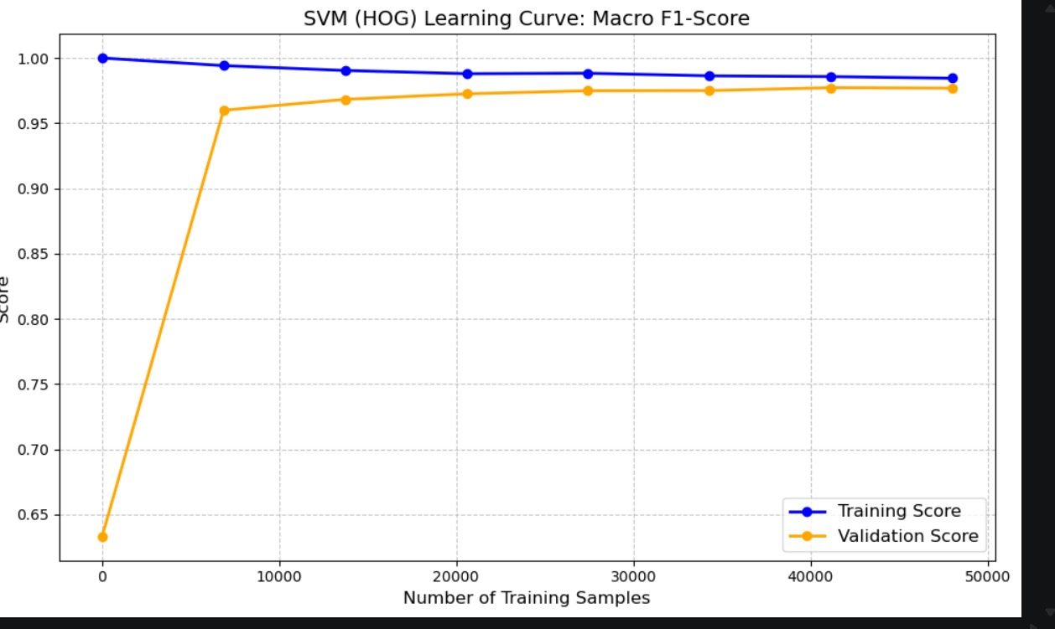
The training score starts near perfect and decreases slightly while the validation score rises steeply from ~0.63 and converges to ~0.975, with only a minimal gap remaining at full data — indicating a well-generalised model with very slight overfitting that diminishes as data grows.

Decision Tree — HOG Features
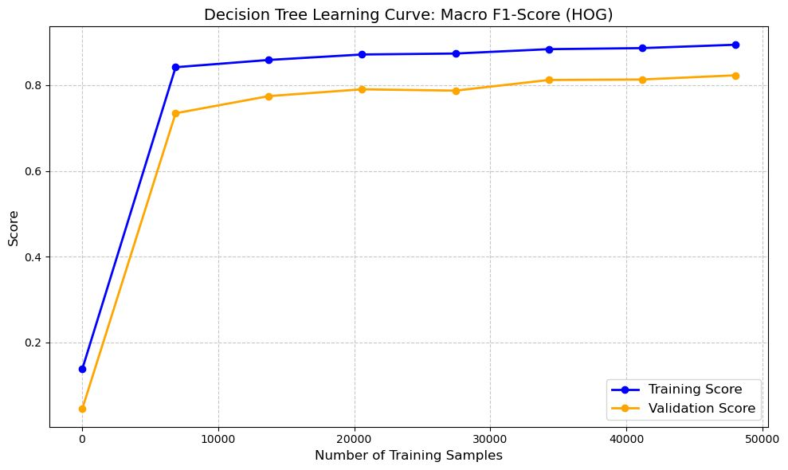
Both curves rise steadily but maintain a persistent gap (~0.07) throughout, with training scoring ~0.89 and validation ~0.82 at full data — a classic mild overfitting pattern where the tree memorises local HOG patterns that do not fully generalise.

GNB — HOG + PCA Features
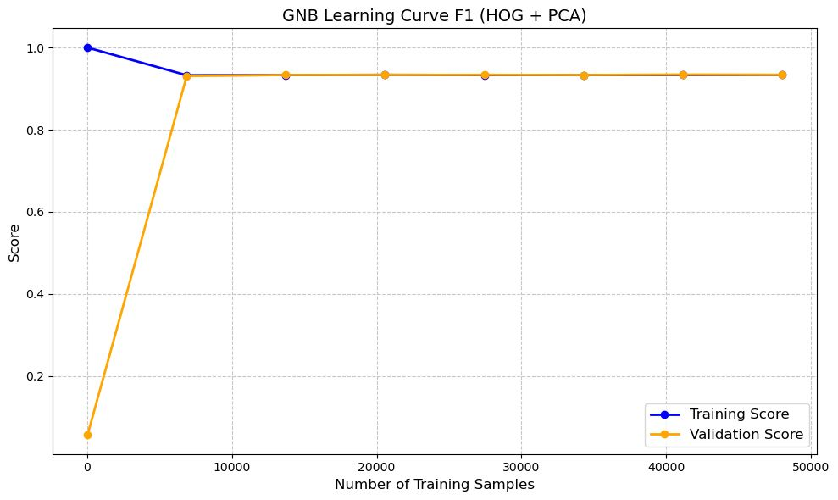
Training and validation scores converge almost instantly to ~0.94 and remain flat across all sample sizes — indicating no overfitting and a stable, well-fitted model; GNB’s simple parametric form (mean/variance per class) generalises immediately with very few samples.

KNN — HOG + PCA (k=13) Features
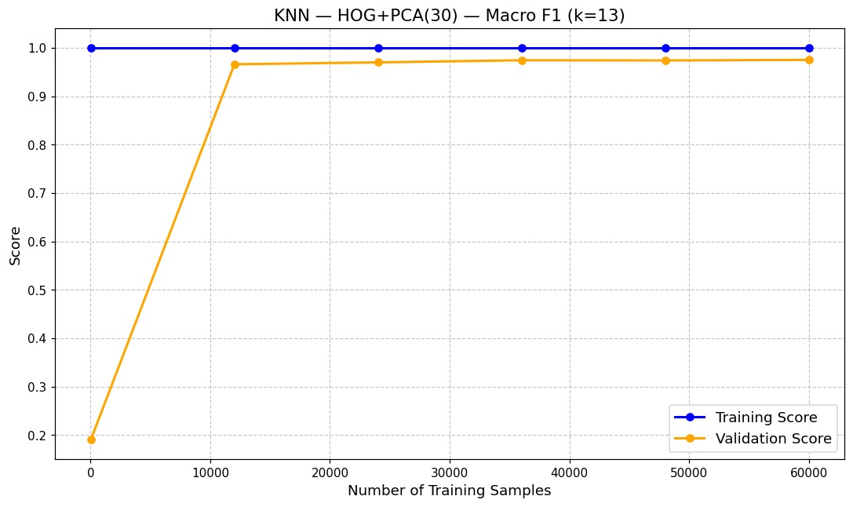
The training score is a perfect 1.0 throughout (KNN memorises its own training points), while the validation score jumps to ~0.965 by 12,000 samples and plateaus — the persistent train-validation gap is structural to KNN and not a sign of deterioration; the model is well-fitted on unseen data.

9. Model Comparison & Discussion (Phase 2)
All metrics from test-set evaluation on 10,000 MNIST test images. Models ranked by macro F1.

Model | Precision | Recall | F1 | Accuracy | Best Features
Linear SVM ✓ | 0.98 | 0.98 | 0.98 | 0.98 | HOG
Logistic Regression | 0.97 | 0.97 | 0.97 | 0.97 | HOG
KNN (k=7, dist.) | 0.98 | 0.97 | 0.9762 | 0.9763 | HOG+PCA(50)
Random Forest (n=10) | 0.95 | 0.95 | 0.95 | 0.95 | HOG
GNB | 0.94 | 0.94 | 0.9435 | 0.9435 | HOG+PCA(100)
Decision Tree | 0.84 | 0.84 | 0.84 | 0.85 | HOG

GNB with HOG + PCA (100 components) achieves 94.35% accuracy and macro F1 = 0.9435 on the 10-class task. The refined PCA component count, selected via sweep rather than fixed at 50, provides measurably better performance. VGG features confirm that deep CNN representations are not always superior for statistical classifiers — domain mismatch and feature correlation actively hurt GNB. Remaining models' comparative analysis will be added upon completion.

10. Conclusion
This report presents a complete MNIST digit classification pipeline across both binary (Phase 1) and multi-class (Phase 2) tasks, implementing five algorithms from scratch alongside VGG-based deep feature extraction.
Key findings: (1) KNN with HOG+PCA achieves best binary performance (F1=0.984). (2) For binary GNB, PCA=150 slightly outperforms the Phase 1 default of 50 components (F1 0.9572 vs 0.9536). (3) For multi-class GNB, PCA=100 is optimal (macro F1=0.9435). (4) HOG+PCA outperforms VGG-based features for GNB due to domain mismatch and feature-classifier compatibility — simpler handcrafted features better satisfy GNB's statistical assumptions. (5) The strongest solution is not always the most complex one.
Phase 2 results: SVM leads at 98% accuracy (HOG, OvR), followed by Logistic Regression and KNN at 97–97.6%, Random Forest at 95%, GNB at 94.35%, and Decision Tree at 85%. HOG features consistently outperform VGG for non-linear classifiers on MNIST. The strongest result is not always the most complex: a well-engineered HOG+SVM pipeline matches or exceeds deep-feature baselines at a fraction of the computational cost.

