Personal Information

Name: Alim Rafli Samsudi
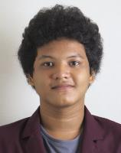

Date of Birth: 1998-09-25

Sex: male

Address: Jl.H.Ung dalam No.83, RT.03/Rw.004, Kelurahan Utan Panjang, Kecamatan Kemayoran, Jakarta Pusat - 10650

Mobile: +6281293392803

Email: alimraflisamsudi@gmail.com

Formal Education


2009 - 2012 | SMP Negeri 78 Jakarta
2012 - 2015 | SMA Negeri 5 Jakarta
2015 - 2019 | Bina Nusantara University

Informal Education


15 January 2015 - 15
Seminar: Computing From Maths to Apps and Games
January 2015
12 May 2016 - 12 May 2016Seminar: Balanced & Binary Tree Data Structure
October 2016 - January
Training as Assistant on Software Laboratory Center Binus
2017

Study Group Indonesia Android Kejar 3.0 by Google
April 2017 - May 2017
Developers

Computer / Special Skill

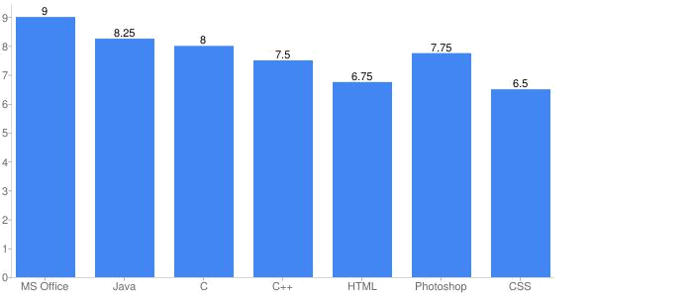

Language Skill

Bahasa Indonesia

English

Native

Good

IPS / IPK History


Semester | IPS | IPK
1 | 3.63 | 3.63
2 | 3.54 | 3.45
3 | 2.85 | 3.31
4 | 2.8 | 3.33

Subject Grade
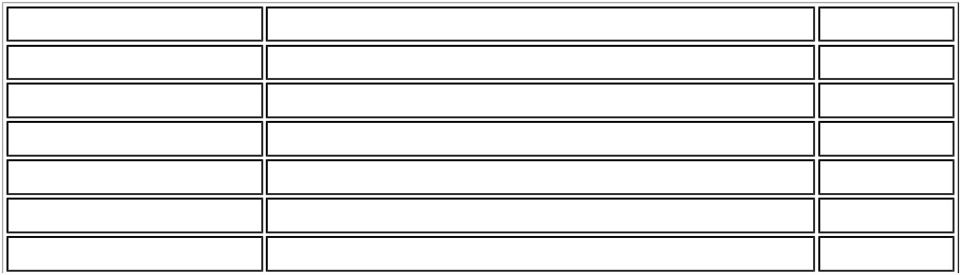

Course Code | Course Name | Grade
CHAR6013 | Character Building: Pancasila | B+
COMP6047 | Algorithm and Programming | A
COMP6060 | Programming Language Concepts | A
ENGL6128 | English in Focus | A
MATH6025 | Discrete Mathematics | B-
MATH6031 | Calculus | A-

  CHAR6014 | Character Building: Kewarganegaraan | B+
COMP6048 | Data Structures | A
COMP6056 | Program Design Methods | B
COMP6175 | Object Oriented Programming | A
ENGL6129 | English Savvy | A-
LANG6061 | Indonesian | B+
MATH6030 | Linear Algebra | B-
CHAR6015 | Character Building: Agama | B+
COMP6049 | Algorithm Design and Analysis | B-
COMP6065 | Artificial Intelligence | C
CPEN6098 | Computer Networks | B-
ENTR6003 | Entrepreneurship I | B
ISYS6169 | Database Systems | A-
COMP6113 | Network Design | C
COMP6120 | Network Programming | A
COMP6132 | Linux Operating System | B
COMP6176 | Human and Computer Interaction | A-
COMP7084 | Multimedia Systems | A-
STAT6021 | Research Methodology | B+

