UNIVERSITAS PUTRA INDONESIA “YPTK” PADANG
FAKULTAS ILMU KOMPUTER

Bacalah Do’a sebelum memulai...semoga Allah memberkati setiap goresan pena saudara Dan dicatat oleh Allah SWT sebagai amal ibadah di sisi-Nya. Amin....

- Buatlah script dan proses inquiry seperti berikut :

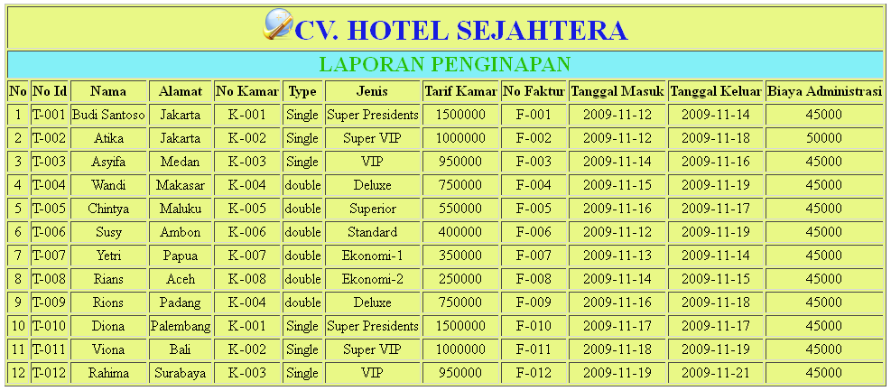

Tambahkan Kolom Diskon dengan ketentuan :
Jika Lama Inap >=4 hari maka disc = 3,5% dari tarif kamar

Koneksi
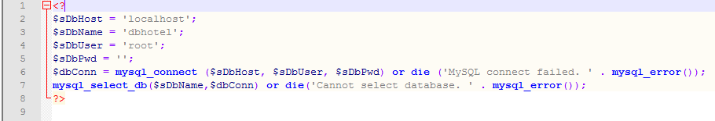

Koding
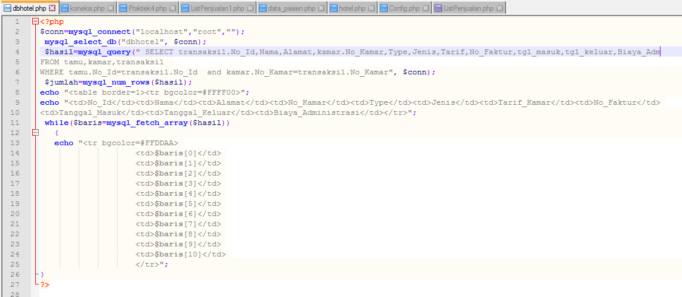

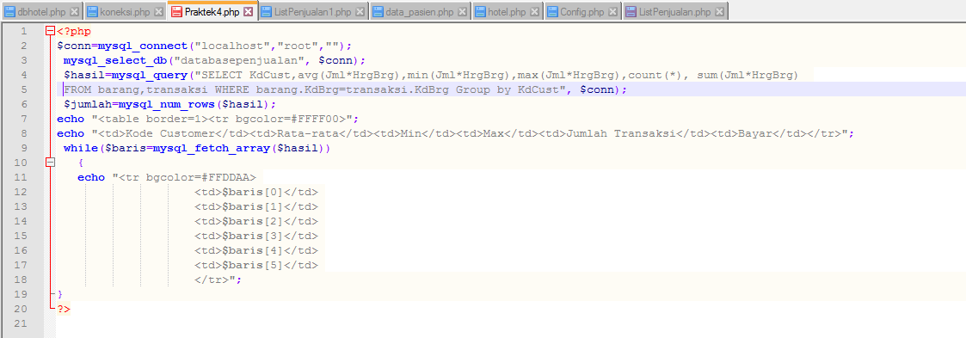
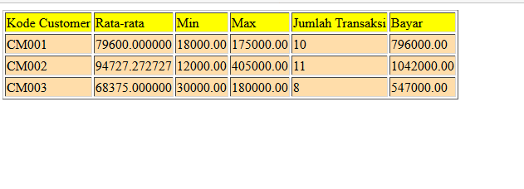
Rumus

SELECT [DISTICNT]{*,column[alias],..}
FROM table
[WHERE condition(s)];
---------------------------------------------------------------------------------------------------------------------------------------------------
1. select DISTINCT KdBrg, NmBrg
FROM Barang
---------------------------------------------------------------------------------------------------------------------------------------------------
2. select DISTINCT KdBrg
FROM Transaksi
---------------------------------------------------------------------------------------------------------------------------------------------------
3. SELECT NoFact , KdBrg , KdCust , Tgl, Jml
FROM Transaksi
WHERE Jml > 2
---------------------------------------------------------------------------------------------------------------------------------------------------
4. SELECT NoFact ,Barang.KdBrg , NmBrg, HrgBrg, KdCust , Tgl, Jml
FROM Transaksi, Barang
WHERE Barang.KdBrg=Transaksi.KdBrg and Jml > 2
---------------------------------------------------------------------------------------------------------------------------------------------------
5. SELECT NoFact as NomorFaktur ,Barang.KdBrg , NmBrg, Customer.KdCust , NmCust, Tgl date,Jml
FROM Transaksi, Barang, Customer
WHERE Barang.KdBrg=Transaksi.KdBrg and Customer.KdCust=Transaksi.KdCust and Jml > 2
---------------------------------------------------------------------------------------------------------------------------------------------------
6. SELECT NoFact as NomorFaktur ,Barang.KdBrg , NmBrg, HrgBrg, Customer.KdCust , NmCust, Tgl date,Jml
FROM Transaksi, Barang, Customer
WHERE Barang.KdBrg=Transaksi.KdBrg and Customer.KdCust=Transaksi.KdCust and Jml > 2

1. Tambahkan HargaBarang, Bayar=Jumlah x HargaBarang

SELECT NoFact as NomorFaktur ,Barang.KdBrg , NmBrg as NamaBarang, Customer.KdCust , NmCust, Tgl date,Jml, HrgBrg as HargaBarang, Jml*HrgBrg as Bayar
FROM Transaksi, Barang, Customer
WHERE Barang.KdBrg=Transaksi.KdBrg and Customer.KdCust=Transaksi.KdCust

2. Tambahkan HargaBarang, Bayar=Jumlah*HargaBarang, Diskon=5% dari Bayar, Bayar1=Bayar-diskon

SELECT NoFact as NomorFaktur ,Barang.KdBrg , NmBrg, Customer.KdCust , NmCust, Tgl date,Jml, HrgBrg as HargaBarang, Jml*HrgBrg as Bayar, (0.05*Jml*HrgBrg) as Diskon, (Jml*HrgBrg)-(0.05*Jml*HrgBrg) as BayarBersih
FROM Transaksi, Barang, Customer
WHERE Barang.KdBrg=Transaksi.KdBrg and Customer.KdCust=Transaksi.KdCust and Jml > 2

3. Tampilkan untuk Customer No 1 s.d 5 menggunakan BETWEEN

SELECT NoFact as NomorFaktur ,Barang.KdBrg , NmBrg, Customer.KdCust , NmCust, Tgl date,Jml, HrgBrg as HargaBarang, Jml*HrgBrg as Bayar, (0.05*Jml*HrgBrg) as Diskon, (Jml*HrgBrg)-(0.05*Jml*HrgBrg) as Bayar1
FROM Transaksi, Barang, Customer
WHERE Barang.KdBrg=Transaksi.KdBrg and Customer.KdCust=Transaksi.KdCust
and Customer.KdCust between 'CM001' and 'CM005'

4. Tampilkan untuk Customer No 1, 5 dan 10 menggunakan IN

SELECT NoFact as NomorFaktur ,Barang.KdBrg , NmBrg, Customer.KdCust , NmCust, Tgl date,Jml, HrgBrg as HargaBarang, Jml*HrgBrg as Bayar, (0.05*Jml*HrgBrg) as Diskon, (Jml*HrgBrg)-(0.05*Jml*HrgBrg) as Bayar1
FROM Transaksi, Barang, Customer
WHERE Barang.KdBrg=Transaksi.KdBrg and Customer.KdCust=Transaksi.KdCust
and Customer.KdCust IN ('CM001','CM005','CM0010')

5. Tampilkan untuk Nama Customer yang awalan huruf 'A' menggunakan LIKE

SELECT NoFact as NomorFaktur ,Barang.KdBrg , NmBrg, Customer.KdCust , NmCust, Tgl date,Jml, HrgBrg as HargaBarang, Jml*HrgBrg as Bayar, (0.05*Jml*HrgBrg) as Diskon, (Jml*HrgBrg)-(0.05*Jml*HrgBrg) as Bayar1
FROM Transaksi, Barang, Customer
WHERE Barang.KdBrg=Transaksi.KdBrg and Customer.KdCust=Transaksi.KdCust
and NmCust LIKE 'A%'

6. Tampilkan semua transaksi diurutkan berdasarkan Nama Customer

SELECT NoFact as NomorFaktur ,Barang.KdBrg , NmBrg, Customer.KdCust , NmCust, Tgl date,Jml, HrgBrg as HargaBarang, Jml*HrgBrg as Bayar, (0.05*Jml*HrgBrg) as Diskon, (Jml*HrgBrg)-(0.05*Jml*HrgBrg) as Bayar1
FROM Transaksi, Barang, Customer
WHERE Barang.KdBrg=Transaksi.KdBrg and Customer.KdCust=Transaksi.KdCust
ORDER BY NmCust

6. Tampilkan semua transaksi dikelompokan berdasarkan Nama Customer

SELECT NoFact as NomorFaktur ,Barang.KdBrg , NmBrg, Customer.KdCust , NmCust, Tgl date,Jml, HrgBrg as HargaBarang, Jml*HrgBrg as Bayar, (0.05*Jml*HrgBrg) as Diskon, (Jml*HrgBrg)-(0.05*Jml*HrgBrg) as Bayar1, count(*) as JmlTransaksi
FROM Transaksi, Barang, Customer
WHERE Barang.KdBrg=Transaksi.KdBrg and Customer.KdCust=Transaksi.KdCust
GROUP BY NmCust

