1. **Use Case**

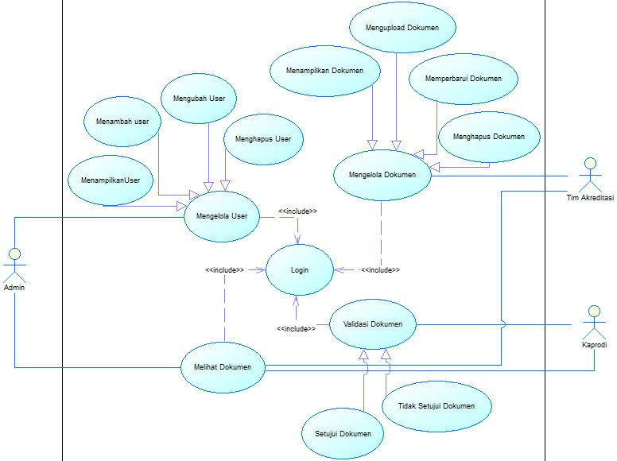

1. **Class Diagram**

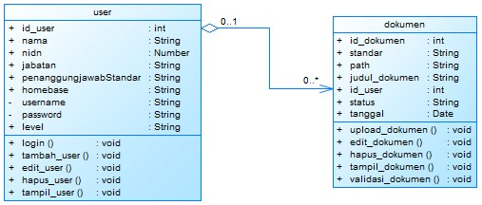

1. **Activity Diagram Mengelola User**

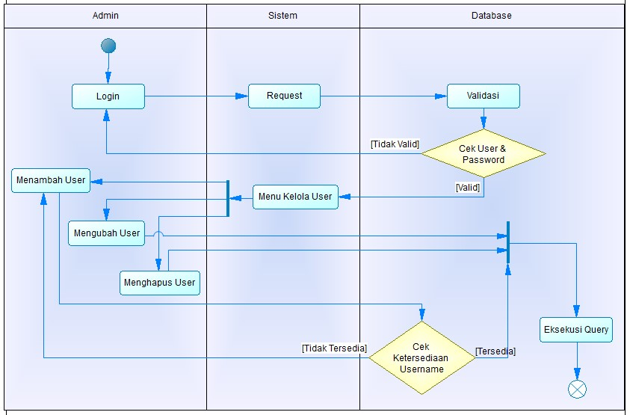

1. **Activity Diagram Mengelola Dokumen**

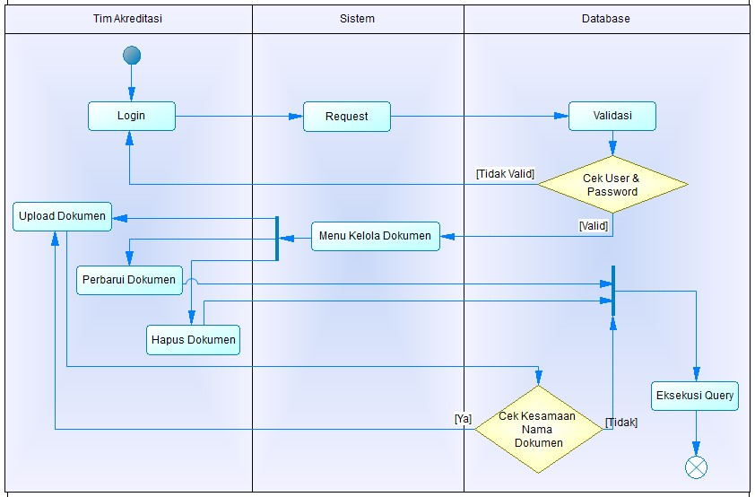

1. **Activity Diagram Validasi Dokumen**

Aktor Admin seharusnya Kaprodi pak, salah tulis.

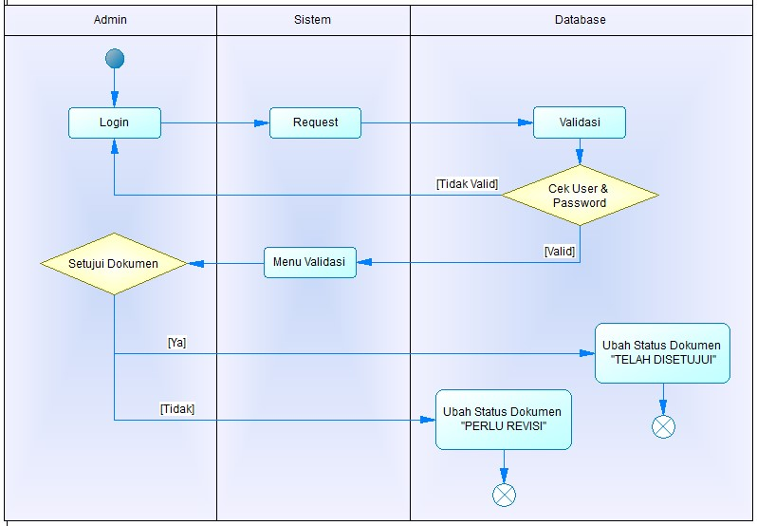

1. **Sequence Diagram Login**

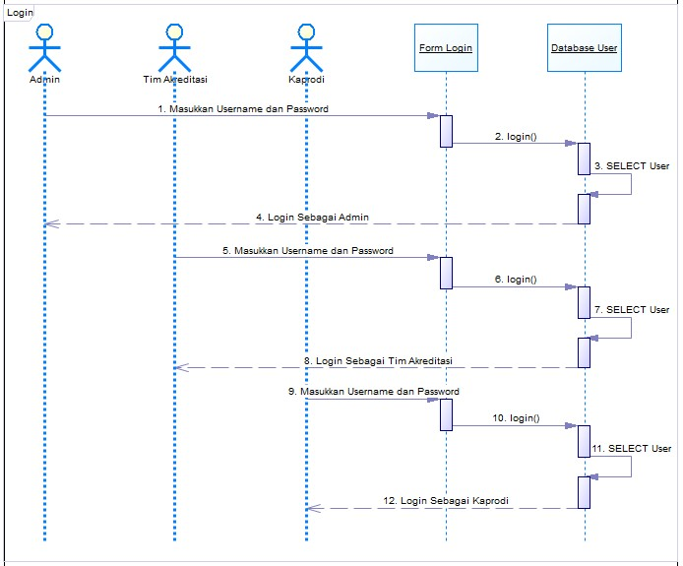

1. **Sequence Diagram Melihat Dokumen**

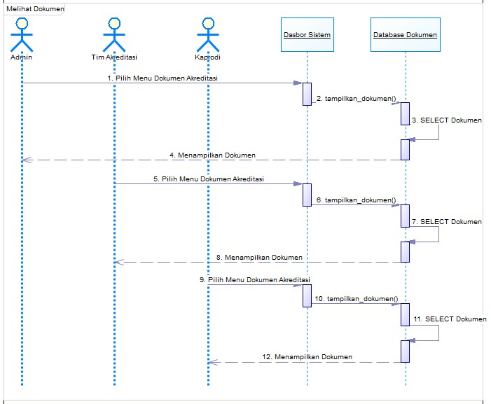

1. **Sequence Diagram Mengelola Dokumen**

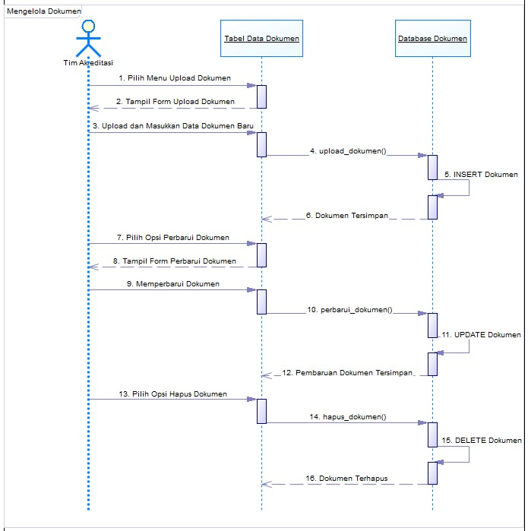

1. **Sequence Diagram Validasi Dokumen**

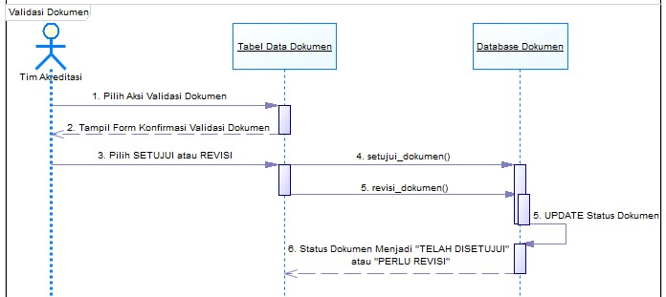

1. **Sequence Diagram Mengelola User**

