**MOBILE CHATBOT APPLICATION TO GIVING A RECOMMENDATION QUR’AN SURAH TO RECITE**

by

**Agung Ramadhan Putra**

**A Thesis**

*Submitted to the Faculty of Nanjing Xiaozhuang University*

*In Partial Fulfillment of the Requirements for the degree of*

**Bachelor of Software Engineering**



School of Information Engineering

Fangshan, Nanjing

May 2020

To:

This thesis, written by Agung Ramadhan Putra, and entitled Mobile Chatbot Application to Give a Recommendation Qur’an Surah to Read Based on Emotion, having been approved in respect to style and intellectual content, is referred to you for judgment.

We have read this thesis and recommend that it be approved.

_______________________________________

type the name of committee member here

_______________________________________

type the name of committee member here

_______________________________________

type the name of committee member here

Date of Defense: May …, 2020

The thesis of Agung Ramadhan Putra is approved.

_______________________________________

_______________________________________

XXXXXX

Chief of Foreign Affairs Office

Nanjing Xiaozhuang University, 2019

*Dedication*

*To my beloved family.*

**ACKNOWLEDGMENTS**

This page is optional.

To copy & paste your work on this page, please highlight this text and replace it.

If you are not including acknowledgements, delete this page.

If you are acknowledging only *one* person, change the title to ACKNOWLEDGMENT.

**TABLE OF** **CONTENTS**

LIST OF TABLES iii

LIST OF FIGURES iii

ABSTRACT iii

CHAPTER 1. INTRODUCTION 3

1.1 The Basics 3

1.2 Margins 3

1.3 Heading Styles 3

1.4 Inserting a Table of Contents 3

1.5 Notes 3

1.6 Page Numbers 3

1.7 Issues with Pagination 3

CHAPTER 2. REVIEW OF LITERATURE 3

2.1 Before You Submit 3

2.2 Inserting Internal Links (Bookmarks) 3

2.3 Sample Pages and Formatting Checklist 3

2.4 Landscape Page 3

CHAPTER 3. RESEARCH METHODOLOGY 3

CHAPTER 4. RESULTS 3

CHAPTER 5. SUMMARY, CONCLUSIONS, AND RECOMMENDATIONS 3

APPENDIX A. SURVEYS 3

APPENDIX B. FORMS 3

LIST OF REFERENCES 3

VITA 3

PUBLICATIONS 3

LIST OF TABLES

Table 2.1 Suggested Line Spacing 3

Table 2.2 Oversized Table 3

Please use correct table captioning throughout your document. Applying captions allow you to update the above list automatically. To update the list, right click on the list and choose ‘Update field’. As long as captions have been applied to each table, the caption will appear in the table.

**After updating this table, single space the table and add 12pt font between entries.**

If you use landscape pages, make sure the landscape page numbers match what is listed in your List of Tables.

LIST OF FIGURES

Figure 2.1 Styles Box 3

Figure 2.2 Purdue Fountains 3

Figure 2.3 Oversized Figures 3

Figure 2.4 Snowy Hovde Hall 1

Please use correct figure captioning throughout your document. Applying captions allow you to update the above list automatically. To update the list, right click on the list and choose ‘Update field’. As long as captions have been applied to each figure, the caption will appear in the table. **After updating this table, single space the table and add 12pt font between entries.**

If you use landscape pages, make sure the landscape page numbers match what is listed in your List of Figures.

**DECLARATION OF ORIGINALITY**

ABSTRACT

Author: LastName, FirstName, Middle Initial. MS

Institution: Nanjing Xiaozhuang University

Degree Received: Choose Graduation Term

Title: Type Your ThesisCapitalizing the First Letter of Major Words: Do Not Use All Caps. Be sure to indent subsequent lines of your title

Committee Chair: FirstName LastName

**REQUIRED SECTION**

Two different kinds of paragraph spacing will be used on this page. The first three lines, where your personal information is included, make up the introduction block or introduction paragraph. Use only single space and set Before/After space setting to zero (in Paragraph setting box).

In the main body of the abstract, use the same spacing you use throughout the rest of your document (either double spacing or 1.5 line spacing).

To copy & paste your work here, please highlight the paragraphs to replace the text.

Keep the section break below to allow Chapter 1 to start page 1.

# 

# INTRODUCTION

## The Basics

This template is best used with MS Office 2013 on a PC or MS Word 2016 on a Mac. It is suggested to turn on the Show/Hide tool (¶) that can be found on the Home ribbon so you can track you spacing and section breaks.

Review the Template Guide before you begin. Use it for troubleshooting. If you can’t find a solution there, try [Microsoft’s extensive help pages](http://office.microsoft.com/en-us/word-help/word-help-and-how-to-FX101818070.aspx).

## Margins

Margin requirements are 1” left, bottom, right, and top margins. 1.5” top margins are required on Title and Statement of Approval pages.

1.5” left margin is recommended by Boiler Copy Maker for screw & post bindings – if you wish to have a hard bound copy made. Hard bound copies are not required for submission to the Graduate School, we will work solely with the PDF copy you upload to ProQuest, requiring 1” left margins.

## Heading Styles

There are many heading styles that have been added to the Styles Ribbon. There are Purdue Headings 1-6 above. You will have to manually change the text back to normal style after you apply the heading. You will want to use these styles so you can generate a table of contents without any issues. If you open the navigation toolbar [Ctrl + F] and under the search document bar you choose “Headings” you will be able to easily track which headings will go in your table of contents.

If after you apply a Style to a heading and you receive **Error! Bookmark not defined** in your Table of Contents after updating the page number, go back to your heading

that is causing the issue and make sure there is still a style applied to it. You can update the entire table to resolve the issue – if you had previously formatted the Table of Contents, you may have to re-format.

## Inserting a Table of Contents

Right click on the existing table of contents and click “Update field”. As long as each heading and subheading has had a Style applied, the heading/subheading will appear in the Table of Contents.

Typically, inserting a table of contents, list of figures, and list of figures should be the last step in the formatting practice. If you’ve made changes to content that moves a heading to a different page number, all you’ll need to do is go back to your inserted table of contents, right click, select ‘Update Field’, and select “Update page numbers only”. This will make changes to your page numbers and won’t affect the headings.

## Notes

If you are planning to include List of Figures and List of Tables, we recommend you using the following method to insert your captions:

1. In Ribbon above, click References
2. In Captions section, click on Insert Caption
3. Next to Label, chose Table or Figure
4. Click OK
5. Type your caption next to the table/figure number.

To create a table of contents you will need to assign a heading style to each heading in your entire document then follow the steps below:

1. Locate your Table of Contents page above
2. In the Ribbon above, click References
3. In the Table of Contents section, click Table of Contents
4. Look past the built-in Table of Contents and select Insert Table of Contents
5. Under the General section in the Show Levels box, select the number of headings you want to show in the Table of contents – 3 levels are common, but it can incorporate all levels, if you wish.

## Page Numbers

Page numbers will go in the upper right hand corner of each portrait page. If you are using any landscape orientation pages, the page number will go in the lower right hand corner with vertical text (see page 11 for example). Page number font and font size needs to be the same as the main body text.

## Issues with Pagination

Occasionally, page numbers will overlap due to section breaks. To fix this issue, simply click on the page number and locate the Design ribbon at the top of the page. Click the drop down arrow on page number > Format page numbers > under the Page numbering section choose Continue from previous section.

# REVIEW OF LITERATURE

## Before You Submit

Before you convert to PDF, carefully review our Formatting Checklist, then double check the formatting of your entire document, page-by-page.

## Inserting Internal Links (Bookmarks)

If you would like to click on a title in the Table of Contents and it take you straight to that page (or figures/tables/equations), follow the steps below: (click on Publications in TOC for example)

1. In the table you’ve created, highlight the text you want to link
2. Click the Insert Ribbon
3. Click Bookmarks
4. Click on or create the appropriate bookmark in the list and click OK
5. Click OK again and your bookmark will be created.

You can use this option to create external hyperlinks as well using the Hyperlink option in the Insert Ribbon (Sample Thesis Pages above is an example of an external hyperlink).

## Sample Pages and Formatting Checklist

The sample pages and Formatting Checklist are available on our website.

**If only one table (or figure) is desired on one page, center the table (or figure) on the page.**

Table 2.1 Suggested Line Spacing Suggested Line Spacing Suggested Line Spacing Suggested Line Spacing

|  |  |
| --- | --- |
| **After Space Setting** | **Where to Use It** |
| **12** (equal to single line spacing) | After lowest level subheadings |
| **18** (equal to1.5 line spacing) | After higher level subheadings |
| **24** (equal to double spacing) | After figure captions or table captions |
| **36** (equal to 3 single spaced blank lines; equal to 1 inch) | After title page blocks, major headings and chapter headings |

**Do not work on TABLE OF CONTENTS, LIST OF FIGURES, or LIST OF TABLES until you finish the last page of your thesis and pagination.**

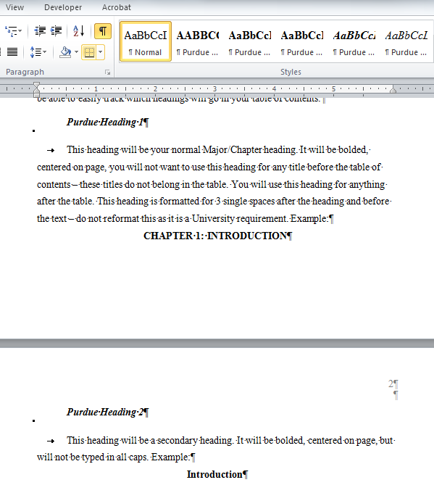

Figure 2.1 Styles Box

Table 2.2 Oversized Table

|  |  |  |  |
| --- | --- | --- | --- |
|  |  |  |  |
|  |  |  |  |
|  |  |  |  |
|  |  |  |  |
|  |  |  |  |
|  |  |  |  |
|  |  |  |  |
|  |  |  |  |
|  |  |  |  |
|  |  |  |  |
|  |  |  |  |
|  |  |  |  |
|  |  |  |  |
|  |  |  |  |
|  |  |  |  |
|  |  |  |  |
|  |  |  |  |
|  |  |  |  |
|  |  |  |  |
|  |  |  |  |
|  |  |  |  |
|  |  |  |  |
|  |  |  |  |
|  |  |  |  |
|  |  |  |  |
|  |  |  |  |
|  |  |  |  |
|  |  |  |  |
|  |  |  |  |
|  |  |  |  |
|  |  |  |  |
|  |  |  |  |
|  |  |  |  |
|  |  |  |  |
|  |  |  |  |
|  |  |  |  |
|  |  |  |  |
|  |  |  |  |
|  |  |  |  |
|  |  |  |  |
|  |  |  |  |
|  |  |  |  |
|  |  |  |  |

Table 2.2 continued

|  |  |  |  |
| --- | --- | --- | --- |
|  |  |  |  |
|  |  |  |  |
|  |  |  |  |
|  |  |  |  |
|  |  |  |  |
|  |  |  |  |
|  |  |  |  |
|  |  |  |  |
|  |  |  |  |
|  |  |  |  |
|  |  |  |  |
|  |  |  |  |
|  |  |  |  |
|  |  |  |  |
|  |  |  |  |
|  |  |  |  |
|  |  |  |  |
|  |  |  |  |
|  |  |  |  |
|  |  |  |  |
|  |  |  |  |

In order to add the table continuation above the table, you’ll need to split the table. You can achieve this by selecting the table, choose Layout ribbon, find the Merge section, and click Split Table. You will want to place the cursor on the line that you’d like to move to the next page before selecting Split Table.

OR

Add a new row above the table and merge the cells to form one cell above the table so you can type the continuation. This row should not have any borders outside of a bottom border to begin the continuation of the table.

Do you have a figure that goes on for 2 or more pages?

Add the caption to the first page and add Figure …. Continued above the figure on the next pages.

Example:

A)



B)

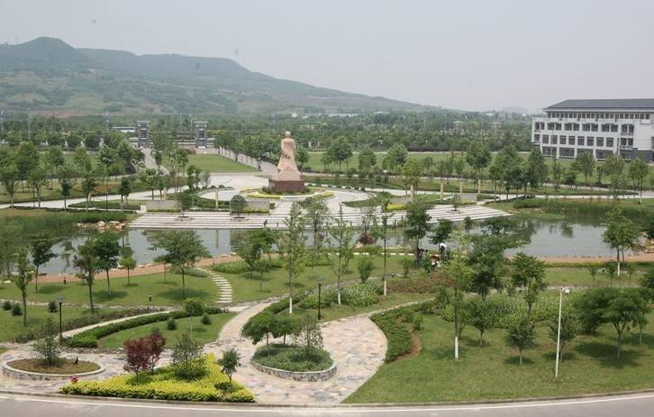

Figure 2.2 Xiaozhuang View

Figure 2.2 continued

C)

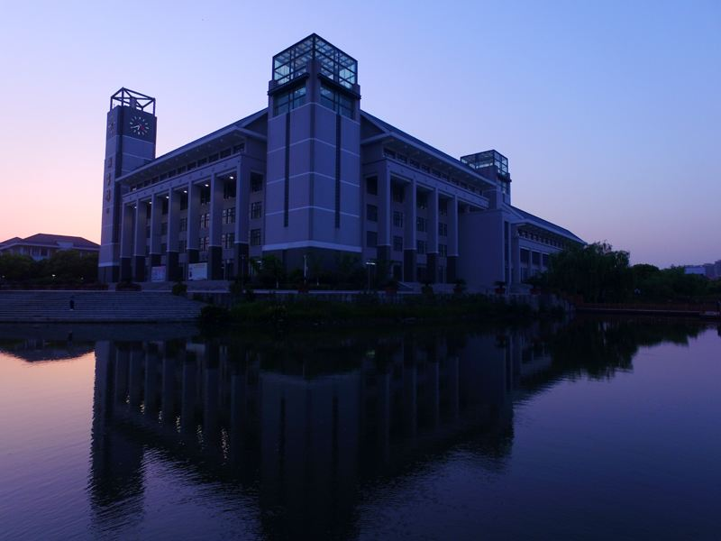

Do you have a figure or a table that is too large to add a caption to the same page as the figure or table?

Add the caption to the page before the figure or table. The caption should be centered on the page vertically.

Example:

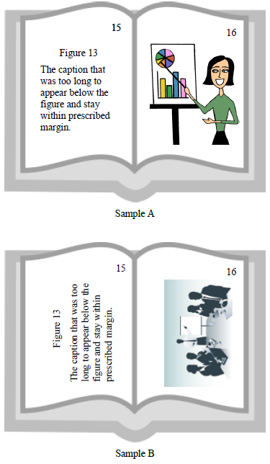

Figure 2.3 Oversized Figures

## Landscape Page

You may use landscaped pages for large tables or figures that normally will not fit within left and right margins. Note that page numbers will need to be added manually with a text box (that is in place in the bottom right hand corner). A normal page number will show up in the upper right hand corner when adding pagination. You will need to unlink this page and the next page’s pagination to previous in order to keep the pagination in the correct place. **Use the page number text box in the lower right corner of this page for additional landscape pages.**

To achieve adding a landscape page, you will need to add a Next Page section break on the previous page. You will also need to add a Next Page section break to the end of this page to convert back to a portriat orientation. It is beneficial to open the Show/Hide control on the Home Ribbon in the Paragraph section so you can see where all extra spacing is and where section and page breaks are.

Captions may be no smaller than size 10 font. Make every effort to allow the text to stay on same page as figure or table; if needed, the text may overflow to the next page. Oversized pages (11x14 or 11x17) may be used to accommodate larger tables.



22

Figure 2.4 Snowy Hovde Hall

# RESEARCH METHODOLOGY

REQUIRED SECTION

# RESULTS

REQUIRED SECTION

# SUMMARY, CONCLUSIONS, AND RECOMMENDATIONS

REQUIRED SECTION

APPENDIX A. SURVEYS

**OPTIONAL SECTION**

If you only have one appendix the title should read APPENDIX, do not include any other information in the title.

Use secondary headings for Appendix titles. You will need to manually type the heading in ALL CAPS, or you can highlight the text and use the Shift + F3 function and it will automatically change the text to ALL CAPS. These headings will be indented in your table of contents, but you will add APPENDICES to the table so they will be indented under a major heading. If you are only using one Appendix, list it as a level 1 heading and do not include APPENDICES in the table of contents.

APPENDIX B. FORMS

If you have large tables or figures to include we ask that you use landscape pages and place the Appendix Title above the figure/table.

LIST OF REFERENCES

Include reference entries here using the style preferred by your department.

References may either be a separate section (like shown in this template) or they may be listed after each chapter. If references are placed at the end of the chapters, they will need to begin on a new page.

References and Appendix placement may be changed to fit the needs of the author.

Examples:

(APA style in Alphabetical order)

Applewood, John (2015, December 17). How to Format a Thesis. Retrieved from [http://www.njxzc.edu.cn/](http://www.purdue.edu/gradschool/research/thesis/index.html)

Brownstone, Daniel (2015, January 24). Sample Thesis Pages. Retrieved from http://www.njxzc.edu.cn/

OR

[ABCM09] Michal Aharon, Gilad Barash, Ira Cohen, and Eli Mordechai. One graph is worth a thousand logs: Uncovering hidden structures in massive system event logs. In Machine Learning and Knowledge Discovery in Databases, pages 227–243. Springer, 2009.

[ABD+07] Naga Ayachitula, Melissa Buco, Yixin Diao, Surendra Maheswaran, Raju Pavuluri, Larisa Shwartz, and Chris Ward. It service management automation-a hybrid methodology to integrate and orchestrate collaborative human centric and automation centric workflows. In Services Computing, 2007. SCC 2007. IEEE International Conference on, pages 574–581.IEEE, 2007.

[AC06] Raman Adaikkalavan and Sharma Chakravarthy. Snoopib: Interval-based event specification and detection for active databases. Data & Knowledge Engineering, 59(1):139–165, 2006.

[AFGY02a] Jay Ayres, Jason Flannick, Johannes Gehrke, and Tomi Yiu. Sequential pattern mining using a bitmap representation. In Proceedings of the eighth ACM SIGKDD international conference on Knowledge discovery and data mining, pages 429–435. ACM, 2002

VITA

**OPTIONAL SECTION**

**We strongly recommend you not include any private data like your home address, email address, or phone number.**

If you are unsure about what to include in your vita, consult with your department and/or major professor. The vita can be written as a narrative or in curriculum vita (CV) form. Please keep vita format identical to the format used in thesis (margins, spacing, and text font).

PUBLICATIONS

**OPTIONAL SECTION**

This is where you can place a list of publication or alternately, you can include a PDF of a published article. This article may either be in color or black and white.

Steps to insert a PDF into a document without having to screenshot:

1. Select Insert ribbon.
2. Select Object in the Text section.
3. Choose the first Adobe Acrobat Document.
4. Locate your file and click Open (after saving each page of your PDF as a separate file).
5. Your file will open, close the file – it will automatically show up in your document and fit within the required margins.
6. Repeat this method for each page of your PDF.

If you have questions or need any guidance inserting a PDF into your document, contact our office.

All pages of publications need page numbers sequential to the number in the rest of your thesis. You may need to block out original page numbers to prevent confusion. You may use the landscape text box and rotate it to fit in the upper right hand corner of the page. You will need to ensure the page number is horizontal when using the text box.

If you have only *one* publication, list the title as PUBLICATION.