Phase 2 - CAB BOOKING APPLICATION

DOMAIN:
INTRANET Application - CAB BOOKING Application.

OBJECTIVE:
The objective of the project is to develop an CAB Booking application for the employee in the organization.

REQUIREMENTS:
- The are two types of people to access the application. One is the Cab admin, and all other employee are treated as User.
- The login UI page for both the people looks identical.
- The Employee can only book only the cab for the particular date and time depending on their shift timings.
- The cab admin should take care of the allocation of cab respectively for each employee.
- Notification about the journey has to be sent by the admin to the user as well as the cab driver end.
- The login should have session tokens and have an additional feature of fingerprint feature as that its not necessary that user need not to give login credentials every time.
- The application should ensure security, agility across every verticals.The quality analysis has to be done by providing appropriate loads on the application.

PROCESS FLOW:
- The process flow has flow between two people, one from the Cab admin and the other end is the user(all the employees of the organization).
- Initially admin has their login credentials for the application. They also have the details of the employee who are in need of cab facility.
- First the admin get logged into the portal and add the employee and corresponding details of them.
- Once a profile is created for an employee, their respective login credentials (user-name, password) gets generated and send to the respective user’s official mail-id. By getting the credentials they can access the application by login into it. They can even change the password if necessary.
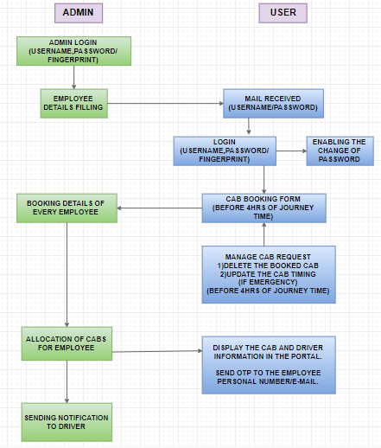

- An additional feature of fingerprint recognition has to be made for each user to ensure security premises.
- After that booking process has to be initiated by the user on a daily basis.
- They can even book cab for a week too but it should be ensured that each ride should be booked before a 4 hours of the journey time. After that time booking is not allowed.
- There is an additional feature known as manage cab request which allows you to delete the cab ride, update the ride timings but all these features will be enabled only before 4hours of the journey.
- All the bookings gets updated in the admin portal, he allocates the cab for each employee according to the business needs.
- After the confirmation of the allocation a notification has to sent to the driver end regarding the passenger details and user end regarding vehicle information and driver information in the portal as well as a personal message.

DESIGN:
The designing process includes high level and low level designing. The designing phase includes the Data model for the application to be designed. Designing of the wire frames as how the application looks like. Designing of Flowchart for the application.

APPLICATION ARCHITECTURE:
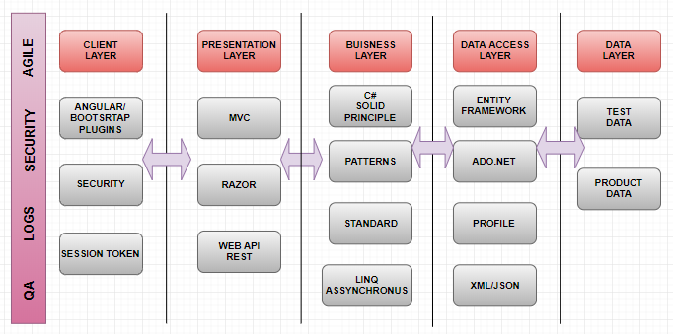

TESTING:
The test data is for Unit Testing and Integration Testing. Functionality, Compatibility, Performance, Database Integration, Security will be tested.

