Name: Adheep Shetty

CSULB ID : 018094724

Email id: AdheepVishwanath.Shetty@student.csulb.edu/

[adheepshetty@gmail.com](mailto:adheepshetty@gmail.com)

Screenshot of database created and dropped:

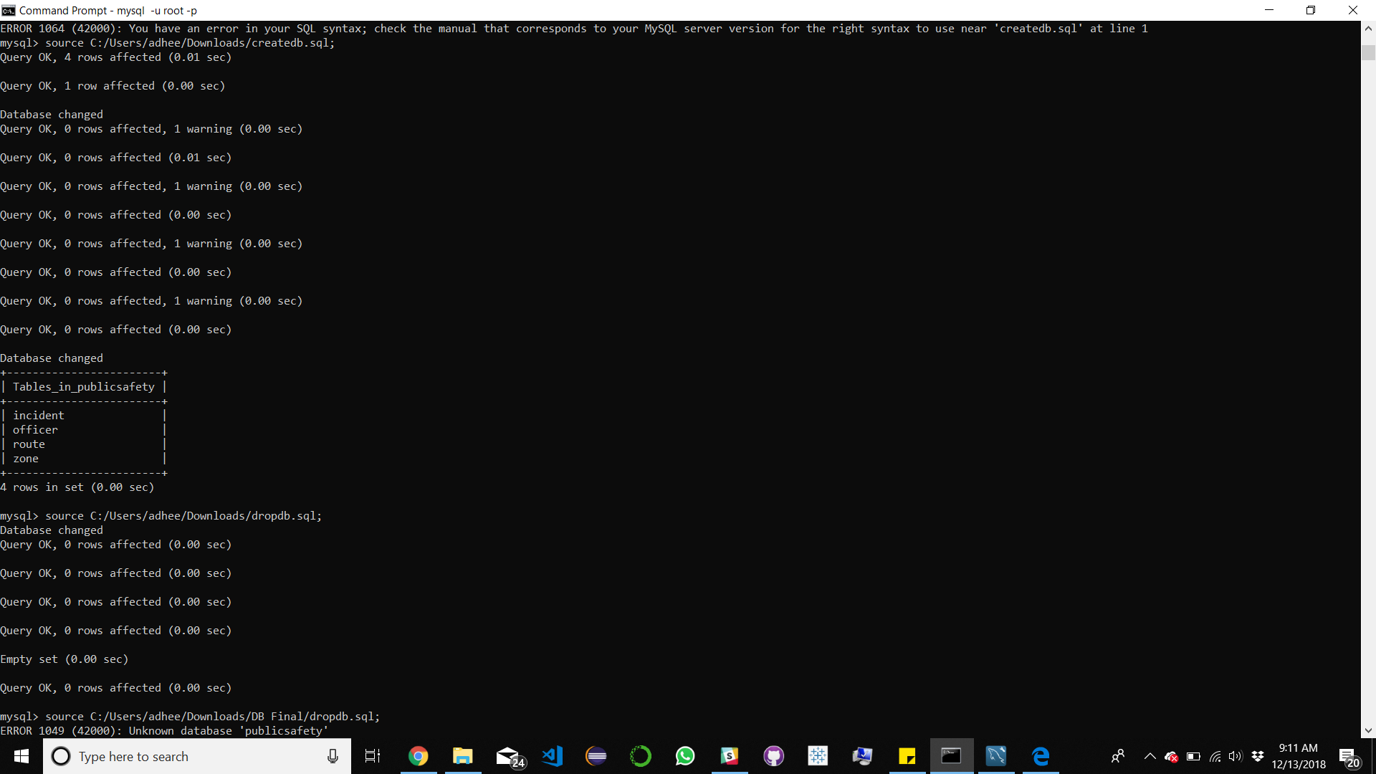

Screenshot of Populate.java’s source code:

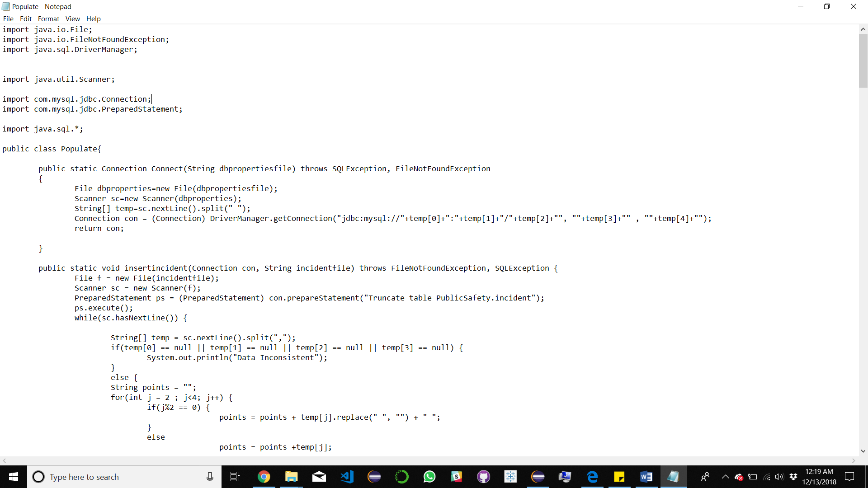

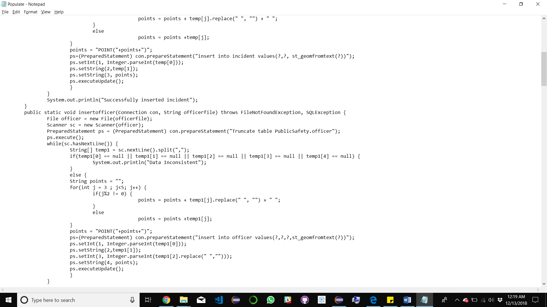

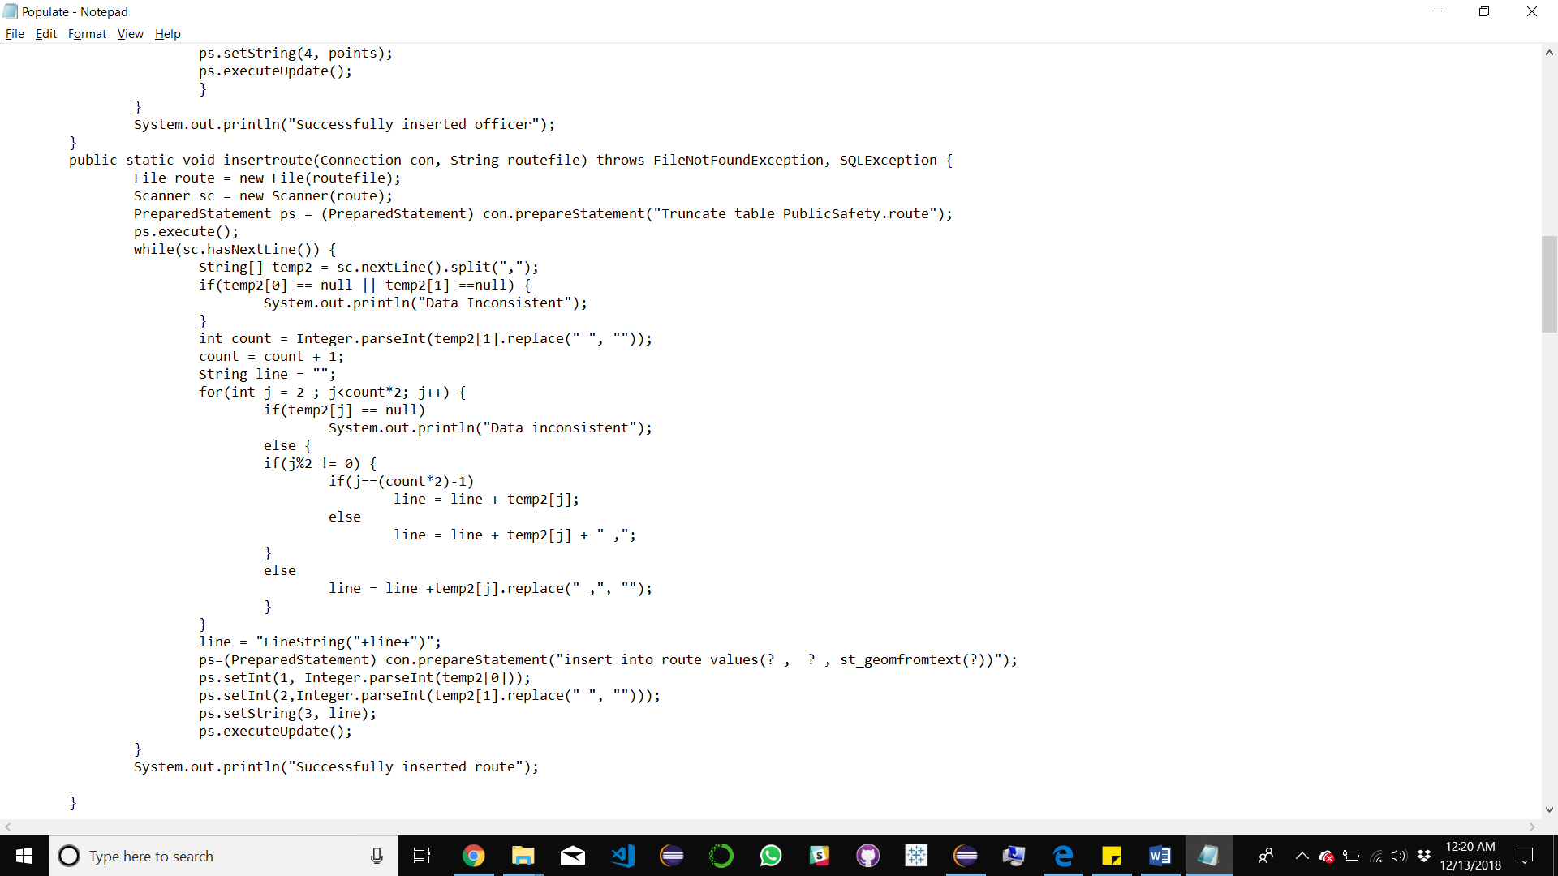

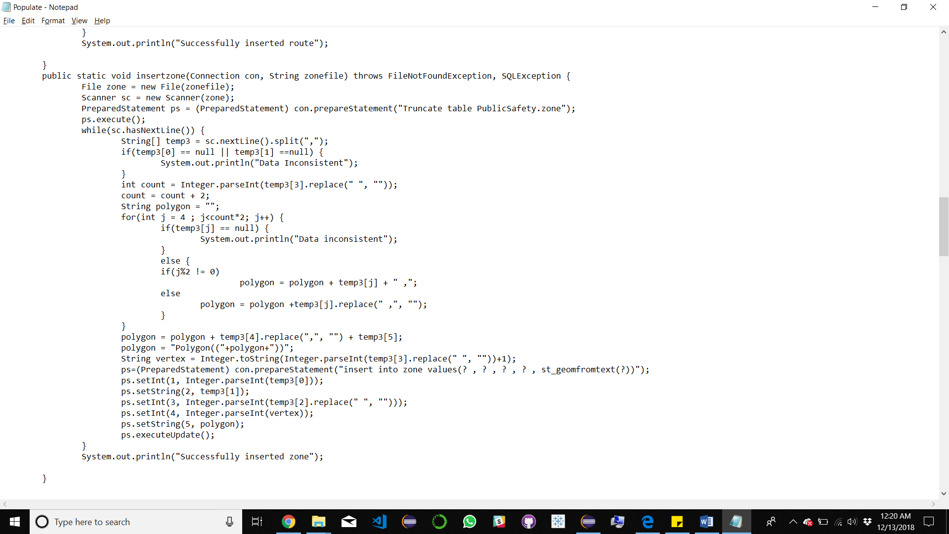

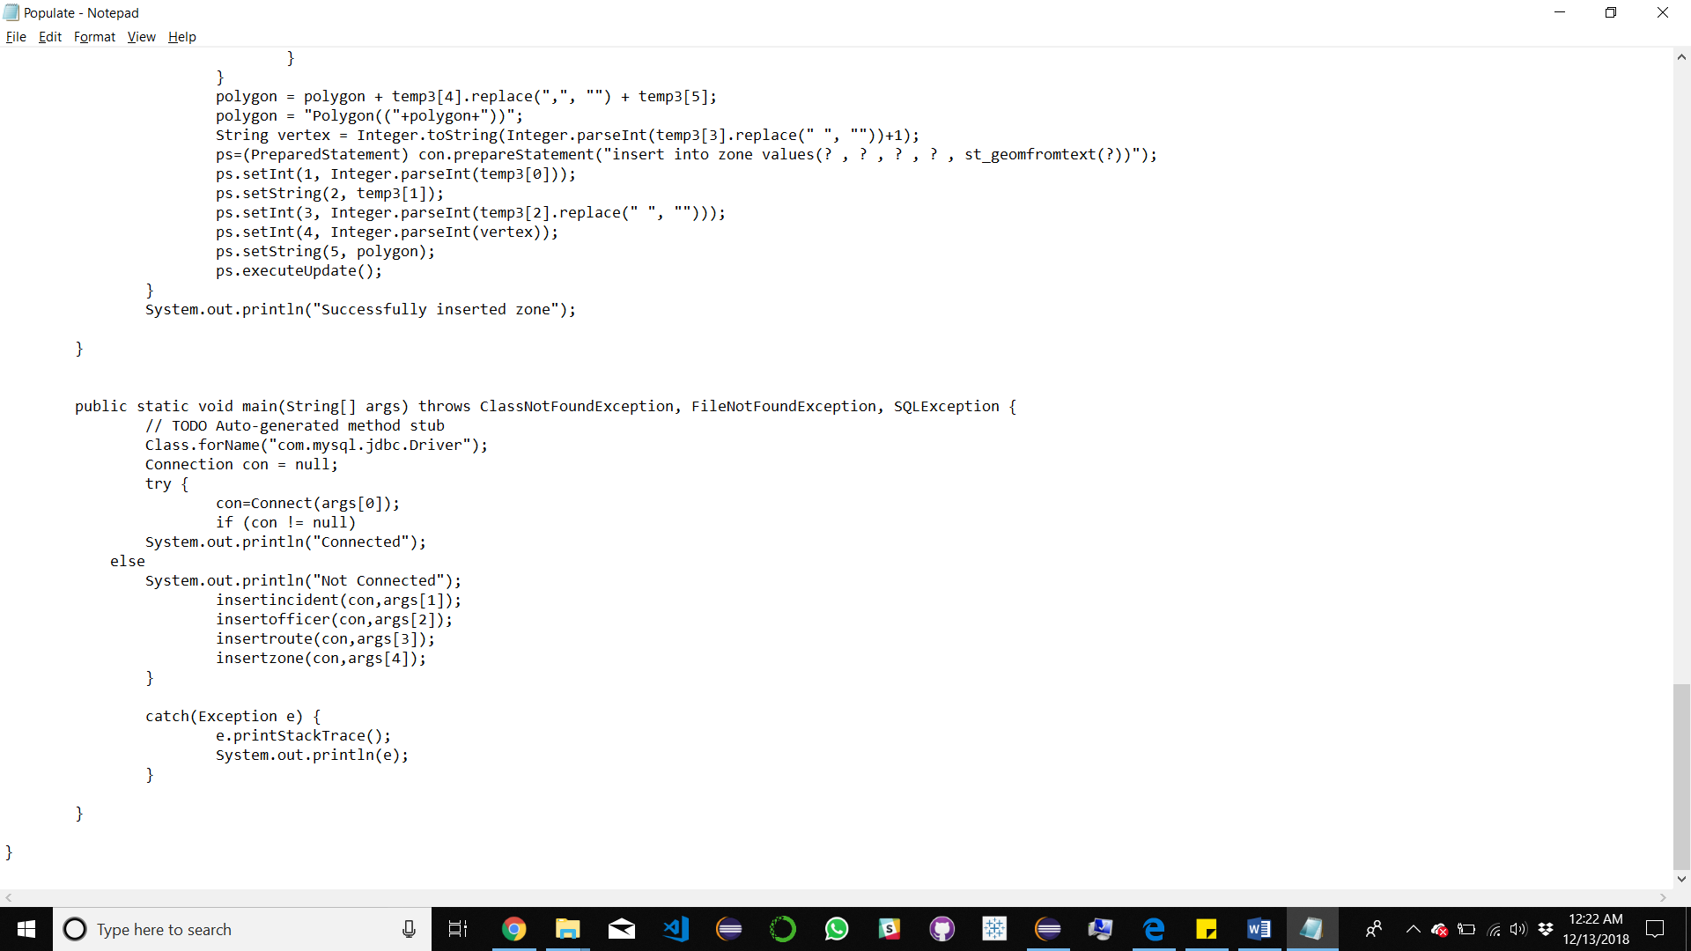

Screenshot of Hw.java’s source code:

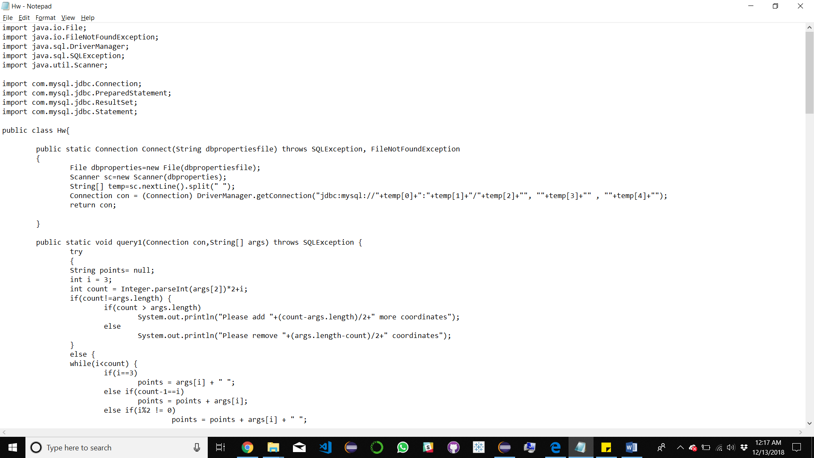

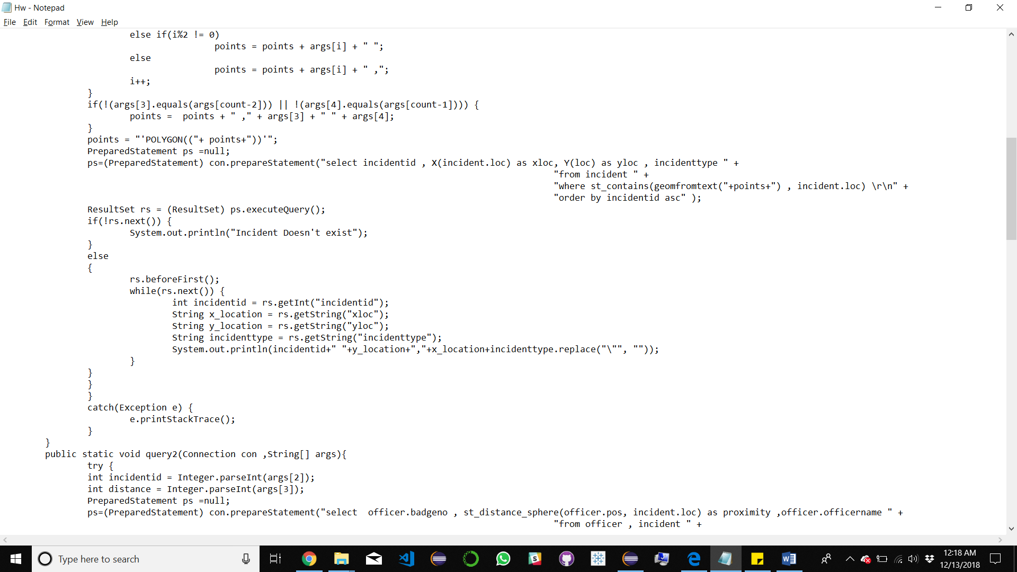

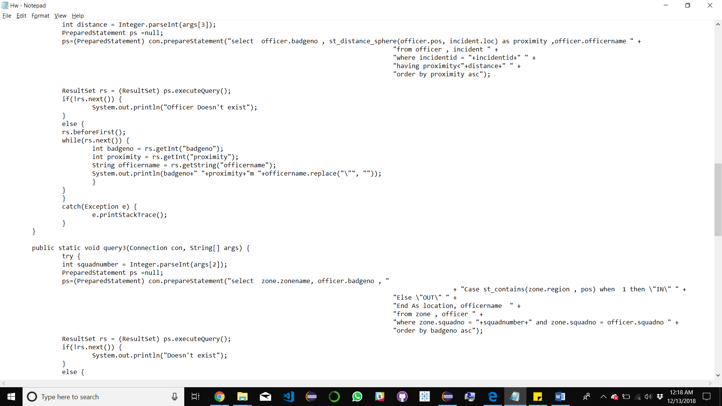

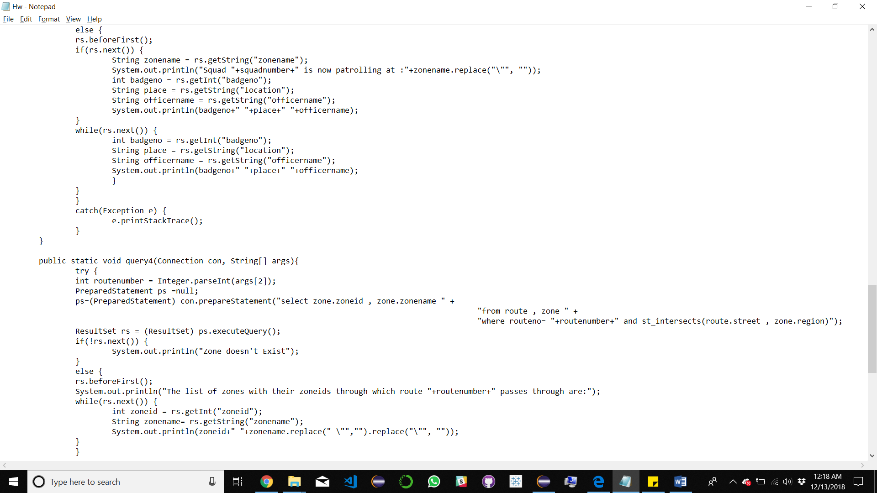

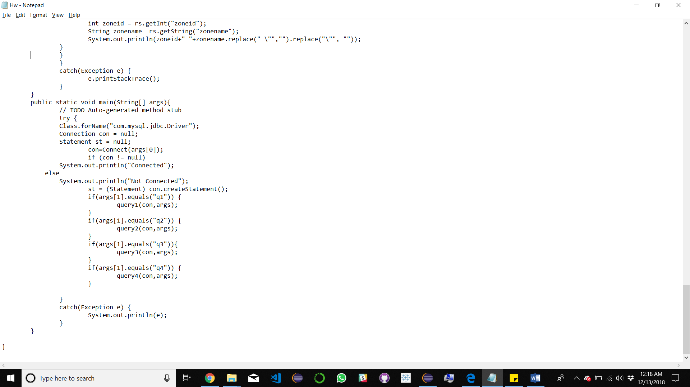

Screenshot of results after running Populate.java:

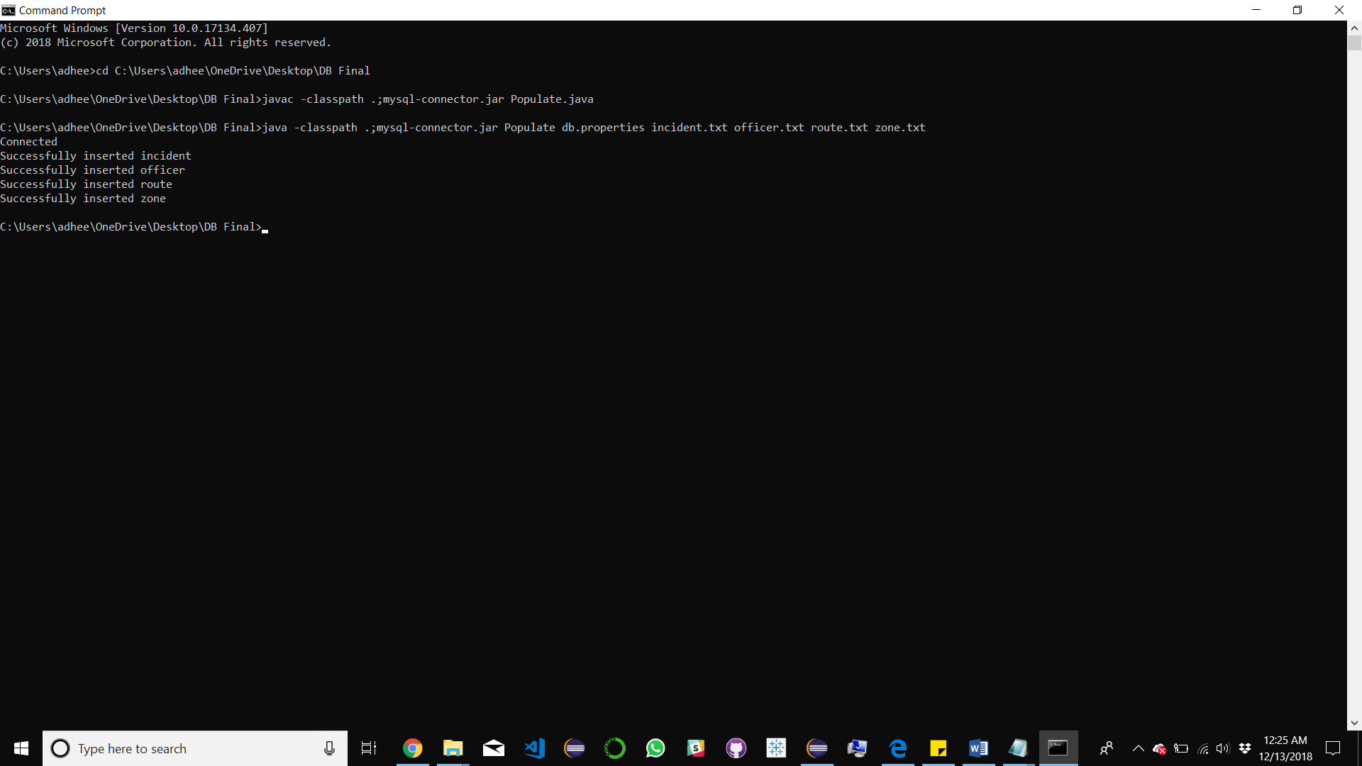

Screenshots of results after running Hw.java:

Result for query 1 for values given in plq1.bat file:

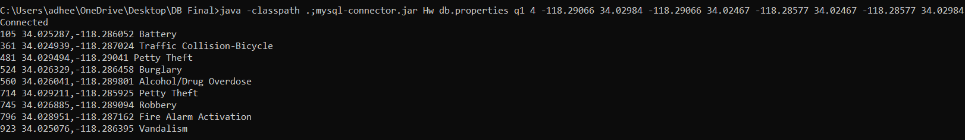

Result for query 2 for values given in plq2.bat file:

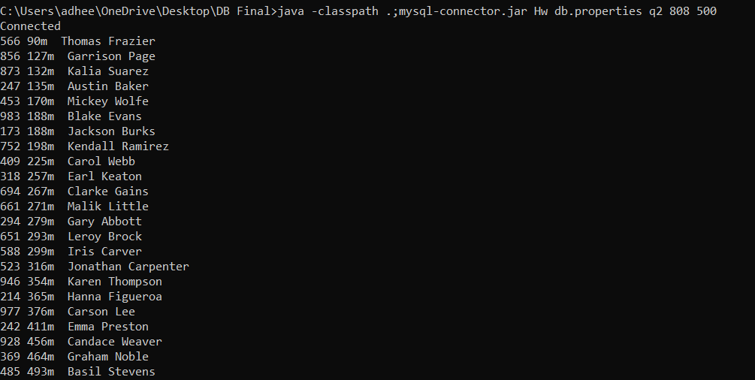

Result for query 3 for values given in plq3.bat file:

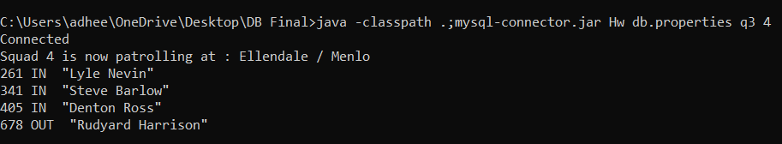

Result for query 4 for values given in plq4.bat file:

