Database : SQL Server 2012

- Tbl_Member

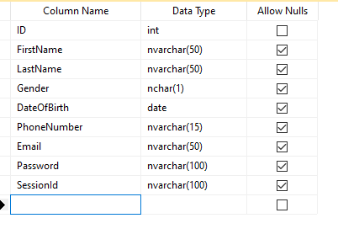

- Tbl_Product

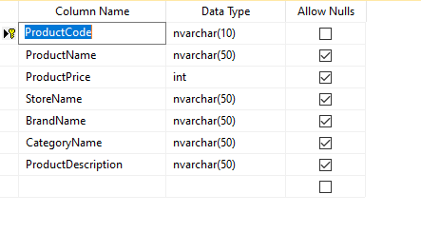

1. Get All Product Without Auth

-Method : Get

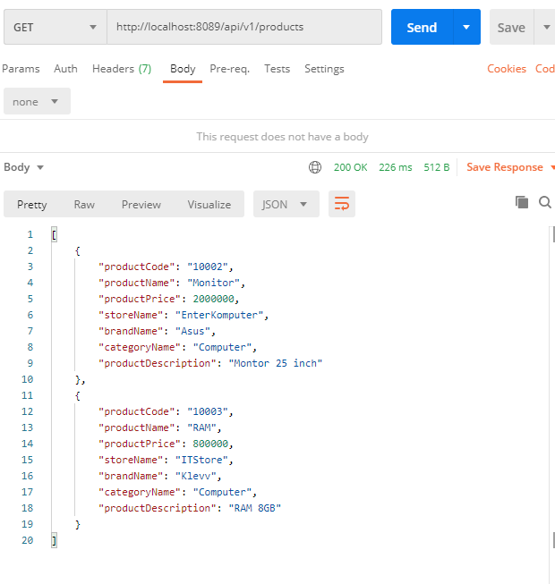

1. Register User With Auth

-Method : Post

-Password hashed

-Request :

|  |
| --- |
| {    "firstName": "Adhe Tiga",    "lastName": "Kushardianto",    "gender": "M",    "dateOfBirth": "19/05/1994",    "phoneNumber": "08273287282",    "email": "adhetiga@gmail.com",    "password": "123456"  } |

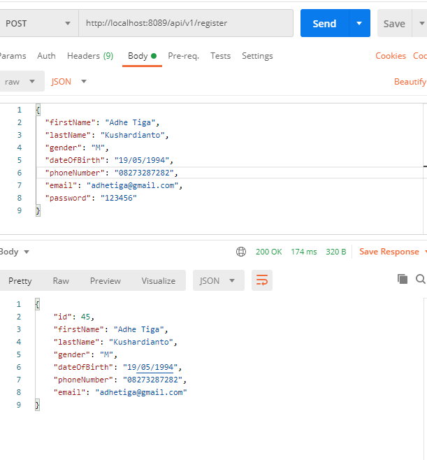

1. Login

- Method : Post

- Create authentication stored session into database Tbl_Member.

- Session encrypted.

- Request :

|  |
| --- |
| {    "phoneNumber": "082136464090",    "email": "",    "password": "123456"  } |

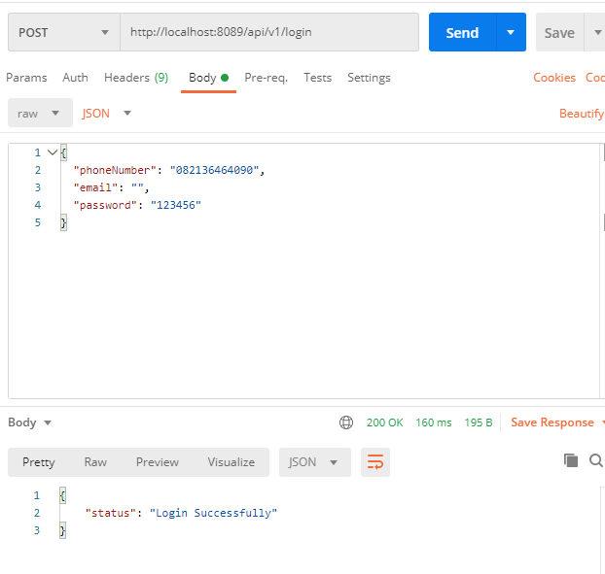

1. Get User Profile With Auth

- Method : Get

- Params : - id

- Value sessionId get from database

- Request :

|  |
| --- |
| {      "sessionId" : "a7Y1cEa8qXDmzFwBEySvaPCNHrKydxkXGldrT8dzLPM="  } |

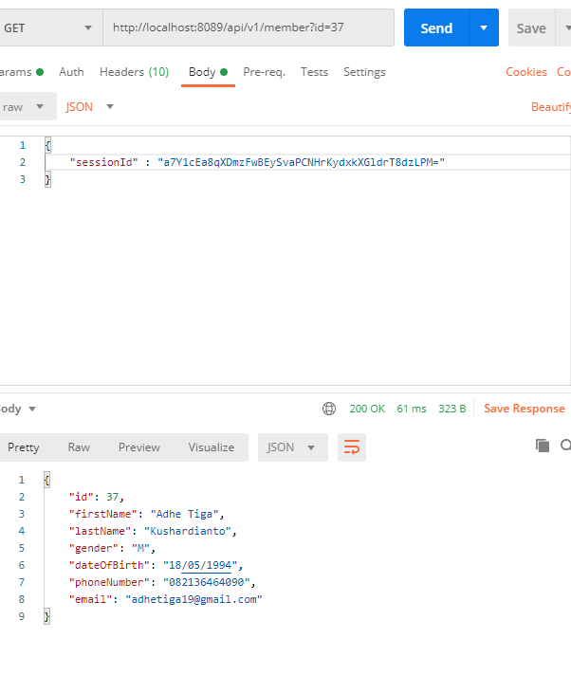

1. Update User Profile

- Value sessionId get from database

- Params : - id

- Value sessionId get from database

- Request :

|  |
| --- |
| {    "firstName": "Adhe Tiga",    "lastName": "Kushardianto",    "gender": "M",    "dateOfBirth": "19/05/1994",    "sessionId": "a7Y1cEa8qXDmzFwBEySvaPCNHrKydxkXGldrT8dzLPM="  } |

