Abstract – MDC Club Management System
The MDC Club Management System is a comprehensive web-based application developed to streamline and digitize the operational and communication workflows of the Marian Dance Club (MDC). The system is designed to support the needs of three distinct user roles: Admins, Faculty, and Students, each with tailored access and capabilities.
The platform enables students to register using their academic credentials, participate in club events, view announcements, track attendance, and place merchandise orders. Admins can manage announcements, attendance, events, and student participation through a dedicated admin dashboard. Faculty members are provided access to track student engagement and event involvement.
Built using PHP and MySQL within a responsive HTML/CSS frontend, the system ensures secure login through password hashing and robust session management. All operations are structured to satisfy First, Second, and Third Normal Forms (1NF, 2NF, 3NF), ensuring database efficiency and integrity.
Additional modules include a contact form for student queries, a media gallery for event highlights, and a merchandise management system. The system enhances communication, saves manual effort, and brings all MDC-related activities into a unified, interactive portal.
This project not only improves the digital presence of the Marian Dance Club but also serves as a scalable and secure solution for managing club operations efficiently.

SOFTWARE REQUIREMENT SPECIFICATIONS

3. SOFTWARE REQUIREMENT SPECIFICATION

3.1 INTRODUCTION
Software Requirement Specification (SRS) is a critical step in the development lifecycle of the MDC Club Management System. This document defines the system functionalities required by Marian College to manage its dance club operations effectively. It is aimed at establishing a mutual understanding between stakeholders (admins, faculty, and students) and the developers, ensuring the system meets all necessary expectations with clarity and precision.

3.2 PURPOSE
The purpose of this SRS is to define the scope, requirements, and structure of the MDC Club Management System. This web application provides a centralized platform for managing club activities such as student registration, event participation, attendance tracking, announcements, and merchandise orders. This SRS serves to:
- Ensure mutual understanding between developers, faculty in-charges, and student users.
- Form the basis for system validation and verification.
- Reduce development cost by clearly defining system behavior.
- Help stakeholders identify their needs with accuracy.

3.3 SCOPE
3.3.1 SYSTEM STATEMENT OF SCOPE
The MDC Club Management System is developed to streamline club operations at Marian College. It features a role-based login system (admin, student, faculty), event registration, announcement broadcasting, attendance marking, and a student support module. The system enhances communication and collaboration between students and coordinators while reducing manual effort.

3.4 TECHNICAL OVERVIEW
3.4.1 USER CHARACTERISTICS
There are three user types:
- Admins: Manage announcements, attendance, user profiles, event participation, and merchandise orders.
- Faculty: Track event involvement and attendance, view student participation.
- Students: Register and log in, view announcements, participate in events, and track orders and attendance.

3.5 FUNCTIONAL REQUIREMENTS
- User Authentication & Registration
  - Students register using name, roll number, email, department, phone, and password.
  - Users login using their credentials. Admins use a secure hashed password.
- Event Management
  - Admins can create and update events.
  - Students can view and register for events.
- Announcement Management
  - Admins can post announcements that students and faculty can view.
- Attendance Tracking
  - Admins mark attendance during events and maintain records.
- Student & Faculty Dashboards
  - Dashboards provide each user role with the tools relevant to their permissions.
- Contact Module
  - Students can submit queries via a contact form; admins view them in the dashboard.
- Media Gallery & Merchandise
  - Admins can upload event photos.
  - Students can view and order merchandise.

3.6 NON-FUNCTIONAL REQUIREMENTS
- Usability: Clean and responsive UI, accessible via desktop and mobile.
- Reliability: System remains stable during regular operations.
- Availability: Accessible on LAN or server-based deployment 24/7.
- Security: Passwords are hashed. Session-based access restricts page views.
- Performance: Fast response to user interactions; minimal loading time.
- Scalability: Easy to extend with new features or higher user volume.
- Maintainability: Modular code with clear documentation.

3.7 STATED REQUIREMENTS
3.7.1 GENERAL REQUIREMENTS
- Login:
  - Session-based login using roll number or admin email and password.
  - Redirect users to respective dashboards.
- Registration:
  - Students fill in personal and academic details.
- Admin Panel:
  - Manage announcements, attendance, student profiles, media gallery, and merchandise.
- Faculty Dashboard:
  - View event participation and attendance.
- Student Dashboard:
  - View announcements, participate in events, track attendance.
- Contact Page:
  - Query form that stores messages in the database.
- About Page:
  - Static page with club mission, team, and achievements.

3.7.2 INPUTS
- Registration: name, email, roll number, department, phone, password.
- Login: roll number/email, password.
- Event Participation: student ID, event ID.
- Admin Input: announcement, attendance, gallery uploads.

3.7.3 PROCESSING
- Validate credentials and roles on login.
- Store and fetch attendance/event data.
- Manage user roles through session control.
- Process merchandise and contact queries.

3.7.4 OUTPUTS
- Personalized dashboards with relevant data.
- Success/error messages for each action.
- List of announcements, events, and messages.
- Reports for admin: attendance and participation.

3.8 EXTERNAL INTERFACE REQUIREMENTS

3.8.1 USER INTERFACES
- Responsive, clean, and consistent layout using embedded CSS.
- Navigation bar and role-based dashboards.
- Forms with labeled fields and validation.
- Video or image backgrounds for UI enhancement.

3.8.2 HARDWARE INTERFACES
- Access via desktop, laptop, tablet, or smartphone.
- Minimum Specs:
  - Processor: Intel Pentium or better
  - RAM: 512MB or more
  - Disk: 100MB free space
  - Internet browser and keyboard input

3.8.3 SOFTWARE INTERFACES
- Operating System: Windows 11 / Linux (XAMPP)
- Web Server: Apache
- Database: MySQL
- Language: PHP (Server-side), HTML/CSS (Frontend)
- Tools: VS Code, phpMyAdmin, Web Browser

MDC Club Database – Table Structures

Table: users
Sl. No | Field Name | Data Type | Constraints | Description
1 | user_id | INT | PRIMARY KEY, AUTO_INCREMENT | Unique ID for each user
2 | email | VARCHAR(100) | NOT NULL, UNIQUE | User email
3 | password | VARCHAR(255) | NOT NULL | Hashed password
4 | role | ENUM('student','admin','faculty') | NOT NULL | User role

Table: student_profiles
Sl. No | Field Name | Data Type | Constraints | Description
1 | user_id | INT | PRIMARY KEY, FOREIGN KEY -> users(user_id) | Link to users table
2 | name | VARCHAR(100) | NOT NULL | Full name of student
3 | roll_number | VARCHAR(50) | UNIQUE, NOT NULL | Unique roll number
4 | department | VARCHAR(50) | NOT NULL | Student department
5 | phone | VARCHAR(15) | NOT NULL | Contact number

Table: faculty_profiles
Sl. No | Field Name | Data Type | Constraints | Description
1 | user_id | INT | PRIMARY KEY, FOREIGN KEY -> users(user_id) | Link to users table
2 | name | VARCHAR(100) | NOT NULL | Full name of faculty
3 | phone | VARCHAR(15) | NOT NULL | Contact number

Table: announcements
Sl. No | Field Name | Data Type | Constraints | Description
1 | id | INT | PRIMARY KEY, AUTO_INCREMENT | Announcement ID
2 | message | TEXT | NOT NULL | Announcement message
3 | posted_on | DATETIME | DEFAULT CURRENT_TIMESTAMP | Date and time posted

Table: attendance
Sl. No | Field Name | Data Type | Constraints | Description
1 | attendance_id | INT | PRIMARY KEY, AUTO_INCREMENT | Unique attendance record
2 | event_id | INT | FOREIGN KEY -> events(event_id) | Linked event
3 | user_id | INT | FOREIGN KEY -> users(user_id) | Linked user (student)
4 | status | ENUM('present','absent') | NOT NULL | Attendance status
5 | date | DATE | NOT NULL | Date of attendance

Table: contact_messages
Sl. No | Field Name | Data Type | Constraints | Description
1 | id | INT | PRIMARY KEY, AUTO_INCREMENT | Message ID
2 | name | VARCHAR(100) | NOT NULL | Name of sender
3 | email | VARCHAR(100) | NOT NULL | Contact email
4 | message | TEXT | NOT NULL | Message content
5 | submitted_at | DATETIME | DEFAULT CURRENT_TIMESTAMP | Submission time

Table: events
Sl. No | Field Name | Data Type | Constraints | Description
1 | event_id | INT | PRIMARY KEY, AUTO_INCREMENT | Event ID
2 | title | VARCHAR(100) | NOT NULL | Event title
3 | description | TEXT |  | Event description
4 | date | DATE | NOT NULL | Event date
5 | venue | VARCHAR(100) |  | Event venue
6 | max_participants | INT |  | Maximum participants

Table: event_participation
Sl. No | Field Name | Data Type | Constraints | Description
1 | participation_id | INT | PRIMARY KEY, AUTO_INCREMENT | Participation ID
2 | event_id | INT | FOREIGN KEY -> events(event_id) | Participated event
3 | user_id | INT | FOREIGN KEY -> users(user_id) | Student participant
4 | status | ENUM('pending','confirmed') | DEFAULT 'pending' | Participation status

Table: media_gallery
Sl. No | Field Name | Data Type | Constraints | Description
1 | id | INT | PRIMARY KEY, AUTO_INCREMENT | Media ID
2 | event_id | INT | FOREIGN KEY -> events(event_id) | Linked event
3 | file_url | VARCHAR(255) | NOT NULL | File path or URL
4 | uploaded_on | DATETIME | DEFAULT CURRENT_TIMESTAMP | Upload timestamp

Table: merchandise
Sl. No | Field Name | Data Type | Constraints | Description
1 | item_id | INT | PRIMARY KEY, AUTO_INCREMENT | Merchandise ID
2 | name | VARCHAR(100) | NOT NULL | Item name
3 | price | DECIMAL(10,2) | NOT NULL | Item price
4 | stock | INT | DEFAULT 0 | Available stock

Table: orders
Sl. No | Field Name | Data Type | Constraints | Description
1 | order_id | INT | PRIMARY KEY, AUTO_INCREMENT | Order ID
2 | user_id | INT | FOREIGN KEY -> users(user_id) | Buyer
3 | item_id | INT | FOREIGN KEY -> merchandise(item_id) | Purchased item
4 | quantity | INT | NOT NULL | Quantity ordered
5 | total_price | DECIMAL(10,2) |  | Total cost
6 | status | ENUM('pending','completed','cancelled') | DEFAULT 'pending' | Order status

Table: messages
Sl. No | Field Name | Data Type | Constraints | Description
1 | message_id | INT | PRIMARY KEY, AUTO_INCREMENT | Message ID
2 | sender_id | INT | FOREIGN KEY -> users(user_id) | Sender user ID
3 | receiver_role | ENUM('student','faculty','admin') | NOT NULL | Receiver role
4 | message | TEXT | NOT NULL | Message content
5 | sent_on | DATETIME | DEFAULT CURRENT_TIMESTAMP | Sent timestamp

UML diagram

Use cases
Student Registration
Use Case Id: | UC-001
Use Case Name: | Student Registration
Created by: | Adithyan H & Melbin Antony
Date Created:
Description: | Allows a student to register for a new MDC account using their personal and academic information.
Primary actor: | Student
Secondary actor: | None
Precondition: | Student is on the registration page.
Postcondition | Student account is created and stored securely in the database.
Main flow: | 1. Student navigates to the registration page.  2. Fills out name, roll number, department, phone, email, and password.  3. Clicks submit.  4. System validates and hashes the password.  5. System stores user details and redirects to login.  6. Use case ends.

Student Login
Use Case Id: | UC-002
Use Case Name: | Student Login
Created by: | Adithyan H & Melbin Antony
Date Created:
Description: | Allows registered students to log in using their roll number and password.
Primary actor: | Student
Secondary actor: | None
Precondition: | Student is registered and on the login page.
Postcondition | Student is authenticated and redirected to dashboard.
Main flow: | 1. Student enters roll number and password.  2. Clicks login.  3. System validates credentials and starts a session.  4. Redirects student to their dashboard.  5. Use case ends.

Admin Login
Use Case Id: | UC-003
Use Case Name: | Admin Login
Created by: | Adithyan H & Melbin Antony
Date Created:
Description: | Allows pre-registered admins to log in using their email and password.
Primary actor: | Admin
Secondary actor: | None
Precondition: | Admin accesses login form.
Postcondition | Admin is authenticated and redirected to admin dashboard.
Main flow: | 1. Admin enters email and password.  2. System checks credentials.  3. If valid, starts session and opens admin panel.  4. Use case ends.

Post Announcements
Use Case Id: | UC-004
Use Case Name: | Post Announcements
Created by: | Adithyan H & Melbin Antony
Date Created:
Description: | Enables admins to post announcements visible to students and faculty.
Primary actor: | Admin
Secondary actor: | None
Precondition: | Admin is logged in.
Postcondition | Announcement is stored and displayed to users.
Main flow: | 1. Admin navigates to Announcements section.  2. Enters message and submits form.  3. System saves message and updates view.  4. Use case ends.

Event Participation
Use Case Id: | UC-005
Use Case Name: | Event Participation
Created by: | Adithyan H & Melbin Antony
Date Created:
Description: | Allows students to register for club events.
Primary actor: | Student
Secondary actor: | None
Precondition: | Student is logged in.
Postcondition | Participation entry is created.
Main flow: | 1. Student views events.  2. Selects event and clicks register.  3. System stores registration.  4. Use case ends.

Mark Attendance
Use Case Id: | UC-006
Use Case Name: | Mark Attendance
Created by: | Adithyan H & Melbin Antony
Date Created:
Description: | Enables admin to mark attendance for participants.
Primary actor: | Admin
Secondary actor: | None
Precondition: | Admin is on attendance page.
Postcondition | Attendance record is saved.
Main flow: | 1. Admin selects event and students.  2. Marks as present/absent.  3. Clicks submit.  4. System updates attendance data.  5. Use case ends.

Submit Contact Message
Use Case Id: | UC-007
Use Case Name: | Submit Contact Message
Created by: | Adithyan H & Melbin Antony
Date Created:
Description: | Students send messages via contact form.
Primary actor: | Student
Secondary actor: | None
Precondition: | Student opens contact page.
Postcondition | Message is saved and visible to admin.
Main flow: | 1. Student fills in name, email, message.  2. Clicks send.  3. System stores message.  4. Use case ends.

Faculty Login
Use Case Id: | UC-008
Use Case Name: | Faculty Login
Created by: | Adithyan H & Melbin Antony
Date Created:
Description: | Faculty members log in using their email and password.
Primary actor: | Faculty
Secondary actor: | None
Precondition: | Faculty is registered and on login page.
Postcondition | Faculty is redirected to their dashboard.
Main flow: | 1. Faculty enters login credentials.  2. System authenticates user.  3. Redirects to faculty dashboard.  4. Use case ends.

Order Merchandise
Use Case Id: | UC-009
Use Case Name: | Order Merchandise
Created by: | Adithyan H & Melbin Antony
Date Created:
Description: | Students can order club merchandise online.
Primary actor: | Student
Secondary actor: | None
Precondition: | Student is logged in and views store.
Postcondition | Order is recorded in the system.
Main flow: | 1. Student selects item and quantity.  2. Clicks add to cart and checks out.  3. Order is saved to database.  4. Use case ends.

Use case diagram

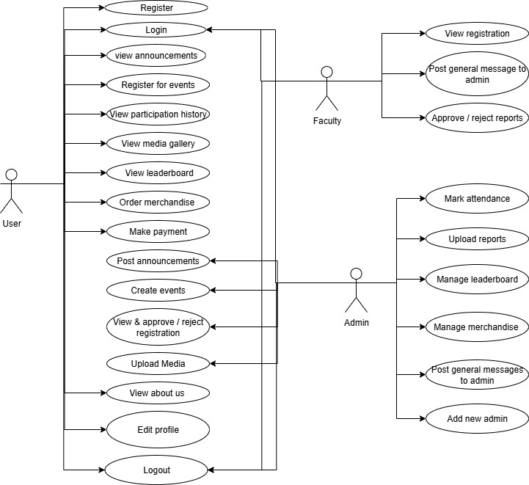

Activity diagram

Admin side:-
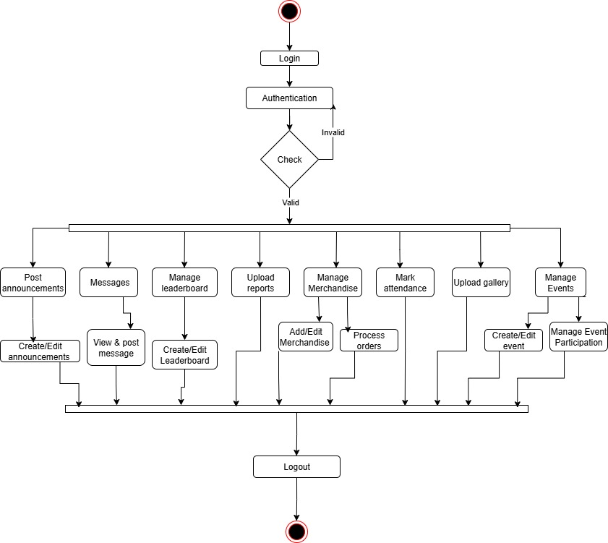

Faculty side:-
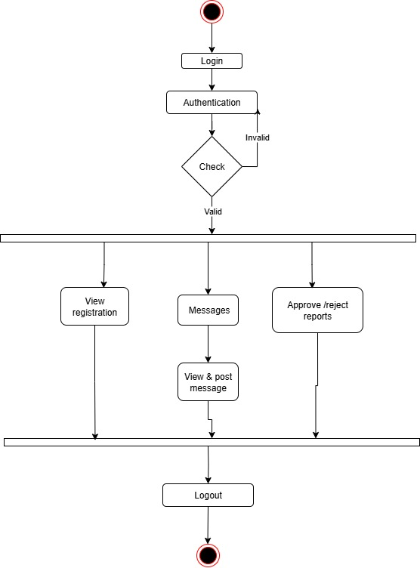

Student side:-
