Predicting Tax Refund or Tax Owed Outcomes
Using Financial Activity Patterns
Milestone 2 - Draft White Paper
Adhilingam Adiswaran
Bellevue University
DSC 680
September 27, 2026

Business Problem and Research Questions
Many taxpayers do not know until late in the year whether federal withholding and estimated payments are aligned with eventual tax liability. An early classification of refund versus tax owed could support withholding review, cash-flow planning, and financial education. This project is not intended to calculate an official return or provide tax advice; it evaluates whether common financial and tax-related indicators can classify the likely direction of the outcome. This restates the purpose established in Milestone 1, which proposed a privacy-preserving synthetic dataset rather than linked personal banking and tax records.
The study asks four questions: (RQ1) Which financial and tax-related variables are most strongly associated with refund versus tax owed? (RQ2) How accurately can supervised classification models predict the outcome? (RQ3) Does a nonlinear Random Forest materially improve predictive performance over interpretable Logistic Regression? (RQ4) Does performance differ across income ranges or filing-status groups? The initial hypotheses were that tax payments relative to estimated liability would be the strongest predictor, nonlinear models might improve performance, and subgroup error rates could differ.

Background and History
Federal income-tax withholding is the amount withheld from pay, and the IRS Tax Withholding Estimator compares estimated tax liability with withholding and estimated payments. The estimator calculates liability from filing status, income, adjustments, deductions, and credits, then determines an estimated refund or amount owed after accounting for taxes already paid and expected payments. This relationship makes withholding, estimated payments, and liability-related features natural predictors for this project (Internal Revenue Service [IRS], n.d.-a).
The IRS Statistics of Income (SOI) program publishes aggregate and sampled statistics covering income, adjusted gross income, deductions, credits, tax, and payments. These sources provide credible ranges and relationships for designing synthetic profiles without claiming access to confidential taxpayer records (IRS, n.d.-b; IRS, 2024). Synthetic data are especially appropriate here because real linked banking and tax-return outcomes are sensitive and difficult to obtain ethically for a classroom project.

Data Explanation and Preparation
The analysis uses 5,000 synthetic individual records generated with a fixed random seed. The distributions were designed to resemble plausible U.S. taxpayer profiles and to reflect the variables proposed in Milestone 1: wages, other income, adjusted gross income (AGI), filing status, dependents, deductions, credits, federal withholding, estimated payments, annual expenses, savings behavior, and income consistency. The binary target, tax_outcome, is Refund or Tax Owed. The generated dataset contains no names, Social Security numbers, account numbers, addresses, or actual transactions.
Reproducible preparation in the attached notebook includes range checks, construction of the target, and feature engineering. Ratios include withholding-to-income, estimated-payment-to-income, income-to-expense, and total tax payments relative to estimated liability. Filing status is one-hot encoded; continuous variables are standardized within the modeling pipeline. The generated data contain no missing values or duplicate identifiers by design, but the notebook preserves explicit quality checks so the workflow can be adapted to external data. Direct outcome fields such as a final refund amount or final balance due are excluded to reduce target leakage.

Brief Data Dictionary
Field | Meaning
adjusted_gross_income | Synthetic annual AGI in U.S. dollars
filing_status | Single, Married Filing Jointly, or Head of Household
federal_withholding | Estimated federal income tax withheld
estimated_tax_payments | Synthetic estimated tax payments
estimated_tax_liability | Simplified synthetic estimate used for the experiment
tax_payments_to_liability | (Withholding + estimated payments) / estimated liability
savings_rate | Share of AGI remaining after modeled expenses
tax_outcome | Binary target: Refund or Tax Owed

Methods
Three supervised classifiers were compared. Logistic Regression serves as the interpretable baseline because its coefficients can describe directional associations after preprocessing. A Decision Tree was included because it can represent nonlinear thresholds as readable rules. Random Forest was selected as the primary ensemble alternative because it can model nonlinear interactions while reducing the variance of a single tree. Gradient boosting was considered but deferred to keep the draft focused on the three methods proposed in Milestone 1.
The data were split into 75% training and 25% held-out testing sets using stratification. Model selection was supported by five-fold stratified cross-validation on the training data. Evaluation included accuracy, precision, recall, F1, ROC-AUC, and confusion matrices. ROC-AUC was emphasized for discrimination, while recall and the confusion matrix were used to examine error types. Permutation importance was used to interpret Random Forest predictions. Performance was also disaggregated by income range and filing status to assess generalization and potential fairness concerns.

Analysis and Results
The synthetic sample was imbalanced: 79.3% of records were labeled Refund and 20.7% Tax Owed. Logistic Regression achieved 87.8% test accuracy, 0.921 F1, and 0.945 ROC-AUC. The Decision Tree achieved 85.2% accuracy, 0.901 F1, and 0.929 ROC-AUC. Random Forest achieved the highest accuracy at 90.2% and the highest F1 at 0.938, while its ROC-AUC was 0.940. Five-fold mean ROC-AUC values were 0.942 for Logistic Regression, 0.918 for the Decision Tree, and 0.936 for Random Forest. Thus, Random Forest improved classification accuracy and F1, but it did not outperform Logistic Regression on ROC-AUC. H2 is therefore only partially supported: nonlinear modeling improved some metrics, but the simpler baseline remained highly competitive.
Model | Accuracy | Precision | Recall | F1 | ROC-AUC
Logistic Regression | 0.878 | 0.954 | 0.890 | 0.921 | 0.945
Decision Tree | 0.852 | 0.958 | 0.851 | 0.901 | 0.929
Random Forest | 0.902 | 0.944 | 0.931 | 0.938 | 0.940
For Random Forest, the held-out confusion matrix contained 204 correctly identified Tax Owed records, 923 correctly identified Refund records, 55 Tax Owed records incorrectly classified as Refund, and 68 Refund records incorrectly classified as Tax Owed. Permutation importance identified tax_payments_to_liability as the dominant predictor, followed by withholding_to_income and federal_withholding. This supports H1 and answers RQ1: the relationship between taxes already paid and estimated liability carries the most predictive information in this synthetic design.
Subgroup results answer RQ4 by showing meaningful variation. Random Forest accuracy ranged from 84.1% for the $100,000-$200,000 group to 92.8% below $50,000. Filing-status accuracy ranged from 87.3% for Single to 93.2% for Head of Household. The $200,000+ test subgroup contained only 56 records and no correctly recalled Refund cases, making that estimate unstable and demonstrating why subgroup sample size must accompany fairness metrics. H3 is supported in the limited sense that errors were not evenly distributed, but the synthetic data do not justify population-level fairness conclusions.

Conclusion
The research questions can be answered within the limits of the synthetic experiment. Common financial and tax-related indicators can classify refund-versus-owed status with strong discrimination in the generated data, and payment-to-liability relationships are the strongest predictors. Random Forest produced the best accuracy and F1, but Logistic Regression produced slightly higher ROC-AUC and remains attractive when interpretability is important. The most important domain takeaway is that an educational early-warning model is technically feasible, but it should be treated as a screening signal rather than an official tax determination.

Assumptions, Limitations, and Challenges
Assumptions include a simplified tax-year environment, plausible but synthetic distributions, and the availability of year-to-date financial summaries before the final filing outcome. The largest limitation is external validity: results on synthetic profiles cannot establish performance for real taxpayers. The simplified liability logic omits many tax-code provisions, and subgroup counts are uneven. Because tax law changes, a model calibrated for one tax year should not be assumed valid for another without review.
The principal challenges were balancing realism with privacy, avoiding target leakage, handling class imbalance, and comparing accuracy with interpretability. These were addressed by calibrating variable concepts to IRS sources, excluding final balance/refund fields, using stratified splitting and class-weighted models, reporting multiple metrics, and comparing an interpretable baseline with nonlinear models. The high importance of the payment-to-liability ratio is expected and useful, but it also requires caution because the synthetic target is constructed from related tax-payment logic.

Future Uses, Recommendations, and Implementation Plan
Future work could incorporate tax-year-specific rules, more realistic monthly cash-flow sequences, calibrated synthetic generation from additional SOI tables, probability calibration, gradient boosting, and validation on a legally obtained de-identified dataset. A reusable version could become a financial-education dashboard that shows a probability band and the factors driving the estimate rather than a definitive prediction.
For a domain audience, the recommendation is to use the model only as an educational screening tool that prompts users to review withholding when the predicted probability of owing tax is elevated. Implementation should begin with a controlled pilot: generate or ingest permitted inputs, run automated data-quality checks, score with both Logistic Regression and Random Forest, display uncertainty and explanations, test subgroup metrics, and route users to official IRS tools or a qualified tax professional for decisions. Before any production use, the organization should establish model governance, annual tax-rule review, privacy controls, monitoring thresholds, and human review of high-risk or ambiguous cases.

Ethical Assessment
Identify. The primary concerns are privacy of financial/tax information, subgroup bias, synthetic-data validity, target leakage or misleading transformations, overinterpretation of feature importance, and misuse of predictions as tax advice. Data credibility is also an ethical issue: the project uses synthetic records and publicly documented IRS concepts rather than presenting simulated records as observed taxpayers. NIST identifies validity and reliability, transparency, explainability, privacy enhancement, and fairness with harmful bias managed as characteristics of trustworthy AI (Tabassi, 2023).
Assess. Privacy likelihood is low in this draft because no real personal records are used, but impact would be severe if identifiable financial data were introduced. Bias likelihood is medium because subgroup performance already varies; impact could be moderate to high if predictions shaped financial decisions. Synthetic-data mismatch is medium likelihood with potentially high impact on generalization. Misuse as tax advice is medium-to-high likelihood if the interface is poorly labeled. Transformation risk is medium because engineered ratios can amplify modeling relationships or be mistaken for causal drivers.
Mitigate. The project excludes direct identifiers and final refund/balance fields, labels all records as synthetic, documents transformations, uses fixed-seed reproducible code, reports multiple validation metrics, disaggregates subgroup results, and distinguishes association from causation. Any production extension should apply data minimization, access controls, retention limits, model documentation, annual tax-rule validation, and clear user-facing disclaimers. IRS guidance should remain the authoritative source for withholding decisions. The dataset was generated for this project using public IRS statistical concepts and was not acquired from private individuals, reducing acquisition and consent risks.

Code and Reproducibility
The attached Jupyter notebook, DSC680_Tax_Outcome_Prediction_Notebook.ipynb, contains the synthetic data generation, data preparation, feature engineering, model training, cross-validation, evaluation, subgroup analysis, and figure generation used for this paper. The workflow uses a fixed random seed and can be rerun with Python, pandas, NumPy, Matplotlib, and scikit-learn. A GitHub URL was not supplied, so the notebook is attached as the reproducibility artifact.

Illustrations
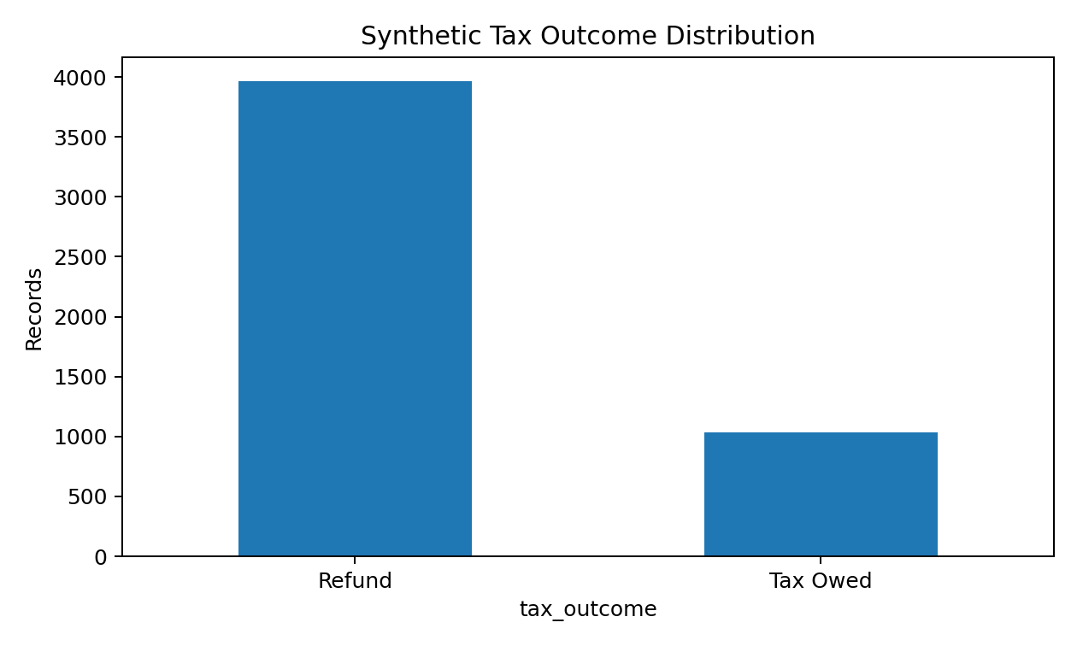
Figure 1. Distribution of synthetic refund and tax-owed outcomes.
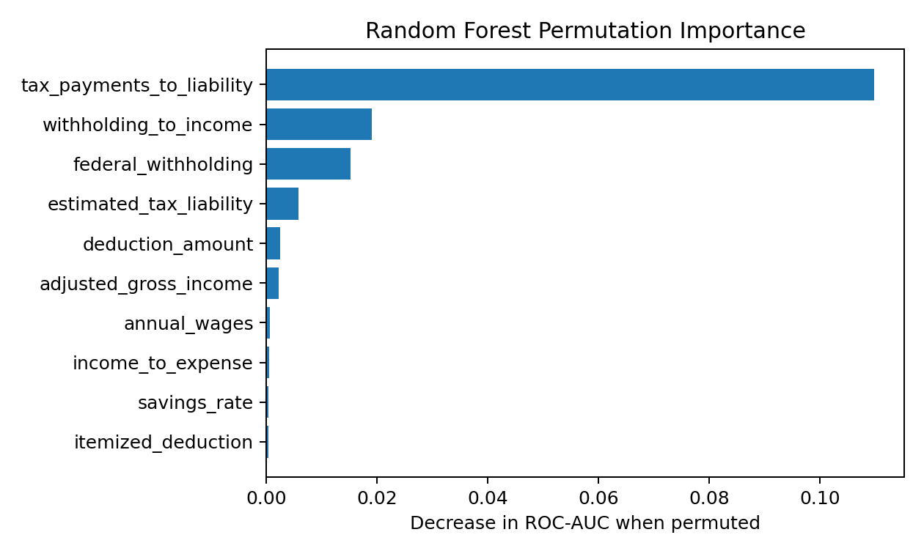
Figure 2. Random Forest permutation importance; payment-to-liability dominates the model.

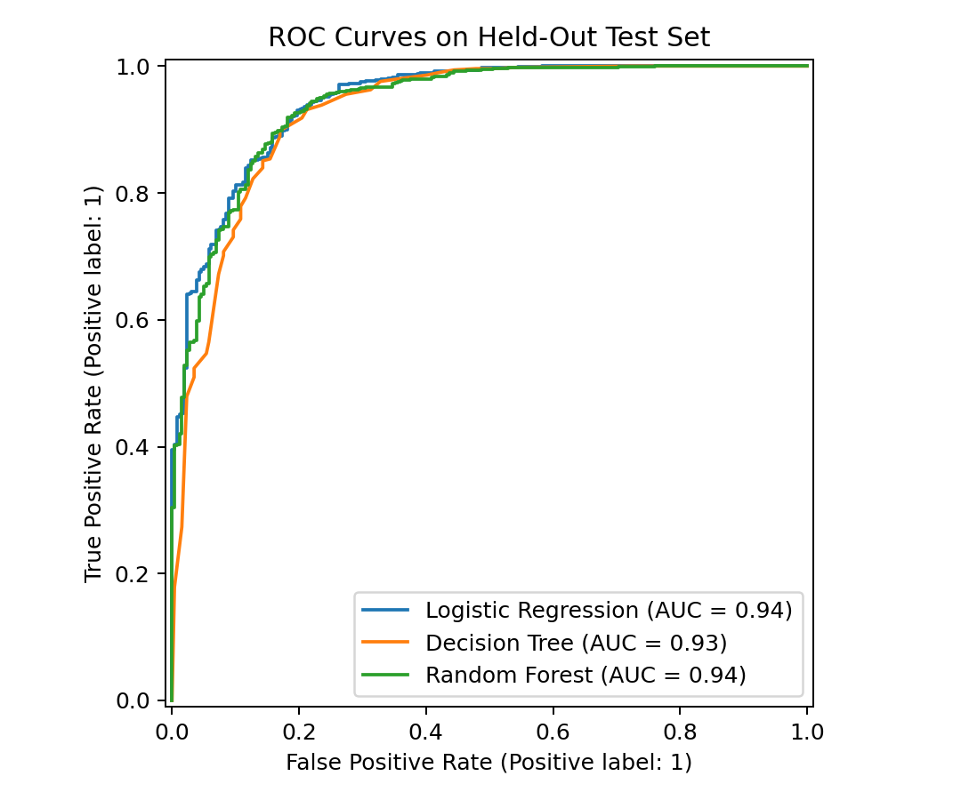
Figure 3. ROC curves for the three classifiers on the held-out test set.
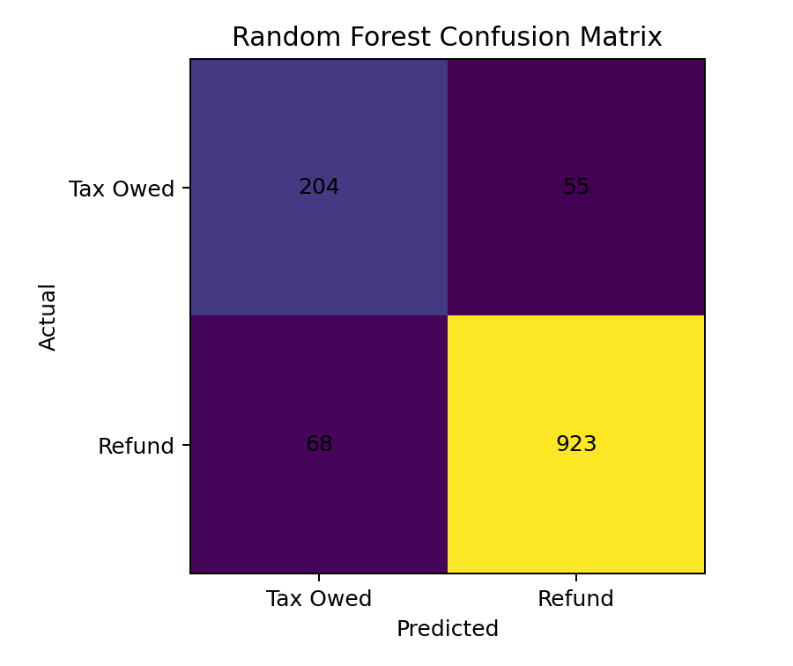
Figure 4. Random Forest confusion matrix on the held-out test set.

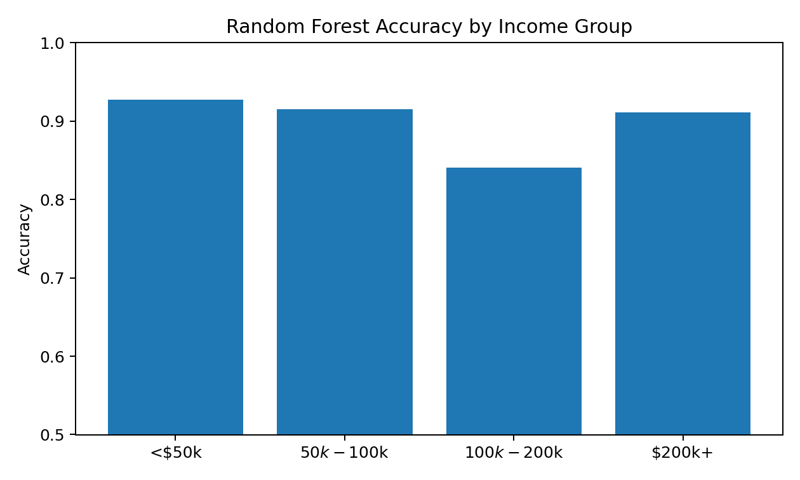
Figure 5. Random Forest accuracy by synthetic income group.

Appendix A: Supporting Documentation

Reproducibility Checklist
- Synthetic dataset: 5,000 records; fixed random seed = 680.
- Train/test split: 75/25, stratified; random_state = 42.
- Cross-validation: five-fold StratifiedKFold with shuffling.
- Models: class-weighted Logistic Regression, Decision Tree, and Random Forest.
- Preprocessing: standardization for numeric fields and one-hot encoding for filing status inside a scikit-learn Pipeline.
- Primary metrics: accuracy, precision, recall, F1, ROC-AUC, confusion matrix, and subgroup accuracy/recall.
- Interpretation: permutation importance on the held-out test set.
- Leakage control: no final refund amount or final balance-due field used as a predictor.

Ethical Risk Register
Concern | Likelihood | Impact | Mitigation
Sensitive data exposure | Low in synthetic draft | Severe | Synthetic data; no direct identifiers; data minimization
Subgroup bias | Medium | Moderate-High | Disaggregated metrics; monitor error gaps
Synthetic mismatch | Medium | High | Calibrate to IRS sources; label limitations; external validation
Prediction treated as tax advice | Medium-High | High | Educational-only labeling; uncertainty; route to IRS/professional
Misleading feature importance | Medium | Moderate | Use permutation importance; distinguish association from causation

Appendix B: Ten Questions an Audience May Ask
1. Why did you use synthetic data instead of real taxpayer or bank records?
2. How did you make the synthetic records realistic enough to support analysis?
3. Why is tax payments relative to estimated liability such a strong predictor?
4. How did you prevent target leakage from making the model unrealistically accurate?
5. Why did Random Forest have higher accuracy but slightly lower ROC-AUC than Logistic Regression?
6. Which error is more important in this application: predicting a refund when tax is owed, or predicting tax owed when a refund occurs?
7. How would the model perform if tax rules or deduction amounts changed in a future year?
8. What do the subgroup results suggest about fairness, and what can they not prove?
9. What additional data or validation would be required before using this with real customers?
10. How would you explain a prediction to a nontechnical user without presenting it as tax advice?

References
Internal Revenue Service. (n.d.-a). Tax Withholding Estimator FAQs. https://www.irs.gov/individuals/tax-withholding-estimator-faqs
Internal Revenue Service. (n.d.-b). SOI tax stats - Individual income tax returns complete report (Publication 1304). https://www.irs.gov/statistics/soi-tax-stats-individual-income-tax-returns-complete-report-publication-1304
Internal Revenue Service. (n.d.-c). SOI tax stats - Individual public-use microdata files. https://www.irs.gov/statistics/soi-tax-stats-individual-public-use-microdata-files
Internal Revenue Service. (2024). Statistics of Income - 2022 individual income tax returns, line item estimates (Publication 4801). https://www.irs.gov/pub/irs-pdf/p4801.pdf
Tabassi, E. (2023). Artificial Intelligence Risk Management Framework (AI RMF 1.0) (NIST AI 100-1). National Institute of Standards and Technology. https://doi.org/10.6028/NIST.AI.100-1

