**Basic Git And GitHub Workflow**

**1. GitHub Repository Creation**

  - Log in to your GitHub account.

  - Create a new repository on GitHub (let's call it "PLPBasicGitAssignment").

  - Initialize it with a README file.

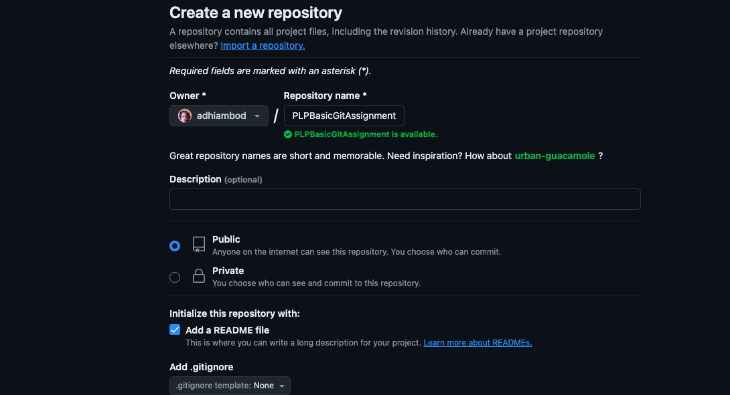

**2. Creating a New Folder (Directory):**

1. **Open a Terminal or Command Prompt**:

* If you're using macOS or Linux, open the Terminal application.
* If you're using Windows, open Command Prompt (cmd) or PowerShell.

1. **Navigate to the Desired Location**:

* Use cd (change directory) command to navigate to the parent directory where you want to create your new folder. For example, if you want to create the folder in your home directory (~):

cd ~

Replace ~ with the path to your desired parent directory if it's not your home

directory.

1. **Create the New Folder**:

-Use the mkdir command followed by the name you want to give to the new folder. For example, to create a folder named PLPBasicGitAssignment, you would use:

mkdir PLPBasicGitAssignment

**3. Initialize a new Git repository**

-Add the correct remote repository URL

git init https://github.com/adhiambod/PLPBasicGitAssignment.git

**4. Connecting to GitHub**

-Replace `<repository-url>` with the actual URL of your GitHub repository.

git remote add origin https://github.com/adhiambod/PLPBasicGitAssignment.git

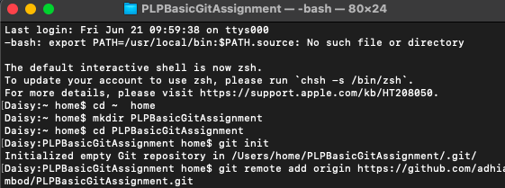

**Steps to Create The File And Add The Text Message Using The Terminal:**

**Navigate to your local folder** (PLPBasicGitAssignment):

Additionally, you can list

cd ~/PLPBasicGitAssignment

This assumes you are already in your home directory (~) and have navigated into the PLPBasicGitAssignment directory.

1. **Create a new text file** (hello.txt): Use the touch command to create an empty hello.txt file:

touch hello.txt

1. **Edit the file and add a text message**: You can use a text editor like nano to open hello.txt and add your message:

nano hello.txt

-In the nano editor, type your desired text message. For example:

Hello, Git!

-To save the changes in nano, press Ctrl + O (Write Out), then Enter to confirm the filename, and Ctrl + X to exit.

-Alternatively, you can directly add the text using the echo command:

echo "Hello, Git!" > hello.txt

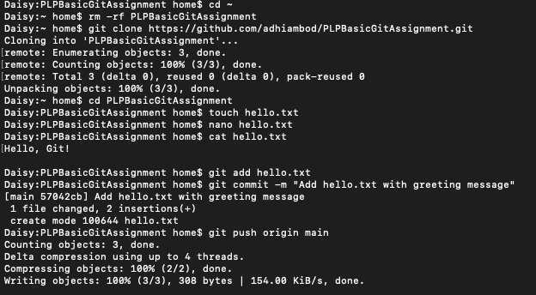

1. **Verify the file content**: To ensure that the text was added correctly, you can view the contents of the file using the cat command:

cat hello.txt

This will display the content of hello.txt in the terminal.

1. **Stage and commit your changes** (if you want to save them in Git):

-Stage the hello.txt file:

git add hello.txt

-Commit the changes with a meaningful message:

git commit -m "Add hello.txt with greeting message"

1. **Push your changes to the remote repository** (if applicable): If you want to push your changes to GitHub or another remote repository, use the git push command:

git push origin main

Replace main with your branch name (master or another branch) if necessary.

7.  **Verify on GitHub:**

  - Visit your GitHub repository in a web browser and confirm that the `hello.txt` file and commit message are visible.

