**Warfare The Game**

1. Introduction:

This is a 3D board game that based on war theme that combining simulation of Land, Underwater, and Air Warfare.

1. Board:

Player is given one board to represent territories of domination.

1. Default Board

* Land Platform

This is the middle part of the board, default of the tiles that colored blue are water tiles that represent sea. The brown tiles surrounding it are the border area of a player that represent dirt area.

* Underwater Platform

This is the bottom part of the board, this part represent underwater. Submarine can use this route to approach enemy from below.

* Air Platform

This is the top part of the board, this part represent sky. Plane can use the top board for fast assault to other territories

1. Board Folding Type

* Type 1
* Type 2
* Type 3

1. Tiles

Tiles are attachment for building basic territories.

You can stack it to represent height or down up of your territories.

Build your own territory to match your tastes and giving additional advantage.

* Land Tiles
* Water Tiles

Water tiles are used to represent water, lake, or river that can be used for water troops or underwater access.

* Grassland Tiles

Grassland tiles are used to represent a rich soil plant can live. Can be used for planting trees.

* Dirt Tiles

Dirt tiles are used to represent wasteland as they don’t have special attributes.

* Underwater Tiles

Underwater tiles are tiles that used to building on the Underwater Platform.

* Air Tiles

Air tiles are tiles that used to building on the Air Platform.

1. Pieces:

Pieces are assets of player. there is two types of pieces, a dynamic one(troops) and static one(bulding).

1. Troops

Used to engage in the board with other player, as a dynamic pieces it can be used for invade or defend. All land troops only can scale tiles with one tiles high differences.

* Land Troops
* Peasant

Moves:

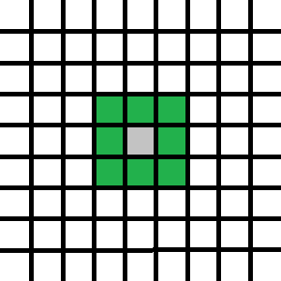

Special: Can defeat the enemy as it walks no matter trees or other kind of troops pieces.

* Tank

Moves:

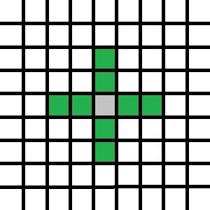

Attack:

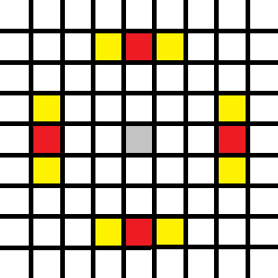

Special: Splash Attack. Surroundings of the targeted attack area will destroyed too.

* Anti Air

Cannot Moves

Attack:

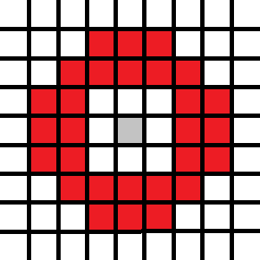

Special: only can target airborne enemies.

* Water Troops
* Submarine

Moves:

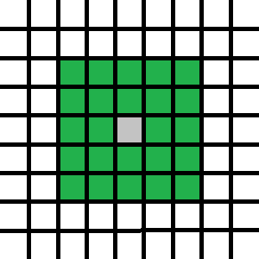

Underwater Attack Surface Attack

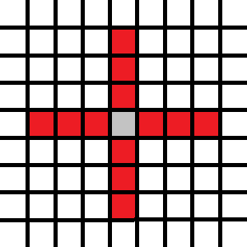 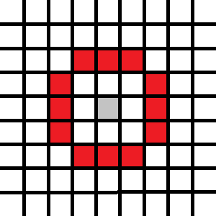

Special: Can move freely underwater, cannot targeted when underwater except by same submarine.

* Air Troops
* Airplane

Moves

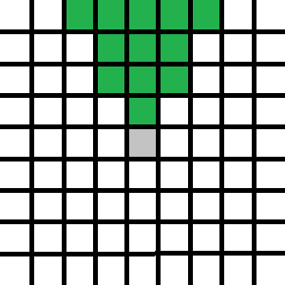

Attack:

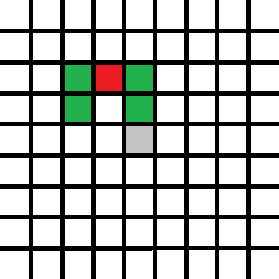 Or 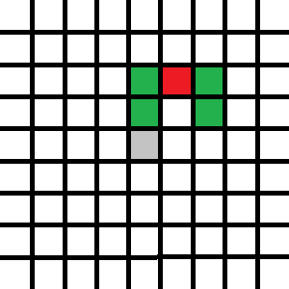

Special: only can fly almost straight according first direction, only can be attacked by Anti Air, can attack only once, after that need to recharged in the airport.

1. Building

Buildings are asset to convert the peasant into other type of troops.

To build the buildings, player need to sacrifice peasant in the shape of the buildings.

Only headquarter is special case that does not need to be build and can be only one per territory.

The buildings other than headquarter are can be used by player other than the builder.

* Land Building
* Headquarters (HQ)

The main base of player. Spawning peasant every turn.

The conversion building from peasant to tank. Need 4 peasant to build one tank.

* Port

The conversion building from peasant to submarine. Need 2 peasant to build and one side must be on water tiles.

* Airport

The conversion building from peasant to airport. Need 3 peasant to build.

* Underwater Building
* Air Building

1. Rules:
2. How to Build Territorry on your Board

The main point of building your territory is:

* On the Land Platform tiles can be stacked freely as long as the differences with surrounding tiles is only one tiles in height.
* On the Land Platform you mustn’t stack 2 tiles or higher which is cut the means of advancing either from you or other player.
* On the Land Platform water tiles must be surrounded or lower than land tiles.
* You can stack air tiles or deep sea tiles to determine your air or deep sea creativity.

1. Placing the Pieces.

* You must place your headquarter on Land Platform 2x2 flat land that can be accessed by minimum one path*.

*not surrounded by water or has 2 or higher tile differences with surrounding tiles.

* You can place trees only on grassland tiles still you can place it freely as much as you want on your own territory.

1. Starting the game.

* Built your territories by your own tastes.
* Place your headquarter on your Land Platform
* Combine 2 or more board according the player agreement.
* Determine of the order of player.(recommended clockwise or counterclockwise)

1. Playing the game

* When it’s your turn, you can move all your troops to take action.
* When one troop finished its action, turn its face right 90’*.

*it is to record which troop has finished action and which has not.

* After you finished your turn, put back your troops face forward*.

*turn it back with 90’ left.

1. Goal

There is a types of goal/play styles that can be done in this game:

1. Occupy the headquarter

* Peasant must reach the enemy headquarter.
* After it placed on top enemy headquarter the peasant cannot be killed or moved.
* The game is over after all of headquarter space is occupied

1. Destroy the headquarter

* There is colored light bulb on the headquarter pieces with a total of five when this rule is used, when headquarter takes damage, the light bulb is removed. When all light bulb are removed (the headquarter takes 5 damage) the player is defeated.

1. Death march

* For every turn the headquarter spawn maximum amount of peasant*.

*the default in the start of game is 2x2 = 4 pieces

* Rule destroying or occupying the headquarters is active.
* Every 10 turn, headquarter space is plugged by one of the peasant (under the same rules as enemy occupying headquarter). When all of the headquarter space are plugged, the game is over.(under 40 turn until game over)

1. Additional Rules