WEEK 1 TASK REPORT
FOUNDATIONS OF MECHANICAL CAD

Connecting Rod – Mechanical Part Modelling

Software Used: SolidWorks and CATIA V5
Part Modelled: Connecting Rod
Task: Week 1 – Foundations of Mechanical CAD
Evidence: Sketches, dimensions, 3D modelling and feature-tree screenshots

1. Introduction
Mechanical Computer-Aided Design (CAD) is used to create accurate two-dimensional sketches, three-dimensional parts, assemblies and engineering drawings. This Week 1 activity focuses on building a strong foundation in mechanical CAD by creating a connecting rod, a representative mechanical component containing circular bosses, holes, a tapered body, internal detailing and multiple filleted regions. The same component was developed using SolidWorks and CATIA V5 to gain practical familiarity with two professional CAD environments.
The modelling workflow involved creating constrained sketches, applying dimensions, generating 3D geometry, adding and removing material through modelling features, and checking the final shape using isometric views. Screenshots were captured at important stages so that the design process can be demonstrated rather than presenting only the final part.

2. Objectives
- Understand the basic concepts and workflow of mechanical CAD.
- Become familiar with the working environments of SolidWorks and CATIA V5.
- Create and constrain sketches using dimensions and geometric relationships.
- Develop a complex mechanical part using feature-based 3D modelling.
- Apply holes, cuts, bosses, fillets and other detailed modelling operations.
- Compare the practical modelling workflow in two CAD platforms.

3. Part Selected – Connecting Rod
A connecting rod was selected because it provides a useful combination of fundamental and intermediate CAD operations. The model contains a large-end region, a small-end region, a tapered connecting body, through openings, internal detailing and rounded transitions. These features provide evidence of sketching, dimensional control, solid creation, material removal and finishing operations.
CAD Element | Application in Model
2D sketching | Main profile and internal features
Dimensional constraints | Control of diameters, lengths and feature locations
3D feature creation | Development of the connecting-rod body and bosses
Cut / hole features | Creation of openings and recessed regions
Fillets / rounded transitions | Smooth connection between major regions
Feature tree / specification tree | Shows the modelling history and design structure

4. SolidWorks Modelling Evidence
The SolidWorks workflow began with the main connecting-rod profile. Dimensions and constraints were applied to control the geometry. Additional sketches were then used to create internal features and end-region details. The model was progressively developed into a 3D part and refined with additional cuts and fillets. The final screenshot shows the completed part together with the FeatureManager design tree.
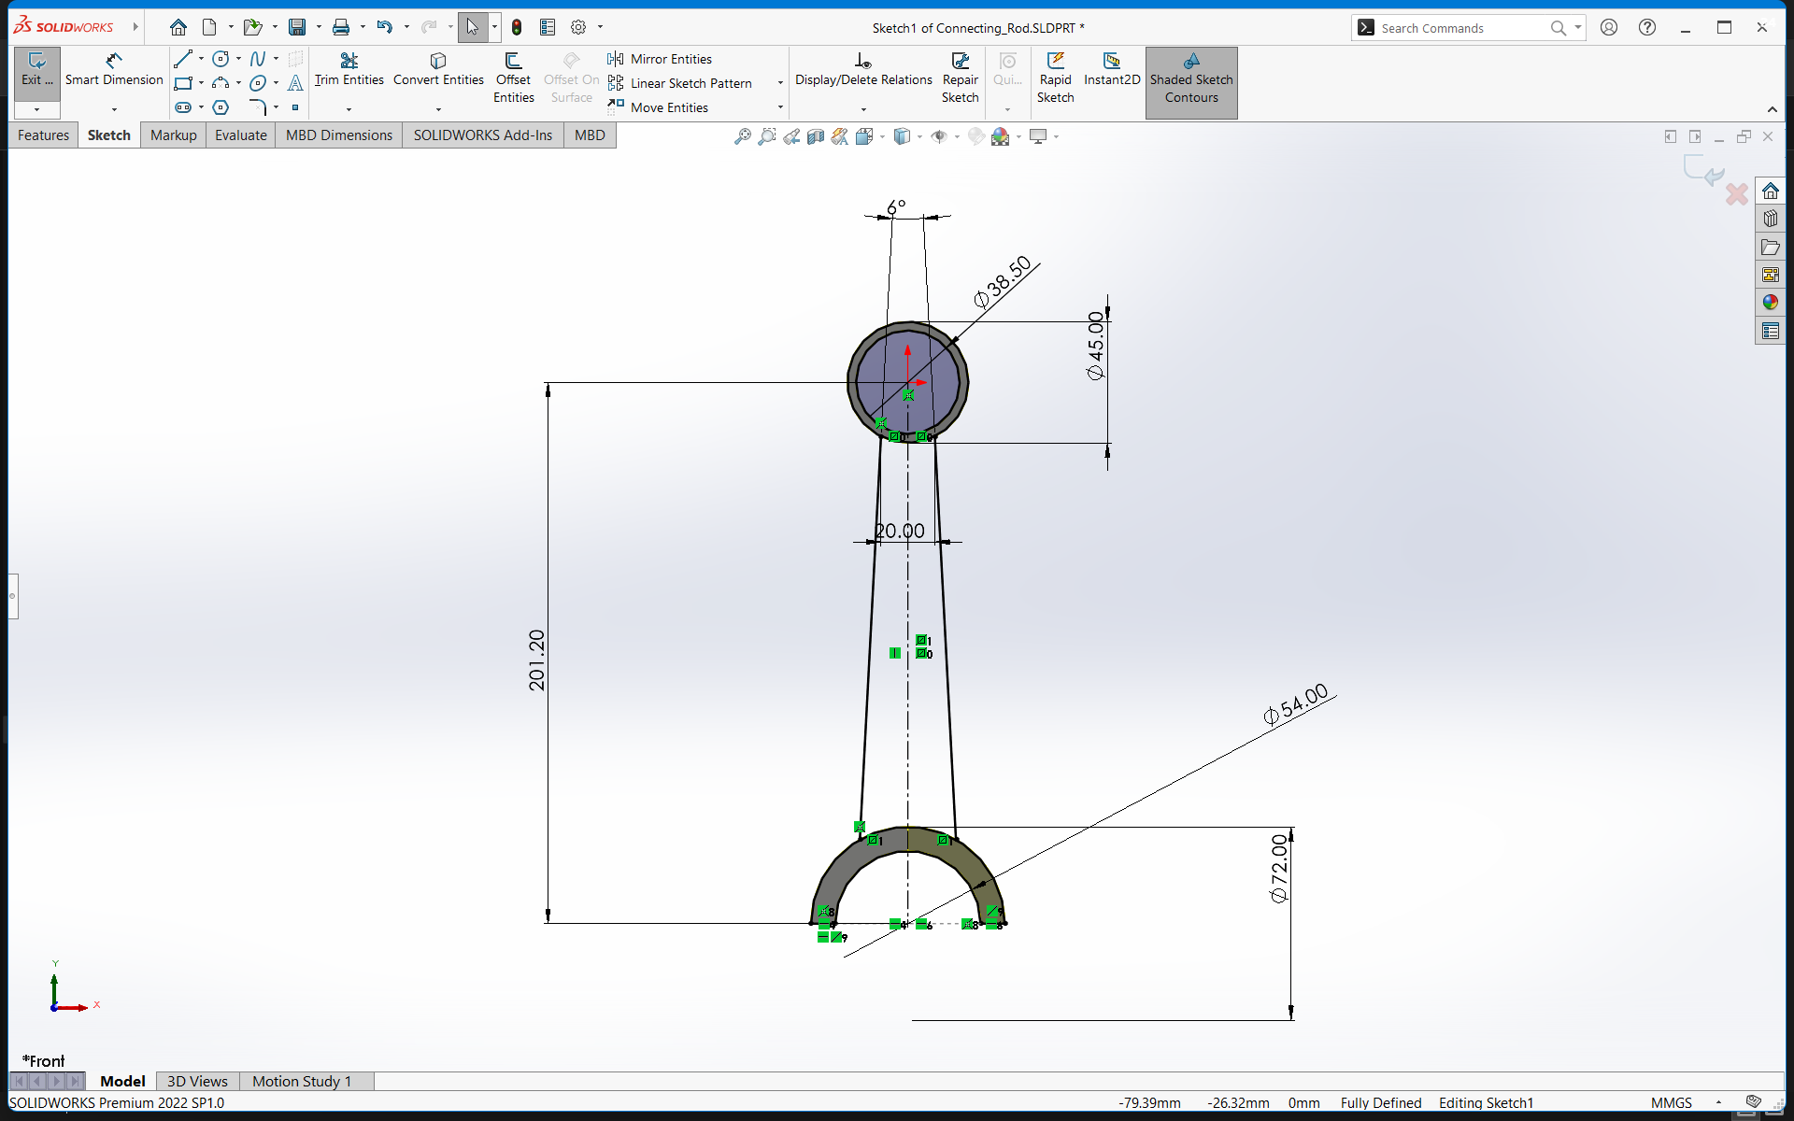
Figure 1. SolidWorks main sketch with overall dimensions and constraints.

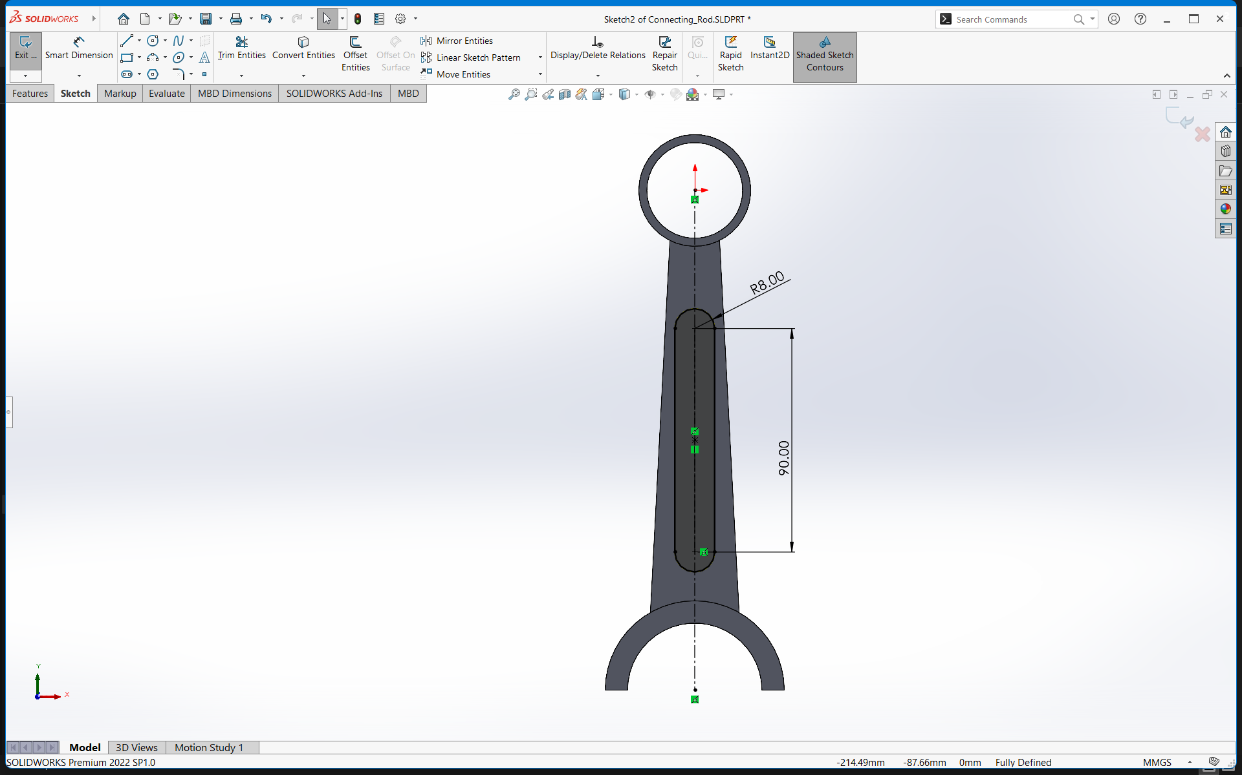
Figure 2. SolidWorks internal feature sketch.

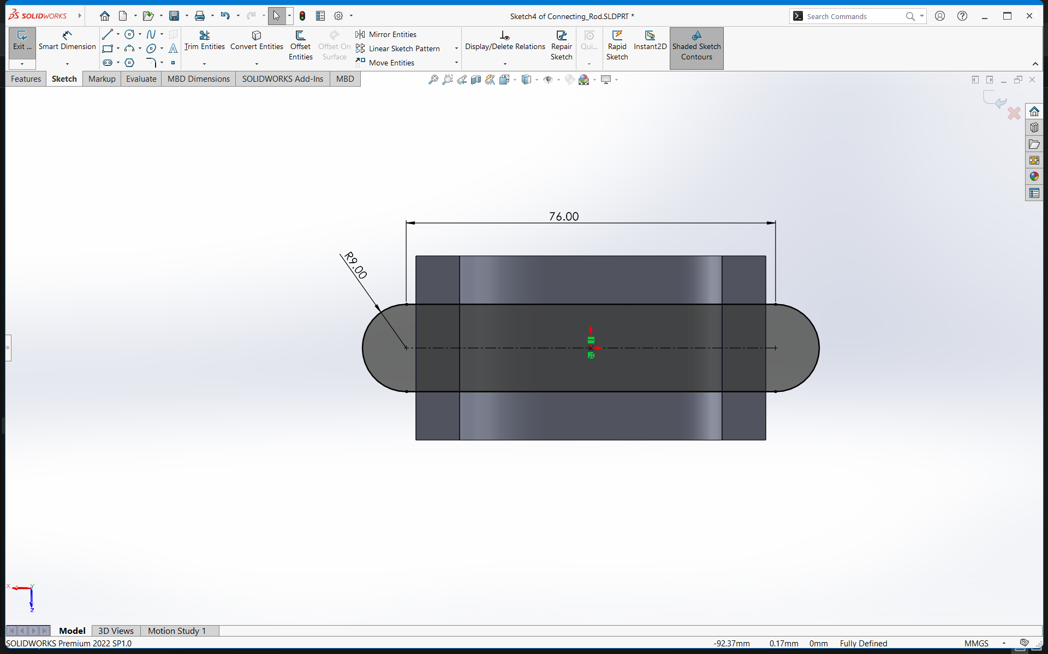
Figure 3. SolidWorks big-end and bolt-hole feature sketch.

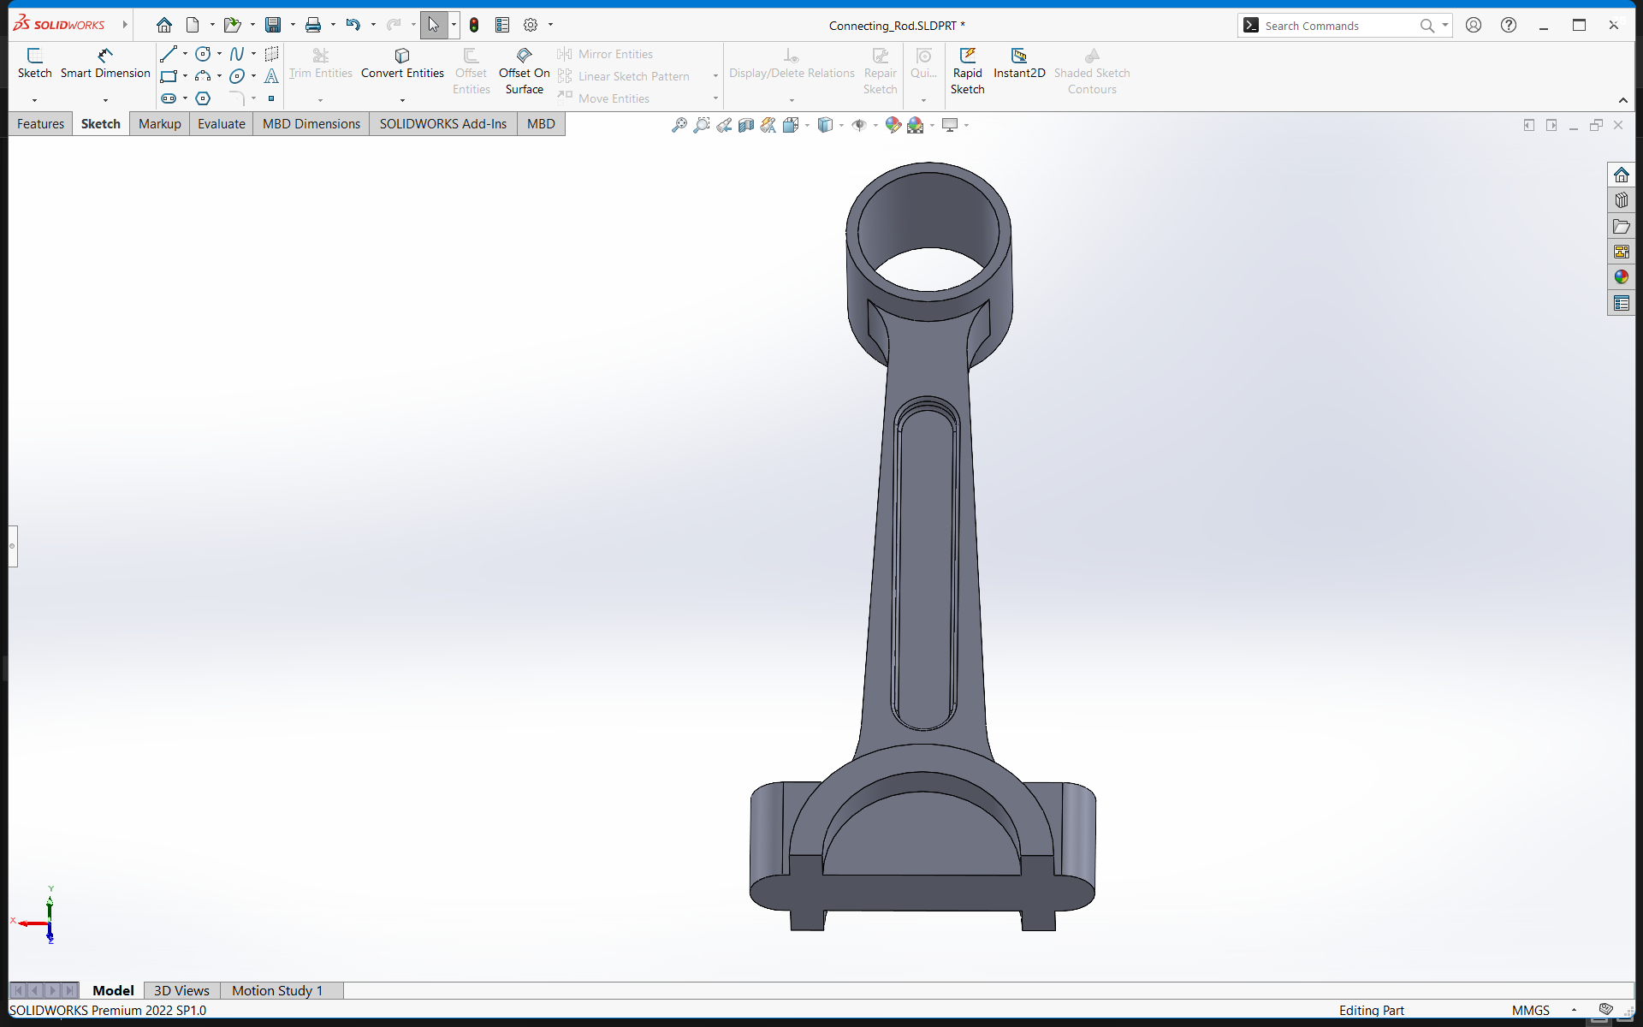
Figure 4. SolidWorks developed 3D connecting-rod model.

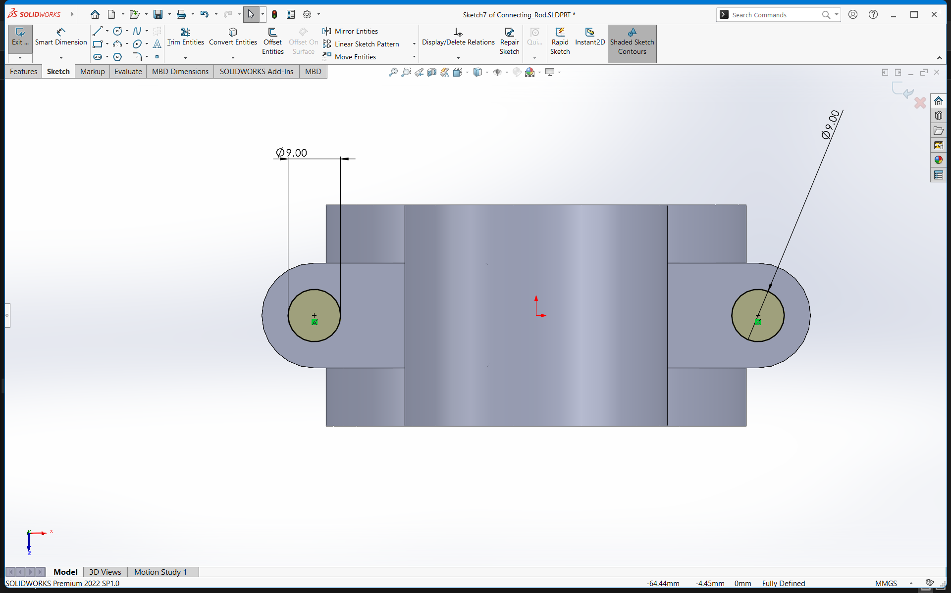
Figure 5. SolidWorks detailed isometric connecting-rod model.

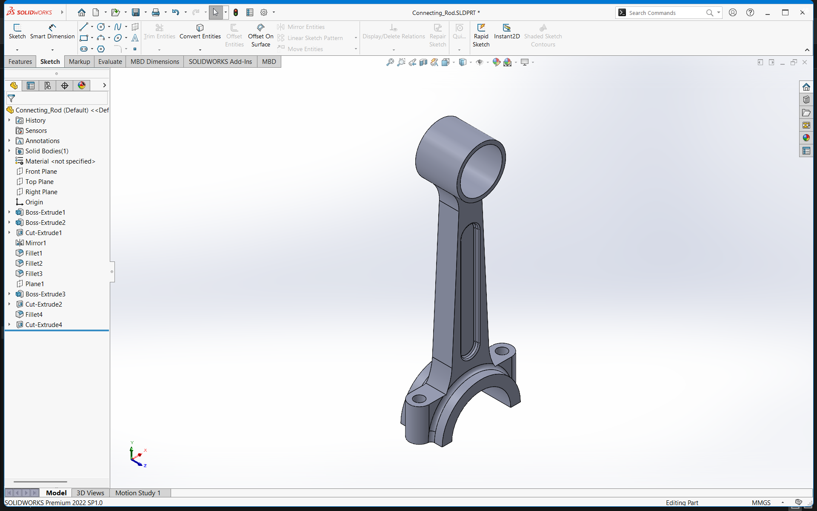
Figure 6. SolidWorks final model with FeatureManager design tree.

5. CATIA V5 Modelling Evidence

The connecting rod was also modelled in CATIA V5. The CATIA evidence demonstrates the use of sketch-based design, dimensional constraints and a structured model tree. The screenshots show the main profile, major dimensional controls, detailed profile constraints and the final 3D connecting rod in the CATIA environment.

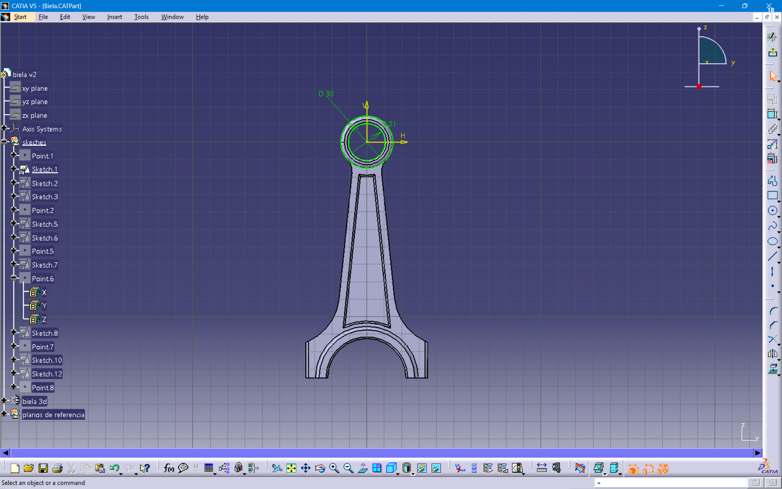

Figure 7. CATIA main connecting-rod sketch with dimensional constraints.

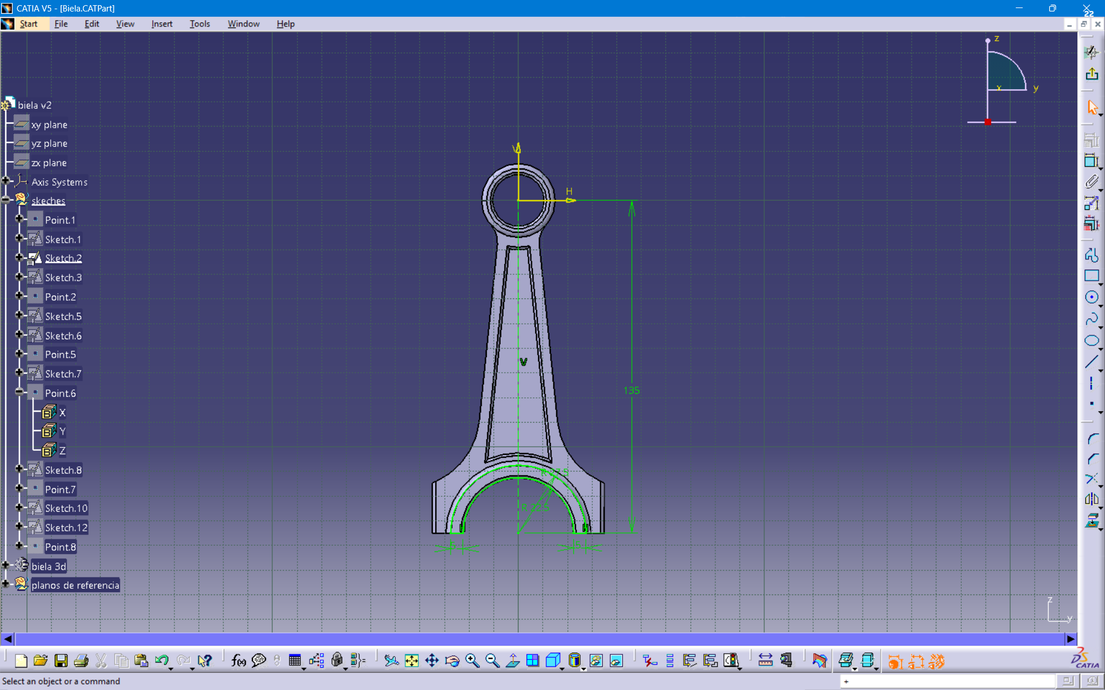
Figure 8. CATIA overall geometry with major dimensional constraints.

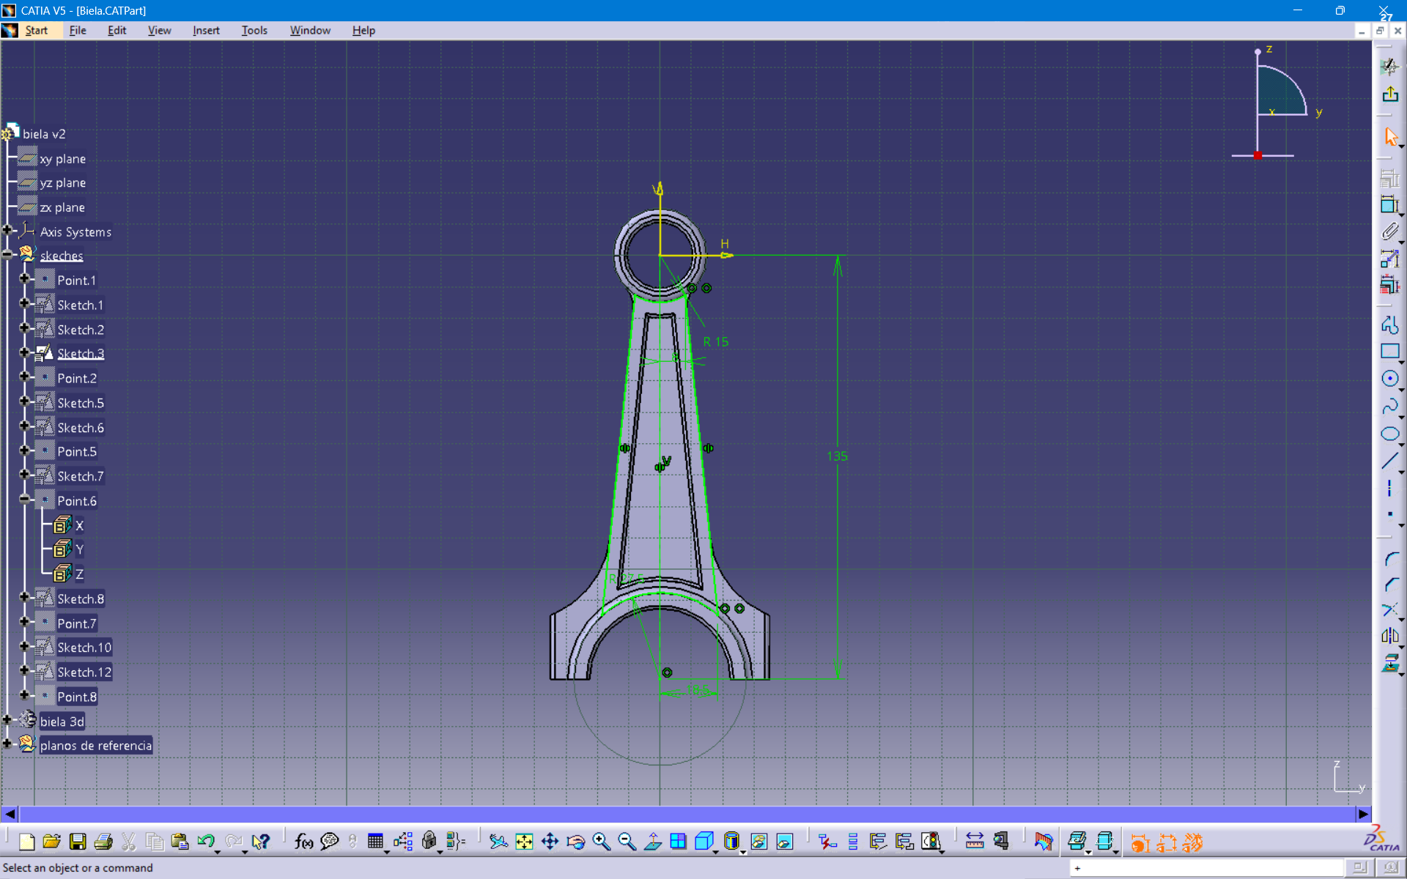
Figure 9. CATIA detailed profile and geometric constraints.

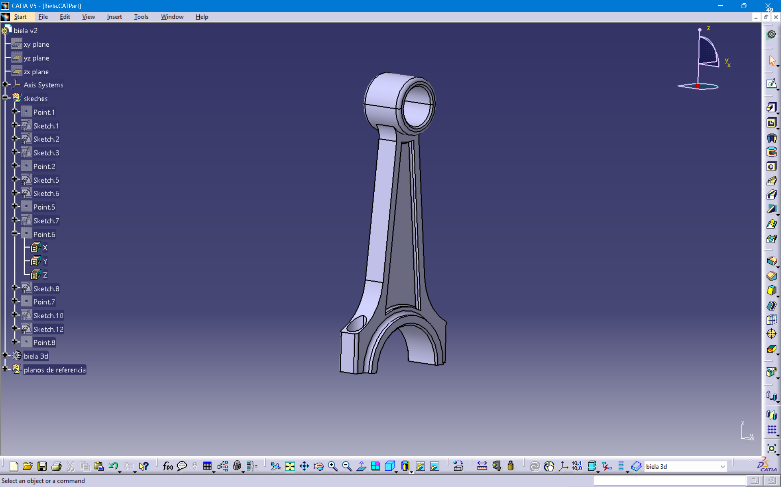
Figure 10. CATIA final 3D connecting-rod model with specification tree.

6. SolidWorks and CATIA Workflow Comparison
Aspect | SolidWorks | CATIA V5
Sketching | Constraint-driven sketch environment | Sketcher-based constrained geometry
Part modelling | FeatureManager-based feature workflow | Part Design / structured feature workflow
Design history | FeatureManager design tree | Specification tree
Visualisation | Isometric and shaded model views | 3D model and specification-tree views
Application in this task | Connecting rod development and detailing | Connecting rod development and detailing

7. Learning Outcomes
- Gained practical understanding of mechanical CAD modelling workflow.
- Practised creating constrained sketches and controlling geometry with dimensions.
- Understood how multiple modelling features can be combined to create a mechanical component.
- Improved familiarity with SolidWorks FeatureManager and CATIA specification-tree environments.
- Learned to document the modelling process using screenshots and structured technical reporting.

8. Conclusion
The Week 1 Mechanical CAD task was completed by developing a connecting rod in SolidWorks and CATIA V5. The activity covered the essential stages of mechanical part modelling, beginning with constrained sketches and progressing through 3D feature creation and detailed finishing. The screenshots provide evidence of the modelling stages and final geometry in both CAD platforms. This exercise establishes a practical foundation for more advanced CAD activities such as assemblies, engineering drawings, design modifications and complex mechanical components.

