Name: Adhika Guna

Main Topic: SQL Injections

Reference #1:

Title: SQL Injection Detection for Web Applications Based on Elastic-Pooling CNN

Total Page: 7.

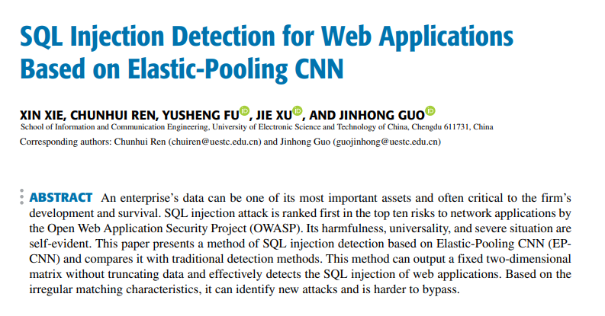

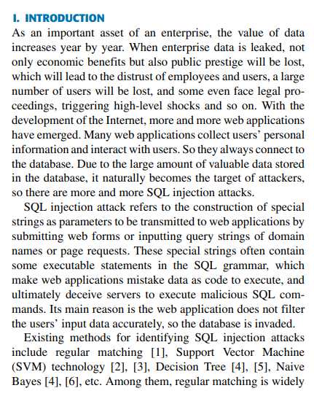

Reference #2

Title: SQL Injection Detection Method Based on Adaptive Deep Forest

Page: 10

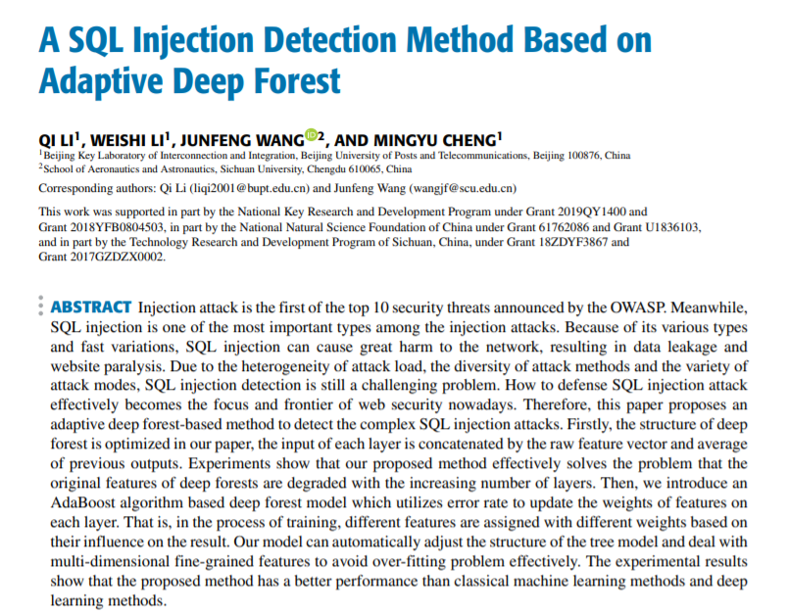

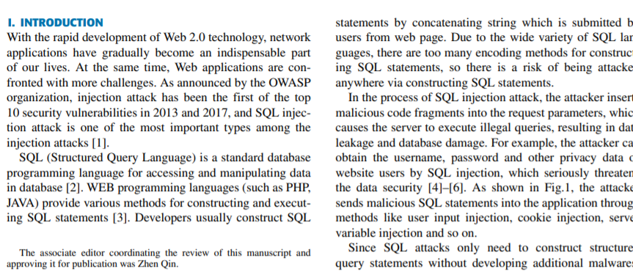

Reference #3

Title: Review of SQL Injection : Problems and Prevention

Page: 5

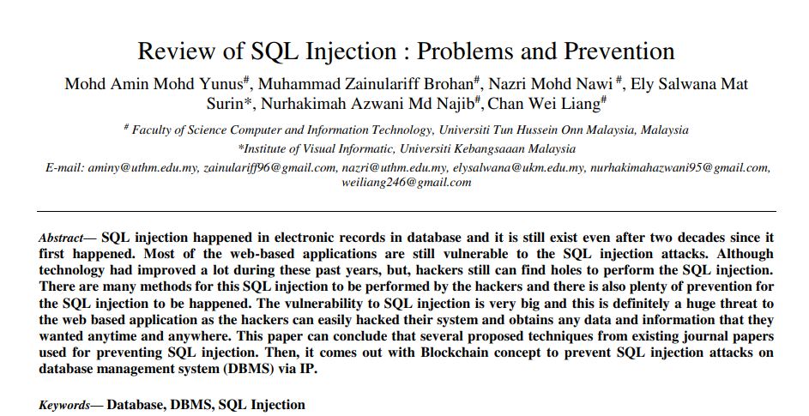

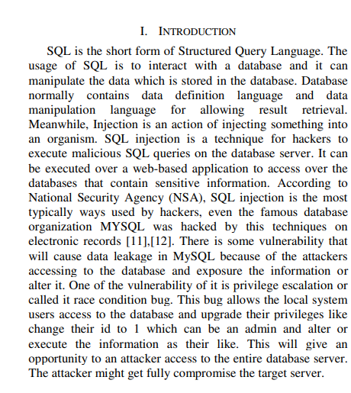

Reference #4

Title: Generation of SQL-injection free secure algorithm to detect and prevent SQL-injection attacks

Page: 7

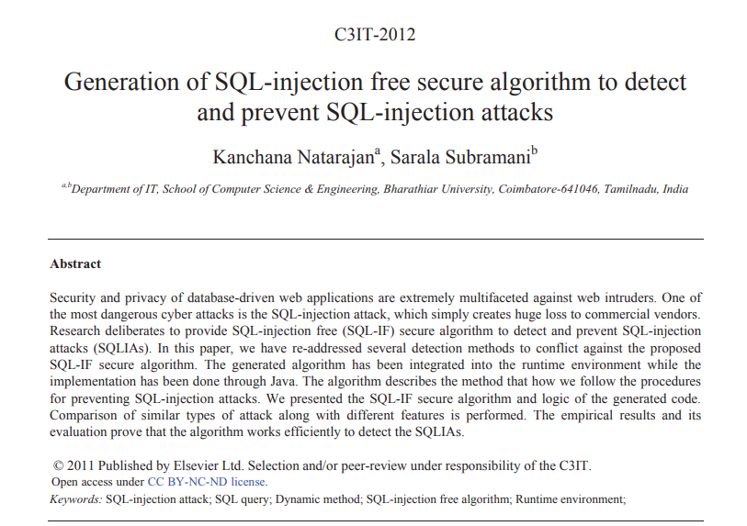

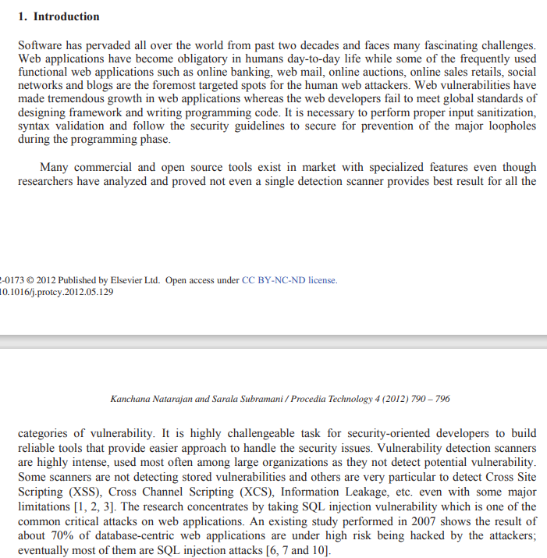

Reference #5

Title: A Study On SQL Injection Technique

Page: 12

