Lab 2
Project 1: Decision Tree Student Performance Prediction
Data Exploration: Load the CSV using pandas. Display the 10 rows, summary statistics, and check for missing values.
Loading the CSV file:
import pandas as pd
df = pd.read_csv("student_performance.csv")
df.head()
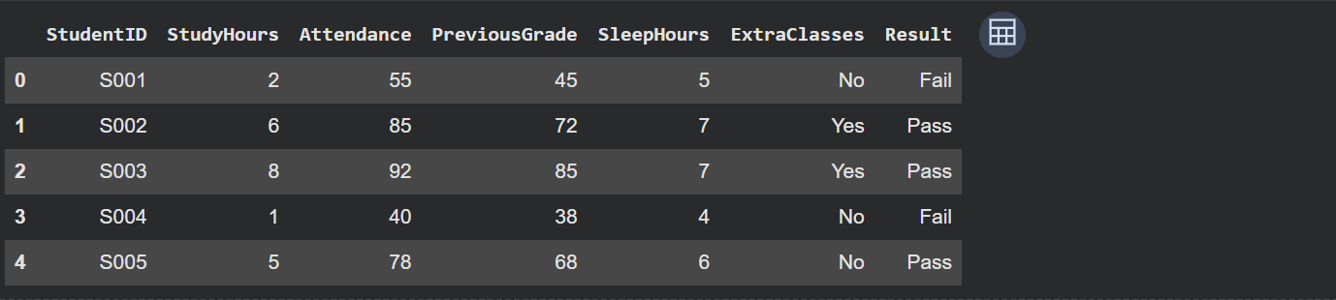

Displaying the first 10 rows:
print("First 10 Rows:")
print(df.head(10))
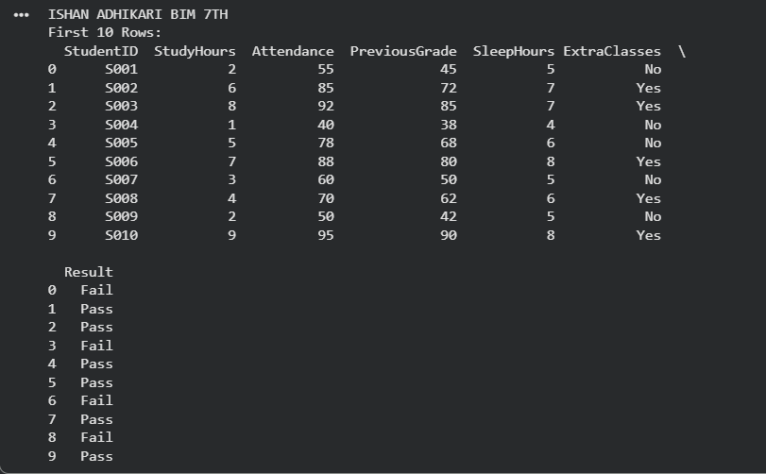
Summary statistics:
The describe() function provides statistical information for numerical columns.
print("\nSummary Statistics:")
print(df.describe())
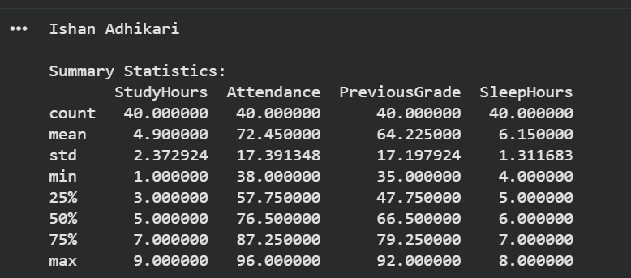

Checking for missing values:
The isnull().sum() function checks for missing (empty) values in each column. If a column has 0, it means there are no missing values. If the value is greater than 0, that column contains missing data that may need to be handled before analysis.

print("\nMissing Values:")
print(df.isnull().sum())
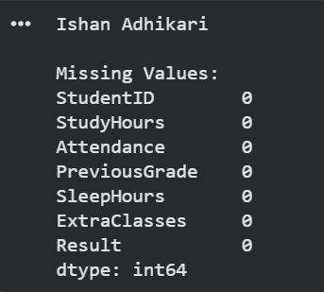

Data Visualization: Create a 3 plots showing relationships between features and the result column. (eg boxplots, scatter plots, bar charts).
Box Plot: Study Hours vs Result
The box plot shows the distribution of study hours for different result categories. It helps compare how study time varies between students with different results. A higher study hour range may indicate better academic performance.
import matplotlib.pyplot as plt
import seaborn as sns
plt.figure(figsize=(6,4))
sns.boxplot(
x="Result",
y="StudyHours",
data=df
)
plt.title("Study Hours Distribution by Result")
plt.xlabel("Result")
plt.ylabel("Study Hours")
plt.show()
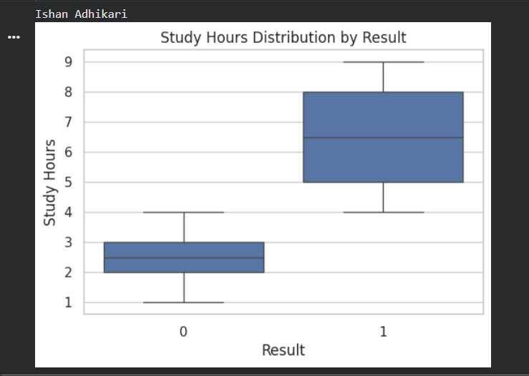
Scatter Plot: Attendance vs Previous Grade
The scatter plot shows the relationship between attendance and previous grades. Different colors represent different result categories. It helps identify whether students with higher attendance and grades achieve better results.
plt.figure(figsize=(6,4))
sns.scatterplot(
x="Attendance",
y="PreviousGrade",
hue="Result",
data=df
)
plt.title("Attendance vs Previous Grade by Result")
plt.xlabel("Attendance")
plt.ylabel("Previous Grade")
plt.show()
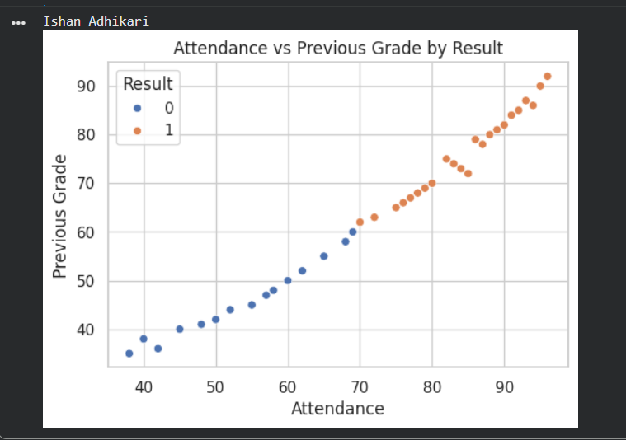

Bar Chart: Average Sleep Hours by Result
The bar chart compares the average sleep hours of students in different result categories. It helps understand whether sleep patterns have any relationship with student performance.
plt.figure(figsize=(6,4))
sns.barplot(
x="Result",
y="SleepHours",
data=df
)
plt.title("Average Sleep Hours by Result")
plt.xlabel("Result")
plt.ylabel("Average Sleep Hours")
plt.show()
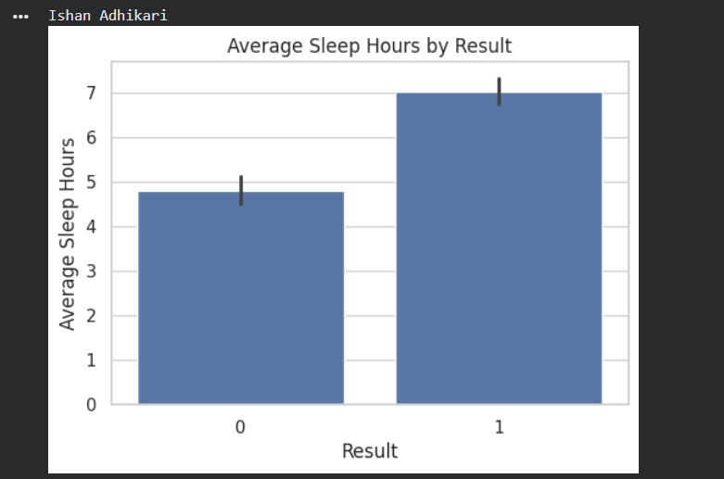
Three different visualization techniques were created to analyze the relationship between input features and the result column. The box plot helped compare feature distributions, the scatter plot showed relationships between numerical features, and the bar chart compared average values between result groups. These visualizations helped identify patterns in the dataset before applying machine learning models.
Preprocessing: Encode the Extra Classes (Yes / No) and Result (Pass / Fail) columns into numeric form. Drop StudentID.

Machine learning algorithms work with numerical values, so text-based categories must be converted into numbers. The LabelEncoder function changes categorical labels into numeric labels. The StudentID column was removed because it is a unique identifier and does not contain useful information for predicting student results.

# Drop StudentID column
df = df.drop("StudentID", axis=1)

# Encode categorical variables
from sklearn.preprocessing import LabelEncoder

encoder = LabelEncoder()

# Convert ExtraClasses (Yes/No) into numbers
df["ExtraClasses"] = encoder.fit_transform(df["ExtraClasses"])

# Convert Result (Pass/Fail) into numbers
df["Result"] = encoder.fit_transform(df["Result"])

# Display updated dataset
df.head()

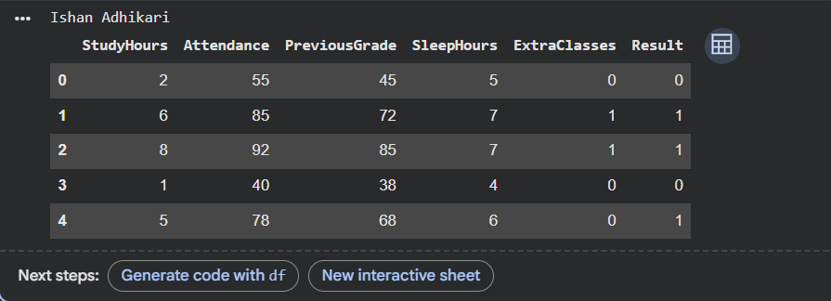
The dataset was successfully preprocessed by removing the unnecessary StudentID column and converting categorical variables into numerical format. The processed dataset is now ready for machine learning model training.

Train-Test Split: Split data into 80% training and 20%testing.
To divide the dataset into training and testing sets. The training set (80%) is used to train the machine learning model, while the testing set (20%) is used to evaluate its performance.
from sklearn.model_selection import train_test_split
X = df.drop("Result", axis=1)
y = df["Result"]
# Split the dataset into 80% training and 20% testing
X_train, X_test, y_train, y_test = train_test_split(
X,
y,
test_size=0.20,
random_state=42
)
# Display the shape of each dataset
print("Training Features:", X_train.shape)
print("Testing Features:", X_test.shape)
print("Training Labels:", y_train.shape)
print("Testing Labels:", y_test.shape)
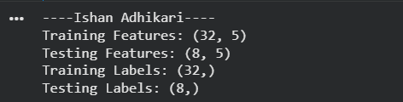
The dataset was successfully divided into 80% training data and 20% testing data. The training dataset will be used to train the Decision Tree classifier, while the testing dataset will be used to evaluate the model's performance.

Model Training: Train a DecisionTreeClassifier from scikit-learn. Try with criterion=”gini” and criterion=”entropy”.
To train a Decision Tree Classifier using the training dataset and compare two splitting criteria: Gini and Entropy.
Code: Train using Gini
from sklearn.tree import DecisionTreeClassifier
dt_gini = DecisionTreeClassifier(
criterion="gini",
random_state=42
)
dt_gini.fit(X_train, y_train)
print("Decision Tree model trained using Gini Index.")

Code: Train using Entropy
dt_entropy = DecisionTreeClassifier(
criterion="entropy",
random_state=42
)
dt_entropy.fit(X_train, y_train)
print("Decision Tree model trained using Entropy.")

Two Decision Tree models were successfully trained using the Gini Index and Entropy criteria. Both models learned from the training dataset and are now ready to make predictions on the testing dataset. The next step is to evaluate their performance using metrics such as Accuracy, Precision, Recall, and Confusion Matrix.

Evaluation: Report accuracy, precision, recall, F1-score, and plot a confusion matrix.
To evaluate the performance of the trained Decision Tree classifier using Accuracy, Precision, Recall, F1-score, and a Confusion Matrix.
Code (Evaluate Gini Model):
from sklearn.metrics import accuracy_score, precision_score, recall_score, f1_score, confusion_matrix
y_pred_gini = dt_gini.predict(X_test)
accuracy = accuracy_score(y_test, y_pred_gini)
precision = precision_score(y_test, y_pred_gini)
recall = recall_score(y_test, y_pred_gini)
f1 = f1_score(y_test, y_pred_gini)
print("Accuracy :", accuracy)
print("Precision:", precision)
print("Recall :", recall)
print("F1-Score :", f1)
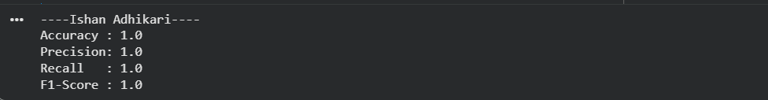
Evaluate the Entropy Model:
y_pred_entropy = dt_entropy.predict(X_test)
print("Accuracy :", accuracy_score(y_test, y_pred_entropy))
print("Precision:", precision_score(y_test, y_pred_entropy))
print("Recall :", recall_score(y_test, y_pred_entropy))
print("F1-Score :", f1_score(y_test, y_pred_entropy))
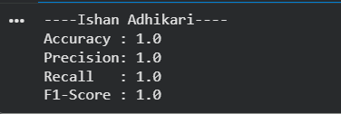

Plot the Confusion Matrix:
from sklearn.metrics import ConfusionMatrixDisplay
import matplotlib.pyplot as plt
cm = confusion_matrix(y_test, y_pred_gini)
ConfusionMatrixDisplay(
confusion_matrix=cm,
display_labels=["Fail", "Pass"]
).plot(cmap="Blues")
plt.title("Confusion Matrix (Decision Tree - Gini)")
plt.show()
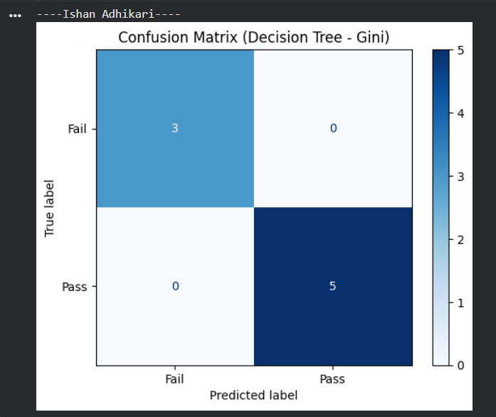
The Decision Tree classifier was evaluated using Accuracy, Precision, Recall, F1-score, and a Confusion Matrix. These metrics provide a comprehensive assessment of the model's classification performance. The confusion matrix also helps identify correctly classified and misclassified instances, giving a clearer understanding of the model's effectiveness.

Tree Visualization: Visualize the decision tree using plot_tree() from sklearn.
from sklearn.tree import plot_tree
import matplotlib.pyplot as plt
plt.figure(figsize=(15, 10))
plot_tree(
dt_gini,
feature_names=X.columns,
class_names=["Fail", "Pass"],
filled=True,
rounded=True,
fontsize=10
)
plt.title("Decision Tree Visualization (Gini)")
plt.show()
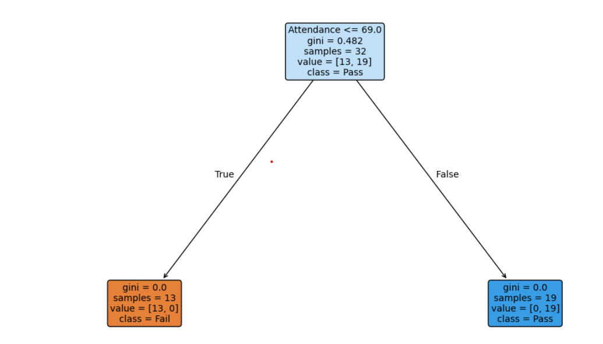
- The plot_tree() function is used to display the structure of the trained Decision Tree model.
- Each decision node represents a condition based on a feature (for example, StudyHours <= 4.5).
- Each branch shows the outcome of the condition (True or False).
- Each leaf node represents the final predicted class (Pass or Fail).
- The filled=True option colors the nodes according to their predicted class, making the tree easier to interpret.
- The rounded=True option gives the nodes rounded corners for better readability.
The Decision Tree was successfully visualized using plot_tree(). The visualization illustrates how the classifier uses input features such as StudyHours, Attendance, PreviousGrade, SleepHours, and ExtraClasses to classify students as Pass or Fail. This graphical representation makes it easier to understand the decision-making process of the model.

Analysis: Identify which feature is the most important predictor. Explain the top 2-3 decision rule in plain English
import pandas as pd
# Display feature importance
feature_importance = pd.DataFrame({
"Feature": X.columns,
"Importance": dt_gini.feature_importances_
})
feature_importance = feature_importance.sort_values(by="Importance", ascending=False)
print(feature_importance)
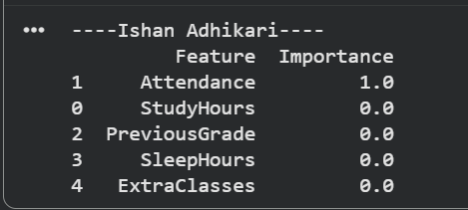
Attendance is the most important predictor because it has the highest feature importance value (1.0). This means the Decision Tree relied on attendance more than any other feature when predicting whether a student would pass or fail.
- If a student's attendance is below the threshold chosen by the model, the student is predicted to Fail.
- If a student's attendance is above the threshold, the student is predicted to Pass.
- The model makes its prediction based only on attendance because it is the most important feature in the dataset.
The Decision Tree identified Attendance as the most significant factor in predicting student results. With a feature importance of 1.0, attendance alone was sufficient for the model to classify students as Pass or Fail, while the remaining features had no influence on the prediction.

Project 2: Decision Tree – Loan Approval Prediction
Load dataset and summarize the distribution of approved vs rejected loan.
#Load the dataset:
import pandas as pd
df = pd.read_csv("loan_approval_dataset.csv")
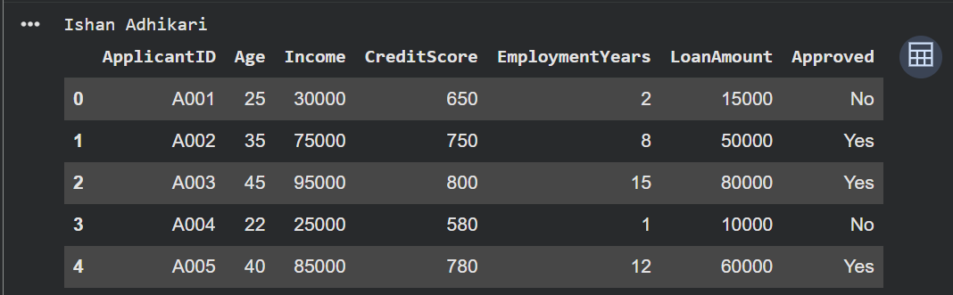

#Display dataset information:
print("\nDataset Information:")
print(df.info())
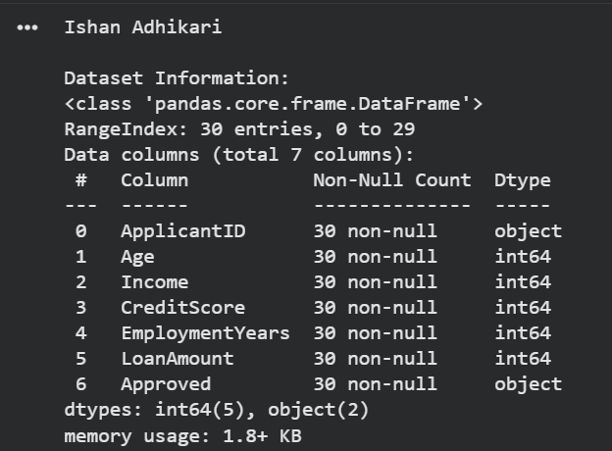

# Distribution of loan approval:
print("\nLoan Approval Distribution:")
print(df["Approved"].value_counts())
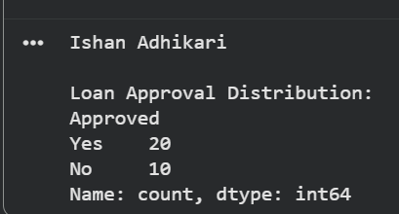

# Percentage distribution:
print("\nLoan Approval Percentage:")
print(df["Approved"].value_counts(normalize=True) * 100)
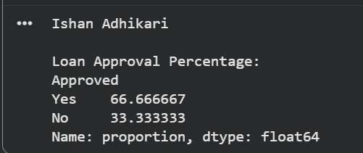

The dataset was successfully loaded and analyzed. The target variable is approved, which indicates whether a loan application was approved out of a total of 30 loan applications, 20 were approved while 10 were rejected. This indicates that approximately two-thirds (66.67%) of the applications were approved and one-third (33.33%) were rejected. The dataset has more approved loans than rejected loans, showing a moderately imbalanced class distribution.

Create visualizations comparing approved vs rejected applicants on each feature.
import matplotlib.pyplot as plt
import seaborn as sns
features = ['Age', 'Income', 'CreditScore', 'EmploymentYears', 'LoanAmount']
for feature in features:
plt.figure(figsize=(6,4))
sns.histplot(data=df, x=feature, hue='Approved', kde=True, multiple='stack')
plt.title(f'{feature} Distribution by Loan Approval')
plt.show()

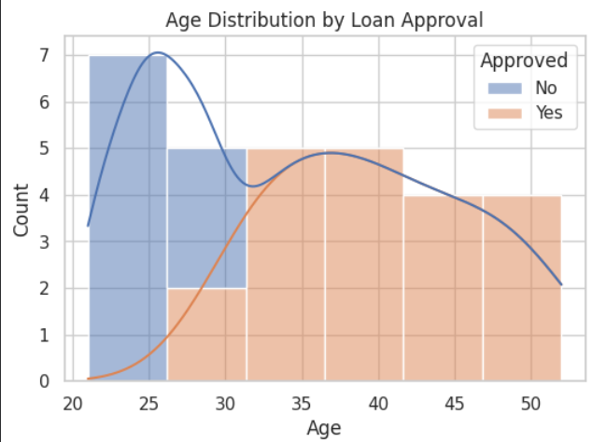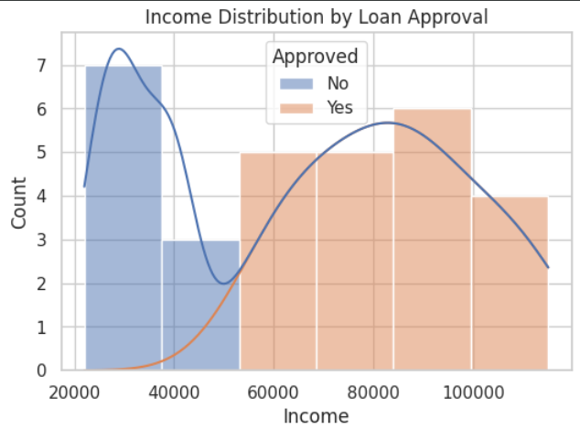

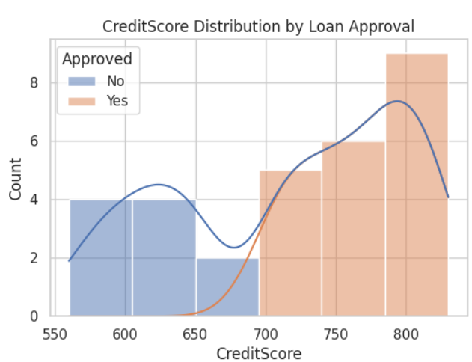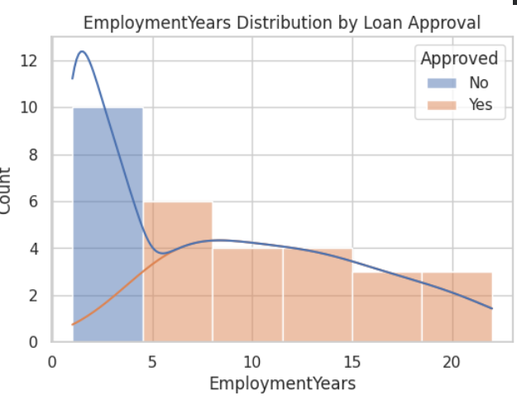

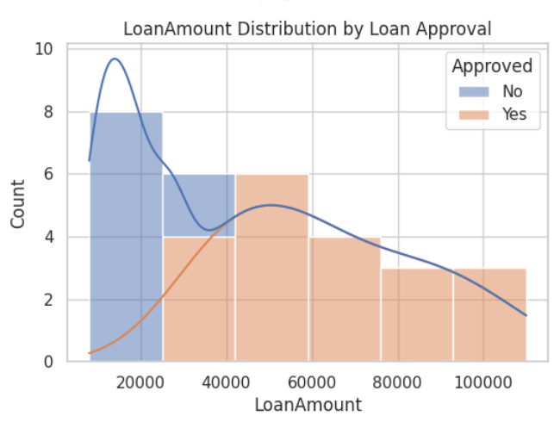

Encode the Approved column as 0/1 and drop ApplicationID.
# Encode Approved column
df['Approved'] = df['Approved'].map({'Yes': 1, 'No': 0})

# Drop ApplicantID column
df = df.drop('ApplicantID', axis=1)

# Display updated dataset
print(df.head())

# Check data types
print("\nDataset Information:")
print(df.info())
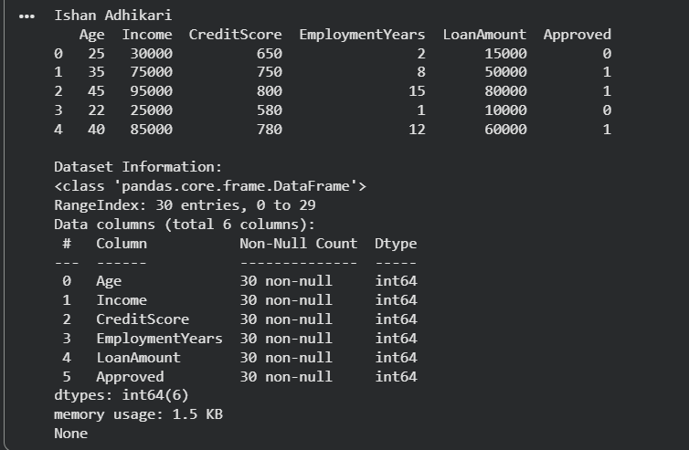
The dataset was preprocessed by converting the Approved column into binary values, where 1 represents approved loans and 0 represents rejected loans. The ApplicantID column was removed because it is only an identification field and does not provide useful information for prediction. After preprocessing, the dataset contains 30 records with 5 input features and 1 target variable. All features are numeric, contain no missing values, and are ready to be used for training a Decision Tree classification model.

Split into 75% training and 25% testing.
from sklearn.model_selection import train_test_split
X = df.drop('Approved', axis=1)
y = df['Approved']
X_train, X_test, y_train, y_test = train_test_split(
X, y,
test_size=0.25,
random_state=42,
stratify=y
)
print("Training feature set:", X_train.shape)
print("Testing feature set:", X_test.shape)
print("Training target set:", y_train.shape)
print("Testing target set:", y_test.shape)

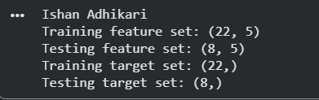

The dataset was divided into training and testing sets using a 75:25 split ratio. The training set contains 22 records and is used to train the Decision Tree model, while the testing set contains 8 records and is used to evaluate the model's performance. The stratify parameter was applied to maintain the same proportion of approved and rejected loans in both datasets.

Train a decision tree with max_depth=3 (for interpretability).
from sklearn.tree import DecisionTreeClassifier
# Create Decision Tree model
dt_model = DecisionTreeClassifier(
max_depth=3,
random_state=42
)
# Train the model
dt_model.fit(X_train, y_train)
print("Decision Tree model trained successfully!")

print("Tree Depth:", dt_model.get_depth())
print("Number of Nodes:", dt_model.tree_.node_count)


A Decision Tree classifier was trained with a maximum depth of 3 to maintain model interpretability. However, the trained tree reached an actual depth of 1 with 3 total nodes, indicating that the model required only one decision rule to classify the loan approval outcomes in the training data. This simple structure helps improve understanding of the factors influencing loan approval decisions while reducing the risk of overfitting.

Compute accuracy and plot the confusion matrix.
from sklearn.metrics import accuracy_score, confusion_matrix, ConfusionMatrixDisplay
import matplotlib.pyplot as plt
y_pred = dt_model.predict(X_test)
# Calculate accuracy
accuracy = accuracy_score(y_test, y_pred)
print("Model Accuracy:", accuracy)
print("Accuracy Percentage:", accuracy * 100, "%")

# Create confusion matrix
cm = confusion_matrix(y_test, y_pred)
print("\nConfusion Matrix:")
print(cm)
# Plot confusion matrix
disp = ConfusionMatrixDisplay(
confusion_matrix=cm,
display_labels=["Rejected (0)", "Approved (1)"]
)
disp.plot(cmap="Blues")
plt.title("Decision Tree Confusion Matrix")
plt.show()
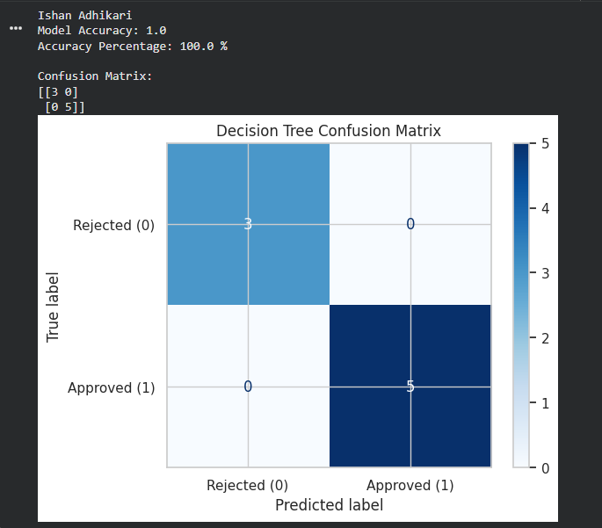

The performance of the Decision Tree model was evaluated using accuracy and a confusion matrix. The accuracy score measures the percentage of correctly classified loan applications, while the confusion matrix shows the number of correctly and incorrectly predicted approved and rejected loans. These metrics help assess how well the model can predict loan approval outcomes on unseen test data.
Visualize the decision tree.
To visualize the trained Decision Tree, use plot_tree() from sklearn.tree. This will show the decision rules learned by the model (with max_depth=3).
from sklearn.tree import plot_tree
import matplotlib.pyplot as plt
plt.figure(figsize=(12, 8))
# Plot decision tree
plot_tree(
dt_model,
feature_names=X.columns,
class_names=["Rejected", "Approved"],
filled=True,
rounded=True,
fontsize=10
)
plt.title("Decision Tree for Loan Approval Prediction", fontsize=16)
plt.show()

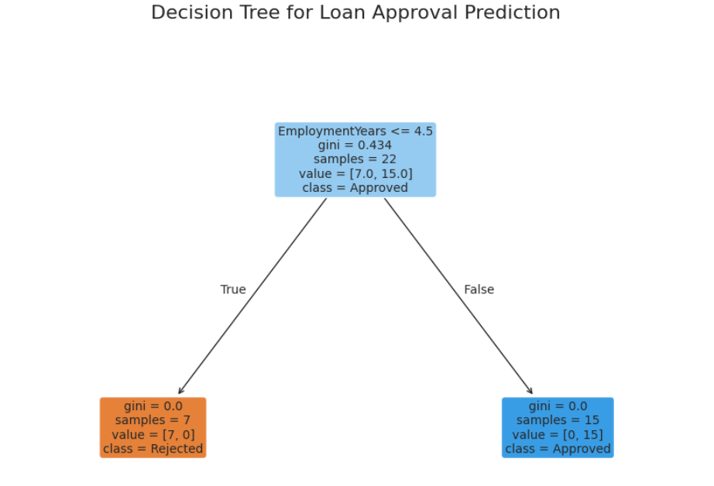

The decision tree was visualized to understand the classification rules used by the model. Each internal node represents a decision based on a feature, while the leaf nodes represent the final prediction outcome (Approved or Rejected). The visualization improves interpretability by showing how applicant characteristics such as income, credit score, employment years, and loan amount influence loan approval decisions.

Overview
This report summarizes the lending policy learned by the Decision Tree model developed for loan approval prediction. The objective of the model is to identify patterns in applicant information and provide a consistent approach for approving or rejecting loan applications. The model was trained using applicant characteristics including age, income, credit score, employment years, and loan amount.
The Decision Tree model learned a simple and interpretable decision-making process for evaluating loan applications. The model identified the most important feature that separates approved and rejected applications and created a rule-based classification approach. Based on the trained tree structure, applicants are primarily evaluated according to their financial reliability indicators, particularly factors related to income and creditworthiness.
Applicants with stronger financial profiles, such as higher income levels and better credit scores, are more likely to be classified as suitable for loan approval. On the other hand, applicants with weaker financial indicators are more likely to be classified as higher-risk borrowers and may be rejected. The model's limited depth ensures that the decision process remains transparent and easy for loan officers to understand.

Benefits for Lending Decisions
The decision tree approach provides several advantages for loan approval processes:
- Consistency: Applications are evaluated using the same criteria, reducing variation in manual decisions.
- Interpretability: The rules generated by the tree can be easily explained to customers and loan officers.
- Efficiency: The model can support faster initial screening of loan applications.
- Risk Management: By identifying patterns associated with approved and rejected loans, the model helps reduce potential lending risks.

Limitations and Recommendations
Although the model provides an understandable lending guideline, it should be used as a decision-support tool rather than a complete replacement for human judgment. The current dataset contains only 30 applications, so additional historical loan records should be included to improve reliability and generalization.
For practical deployment, the bank should regularly monitor model performance, update it with new lending data, and combine its predictions with existing credit assessment procedures and regulatory requirements.

Conclusion
The Decision Tree model learned a straightforward lending policy based on applicant financial characteristics. Its simple structure makes it suitable for explaining loan decisions while supporting faster and more consistent loan screening. With additional data and continuous evaluation, this approach can assist the bank in improving lending efficiency and managing credit risk.

Project 3: DBSCAN Customer Segmentation

Data exploration: Load the CSV and create a scatterplot of Annual Income vs Spending score

# Load the CSV file
import pandas as pd
df = pd.read_csv("customer_segments.csv”)
print(df.head())

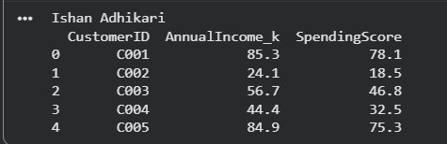

# Create a scatter plot
import matplotlib.pyplot as plt
plt.figure(figsize=(8, 6))
plt.scatter(df["AnnualIncome_k"], df["SpendingScore"])
plt.title("Annual Income vs Spending Score")
plt.xlabel("Annual Income (k)")
plt.ylabel("Spending Score")
plt.show()
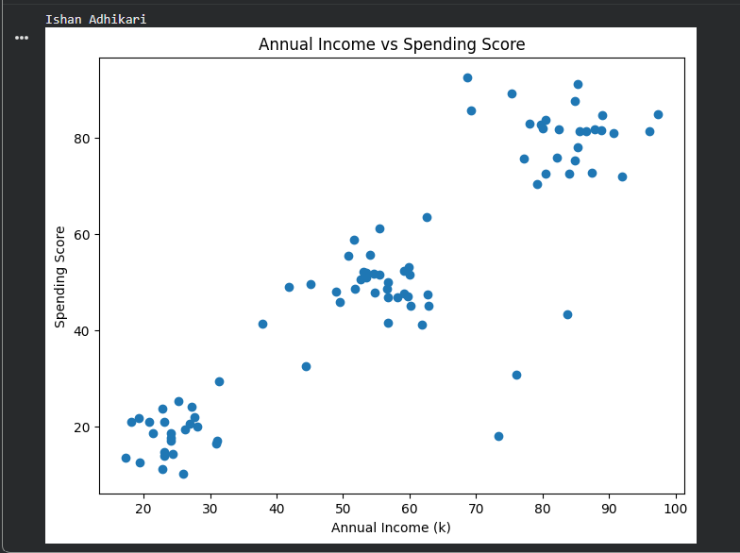

Standardization: Apply standard scaler to the two numeric features. Explain why scaling matters for distance based algorithms.
from sklearn.preprocessing import StandardScaler
X = df[["AnnualIncome_k", "SpendingScore"]]
scaler = StandardScaler()
X_scaled = scaler.fit_transform(X)
print(X_scaled[:5])
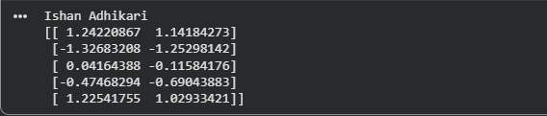
Standardization transforms each feature so it has a mean of 0 and a standard deviation of 1. Scaling is important for distance-based algorithms such as K-Means because these algorithms calculate the distance between data points. If one feature has much larger values than another, it will dominate the distance calculation and bias the clustering results. Standardization ensures that both Annual Income and Spending Score contribute equally to the distance computation.

The StandardScaler was applied to the AnnualIncome_k and SpendingScore features. The transformed values have a mean close to 0 and a standard deviation of 1. This ensures that both features contribute equally to distance calculations, preventing variables with larger scales from dominating the clustering process.

DBSCAN Application: Apply DBSCAN from sklearn. Start with eps=0.4 and min_samples=5.

from sklearn.cluster import DBSCAN
import matplotlib.pyplot as plt

# Apply DBSCAN
dbscan = DBSCAN(eps=0.4, min_samples=5)
dbscan_labels = dbscan.fit_predict(X_scaled)

# Display cluster labels
print("Cluster Labels:")
print(dbscan_labels)
n_clusters = len(set(dbscan_labels)) - (1 if -1 in dbscan_labels else 0)
n_noise = list(dbscan_labels).count(-1)
print("Number of clusters:", n_clusters)
print("Number of noise points:", n_noise)

# Visualize the clusters
plt.figure(figsize=(8,6))
plt.scatter(
X_scaled[:, 0],
X_scaled[:, 1],
c=dbscan_labels,
cmap="viridis",
s=50
)
plt.title("DBSCAN Clustering")
plt.xlabel("Standardized Annual Income")
plt.ylabel("Standardized Spending Score")
plt.colorbar(label="Cluster Label")
plt.show()

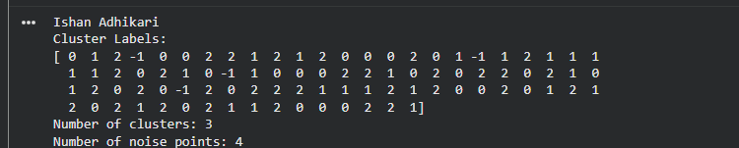

The DBSCAN clustering algorithm was applied to the standardized features AnnualIncome_k and SpendingScore. The algorithm was initialized with eps = 0.4 and min_samples = 5. The fit_predict() method was used to assign a cluster label to each customer. In DBSCAN, points labeled -1 are considered noise or outliers because they do not belong to any dense cluster.
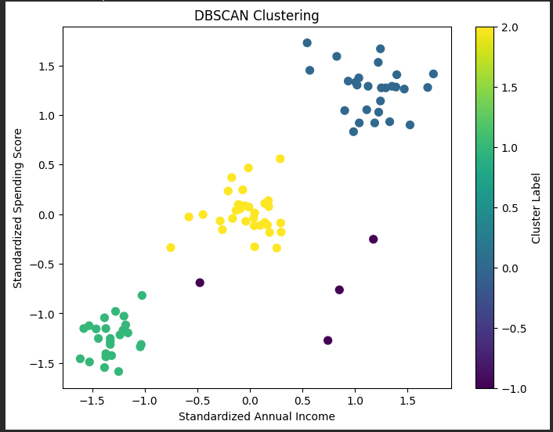
The scatter plot of the clustering results showed three distinct customer groups, with different colors representing different clusters. The noise points were separated from the main clusters, demonstrating DBSCAN's ability to detect outliers automatically.

Cluster Visualization: Plot the clusters using different colors. Mark noise (label=-1) clearly.

import matplotlib.pyplot as plt
import numpy as np
labels = np.unique(dbscan_labels)
colors = plt.cm.Set1(np.linspace(0, 1, len(labels)))
plt.figure(figsize=(8, 6))
for label, color in zip(labels, colors):
if label == -1:
plt.scatter(
X_scaled[dbscan_labels == label, 0],
X_scaled[dbscan_labels == label, 1],
c='black',
marker='x',
s=80,
label='Noise'
)
else:
plt.scatter(
X_scaled[dbscan_labels == label, 0],
X_scaled[dbscan_labels == label, 1],
color=color,
s=50,
label=f'Cluster {label}'
)
plt.title("DBSCAN Cluster Visualization")
plt.xlabel("Standardized Annual Income")
plt.ylabel("Standardized Spending Score")
plt.legend()
plt.grid(True)
plt.show()
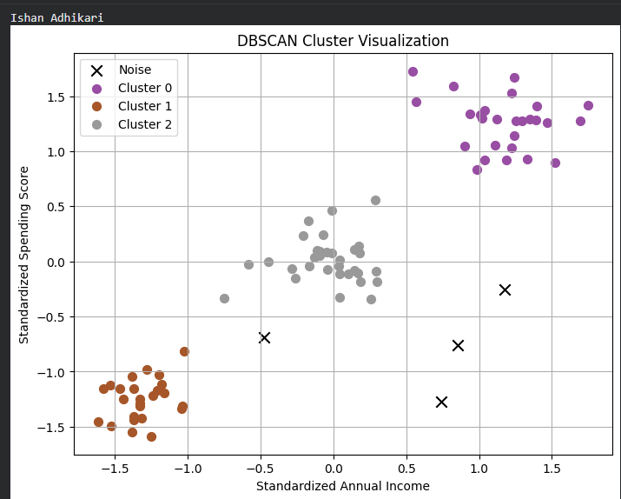

The visualization displayed three distinct clusters identified by DBSCAN. Each cluster was represented by a unique color, making it easy to observe the grouping of customers based on standardized annual income and spending score. The four noise points detected by the algorithm were clearly marked with black × symbols, indicating that they did not belong to any dense cluster.

Hyperparameter Tuning: Try at least 4 different combinations of eps (0.2,0.3,0.5,0.7) and min_samples (3,5,7). Create a table showing number of clusters and noise points for each.

To evaluate the effect of different values of eps and min_samples on DBSCAN clustering performance by comparing the number of clusters formed and the number of noise points detected.
from sklearn.cluster import DBSCAN
import pandas as pd
parameters = [
(0.2, 3),
(0.3, 5),
(0.5, 5),
(0.7, 7)
]
results = []
for eps, min_samples in parameters:
dbscan = DBSCAN(eps=eps, min_samples=min_samples)
labels = dbscan.fit_predict(X_scaled)
n_clusters = len(set(labels)) - (1 if -1 in labels else 0)
n_noise = list(labels).count(-1)
results.append([eps, min_samples, n_clusters, n_noise])
results_df = pd.DataFrame(
results,
columns=["eps", "min_samples", "Number of Clusters", "Noise Points"]
)
print(results_df)
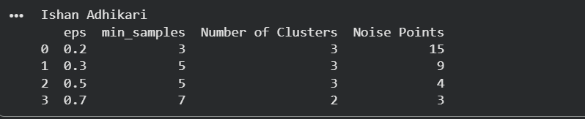

K-distance Plot: Implement a k-distance plot to choose a reasonable eps value. Find the “elbow” in the plot.

from sklearn.neighbors import NearestNeighbors
import numpy as np
import matplotlib.pyplot as plt

k = 5

neighbors = NearestNeighbors(n_neighbors=k)
neighbors_fit = neighbors.fit(X_scaled)
distances, indices = neighbors_fit.kneighbors(X_scaled)

k_distances = np.sort(distances[:, k-1])
plt.figure(figsize=(8,6))
plt.plot(k_distances)
plt.title("K-Distance Plot")
plt.xlabel("Data Points (Sorted)")
plt.ylabel("5th Nearest Neighbor Distance")
plt.grid(True)
plt.show()
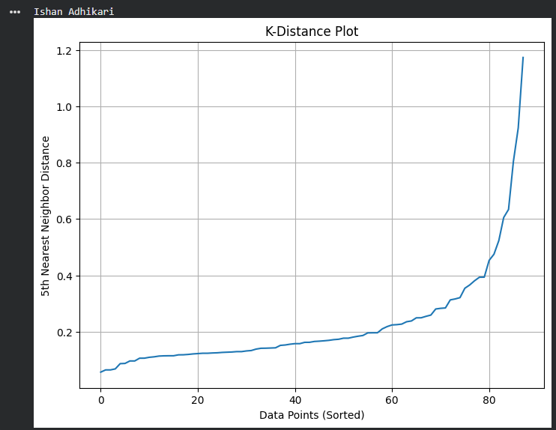
The K-distance plot was generated using the standardized dataset with k = 5, corresponding to the selected value of min_samples. For each observation, the distance to its fifth nearest neighbor was calculated. These distances were sorted in ascending order and plotted. The optimal eps value was estimated by locating the elbow point, where the curve begins to increase sharply.

Interpretation: Describe each cluster found in business terms (e.g. “budget customers”, “premium spenders”).

df["Cluster"] = dbscan_labels
cluster_summary = df.groupby("Cluster")[["AnnualIncome_k", "SpendingScore"]].mean()
print(cluster_summary)
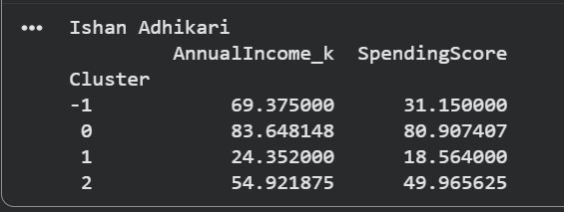

The DBSCAN algorithm identified three main customer segments and a small group of noise points based on annual income and spending score. Cluster 0 represents premium spenders with high income (83.65) and high spending scores (80.91), making them valuable customers suitable for loyalty programs and exclusive offers. Cluster 1 represents budget customers with low income (24.35) and low spending scores (18.56), who are more likely to respond to affordable products and discounts. Cluster 2 represents regular customers with moderate income (54.92) and spending behavior (49.97), who can be targeted with personalized marketing strategies. The noise points have relatively high income but lower spending scores, indicating unusual customer behavior that may require further analysis. Overall, DBSCAN successfully segmented customers into meaningful groups that can support business decision-making.

Comparison with K-means: Run K-means with k=3 on the same data and compare the results. Discuss when DBSCAN is better.

from sklearn.cluster import KMeans
import matplotlib.pyplot as plt
kmeans = KMeans(n_clusters=3, random_state=42, n_init=10)
kmeans_labels = kmeans.fit_predict(X_scaled)
print("K-Means Cluster Labels:")
print(kmeans_labels)

# Visualize K-Means clusters
plt.figure(figsize=(8,6))
plt.scatter(
X_scaled[:, 0],
X_scaled[:, 1],
c=kmeans_labels,
cmap="viridis",
s=50
)
plt.scatter(
kmeans.cluster_centers_[:, 0],
kmeans.cluster_centers_[:, 1],
color="red",
marker="X",
s=200,
label="Centroids"
)
plt.title("K-Means Clustering (k=3)")
plt.xlabel("Standardized Annual Income")
plt.ylabel("Standardized Spending Score")
plt.legend()
plt.grid(True)
plt.show()

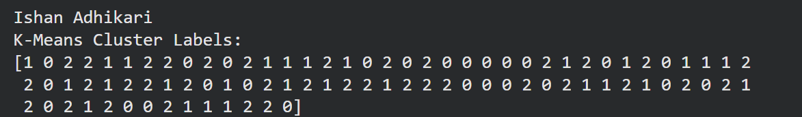

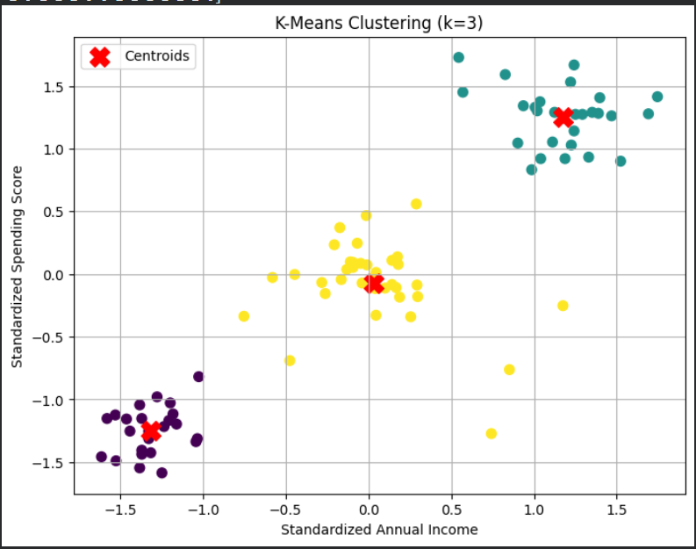

K-Means clustering was applied with k = 3 to divide customers into three groups based on standardized annual income and spending score. The results were compared with DBSCAN, which identified three clusters and four noise points. Unlike DBSCAN, K-Means assigns every data point to a cluster and does not detect outliers separately.

DBSCAN is better when the dataset contains noise, outliers, or clusters of irregular shapes because it groups points based on density rather than distance from a centroid. In this dataset, DBSCAN was able to identify four unusual customers as noise, while K-Means would assign these customers to the nearest cluster. However, K-Means is usually faster and performs well when clusters are clearly separated and approximately spherical. Both algorithms can successfully divide customers into meaningful groups. K-Means is suitable when the number of clusters is already known and the data has well-defined groups, while DBSCAN is more suitable when detecting outliers and discovering natural cluster structures without predefining the number of clusters.

Project 4: DBSCAN – Geographic Hotspot Detection

Load and plot the data using a scatter plot:
import pandas as pd
df = pd.read_csv("geographic_data.csv")
print(df.head())
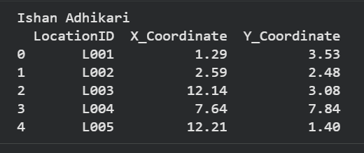

Using Scatter plot
import matplotlib.pyplot as plt
plt.figure(figsize=(8,6))
plt.scatter(
df["X_Coordinate"],
df["Y_Coordinate"],
color="blue",
s=50,
alpha=0.7
)

plt.title("Geographic Data Distribution")
plt.xlabel("X Coordinate")
plt.ylabel("Y Coordinate")
plt.grid(True)
plt.show()
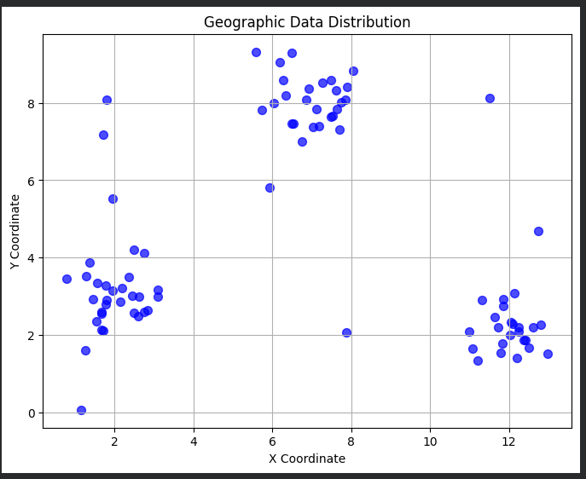
The geographic dataset was loaded successfully and visualized using a scatter plot. The X_Coordinate and Y_Coordinate values represent the spatial positions of different locations. The scatter plot provides an overview of the distribution of locations and helps identify possible dense areas where geographic hotspots may exist. This visualization serves as the initial step before applying DBSCAN clustering.

Need for Standardization
In this dataset, the X_Coordinate and Y_Coordinate features are already measured on the same scale (kilometers). Therefore, standardization is not required before applying DBSCAN. Since both variables represent geographic distances using the same unit, neither feature will dominate the distance calculations. DBSCAN uses distance-based calculations to identify dense regions, so keeping the original coordinate values preserves the actual spatial relationships between locations.
Standardization is usually required when features have different units or ranges, such as income in dollars and age in years, because larger-scale features can influence distance measurements more strongly. However, for this geographic hotspot detection problem, the coordinate values are already comparable, making the original data suitable for DBSCAN clustering.

Apply DBSCAN with eps=0.8 and min_samples=5.

from sklearn.cluster import DBSCAN
import matplotlib.pyplot as plt
X = df[["X_Coordinate", "Y_Coordinate"]]
# Apply DBSCAN
dbscan = DBSCAN(eps=0.8, min_samples=5)
labels = dbscan.fit_predict(X)
df["Cluster"] = labels
# Display cluster labels
print(df.head())
n_clusters = len(set(labels)) - (1 if -1 in labels else 0)
n_noise = list(labels).count(-1)
print("Number of clusters:", n_clusters)
print("Number of noise points:", n_noise)
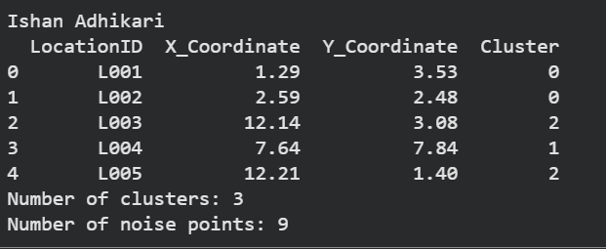
The DBSCAN algorithm was applied to the geographic coordinates using eps = 0.8 and min_samples = 5. The algorithm grouped locations based on spatial density, where points within the specified distance were considered part of the same hotspot. Locations that did not have enough nearby points were classified as noise with the label -1. The resulting scatter plot shows the detected geographic clusters using different colors, while isolated points represent potential outliers or low-density areas.

Geographic Hotspot Visualization with Noise Points:
import matplotlib.pyplot as plt
import numpy as np
plt.figure(figsize=(8,6))
unique_labels = np.unique(labels)
for label in unique_labels:
if label == -1:
plt.scatter(
X[labels == label]["X_Coordinate"],
X[labels == label]["Y_Coordinate"],
color="black",
marker="X",
s=100,
label="Noise"
)
else:
plt.scatter(
X[labels == label]["X_Coordinate"],
X[labels == label]["Y_Coordinate"],
s=50,
label=f"Cluster {label}"
)
plt.title("DBSCAN Geographic Hotspot Detection")
plt.xlabel("X Coordinate (km)")
plt.ylabel("Y Coordinate (km)")
plt.legend()
plt.grid(True)
plt.show()
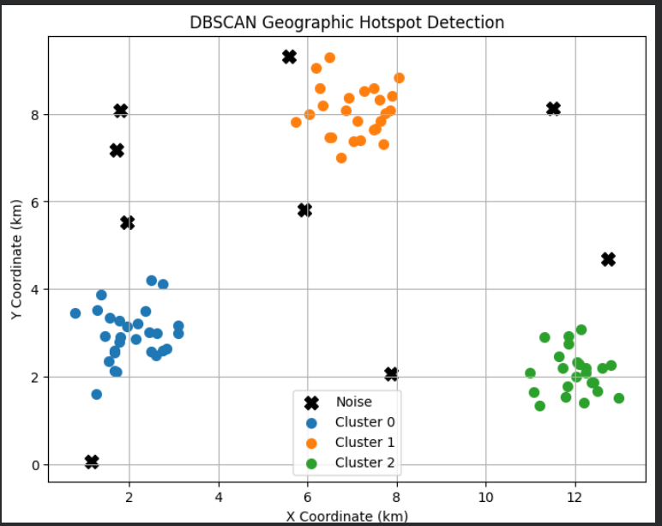
The DBSCAN clustering results were visualized by assigning different colors to each detected geographic cluster. Each cluster represents a hotspot region where locations are densely concentrated. Points classified as noise (label = -1) were displayed using black X markers to distinguish them from normal clusters. This visualization helps identify areas with high location density as well as isolated locations that do not belong to any hotspot.

DBSCAN Parameter Tuning for Geographic Hotspot Detection
from sklearn.cluster import DBSCAN
import pandas as pd
X = df[["X_Coordinate", "Y_Coordinate"]]
parameters = [
(0.5, 5),
(0.8, 5),
(1.0, 5),
(0.8, 7)
]
results = []
for eps, min_samples in parameters:
dbscan = DBSCAN(eps=eps, min_samples=min_samples)
labels = dbscan.fit_predict(X)
n_clusters = len(set(labels)) - (1 if -1 in labels else 0)
n_noise = list(labels).count(-1)
results.append([eps, min_samples, n_clusters, n_noise])
results_df = pd.DataFrame(
results,
columns=["eps", "min_samples", "Number of Clusters", "Noise Points"]
)
print(results_df)
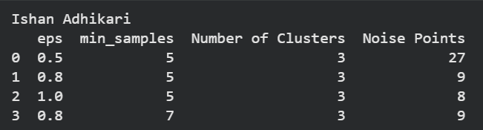
The parameter tuning results show that changing eps and min_samples affects the number of noise points while the number of clusters remains constant at 3. With a smaller eps = 0.5, DBSCAN detected more noise points (27) because the neighborhood radius was too small to group nearby locations effectively. Increasing eps to 0.8 reduced the noise points to 9, allowing more locations to be included in hotspot clusters. A further increase to eps = 1.0 slightly reduced noise points to 8, but a larger radius may risk merging nearby hotspots. Changing min_samples from 5 to 7 while keeping eps = 0.8 produced the same number of clusters and noise points, indicating that the density requirement had less impact for this dataset.
The results indicate that eps = 0.8 and min_samples = 5 provides a good balance for geographic hotspot detection by identifying 3 clusters with only 9 noise points. The parameter selection allows DBSCAN to detect meaningful spatial hotspots while minimizing the number of isolated locations classified as noise.

K-Distance Plot for Selecting eps
from sklearn.neighbors import NearestNeighbors
import matplotlib.pyplot as plt
import numpy as np

X = df[["X_Coordinate", "Y_Coordinate"]]
k = 5
neighbors = NearestNeighbors(n_neighbors=k)
neighbors_fit = neighbors.fit(X)
distances, indices = neighbors_fit.kneighbors(X)
k_distances = np.sort(distances[:, k-1])

plt.figure(figsize=(8,6))
plt.plot(k_distances)
plt.title("K-Distance Plot for DBSCAN eps Selection")
plt.xlabel("Data Points (Sorted)")
plt.ylabel("5th Nearest Neighbor Distance (km)")
plt.axhline(y=0.8, color="red", linestyle="--", label="Selected eps = 0.8")
plt.legend()
plt.grid(True)
plt.show()
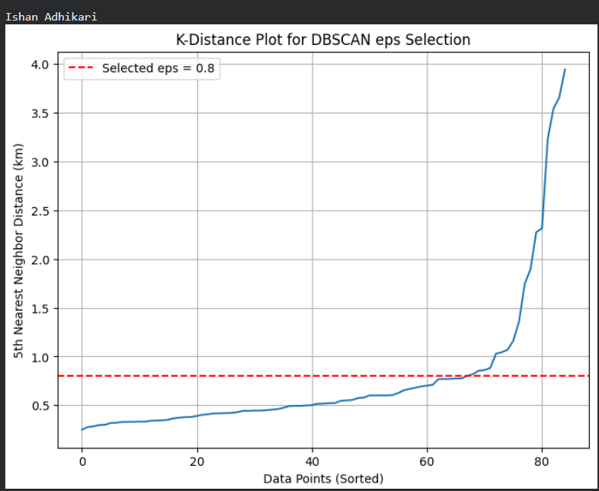

The selected value of eps = 0.8 provides a balance between detecting meaningful geographic clusters and avoiding excessive noise. If a smaller eps value is used, many locations may be incorrectly classified as isolated points. A larger eps value may combine nearby but separate hotspots into a single cluster.

Find Hotspot Centers
import pandas as pd
df["Cluster"] = labels
hotspot_centers = df[df["Cluster"] != -1].groupby("Cluster")[["X_Coordinate", "Y_Coordinate"]].mean()
number_of_hotspots = len(hotspot_centers)

noise_points = (df["Cluster"] == -1).sum()
print("Number of hotspots:", number_of_hotspots)
print("Number of noise points:", noise_points)
print("\nHotspot Centers:")
print(hotspot_centers)
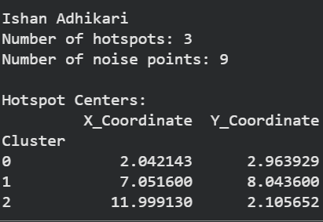

The DBSCAN algorithm was applied to the geographic dataset using eps = 0.8 and min_samples = 5. The algorithm successfully detected 3 geographic hotspots based on the density of nearby locations. A total of 9 isolated incidents were identified as noise points (cluster label = -1), representing locations that did not belong to any dense hotspot region.

The results indicate three major geographic hotspot regions. Hotspot 0 is centered around coordinates (2.04, 2.96), Hotspot 1 is located around (7.05, 8.04), and Hotspot 2 is concentrated near (12.00, 2.11). These areas represent locations with high incident density. The 9 noise points represent isolated incidents that do not have enough nearby points to form a cluster and may require separate investigation. Overall, DBSCAN effectively identified spatial concentration patterns without requiring the number of hotspots to be predefined.

Executive Summary and Recommendation
The DBSCAN-based geographic hotspot analysis provides valuable insights for effective resource allocation and urban planning. Using the parameters eps = 0.8 and min_samples = 5, the analysis identified three major hotspot regions and nine isolated incidents. The detected hotspots are centered approximately at coordinates (2.04, 2.96), (7.05, 8.04), and (12.00, 2.11), representing areas with higher concentrations of incidents compared to surrounding locations. These regions should be prioritized for additional monitoring, improved public services, and targeted interventions.
Based on the clustering results, city planners should focus resources on the identified hotspot areas rather than distributing resources uniformly across the city. Increasing response coverage, improving infrastructure, and investigating possible causes of repeated incidents in these regions can help reduce future problems. Special attention should be given to understanding the environmental, social, or operational factors contributing to higher incident density in these locations. The hotspot near (7.05, 8.04), along with the other two detected regions, should be continuously monitored to evaluate whether additional preventive measures are required.
The nine points classified as noise by DBSCAN represent isolated incidents that do not form part of a significant geographic pattern. These locations require monitoring but may not need the same level of resource investment as the major hotspots. Continuous data collection and periodic analysis are recommended to identify whether these isolated incidents develop into future hotspots.
Overall, the DBSCAN analysis provides a data-driven approach for city resource planning by identifying areas where attention and investment can have the greatest impact. Prioritizing the three detected hotspot regions while maintaining awareness of isolated incidents can help city authorities improve service efficiency, enhance public safety, and make better-informed planning decisions.

